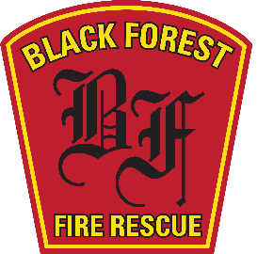
Black Forest Fire Rescue Protection District
11445 Teachout Road
Colorado Springs, Colorado 80908
Ph-719.495.4300
www.bffire.org

“Always Ready, Always Forward, Always Learning.”

Office of the Fire Marshal
Thursday, October 22, 2020

Black Forest Fire Rescue Protection District will require the landowner/Developer to adhere to the current approved version of the El Paso County Land Development Code, Section 6.3.3 subsections (C)(1)Water Supply, (C),(2),(3) Roads and (D) Construction in Wildland Fire Areas, in their entirety.
The landowner may request a variance to the code by submitting a variance request form to the Black Forest Fire Rescue Protection District, Office of the Fire Marshal. The form may be found on our website at www.bffire.org or in person at our main station 11445 Teachout Rd, Colorado Springs, Co 80908 phone 719-495-4300.

Any Questions may be directed to the Fire Chief or Deputy Fire Chief at 719-495-4300.

Respectfully,

James Rebitski
Deputy Fire Chief
Black Forest Fire Rescue

