December 14, 2018

RE: McMillen Administrative Relief – Lot Size Variance

File: ADR-18-009
Parcel No.: 7132002029

To Whom It May Concern:

This letter is to inform property owners adjacent to the above mentioned properties that the applicant, Mark D. McMillen, has requested approval of administrative relief to allow a minimum lot size of 4.1 acres, when 5 acres is required in the RR-5 (Residential Rural) Zoning District. The Planning and Community Development Director may make a formal decision regarding the administrative relief request on January 2, 2018 at 4:30 P.M. Any comments or questions may be forwarded to me prior to that decision. At the discretion of the Planning and Community Development Director, the approval process may be elevated to the Board of Adjustment for consideration. Administrative approval by the Planning and Community Development Director is subject to the appeal provisions of the Land Development Code.

You may view the application documents online at www.epcdevplanreview.com. Please feel free to contact me with any questions, comments, or concerns you may have prior to the decision.

Respectfully,
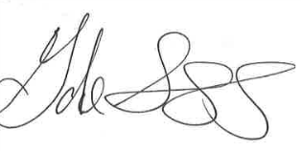
Gabe Sevigny, Planner I
El Paso County Planning and Community Development
719-520-7943
gabesevigny@elpasoco.com

