Early Assistance Meeting Number: EA26107
Project Name: Maguire Property Rezone and Subdivide
Project Location: 18110 KNOLLWOOD DR
Project Parcel No: 7114100017 7114100022
Project Description: Rezone of approximately 1.70 AC (74,185 SF) from Rural Residential (RR-5) to Commercial Community (CC) and a subsequent subdivision of the applicable properties.
Meeting Date: Wed, September 29, 2026 @ 11 am

El Paso County Planning & Community Development Planning Checklist

Request – Map Provided by Applicant
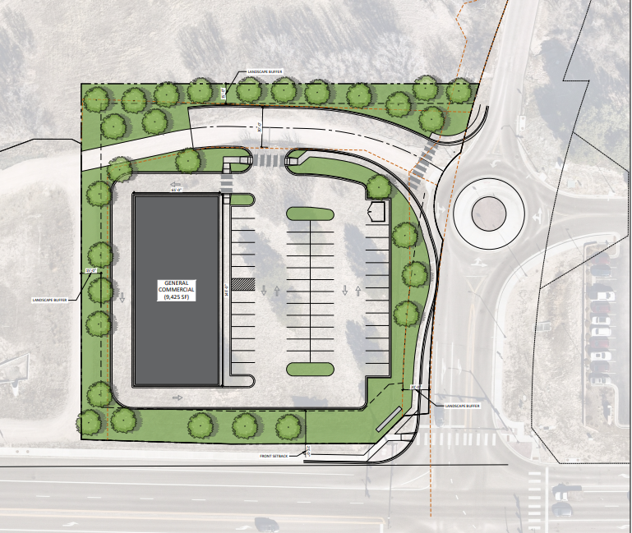

Zoning District(s)
 | Zone | Name
Existing | RR-5 | Rural Residential
Proposed | RR-5 | Rural Residential
 | CC | Commercial Community

Zone Map
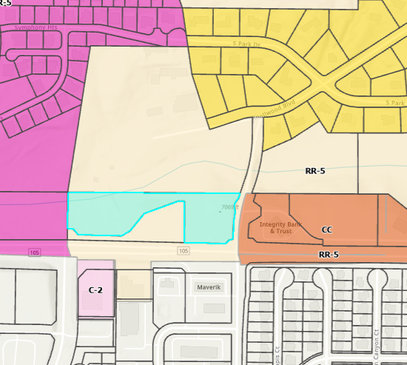

Zoning Analysis
The proposal to rezone a portion of two lots for a total of 1.76 acres meets the Table 5-5 CC zoning district standard to allow for the creation of 1 lot. Pursuant to Table 5-1 in the Land Development Code, the use of Retail Sales, General is allowed in the proposed CC Zoning District, subject to a Site Development Plan.
Table 5-5
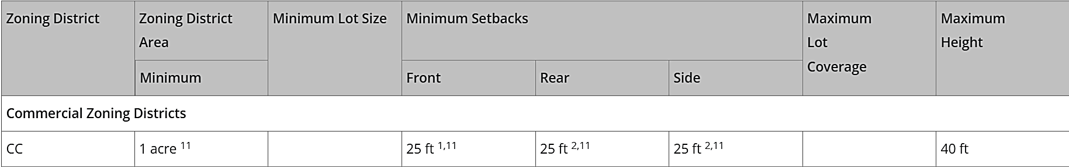
¹ Gasoline pumps and canopies shall be at least 15 feet from the front property line or public right-of-way, except where the landscaping regulations require a greater setback.
² The minimum setback is 25 feet from the perimeter boundary of the district, but no minimum setback is required from any internal side or rear lot line within the same district.
¹¹ If the building is established as or converted to condominium units in accordance with Chapter 7 of this Code, the building and lot shall meet the minimum lot area and setbacks, but the individual units are not required to meet the minimum lot area, maximum lot coverage, or setback requirements.
Table 5-4
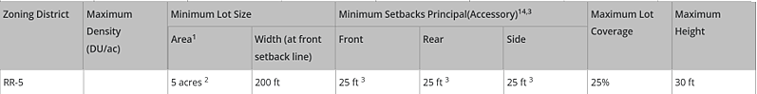
¹ Specific uses may be subject to larger minimum lot area requirements.
² In the event that the land to be partitioned, platted, sold or zoned abuts a section line County road, the minimum lot area for lots abutting the road shall be 4.75 acres and minimum lot width shall be 165 ft.
³ Agricultural stands shall be setback a minimum of 35 feet from all property lines.
¹⁴ If no separate setback is shown in parentheses for accessory structures, the principal structure setback applies to accessory structures.

Please review Table 5-1 to confirm that any specific uses in mind would be allowed.
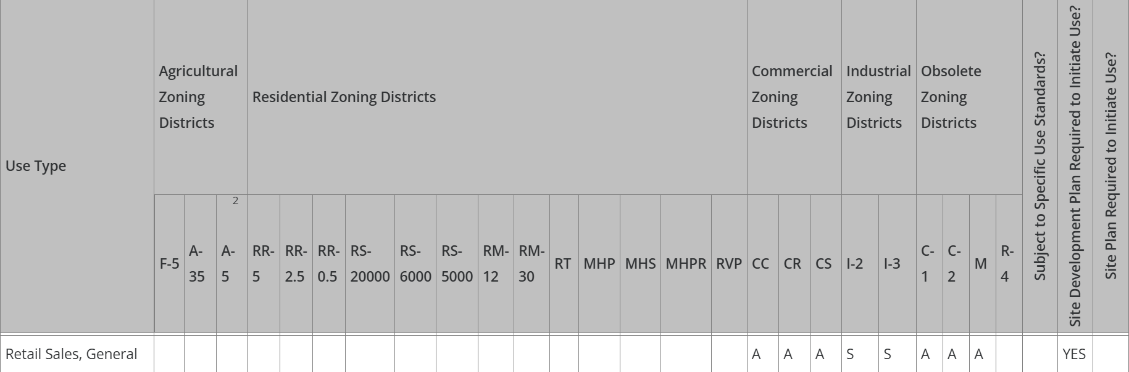

Application Type(s) Hearing: Required/ Optional/ No
Rezone (Map Amendment) | Yes – 2: PC and BoCC
Final Plat | Yes – 2: PC and BoCC
Site Development Plan | No

Available submittal guides for each process (comprehensive submittal requirements will be shown in EDARP project pages for each application)
Map Amendment (rezoning) submittal checklist
- Application/Petition Form
- Mineral Rights Certification

Final Plat submittal checklist
- Application Form
- Mineral Estate Certification
- Fire Protection Report
  - List of Qualified Individuals to prepare
- Soils and Geology report
- Subdivision Improvements Agreement
- Water Resources Report
- Water supply summary info form
- Wastewater disposal
- Road Impact Fee acknowledgement
- PCM - MHFD Detention Calcs or SDI Form
- PCM - Notice of Intent to Construct a Non-Juris. Water Impoundment Structure (proof of submittal)
- PCM Applicability Form

Site Development Plan submittal checklist (after approval of rezoning and plat)
Application/Petition Form
Landscape Plan drawings
Lighting Plan
Road Impact Fee Acknowledgement
Site Development Plan
Erosion and Stormwater Quality Control Permit (ESQCP)
Financial Assurance Estimate (FAE) Form
Grading & Erosion Control (GEC) Checklist
PCM - MHFD Detention Calcs or SDI Form
PCM - Notice of Intent to Construct a Non-Juris. Water Impoundment Structure (proof of submittal)
PCM Applicability Form
Drainage Report - Final
Traffic Impact Study
PCM Maintenance Agreement (MS WORD version required - attachments included)

Assessor Map of Unplatted parcel
Current unplatted legal parcels
- Parcel 7114100022 was created in 2001, at 5.61 acres under RR-5 zoning. Portions of the property were conveyed for DOT and County purposes in 2023, reducing the property size to 4.13 acres, but it remains a legally created parcel.
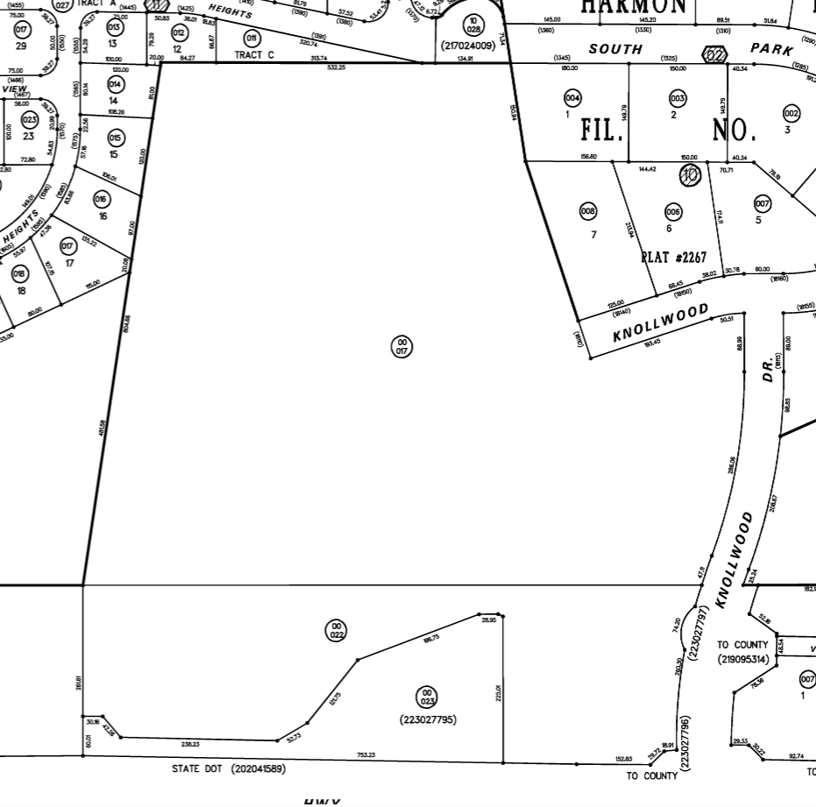

Road Impact Fees:
Due at time of building permit/Site Development Plan approval
The owner agrees on behalf of him/herself and any developer or builder successors and assignees that Subdivider and/or said successors and assigns shall be required to pay traffic impact fees in accordance with the El Paso County Road Impact Fee Program Resolution (Resolution No. 25-337), or any amendments thereto, at or prior to the time of building permit submittals. The fee obligation, if not paid at approval/building permit, shall be documented on all sales documents and on plat notes to ensure that a title search would find the fee obligation before sale of the property

**You will schedule a preconstruction meeting with our inspections team AFTER your approval of the Site Development Plan.

Contact: bradwalters@elpasoco.com

Approval Criteria
5.3.5. Map Amendment (Rezoning)

(B) Criteria for Approval. In approving a Map Amendment, the following findings shall be made:
• The application is in general conformance with the El Paso County Master Plan including applicable Small Area Plans or there has been a substantial change in the character of the neighborhood since the land was last zoned;
• The rezoning is in compliance with all applicable statutory provisions, including but not limited to C.R.S. § 30-28-111 § 30-28-113, and § 30-28-116;
• The proposed land use or zone district is compatible with the existing and permitted land uses and zone districts in all directions; and
• The site is suitable for the intended use, including the ability to meet the standards as described in Chapter 5 of the Land Development Code, for the intended zone district.

7.2.1 (D) (3) Final Plat
(f) Criteria for Approval. In approving a final plat, the approving authority shall find that:
- The subdivision is in conformance with the goals, objectives, and policies of the Master Plan;
- The subdivision is in substantial conformance with the approved preliminary plan;
- The subdivision is consistent with the subdivision design standards and regulations and meets all planning, engineering, and surveying requirements of the County for maps, data, surveys, analyses, studies, reports, plans, designs, documents, and other supporting materials;
- Either a sufficient water supply has been acquired in terms of quantity, quality, and dependability for the type of subdivision proposed, as determined in accordance with the standards set forth in the water supply standards [C.R.S. § 30-28-133(6)(a)] and the requirements of Chapter 8 of this Code, or, with respect to applications for administrative final plat approval, such finding was previously made by the BoCC at the time of preliminary plan approval;
- A public sewage disposal system has been established and, if other methods of sewage disposal are proposed, the system complies with State and local laws and regulations, [C.R.S. § 30-28-133(6)(b)] and the requirements of Chapter 8 of this Code;
- All areas of the proposed subdivision which may involve soil or topographical conditions presenting hazards or requiring special precautions have been identified and that the proposed subdivision is compatible with such conditions [C.R.S. § 30-28-133(6)(c)];
- Adequate drainage improvements are proposed that comply with State Statute [C.R.S. § 30-28-133(3)(c)(VIII)] and the requirements of this Code and the ECM;
- Legal and physical access is provided to all parcels by public rights-of-way or recorded easement, acceptable to the County in compliance with this Code and the ECM;
- Necessary services, including police and fire protection, recreation, utilities, and transportation systems, are or will be made available to serve the proposed subdivision;
- The final plans provide evidence to show that the proposed methods for fire protection comply with Chapter 6 of this Code;
- Off-site impacts were evaluated and related off-site improvements are roughly proportional and will mitigate the impacts of the subdivision in accordance with applicable requirements of Chapter 8;
- Adequate public facilities or infrastructure, or cash-in-lieu, for impacts reasonably related to the proposed subdivision have been constructed or are financially guaranteed through the SIA so the impacts of the subdivision will be adequately mitigated;
- The subdivision meets other applicable sections of Chapter 6 and 8; and
- The extraction of any known commercial mining deposit shall not be impeded by this subdivision [C.R.S. §§ 34-1-302(1), et seq.]

Relevant Current/Past History:

Design and Landscaping (at PPR)

Site Design/Layout (Lot pattern, circulation/road design, open space, preservation of natural features, compatibility internally and with adjacent land uses)

Landscaping
☒ | Expressway, Principal arterial area depth – 25’-Trees required 1 per 20’
☐ | Urban interchange/Intersection area depth – 25’- N/A
☐ | Minor arterial area depth 20’ – Trees required 1 per 25’ (Old Ranch Rd)
☒ | Non-arterial area depth 10’ – Trees required 1 per 30’
☒ | Parking lot landscaping required
☐ | Buffer between non-residential and residential districts separated by a non-arterial road or public alley  ☐ Zone Boundary Buffer

6.2.2. Landscape Requirements
- Applies to All Land Uses. The requirements of this Section shall apply to all uses. PUD's may have their requirements modified subject to the individual PUD.

(B) Roadway Landscaping Requirements. Roadway landscaping areas are required. A roadway landscaping area is located along the lot, parcel or tract frontage between the road right-of-way, easement, or tract boundary lines and any building or use.

(C) Parking Lot Landscape Requirements.
- Required Trees.
A tree of a type suitable for parking lots shall be provided for every 15 parking spaces in parking lots with 15 or more parking spaces. The required trees may be clustered and shall be located in a manner which will divide and break up expanses of paving and long rows of parking and create a canopy effect over the parking lot. See Landscaping and Planting Manual for island details.

(5) Required Parking Lot Screening. Parking lots shall be screened from view from adjacent roads and properties with differing land uses. The minimum height of the screening shall be 3 feet and may be accomplished by using berms and plantings. A minimum of ⅔ of the road frontage or common lot, parcel, or tract boundary, not counting intersecting driveways, shall be provided with the required screening. The maximum spacing of plants to achieve an acceptable screen and the maximum acceptable grades for screening areas, such as grass berms and plantings beds, should be consistent with the Landscaping and Planting Manual.

Decorative walls or fences may be approved if the Director finds that:
• The wall or fence avoids a blank and monotonous appearance by architectural articulation and the planting of vines, shrubs, or trees.
• The total use of berms or plantings is not physically feasible; or
• The wall or fence attractively compliments the use of berms or plantings.
(E) Internal Landscaping. The following internal landscaping is required:
- Requirements for Non-Residential Uses. The following internal landscaping is required for non-residential uses:
  - Minimum Required Internal Landscaped Area. A minimum of 5% of the lot or parcel shall be landscaped.
  - Minimum Number of Trees in Landscaped Area. A minimum of 1 tree shall be provided for every 500 square feet of required internal landscape area.
  - Trees Replaced by Shrubs. A maximum of ½ of the required trees may be substituted with shrubs adjacent to retail store fronts where the view of wall signs may be obstructed. At least 10 shrubs with a minimum container size of 5 gallons shall be provided for each tree that is replaced.

(4) Authority of Director to Approve Substitute Landscape Designs. The PCD Director may approve landscaping that does not meet the specific requirements of this Section provided the proposed landscaping meets the purpose of this Section, promotes the concepts contained in the Landscaping and Planting Manual, and provides an equivalent benefit to the community and environment as would otherwise be achieved by meeting the specific requirements of this Section. This authority shall not allow the PCD Director to eliminate the requirement for landscaping or to diminish the total landscaped area required by this Section.

Signage: (at PPR)
Please show signs on site development plan, but any signs will require separate sign permit. Sign permit applications are self-initiated at https://epcdevplanreview.com/

6.2.10. Signs, On-Premise
(2) Commercial and Industrial Zoning Districts.

Parking Requirements: (at PPR)
Parking design standards are outlined in 6.2.5 Parking, Loading, and Maneuvering Standards

Table 6-2. Minimum Parking Requirements by Use
Once you calculate the number of spaces required, see Table 6-3. Disabled Parking Space Requirements, to determine number of required ADA spaces.

Lighting: (at PPR)
6.2.3. Lighting
(d) Maximum Levels. Maximum on-site lighting levels shall not exceed 10 foot candles, except for loading and unloading platforms where the maximum lighting level shall be 20 foot candles.
(e) Measurement at Property Boundaries. Light levels measured at the property line of the development site adjacent to residential property or public right of way shall not exceed 0.1 foot candles as a direct result of the on-site lighting.
Photometric Plan ReqRequired | ☒

Site Characteristics\ Constraints\ Environmental Standards:
Hazards to be identified on plat.

(B) Hazards. Land shall not be divided until hazards have been removed or the impact of hazards has been mitigated as determined by the PCD Director. Lots or tracts subject to hazards which may be eliminated through specialized engineering shall be identified on the plat. Identification of hazards on the plat shall include a statement about the specific hazard and a statement of the engineering alterations required to eliminate the hazard. The following hazards are subject to these requirements:
(3) Unsuitable Building Areas. Areas within lots or tracts which reflect 1 or more of the following characteristics shall be deemed unsuitable for building and shall be identified as no build areas on the plat:
• Areas not suitable for location of water or sewage disposal systems as determined by State and County health regulations.
• Areas where slopes are greater than 30%.
• Areas of identified or designated geologic, soil, or natural hazards as identified in the geology and soils report or designated in the El Paso County hazard identification inventory; provided that the limitations cannot be overcome through the application of specialized engineering or mitigation.
• Areas within the 100-year floodplain as reflected on FEMA Flood Insurance Rate Map (FIRM), within proposed boundaries as reflected in LOMR/CLOMR, or as determined by a flood study as approved by the Floodplain Administrator.
• Areas within easements, without the permission or release from the beneficiary of the easement holder.

SLOPE
30% slope areas indicated below must be depicted as No Build Areas on plat.

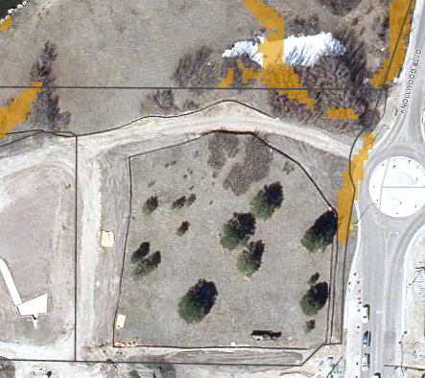

PREBLE’S MOUSE
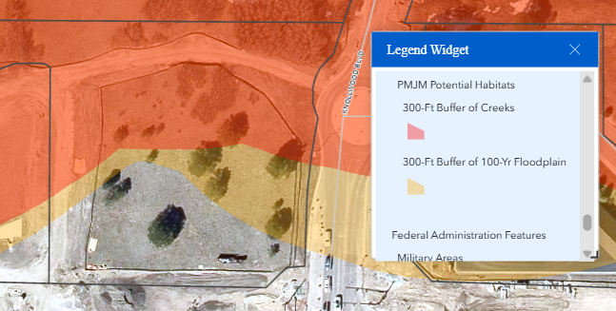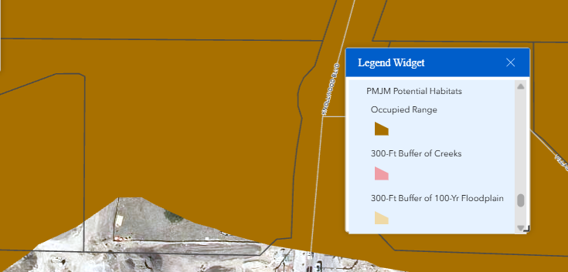
This requires a Block Clearance letter from the US Fish and Wildlife Service.

Wildlife Impact Level – 1 (Low)
Wildland Urban Interface – Non-Hazard area; unlikely for the fire department to require a Wildfire Hazard Mitigation Plan, but Fire Protection report required for Final Plat

Districts
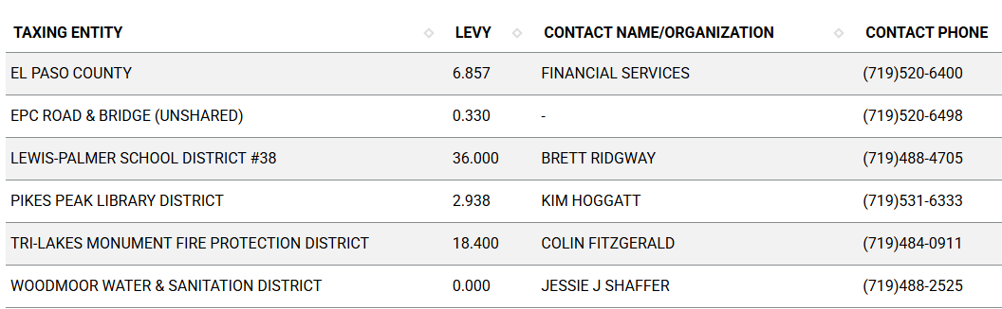

Road Impact Fees:
(See Engineering checklist)

Proposed source of water |  |  | Proposed method of wastewater disposal
☒ | Central System |  | ☒ | Central System
District Name: |  | Woodmoor Water & Sanitation District | District Name: |  | Woodmoor Water & Sanitation District

Water/Wastewater:
Water Region 2

For rezoning: address water and sewer in letter of intent; but services will be confirmed at final plat.

For plat: 300-year water sufficiency finding
(B) Water Resource Report.
(1) General.
(a) Purpose. The purpose of the water resources report is to provide the data necessary for the Planning Commission and the BoCC to determine whether the proposed water supply is sufficient in terms of quality, quantity and dependability for the proposed subdivision.
(b) Water Resources Report Required. A water resources report as required by this Section shall be submitted with sketch plan, preliminary plan, final plat, and any subdivision applications which will create a new lot. A copy of the report will be kept on file in the El Paso County PCD.
(c) Prepared by Qualified Professional. The water resources report shall be prepared by a qualified hydrogeologist, hydrologist, licensed civil engineer, qualified groundwater geologist, or other qualified professional with appropriate experience.
(d) Document Adequate Water Supply. The Water Resources Report shall include adequate documentation that the proposed water supply is sufficient in terms of quantity, dependability, and quality for the proposed subdivision.
(e) Enforcement. In addition to any other remedies provided by law or this Code, the BoCC shall have the right to enforce compliance with the provisions of this Section, including any agreement provided pursuant to this Section, by means of withholding building permits within the subject subdivision or withholding plat approvals for additional development phases within the subject subdivision pending full compliance or other resolution.

(3)Water Resource Report. The water resource report shall document the requirements of this Section and shall include the following data, documentation, and analysis at a level of detail necessary to make the determinations of sufficiency

For PPR: Contact Woodmoor Water & Sanitation District for Tap fees and infrastructure connections.

Fire District:
TRI-LAKES MONUMENT FIRE PROTECTION DISTRICT (719)484-0911

https://www.monumentfire.org/

Fire District Design Concerns/Emergency Services Issues:
This property is in a non-hazard area per Colorado WUI map. The Fire District administers wildfire protection standards, and will likely comment on access and water supply for fire fighting purposes.

Commissioner District: 1 – Holly Williams

Parks and trails:
El Paso County Parks Department. The 2022 El Paso County Parks Master Plan shows no impacts by this project to any existing or proposed parks, trails, or open space. As such, no parkland or trail easement dedications will be necessary as this project moves forward.

Regional and urban park fees will be assessed upon review of the forthcoming preliminary plans and final plats, if required in the future.

EPC Parks staff does not need to attend this Early Assistance meeting.

Annexations/Intergovernmental/ Jurisdictional Access issues:
Monument 3 Mile Annexation Plan – will be a reviewing agency.
No Comments or concerns from the Town at this time

Master Plan Information
Placetype: Suburban Development
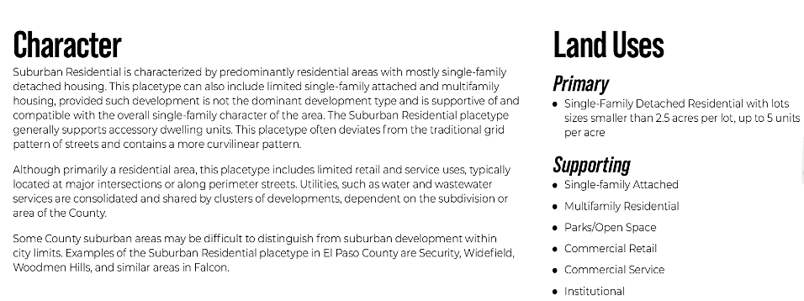
Area of Change: Minimal Change, Developed
These areas have undergone development and have an established character. Developed areas of minimal change are largely built out but may include isolated pockets of vacant or underutilized land. These key sites are likely to see more intense infill development with a mix of uses and scale of redevelopment that will significantly impact the character of an area. For example, a large amount of vacant land in a suburban division adjacent to a more urban neighborhood may be developed and change to match the urban character and intensity so as to accommodate a greater population. The inverse is also possible where an undeveloped portion of an denser neighborhood could redevelop to a less intense suburban scale. Regardless of the development that may occur, if these areas evolve to a new development pattern of differing intensity, their overall character can be maintained.

Key Areas: Tri-Lakes
Tri-Lakes is the northern gateway into the County along Interstate 25 and Highway 83. It is situated between Pike National Forest, the United States Air Force Academy, and Black Forest. With significant suburban development and some mixed-use development, this Key Area supports the commercial needs of many of the residents in northern El Paso County. Tri-Lakes also serves as a place of residence for many who commute to work in the Denver Metropolitan Area. It is also an activity and entertainment center with the three lakes (Monument Lake, Woodmoor Lake, and Palmer Lake) that comprise its namesake and direct access to the national forest. Tri-Lakes is the most well-established community in the northern part of the County with a mixture of housing options, easy access to necessary commercial goods and services, and a variety of entertainment opportunities. Future development in this area should align with the existing character and strengthen the residential, commercial, employment, and entertainment opportunities in the adjacent communities of Monument, Palmer Lake, and Woodmoor.

Next Steps
- After this meeting, you will have access to the notes presented in this meeting as well as a recording of this meeting at this link
- You will be sent a submittal request for the list of documents required for the Site Development Plan. The request will come from “EPCDev” so check your junk/spam folder if you do not see it in your inbox.
- You may upload documents one at a time as you procure them, but you will only hit Submit once all documents are uploaded
- My supervisor will “triage” your documents and give them a cursory review to determine if they are acceptable. If they are not, he will return a request to resubmit them with a comment regarding why they were rejected. If they are accepted you will receive a payment request.
- Once you make the payment, the initial review cycle of 14 days will commence
- In that 14 days, County Staff and other outside agencies will be invited to review your documents and make comments
- One the 14th day, you will receive all comments as well as a resubmittal request for the documents we would like to see revised
- You will then be on your own timeline to resubmit the revised documents
- Once you resubmit, a 2nd review cycle will commence, which could be 7 to 14 days depending on the scope of the revisions requested.
- This cycle will repeat until all comments are addressed
- We will stamp your plans approved and provide necessary signatures on Engineer documents and upload them to the EDARP file under “Approved Documents”
- You will use the stamped approved plans to submit with your building permit application at Pikes Peak Regional Building.
- You will need to set up a Pre-Con meeting with Brad Walters inspections team (bradwalters@elpasoco.com)

Helpful Links

Planning Website: https://planningdevelopment.elpasoco.com/

El Paso County Master Plan: https://planningdevelopment.elpasoco.com/#1510603950097-f5d985dc-35b2
Water Master Plan: https://planningdevelopment.elpasoco.com/#1515613078151-9a697e85-b1a7
Parks Master Plan: https://parks.elpasoco.com/parks-and-recreation/park-planning/
Mineral Extraction Master Plan: https://planningdevelopment.elpasoco.com/#1515613078151-9a697e85-b1a7

Forms and Templates: https://planningdevelopment.elpasoco.com/forms-and-affidavits/

Applications and Checklists: https://planningdevelopment.elpasoco.com/applications-and-checklists/

Land Development Code: https://library.municode.com/co/el_paso_county/codes/land_development_code

EDARP: https://epcdevplanreview.com/

Public GIS: https://experience.arcgis.com/experience/94cea8ccda3d4806a3fd500d2b5a4433?draft=true

Wrap Up
-If subdivision is proposed, recording fees, park and school fees and road impact fees may apply.

-Fees are subject to change. The fees at the time of application apply.

-Road Impact Fees
Please see the following website for information on the EPC Road Impact Fee Project. https://publicworks.elpasoco.com/road-impact-fees/ to include fee schedule.
As of December 15, 2016, per Resolution 16-454, on and after January 1, 2020, property in the unincorporated area of the county that receives a Land Use Approval either in a public hearing or administratively, is subject to the payment of Road Impact Fees. After December 31, 2024, in accordance with BoCC Resolution 24-377 the fee is paid for new residential and non-residential uses and structures and expansions of non-residential uses and structures. Road Impact fees are typically paid at time of building permit. If no building permit is being obtained for a particular Land Use application, then Road Impact Fees must be paid at the time of Site Development Plan or Special Use approval. If there are questions about EPC Road Impact program or fees, please contact DPW Development Review Services and the Engineer of the Day.

- Engineering Criteria Manual (ECM) Deviations.
The fee for any additional ECM deviation requests (more than two per land use application) - $1483.00 each per current Fee Schedule. Please note ECM deviation requests may result in additional processing and project review time. ECM Deviations should be submitted prior to the initial Site Development Plan or Final Plat submittal to preclude changes having to be made to engineering plans and documents if the deviation is not approved. Submission of an ECM deviation request does not imply or guarantee that the deviation will be approved. An ECM Deviation form must be submitted to include complete exhibits and justification excluding cost with supporting engineering criteria. If there are questions about ECM Deviation requests, please contact DPW Development Review Services and the Engineer of the Day.

-The fee for any additional waiver/deviation requests (more than two) - $550.00 each. Please note that requests for waivers and/or deviations may result in additional processing/review delay.

-All items requested must accompany the submittal for it to be complete, prior to payment request or the submittal will not be complete and ready for review agencies.

-A temporary use permit shall be applied for and approved for any staging area associated with development, such as a sales office, construction trailer, or contractor's equipment yard, prior to scheduling of the pre-construction meeting with El Paso County Planning and Community Development. If a Planned Unit Development is proposed, the temporary staging area should be shown on the development guideline and phasing plan.

-All prospective timelines for review are subject to departmental staffing and workload.

-Early Assistance is valid for 12 months from submittal of the EA application. If a project submittal is not received within 12 months, a new EA meeting may be required. An audio/video copy of the meeting is available in EDARP within the EA folder.

- Applications scheduled for public hearings may be heard as a regular item at the request of staff or a hearing body member.

- Any comments or commitments made by any member of the County Staff during this early assistance meeting are only preliminary in nature and should not be relied upon by the applicant. All prospective applicants should be informed that formal comments cannot be made by staff until after the application is submitted.

