EPC Pond Comments:

EPC DPW Stormwater

Review 1: EPC DPW Stormwater comments have been provided (in orange text boxes) on the following uploaded documents: - CDs - Drainage Report - ESQCP - FAE - GEC Checklist - PCM Applicability Form - PCM Maintenance Agreement - PCM - MHFD Detention Calcs or SDI Form - PCM O&M Manual - SWMP - SWMP Checklist Please provide the following document upon resubmittal: - PCM - Notice of Intent to Construct a Non-Jurisdictional Water Impoundment Structure (proof of submittal) Reviewed by: Mikayla Hartford, P.E. Engineer - Stormwater 719.339.5053 MikaylaHartford@elpasoco.com Zachary Jannusch Associate Engineer - Stormwater 719.500.3170 ZacharyJannusch@elpasoco.com
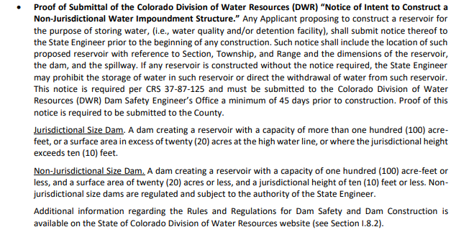

M&S RESPONSE: The Non-Jurisdictional Water Structure Notice for 3 ponds have been completed and sent to the DWR. Please find the attached poof of submittal.

_________________________________________________________________________
EPC DPW Development Services - Engineering

Engineering Review Ver.1 Please see engineer review comments on the following documents FDR_V1 CD_V1s FAE_V1 ESQCP_V1 Provide Detention Maintenance Agreement GEC_V1 Note the CDs and GEC plan set can be combined into one set since they are same sheets. Edward Schoenheit, Engineer E.P.C. Dept. of Public Works 2880 International Circle Colorado Springs, CO. 80910 Office: 719.520.6813 Cell: 719.502.9659 edwardschoenheit@elpasoco.com https://publicworks.elpasoco.com/department-public-works/county-engineer/
M&S RESPONSE: Storm, PCM and GEC plans are all combined into one 27 plan package

