Early Assistance Meeting Number: EA26109
Project Name: Pine Cone Ridge Combined Prelim/Final
Project Location: Glen Moor Way
Project Parcel No: 5134000001
Project Description: Combined preliminary plan and final plat to create 15 rural residential lots. Request: The Pine Cone Ridge preliminary plan is expired (SP06003). No water finding was made at the time of the preliminary plan. The owner would like to maintain the same layout as was previously approved, however, the owner would request a new application for a combined preliminary plan and final plat.
Meeting Date: Tuesday, October 13, 2026 @ 3 pm

El Paso County Planning & Community Development Planning Checklist

Request – Map Provided by Applicant
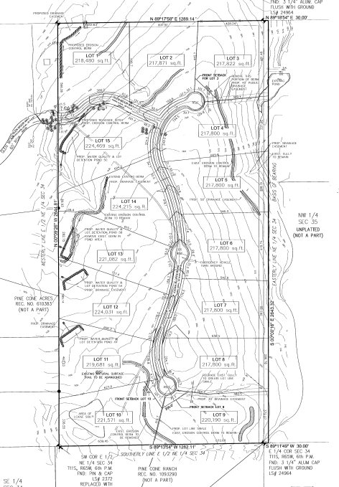

- Nothing needed for access to Autobahn property since they own adjacent property with access
- Public vs private roads:
  - Joint access easement for private road.
- Deviation for cul-de-sac length
- Paving might be needed if TIS is >200 ADT

Zoning District(s)
 | Zone | Name
Existing | RR-5 | Rural Residential
Proposed | RR-5 | Rural Residential

Zone Map
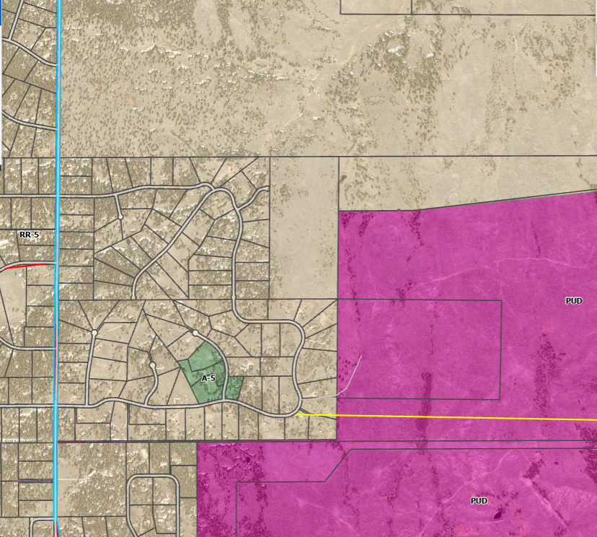

Zoning Analysis
The proposal to plat 15 lots on approximately 80 acres, with 3.9 acres aside for roads (as proposed in original project), conforms to the RR-5 Zoning District standards in Table 5-4.

Table 5-4
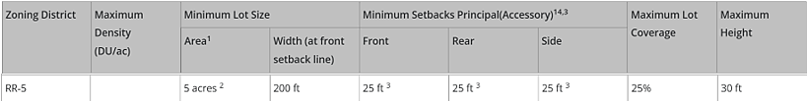
¹ Specific uses may be subject to larger minimum lot area requirements.
² In the event that the land to be partitioned, platted, sold or zoned abuts a section line County road, the minimum lot area for lots abutting the road shall be 4.75 acres and minimum lot width shall be 165 ft.
³ Agricultural stands shall be setback a minimum of 35 feet from all property lines.
Table 5-4
¹⁴ If no separate setback is shown in parentheses for accessory structures, the principal structure setback applies to accessory structures.

Application Type(s) Hearing: Required/ Optional/ No
Final Plat | Yes – 2: PC and BoCC

Available submittal guides for each process (comprehensive submittal requirements will be shown in EDARP project pages for each application)

Final Plat submittal checklist
- Application Form
- Mineral Estate Certification
- Fire Protection Report
  - List of Qualified Individuals to prepare
- Soils and Geology report
- Subdivision Improvements Agreement
- Water Resources Report
- Water supply summary info form
- Wastewater disposal
- Road Impact Fee acknowledgement
- PCM - MHFD Detention Calcs or SDI Form
- PCM - Notice of Intent to Construct a Non-Juris. Water Impoundment Structure (proof of submittal)
- PCM Applicability Form

Plat notes
Currently unplatted legal parcel

Road Impact Fees:
Due at time of building permit
The owner agrees on behalf of him/herself and any developer or builder successors and assignees that Subdivider and/or said successors and assigns shall be required to pay traffic impact fees in accordance with the El Paso County Road Impact Fee Program Resolution (Resolution No. 25-337), or any amendments thereto, at or prior to the time of building permit submittals. The fee obligation, if not paid at approval/building permit, shall be documented on all sales documents and on plat notes to ensure that a title search would find the fee obligation before sale of the property

**You will schedule a preconstruction meeting with our inspections team AFTER your approval of the Site Development Plan.

Contact: bradwalters@elpasoco.com

Approval Criteria
Prelim and Final Plat may be combined, but application must meet all criteria for both.

7.2.1. D)(2) Preliminary Plan.
(e) Criteria for Approval. In approving a preliminary plan, the BoCC shall find that:
- The proposed subdivision is in general conformance with the goals, objectives, and policies of the Master Plan;
- The subdivision is consistent with the purposes of this Code;
- The subdivision is in conformance with the subdivision design standards and any approved sketch plan;
- A sufficient water supply has been acquired in terms of quantity, quality, and dependability for the type of subdivision proposed, as determined in accordance with the standards set forth in the water supply standards [C.R.S. § 30-28-133(6)(a)] and the requirements of Chapter 8 of this Code (this finding may not be deferred to final plat if the applicant intends to seek administrative final plat approval);
- A public sewage disposal system has been established and, if other methods of sewage disposal are proposed, the system complies with state and local laws and regulations, [C.R.S. § 30-28-133(6) (b)] and the requirements of Chapter 8 of this Code;
- All areas of the proposed subdivision, which may involve soil or topographical conditions presenting hazards or requiring special precautions, have been identified and the proposed subdivision is compatible with such conditions. [C.R.S. § 30-28-133(6)(c)];
- Adequate drainage improvements complying with State law [C.R.S. § 30-28-133(3)(c)(VIII)] and the requirements of this Code and the ECM are provided by the design;
- The location and design of the public improvements proposed in connection with the subdivision are adequate to serve the needs and mitigate the effects of the development;
- Legal and physical access is or will be provided to all parcels by public rights-of-way or recorded easement, acceptable to the County in compliance with this Code and the ECM;
- The proposed subdivision has established an adequate level of compatibility by (1) incorporating natural physical features into the design and providing sufficient open spaces considering the type and intensity of the subdivision; (2) incorporating site planning techniques to foster the implementation of the County's plans, and encourage a land use pattern to support a balanced transportation system, including auto, bike and pedestrian traffic, public or mass transit if appropriate, and the cost effective delivery of other services consistent with adopted plans, policies and regulations of the County; (3) incorporating physical design features in the subdivision to provide a transition between the subdivision and adjacent land uses; (4) incorporating identified environmentally sensitive areas, including but not limited to, wetlands and wildlife corridors, into the design; and (5) incorporating public facilities or infrastructure, or provisions therefore, reasonably related to the proposed subdivision so the proposed subdivision will not negatively impact the levels of service of County services and facilities;
- Necessary services, including police and fire protection, recreation, utilities, open space and transportation system, are or will be available to serve the proposed subdivision;
- The subdivision provides evidence to show that the proposed methods for fire protection comply with Chapter 6 of this Code; and
- The proposed subdivision meets other applicable sections of Chapter 6 and 8 of this Code.

7.2.1 (D) (3) Final Plat
(f) Criteria for Approval. In approving a final plat, the approving authority shall find that:
- The subdivision is in conformance with the goals, objectives, and policies of the Master Plan;
- The subdivision is in substantial conformance with the approved preliminary plan;
- The subdivision is consistent with the subdivision design standards and regulations and meets all planning, engineering, and surveying requirements of the County for maps, data, surveys, analyses, studies, reports, plans, designs, documents, and other supporting materials;
- Either a sufficient water supply has been acquired in terms of quantity, quality, and dependability for the type of subdivision proposed, as determined in accordance with the standards set forth in the water supply standards [C.R.S. § 30-28-133(6)(a)] and the requirements of Chapter 8 of this Code, or, with respect to applications for administrative final plat approval, such finding was previously made by the BoCC at the time of preliminary plan approval;
- A public sewage disposal system has been established and, if other methods of sewage disposal are proposed, the system complies with State and local laws and regulations, [C.R.S. § 30-28-133(6)(b)] and the requirements of Chapter 8 of this Code;
- All areas of the proposed subdivision which may involve soil or topographical conditions presenting hazards or requiring special precautions have been identified and that the proposed subdivision is compatible with such conditions [C.R.S. § 30-28-133(6)(c)];
- Adequate drainage improvements are proposed that comply with State Statute [C.R.S. § 30-28-133(3)(c)(VIII)] and the requirements of this Code and the ECM;
- Legal and physical access is provided to all parcels by public rights-of-way or recorded easement, acceptable to the County in compliance with this Code and the ECM;
- Necessary services, including police and fire protection, recreation, utilities, and transportation systems, are or will be made available to serve the proposed subdivision;
- The final plans provide evidence to show that the proposed methods for fire protection comply with Chapter 6 of this Code;
- Off-site impacts were evaluated and related off-site improvements are roughly proportional and will mitigate the impacts of the subdivision in accordance with applicable requirements of Chapter 8;
- Adequate public facilities or infrastructure, or cash-in-lieu, for impacts reasonably related to the proposed subdivision have been constructed or are financially guaranteed through the SIA so the impacts of the subdivision will be adequately mitigated;
- The subdivision meets other applicable sections of Chapter 6 and 8; and
- The extraction of any known commercial mining deposit shall not be impeded by this subdivision [C.R.S. §§ 34-1-302(1), et seq.]

Relevant Current/Past History:
SP06003 – Preliminary Plan (Expired)

Design and Landscaping
Site Design/Layout (Lot pattern, circulation/road design, open space, preservation of natural features, compatibility internally and with adjacent land uses)

Landscaping
☐ | Expressway, Principal arterial area depth – 25’-Trees required 1 per 20’
☐ | Urban interchange/Intersection area depth – 25’- N/A
☐ | Minor arterial area depth 20’ – Trees required 1 per 25’ (Old Ranch Rd)
☐ | Non-arterial area depth 10’ – Trees required 1 per 30’
☐ | Parking lot landscaping required
☐ | Buffer between non-residential and residential districts separated by a non-arterial road or public alley  ☒ Zone Boundary Buffer

Subdivision landscape design considerations:
(b) Landscaping between Differing Land Uses. Landscaping should be provided, especially as a buffer between different types of uses. Xeriscape should be used whenever possible to minimize water consumption.
6.2.2. Landscape Requirements

(4) Authority of Director to Approve Substitute Landscape Designs. The PCD Director may approve landscaping that does not meet the specific requirements of this Section provided the proposed landscaping meets the purpose of this Section, promotes the concepts contained in the Landscaping and Planting Manual, and provides an equivalent benefit to the community and environment as would otherwise be achieved by meeting the specific requirements of this Section. This authority shall not allow the PCD Director to eliminate the requirement for landscaping or to diminish the total landscaped area required by this Section.

Signage:
If proposing signage for the subdivision, include in your submittal:

(4) Master Sign Plans.
(a) Applicability. A Master Sign Plan may be approved by the PCD Director in association with applications that are approved administratively and by the BoCC in association with applications that are approved or otherwise elevated to the BoCC for public hearing as an alternative to the requirements set forth in this Section. A Master Sign Plan must be requested with an associated development application for 1 of the uses and developments listed below:
• Residential subdivisions.

Review Criteria. In approving a Master Sign Plan the approval authority shall find each of the following:
- Placement. All signs shall be placed where they are visible and legible. Factors to be considered include its location relative to traffic movement and access points, site features, other structures, and orientation relative to viewing distances and viewing angles. Wall signs may be approved on building walls other than the wall of the space occupied by the tenant in commercial centers in which some tenants have little or no visibility from the street.
- Quantity. The number of signs that may be approved within any development shall be sufficient to provide necessary facilitation of internal circulation of vehicular and pedestrian traffic and way finding for safety of the occupants of vehicles and pedestrians. Factors to be considered shall be those that impact safety considerations such as the size of the development and the number of development sub-areas.
- Size. All signs shall be no larger than necessary for visibility and legibility. Factors to be considered in determining appropriate size include topography, volume and speed of traffic, viewing distances and angles, proximity to adjacent uses, and placement of display. In no event shall a Master Sign Plan contain a freestanding sign that exceeds the maximum height standard permitted by this Section unless otherwise approved by the BoCC as part of a Master Sign Plan. In no event shall a Master Sign Plan contain a wall sign that exceeds by more than 25 percent any maximum size (area) standard permitted by this Section.
- Design Features and Materials. Sign design themes and materials shall be compatible with the architecture, colors, and materials of the associated development and/or structures as applicable.
- Development Standards. The approval authority may not reduce any sign development standard to less than 50 percent of any minimum standard, nor increase any sign development standard by more than 100 percent of the maximum standard. Notwithstanding the foregoing, the approval authority shall not base any decision on the message content of a sign.
- Amendments. The PCD Director may administratively approve minor amendments to a Master Sign Plan where such changes are determined by the PCD Director to have little or no visual impact and are consistent with the intent of the original approval.

Parking Requirements:

Lighting:
Photometric Plan ReqRequired | ☐

Site Characteristics\ Constraints\ Environmental Standards:
Hazards to be identified on plat.
* Geologic Hazards and associated development considerations were identified in the 2006 Soils and Geology report. Specific lots, hazards, and mitigation measures need to be called out on the plat.

(B) Hazards. Land shall not be divided until hazards have been removed or the impact of hazards has been mitigated as determined by the PCD Director. Lots or tracts subject to hazards which may be eliminated through specialized engineering shall be identified on the plat. Identification of hazards on the plat shall include a statement about the specific hazard and a statement of the engineering alterations required to eliminate the hazard. The following hazards are subject to these requirements:
(3) Unsuitable Building Areas. Areas within lots or tracts which reflect 1 or more of the following characteristics shall be deemed unsuitable for building and shall be identified as no build areas on the plat:
• Areas not suitable for location of water or sewage disposal systems as determined by State and County health regulations.
• Areas where slopes are greater than 30%.
• Areas of identified or designated geologic, soil, or natural hazards as identified in the geology and soils report or designated in the El Paso County hazard identification inventory; provided that the limitations cannot be overcome through the application of specialized engineering or mitigation.
• Areas within the 100-year floodplain as reflected on FEMA Flood Insurance Rate Map (FIRM), within proposed boundaries as reflected in LOMR/CLOMR, or as determined by a flood study as approved by the Floodplain Administrator.
• Areas within easements, without the permission or release from the beneficiary of the easement holder.

SLOPE
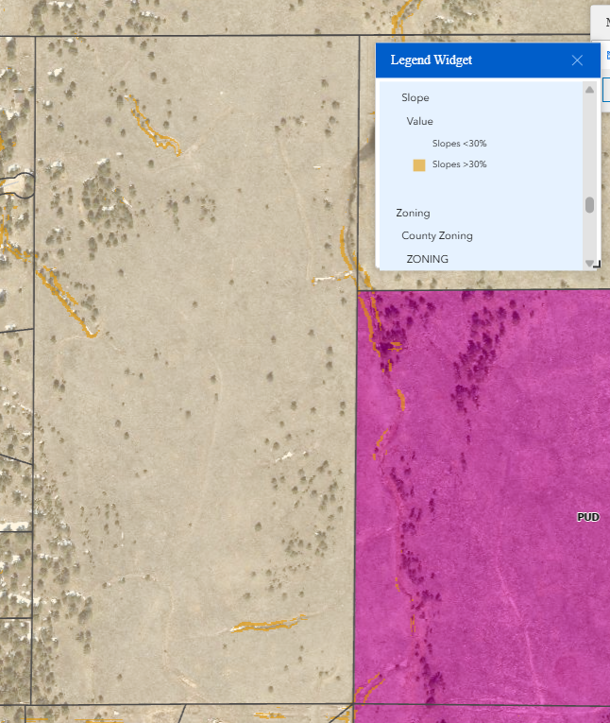
30% slope areas indicated below must be depicted as No Build Areas on plat, or otherwise addressed.

PREBLE’S MOUSE
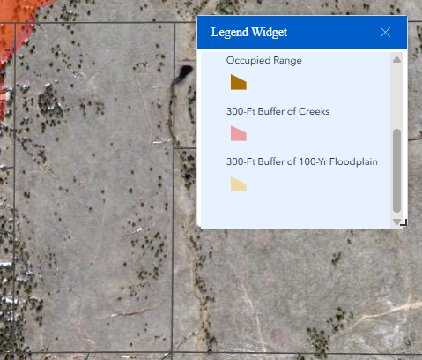
This requires a Block Clearance letter from the US Fish and Wildlife Service.

Wildlife Impact Level – 3 (Moderate)

WILDFIRE
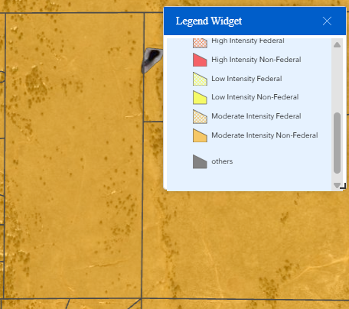

New Wildfire Protection Standards in Land Development Code Effective July 1, 2026
FPD = Fire Protection District  WRC = Wildfire Resiliency Code |  |  | WUI = Wildland Urban Interface  LDC = Land Development Code
LDC Section | When it applies |  |  | Who reviews compliance
6.3.3 | All development, regardless of fire hazard level |  |  | FPD (if in district and not exempt* from FPD Code)  - or -  County (if outside FPD / exempt* from FPD Code)
6.3.4 | Properties outside FPD and inside the mapped WUI |  |  | County
Adopted LDC |  | Link to Revised Code
WRC Map |  | Link to WRC Map
Appendix E |  | Link to Appendix E
Project Applicability
Property in WUI: |  | ☒ Yes ☐ No
Fire Intensity Classification: |  | ☐ Low Hazard ☒ Moderate Hazard ☐ High Hazard
Served by Fire District: |  | ☒ Yes: ☐ No
projects within a fire district
If YES WUI and WITHIN FPD |  | ☒ Fire District enforces compliance with WRC (unless exempt,* then County enforces 6.3.3)
If NO WUI and WITHIN FPD |  | ☐ Fire District enforces compliance with WRC (unless exempt,* then County enforces 6.3.3)
* EXEMPTIONS: Even when in a Fire District, 6.3.3 always applies and is always reviewed by the County for:
- Detached one or two family dwellings or townhomes on:
- An unplatted parcel (legal lot)
- A subdivision with four or fewer platted lots
- A subdivision recorded before December 10, 2013
- Factory built units certified by the State of Colorado
- Factory built units constructed to federal standards
- Accessory structures
projects outside a fire district
If YES WUI and NOT IN FPD |  | ☐ Appendix E applies (Affidavit notarized by owners, and WRC File created in EDARP)  ☐ Land Development Code Sections 6.3.3 and 6.3.4 apply  ☐ Condition of approval / plat note regarding compliance with Appendix E
If NO WUI and NOT IN FPD |  | ☐ Land Development Code Section 6.3.3 enforced by County
additional requirements for plats, non-structural commercial uses
Required for all subdivisions: |  |  | ☒ Fire Protection Report
Commercial not subject to Appendix E: |  |  | ☐ Wildfire Hazard Mitigation Plan

- Fire Protection Report. A Fire Protection Report is required for any subdivision application and shall include an analysis of compliance with this Code, the applicable fire code, and at a minimum the following:
  - Description of proposed development to include acreage, number of lots/dwelling units, etc.
  - Water supply to be used for fire suppression (fire hydrants, dry hydrants, cisterns, automatic sprinkler system, etc.).
  - Maintenance plan if cisterns and dry hydrants will be used.
  - Information regarding the internal and external roadways and if an emergency vehicle can utilize those roadways.
  - Information on any emergency access roads and/or gates.
  - The fire intensity classification when located within the wildland urban interface area and an analysis of compliance with Appendix E (when applicable).
- Fire Protection Commitment. A written commitment to provide structural fire protection may be required for any proposed subdivision located outside the boundaries of a Fire District or otherwise exempt from the adopted fire code. The PCD Director may require a written commitment for other development applications.
- Development Outside Fire Authority Boundaries. Proposed subdivisions outside the boundaries of a Fire District shall annex into a district or provide evidence of a contract for service from a Fire District or Fire Department. Waivers of this requirement may only be approved by the Board of County Commissioners. An applicant's waiver request shall, at a minimum, include the following:
- A letter from the nearest fire district or fire department demonstrating that annexation is not economically feasible.
- A letter or report from a Third Party Fire Reviewer providing a recommendation to the Board of County Commissioners that the proposed development complies with the Fire Protection and Wildfire Mitigation Section of this Code. In the case of a conflict between adopted standards and this Code, the Third Party Fire Reviewer may recommend an alternative design which accomplishes the purposes of this section and provides an equivalent benefit to the development.

Districts
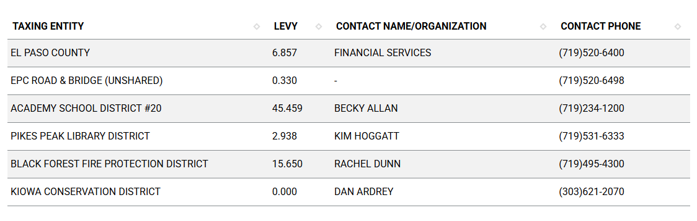
Road Impact Fees:
(See Engineering checklist)

Proposed source of water |  | Proposed method of wastewater disposal
☐ | Central System  Well | ☐ | Central System
District Name: |  | District Name:
☒ | Well | ☒ | OWTS

Water/Wastewater:
Water Region 4a

8.4.7. Water Supply Standards
(B) Water Resource Report.
(1) General.
(a) Purpose. The purpose of the water resources report is to provide the data necessary for the Planning Commission and the BoCC to determine whether the proposed water supply is sufficient in terms of quality, quantity and dependability for the proposed subdivision.
(b) Water Resources Report Required. A water resources report as required by this Section shall be submitted with sketch plan, preliminary plan, final plat, and any subdivision applications which will create a new lot. A copy of the report will be kept on file in the El Paso County PCD.
(c) Prepared by Qualified Professional. The water resources report shall be prepared by a qualified hydrogeologist, hydrologist, licensed civil engineer, qualified groundwater geologist, or other qualified professional with appropriate experience.
(d) Document Adequate Water Supply. The Water Resources Report shall include adequate documentation that the proposed water supply is sufficient in terms of quantity, dependability, and quality for the proposed subdivision.

(3)Water Resource Report. The water resource report shall document the requirements of this Section and shall include the following data, documentation, and analysis at a level of detail necessary to make the determinations of sufficiency

For subdivisions with 4 lots or more whose water supply consists of wells, and particularly where there are water augmentation or replacement obligations, the applicant shall establish an HOA or other entity approved by the CAO that shall be responsible to carry out the obligations under the water court decree, Colorado Groundwater Determination, and any related augmentation or replacement plans. For subdivisions with 3 lots or less, while creation of an HOA is preferred, responsibility for the obligations may be placed on the individual lot owners in the covenants or in a Joint Use Well-Sharing and Easement Agreement. Unless the water court or Colorado Groundwater Commission authorizes differently, no more than 6 lots shall share a well in a joint-use well sharing arrangement. Plat notes concerning the responsibility for the obligations and for conveyances of water rights shall be included on the face of the final plat. Prior to recording the final plat for any such subdivision, the applicant shall provide to PCD and the CAO for review and approval documents including, but not limited to, water court decrees and plans for augmentation signed by the Water Judge; determinations of water rights and replacement plans signed by the Colorado Groundwater Commission; deeds to cure defects in title to water rights; form deeds conveying water rights to individual lot owners; deeds conveying water rights for augmentation or replacement to the HOA (or to lot owners for subdivisions with 3 lots or less); Joint Use Well Sharing and Easement Agreements (where applicable); restrictive covenants; and documents creating the HOA including articles of incorporation, certificate of incorporation by the Secretary of State, and bylaws.

Summary of documents needed for Review by County Attorney’s Office:
- Water Supply Information Summary Form
- Water Resources report, including:
  - Copies of all Water Court Decrees
  - Copies of all Colorado Groundwater
  - Commission Determinations of Water Rights
  - State Engineer's Office Opinion
  - Deeds and/or other documents that establish applicant's ownership of water rights for the proposed subdivision
- HOA documentation, to include:
  - Declaration of Covenants
  - HOA articles of incorporation,
  - certificate of incorporation by the Secretary of State,
  - HOA bylaws

Fire District:
Black Forest Fire Protection District |(719) 495-4300 | https://www.bffire.org/

Black forest FPD is on Assessor records as taxing entity.

During the 2006 review, BFFRPD required a 30,000 gallon underground cistern. This requirement may change, but be prepared for similar requests to meet section 6.3.3 of the LDC.
- Be sure to provide turnarounds, and access easements on the plat for any cisterns.

Fire District Design Concerns/Emergency Services Issues:

Commissioner District: 1 – Holly Williams

Parks and trails:
El Paso County Parks Department. The 2022 El Paso County Parks Master Plan shows no impacts by this project to any existing or proposed parks, trails, or open space. As such, no parkland or trail easement dedications will be necessary as this project moves forward.

Regional and urban park fees will be assessed upon review of the forthcoming preliminary plans and final plats, if required in the future.

EPC Parks staff does not need to attend this Early Assistance meeting.

Annexations/Intergovernmental/ Jurisdictional Access issues:

Master Plan Information
Placetype: Rural

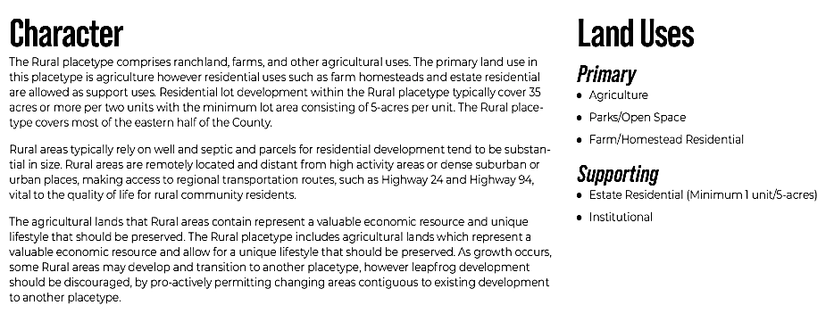

Area of Change: Minimal Change, Undeveloped
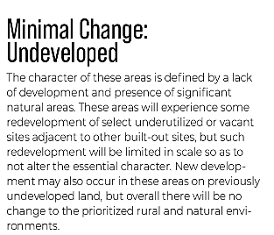

Key Areas: Forested Areas
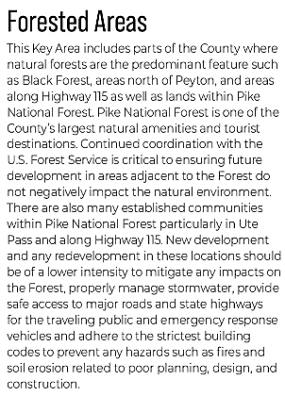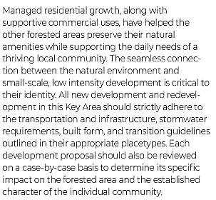

Next Steps
- After this meeting, you will have access to the notes presented in this meeting as well as a recording of this meeting at this link
- You will be sent a submittal request for the list of documents required for the Site Development Plan. The request will come from “EPCDev” so check your junk/spam folder if you do not see it in your inbox.
- You may upload documents one at a time as you procure them, but you will only hit Submit once all documents are uploaded
- My supervisor will “triage” your documents and give them a cursory review to determine if they are acceptable. If they are not, he will return a request to resubmit them with a comment regarding why they were rejected. If they are accepted you will receive a payment request.
- Once you make the payment, the initial review cycle of 14 days will commence
- In that 14 days, County Staff and other outside agencies will be invited to review your documents and make comments
- One the 14th day, you will receive all comments as well as a resubmittal request for the documents we would like to see revised
- You will then be on your own timeline to resubmit the revised documents
- Once you resubmit, a 2nd review cycle will commence, which could be 7 to 14 days depending on the scope of the revisions requested.
- This cycle will repeat until all comments are addressed
- We will stamp your plans approved and provide necessary signatures on Engineer documents and upload them to the EDARP file under “Approved Documents”
- You will use the stamped approved plans to submit with your building permit application at Pikes Peak Regional Building.
- You will need to set up a Pre-Con meeting with Brad Walters inspections team (bradwalters@elpasoco.com)

Helpful Links

Planning Website: https://planningdevelopment.elpasoco.com/

El Paso County Master Plan: https://planningdevelopment.elpasoco.com/#1510603950097-f5d985dc-35b2
Water Master Plan: https://planningdevelopment.elpasoco.com/#1515613078151-9a697e85-b1a7
Parks Master Plan: https://parks.elpasoco.com/parks-and-recreation/park-planning/
Mineral Extraction Master Plan: https://planningdevelopment.elpasoco.com/#1515613078151-9a697e85-b1a7

Forms and Templates: https://planningdevelopment.elpasoco.com/forms-and-affidavits/

Applications and Checklists: https://planningdevelopment.elpasoco.com/applications-and-checklists/

Land Development Code: https://library.municode.com/co/el_paso_county/codes/land_development_code

EDARP: https://epcdevplanreview.com/

Public GIS: https://experience.arcgis.com/experience/94cea8ccda3d4806a3fd500d2b5a4433?draft=true

Wrap Up
-If subdivision is proposed, recording fees, park and school fees and road impact fees may apply.

-Fees are subject to change. The fees at the time of application apply.

-Road Impact Fees
Please see the following website for information on the EPC Road Impact Fee Project. https://publicworks.elpasoco.com/road-impact-fees/ to include fee schedule.
As of December 15, 2016, per Resolution 16-454, on and after January 1, 2020, property in the unincorporated area of the county that receives a Land Use Approval either in a public hearing or administratively, is subject to the payment of Road Impact Fees. After December 31, 2024, in accordance with BoCC Resolution 24-377 the fee is paid for new residential and non-residential uses and structures and expansions of non-residential uses and structures. Road Impact fees are typically paid at time of building permit. If no building permit is being obtained for a particular Land Use application, then Road Impact Fees must be paid at the time of Site Development Plan or Special Use approval. If there are questions about EPC Road Impact program or fees, please contact DPW Development Review Services and the Engineer of the Day.

- Engineering Criteria Manual (ECM) Deviations.
The fee for any additional ECM deviation requests (more than two per land use application) - $1483.00 each per current Fee Schedule. Please note ECM deviation requests may result in additional processing and project review time. ECM Deviations should be submitted prior to the initial Site Development Plan or Final Plat submittal to preclude changes having to be made to engineering plans and documents if the deviation is not approved. Submission of an ECM deviation request does not imply or guarantee that the deviation will be approved. An ECM Deviation form must be submitted to include complete exhibits and justification excluding cost with supporting engineering criteria. If there are questions about ECM Deviation requests, please contact DPW Development Review Services and the Engineer of the Day.

-The fee for any additional waiver/deviation requests (more than two) - $550.00 each. Please note that requests for waivers and/or deviations may result in additional processing/review delay.

-All items requested must accompany the submittal for it to be complete, prior to payment request or the submittal will not be complete and ready for review agencies.

-A temporary use permit shall be applied for and approved for any staging area associated with development, such as a sales office, construction trailer, or contractor's equipment yard, prior to scheduling of the pre-construction meeting with El Paso County Planning and Community Development. If a Planned Unit Development is proposed, the temporary staging area should be shown on the development guideline and phasing plan.

-All prospective timelines for review are subject to departmental staffing and workload.

-Early Assistance is valid for 12 months from submittal of the EA application. If a project submittal is not received within 12 months, a new EA meeting may be required. An audio/video copy of the meeting is available in EDARP within the EA folder.

- Applications scheduled for public hearings may be heard as a regular item at the request of staff or a hearing body member.

- Any comments or commitments made by any member of the County Staff during this early assistance meeting are only preliminary in nature and should not be relied upon by the applicant. All prospective applicants should be informed that formal comments cannot be made by staff until after the application is submitted.

