Early Assistance Meeting Number: EA2692
Project Name: Rollercoaster Rd Minor Sub
Project Location: 16685 Rollercoaster Rd
Project Parcel Nos. 6121000008
Project Description: The purpose of the Minor Subdivision request is for a proposed three lot subdivision. Currently the property has a residence and horse barn facility along the southern portion of the property. The request would maintain the horse facility on one lot of approximately 12 acres and create two approximately 5-acre lots fronting off of the asphalt paved private road along the north property line.
Meeting Date: Monday, August 17, 2026 @ 3 pm

El Paso County Planning & Community Development Planning Checklist

Request – Map Provided by Applicant
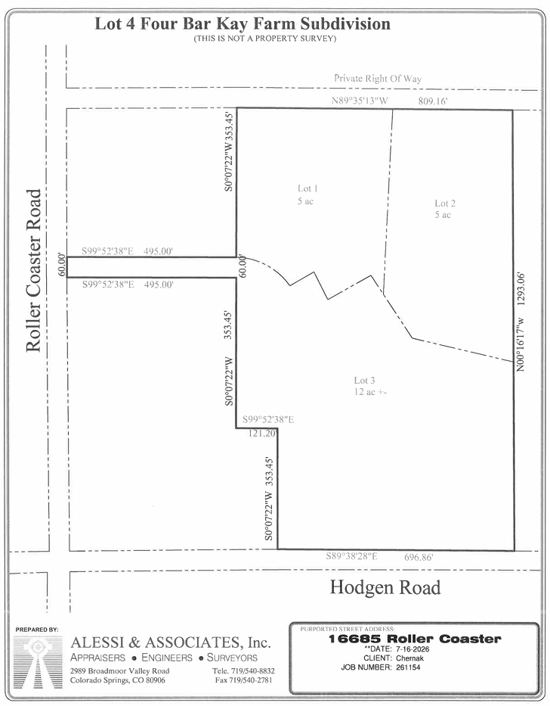

Zoning
Existing Zone(s)
Zone |  | Name
A-5 |  | Agricultural

Zone Map (existing conditions of approval)
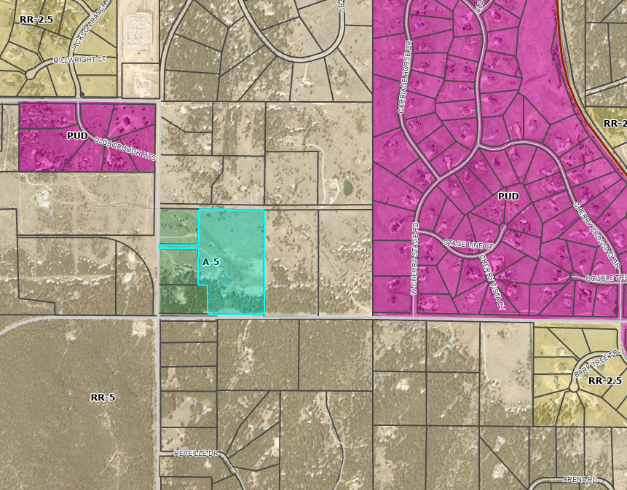

Zoning Analysis
A-5, Agricultural District. The A-5 zoning district is a 5-acre district primarily intended to conserve agricultural resources and ranching operations and accommodate limited residential use.
- All proposed lots are greater than 5-acres
- Use of the lots would be limited to Agricultural or Residential uses

Zoning District Requirements (density, lot size, lot design standards, building setbacks)
Minimum Lot Size: 5 acres (2)
Minimum width (at front setback line): 200 ft
Minimum Front setback: 25 ft (3,4)
Minimum Rear setaback: 25 ft (3,4)
Minimum Side setback: 25 ft (3,4)
Minimum Lot Coverage: None
Maximum Height: 30 ft
² In the event that the land to be partitioned, platted, sold or zoned abuts a section line County road, the minimum lot area for lots abutting the road shall be 4.75 acres and minimum lot width shall be 165 ft.
³ Agricultural stands shall be setback a minimum of 35 feet from all property lines.
⁴ Sawmills shall be setback a minimum of 300 feet from all property lines.

Plat Map or Parcel Map (conditions of approval):
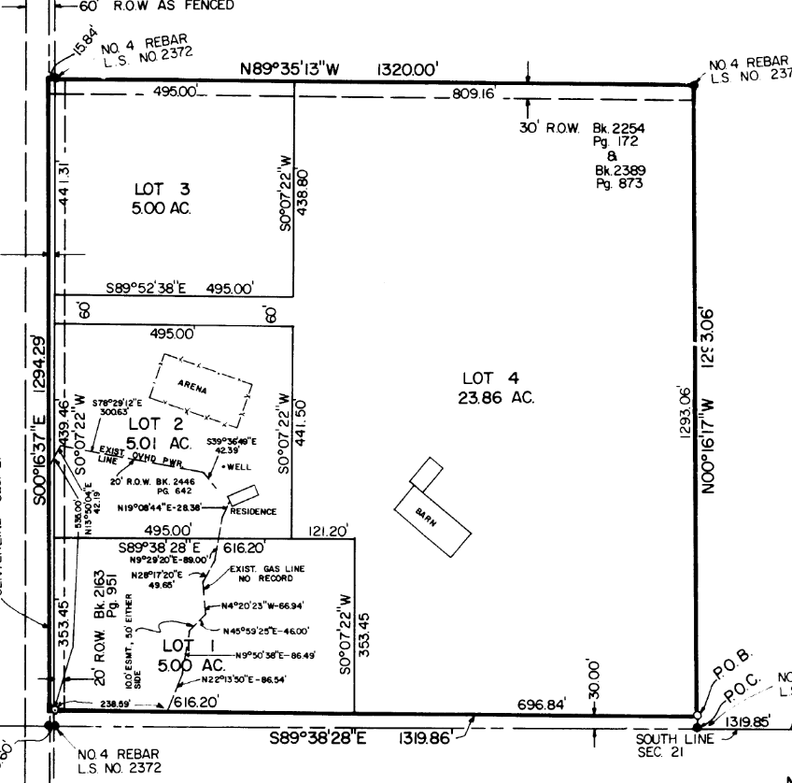
Plat 4788 (1977)
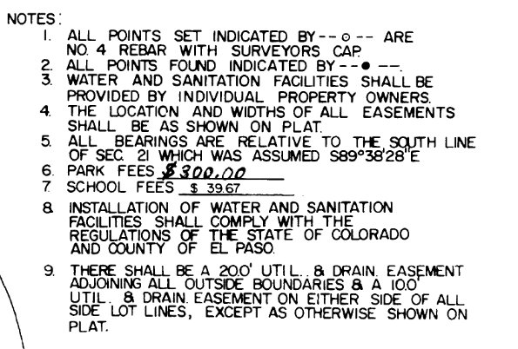
Plat notes from Plat 4788 (1977)

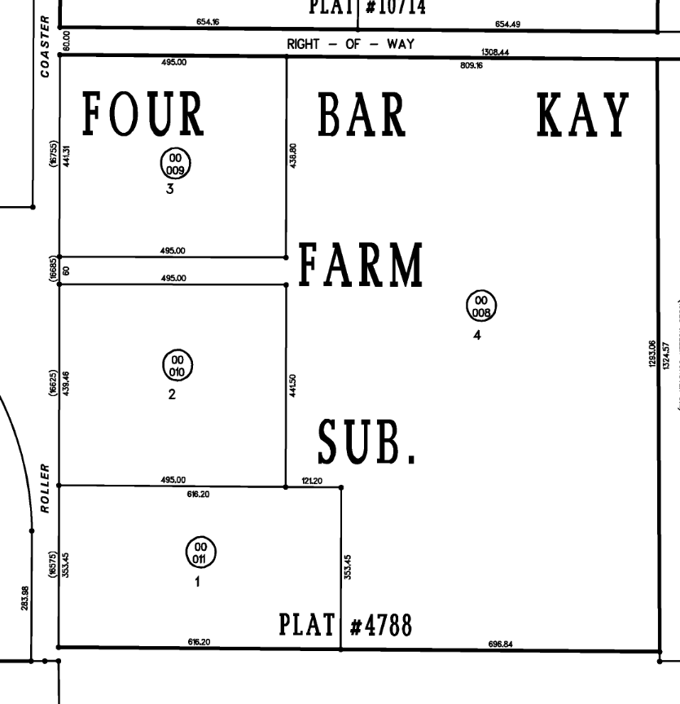
Current Assessor Map

Application Type(s) Hearing: Required/ Optional/ No
Final Plat – Minor Subdivision | Yes - BoCC

Approval Criteria:
Final Plat: (21 day initial review cycle, 14 day subsequent review cycles)
7.2.1.D.3.f. Final Plat:
Criteria for Approval. In approving a final plat, the approving authority shall find that:
- The subdivision is in conformance with the goals, objectives, and policies of the Master Plan;
- The subdivision is in substantial conformance with the approved preliminary plan;
- The subdivision is consistent with the subdivision design standards and regulations and meets all planning, engineering, and surveying requirements of the County for maps, data, surveys, analyses, studies, reports, plans, designs, documents, and other supporting materials;
- Either a sufficient water supply has been acquired in terms of quantity, quality, and dependability for the type of subdivision proposed, as determined in accordance with the standards set forth in the water supply standards [C.R.S. § 30-28-133(6)(a)] and the requirements of Chapter 8 of this Code, or, with respect to applications for administrative final plat approval, such finding was previously made by the BoCC at the time of preliminary plan approval;
- A public sewage disposal system has been established and, if other methods of sewage disposal are proposed, the system complies with State and local laws and regulations, [C.R.S. § 30-28-133(6)(b)] and the requirements of Chapter 8 of this Code;
- All areas of the proposed subdivision which may involve soil or topographical conditions presenting hazards or requiring special precautions have been identified and that the proposed subdivision is compatible with such conditions [C.R.S. § 30-28-133(6)(c)];
- Adequate drainage improvements are proposed that comply with State Statute [C.R.S. § 30-28-133(3)(c)(VIII)] and the requirements of this Code and the ECM;
- Legal and physical access is provided to all parcels by public rights-of-way or recorded easement, acceptable to the County in compliance with this Code and the ECM;
- Necessary services, including police and fire protection, recreation, utilities, and transportation systems, are or will be made available to serve the proposed subdivision;
- The final plans provide evidence to show that the proposed methods for fire protection comply with Chapter 6 of this Code;
- Off-site impacts were evaluated and related off-site improvements are roughly proportional and will mitigate the impacts of the subdivision in accordance with applicable requirements of Chapter 8;
- Adequate public facilities or infrastructure, or cash-in-lieu, for impacts reasonably related to the proposed subdivision have been constructed or are financially guaranteed through the SIA so the impacts of the subdivision will be adequately mitigated;
- The subdivision meets other applicable sections of Chapter 6 and 8; and
- The extraction of any known commercial mining deposit shall not be impeded by this subdivision [C.R.S. §§ 34-1-302(1), et seq.]

Processing Issues and Options
Joint access easement if accessing all 3 lots from the existing access off of Roller Coaster Rd.

Relevant Past History:
- 1971: Single Family residence and stable built on the property
- 1973: Rezone from A-5 to A-2 approved (PCD File No P73021Z) **Changes in zoning nomenclatures over time eventually changed this back to A-5
- 1973: Special Use for a commercial stable with a tack shop addition approved (PCD Fil No AL73010Z)
- 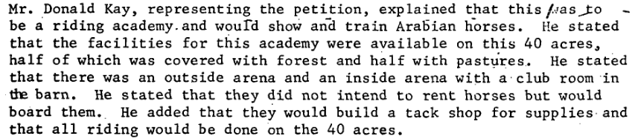
- 1977: Formally platted as Lot 4 of Four Bar Kay Farms Sub (Reception #378734) (PCD File No MS77010)
- 1997: Current owners purchased Lot (Deed at Rec #97012073)
- 2021: Early Assistance request to subdivide two five acre lots at the north end of the existing site (PCD Fil No EA2157). Minor subdivision application never submitted.
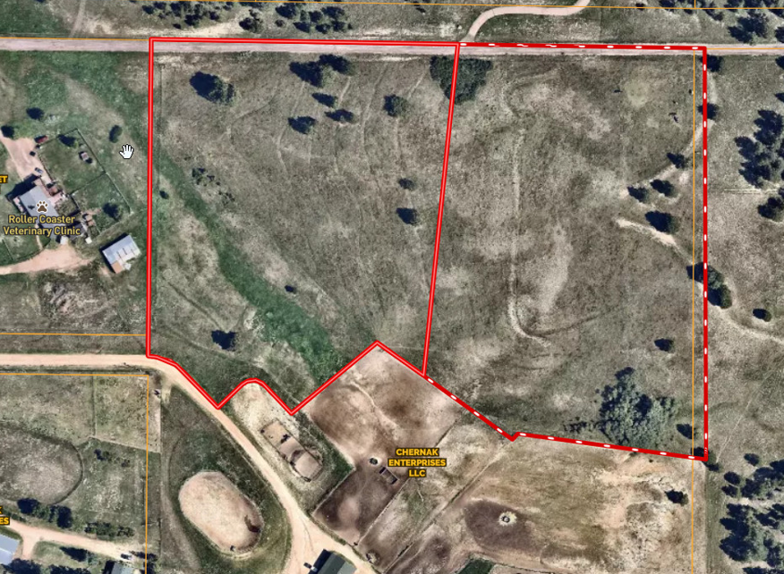
- 2026: Early Assistance request for the same proposal

Design and Landscaping
** Landscaping requirements do not apply to Rural/Agricultural development

Site Design/Layout (Lot pattern, circulation/road design, open space, preservation of natural features, compatibility internally and with adjacent land uses)

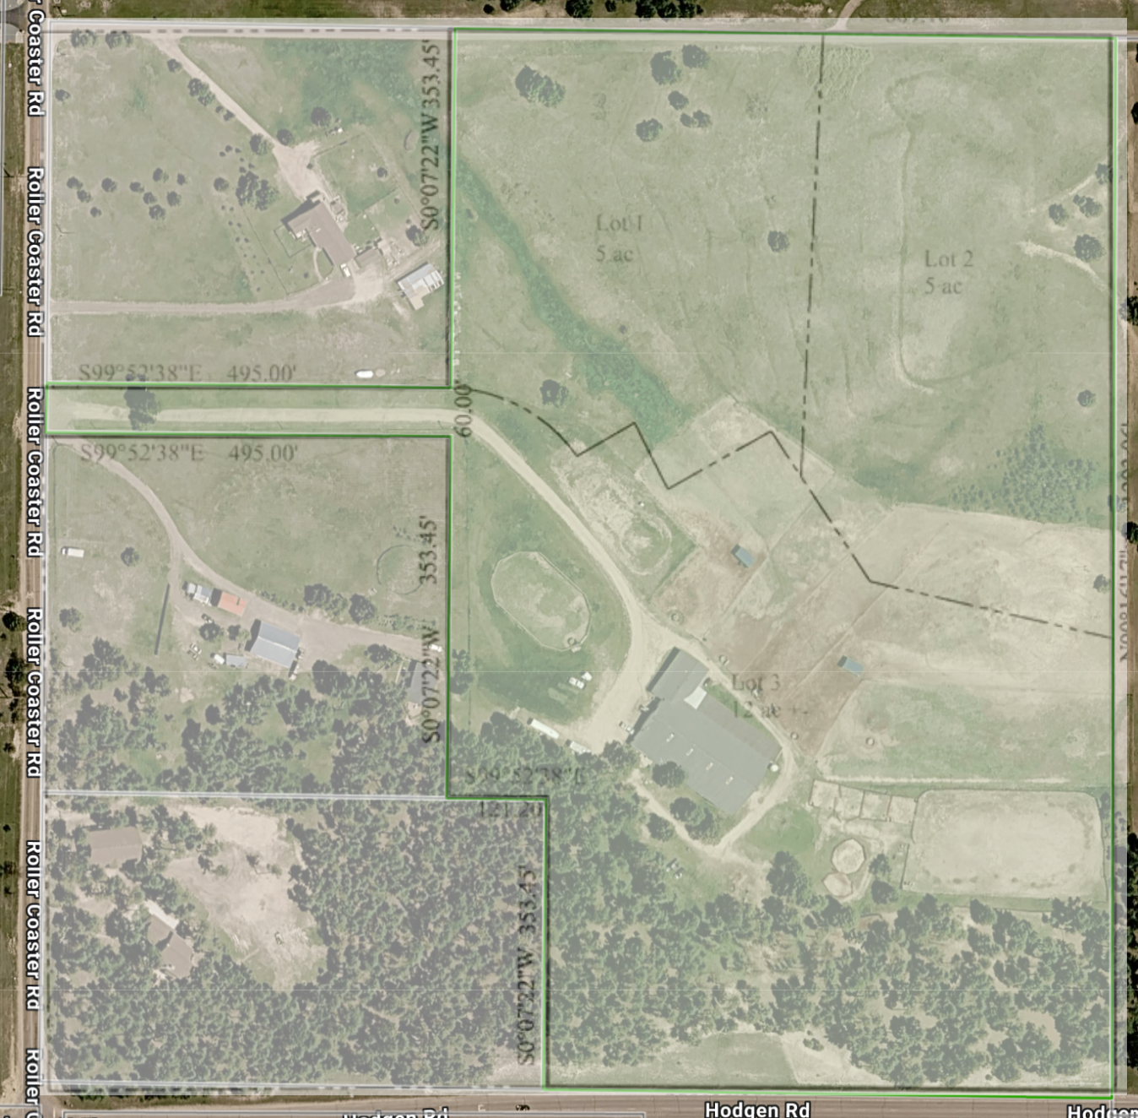
Overlay of proposed subdivision on current parcel
- Surrounding uses are mostly residential with a few home businesses and a vet clinic
- Minimum Frontage. Lots shall have a minimum of 30 feet of frontage on and have access from a public road, except where private roads are approved by the BoCC pursuant to waiver granted under Section 8.4.4 (E).
- Private Roads Require Waiver. The use of private roads is limited and allowed only by waiver. In granting a waiver to allow private roads, the BoCC shall make written findings supporting the use of private roads and may require the owner to enter into a Private Road Maintenance Agreement or create covenants whereby the lot owners are required to maintain the private roads.
- (See waiver section of this list for info on applying for a waiver)

Site Characteristics\ Constraints\ Environmental Standards:
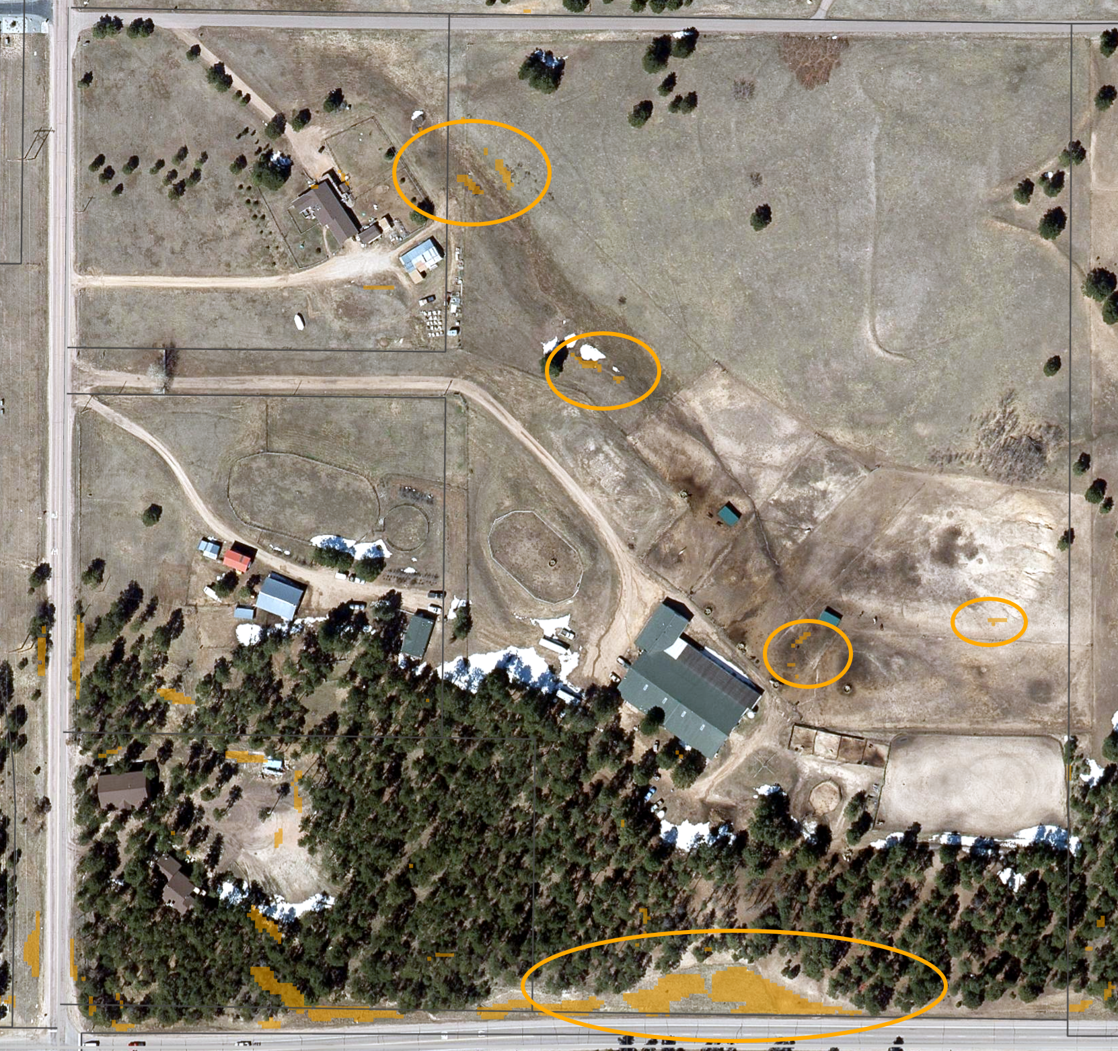

Minimal areas of slope > 30% (orange)

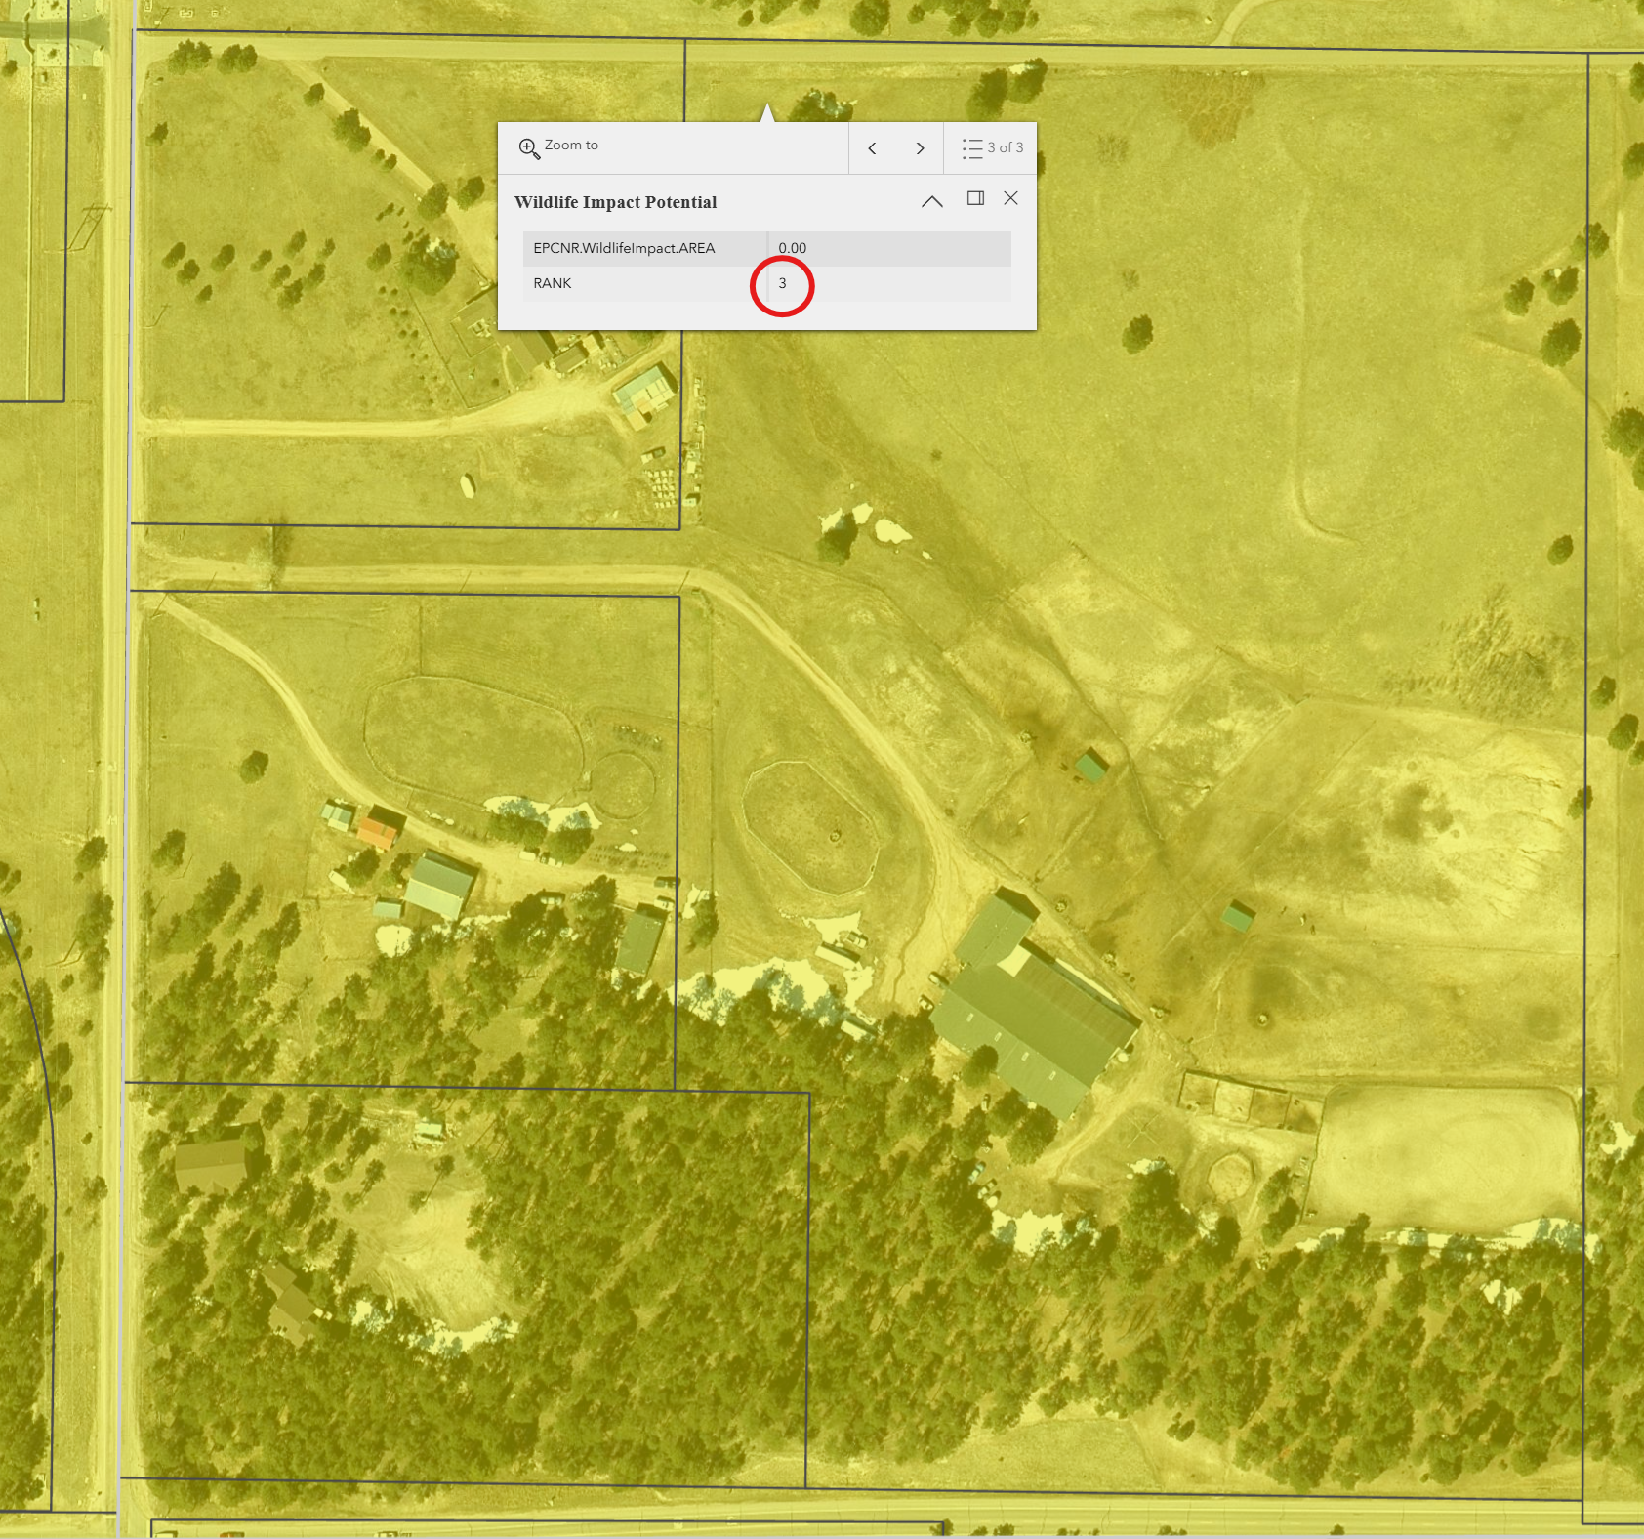
Level 3 - Moderate
- Will need to provide a Wildlife Impact Report

☐ | 30% or greater slope | Topography: | none
☒ | CGS review required (separate fee to CGS) | Soils/geology: |  | Tomah Crowfoot Complex
☒ | Floodplain | Floodplain comment: |  | N/A (Engineering to discuss)
☐ | Preble’s mouse | N/A

Districts

Taxing Entities
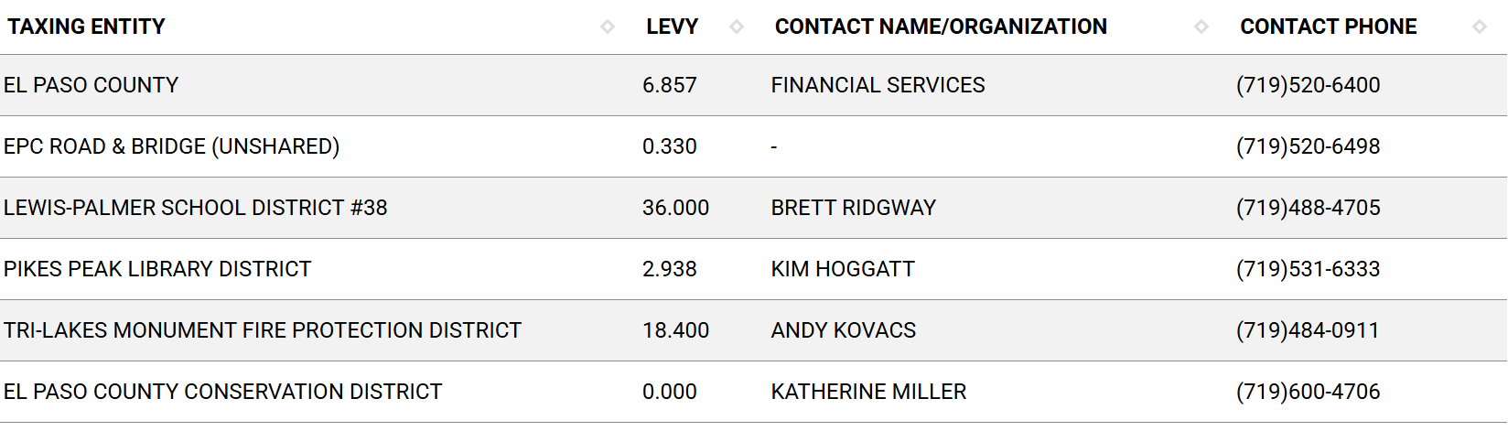
Proposed source of water |  |  | Proposed method of wastewater disposal
☐ | Central System |  | ☐ | Central System
District Name: |  | N/A (Well) | District Name: |  | N/A (Septic)

Water/wastewater comments
8.4. – DESIGN CONSIDERATIONS AND STANDARDS

The State of Colorado required a 100-year water sufficiency finding and El Paso County requires a 300-year water sufficiency finding for each new lot being created. Lastly, the water must be shown to be of acceptable drinking quality and receive endorsement from the EPC Public Health Department.

8.4.7 (4)(a) General Provisions.
The Planning Commission shall, as part of its deliberations, make a recommendation regarding the sufficiency of the proposed water supply. The BoCC shall determine the sufficiency of the proposed water supply in terms of quantity, dependability, and quality based on the information presented and the recommendation of the Planning Commission.

In determining the sufficiency of a proposed water supply, the BoCC shall, at a minimum, consider the Water Resources Report, data and recommendations from the State Engineer's Office, CAO, EPCPH, and the County staff, the recommendations of the Planning Commission, and public comment. In all cases the burden of proof in demonstrating sufficiency rests with the applicant, and it shall be the applicant's sole responsibility to document in the Water Resources Report that the proposed water supply is sufficient in terms of quantity, dependability, and quality.

8.4.7 (B)(1) Water Resource Report.
(b) Water Resources Report Required. A water resources report as required by this Section shall be submitted with sketch plan, preliminary plan, final plat, and any subdivision applications which will create a new lot. A copy of the report will be kept on file in the El Paso County PCD.
(c) Prepared by Qualified Professional. The water resources report shall be prepared by a qualified hydrogeologist, hydrologist, licensed civil engineer, qualified groundwater geologist, or other qualified professional with appropriate experience.
(d) Document Adequate Water Supply. The Water Resources Report shall include adequate documentation that the proposed water supply is sufficient in terms of quantity, dependability, and quality for the proposed subdivision.

(c) Final Plat and Replat Report. The water resource report submitted with the final plat shall include all of the data needed to determine whether the proposed water supply is sufficient in terms of quality, quantity and dependability for the type of subdivision proposed. The report shall be based on engineering calculations and site-specific data and shall include a detailed discussion of the water demand, supply, quality, dependability, and supply facilities for the proposed subdivision.
A water resources report is not required if the BoCC made a finding that the proposed water supply plan of the preliminary plan was sufficient in terms of quantity, quality and dependability. However, an amended water resources report is required if there is a substantial change in either the water supply or the estimated water demand.
8.4.7(B)(5) Finding of Sufficient Dependability. The proposed water supply shall meet the following criteria to be found sufficient in terms of dependability:
- The supply is of sufficient quantity to meet the needs of the proposed subdivision for 300 years;
- The proposed water supply system and water supply is capable of meeting the average annual and peak daily demand of the proposed subdivision; and
The applicant has provided adequate evidence of ownership or the right of acquisition or use of existing or proposed water rights sufficient in quantity, dependability, and quality to serve the proposed uses within the subdivision; and (1) the legal capability to accomplish any changes in the uses or points of diversion of the rights with quantities and dependability necessary to serve the proposed subdivision without material injury to vested water rights; or (2) adequate evidence that the public or private water provider can and will supply the proposed subdivision with water of adequate quality, quantity and dependability.

8.4.8.(C)(2) Onsite Wastewater Treatment Systems (OWTS).
2 OWTS Sites Required for All Lots or Parcels. All lots shall be designed to ensure that each lot has a minimum of 2 sites appropriate for OWTS which do not fall in the restricted areas identified on the preliminary plan; soils and geology report delineated wetland or floodplain maps; or other reports required under this Code.

Fire District:
Will need Fire Protection Report and Fire Commitment Letter from
Tri-Lakes Monument Fire Protection District
- 719-484-0911
- Contact Page

Wildland Fire and Hazard Mitigation Plan:
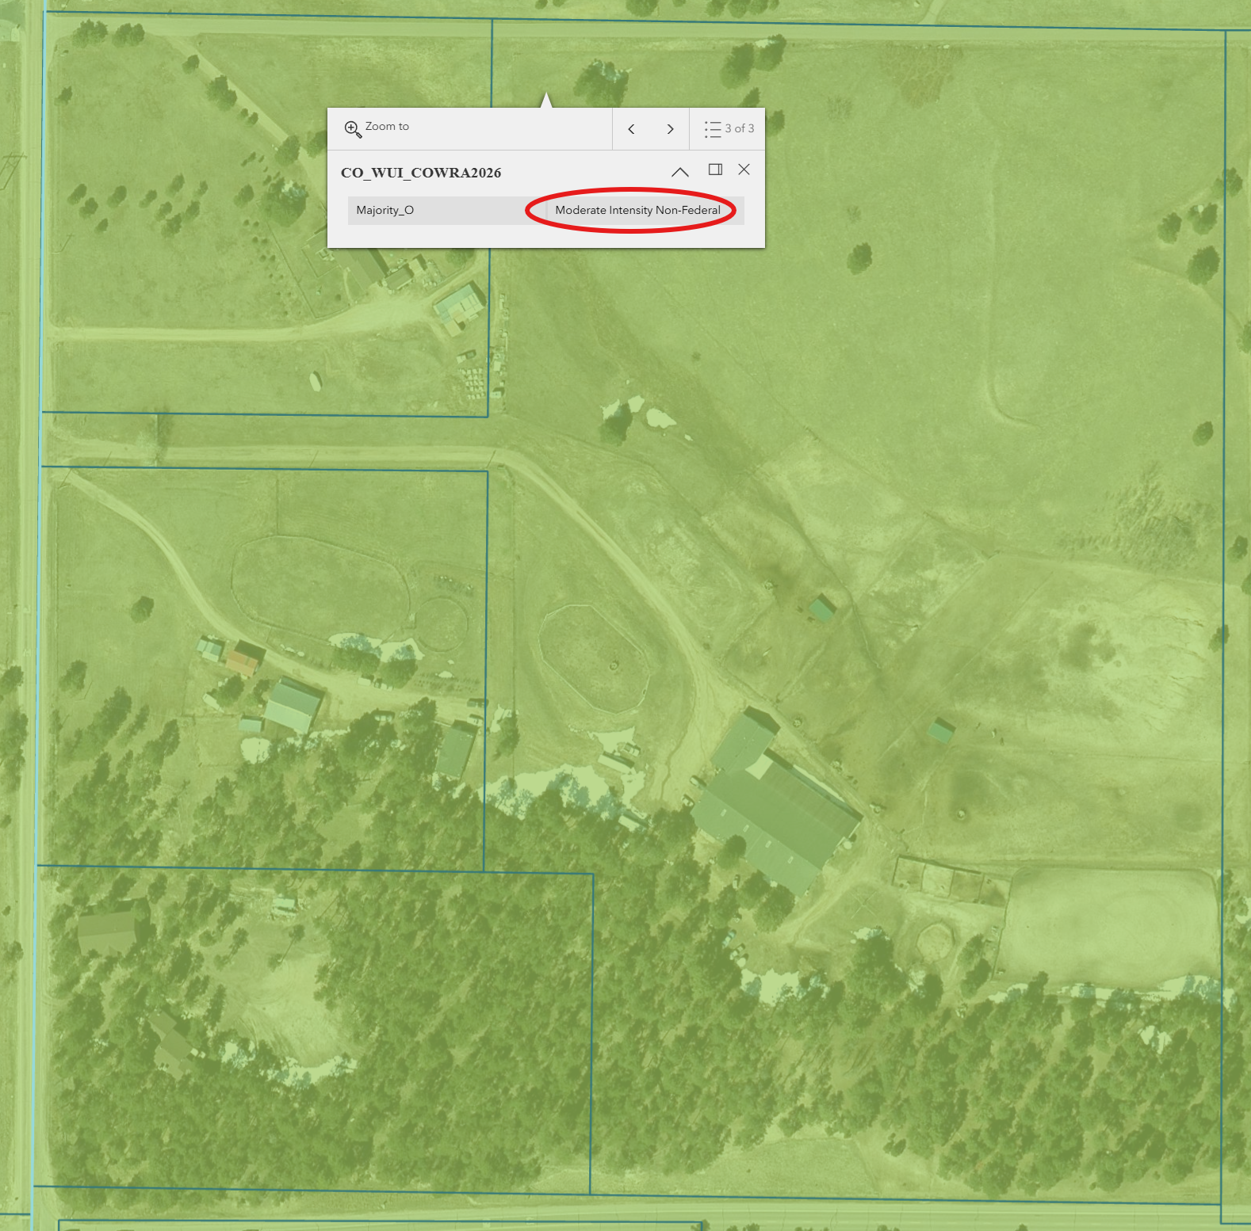
Wildland Urban Interface – Moderate Intensity
- Will may need a Wildland Fire and Hazard Mitigation Plan if fire district asks for it in the review process

Emergency Services Issues:
Access must meet applicable Fire Protection District standards for turnarounds, etc.

Commissioner District: 1

Code Waivers:
7.3. - WAIVERS
7.3.2. Authorization to Grant Waivers
(A) Planning Commission Recommendation. The Planning Commission will hear the request for a waiver from the standards and make recommendations to the BoCC.
(B) BoCC Authorized to Grant Waivers. After receiving a recommendation from the Planning Commission, the BoCC may approve a waiver from any of the subdivision design standards and requirements of this Code.

7.3.3. Criteria for Approval of Waivers
A waiver from standards shall be approved only upon the finding, based upon the evidence presented in each specific case, that:
• The waiver does not have the effect of nullifying the intent and purpose of this Code;
• The waiver will not result in the need for additional subsequent waivers;
• The granting of the waiver will not be detrimental to the public safety, health, or welfare or injurious to other property;
• The conditions upon which the request for a waiver is based are unique to the property for which the waiver is sought and are not applicable to other property;
• A particular non-economical hardship to the owner would result from a strict application of this Code;
• The waiver will not in any manner vary the zoning provisions of this Code; and
• The proposed waiver is not contrary to any provision of the Master Plan.

7.3.5. Waiver Application Requirements
The written request for a waiver shall state in detail the extent of the waiver, the grounds for the requested waiver and all of the facts relied upon by the applicant. The applicant shall have the burden of providing both the justification for their waiver requests and sufficient documentation to allow PCD to properly evaluate the engineering and planning impacts of the requested waiver.

Parks and trails:
No response as of the date of this meeting. (Will be invited to review the submitted documents and will provide park fee amounts)

Annexations/Intergovernmental/ Jurisdictional Access issues:
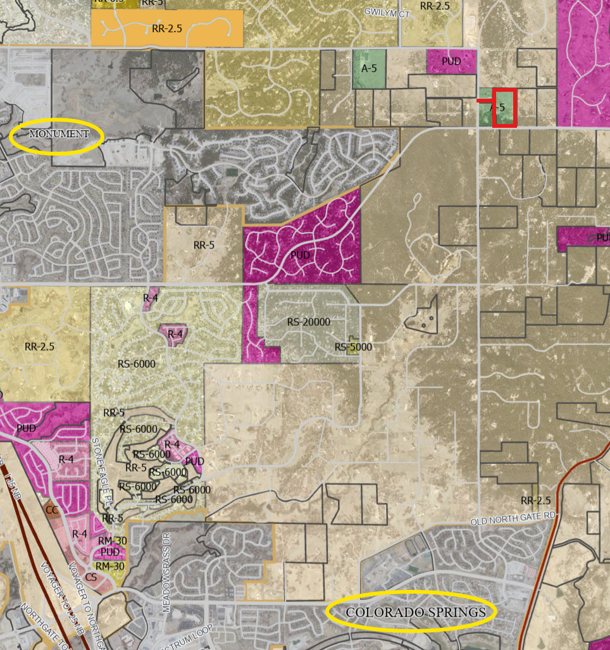
The City of Colorado Springs Planning department and Public Works, and the Town of Monument were invited to attend due to close proximity to their planning jurisdictions. As of the date of this meeting, no response has been received. (Will be invited to review the submittal documents).

Your El Paso Master Plan:

Placetype – Large-Lot Residential
The Large-Lot Residential placetype consists almost entirely of residential development and acts as the transition between placetypes. Development in this placetype typically consists of single-family homes occupying lots of 2.5 acres or more, and are generally large and dispersed throughout the area so as to preserve a rural aesthetic. The Large-Lot Residential placetype generally supports accessory dwelling units as well. Even with the physical separation of homes, this placetype still fosters a sense of commu nity and is more connected and less remote than Rural areas. Large-Lot Residential neighborhoods typically rely on well and septic, but some developments may be served by central water and wastewater utilities. If central water and wastewater can be provided, then lots sized less than 2.5 acres could be allowed if; 1.) the overall density is at least 2.5 acres/lot, 2.) the design for development incorporates conservation of open space, and 3.) it is compatible with the character of existing developed areas. Conservation design (or clustered development) should routinely be considered for new development within the Large-Lot Residential placetype to provide for a similar level of development density as existing large-lot areas while maximizing the preservation of contiguous areas of open space and the protection of environmental features. While the Large-Lot Residential placetype is defined by a clear set of characteristics, the different large-lot areas that exist throughout the County can exhibit their own unique characters based on geography and landscape.

Land Uses
Primary
• Single-family Detached Residential (typically 2.5-acre lots or larger)
Supporting
• Parks/Open Space
• Commercial Retail (Limited)
• Commercial Service (Limited)
• Agriculture

**See pages 26 and 27 in the Master Plan for more info

Area of Change - Minimal Change: Developed
These areas have undergone development and have an established character. Developed areas of minimal change are largely built out but may include isolated pockets of vacant or underutilized land. These key sites are likely to see more intense infill development with a mix of uses and scale of redevelopment that will significantly impact the character of an area. For example, a large amount of vacant land in a suburban division adjacent to a more urban neighborhood may be developed and change to match the urban character and intensity so as to accommodate a greater population. The inverse is also possible where an undeveloped portion of an denser neighborhood could redevelop to a less intense suburban scale. Regardless of the development that may occur, if these areas evolve to a new development pattern of differing intensity, their overall character can be maintained.

Key Area – Tri-Lakes Area
Tri-Lakes is the northern gateway into the County along Interstate 25 and Highway 83. It is situated between Pike National Forest, the United States Air Force Academy, and Black Forest. With significant suburban development and some mixed-use development, this Key Area supports the commercial needs of many of the residents in northern El Paso County. Tri-Lakes also serves as a place of residence for many who commute to work in the Denver Metropolitan Area. It is also an activity and entertainment center with the three lakes (Monument Lake, Wood moor Lake, and Palmer Lake) that comprise its namesake and direct access to the national forest. Tri-Lakes is the most well-established community in the northern part of the County with a mixture of housing options, easy access to necessary commercial goods and services, and a variety of entertainment opportunities. Future development in this area should align with the existing character and strengthen the residential, commercial, employment, and entertainment opportunities in the adjacent communities of Monument, Palmer Lake, and Woodmoor.

Goals and strategies for specific elements listed above can be found in Chapter 14 of the Master Plan.

Water Master Plan Area:
Water Region 2 (Monument Area)
Region 2, located in the northwest corner of El Paso County, is expected to experience significant growth through 2060. The I‐25 corridor passes through the center of the region and offers optimal growth areas in and around the Towns of Palmer Lake and Monument. Growth is anticipated along both the east and west sides of I‐25 by 2040. Additional growth areas are located near Colorado State Highway 83. Low‐density developments are expected by 2040 for both the north and south sides of Hodgen Road, along the Highway 83 corridor. Substantial growth is projected along Highway 83 in northwestern El Paso County. Planned growth areas are expected to be low density and would currently rely on well and septic systems, as no centralized well or sewer systems are available. Region 2 bordering Douglas County also has projected growth by 2060 between Furrow Road and Roller Coaster Road. See Figure 5.4 for Region 2 growth map projections.

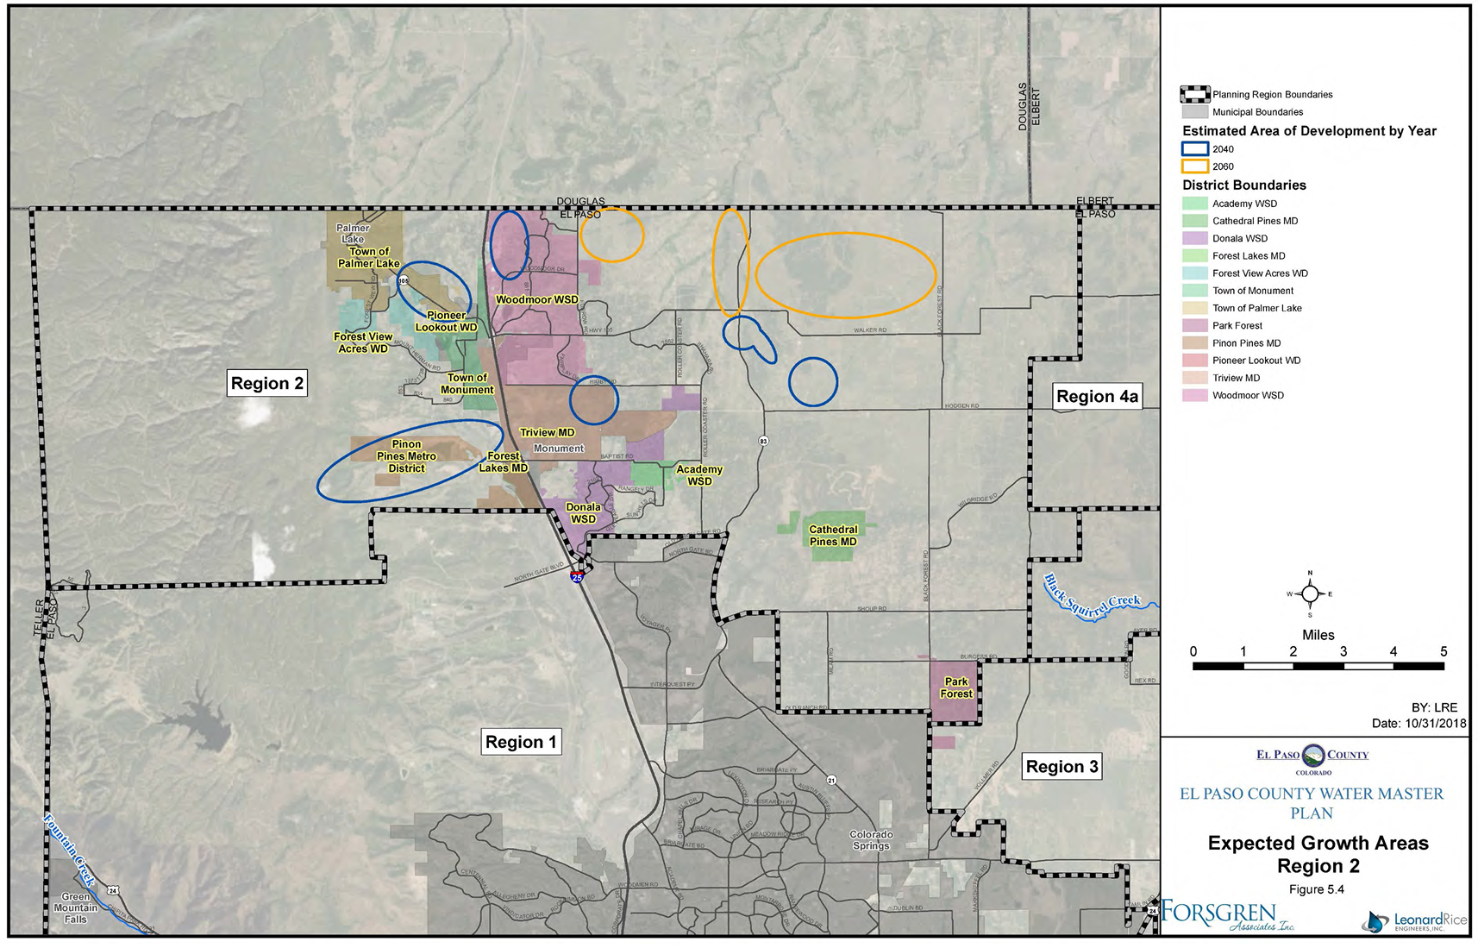

Next Steps
The following documents will be requested for submittal with this Final Plat application. (I have provided links where we have them available for specific forms and checklists. Some documents will need to obtained from specific agencies or certified professionals.)
- Application/Petition Form
- Closures Sheet (Survey)
- Final Plat Drawings
- Legal Description (as a word doc)
- Letter of Intent
- Title Commitment (current within 1 year of submittal)
- Mineral Rights Certification
- PCM Applicability Form
- Electric Provider Commitment Letter
- Fire Commitment Letter
- Natural Gas Commitment Letter
- Drainage Report – Final
- Fire Protection Report
- Natural Features Report
- Noxious Weed Management Plan
- Soils & Geology Report
- Wastewater Treatment Report
- Water Resources Report
- Water Supply Information Sheet
- Wildlife Impact Report
- Financial Assurance Estimate Form
- Construction Drawings

List of qualified professionals for Water Resources Report
List of qualified professionals for Fire Protection Reports/Plans
Process
- A submittal request will be sent for the documents listed above.
- Once all documents are received and accepted, a payment request will be sent for $5834.
- Once payment is made, a 21 day review cycle will initiate in which all documents will be sent out to various agencies for review and neighbors within 500 feet of the property boundaries will be notified of the proposed development and given opportunity to submit their input about it.
- Review comments will filter in over the 21 day period and on the 21st day, county staff will return their comments along with a resubmittal request for documents that need to be revised and resubmitted.
- Once we receive the resubmittal, a 2nd review cycle of 14 days will initiate and the process will repeat until all comments are resolved.
- Once all comments are resolved, you will be added to the hearing agenda for Planning Commission and Board of County Commissioners (6 to 8 weeks out from final submittal).
- Planning Commission will make a recommendation to the BoCC to approve or deny the project.
- BoCC will make the final determination to approve or deny
- If the project is denied, a disapproval resolution will be drafted and recorded
- If approval is granted, an approval resolution will be drafted and recorded along with the plat.

Helpful Links

Planning Website: https://planningdevelopment.elpasoco.com/

El Paso County Master Plan: https://planningdevelopment.elpasoco.com/#1510603950097-f5d985dc-35b2
Water Master Plan: https://planningdevelopment.elpasoco.com/#1515613078151-9a697e85-b1a7
Parks Master Plan: https://parks.elpasoco.com/parks-and-recreation/park-planning/
Mineral Extraction Master Plan: https://planningdevelopment.elpasoco.com/#1515613078151-9a697e85-b1a7

Forms and Templates: https://planningdevelopment.elpasoco.com/forms-and-affidavits/

Applications and Checklists: https://planningdevelopment.elpasoco.com/applications-and-checklists/

Land Development Code: https://library.municode.com/co/el_paso_county/codes/land_development_code

EDARP: https://epcdevplanreview.com/

Public GIS: https://experience.arcgis.com/experience/94cea8ccda3d4806a3fd500d2b5a4433?draft=true

Wrap Up
-If subdivision is proposed, recording fees, park and school fees and road impact fees may apply.

-Fees are subject to change. The fees at the time of application apply.

-Road Impact Fees
Please see the following website for information on the EPC Road Impact Fee Project. https://publicworks.elpasoco.com/road-impact-fees/ to include fee schedule.
As of December 15, 2016, per Resolution 16-454, on and after January 1, 2020, property in the unincorporated area of the county that receives a Land Use Approval either in a public hearing or administratively, is subject to the payment of Road Impact Fees. After December 31, 2024, in accordance with BoCC Resolution 24-377 the fee is paid for new residential and non-residential uses and structures and expansions of non-residential uses and structures. Road Impact fees are typically paid at time of building permit. If no building permit is being obtained for a particular Land Use application, then Road Impact Fees must be paid at the time of Site Development Plan or Special Use approval. If there are questions about EPC Road Impact program or fees, please contact DPW Development Review Services and the Engineer of the Day.

- Engineering Criteria Manual (ECM) Deviations.
The fee for any additional ECM deviation requests (more than two per land use application) - $1483.00 each per current Fee Schedule. Please note ECM deviation requests may result in additional processing and project review time. ECM Deviations should be submitted prior to the initial Site Development Plan or Final Plat submittal to preclude changes having to be made to engineering plans and documents if the deviation is not approved. Submission of an ECM deviation request does not imply or guarantee that the deviation will be approved. An ECM Deviation form must be submitted to include complete exhibits and justification excluding cost with supporting engineering criteria. If there are questions about ECM Deviation requests, please contact DPW Development Review Services and the Engineer of the Day.

-The fee for any additional waiver/deviation requests (more than two) - $550.00 each. Please note that requests for waivers and/or deviations may result in additional processing/review delay.

-All items requested must accompany the submittal for it to be complete, prior to payment request or the submittal will not be complete and ready for review agencies.

-A temporary use permit shall be applied for and approved for any staging area associated with development, such as a sales office, construction trailer, or contractor's equipment yard, prior to scheduling of the pre-construction meeting with El Paso County Planning and Community Development. If a Planned Unit Development is proposed, the temporary staging area should be shown on the development guideline and phasing plan.

-All prospective timelines for review are subject to departmental staffing and workload.

-Early Assistance is valid for 12 months from submittal of the EA application. If a project submittal is not received within 12 months, a new EA meeting may be required. An audio/video copy of the meeting is available in EDARP within the EA folder.

- Applications scheduled for public hearings may be heard as a regular item at the request of staff or a hearing body member.

- Any comments or commitments made by any member of the County Staff during this early assistance meeting are only preliminary in nature and should not be relied upon by the applicant. All prospective applicants should be informed that formal comments cannot be made by staff until after the application is submitted.

