EA File No. EA2692 Roller Coaster Road
Engineering Meeting Notes

EA Meeting Date/Time: | Monday, 8/17/2026 3:00
Parcel Number: | 6121000008
Address./Plat No./Acre: | 16685 Roller Coaster Road / R04788 / 23.86 Acres
Project Manager/Phone: | Lacey Dean (719) 520-7943
Development Services Engineer/Phone: | Joe Sandstrom (719) 520-6314
Stormwater Engineer/Phone | Zachary Jannusch (719) 500-3170
Application/Land Use Type: | Final Plat
Information noted in red was added after the meeting

IMPORTANT NOTE:
These Engineering meeting notes are based on the information provided by the Applicant and reasonable preliminary research. The County requirements and policies in effect at the time of the meeting may change prior to the project submittal date, and the requirements and policies in effect at the date of submittal shall apply. Based on the applicant-provided information and preliminary research, these notes are the best estimate of the requirements expected to be met by the Applicant. The actual requirements may change based on project revisions, new information, or constraints that were unavailable or overlooked at the time of the Early Assistance meeting. It is solely the Applicant’s responsibility to research and be familiar with state and federal laws and permitting requirements; the County’s regulations, codes and criteria; the requirements of other applicable local, state or federal agencies; and any governing documents that apply to the project, including previous drainage and transportation studies and previous land use approvals and conditions. Reference links are provided at the end of this document.
REQUEST
Proposed a three Lot Minor Subdivision. This application has been reviewed as a Early Assistance Meeting 2021 (EA2157)

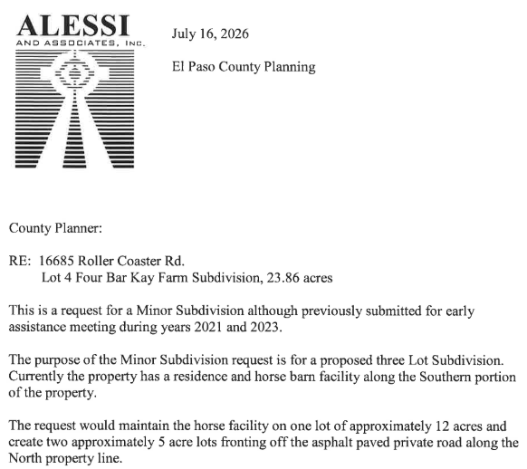
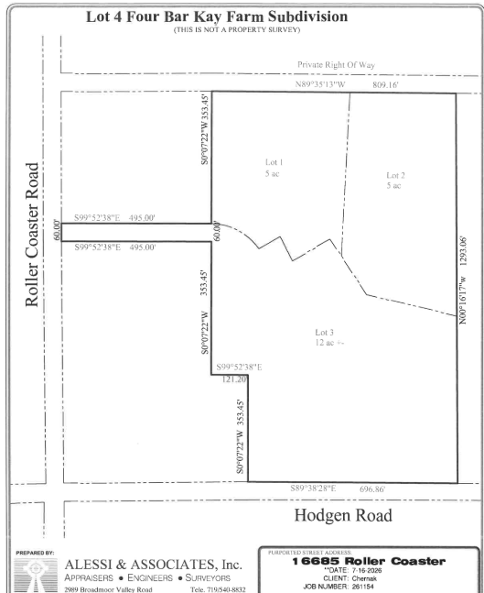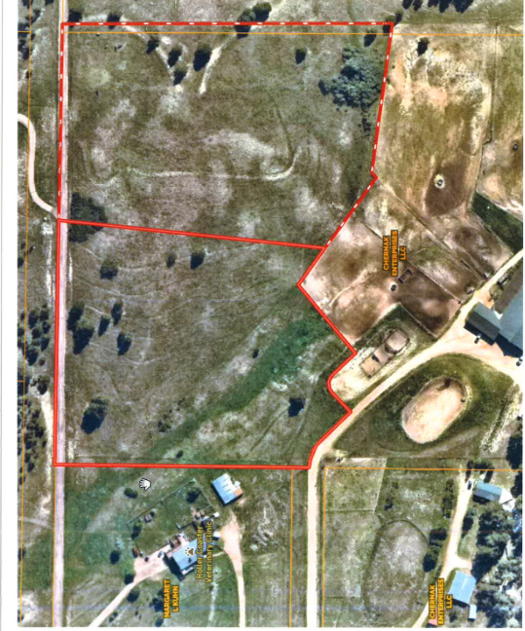

Drainage Impacts
Requirements
Documents |  | Design Elements
☐ | Drainage Basin Planning Study (DBPS) | ☐ | Full Spectrum Detention
☐ | Master Development Drainage Plan (MDDP) | ☐ | Permanent Water Quality
☒ | Preliminary/Final Drainage Report/Letter | ☐ | Downstream Conveyance Analysis (to include possible offsite improvements)
☒ | Financial Assurance Estimate (FAE) Form | ☐ | Floodplain Impacts
☐ | Builder’s Erosion and Stormwater Quality Control Permit (BESQCP) | ☐ | Public Improvements
☐ | Erosion and Stormwater Quality Control Permit (ESQCP)
☐ | Grading & Erosion Control (GEC) Plan & GEC Checklist | Miscellaneous
☐ | Stormwater Management Plan (SWMP) & SWMP Checklist | ☐ | Construction Activity Permit/ CDPHE Discharge Permit/CDPHE APEN Fee
☒ | PCM Applicability Form | ☐ | Special Districts/Water Quality Authority Areas
☐ | PCM Maintenance Agreement and O&M Manual
☐ | MHFD-Detention Basin Design Workbook or SDI Sheet
☐ | Pre-Subdivision Site Grading Form
☐ | Deviation Request

Basin Name/Studied | Basin Fee^{1, 2} | Bridge Fee¹
West Cherry Creek / Unstudied | $0 | $0
Smith Creek / Studied | $11,122 | $1,492
¹ Per impervious acre, collected prior to recordation of Final Plat. Fee amounts are based on the current fee schedule at the time of the Early Assistance meeting. Fees are subject to change.
² A 25% fee reduction applies for low density residential lots (2.5 acres and greater lot sizes). The reduction only applies to the basin fee.

Drainage Notes:
- A Final Drainage Report is required from a Colorado Professional Engineer. Water quality and detention shall be addressed in the report.
- Drainage basin and bridge fees are due at final plat recordation and are based on the increase in impervious acreage within a fee basin. A 25% fee reduction applies to large lots (2.5 acres or greater). The reduction only applies to the basin fee. The Drainage Report will provide the fee calculation and amount.
  - Fees are calculated according to the current fee schedule at time of application approval.
  - It appears that the northern portion of the site where the new lots are proposed is within the West Cherry Creek drainage basin which has no fees associated but this will be analyzed in the drainage report.
- This property is in Zone X, Area of Minimal Flood Hazard, based upon review of the FEMA FIRM. The flood map for the selected area is number 08041C0285G, effective on 12/7/2018. This area does not contain a regulatory floodplain.
- There is an area within the property that appears to be wetlands based on the aerial imagery. It isn’t currently identified on the National Wetlands Inventory, however it would fall under Colorado State Waters. I recommend contacting Colorado Department of Public Health and Environment in advance of preparing your application to find out how this may impact the application.
  - If the flows are higher than 15 cfs through this area, it will be notated as a drainage easement on the final plat which is a no build and no storage of materials area. This will be determined in the drainage report.
  - Website: https://cdphe.colorado.gov/dredge-and-fill
  - Email contact: cdphe_df_wqcd@state.co.us
  - Main Phone: 303-692-2000
  - Training that was recently conducted about the Dredge and Fill Program (from website banner): https://drive.google.com/drive/folders/1FTi3qw0f77F2v2Y7xqlFxnYVffQQukGC
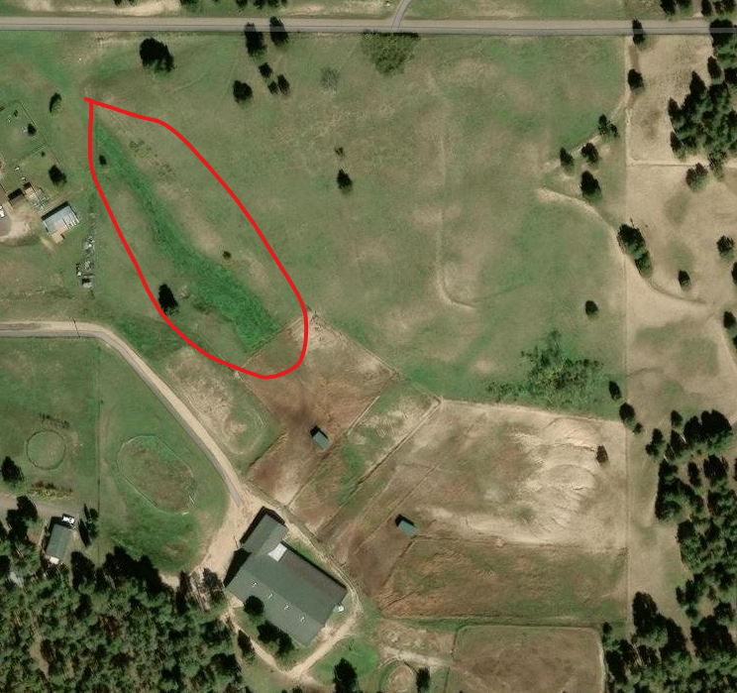
- An EPC Stormwater Permit (ESQCP) will be needed if/when one of the following criteria are triggered:
  - Project has >1 ac of soil disturbance, or:
  - Project has <1 ac of soil disturbance and is part of a Larger Common Plan of Development, or:
  - Cut and/or fill >500 cubic yards of soil, or:
  - The site is located in or adjacent to a sensitive area.
- If/when the site disturbs >1 ac of soil, and >1 ac of the site is not excluded, a stormwater quality treatment facility (PCM) will be needed for the runoff from the non-excluded areas. Exclusions can be found in our PCM Applicability Form and ECM Appendix I.6.1.B
  - Anticipated Exclusion: Large Lot Single Family Sites (ECM Appendix I.6.1.B.5)
    - “A single-family residential lot, or agricultural zoned lands, greater than or equal to 2.5 acres in size per dwelling and having a total lot impervious area of less than 10 percent.”

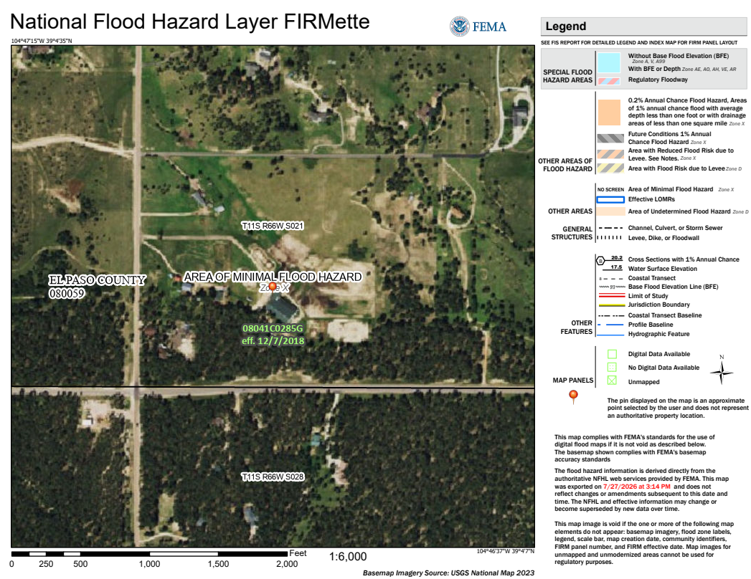
Traffic Impacts
Requirements
☐ | Traffic Impact Study/Memorandum | ☒ | Road Impact Fee | ☒ | Joint Access Easement
☒ | Road Construction Plans | ☐ | Road Impact Fee Acknowledgement Form | ☐ | County/CDOT project coordination required
☐ | Public Improvements | ☒ | Driveway Access Permit | ☐ | Outsourcing of Traffic Impact Study
☐ | Deviation Request | ☐ | Signal Warrant Study | ☐ | New Road Access Permit

Adjacent Road Name |  | Ex. ROW (ft) | Surface | PCI Rating |  | 2045 MTCP |  |  | 2065 MTCP |  |  | Required Intersection Spacing (ft)
 |  |  |  |  |  | Classification | ROW | Dedication | Classification | ROW | Potential Preservation | Required Intersection Spacing (ft)
Roller Coaster Road (Major Collector) |  | 60’ | Paved | 84 |  | Local | 70’ | 5’ | Local | 70’ | 5’ | 330’
Hodgen Road |  | ~60’ | Paved | 89 |  | Minor Arterial | 100’ | 20’ | Minor Arterial | 100’ | 0’ | ¼ mile
 |  |  | Other (i.e. multi-jurisdictional):
Metro District |  |  |  |  | Choose an item.

Traffic Notes:
- El Paso County will request a 5’ public improvement easement to be dedicated to the County along Roller Coaster Road property frontage to meet our current local road cross section. The County will request 20’ of right of way dedication along Hodgen Road to accommodate for future roadway improvements planned in the County Major Transportation Corridors Plan (2024 MTCP).
- Below are some images from the 2024 EPC Major Transportation Corridors Plan. There are proposed improvements along Hodgen Road from Roller Coaster Road to the East and on Roller Coaster Road from Old North Gate up to Hodgen. A new roadway connection of Roller Coaster Road is proposed from Hodgen Road up to Higby Road.
- MTCP Website: https://publicworks.elpasoco.com/department-public-works/major-transportation-corridors-2045-update/
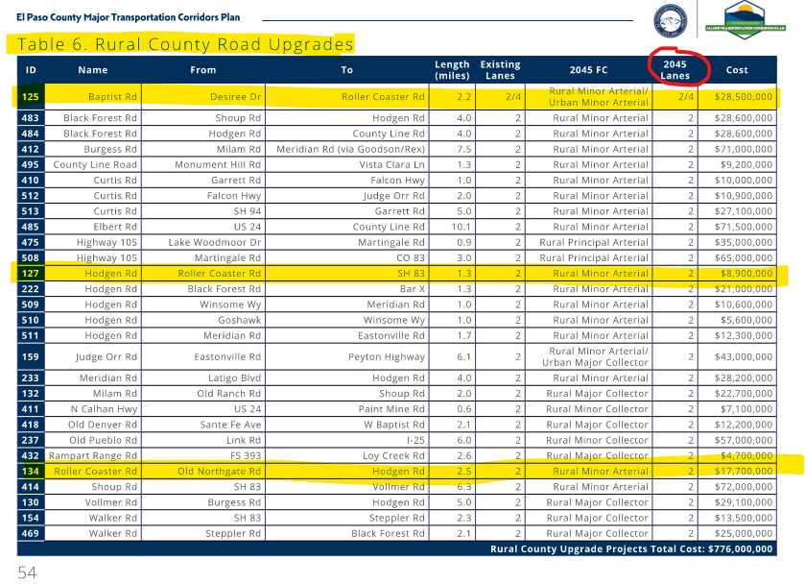
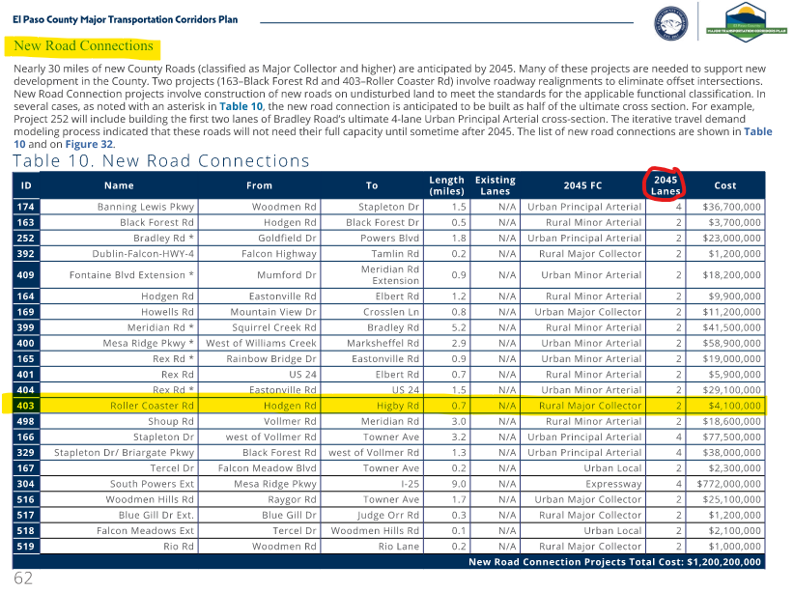
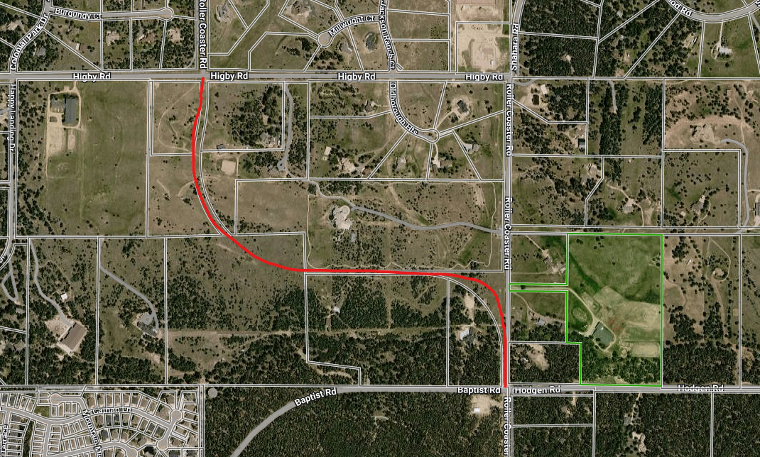

- A traffic impact study exemption can be requested by addressing the exemption in the Engineering Criteria Manual B.1.2.D:
  - Vehicular Traffic: (1) Daily vehicle trip-end generation is less than 100 or the peak hour trip generation is less than 10; (2) there are no additional proposed minor or major roadway intersections on major collectors, arterials, or State Highways; (3) the increase in the number of vehicular trips does not exceed the existing trip generation by more than 10 peak hour trips or 100 daily trip ends; (4) the change in the type of traffic to be generated (i.e., the addition of truck traffic) does not adversely affect the traffic currently planned for and accommodated within, and adjacent to, the property; (5) acceptable LOS on the adjacent public roadways, accesses, and intersections will be maintained; (6)no roadway or intersection in the immediate vicinity has a history of safety or accident problems; and (7) there is no change of land use with access to a State Highway.
- The paved access to the north of this property is either public or private ROW, however a roadway built to County standards was never constructed here and this is a private access. The existing access appears to be 16’ wide. More research will be needed by the applicant at time of the subdivision application if planning to take access here.
  - A joint access and maintenance agreement will be required with the other property owners currently taking access here.
  - If this is determined to be County ROW, a license agreement will be required.
  - This access does not meet minimum fire access standards from the Land Development Code Chapter 6.3.3 (minimum 24’ width).
  - County criteria requires that a roadway built to minimum county standards is required to serve more than 3 lots. There are already 3 lots taking access from the 16’ wide access to the north. The access will need to be improved up to County standards for a local road up to the access point for the proposed lot 2 in the submitted site map.
  - Construction Drawings completed by a professional engineer registered in the state of Colorado would be required for any improvements that are required for the northern access.
  - A Financial Assurance Estimate and posted collateral will be required if improving the roadway.
  - It looks like the northern paved access is on the edge or outside of the 60’ right of way.
  - The Monument Fire District may require improvements to this access to meet their minimum access standards. I suggest contacting them regarding access and any other requirements that they may have prior to submitting an application to the County.
  - An easier path forward may be to take joint access from the existing property access to Roller Coaster Road.
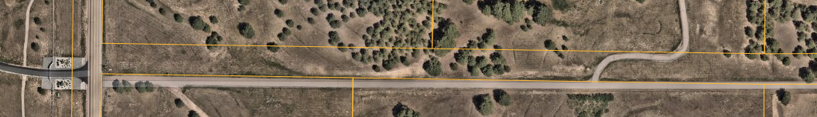
- The existing access onto Roller Coaster Road exceeds the maximum width allowed by the County which is 24’. Currently it appears to be at least 60’ wide. Suggest working with the property owner to the south who shares this access to modify the access point so that it conforms to County standards and is no wider than 24’ where it connects to Roller Coaster Road.
  - If the new lots will be taking access here instead of from the north access, an access permit for these lots will be required prior to building permit and the access will need to be modified at that time.
  - If all 3 lots will be taking access from the existing driveway, a joint access easement and maintenance agreement shall be recorded with the Clerk and Recorder’s Office.
  - Driveways connecting to a paved roadway shall be paved within the right of way. The existing driveway must install a paved apron (no wider than 24’) to come into compliance with County standards.
- The El Paso County Road Impact Fee program is applicable to this development. Fees are assessed by type of use. This application would be classified under Single-Family Detached. Current fees are $4,101 for all proposed homes. Fees are due at building permit. More information about the program can be found at the following link.
  - https://publicworks.elpasoco.com/road-impact-fees/
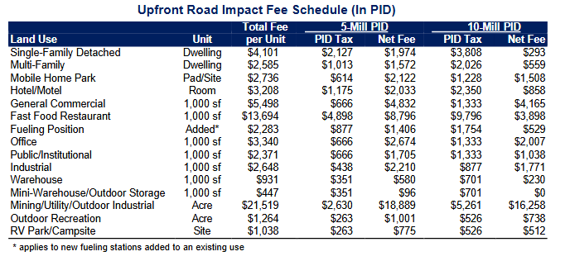
- An El Paso County Driveway Access Permit is required before any access is established from the proposed lots to the roadway. This is due at time of building permit for new construction. The application can be completed online via EDARP: https://epcdevplanreview.com/Applications/Create_Email under Access Permit (standalone).
- Rural County Road Detail
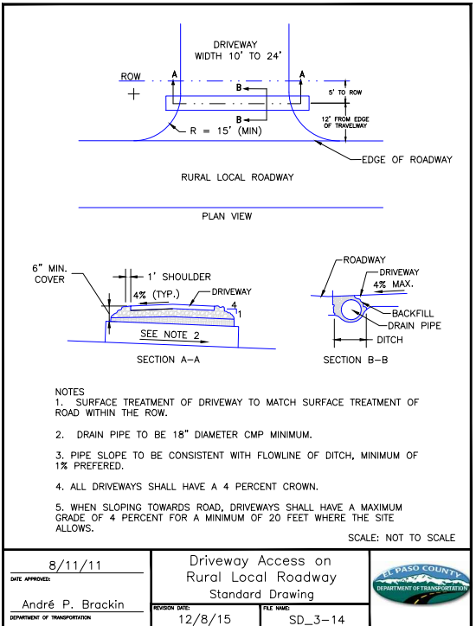
Anticipated Engineering Review and Construction Permit Fees
Fees apply if access will be taken from the north access for improvements permitting
Engineering Application | Review Fee¹
Minor Construction Drawings | $3,151
Construction Permit | $5,390

¹ Fee amounts are based on the current fee schedule at the time of the Early Assistance meeting. Fees are subject to change.

Full Fee Schedule: https://planningdevelopment.elpasoco.com/#1515613078895-69552b09-44a4

COUNTY CODES AND CRITERIA:
El Paso County Land Development Code (LDC) (2016): https://planningdevelopment.elpasoco.com/land-development-code/
El Paso County Engineering and Drainage Criteria Manuals (ECM) (2020) & (DCM) Volumes 1 and 2 and Update:
https://planningdevelopment.elpasoco.com/planning-community-development/engineering/#1519834440345-f2ddfd20-0d90
El Paso County 2045 Major Transportation Corridors Plan (MTCP) Update: https://publicworks.elpasoco.com/department-public-works/major-transportation-corridors-2045-update/
El Paso County Road Impact Fee Program: https://publicworks.elpasoco.com/road-impact-fees/
El Paso County Development Fees: https://planningdevelopment.elpasoco.com/#1515613078895-69552b09-44a4
El Paso County Projects (EDARP): https://epcdevplanreview.com/Public
El Paso County Municode Library: https://library.municode.com/co/el_paso_county
Planning and Community Development: https://planningdevelopment.elpasoco.com/planning-development-forms/#1643393391537-a0dac52d-1b3b
El Paso County Stormwater Page: https://publicworks.elpasoco.com/stormwater/
Assessor’s Information
Assessor’s Data: https://property.spatialest.com/co/elpaso/#/ Assessor’s Map: https://community.spatialest.com/co/elpaso/#/Property-Search/
Drainage Links:
Mile High Flood District: http://MHFD.org
Detention Pond Compliance Website: https://maperture.digitaldataservices.com/gvh/?viewer=cswdif
State DWR: http://water.state.co.us/SURFACEWATER/DAMSAFETY/Pages/DamSafety.aspx
NOAA Rainfall: https://hdsc.nws.noaa.gov/hdsc/pfds/pfds_map_cont.html?bkmrk=co
Floodplain: https://www.pprbd.org/Download/Floodplain#floodplainHandouts
https://pprbd.maps.arcgis.com/apps/webappviewer/index.html?id=1d9243f3606542159a0a418070b08686
https://msc.fema.gov/portal/advanceSearch
Fountain Creek Watershed: http://www.fountain-crk.org/
Upper Black Squirrel Creek Ground Water Management District Mapping Study: https://upperblacksquirrelcreekwater.com/waterStudies.php
Water Rights:
Colorado Division of Natural Resources: https://dwr.state.co.us/Portal/dwr/AskDWR
State Transportation Links
Colorado Department of Transportation (CDOT) M&S Standards and Specifications, Access Code and Permit:
  - https://www.codot.gov/business/designsupport/standard-plans
  - https://www.codot.gov/business/permits/accesspermits
  - https://www.codot.gov/business/permits/accesspermits/references

Local Governing Authorities
City of Colorado Springs: https://coloradosprings.gov/
City of Fountain: https://www.fountaincolorado.org/
Town of Calhan: http://calhan.co/
Green Mountain Falls: https://gmfco.elpasoco.com/
Town of Monument: http://www.townofmonument.org/
Town of Palmer Lake: http://www.townofpalmerlake.com/
Contact Information
CDOT R2 Permits Program Manager | (719)562-5540
Work in Right of Way Permit | (719)520-6869
Right of Way Vacation | (719)520-6897
Floodplain Administrator | (719)327-2898
EPC Public Health | (719)578-3199
CDPHE Air Quality Division | (303)692-3100
CDPHE Water Quality Division | (303)692-3500
Cherry Creek Basin Water Quality Authority | (303)239-5400

Traffic Information
Traffic Impact Study (ECM Appendix B)*
Full TIS | ADT > 1,000 or Pk Hr > 100
Intermediate TIS | ADT < 1,000 or Pk Hr < 100
Traffic Memo | ADT ≤ 500 or Pk Hr ≤ 50
No TIS | ADT < 100 or Pk Hr < 10
*An approved TIS that has been prepared in the last three years may be revised or updated where a proposed access is changed or a change in the proposed action may result in a new trip generation that exceeds the original trip generation estimates. An amendment letter is required.
**If the original TIS is older than three years, an entirely new TIS shall be prepared.
***Any submitted TIS is subject to third party review based on size and complexity, in which additional fees will be assessed to the applicant.
The applicant is responsible for obtaining any necessary approvals for impacts within other jurisdictions. It is recommended that the applicant approach the jurisdiction early in the development process for any additional requirements. If the proposal is impacted by an El Paso County Department of Public Works project, coordination with DPW is required.
Pavement Condition Index
The Pavement Condition Index (PCI) is a numerical rating system that measures the condition of a road's pavement on a scale of 0 to 100. A score of 100 indicates a newly paved road, while 0 is the worst possible condition. The PCI is calculated based on the type and severity of distresses observed on the pavement surface, such as cracking, rutting, scaling, and spalling. Other factors that can affect the PCI score include Pavement age, Climate and precipitation, Traffic loads, and maintenance.

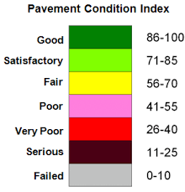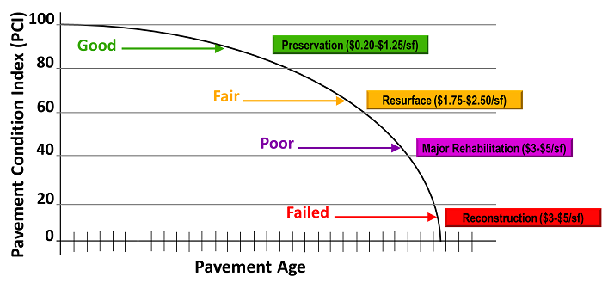
Drainage Report/Plan Information
Drainage Basin Planning Study (DBPS) – May be required with a very large development
Master Development Drainage Plan (MDDP) – Required with phased development greater than 10 acres (may be required with Sketch Plan) (DCM Section 4.2)
Drainage Letter Report – With a Re-plat, Minor Sub or Plot Plan (DCM Section 4.5) where a final drainage report has previously been approved.
Preliminary Drainage Report (PDR) – Required with a Preliminary Plan (DCM Section 4.3)
Final Drainage Report (FDR) – Required with a Final Plat (DCM Section 4.4)
Drainage Master Plan/Floodplain Information
If it is undetermined at this time if an adopted Drainage Basin Planning Study (DBPS) or Master Plan exists in this area, the applicant is responsible for researching the appropriate information.
If the subdivision application impacts the FEMA floodplain, a FEMA Letter of Map Revision may be required. If the site is in or near a floodplain, contact the Regional Floodplain Administrator for allowed floodplain uses and procedural requirements. It is the Applicant’s responsibility to research the effects and implications of developing in or near a floodplain, including limited uses, floodplain development permits, geotechnical, wetland and wildlife studies, structural requirements, flood insurance and potential future floodplain mapping updates. FEMA's FIRM maps may be out of date or at a low level of accuracy.
If the site lies within the Cherry Creek Basin Water Quality Authority area and is not rural density, the applicant should discuss any concerns related to the development with the CCBWQA’s consultant.
If the site lies within the Fountain Creek watershed, the District has authority over the floodplain impacts and is advisory to the County on uses outside of the floodplain. The applicant should discuss any concerns related to the development with District staff.
Detention/Water Quality PCM & Downstream Conveyance Information
Per ECM Chapter 3.2.8.B: “The proposed project or developed land use shall not change historical runoff values, cause downstream damage, or adversely impact adjacent properties.”
The project must provide an acceptable method of storm drainage conveyance and may be required to construct (or contribute an equitable share to the construction of) a storm conveyance or collector system.
If the site conveys storm drainage flows through or across an adjacent private property, then the applicant is responsible for obtaining off-site drainage easements in accordance with the Engineering Criteria Manual Section 3.3.3.K. Any offsite easements necessary for the development shall be recorded prior to County Plan approvals.
If on-site facilities are required, the applicant will be required to provide access and drainage easements in accordance with Section 11.2.2 of the Drainage Criteria Manual.
If a water quality and/or detention facility is applicable, some or all of the following documents may be required: Operation and Maintenance (O&M) Manual, Private Detention Basin / Stormwater Quality BMP (ie: PCM) Maintenance Agreement, and Stormwater Detention and Infiltration (SDI) Form.
For post-construction water quality PCM requirements, see Appendix I of the Engineering Criteria Manual. If/when the site disturbs >1ac of non-excluded areas, a stormwater quality treatment facility (ie: PCM) will be needed for the runoff from the non-excluded areas. Exclusions can be found in our PCM Applicability Form and ECM Appendix I.7.1.
State Engineer’s requirements regarding dams and water rights apply. Jurisdictional/Non-Jurisdictional dam construction forms are typically required for detention facilities. If applicable, provide proof of submittal of the State’s “Notice of Intent to Construct a Non-Jurisdictional Water Impoundment Structure” form.

Grading, Erosion, and Sediment Control Information
The Grading and Erosion Control (GEC) Plan must be prepared in accordance with Drainage Criteria Manual Vol. 2, Chapter 3 and the County’s GEC Checklist.
An Erosion and Stormwater Quality Control Permit (ESQCP) and Permanent Control Measure are required for the following conditions per ECM Appendix I.4:
- Construction activities that result in land disturbance of greater than or equal (≥) to one acre, or
- Construction activities that result in less than (<) one acre if the activity is part of a larger “Common Plan of Development or Sale” (ECM Chapter 1.22) that would disturb one acre or more of ground surface
An ESQCP may be required as determined by the ECM Administrator for the following conditions per ECM Appendix I.4:
- Construction activities that are located in or adjacent to a Sensitive Area, or
- Cut and/or fill greater than (>) 500 cubic yards of soil
See the three ESQCP exclusions listed in ECM Chapter 5.6.3.
An application for an ESQCP shall be accompanied by the following:
- Drainage Report  - ESQCP Form  - Financial Surety  - GEC Plan and GEC Checklist | - PCM Applicability Form  - Stormwater Management Plan (SWMP) and SWMP Checklist  - O&M Manual (for sites requiring a PCM)  - PCM Maintenance Agreement (for sites requiring a PCM
A Builder’s Erosion and Stormwater Quality Control Permit (BESQCP) is required for residential building lots with < 1 acre of disturbed areas and does not meet any of the criteria for an ESQCP listed above.
Construction activities that disturb >1ac of soil are required by the Environmental Protection Agency (EPA) to obtain a Construction Stormwater Permit through the Colorado Department of Public Health & Environment (CDPHE) Water Quality Control Divisions. For projects with soil disturbances >1ac but <25ac, a County Construction Activity Permit is required, contact El Paso County’s Public Health Department for further information regarding the permit. All land development activities greater than twenty-five (25) acres or with construction duration longer than six (6) months must obtain an Air Pollution Emission Notice and Emissions Permit through CDPHE’s Air Quality Control Division.
Deviations
All engineering designs and studies shall be performed in conformance with adopted codes, standards and criteria. Any deviations are to be formally identified and requested in writing, with justification provided per ECM Section 5.8. All deviation requests must be approved by the ECM Administrator prior to submitting the application for review, or delays in the review and additional fees may result. The Applicant must submit adequate justification for consideration of the request(s).
Public Improvements Information
If public improvements are required, the applicant will be required to enter into a Subdivision Improvement Agreement (SIA) or a development agreement (if the project is not a subdivision) with the County. Refer to the El Paso County Land Development Code for information on the SIA and the ECM for the required format of the associated Financial Assurance Estimate. All forms are available online.
Construction drawings for the required public improvements must be reviewed and approved by PCD and the County Engineer. All Construction drawing submittals shall adhere to the criteria set forth in the ECM. A construction plan review fee will be assessed when the plans are submitted for review.
Geotechnical reports for earthwork and pavement designs must be reviewed and approved. All submittals must adhere to the criteria set forth in the ECM.
Any work within the Right of Way will require a permit from El Paso County Department of Public Works.
Any Fire cistern(s) and mailbox kiosks need to be shown on the construction drawings.
Metro District Fees
Woodmen Road Metro District | Central Marksheffel Metro District | Lorson Ranch Metro District | Constitution Heights Metro District
- Effective January 1, 2026, El Paso County collects and keeps fees set by district.  - After December 31, 2020 no property in the Amended Service Area shall be permitted to join the WRMD, and shall participate fully in the Fee Program.  - As of January 1, 2021 and until either bonds retire or December 31, 2027, whichever occurs sooner, El Paso County must pay a portion of the Road Impact Fee it collects from property in the Amended Service Area that receives final plat approval to WRMD. | - Property in district pays no fee  - District granted $2.9 million in Fee Program Credit  - Fee Program will pay annual credit reimbursements to District, or can sell credits | - Property in district pays full fee  - District granted $4.1 million in credit  - Credits used toward future development, can apply for reimbursement, can sell credits | - Property in district pays full fee  - District granted $3.1 million in credit  - Used toward future development, can sell credits, NO reimbursement  - County will collect building permit fees for reimbursement of PPRTA improvements to Marksheffel Road from property within District and some property outside District – Credit given toward Impact Fee for amount of building permit fee paid.
*Properties within the Meridian Crossing subdivision are not subject to the county wide road impact fee.

