Letter of Intent
Kennel Permit for my Personal Pack of Rescues AND
building out for my non-profit creating a sanctuary for Northern Breed Canines
Woof Rescue 501c3, dba Basecamp Eden

Pallas Reichman Dame
Owner and Applicant
Property Address:
38435 Judge Orr Road
Calhan, CO 80808
Cell:
303-898-0393
Email:
pallas@creakydoor.net
Tax Schedule Number: r0300000005
Zoning: A35
I attempted to cover all of these below listed questions in my information below as I explain what we are doing. If you require additional information, I am more than happy to dive deeper in whatever areas you have questions about. I am not asking for any alternatives. What we are doing is not complicated and basically outdoor habitats.
Parking/Loading/Maneuvering
It is going to be a 3,250 sqft parking lot; which will accommodate up to 10 cars.
Lighting
We will have one light pole to illuminate the 3,250 sqft parking lot.
Square Feet of Office or USE Space in the Barn for road impact
There will be no office or use space in any of the barns, everyone will be working remotely so there will be no need for offices or use space in the barn.
Meets ALL These Standards:
5.2.30. Kennel
(B) Major.
(1) Applicability. A kennel in which 9 or more dogs or cats exist, and all of which exceed 4 months in age. Dogs or cats owned by the occupants of the premises shall be included In the count.
- I am actively working with Jessica Branham from PACFA- all my personal animals/Canine rescues are already approved by them to keep on my property.
- We are having our final PACFA inspection on the January 28th, 2026 for our PACFA licensing.
(2) Minimum Setback for Kennel. Structures and outdoor areas used as part of a kennels operation adjoining a residential, forestry, or agricultural zoning district shall be setback a minimum of 200 feet from all property boundaries. The PCD Director may allow a reduction in the setback where appropriate actions are taken to mitigate potential impacts.
- The setback for the outdoor dog enclosures is 800 feet from Judge Orr Road. Thousands of feet from any other road. The property is 1 mile by ½ a mile in length and width.
- The setback for the first barn closest to the road is–550 feet from Judge Orr Road, and thousands of feet from any other road again, as the property is 1 mile by ½ a mile in length and width.
(3) Overnight Boarding. Where overnight boarding occurs, animals shall not be allowed unsupervised outdoor access.
- ALL CANINES will ALWAYS be in inescapable outdoor enclosures with a dedicated dog house and access to a large play yard through a Sally Port from the main entrance into the individual enclosure. All dogs are ALWAYS monitored with a human inside of the play yard. We do not do group play unless all the dogs know each other and live that way in regular life. When the dogs are not playing, they stay in their dedicated enclosures.
(4) Conducted in Accordance with Laws. The kennel shall be conducted in compliance with all applicable county, state and federal laws.
- I/we are actively working with PACFA, Jessica Branham. Our final inspection for PACFA certification is 1-28-2026.
Site Development Plan
- Will be submitted accordingly. The kennel portion will be overlayed with the primary use site plan that has already been approved by the county for both my house on one end of the property, and the barns, connexes and road to the barns, in the other area of the property.
- This is an animal sanctuary. There will be little to no traffic into the sanctuary minus volunteers coming to help and participate.
- In the future we may offer tours of the animals to small groups like a single class from a school, an organization/corporate team, unit of veterans, etc.. that wants to come out and learn about our animals, stuff like that. Very small, scheduled visitations.
- We will never be an ‘Open To The Public’ come and buy tickets to see what is going on organization. All visitors will ALWAYS be by invitation and scheduling only. The animal sanctuary is to give sanctuary to the animals. Not a zoo to give entertainment to humans.
- This land is MY personal land and I am using a small portion of the acreage as my animal sanctuary.
- RV’s onsite:
  - I have a few RV’s on the property. They are used ONLY for my volunteers to stay in and care for the animals. Volunteers take shifts. The RV’s are also used as shelter for the volunteers to get out of the elements. Nobody lives in the RV’s. The RV’s are not used for personal hygiene or going to the bathroom. They are winterized inside.
  - I have a professionally managed port-a-potty on the property, this is where everyone uses the toilet, rain or shine, wind or snow.
  - The Volunteer Shifts which use the RV’s are necessary in order to provide proper care of all of the animals and ensure their safety day and night. PACFA also requires to ALWAYS have someone on the property. I also have a horse with two more coming, goats, mini-pigs and ducks. The volunteers also take care of all of the livestock.
  - The volunteers provide morning, afternoon and evening feedings of the animals. They clean up the pens and dog enclosures of poop and manure. They ensure the livestock are all put away at night. They ensure everyone has water, the generators are up and running to keep the pump house going all night and with heat, as we don’t have power on the property yet. Its’ coming but it’s been many many many months to get here. They monitor the property for trespassers and just to ensure proper care for all of the living beings on the property.
  - Once my house is built, and I am personally on the property more often, I will still have the volunteers performing the same way in order to perform proper care of all of the animals. I currently live 2 hours away in Arvada and require all of this help regardless. All of these animals require a team to care for them indefinitely.
- Dog Waste:
  - As noted below in the additional information I have provided. All dog waste will be physically removed from the property. It will be removed by us REGULARLY with our dump trailer and taken to the dump, OR it will be removed by a professional trash management service when paying for a service makes financial sense. The ONLY other way to destroy dog poop is through incineration. We will not be keeping this on the property. That’s just gross.

To Whom It May Concern,
This will serve as my letter of intent for my kennel application.
I am providing examples of what the fencing will ultimately be once we have funding and what the current fencing in use actually is.
I am also sharing our Birds Eye view of OUR plans as well as what we AREN'T doing and what future potential holds.
WHAT I CURRENTLY HAVE FOR MY PERSONAL DOGS ON THE RANCH AND WHAT WE WILL CONTINUE TO USE FOR THE FORESEEABLE FUTURE BECAUSE IT IS AFFORDABLE UNTIL WE HAVE SIZABLE DONATIONS TO BUILD THE FOREVER 12 FT FENCING ENCLOSURES AS DESCRIBED ABOVE
- The individual photos attached are from my personal dog enclosures on the ranch.

  - PACFA has granted legal permission on their side for me to have these dogs on the property. I am well aware the county has their own rules but they came with me when I bought this land. Now I am finally able to apply for this kennel permit to be fully in compliance as well with my personals as well as the non-profit animal rescue I am building. Woof Rescue (501c3) registered in the state of Colorado– I have a full legal team I am working with out of Orlando, Florida on the legal side of the non-profit.
- The fencing height we currently have is under 7 feet and is created from metal welded wire panels around the perimeter with chain link panels on the top to create secure, inescapable enclosures. This is the style we will continue with until we have funding to start building the 12ft kind with hot wire that I am referencing in the below links.
- The animals/canines are not and will never be bred. They will be lifetime sanctuary animals that have been rescued from euthanasia or other inhumane conditions. All animals will be spayed or neutered.
- Eventually, we may create a program to adopt out dogs that are best suited and happiest for traditional home life in houses vs sanctuary life on the ranch per PACFA regulations.. But for the foreseeable future, all animals have their forever home on our ranch.
- We are not a groomer or anything other than a rescue and lifetime sanctuary for these OUTDOOR ONLY animals.
- We MAY offer boarding to other Northern Breeds in dedicated OUTDOOR enclosures in the future PER PACFA regulations. No PAID boarding would ever be indoors, or on concrete runs, etc.. ALL of our canines are OUTDOOR dogs only in outdoor equipped runs and enclosures.
- All runs and enclosures are dirt foundations.
- ALL dog poop is cleaned daily and disposed of through either a contracted trash service just like urban and suburban areas or we will do regular dump runs. We do not keep piles of dog poop on the property. Dog poop cannot be disposed of in any other capacity than incineration or physical removal and taken to a dump.
- Our breeds are northern breeds.. all genetically built for outdoor lifestyle and ALL legally governed under PACFA .. Pet Animal Care and Facilities Act in Colorado.
- We have been actively working with PACFA for 6 months plus as we have been working towards where we are now. Our current plan is to have our final inspection on January 28th with Jessica Brannam from PACFA.. pending weather cooperation.

The following photos are our current kennel/dog runs, complete with doghouses, dig guard, sally ports (door enclosure before the door into the run itself, plus the shared play yard with monitored play only.
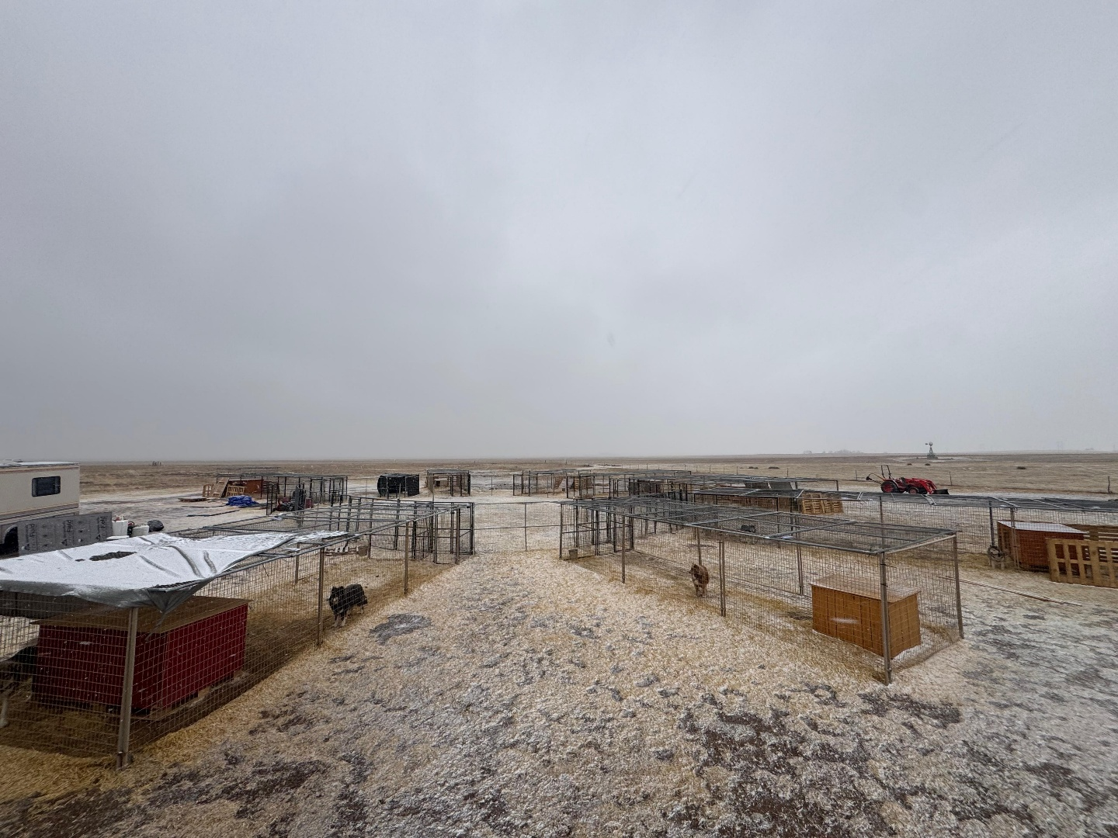
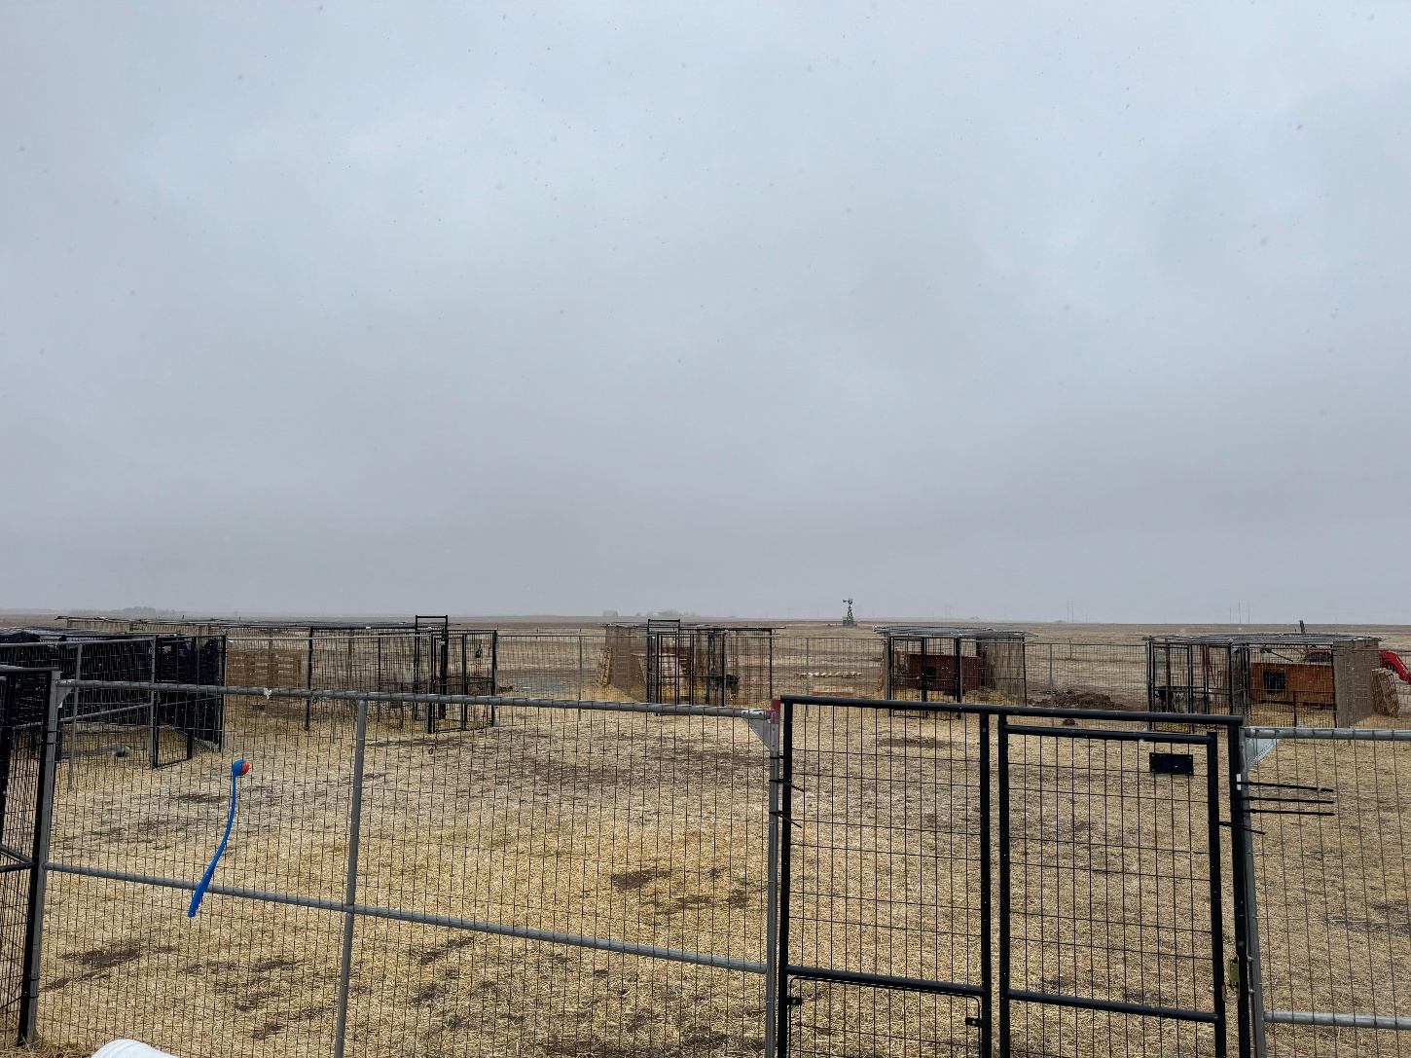
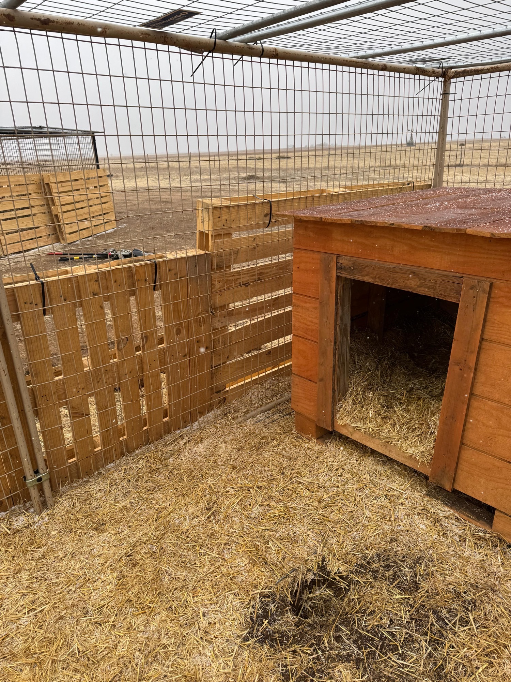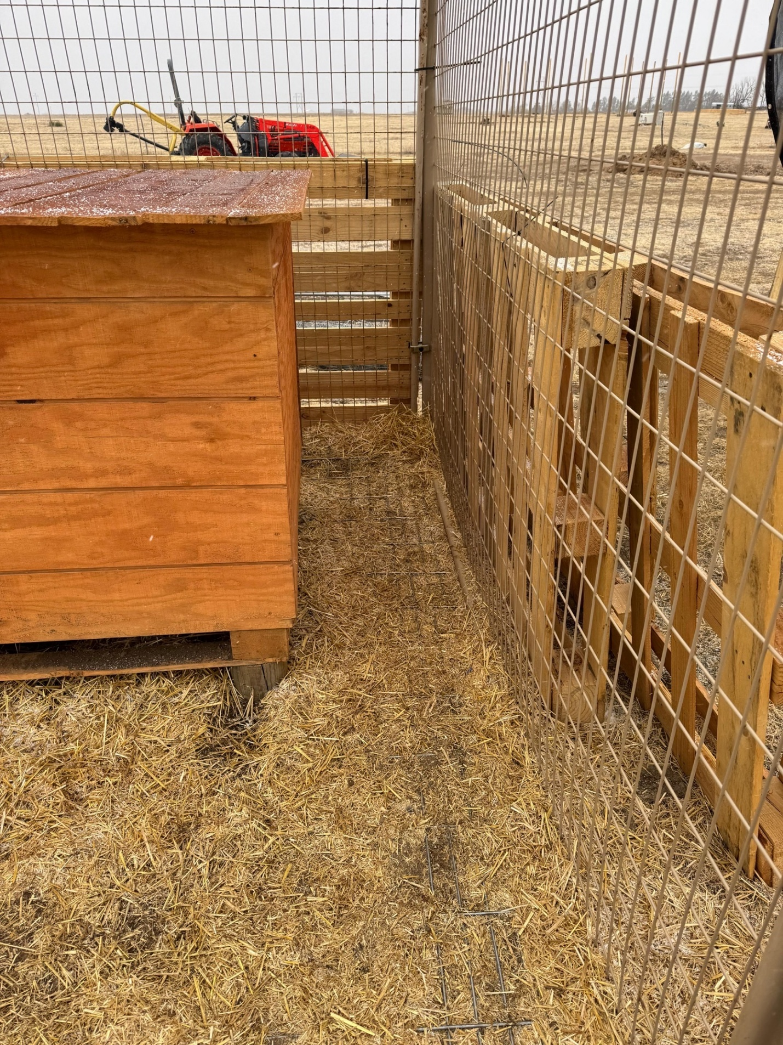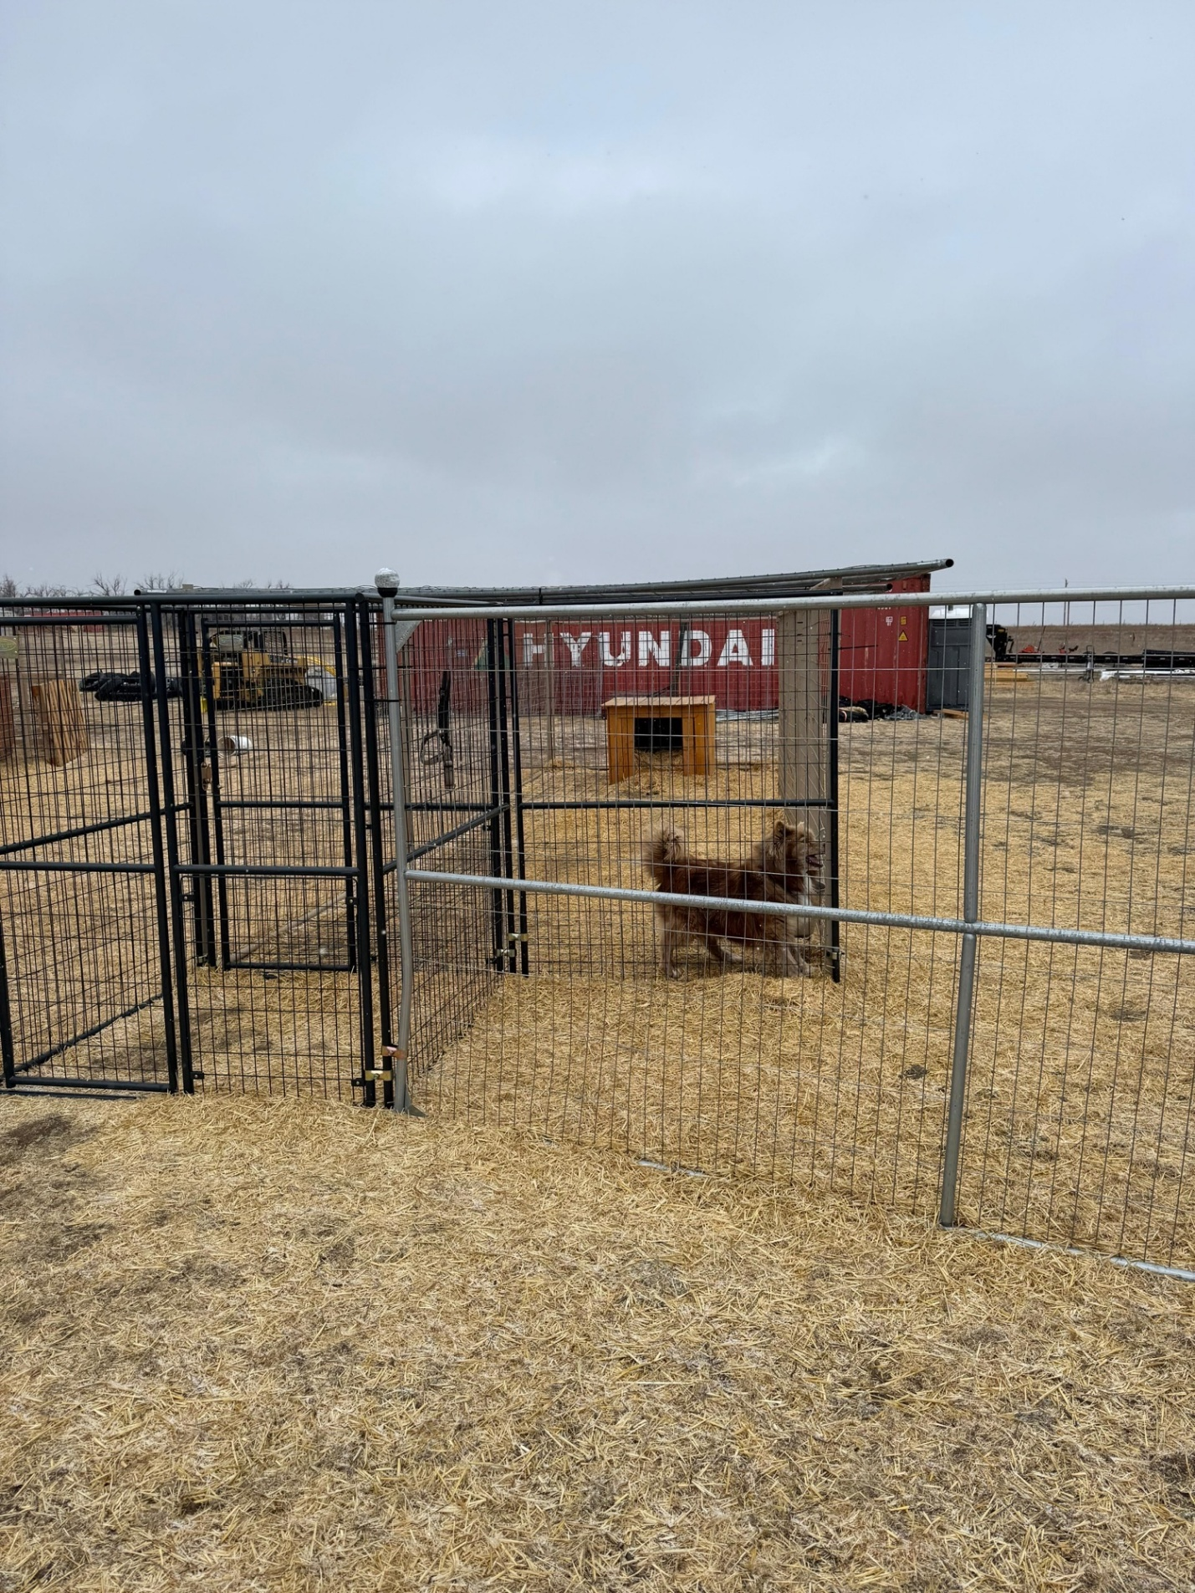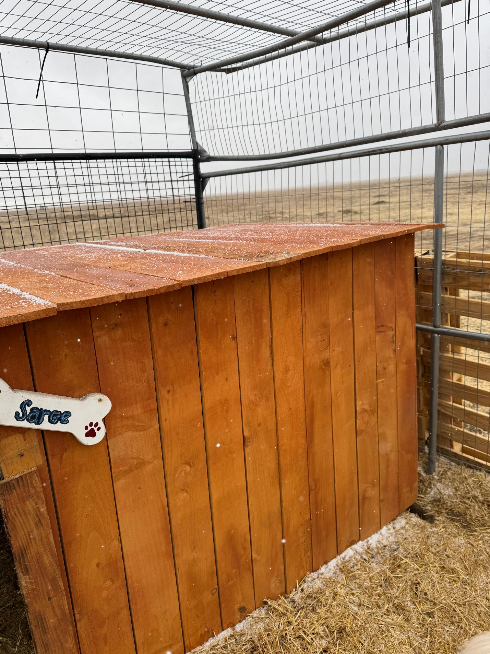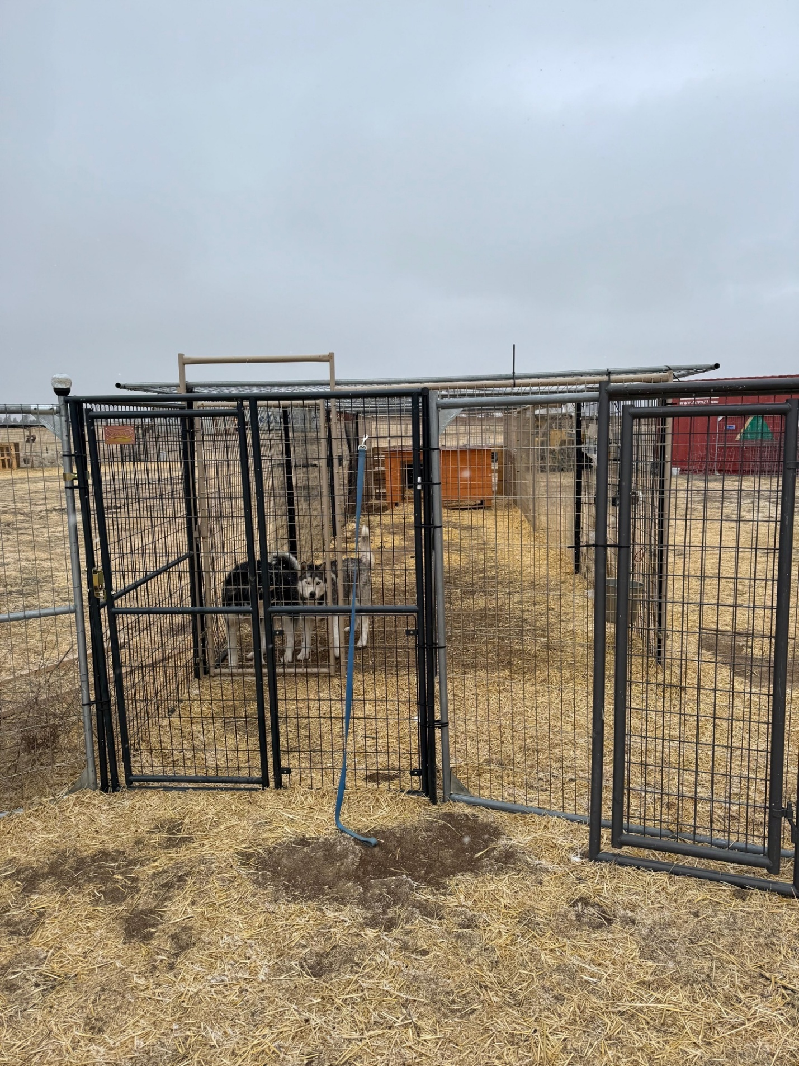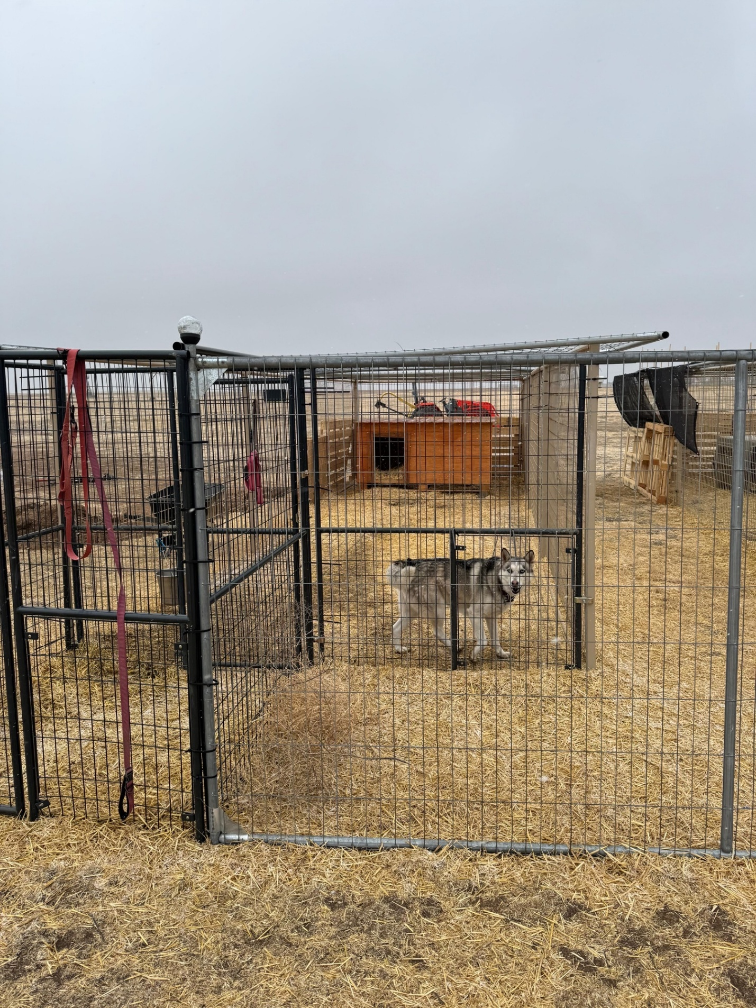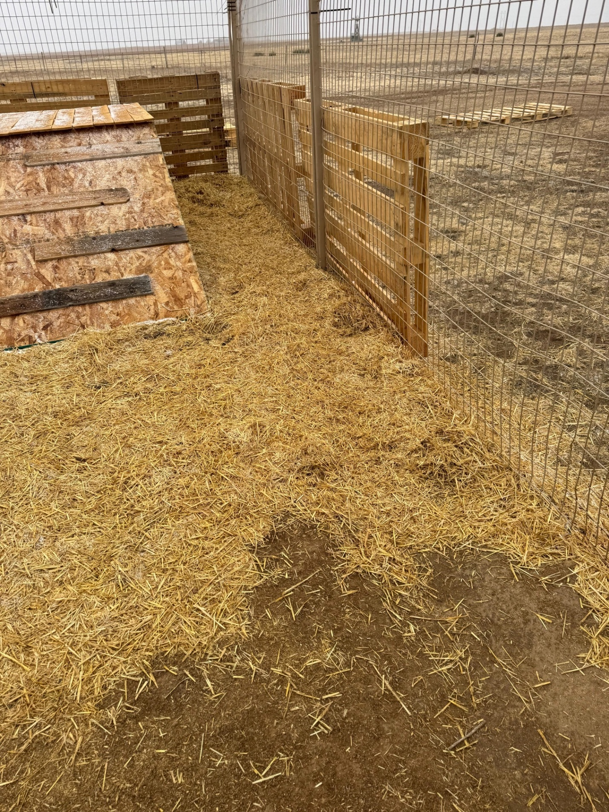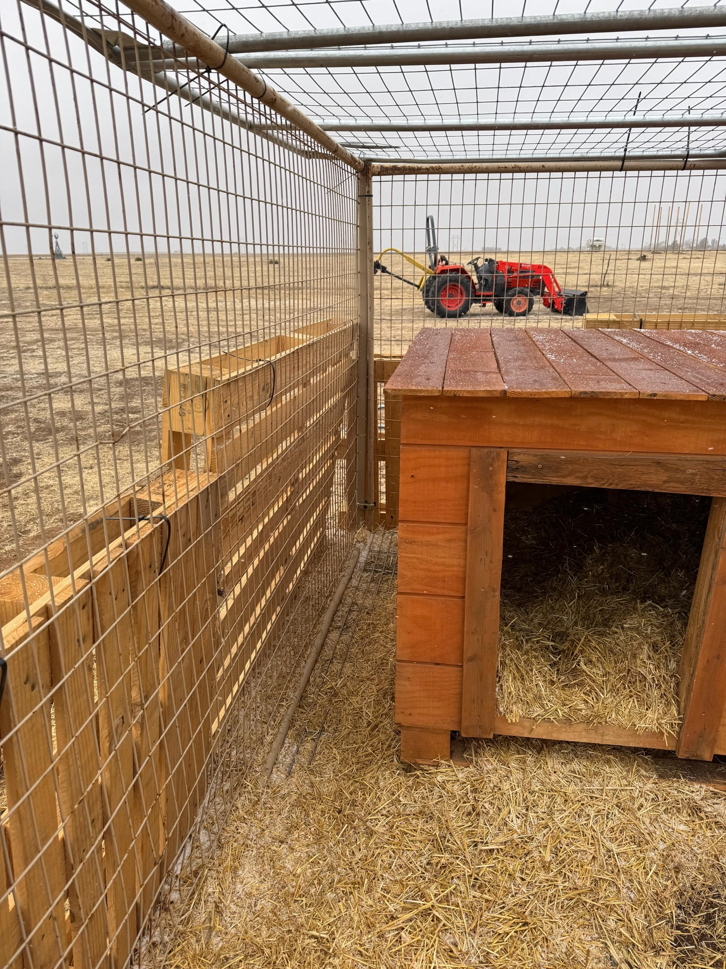
OUR FUTURE FENCING GOALS AT 12ft HEIGHT (requiring permit I believe?) WITH HOTWIRE ON THE TOP TO SECURE THE OUTDOOR ENCLOSURES DESIGNED PER PACFA REGULATIONS

- The fencing we will ultimately build will be 12 Ft tall with hot wire at the top. It is built with 12 ft wooden poles and welded wire. It does not obstruct vision through or around. I have included some links to review below from another high-quality rescue in Ohio with fencing examples that we will emulate its’ construction style.
- The first video is an aerial view of the enclosures they have with the fencing style not configuration that we will use. Ours will be this fencing style as stated but to reiterate, our configuration will be very different.
- Also, please note, these enclosures are created to resemble natural outdoor environments and non-traditional kennel runs as it is not a traditional kennel. Ours will be the same in this regard. These enclosures on my property will average $6000 AND UP per enclosure for fencing and the natural habitat we will build all built on the land itself. Not concrete.
- We will most closely resemble (The Wild Animal Sanctuary in Keenseburg) but our enclosures will be much smaller. We will be taking various aspects of their enclosure design for our canines. As you can see, the enclosures are all built on wild grassland.. same as ours is and will ultimately be built. Not Indoor environments like traditional kennels. https://www.wildanimalsanctuary.org/, as you can see.. open grassland large space natural habitats in the enclosures. https://www.wildanimalsanctuary.org/visit-us - this goes way beyond what we will be doing ,but it describes the type of environment the animals live in- https://www.wildanimalsanctuary.org/facilities- they are BIG time with all kinds of animals an massive funding. We are (tiny time) compared to them, with Just me funding the care of our animals at this time. But our goal is to move in this direction as far as the habitats go over time.

PLEASE SEE LINKS DEMONSTRATING THE FUTURE ENCLOSURES BELOW
- https://www.instagram.com/reel/CvQNQO4AwmG/?igsh=ZG90eG94bXNuZ29j
- https://www.instagram.com/p/DRwrUXFDaIw/?igsh=dXBrNmdqcWZ2OGNx
- https://www.instagram.com/p/DLIVTGJJRLa/?igsh=MXVnMzE1bDRlZ2tmZA==
- https://www.instagram.com/p/DHuG756SbMy/?igsh=MW4zczkyYnZodmtmaw==
- https://www.instagram.com/reel/DGkz_dvsJH0/?igsh=dXBpenM5ZmcxbzRr
- https://www.instagram.com/reel/C64YznLiLg1/?igsh=MXhoYzRwbXpqZ2w1

