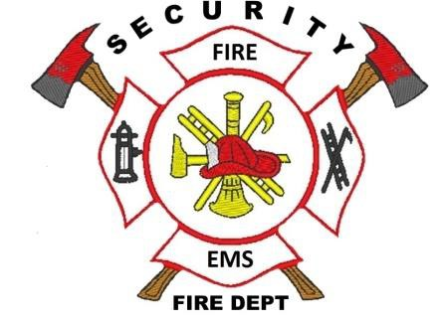

Security Fire Protection District
Fire Chief ~ David Girardin

Date: 02/09/2021

To: Lorson LLC
Attn: Jeff Mark

This letter is being written to serve as a letter of commitment for emergency services coverage for: the proposed Hillside at Lorson Ranch

The service provided will include structure and wildland fire coverage, response to medical situations, plan reviews, and fire inspections.

If you have any questions please feel free to contact me.

Thank you,
David Girardin
Fire Chief
Security Fire Protection District

CC:

Alex Martin
Fire Inspections
Security Fire Protection District

400 Security Boulevard ~ Security, Colorado 80911 ~ (719) 392-3271 ~ securityfiredept.org

