STORMWATER FACILITY
MAINTENANCE AGREEMENT AND EASEMENT

This STORMWATER FACILITY MAINTENANCE AGREEMENT AND EASEMENT (Agreement) is made by and between El Paso County by and through THE BOARD OF COUNTY COMMISSIONERS OF EL PASO COUNTY, COLORADO (Board or County) and PT Eagleview LLC (Developer) and EAGLEVIEW METROPOLITAN DISTRICT (Metro District), a quasi-municipal corporation and political subdivision of the State of Colorado. The above may occasionally be referred to herein singularly as “Party” and collectively as “Parties.”

Recitals
A. WHEREAS, the Metro District was organized to provide certain public services and facilities serving the residents and taxpayers within the development known as Eagleview in El Paso County, Colorado; and

B. WHEREAS, the Metro District is authorized pursuant to its Service Plan to provide various public improvements and services, including the design, financing, installation, construction, acquisition, operation, and maintenance of flood and surface drainage improvements, including but not limited to detention ponds, both within and without its boundaries; and

C. WHEREAS, the Metro District will own, operate and maintain those public improvements not dedicated to another governmental entity; and

D. WHEREAS, Developer is the owner of certain real estate (the Property) in El Paso County, Colorado, which Property is legally described in Exhibit A attached hereto and incorporated herein by this reference, and which lies within the Metro District; and

E. WHEREAS, Developer desires to plat and develop on the Property a subdivision to be known as Eagleview (Subdivision); and

F. WHEREAS, the development of this Property will increase the volume of water runoff, and, therefore, it is in the best interest of public health, safety and welfare for the County to condition approval of this Subdivision on Developer’s promise to construct adequate stormwater control facilities for the Subdivision; and

G. WHEREAS, the El Paso County Land Development Code, as periodically amended, requires the construction and maintenance of drainage facilities adequate to maintain historic stormwater flow patterns, protect natural and man-made drainage conveyances, and prevent property damage in connection with land development and subdivisions, and further requires that developers enter into maintenance agreements and easements with the County for such drainage facilities; and

H. WHEREAS, Section 2.9 of the El Paso County Drainage Criteria Manual, Volume 1 provides for a developer’s promise to maintain a subdivision’s drainage facilities in the event the County does not assume such responsibility; and

I. WHEREAS, Developer desires to construct for the Subdivision drainage conveyance facilities (“Stormwater Facilities”) as the means for providing adequate drainage and stormwater runoff control and to provide for the operation, cleaning, maintenance and repair of such Stormwater Facilities; and

J. WHEREAS, Developer desires to construct the Stormwater Facilities on portions of the Property located within the Metro District as set forth on Exhibit B attached hereto and incorporated herein by this reference, within the areas legally described in Exhibit C, attached hereto and incorporated herein by this reference (the “Stormwater Facilities Area”); and

K. WHEREAS, Developer shall be charged with the duties of constructing the Stormwater Facilities and providing the necessary easements and access to the Stormwater Facilities in the Stormwater Facilities Area, the County intends in the future to accept the duties of operating, maintaining and repairing the Stormwater Facilities on the Stormwater Facilities Area, except for the coir matting within reach RWT080, and, following acceptance by the Metro District, the Metro District shall be responsible for maintenance of the wetlands, grasses, vegetation and reinforcing fabrics (consisting of coir matting within reach RWT080) within the Stormwater Facilities Area; and

L. WHEREAS, the County, in order to protect the public health, safety and welfare, desires the means to access, construct, maintain, and repair the Stormwater Facilities and the Stormwater Facilities Area, as well as to recover its costs incurred in connection therewith, in the event the Developer or Metro District fails to meet their obligations to do the same; and

M. WHEREAS, the County conditions approval of this Subdivision on the Developer’s promise to so construct the Stormwater Facilities, and further conditions approval on the Metro District’s promise to clean, maintain and repair wetlands, grasses, vegetation and reinforcing fabrics (consisting of coir matting within reach RWT080) in the Stormwater Facilities Area following acceptance by the Metro District, and on the Developer’s and/or Metro District’s promises to reimburse the County in the event the burden falls upon the County to construct the Stormwater Facilities or to clean, maintain and/or repair wetlands, grasses, vegetation and reinforcing fabrics (consisting of coir matting within reach RWT080) in the Stormwater Facilities Area serving this Subdivision; and

N. WHEREAS, the County, in order to secure performance of the promises contained herein, conditions approval of this Subdivision upon the Developer’s grant herein of a perpetual drainage and access easement over the Stormwater Facilities Area as depicted in Exhibit B and legally described in Exhibit C to the County and the Metro District for the purpose of allowing the County access to construct, inspect, upgrade, clean, maintain, repair the Stormwater Facilities and, following acceptance by the Metro District, allowing the Metro District to access and inspect the Stormwater Facilities Area and, when so necessary, to clean, maintain and/or repair the wetlands, grasses, vegetation and reinforcing fabrics (consisting of coir matting within reach RWT080) in the Stormwater Facilities Area; and

O. WHEREAS, it is the Parties’ wish to memorialize their mutual understanding regarding ongoing maintenance of the Stormwater Facilities and Stormwater Facilities Area; and

P. WHEREAS, pursuant to Colorado Constitution, Article XIV, Section 18(2) and Section 29-1-203, Colorado Revised Statutes, governmental entities may cooperate and contract with each other to provide any function, services, or facilities lawfully authorized to each.

Agreement

NOW, THEREFORE, in consideration of the mutual promises contained herein, the sufficiency of which are hereby acknowledged, the Parties agree as follows:

1. Incorporation of Recitals: The Parties incorporate the Recitals above into this Agreement.

2. Covenants Running with the Land: Developer and the Metro District agree that this entire Agreement and the performance thereof shall become a covenant running with the land, which land is legally described in Exhibit A attached hereto, and that this entire Agreement and the performance thereof shall be binding upon themselves, their respective successors and assigns.

3. Construction: Developer shall construct the following Stormwater Facilities on the Stormwater Facilities Area: concrete check structures within the Falcon Drainage Basin west tributary reach RWT094 north of S. Arroya Lane crossing, concrete check structures within reaches RWT092 and RWT054, and coir matting within reach RWT080. Developer shall not commence construction of the Stormwater Facilities until the County has approved in writing the plans and specifications for the Stormwater Facilities and this Agreement has been signed by all Parties and returned to the County. Developer shall complete construction of the Stormwater Facilities in substantial compliance with the County-approved plans and specifications for the Stormwater Facilities and shall provide certification from a Colorado-registered Professional Engineer that the Stormwater Facilities were constructed in compliance with and provide the capacity required by such plans and specifications, in accordance with ECM requirements. Failure to meet these requirements shall be a material breach of this Agreement and shall entitle the County to pursue any remedies available to it at law or in equity to enforce the same. Construction of the Stormwater Facilities shall be substantially completed within one (1) year (defined as 365 days), which one year period will commence to run on the date the approved plat of the Subdivision is recorded in the records of the El Paso County Clerk and Recorder.

In the event construction of the Stormwater Facilities is not substantially completed within the one (1) year period, or if the Subdivision is in violation of its Erosion and Stormwater Quality Control Permit (‘ESQCP”) terms and conditions and Developer has not made an effort to remedy the violation in a reasonable amount of time as determined by the County, then the County may exercise its discretion to complete the Stormwater Facilities and shall have the right to seek reimbursement from the Developer and its respective successors and assigns for its actual costs and expenses incurred in the process of completing construction.

4. Maintenance: Subject to Paragraph 15 below, the Developer and Metro District shall not allow any trees or shrubs that will impair the structural integrity of or the flow through the Stormwater Facilities to be planted or grow within or adjacent to the Stormwater Facilities.

Subject to Paragraph 15 below, the Developer and Metro District also agree, for themselves and their successors and assigns, that they will maintain and properly manage the wetlands, grasses, vegetation, and reinforcing fabrics (consisting of coir matting within reach RWT080) in the Stormwater Facilities Area in compliance with the “Routine Maintenance Activities” specified in Exhibit D and other requirements or conditions of approval. Upon the conveyance of the Stormwater Facilities to the County, and following acceptance by the Metro District, the Metro District agrees that its obligations with respect to the wetlands, grasses, vegetation, and reinforcing fabrics (consisting of coir matting within reach RWT080) shall continue, but the easements (and corresponding rights) granted to the Metro District herein with respect to the “Routine Maintenance Activities” specified in Exhibit C shall be subordinate to the rights of the County as provided herein. If the County maintains or repairs any wetlands or non-structural vegetated areas in the course of properly maintaining the structural Stormwater Facilities or to protect the structural facilities from erosion or other hazards, the provisions described in Section 6 of this Agreement shall apply. The County, at its sole cost and expense, shall restore the surface, to the extent reasonably practicable, the Stormwater Facilities Area and repair all damage to wetlands, grasses, vegetation, and reinforcing fabrics (consisting of coir matting within reach RWT080) in the Stormwater Facilities Area that are disturbed, disrupted or damaged by the County or its employees or third parties authorized by County in performing its duties or undertaking any activities pursuant to this Agreement.

5. Creation of Easement: Developer hereby grants the County and the Metro District a non-exclusive perpetual drainage easement and access easement, together with all rights as are incidental to the full use and enjoyment of the easement rights, upon, over, above, through and across the Stormwater Facilities Area described in Exhibit C (“Easement”). The purpose of the Easement is to allow the County to access, inspect, clean, repair, replace, remove, enlarge, use, operate and maintain the Stormwater Facilities and the District to access, inspect, clean, maintain and manage the wetlands, grasses, vegetation and reinforcing fabrics (consisting of coir matting within reach RWT080) in the Stormwater Facilities Area; however, the creation of the Easement does not expressly or implicitly impose on the County a duty to so inspect, clean, repair or maintain the Stormwater Facilities or any appurtenant improvements until the time of County acceptance of the Stormwater Facilities and the Metro District likewise does not have the obligation to inspect, clean, repair, maintain and manage the wetlands, grasses, vegetation, and reinforcing fabrics (consisting of coir matting within reach RWT080) of the Stormwater Facilities Area until the time of Metro District acceptance thereof.

6. County’s Rights and Obligations: Any time the County determines, in the sole exercise of its discretion, that the Stormwater Facilities have not been properly cleaned, maintained and/or otherwise kept in good repair by the Developer, or the wetlands, grasses, vegetation and reinforcing fabrics (consisting of coir matting within reach RWT080) have not been properly maintained by the Metro District following acceptance by the Metro District, the County shall give reasonable notice of such to the Developer and/or the Metro District, and their respective successors and assigns. The notice shall provide a reasonable time to correct the problems. Should the responsible Parties fail to correct the specified problems, the County may enter upon the Stormwater Facilities Area described in Exhibit C to perform the needed work and shall have the right to seek reimbursement from the responsible Parties for its actual costs and expenses in performing the work. Notice shall be effective to the above by the County’s deposit of the same into the regular United States mail, postage pre-paid. Notwithstanding the foregoing, this Agreement does not expressly or implicitly impose on the County a duty to so inspect, clean, repair or maintain the Stormwater Facilities prior to its acceptance of the Stormwater Facilities.

7. Reimbursement of County’s Costs / Covenant Running With the Land: Subject to Paragraph 15 below, the Developer and the Metro District, subject to Metro District budgeting and annual appropriations, agree and covenant, for themselves and their respective successors and assigns, that they will reimburse the County for their respective share of the County’s actual costs and expenses incurred in the process of the County’s performance of the Developer and the Metro District’s respective obligations under this Agreement pursuant to the provisions of this Agreement.

The term “actual costs and expenses” shall be liberally construed in favor of the County, and shall include, but shall not be limited to, labor costs, tools and equipment costs, supply costs, and engineering and design costs, regardless of whether the County uses its own personnel, tools, equipment and supplies, etc. to correct the matter. In the event the County initiates any litigation or engages the services of legal counsel in order to enforce the provisions arising herein, the County shall be entitled to its damages and costs, including reasonable attorney’s fees, regardless of whether the County contracts with outside legal counsel or utilizes in-house legal counsel for the same.

8. Contingencies of Land Use/Land Disturbance Approval: Developer’s and the Metro District’s execution of this Agreement is a condition of subdivision, land use, or land disturbance approval. The County’s rejection of any documentation submitted hereunder shall mean that the appropriate condition of this Agreement has not been fulfilled. Additional conditions of this Agreement include:

a. Notation that a drainage and access easement has been conveyed pursuant to this Agreement on the final plat of the subdivision, from Developer to the Metro District and the County.

9. Agreement Monitored by El Paso County Planning and Community Development Department and/or El Paso County Department of Public Works: Any and all actions and decisions to be made hereunder by the County shall be made by the Executive Director of the El Paso County Planning and Community Development Department and/or the Executive Director of the El Paso County Department of Public Works. Accordingly, any and all documents, submissions, plan approvals, inspections, etc. shall be submitted to and shall be made by the Executive Director of the Planning and Community Development Department and/or the Executive Director of the El Paso County Department of Public Works.

10. Indemnification and Hold Harmless: To the extent authorized by law, Developer and the Metro District agree, for themselves, their respective successors and assigns, that they will indemnify, defend, and hold the County harmless from any and all loss, costs, damage, injury, liability, claim, lien, demand, action and causes of action whatsoever, whether at law or in equity, arising from or related to their respective intentional or negligent acts, errors or omissions or that of their agents, officers, servants, employees, invitees and licensees in the performance of their respective obligations under this Agreement. Nothing in this Paragraph shall be deemed to waive or otherwise limit the defense available to the County and the Metro District pursuant to the Colorado Governmental Immunity Act, Sections 24-10-101, et seq. C.R.S., or as otherwise provided by law.

11. Severability: In the event any Court of competent jurisdiction declares any part of this Agreement to be unenforceable, such declaration shall not affect the enforceability of the remaining parts of this Agreement.

12. Third Parties: This Agreement does not and shall not be deemed to confer upon or grant to any third party any right to claim damages or to bring any lawsuit, action or other proceeding against either the County, the Developer, the Metro District, or their respective successors and assigns, because of any breach hereof or because of any terms, covenants, agreements or conditions contained herein.

13. Solid Waste or Hazardous Materials: Should any refuse from the Stormwater Facilities Area be suspected or identified as solid waste or petroleum products, hazardous substances or hazardous materials (collectively referred to herein as “hazardous materials”), the Developer and the Metro District shall take all necessary and proper steps to characterize the solid waste or hazardous materials and properly dispose of it in accordance with applicable State and/or Federal environmental laws and regulations, including, but not limited to, the following: Solid Wastes Disposal Sites and Facilities Acts, §§ 30-20-100.5 – 30-20-119, C.R.S., Colorado Regulations Pertaining to Solid Waste Disposal Sites and Facilities, 6 C.C.R. 1007-2, et seq., Solid Waste Disposal Act, 42 U.S.C. §§ 6901-6992k, and Federal Solid Waste Regulations 40 CFR Ch. I. The County shall not be responsible or liable for identifying, characterizing, cleaning up, or disposing of such solid waste or hazardous materials. Notwithstanding the previous sentence, should any refuse cleaned up and disposed of by the County be determined to be solid waste or hazardous materials, the Developer and the Metro District, but not the County, shall be responsible and liable as the owner, generator, and/or transporter of said solid waste or hazardous materials.

14. Applicable Law and Venue: The laws, rules, and regulations of the State of Colorado and El Paso County shall be applicable in the enforcement, interpretation, and execution of this Agreement, except that Federal law may be applicable regarding solid waste or hazardous materials. Venue shall be in the El Paso County District Court.

15. Limitation on Developer’s and Metro District’s Obligation and Liability: The obligation and liability of the Developer hereunder shall only continue until such time as all of the following occur: (i) the Final Plat as described in Paragraph E of the Recitals set forth above is recorded; (ii) the Developer completes the construction of the Stormwater Facilities; (iii) the Stormwater Facilities except for the coir matting within reach RWT080 are conveyed to and accepted for maintenance and operation responsibilities by the County; and (iv) the wetlands, grasses, vegetation, and reinforcing fabrics (consisting of coir matting within reach RWT080) are conveyed to and accepted for maintenance by the Metro District. By execution of this agreement, the Metro District agrees to accept all responsibilities and to perform all duties assigned to it under this Agreement, upon completion of items (i), (ii), (iii) and (iv) herein.

16. Governmental Immunity. Nothing in this Agreement shall be construed to be a waiver, in whole or in part, of any right, privilege or protection afforded the County or its Board, the Metro District or its Board of Directors, or their respective officers, employees, servants, agents or authorized volunteers pursuant to the Colorado Governmental Immunity Act, Sections 24-10-101, et seq., C.R.S.

17. Annual Appropriations. The Metro District does not intend hereby to create a multiple-fiscal year direct or indirect debt or other financial obligation whatsoever.

18. Contract Modification. The Agreement may not be amended, altered or otherwise changed except by a written agreement signed by the Parties.

19. Counterpart Execution. This Agreement may be executed in counterparts, each of which shall be deemed an original, and all of which together shall constitute one and the same instrument

IN WITNESS WHEREOF, the Parties affix their signatures below.

Executed this _________ day of _________________, 20___, by:
PT Eagleview LLC
By: __________________________________________
Andrew J. Biggs, Manager

The foregoing instrument was acknowledged before me this _______ day of ______________, 20___, by Andrew J. Biggs, Manager, of PT Eagleview LLC.

Witness my hand and official seal.
My commission expires: _________________
__________________________________________
Notary Public

Executed this _________ day of _________________, 20___, by:
EAGLEVIEW METROPOLITAN DISTRICT

By: __________________________________________
Andrew J. Biggs, President

Attest:
By: __________________________________________
Joseph W. DesJardin, Secretary

The foregoing instrument was acknowledged before me this _______ day of ______________,
20___, by Andrew J. Biggs, President, of EAGLEVIEW METROPOLITAN DISTRICT.

Witness my hand and official seal.
My commission expires: _________________
__________________________________________
Notary Public
Executed this ________ day of _______________________, 20___, by:

BOARD OF COUNTY COMMISSIONERS
OF EL PASO COUNTY, COLORADO

By: __________________________________
Gilbert LaForce, Engineering Manager
Development Services, Department of Public Works
Designee of Joshua Palmer, County Engineer
Authorized signatory pursuant to Resolution No. 24-145

The foregoing instrument was acknowledged before me this _______ day of ______________, 20___, by __________________, Engineering Manager, El Paso County Department of Public Works.

Witness my hand and official seal.
My commission expires: __________________

_________________________________________
Notary Public

Approved as to Content and Form:

______________________________________
Assistant County Attorney

Exhibit A
Exhibit B
Exhibit C
Exhibit D

Exhibit A

LEGAL DESCRIPTION OF PROPERTY:

A PORTION OF THE NORTHWEST QUARTER OF SECTION 26, TOWNSHIP 12 SOUTH, RANGE 65 WEST OF THE 6th P.M., EL PASO COUNTY, COLORADO, MORE PARTICULARLY DESCRIBED AS FOLLOWS:

BEGINNING AT THE NORTHEAST CORNER OF SAID NORTHWEST QUARTER OF SECTION 26, AS ACCEPTED AND USED IN THE PLATS OF MFY FARM SUBDIVISION AND PAINT BRUSH HILLS FILING NO. 3, RECORDED IN PLAT BOOK T-3 AT PAGE 93 AND IN PLAT BOOK U-3 AT PAGE 79, RESPECTIVELY, OF THE RECORDS OF SAID EL PASO COUNTY; THENCE S00°02'11"E, ALONG THE EAST LINE OF SAID NORTHWEST QUARTER OF SECTION 26, A DISTANCE OF 2587.22 FEET TO THE CENTER QUARTER CORNER OF SAID SECTION 26; THENCE N89°28'49"W, A DISTANCE OF 978.75 FEET TO THE NORTHEAST CORNER OF LOT 30 OF STAPLETON ESTATES FILING NO. 1, AS RECORDED IN PLAT BOOK R-3 AT PAGE 76 OF THE RECORDS OF SAID EL PASO COUNTY; THENCE N89°31'16"W, ALONG THE BOUNDARY LINE OF SAID STAPLETON ESTATES FILING NO. 1, A DISTANCE OF 1063.31 FEET TO THE NORTHWEST CORNER OF LOT 8 OF SAID

STAPLETON ESTATES FILING NO. 1; THENCE N00°26'14"W ALONG THE EAST LINE OF SAID STAPLETON ESTATES FILING NO. 1, A DISTANCE OF 2561.60 FEET TO A POINT ON THE NORTH LINE OF SAID NORTHWEST QUARTER OF SECTION 26; THENCE N89°46'46"E, ALONG SAID NORTH LINE AND ALONG THE SOUTHERLY BOUNDARY LINE OF SAID MFY FARM SUBDIVISION, A DISTANCE OF 2059.89 FEET TO THE POINT OF BEGINNING.

SAID TRACT CONTAINS 121.20 ACRES OF LAND, MORE OR LESS.

PREPARED BY:
KEVIN F. LLOYD, COLORADO P.L.S. NO. 26965
FOR AND ON BEHALF OF RAMPART SURVEYS, INC.
P.O. BOX 5101
WOODLAND PARK, COLORADO 80866
719-687-0920

EXHIBIT B
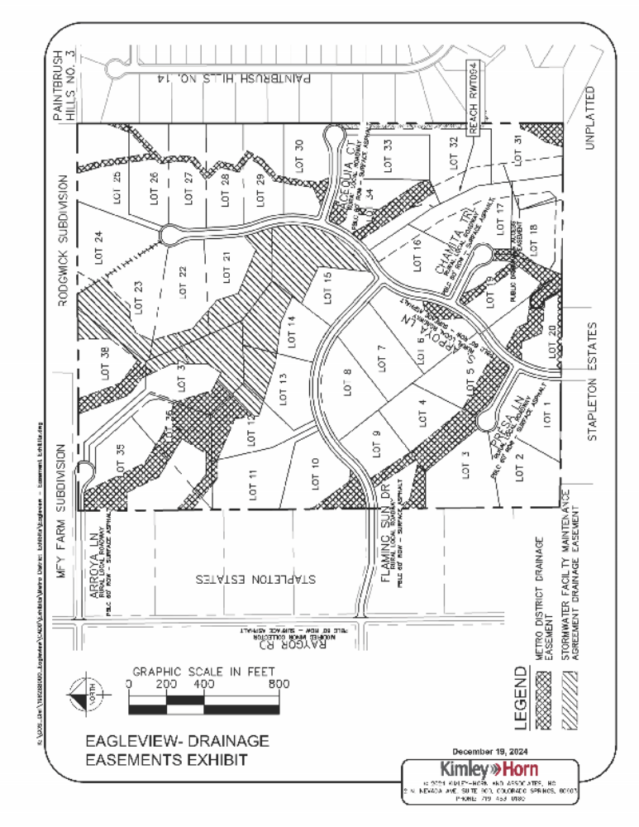

EXHIBIT C
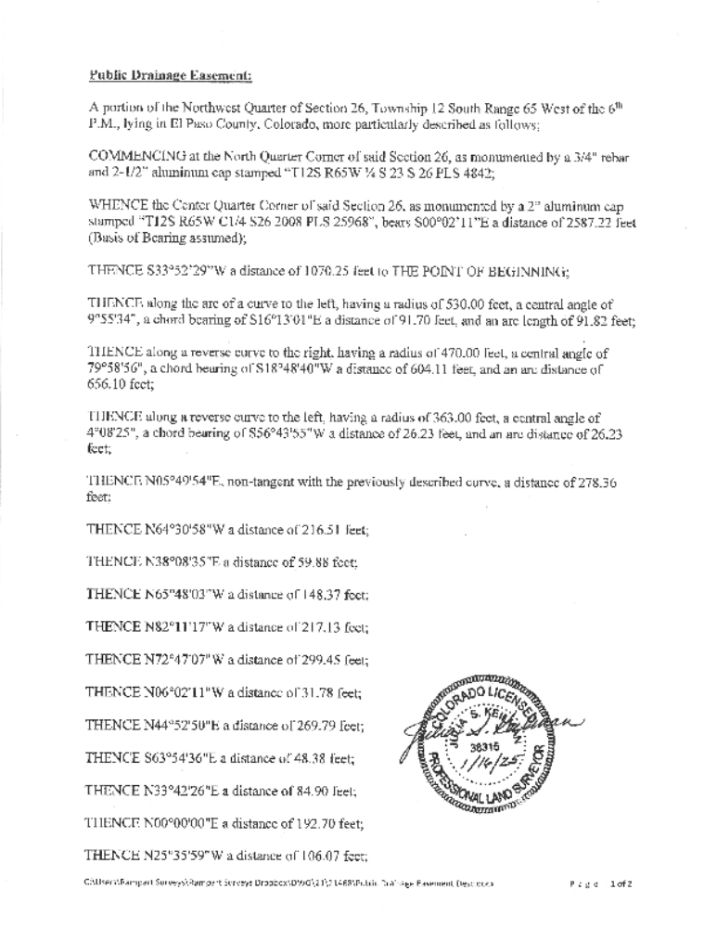

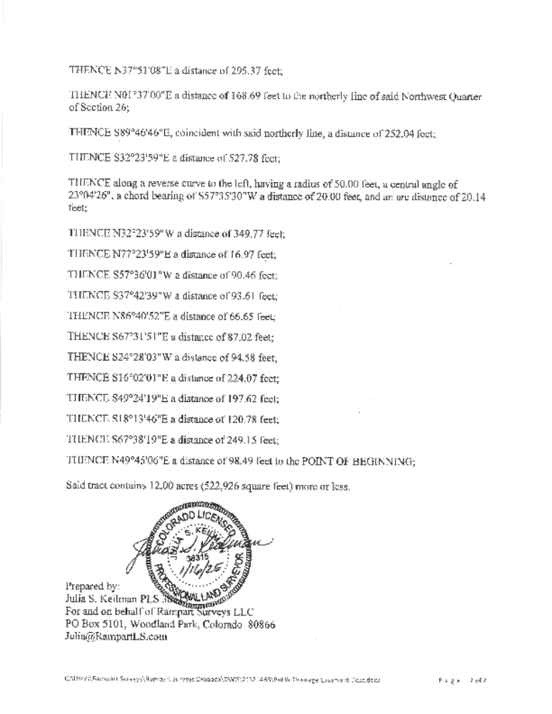

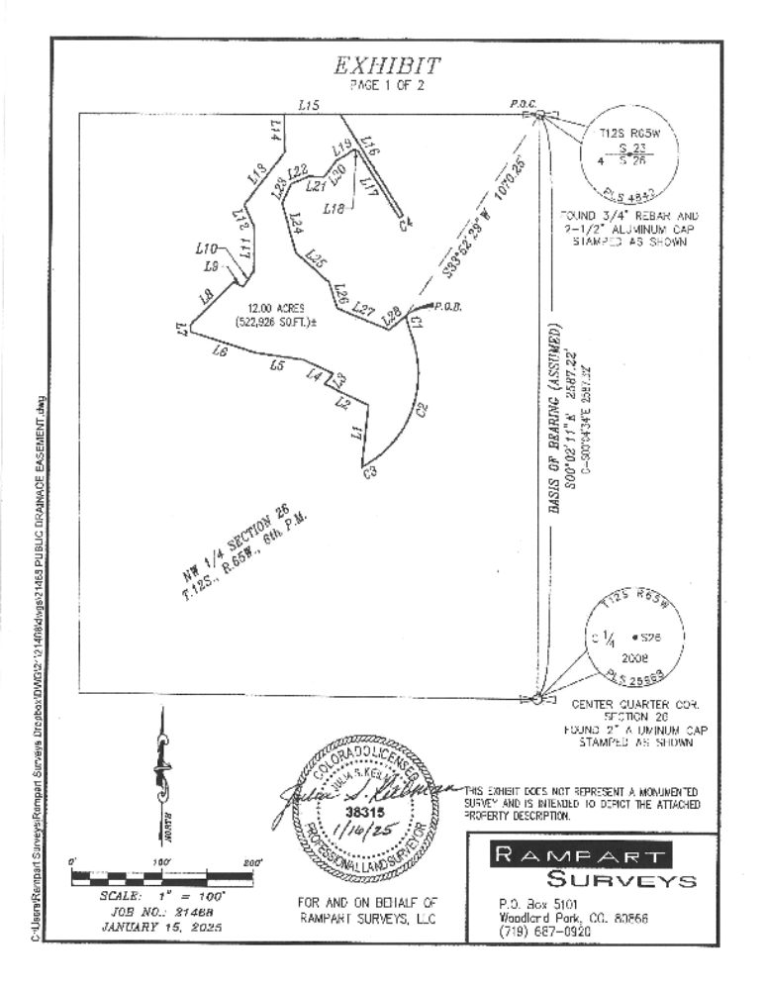

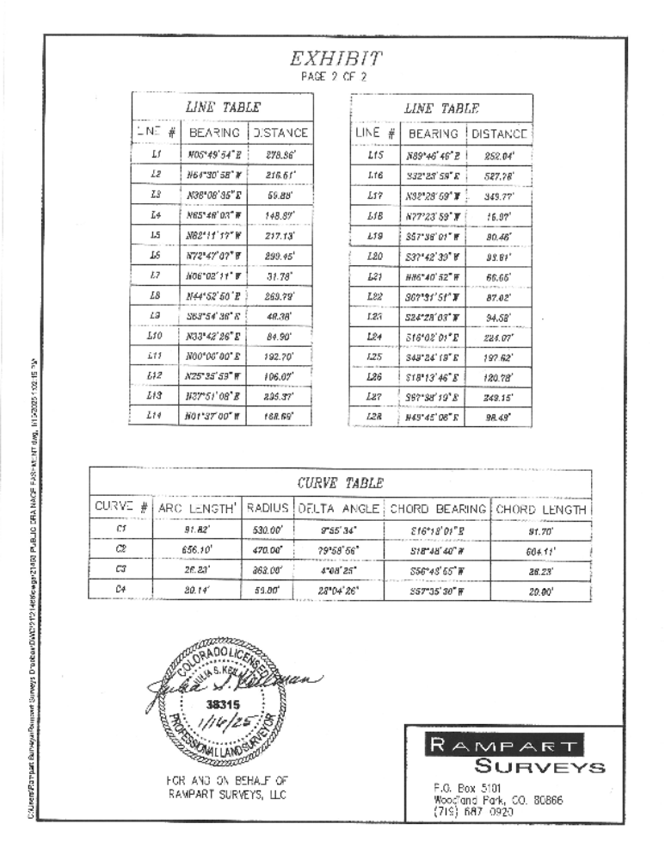

EXHIBIT D

