March 19, 2019
Planning and Community Development Department
Craig Dossey, Executive Director

Gary and Brenda Brinkman
4507 Silver Nell Drive
Colorado Springs, CO 80908

Jerome Hannigan and Associates, Inc.
19360 Spring Valley Road
Monument, CO 80132

RE: Settler’s View – Final Plat – (SF-18-041)

This is to inform you that the above-reference request for approval of final plat was heard and approved by the El Paso County Planning Commission on March 19, 2019, at which time a recommendation for approval was made to authorize development of 14 single-family lots and 2.59 acres of right-of-way. The 40.61 acres parcel is zoned RR-2.5 (Residential Rural) and is located north of Hodgen Road, south of Silver Nell Drive, East of the Walden Development and west of Steppler Road and within Section 23, Township 11 South, Range 66 West of the 6th P.M. The subject property area is within the boundaries of the Black Forest Preservation Plan (1987) area. (Parcel No. 61000-00-463)
This recommendation for approval is subject to the following:

CONDITIONS
- All Deed of Trust holders shall ratify the plat. The applicant shall provide a current title commitment at the time of submittal of the Mylar for recording.

- Colorado statute requires that at the time of the approval of platting, the applicants provide the certification of the County Treasurer’s Office that all ad valorem taxes applicable to such subdivided land, or years prior to that year in which approval is granted, have been paid. Therefore, this plat is approved by the Board of County Commissioners on the condition that the applicants or developer must provide to the Planning and Community Development Department, at the time of recording the plat, a certification from the County Treasurer’s Office that all prior years’ taxes have been paid in full.

- The applicants must pay, for each parcel of property, the fee for tax certification in effect at the time of recording the plat.

- The applicants shall submit the Mylar to Enumerations for addressing.

- The applicants shall comply with federal and state laws, regulations, ordinances, review and permit requirements, and other agency requirements, if any, of applicable agencies including, but not limited to, the Colorado Division of Wildlife, Colorado Department of Transportation, U.S. Army Corps of Engineers and the U.S. Fish and Wildlife Service regarding the Endangered Species Act, particularly as it relates to the Preble's Meadow Jumping Mouse as a listed species.

- Driveway permits will be required for each access to an El Paso County owned and maintained roadway. Driveway permits are obtained from the El Paso County Planning and Community Development Department.

- Collateral sufficient to ensure that the public and private improvements are constructed as listed in the approved financial assurance estimate shall be provided when the final plat is recorded.

- The Subdivider(s) agrees on behalf of him/herself and any developer or builder successors and assignees that Subdivider and/or said successors and assigns shall be required to pay traffic impact fees in accordance with the El Paso County Road Impact Fee Program Resolution (Resolution No. 18-471), or any amendments thereto, at or prior to the time of building permit submittals. The fee obligation, if not paid at final plat recording, shall be documented on all sales documents and on plat notes to ensure that a title search would find the fee obligation before sale of the property.
- Park fees in the amount of $6,020.00 in lieu of land dedication for regional parks (Area 2) fees shall be paid at the time of plat recordation.

- School fees in the amount of $4,312.00 in lieu of school land dedication shall be paid to El Paso County for the benefit of Lewis Palmer School District No. 38 at the time of plat recordation.

- The developer shall participate in a fair and equitable manner in the design and future paving of Steppler Road north of Silver Nell Drive and south of Walker Road. The fair share attributed to Settlers View subdivision shall be deposited as escrow in the amount of $32,970, corresponding to a roughly six point seven percent (6.7%) proportionate impact. An escrow agreement shall be completed and deposited prior to recording the final plat.
NOTATION
- Final plats not recorded within 12 months of Board of County Commissioner approval shall be deemed expired, unless an extension is approved.

The Planning Commission is advisory to the Board of County Commissioners.

Should you have any questions, or if I can be of further assistance, please contact me at 719-520-6300.

Sincerely,

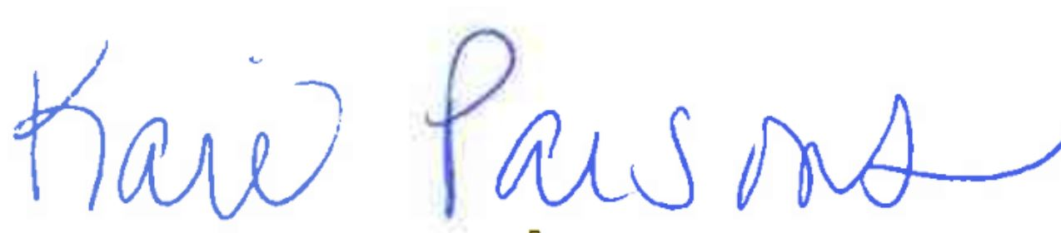

Kari Parsons, Planner II

File No. SF-18-041

