To: El Paso County Board of Directors
El Paso Planning Commission
Re: Mills Timber Subdivision Concerns Regarding Grandwood Rezone
Date: September 10, 2020

This letter is a follow-up to our Letter of Opposition submitted 6/27/19 which requested lot size transition adjustments where the 2.5 Grandwood Ranch lots meet existing adjacent lower density lots. The developer appears unwilling to compromise.
Situation Overview: Existing low density neighbor lots (diagram below) account for approximately 50% of the Grandwood Ranch north border. The 2.5 acre Grandwood Ranch rezone violates EPC Land Development Code, Section 5.3.5(B), third criteria, which states: “The proposed land use or zone district is compatible with the existing and permitted land uses and zone districts in all directions” The proposed Grandwood rezone is not compatible on the north border.
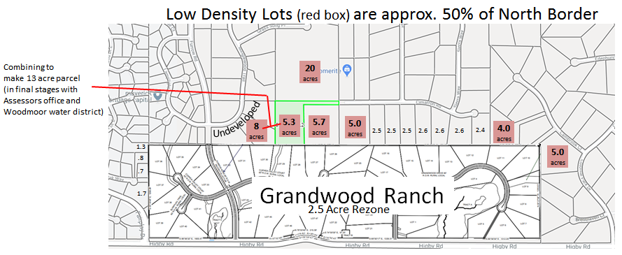
The Grandwood response to our original letter of opposition argues their current plat “provides a suitable transition from the smaller lots to the west to the existing land use zone districts to the north and east”. We will argue that the smaller lots to the west are a minor part of the perimeter and not indicative of the character of the majority of the land surrounding the proposed rezone.
Our family places great value on open space as a compliment to development. In fact, when we developed our property in 2002, we increased our zoning to RR-5 to match the RR-5 zoning below us to the south and to the neighbors’ 20 acre lot above us to the north. (See July 8, 2002 letter below) We have also held the three additional lots (8 total acres shown above) undeveloped for decades and are in the final stages of combining them to the 5.3 acre lot to make a 13 acre parcel. (See WWSD Public Hearing notice & Assessors office combine form below).
We understand that rezoning is an exception granted by the BOCC, when criteria are met. Good land use planning would at least site/create larger parcels near neighboring lower density lots. The 48-lot Grandwood Ranch development could easily be reduced by one lot to accomplish this valuable goal. Please support an increase in the lots adjacent to our RR-5 lots mentioned above. (Convert three 2.5 acre lots into two 3.75 acre lots).
At the BOCC meeting, I will show many EPC examples where lot sizes have been adjusted to provide a suitable transition to existing lower density perimeter lots in situations similar to this one.

Note: The zoning map on the EDARP website on the Grandwood Rezone project incorrectly shows our zoning as RR 2.5. This map was incorrect when the first plat was created and is still incorrect after the most recent 4/12/20 update. Perhaps lot transition adjustments would have been made to the plat if they had been looking at had the correct information.

I believe we raise valid concerns and appreciate your consideration

Regards,
Jon David Mills
Jon David Mills
Mills Timber Subdivision

