Early Assistance Meeting Number: EA25108
Project Name: Harding/Ortega/Proebstle
Project Location: 15488 Golden Acres Point / Latigo Blvd
Project Parcel Nos. 4200000455 4200000458
Project Description: We would like to subdivide two properties. Different family members own the three properties at 15728, 15488, and 15437 Golden Acres Point. Parents and two siblings (sisters). We have two other siblings that would like to build on two of the properties listed above. The Harding's would like to purchase 35 acres at 15437 Golden Acres and start to build immediately while the Proebstle's are newly married and would be gifted 5 acres of the property from 15488 Golden Acres to be able to build on as they are able to.
Meeting Date: 10/23/25

El Paso County Planning & Community Development Planning Checklist

Request – Map Provided by Applicant
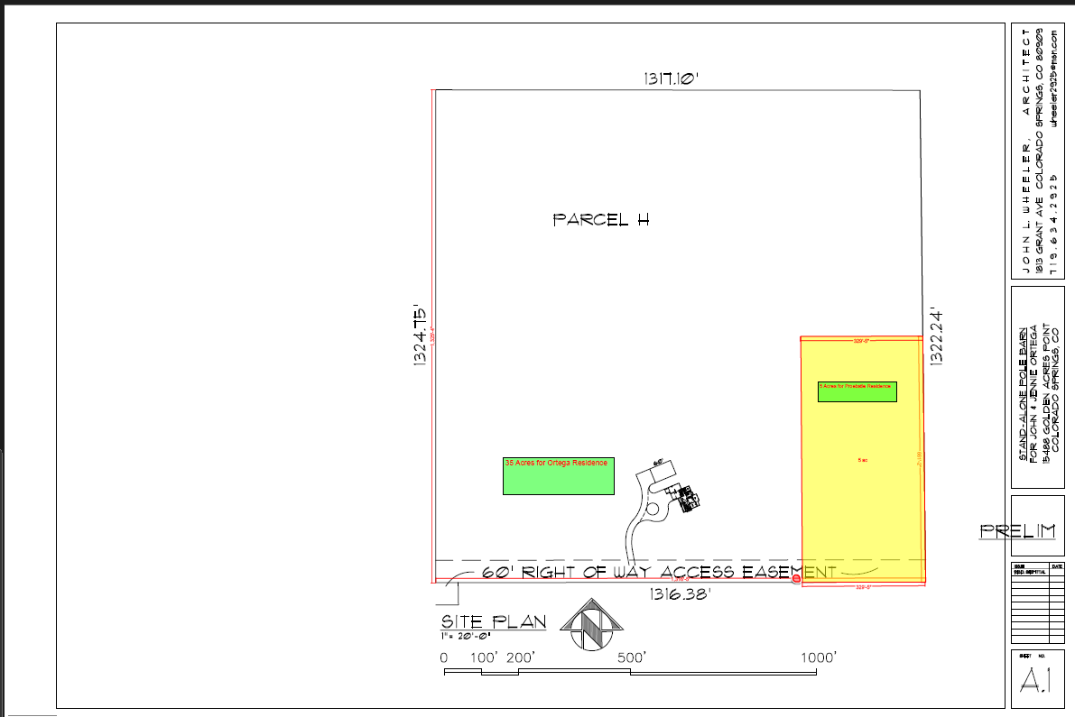
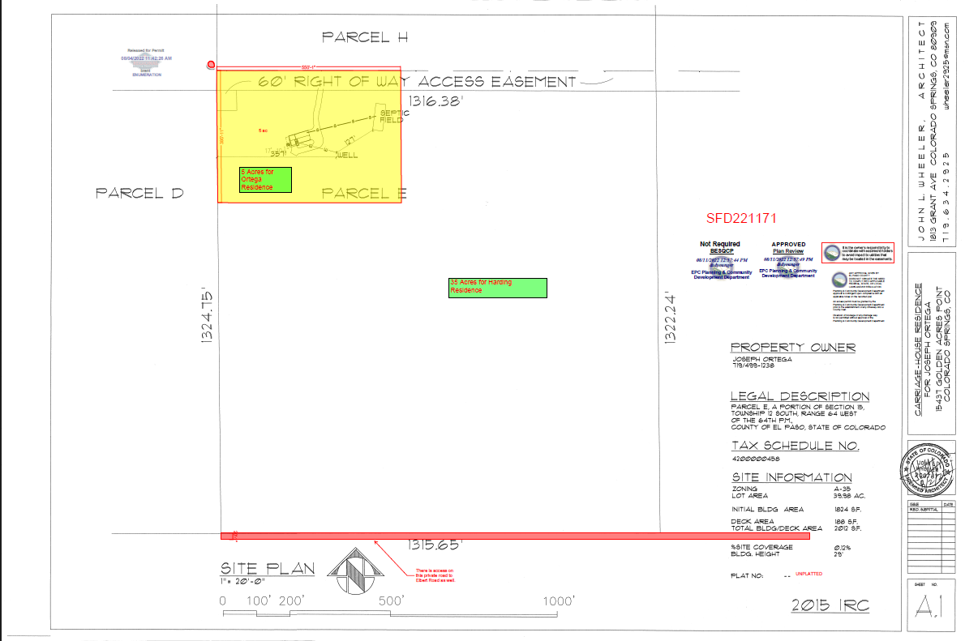

Zoning
Existing Zone(s)
Zone |  | Name
A-35 |  | Agricultural
Proposed Zone(s)
Zone |  | Name
RR-5 |  | Residential Rural

Zone Map (existing conditions of approval)
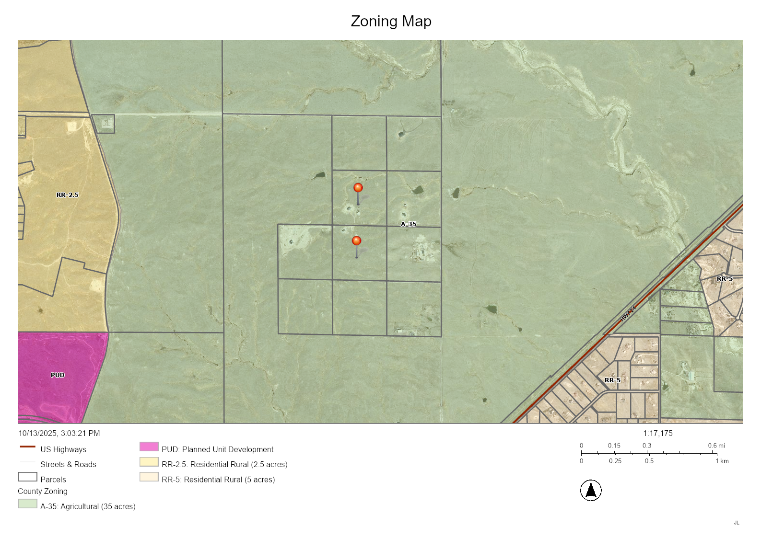

Zoning Analysis
The properties are currently within the A-35 zoning district and will require a rezone to a smaller zoning district, such as RR-5, to allow for the creation of 5-acre lots. Two applications are required for this proposal:

- Rezoning (Map Amendment)
- Final Plat

There are alternatives to consider. It is of note that the current A-35 zoning permits for an “Additional Dwelling Unit” by right (no zoning permits).

Dwelling, Additional — A dwelling unit, allowed in the A-35 District only, either within or added to an existing single-family detached dwelling or located as a separate accessory structure on the same lot or parcel as the principal single-family dwelling, for use as a complete, independent living facility with provisions within the dwelling unit for cooking, eating, sanitation, and sleeping. The additional dwelling shall be considered an accessory use to the principal dwelling.

In addition to the ADU, each property allows for one “Accessory Living Quarters” (ALQ). However, ALQs have development limitations including that they cannot be rented/leased, size, connection to the same utilities as the principal structure (home).

Accessory Living Quarters — Lodging, which may include a kitchen, that is accessory to the principal dwelling which may be occupied only by occasional, non-paying guests of the family residing in the principal dwelling. Accessory living quarters are not considered dwelling units. The term does not include farm/ranch residence, caretakers quarters, or an additional dwelling.

Zoning District Requirements (density, lot size, lot design standards, building setbacks)
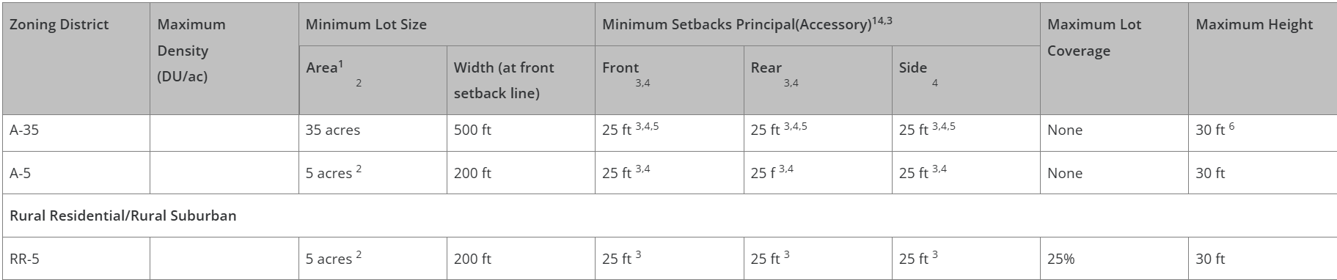

Application Type(s) Hearing: Required
Rezoning (Map Amendment) | PC + BoCC
Final Plat (minor subdivision) | PC + BoCC

Approval Criteria:
5.3.5. Map Amendment (Rezoning)

(B) Criteria for Approval. In approving a Map Amendment, the following findings shall be made:
- The application is in general conformance with the El Paso County Master Plan including applicable Small Area Plans or there has been a substantial change in the character of the neighborhood since the land was last zoned;
- The rezoning is in compliance with all applicable statutory provisions, including but not limited to C.R.S. § 30-28-111 § 30-28-113, and § 30-28-116;
- The proposed land use or zone district is compatible with the existing and permitted land uses and zone districts in all directions; and
- The site is suitable for the intended use, including the ability to meet the standards as described in Chapter 5 of the Land Development Code, for the intended zone district.

Final Plat approval criteria:
- The proposed subdivision is in general conformance with the goals, objectives, and policies of the Master Plan.
- The subdivision is consistent with the purposes of the Land Development Code (“Code”).
- The subdivision is in conformance with the subdivision design standards and regulations and meets all planning, engineering, and surveying requirements of the County for maps, data, surveys, analysis, studies, reports, plans, designs, documents, and other supporting materials.
- A sufficient water supply has been acquired in terms of quantity, quality, and dependability for the type of subdivision proposed, as determined in accordance with the standards set forth in the water supply standards [C.R.S. § 30-28-133(6)(a)] and the requirements of Chapter 8 of the Code.
- A public sewage disposal system has been established and, if other methods of sewage disposal are proposed, the system complies with state and local laws and regulations, [C.R.S. § 30-28-133(6) (b)] and the requirements of Chapter 8 of the Code.
- All areas of the proposed subdivision, which may involve soil or topographical conditions presenting hazards or requiring special precautions, have been identified and the proposed subdivision is compatible with such conditions. [C.R.S. § 30-28-133(6)(c)].
- Adequate drainage improvements complying with State law [C.R.S. § 30-28-133(3)(c)(VIII)] and the requirements of the Code and the Engineering Criteria Manual (“ECM’”) are provided by the design.
- The location and design of the public improvements proposed in connection with the subdivision are adequate to serve the needs and mitigate the effects of the development.
- Legal and physical access is or will be provided to all parcels by public rights-of-way or recorded easement, acceptable to the County and in compliance with the Code and the ECM.
- The proposed subdivision has established an adequate level of compatibility by (1) incorporating natural physical features into the design and providing sufficient open spaces considering the type and intensity of the subdivision; (2) incorporating site planning techniques to foster the implementation of the County's plans, and encourage a land use pattern to support a balanced transportation system, including auto, bike and pedestrian traffic, public or mass transit if appropriate, and the cost effective delivery of other services consistent with adopted plans, policies and regulations of the County; (3) incorporating physical design features in the subdivision to provide a transition between the subdivision and adjacent land uses; (4) incorporating identified environmentally sensitive areas, including but not limited to, wetlands and wildlife corridors, into the design; and (5) incorporating public facilities or infrastructure, or provisions therefor, reasonably related to the proposed subdivision so the proposed subdivision will not negatively impact the levels of service of County services and facilities.
- Necessary services, including police and fire protection, recreation, utilities, open space and transportation system, are or will be available to serve the proposed subdivision.
- The subdivision provides evidence to show that the proposed methods for fire protection comply with Chapter 6 of the Code.
- The proposed subdivision meets other applicable sections of Chapters 6 and 8 of the Code.
- Off-site impacts were evaluated, and related off-site improvements are roughly proportional and will mitigate the impacts of the subdivision in accordance with applicable requirements of Chapter 8 of the Code.
- Adequate public facilities or infrastructure, or cash-in-lieu, for impacts reasonably related to the proposed subdivision have been constructed or are financially guaranteed through the SIA so the impacts of the subdivision will be adequately mitigated.
- The extraction of any known commercial mining deposit shall not be impeded by this subdivision [C.R.S. §§ 34-1-302(1), et seq.].
LDC Sections 7.2.1(D)(2)(e) & 7.2.1 (D)(3)(f)

Minor subdivision must meet the standards of both a preliminary plan and a final plat. The criteria in full can be found in Chapter 7 and 8 of the Land Development Code. Please note this list does not contain all regulations/requirements of the LDC, such as fire code regulations in Chapter 6.

Processing Issues and Options
There is no direct access/frontage to public roads. LDC subdivision waivers are required.

Relevant Past History:
No relevant history.

Design and Landscaping

Site Design/Layout (Lot pattern, circulation/road design, open space, preservation of natural features, compatibility internally and with adjacent land uses)
The submitted lot configuration requires BoCC LDC waiver approval for private roads and lack of frontage to a public road. Please include the waiver requests and address the approval criteria in the final plat letter of intent. The specific LDC citations are: 7.3.3, 8.4.3.B.2.e, and 8.4.4.E.

Landscaping
☐ | Expressway, Principal arterial area depth – 25’-Trees required 1 per 20’
☐ | Urban interchange/Intersection area depth – 25’- N/A
☐ | Minor arterial area depth 20’ – Trees required 1 per 25’
☐ | Non-arterial area depth 10’ – Trees required 1 per 30’
☐ | Parking lot landscaping required
☐ | Buffer between non-residential and residential districts separated by a non-arterial road or public alley

N.A

Site Characteristics\ Constraints\ Environmental Standards:
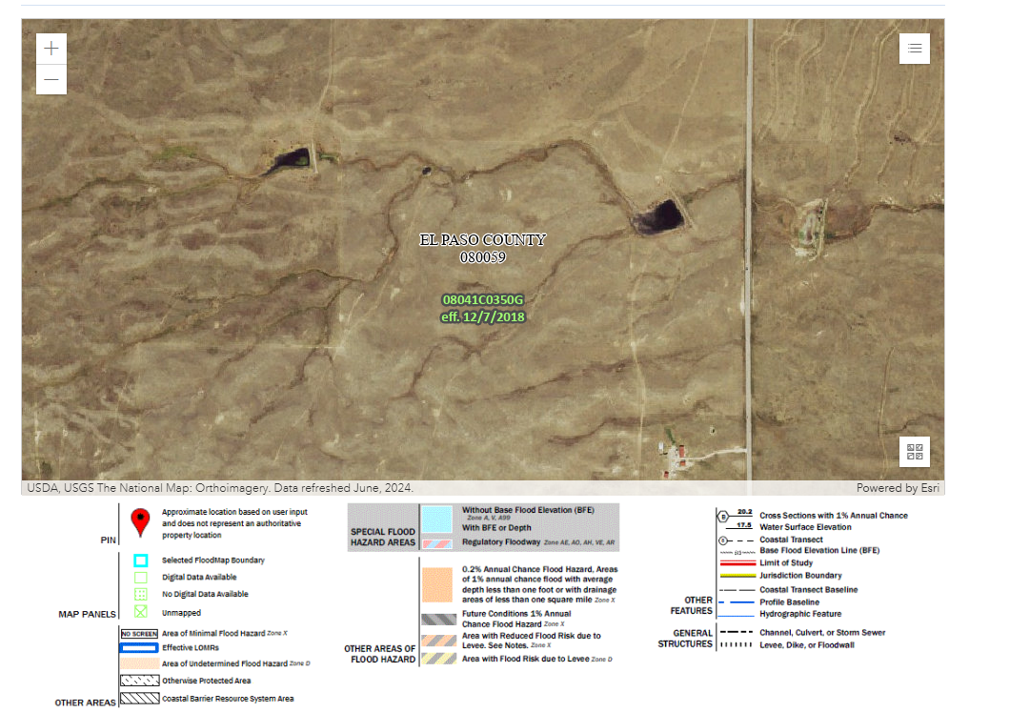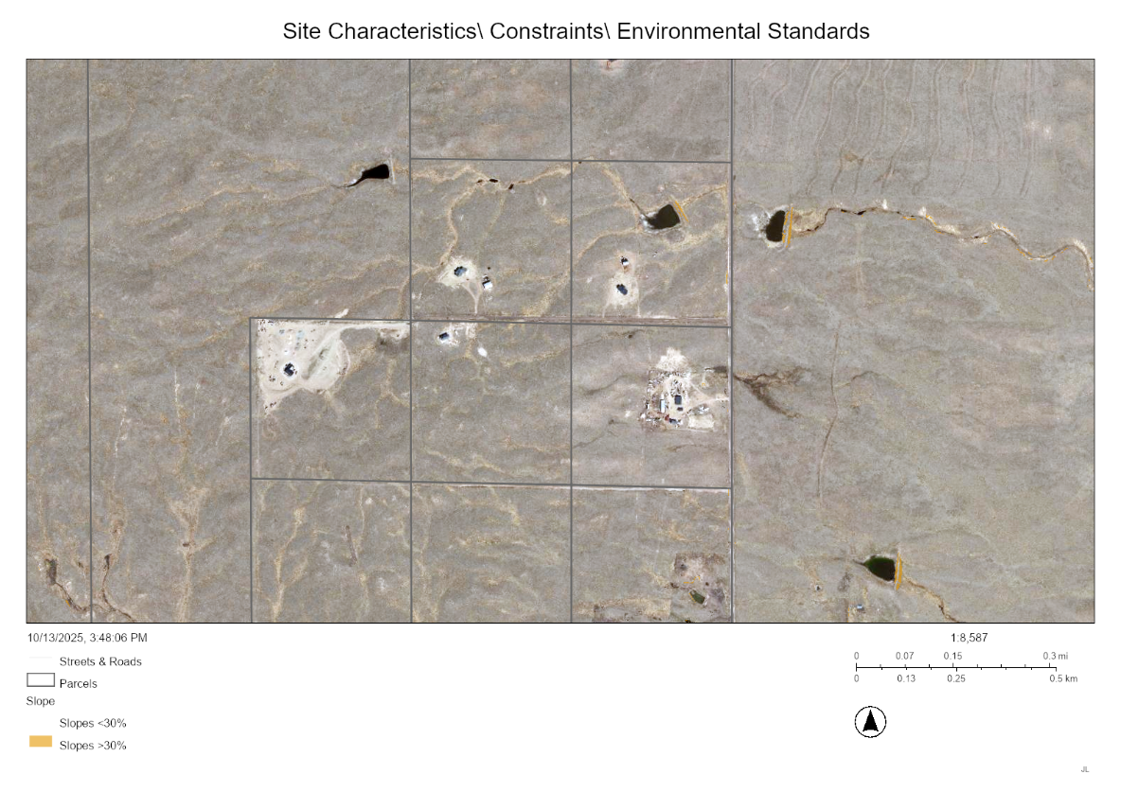

☐ | 30% or greater slope | Topography:
☒ | CGS review required (separate fee to CGS) | Soils/geology: |  | A Soils and Geology Report is required with the Final Plat.
☐ | Floodplain | Floodplain comment:
☐ | Noise mitigation required | Noise comment:
☐ | Preble’s mouse

Districts

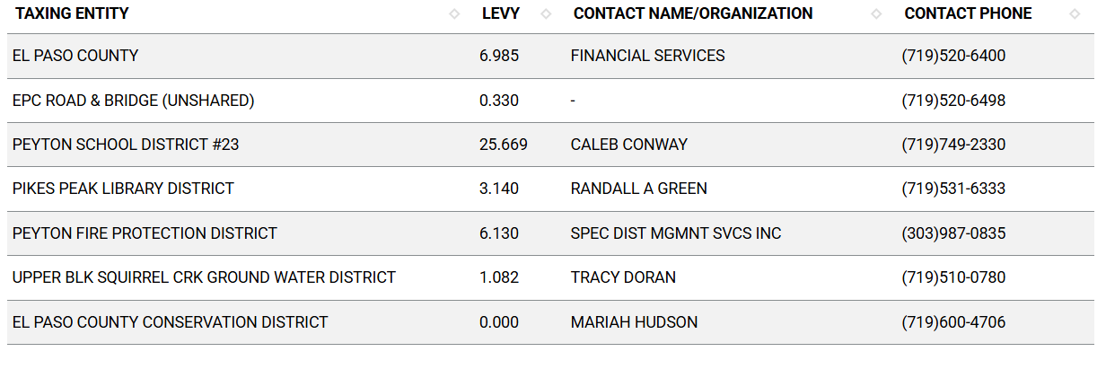
Proposed source of water |  |  | Proposed method of wastewater disposal
☐ | Central System |  | ☐ | Central System
District Name: |  |  | District Name:

Water/wastewater comments
The State of Colorado required a 100-year water sufficiency finding and El Paso County requires a 300-year water sufficiency finding for each new lot being created. HOA or covenants are required to demonstrate how the water rights are being conveyed. Lastly, the water must be shown to be of acceptable drinking quality and receive endorsement from the EPC Public Health Department.

8.4.7 (4)(a) General Provisions.
The Planning Commission shall, as part of its deliberations, make a recommendation regarding the sufficiency of the proposed water supply. The BoCC shall determine the sufficiency of the proposed water supply in terms of quantity, dependability, and quality based on the information presented and the recommendation of the Planning Commission.

In determining the sufficiency of a proposed water supply, the BoCC shall, at a minimum, consider the Water Resources Report, data and recommendations from the State Engineer's Office, CAO, EPCPH, and the County staff, the recommendations of the Planning Commission, and public comment. In all cases the burden of proof in demonstrating sufficiency rests with the applicant, and it shall be the applicant's sole responsibility to document in the Water Resources Report that the proposed water supply is sufficient in terms of quantity, dependability, and quality.

8.4.7 (B)(1) Water Resource Report.
(b) Water Resources Report Required. A water resources report as required by this Section shall be submitted with sketch plan, preliminary plan, final plat, and any subdivision applications which will create a new lot. A copy of the report will be kept on file in the El Paso County PCD.
(c) Prepared by Qualified Professional. The water resources report shall be prepared by a qualified hydrogeologist, hydrologist, licensed civil engineer, qualified groundwater geologist, or other qualified professional with appropriate experience.
(d) Document Adequate Water Supply. The Water Resources Report shall include adequate documentation that the proposed water supply is sufficient in terms of quantity, dependability, and quality for the proposed subdivision.

(c) Final Plat and Replat Report. The water resource report submitted with the final plat shall include all of the data needed to determine whether the proposed water supply is sufficient in terms of quality, quantity and dependability for the type of subdivision proposed. The report shall be based on engineering calculations and site-specific data and shall include a detailed discussion of the water demand, supply, quality, dependability, and supply facilities for the proposed subdivision.
A water resources report is not required if the BoCC made a finding that the proposed water supply plan of the preliminary plan was sufficient in terms of quantity, quality and dependability. However, an amended water resources report is required if there is a substantial change in either the water supply or the estimated water demand.

8.4.7(B)(5) Finding of Sufficient Dependability. The proposed water supply shall meet the following criteria to be found sufficient in terms of dependability:
- The supply is of sufficient quantity to meet the needs of the proposed subdivision for 300 years;
- The proposed water supply system and water supply is capable of meeting the average annual and peak daily demand of the proposed subdivision; and
The applicant has provided adequate evidence of ownership or the right of acquisition or use of existing or proposed water rights sufficient in quantity, dependability, and quality to serve the proposed uses within the subdivision; and (1) the legal capability to accomplish any changes in the uses or points of diversion of the rights with quantities and dependability necessary to serve the proposed subdivision without material injury to vested water rights; or (2) adequate evidence that the public or private water provider can and will supply the proposed subdivision with water of adequate quality, quantity and dependability.

8.4.8 Wastewater Disposal
(B) Minimum Standards.
(b) Compliance with EPCPH Regulations. All wastewater disposals systems shall comply with the EPCPH regulations and the CDPHE guidelines, as applicable.
i. An OWTS with design capacity less than or equal to 2,000 GPD must comply with regulations adopted by El Paso County Board of Health (EPCBoH) pursuant to this regulation and the OWTS Act. Within the jurisdiction of EPCBoH and EPCPH, the regulations promulgated by the EPCBoH govern all aspects of OWTS permits, performance, location, construction, alteration, installation, and use.
ii. An OWTS with design capacity greater than 2,000 GPD must comply with this regulation, site location and design approval in section 25-8-702, C.R.S., and the discharge permit requirements in the Water Quality Control Act, 25-8-501, et seq. C.R.S. OWTS with design capacity greater than 2,000 GPD must also comply with Appendix B of this Code.

(c) Favorable Recommendation from EPCPH Required. The EPCPH is considered the County's expert concerning the adequacy of a proposed sewage treatment system. No sketch or preliminary plan or final plat shall receive the approval of the BoCC unless EPCPH has made a favorable recommendation regarding the proposed method of sewage disposal.

(2) 2 OWTS Sites Required for All Lots or Parcels. All lots shall be designed to ensure that each lot has a minimum of 2 sites appropriate for OWTS which do not fall in the restricted areas identified on the preliminary plan; soils and geology report delineated wetland or floodplain maps; or other reports required under this Code.

Fire District:
Peyton Fire Protection District
303-987-0835

Wildland Fire and Hazard Mitigation Plan:
May be required – depending on hazard level.

Roland Peterson
Fire Safety and Wildfire Mitigation Program Manager
RolandPeterson@elpasoco.com

Emergency Services Issues:
Access and turnarounds etc.

Commissioner District: 2

Code Waivers:
Subdivision code waivers are approved by the BoCC and must meet the approval requirements in Chapter 7.

Parks and trails:

Annexations/Intergovernmental/ Jurisdictional Access issues:
N.A

Road Impact Fee Program (PID Inclusion):
The road impact fee is a development fee administered by EPC Public Works Department. The RIF acknowledgement form has been uploaded to this EA file in EDARP.

Your El Paso Master Plan

Placetype: Suburban Residential
Character:
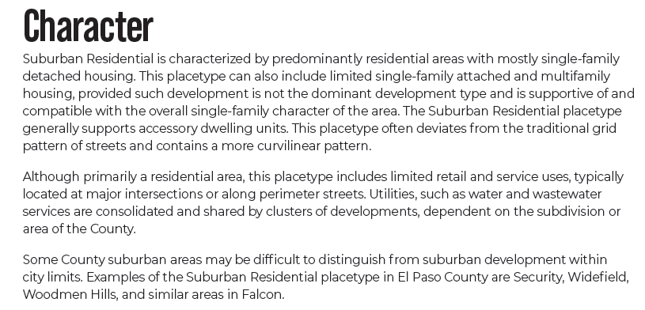

Recommended Land Uses:
- 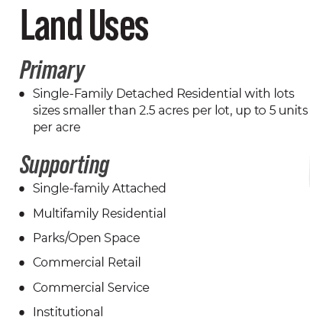

Goals, Objectives, Strategies:
Objective LU3-3: The Suburban Residential placetype should be characterized by predominantly residential areas with mostly single-family detached housing.

Area of Change Designation: New Development
Description:
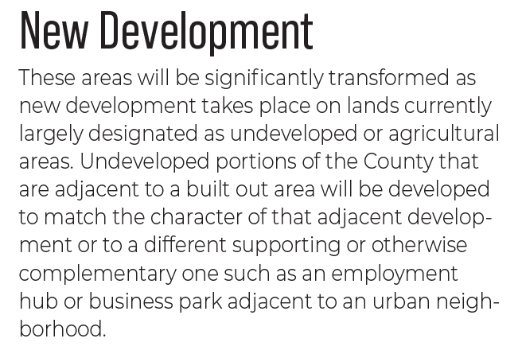

Goals, Objectives, Strategies:
Objective LU1-1: Some areas of the County should be planned for new development, while other areas should be preserved, protected, or see little new development.

Key Area: The properties are not located within a key area.

Water Master Plan Area:
Region 3

Recommendations:
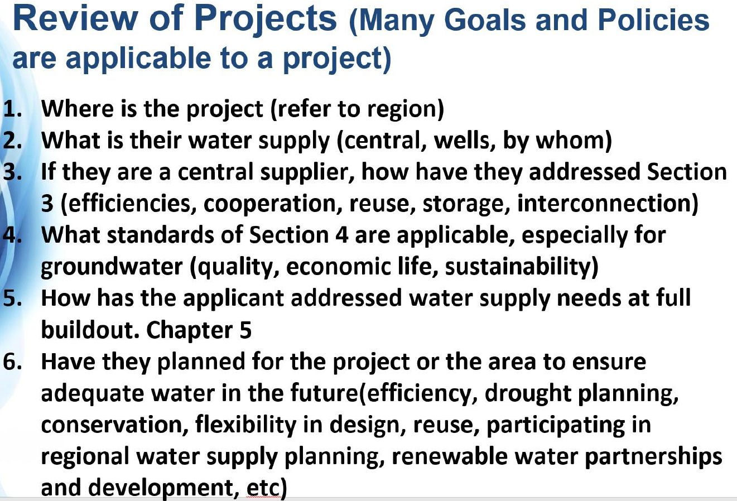

Wildlife impact
1 - Low

Parks Master Plan:

Helpful Links

Planning Website: https://planningdevelopment.elpasoco.com/

El Paso County Master Plan: https://planningdevelopment.elpasoco.com/#1510603950097-f5d985dc-35b2
Parks, Mineral and Water Master Plan: https://planningdevelopment.elpasoco.com/resources-and-references/#1516982531779-52cc0e87-01af

Forms and Templates: https://planningdevelopment.elpasoco.com/planning-development-forms/#1510677560407-ff8cfff5-69b2716b-00f9cbba-0c21

Land Development Code: https://library.municode.com/co/el_paso_county/codes/land_development_code

EDARP: https://epcdevplanreview.com/

Public GIS: https://elpasoco.maps.arcgis.com/apps/View/index.html?appid=5be6431018594c67b035ad0aad3e7e8a

Wrap Up
-If subdivision is proposed, recording fees, park and school fees and road impact fees may apply.

-Fees are subject to change. The fees at the time of application apply.

-Road Impact Fees
Please see the following website for information on the EPC Road Impact Fee Project. https://publicworks.elpasoco.com/road-impact-fees/ to include fee schedule.
As of December 15, 2016, per Resolution 16-454, on and after January 1, 2020, property in the unincorporated area of the county that receives a Land Use Approval either in a public hearing or administratively, is subject to the payment of Road Impact Fees. After December 31, 2024, in accordance with BoCC Resolution 24-377 the fee is paid for new residential and non-residential uses and structures and expansions of non-residential uses and structures. Road Impact fees are typically paid at time of building permit. If no building permit is being obtained for a particular Land Use application, then Road Impact Fees must be paid at the time of Site Development Plan or Special Use approval. If there are questions about EPC Road Impact program or fees, please contact DPW Development Review Services and the Engineer of the Day.

- Engineering Criteria Manual (ECM) Deviations.
The fee for any additional ECM deviation requests (more than two per land use application) - $1483.00 each per current Fee Schedule. Please note ECM deviation requests may result in additional processing and project review time. ECM Deviations should be submitted prior to the initial Site Development Plan or Final Plat submittal to preclude changes having to be made to engineering plans and documents if the deviation is not approved. Submission of an ECM deviation request does not imply or guarantee that the deviation will be approved. An ECM Deviation form must be submitted to include complete exhibits and justification excluding cost with supporting engineering criteria. If there are questions about ECM Deviation requests, please contact DPW Development Review Services and the Engineer of the Day.

-The fee for any additional waiver/deviation requests (more than two) - $550.00 each. Please note that requests for waivers and/or deviations may result in additional processing/review delay.

-All items requested must accompany the submittal for it to be complete, prior to payment request or the submittal will not be complete and ready for review agencies.

-A temporary use permit shall be applied for and approved for any staging area associated with development, such as a sales office, construction trailer, or contractor's equipment yard, prior to scheduling of the pre-construction meeting with El Paso County Planning and Community Development. If a Planned Unit Development is proposed, the temporary staging area should be shown on the development guideline and phasing plan.

-All prospective timelines for review are subject to departmental staffing and workload.

-Early Assistance is valid for 12 months from submittal of the EA application. If a project submittal is not received within 12 months, a new EA meeting may be required. An audio/video copy of the meeting is available in EDARP within the EA folder.

- Applications scheduled for public hearings may be heard as a regular item at the request of staff or a hearing body member.

- Any comments or commitments made by any member of the County Staff during this early assistance meeting are only preliminary in nature and should not be relied upon by the applicant. All prospective applicants should be informed that formal comments cannot be made by staff until after the application is submitted.

