Early Assistance Meeting Number: EA2657
Project Name: Phillips Property Subdivision
Project Location: 12835 Evans Rd Elbert, Co. 80106
Project Parcel No.: 4100000148
Project Description: 37.82 acres to be divided between 3 beneficiaries.
Meeting Date: May 14, 2026 at 1:30 PM

El Paso County Planning & Community Development Planning Checklist

Request – Map Provided by Applicant
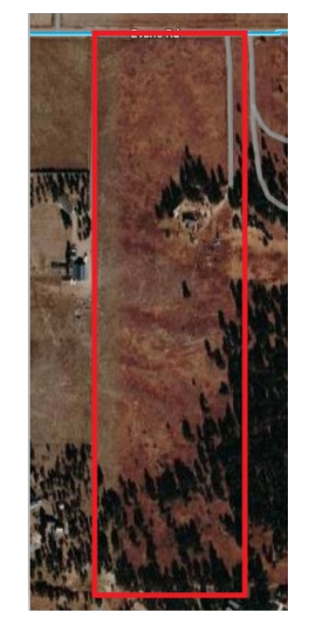

Zoning
Existing Zone(s)
Zone |  | Name
A-35 |  | Agricultural

Proposed Zone(s)
Zone |  | Name
RR-5 |  | Residential Rural
A-5 |  | Agricultural

Zone Map (existing conditions of approval)
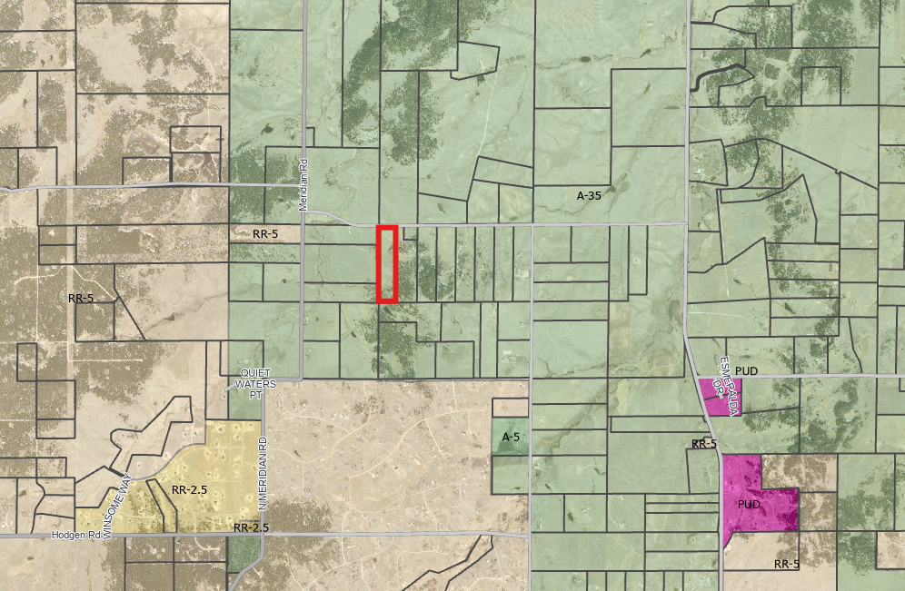

Zoning Analysis
Existing Zone District
The A-35 zoning district is a 35 acre district primarily intended to accommodate rural communities and lifestyles, including the conservation of farming, ranching and agricultural resources.

Proposed Zone District Options
The A-5 zoning district is a 5 acre district primarily intended to conserve agricultural resources and ranching operations and accommodate limited residential use.

The RR-5 zoning district is a 5 acre district intended to accommodate low-density, rural, single-family residential development.

Table 5-1. – Principal Uses lists land uses that are allowed, not allowed, or require special use review. Generally, RR-5 and A-5 are very similar. A-5 allows for a few more options that are more agricultural in nature.

Zoning District Requirements (density, lot size, lot design standards, building setbacks)
Zone District | Min. Lot Size | Min. Width | Min. Setbacks |  |  | Max. Lot Coverage | Max. Height
Zone District | Min. Lot Size | Min. Width | Front | Rear | Side | Max. Lot Coverage | Max. Height
A-35 | 35 acres | 500’ | 25’ | 25’ | 25’ | None | 30’
A-5 | 5 acres | 200’ | 25’ | 25’ | 25’ | None | 30’
RR-5 | 5 acres | 200’ | 25’ | 25’ | 25’ | 25% | 30’

Plat Map or Parcel Map (conditions of approval):
This property is not platted.

Application Type(s)
Map Amendment (Rezone) | Public Hearing is Required
Final Plat | Public Hearing is Required

Approval Criteria:
Land Development Code Section 5.3.5. Map Amendment (Rezoning)
(B) Criteria for Approval. In approving a Map Amendment, the following findings shall be made:
- The application is in general conformance with the El Paso County Master Plan including applicable Small Area Plans or there has been a substantial change in the character of the neighborhood since the land was last zoned;
- The rezoning is in compliance with all applicable statutory provisions, including but not limited to C.R.S. § 30-28-111 § 30-28-113, and § 30-28-116;
- The proposed land use or zone district is compatible with the existing and permitted land uses and zone districts in all directions; and
- The site is suitable for the intended use, including the ability to meet the standards as described in Chapter 5 of the Land Development Code, for the intended zone district.

Land Development Code Section 7.2.1(3) Final Plat
(f) Criteria for Approval. In approving a final plat, the approving authority shall find that:
- The subdivision is in conformance with the goals, objectives, and policies of the Master Plan;
- The subdivision is in substantial conformance with the approved preliminary plan;
- The subdivision is consistent with the subdivision design standards and regulations and meets all planning, engineering, and surveying requirements of the County for maps, data, surveys, analyses, studies, reports, plans, designs, documents, and other supporting materials;
- Either a sufficient water supply has been acquired in terms of quantity, quality, and dependability for the type of subdivision proposed, as determined in accordance with the standards set forth in the water supply standards [C.R.S. § 30-28-133(6)(a)] and the requirements of Chapter 8 of this Code, or, with respect to applications for administrative final plat approval, such finding was previously made by the BoCC at the time of preliminary plan approval;
- A public sewage disposal system has been established and, if other methods of sewage disposal are proposed, the system complies with State and local laws and regulations, [C.R.S. § 30-28-133(6)(b)] and the requirements of Chapter 8 of this Code;
- All areas of the proposed subdivision which may involve soil or topographical conditions presenting hazards or requiring special precautions have been identified and that the proposed subdivision is compatible with such conditions [C.R.S. § 30-28-133(6)(c)];
- Adequate drainage improvements are proposed that comply with State Statute [C.R.S. § 30-28-133(3)(c)(VIII)] and the requirements of this Code and the ECM;
- Legal and physical access is provided to all parcels by public rights-of-way or recorded easement, acceptable to the County in compliance with this Code and the ECM;
- Necessary services, including police and fire protection, recreation, utilities, and transportation systems, are or will be made available to serve the proposed subdivision;
- The final plans provide evidence to show that the proposed methods for fire protection comply with Chapter 6 of this Code;
- Off-site impacts were evaluated and related off-site improvements are roughly proportional and will mitigate the impacts of the subdivision in accordance with applicable requirements of Chapter 8;
- Adequate public facilities or infrastructure, or cash-in-lieu, for impacts reasonably related to the proposed subdivision have been constructed or are financially guaranteed through the SIA so the impacts of the subdivision will be adequately mitigated;
- The subdivision meets other applicable sections of Chapter 6 and 8; and
- The extraction of any known commercial mining deposit shall not be impeded by this subdivision [C.R.S. §§ 34-1-302(1), et seq.]

Processing Issues and Options
Access and frontage will need to be contemplated.
- The Land Development code requires that all parcels have frontage to a public right of way. This can be achieved through narrow lots or a flag lot configuration. Flag lot regulations will be listed below.
- Alternatively, you may request a waiver of the requirement for all lots to have frontage on public right-of-way. You would then depict a driveway and submit an Access Easement and Maintenance Agreement as part of this application.

LDC Sec. 8.4.3(B)(4) Flag Lots.
(a) Only Allowed Where Other Options Impractical. Flag lots shall only be used where other lot layouts are impractical.
(b) Not Used to Avoid Public Road or Utilities Construction. Flag lots shall not be used as a means of avoiding the construction of public roads or the extension of utilities.
(c) Cul-De-Sac Required. The lot layout shall incorporate a cul-de-sac where 3 or more abutting flag lots would occur.
(d) Shared Access. Flag lots shall be required to share access where inadequate frontage exists for multiple accesses in accordance with the access requirements of the ECM.
(e) Minimum Pole Width. The minimum width for a flag lot pole shall be 30 feet.
(f) Maximum Pole Length. The length of the flag lot pole shall not exceed the length of the longest side of the flag portion of the flag lot.
(g) Pole Not Included in Lot Area. The area of the pole of the flag lot shall not be included in the lot area in meeting the minimum lot area requirements. Where the pole is irregular or wedge shaped the PCD Director shall determine where the flag pole is measured to.

A couple of notes based on the above:
- (f) It appears that the max pole length may not meet the requirement. If that is the case, a waiver will be required.
- (g) Please ensure that the pole is not included in the lot area.

Non-Flag Configuration
LDC definition for driveway: A facility for the passage of vehicles that provides access from a public or private road to no more than 3 lots.

Sec. 6.3.3(C)(2) and (3) – review road and non-road access requirements.

Sec. 6.3.3(C)(3)(j) Turnouts and Turnarounds Required.
(i) Driveways. Where the required driveway is greater than 300 feet, it shall be provided with turnouts or turnarounds at locations approved by the approval authority with recommendation from the Fire Authority.
(ii) Turnarounds Required. The fire authority may provide a recommendation regarding turnarounds. Dead-end emergency vehicle lanes in excess of 300 feet in length shall be provided with turnouts and turnarounds as approved by the approval authority. The turnaround at the terminus shall have a minimum radius of 50 feet. The approval authority shall be authorized to approve, as an alternative, a "hammerhead" turnaround to provide emergency vehicles with a three-point turnaround.

Design and Landscaping

Site Design/Layout (Lot pattern, circulation/road design, open space, preservation of natural features, compatibility internally and with adjacent land uses)
8.4.1(G) Preservation of Natural Landscape. The primary importance of the preservation and enhancement of the natural landscape and vegetation shall be considered.

Landscaping
☐ | Expressway, Principal arterial area depth – 25’-Trees required 1 per 20’
☐ | Urban interchange/Intersection area depth – 25’- N/A
☐ | Minor arterial area depth 20’ – Trees required 1 per 25’
☐ | Non-arterial area depth 10’ – Trees required 1 per 30’
☐ | Parking lot landscaping required
☐ | Buffer between non-residential and residential districts separated by a non-arterial road or public alley

Not required due to rural setting and residential land uses.

Signage:
Very limited signage would be allowed in a residential zone district and would not be reviewed with this type of application.

Parking Requirements:
Parking is not reviewed with this type of application.

Per LDC Sec. 6.2.5: The single-family residential land use requires parking at a rate of 2 parking spaces per dwelling unit.
Lighting:
Lighting is not reviewed with this type of application.

Site Characteristics\ Constraints\ Environmental Standards:
LDC Ch. 8 – drainage, floodplain, fire protection. The following reports are required.
- Fire Protection – Sec. 6.3.3
- Noxious Weed Management Plan – Sec. 6.3.5 (as applicable, check with Environmental Division)
- Wetlands Analysis – Sec. 6.3.8
- Wildlife – Sec. 6.3.9
- Noise Study – Sec. 8.4.2 (as applicable, if determined to not be applicable, include in Impact Identification Statement)
- Water Resources – Sec. 8.4.7
- Wastewater Treatment – Sec. 8.4.8
- Soils & Geology – Sec. 8.4.9

☐ | 30% or greater slope | Comment: | None
☒ | CGS review required (separate fee to CGS) | Comment: | None
☐ | Floodplain | Comment: | None
☐ | Noise mitigation required | Comment: | None
☐ | Preble’s mouse | Comment: | None

Districts
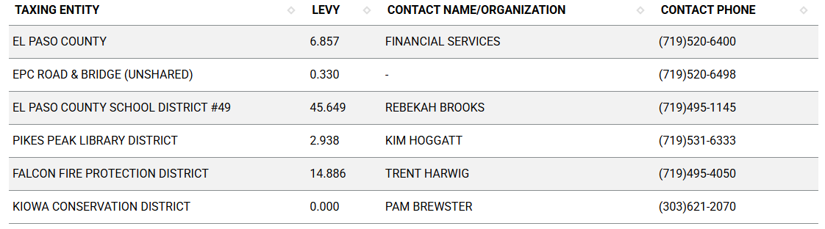

Proposed source of water |  |  | Proposed method of wastewater disposal
☐ | Central System |  | ☐ | Central System
District Name: |  | Well | District Name: |  | Septic

Water/wastewater comments
8.4.7 (4)(a) General Provisions.
The Planning Commission shall, as part of its deliberations, make a recommendation regarding the sufficiency of the proposed water supply. The BoCC shall determine the sufficiency of the proposed water supply in terms of quantity, dependability, and quality based on the information presented and the recommendation of the Planning Commission.

In determining the sufficiency of a proposed water supply, the BoCC shall, at a minimum, consider the Water Resources Report, data and recommendations from the State Engineer's Office, CAO, EPCPH, and the County staff, the recommendations of the Planning Commission, and public comment. In all cases the burden of proof in demonstrating sufficiency rests with the applicant, and it shall be the applicant's sole responsibility to document in the Water Resources Report that the proposed water supply is sufficient in terms of quantity, dependability, and quality.

8.4.7 (B)(1) Water Resource Report.
(b) Water Resources Report Required. A water resources report as required by this Section shall be submitted with sketch plan, preliminary plan, final plat, and any subdivision applications which will create a new lot. A copy of the report will be kept on file in the El Paso County PCD.
(c) Prepared by Qualified Professional. The water resources report shall be prepared by a qualified hydrogeologist, hydrologist, licensed civil engineer, qualified groundwater geologist, or other qualified professional with appropriate experience.
(d) Document Adequate Water Supply. The Water Resources Report shall include adequate documentation that the proposed water supply is sufficient in terms of quantity, dependability, and quality for the proposed subdivision.

(c) Final Plat and Replat Report. The water resource report submitted with the final plat shall include all the data needed to determine whether the proposed water supply is sufficient in terms of quality, quantity and dependability for the type of subdivision proposed. The report shall be based on engineering calculations and site-specific data and shall include a detailed discussion of the water demand, supply, quality, dependability, and supply facilities for the proposed subdivision.
A water resources report is not required if the BoCC made a finding that the proposed water supply plan of the preliminary plan was sufficient in terms of quantity, quality and dependability. However, an amended water resources report is required if there is a substantial change in either the water supply or the estimated water demand.
8.4.7(B)(5) Finding of Sufficient Dependability. The proposed water supply shall meet the following criteria to be found sufficient in terms of dependability:
- The supply is of sufficient quantity to meet the needs of the proposed subdivision for 300 years;
- The proposed water supply system and water supply is capable of meeting the average annual and peak daily demand of the proposed subdivision; and
The applicant has provided adequate evidence of ownership or the right of acquisition or use of existing or proposed water rights sufficient in quantity, dependability, and quality to serve the proposed uses within the subdivision; and (1) the legal capability to accomplish any changes in the uses or points of diversion of the rights with quantities and dependability necessary to serve the proposed subdivision without material injury to vested water rights; or (2) adequate evidence that the public or private water provider can and will supply the proposed subdivision with water of adequate quality, quantity and dependability.

8.4.8 Wastewater Disposal
(B) Minimum Standards.
(b) Compliance with EPCPH Regulations. All wastewater disposals systems shall comply with the EPCPH regulations and the CDPHE guidelines, as applicable.
i. An OWTS with design capacity less than or equal to 2,000 GPD must comply with regulations adopted by El Paso County Board of Health (EPCBoH) pursuant to this regulation and the OWTS Act. Within the jurisdiction of EPCBoH and EPCPH, the regulations promulgated by the EPCBoH govern all aspects of OWTS permits, performance, location, construction, alteration, installation, and use.
ii. An OWTS with design capacity greater than 2,000 GPD must comply with this regulation, site location and design approval in section 25-8-702, C.R.S., and the discharge permit requirements in the Water Quality Control Act, 25-8-501, et seq. C.R.S. OWTS with design capacity greater than 2,000 GPD must also comply with Appendix B of this Code.

(c) Favorable Recommendation from EPCPH Required. The EPCPH is considered the County's expert concerning the adequacy of a proposed sewage treatment system. No sketch or preliminary plan or final plat shall receive the approval of the BoCC unless EPCPH has made a favorable recommendation regarding the proposed method of sewage disposal.

(2) 2 OWTS Sites Required for All Lots or Parcels. All lots shall be designed to ensure that each lot has a minimum of 2 sites appropriate for OWTS which do not fall in the restricted areas identified on the preliminary plan; soils and geology report delineated wetland or floodplain maps; or other reports required under this Code.

Fire District:
Falcon Fire Protection District.

A Fire Protection Report is required with the Final Plat application.

Wildland Fire and Hazard Mitigation Plan:
May be required - based on Falcon Fire Protection District.

Commissioner District: District 1; Commissioner Williams

Code Waivers:
A waiver may be required depending on the ultimate arrangements of lots. Waivers would be required in the following scenarios.
- Flag lots where the pole length exceeds the length of the flag portion of the lot - LDC Sec. 8.4.3(B)(4)(f)
- Lots are not accessed from public right of way – LDC Sec. 8.4.4(E)(2)

Please include the waiver request in the Letter of Intent for the final plat. Approval criteria for a waiver request are listed below.

7.3.3. Criteria for Approval of Waivers. Waiver from standards shall be approved only upon the finding, based upon the evidence presented in each specific case, that:
- The waiver does not have the effect of nullifying the intent and purpose of this Code;
- The waiver will not result in the need for additional subsequent waivers;
- The granting of the waiver will not be detrimental to the public safety, health, or welfare or injurious to other property;
- The conditions upon which the request for a waiver is based are unique to the property for which the waiver is sought and are not applicable to other property;
- A particular non-economical hardship to the owner would result from a strict application of this Code;
- The waiver will not in any manner vary the zoning provisions of this Code; and
- The proposed waiver is not contrary to any provision of the Master Plan.

Parks and trails:
The 2022 El Paso County Parks Master Plan shows no impacts to existing or proposed parks, trails, or open space. As such no trail easement dedications will be necessary for this project. Regional park fees will be assessed upon review of the forthcoming platting actions.
Contact:
Ashlyn Mathy
Parks Planner
Park Planning Division
El Paso County Parks Department
Office 719.520.6978

Wildlife impact
This property is considered to have moderate wildlife impact potential.

Your El Paso Master Plan

Placetype:
Character: Rural
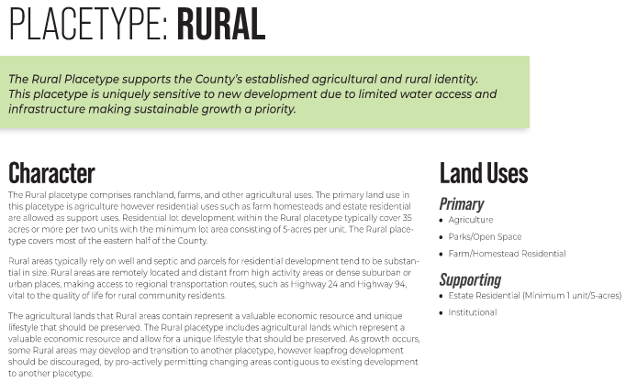

Area of Change Designation:
Description: Minimal Change: Undeveloped
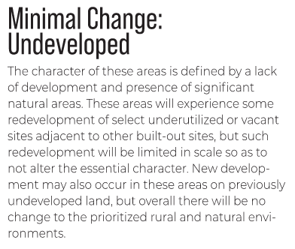

Key Area:
Character: Not Applicable
Parcel is not within a designated key area.

Helpful Links

Planning Website: https://planningdevelopment.elpasoco.com/

El Paso County Master Plan: https://planningdevelopment.elpasoco.com/#1510603950097-f5d985dc-35b2
Water Master Plan: https://planningdevelopment.elpasoco.com/#1515613078151-9a697e85-b1a7
Parks Master Plan: https://parks.elpasoco.com/parks-and-recreation/park-planning/
Mineral Extraction Master Plan: https://planningdevelopment.elpasoco.com/#1515613078151-9a697e85-b1a7

Forms and Templates: https://planningdevelopment.elpasoco.com/forms-and-affidavits/

Applications and Checklists: https://planningdevelopment.elpasoco.com/applications-and-checklists/

Land Development Code: https://library.municode.com/co/el_paso_county/codes/land_development_code

EDARP: https://epcdevplanreview.com/

Public GIS: https://experience.arcgis.com/experience/94cea8ccda3d4806a3fd500d2b5a4433?draft=true

Wrap Up
-If subdivision is proposed, recording fees, park and school fees and road impact fees may apply.

-Fees are subject to change. The fees at the time of application apply.

-Road Impact Fees
Please see the following website for information on the EPC Road Impact Fee Project. https://publicworks.elpasoco.com/road-impact-fees/ to include fee schedule.
As of December 15, 2016, per Resolution 16-454, on and after January 1, 2020, property in the unincorporated area of the county that receives a Land Use Approval either in a public hearing or administratively, is subject to the payment of Road Impact Fees. After December 31, 2024, in accordance with BoCC Resolution 24-377 the fee is paid for new residential and non-residential uses and structures and expansions of non-residential uses and structures. Road Impact fees are typically paid at time of building permit. If no building permit is being obtained for a particular Land Use application, then Road Impact Fees must be paid at the time of Site Development Plan or Special Use approval. If there are questions about EPC Road Impact program or fees, please contact DPW Development Review Services and the Engineer of the Day.

- Engineering Criteria Manual (ECM) Deviations.
The fee for any additional ECM deviation requests (more than two per land use application) - $1483.00 each per current Fee Schedule. Please note ECM deviation requests may result in additional processing and project review time. ECM Deviations should be submitted prior to the initial Site Development Plan or Final Plat submittal to preclude changes having to be made to engineering plans and documents if the deviation is not approved. Submission of an ECM deviation request does not imply or guarantee that the deviation will be approved. An ECM Deviation form must be submitted to include complete exhibits and justification excluding cost with supporting engineering criteria. If there are questions about ECM Deviation requests, please contact DPW Development Review Services and the Engineer of the Day.

-The fee for any additional waiver/deviation requests (more than two) - $550.00 each. Please note that requests for waivers and/or deviations may result in additional processing/review delay.

-All items requested must accompany the submittal for it to be complete, prior to payment request or the submittal will not be complete and ready for review agencies.

-A temporary use permit shall be applied for and approved for any staging area associated with development, such as a sales office, construction trailer, or contractor's equipment yard, prior to scheduling of the pre-construction meeting with El Paso County Planning and Community Development. If a Planned Unit Development is proposed, the temporary staging area should be shown on the development guideline and phasing plan.

-All prospective timelines for review are subject to departmental staffing and workload.

-Early Assistance is valid for 12 months from submittal of the EA application. If a project submittal is not received within 12 months, a new EA meeting may be required. An audio/video copy of the meeting is available in EDARP within the EA folder.

- Applications scheduled for public hearings may be heard as a regular item at the request of staff or a hearing body member.

- Any comments or commitments made by any member of the County Staff during this early assistance meeting are only preliminary in nature and should not be relied upon by the applicant. All prospective applicants should be informed that formal comments cannot be made by staff until after the application is submitted.

