

Commissioners:
Darryl Glenn (President)
mark Waller (President Pro Tempore)

Stan Vanderwerf
Longinos Gonzalez
Peggy Littleton

Planning and Community Development
Craig Dossey, executive Director

12/31/18

NextEra Energy Resources, Inc.
Alsey.davidson@nexteraenergy.com

Tina Brazil
Core Consultants
brazil@corecivil.com

Dear Applicant and/or Consultant:

Subject: Grazing Yak Solar- WSEO-18-2 Review 1- Incomplete due to lack of clarity on legal

The purpose of this letter is to provide you with the review agency responses to the above named development application that have been received to-date by Planning and Community Development.

You are encouraged to directly contact those agencies that did provide review comments if the comments require additional action by the applicant/applicant’s representative. You are also encouraged to directly contact those agencies that did not provide review comments if such response is required by state statutes and the El Paso County Land Development Code.

EL PASO COUNTY PLANNING AND COMMUNITY DEVELOPMENT DEPARTMENT

Planning

The Grazing Yak Solar WSE-O application is being reviewed under Section 4.3.5, WSE-O (Wind and/or Solar Energy Generation Plan Overlay) District zoning district, of the El Paso County Land Development Code (2018) and the Board adopted procedures manual. (The procedures have been uploaded as a comment for your reference.

Section 4.3.5.D.2 of the Land Development Code states that, “A development impact mitigation agreement shall be required with all wind and/or solar energy generation plan overlay district applications.” Staff is not requiring impact mitigation with this application due to the minimal, if any, impacts anticipated with the project. Therefore, the applicant is requesting a waiver of this section as to be indicated in the applicant’s Letter of Intent.

- Please see redline items uploaded to EDARP. Please revise the items and upload them. A complete review will occur after basic legal and project area is determined. Staff anticipated the WSE-O solar boundary as shown on the submitted zoning map and boundary map. The WSEO plan and application do not match these. 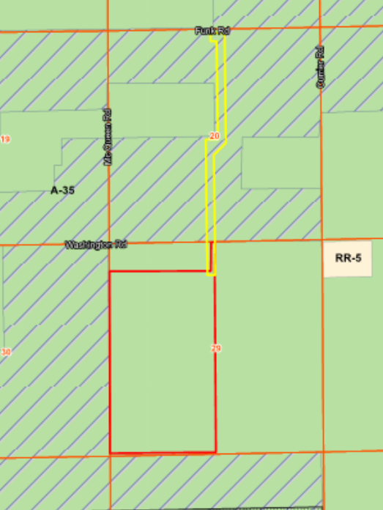
- Please add an application sheet identifying Core Consulting as an authorized representative of the Grazing Yak Solar Project. Please verify legal for the area to be included within the WSE-O. Are we really overlaying 1200 + acres or 270 acres? This will most likely result in 6 pages being uploaded (4 have been completed, but will need to be re-uploaded).
- The legal should describe the boundaries of the WSE-O for the solar facility, substation and existing or proposed collection lines. If the entire parcel is not to be a part of the WSE-O than it does not need to be included. The area in red, yellow and pink (270 acres) in the boundary map is the area to be included in the WSE-O legal not the entirety of the parcels. Create a 270 acre legal please. All the reports should include the 270 acres.

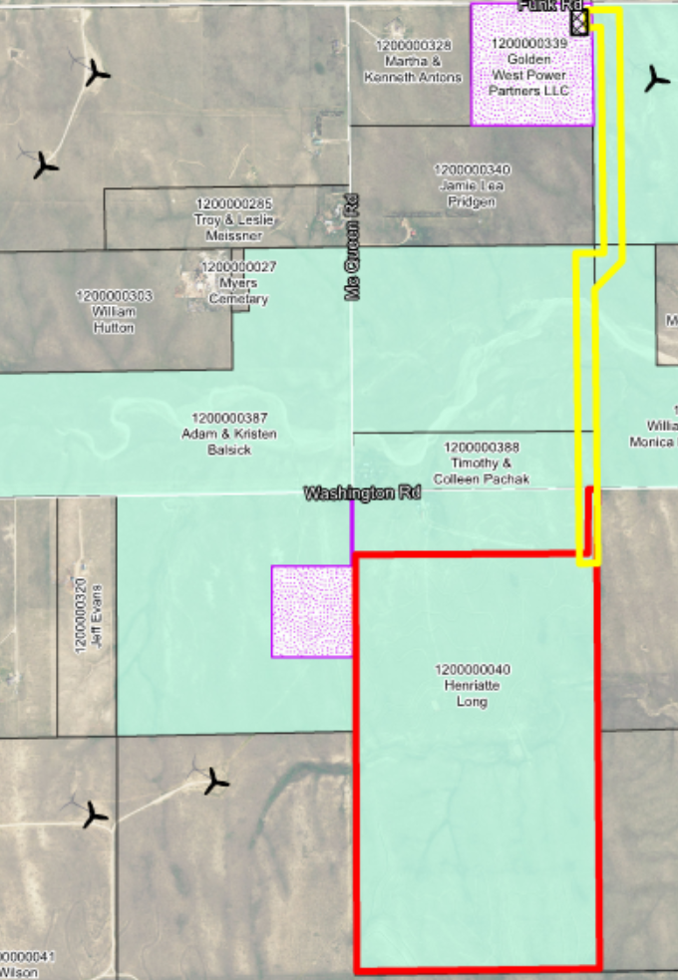

Engineering Department
To be provided upon legal clarification.

COLORADO STATE FOREST SERVICE

The primary wildland fuel type for this proposal is grassland with scattered trees having a low wildfire hazard potential. No special fire mitigation plans or other actions are necessary for final approval by the Colorado State Forest Service.

PUBLIC SERVICE COMPANY OF COLORADO

Public Service Company of Colorado’s Right of Way & Permits Referral Desk has reviewed the plans for Grazing Yak Solar Facility WSE-O and has no apparent conflict.

Please contact me at donna.l.george@xcelenergy.com or 303-571-3306 if there are any questions with this referral response.

Donna George
Right of Way and Permits
Public Service Company of Colorado

911 AUTHORITIES –ELPASO/TELLER COUNTY

No new street names requested No action for 911 Thank you Justin

MOUNTAIN VIEW ELECTRIC ASSOCIATION, INC.

This area is within MVEA certificated service area. MVEA will serve this area with start-up power and any additional power as needed. The necessary lines will be constructed according to our extension policy. Connection requirements may include provisions for necessary line extensions and or other system improvements along with easements, and payment of all fees under MVEA line extension policy. Information concerning these requirements can be obtained by contacting the Engineering Department of MVEA.

MVEA has existing facilities near and within these parcels of land. If there is any removal or relocation of facilities it will be at the expense of the applicant and a review of easements will be required in order to serve.
If additional information is required, please contact our office at (719) 495-2283.

Sincerely,

Cathy Hansen-Lee
Engineering Administrative Assistant

ELPASO COUNTY ENVIRONMENTAL SERVICES

The El Paso County Environmental Division has completed its review of the Grazing Yak Solar Facility WSE-O. Our review consisted of the following items: wetlands, federal and state listed threatened or endangered species, general wildlife resources and noxious weeds.

- An approved Jurisdictional Determination from the U.S. Army Corps of Engineers (USCOE) shall be provided to the Planning and Community Development Department prior to project commencement. The applicant is hereby on notice that the USCOE has regulatory jurisdiction over wetlands. It is the applicant’s responsibility, and not El Paso County’s, to ensure compliance with all applicable laws and regulations, including, but not limited to, the Clean Water Act.

- Documentation from the U.S. Fish and Wildlife Service (USFWS) related to the Preble’s meadow jumping mouse shall be provided to the Planning and Community Development Department prior to ground disturbing activities occurring within 300 feet of the 100-year floodplain of Horse Creek. The applicant is hereby on notice that the USFWS has regulatory jurisdiction over threatened and endangered species and migratory birds, respectively. It is the applicant’s responsibility, and not El Paso County’s, to ensure compliance with all applicable laws and regulations, including but not limited to, the Endangered Species Act and the Migratory Bird Treaty Act.

- Colorado Parks and Wildlife makes recommendations related to seeding, fencing, migratory birds and raptor buffer zones in the letter dated November 30, 2018. It is strongly suggested that these recommendations be followed.

It is strongly recommended that the applicant obtain the necessary approvals from all federal, state and county agencies as a part of their planning process.

We appreciate the opportunity to comment on this project. If you have any questions or concerns, please contact me at (719) 520-7845.

COLORADO GEOLOGICAL SURVEY

The 270-acre site (approximate centerpoint 38.9833, -104.2529) does not contain, nor is it exposed to, any geologic hazards that would preclude the proposed solar facility use. Terracon's 9/27/2018 geotechnical recommendations are valid; provided Terracon's recommendations are adhered to, CGS has no objection to approval.

PIKES PEAK REGIONAL BUILDING DEPARTMENT

Regarding a request for approval of a solar energy plan across multiple parcels (primarily 1200000040), Enumerations has the following comments:
- An address separate from the existing residence will be assigned for the solar array for permitting purposes. The application indicates that the area where the array is to be constructed will most likely be separated from the existing parcel via sale. In that case, the address assigned to the solar array will be the parcel address for the new parcel, and the existing residence will retain its’ current address.
- The applicant should contact Enumerations to establish this address prior to submitting plans for review/permit.
- Floodplain has no comment or objection.

Brent Johnson
Enumerations Plans Examiner Pikes Peak Regional Building Department
O: 719-327-2888 E: brent@pprbd.org W: pprbd.org

Comments received from any of the non-responding agencies following the issuance of this letter will be forwarded to the applicant/applicant’s representative via EDARP.

Due to the number of comments and necessary revisions to the plan(s) an additional detailed review will be necessary. Please address the comments as listed above. A detailed letter needs to accompany the revisions to allow for an expeditious re-review timeframe. The letter should include each comment listed above and, immediately thereafter, include a response from the applicant addressing the comment.

If any review agency has an issue that needs resolution or requires a revision, you will need to provide the necessary documents, drawings, etc., to the Planning and Community Development Department in the form of a resubmittal. The Planning and Community Development Department will then forward the resubmitted items directly to the appropriate review agency. If you have any questions pertaining to specific agency comments please contact the appropriate agency directly.

PLEASE NOTE: The application cannot be scheduled for public hearing until and unless a final response has been received by Planning and Community Development from those agencies that are required (pursuant to state statute and the El Paso County Land Development Code) to provide such response (i.e.- State Engineer’s Office, County Attorney’s Office, County Health Department, etc).

In order to be considered for the Planning Commission hearing, all outstanding issues must be resolved. Please contact me if you would like to schedule a meeting with myself or the multi-disciplinary team.

When all the comments have been addressed and corrections made please submit the required documents as requested in EDARP.

If you have any questions feel free to contact me at 520-6306.

Best Regards,

Kari Parsons
El Paso County Planning and Community Development Department

cc: Jeff Rice PE, Engineering
File: WSE-O-18-2

