SUBDIVISION IMPROVEMENTS AGREEMENT

THIS AGREEMENT, made between PIKES PEAK HABITAT FOR HUMANITY, INC., hereinafter called the "Subdivider," and El Paso County, by and through the Board of County Commissioners of El Paso County, Colorado, hereinafter called the "County," shall become effective the date of approval of the Final Plat by the Board of County Commissioners.

WITNESSETH:

WHEREAS, the Subdivider, as a condition of approval of the final plat of RISING MOON FILING NO. 1, wishes to enter into a Subdivision Improvements Agreement, as provided for by Section 30-28-137 (C.R.S.), Chapter 5 of the El Paso County Engineering Criteria Manual and Chapter 8 of the El Paso County Land Development Code incorporated herein; and

WHEREAS, pursuant to the same authority, the Subdivider is obligated to provide security or collateral sufficient in the judgment of the Board of County Commissioners to make reasonable provision for completion of certain improvements set forth on Exhibit A attached hereto and incorporated herein; and

WHEREAS, the Subdivider wishes to provide collateral to guarantee performance of this Agreement including construction of the above-referenced improvements by means of Letter of Credit.

NOW, THEREFORE, in consideration of the following mutual covenants and agreements, the Subdivider and the County agree as follows:
l. The Subdivider agrees to construct and install, at its sole expense, all of those improvements as set forth on the Financial Assurance Estimate attached hereto as Exhibit A and incorporated herein by reference. To secure and guarantee performance of its obligations as set forth herein, the Subdivider agrees to provide collateral to remain in effect at all times until the improvements are completed and accepted in accordance with Chapter 5 of the ECM.
Security and collateral shall be in the form of Letter of Credit issued by ANB Bank in the amount of $755,042.47.
[X] If this box is checked, the Subdivider has elected to defer installation of portions of the sidewalk in this Subdivision, pursuant to the terms and conditions of the Sidewalk Addendum attached hereto and incorporated herein by reference.

2. Subdivider is responsible for providing any renewals of collateral to ensure that there is never a lapse in security coverage. Subdivider shall procure renewal/extension/replacement collateral at least fifteen (15) days prior to the expiration of the original or renewal/extension/replacement collateral then in effect. Failure to procure renewal/extension/replacement collateral within this time limit shall be a default under this Agreement and shall allow the County to execute on the collateral. In addition, if Subdivider allows collateral to lapse at any time, no lots in the subdivision may be sold, conveyed or transferred, whether by Deed or Contract, after the expiration date of such collateral until the improvements identified on the Financial Assurance Estimate attached hereto as Exhibit A have been completed and final acceptance is received from the County. If replacement collateral is used for renewal, approval by the Board of County Commissioners is required.

3. No lots in the subdivision shall be sold, conveyed or transferred, whether by Deed or by Contract, nor shall building permits be issued until and unless the required improvements for the subdivision have been constructed and completed in accordance with the approved construction plans and preliminary acceptance is received from the County. In the alternative, lots within the subdivision may be sold, conveyed or transferred and / or have building permits issued upon receipt of collateral acceptable to the County, pursuant to this Agreement, which is sufficient to guarantee construction of the improvements in the attached Financial Assurance Estimate.

4. The Subdivider agrees that all of those certain public improvements to be completed as identified in the attached Financial Assurance Estimate shall be constructed in compliance with the following:

a. All laws, resolutions and regulations of the United States, State of Colorado, El Paso County and its various agencies, affected special districts and/or servicing authorities.

b. Such other designs, drawings, maps, specifications, sketches and other matter submitted to and approved by any of the above-stated governmental entities.

5. All improvements shall be completed by the Subdivider, meeting all applicable standards for preliminary acceptance, within 24 (twenty-four) months from the date of notice to proceed in the Construction Permit for the Subdivision. If the Subdivider determines that the completion date needs to be extended, the Subdivider shall submit a written request for a change in the completion date to the ECM Administrator at least 90 days in advance of the required completion date. The request shall include the reasons for the requested change in completion date, the proposed new completion date, and prove collateral is in place to cover the extension time requested. The completion date for the Subdivision may be extended one time, for a period no longer than 6 months, at the discretion of the ECM Administrator. Any additional requests for extension of the completion date will be scheduled for hearing by the Board of County Commissioners. The ECM Administrator or the Board of County Commissioners may require an adjustment in the amount of collateral to take into account any increase in cost due to the delay including inflation.

6. It is mutually agreed pursuant to the provisions of Section 30-28-l37 (3) C.R.S. that the County or any purchaser of any lot, lots, tract or tracts of land subject to a plat restriction which is the security portion of a Subdivision Improvements Agreement shall have the authority to bring an action in any District Court to compel the enforcement of any Subdivision Improvements Agreement on the sale, conveyance, or transfer of any such lot, lots, tract or tracts of land or of any other provision of this article. Such authority shall include the right to compel rescission of any sale, conveyance, or transfer of any lot, lots, tract or tracts of land contrary to the provisions of any such restrictions set forth on the plat or in any separate recorded instrument, but any such action shall be commenced prior to the issuance of a building permit by the County where so required or otherwise prior to commencement of construction on any such lot, lots, tract or tracts of land.

7. It is further mutually agreed that, pursuant to the provisions of Section 30-28-l37 (2) C.R.S. and Chapter 5 of the County’s Engineering Criteria Manual, as improvements are completed, the Subdivider may apply to the Board of County Commissioners for a release of part or all of the collateral deposited with said Board. Upon inspection and approval, the Board shall release said collateral. The County agrees to respond to an inspection request in a reasonable time upon receipt of the request. If the Board determines that any of such improvements are not constructed in substantial compliance with specifications it shall furnish the Subdivider a list of specific deficiencies and shall be entitled to withhold collateral sufficient to ensure such substantial compliance. If the Board of County Commissioners determines that the Subdivider will not construct any or all of the improvements in accordance with all of the specifications, the Board of County Commissioners may withdraw and employ from the deposit of collateral such funds as may be necessary to construct the improvements in accordance with the specifications.

8. The Subdivider agrees, and both parties acknowledge, that the construction of the improvements identified and guaranteed through this Subdivision Improvements Agreement shall follow the inspection, collateral, and acceptance process that is identified in Chapter 5 of the County’s Engineering Criteria Manual. This is to include, among other things, a Preliminary Acceptance process, replacement of performance collateral with appropriate Warranty collateral at that time, and a 2-year warranty period prior to final acceptance. Where any inconsistency exists between Chapter 5 of the Engineering Criteria Manual and the Land Development Code with respect to these inspections, collateral and acceptance processes, the Engineering Criteria Manual is the controlling document.

9. The Subdivider agrees to provide the County with a title insurance commitment at time of final platting evidencing that fee simple title of all lands in the subdivision is vested with the subdivider.

10. The County agrees to approval of the final plat of Rising Moon Filing No. 1 subject to the terms and conditions of this Agreement.

11. Parties hereto mutually agree that this Agreement may be amended from time to time provided that such amendment be in writing and signed by all parties hereto.

12. This Agreement shall take effect on the date of approval of the Final Plat.

13. The Subdivider agrees for itself and its successors and assigns that Subdivider and/or its said successors and assigns shall be required to pay traffic impact fees in accordance with the El Paso County Road Impact Fee Program at or prior to the time of building permit submittals.

IN WITNESS WHEREOF, the parties have hereunto set their hands and seals the day and year below written.

BOARD OF COUNTY COMMISSIONERS OF

EL PASO COUNTY, COLORADO

__________________________________________

Meggan Herington, Executive Director

Planning and Community Development Department

Authorized signatory pursuant to LDC

The foregoing instrument was acknowledged before me this ______day of ______________,20______, by____________________________, Executive Director of El Paso County Planning and Community Development Department.

Witness my hand and official seal.

My commission expires: _______________
____________________________________
Notary Public

Approved as to Form:
______________________________________
Assistant County Attorney

SUBDIVIDER:

PIKES PEAK HABITAT FOR HUMANITY, INC.

By: _____________________________________
Joseph DesJardin, President

Subscribed, sworn to and acknowledged before me this ________ day of _________________, 20____, by the parties above named.

Witness my hand and official seal.

My commission expires: _________________.

_________________________________________
Notary Public
SIDEWALK ADDENDUM
RISING MOON FILING NO. 1

The County and Subdivider hereby agree as follows:

- The Subdivider shall be required to install sidewalks adjacent to all Subdivision tracts and open space parcels in connection with construction of public roads and pursuant to the provisions of the Subdivision Improvements Agreement. These sidewalk portions have been included in the Financial Assurance Estimate attached hereto as Exhibit A.

- The provisions of this Sidewalk Addendum shall apply to all other segments of sidewalk within the Subdivision (“Deferred Sidewalks”) and shall control in the event of any conflict with the provisions of the Subdivision Improvements Agreement. The Deferred Sidewalks are depicted in the drawing attached hereto as Exhibit B.

- The Subdivider may defer construction of Deferred Sidewalks. Each segment of a Deferred Sidewalk must be constructed prior to the earlier of a) issuance of a certificate of occupancy for the lot to which the Deferred Sidewalk is adjacent, or b) two years after preliminary acceptance of the Subdivision improvements included in the Financial Assurance Estimate attached hereto as Exhibit A (the “Exhibit A Improvements”).

- The Financial Assurance Estimate for the Deferred Sidewalks is attached hereto as Exhibit C. Collateral for completion of the Deferred Sidewalks shall be provided in the form of a Letter of Credit issued by ANB Bank in the amount of $70,093.00.

- Pedestrian ramps must be constructed at the same time the sidewalk for the tract, parcel, or lot to which the pedestrian ramp is adjacent is constructed. Collateral for pedestrian ramps shall be included in the appropriate Financial Assurance Estimate, depending on location.

- Deferred Sidewalks shall be eligible for preliminary acceptance only as a whole upon completion of the last segment of Deferred Sidewalk. Preliminary acceptance of the Deferred Sidewalks shall be followed by a two-year defect warranty period, for which collateral acceptable to the County shall be provided.

- Final acceptance of the Exhibit A Improvements may only occur concurrent with or after preliminary acceptance of the Deferred Sidewalks.

- The Subdivider hereby agrees, for itself and its successors and assigns, to indemnify, defend, and hold harmless El Paso County and its officials, employees, from any and all loss, costs, damage, injury, liability, attorney’s fees, claim, lien, demand, action and cause of action whatsoever, whether at law or in equity, arising from or related to any suit, claim, or allegation before any court or administrative body that this Agreement, including the Sidewalk Addendum, its implementation or enforcement, or the planning, design, construction, installation, and acceptance by the County of sidewalks in this Subdivision, including but not limited claims of violation of any federal, state, or local law, including but not limited to the Americans with Disabilities Act, or any regulation promulgated thereunder.

SUBDIVIDER: BOARD OF COUNTY COMMISSIONERS:

_
By:______________________________ By: _____________________________________
Joseph DesJardin, President,
PIKES PEAK HABITAT
FOR HUMANITY, INC.

SIDEWALK ADDENDUM
RISING MOON FILING NO. 1
EXHIBIT A
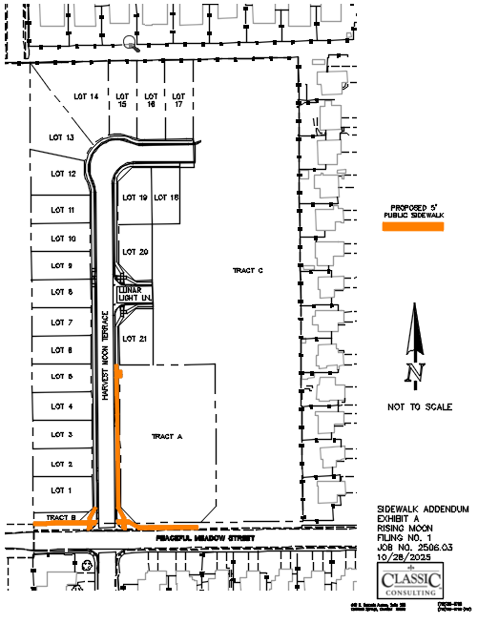

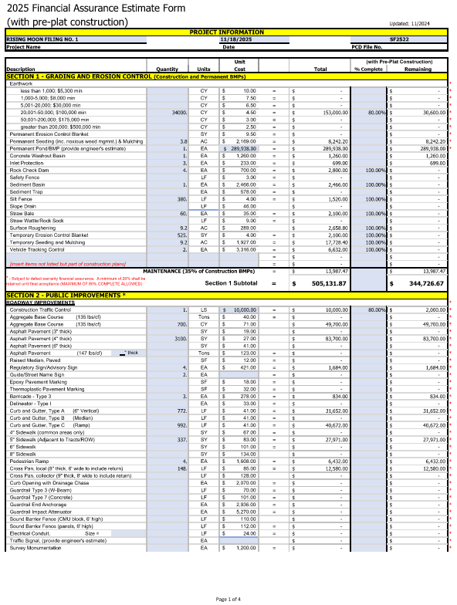

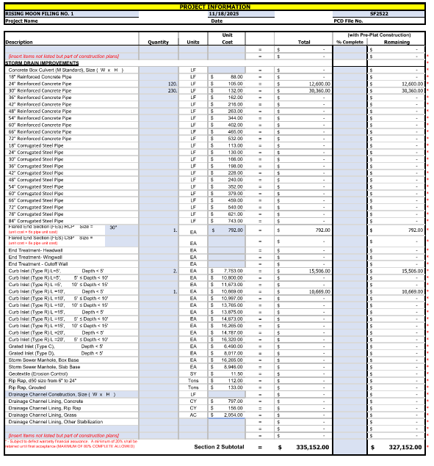

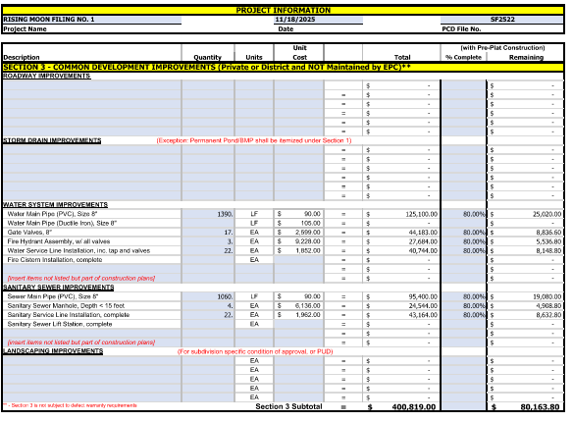

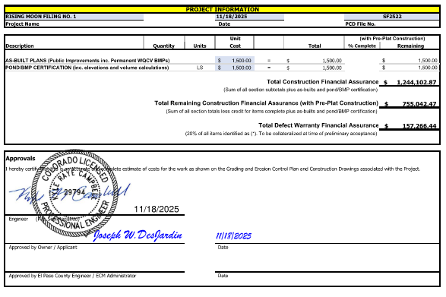

SIDEWALK ADDENDUM
RISING MOON FILING NO. 1
EXHIBIT B

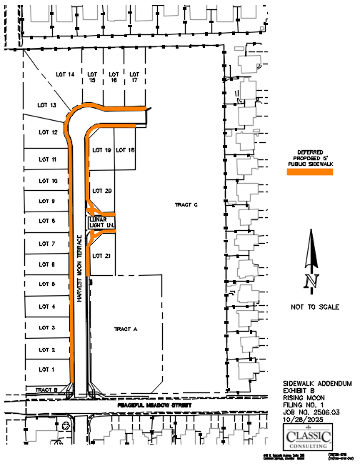
SIDEWALK ADDENDUM
RISING MOON FILING NO. 1
EXHIBIT C

