Early Assistance Meeting Number: EA256
Project Name: Schubert Ranches Solar- Circuit energy solutions
Project Location: S Ellicott Highway (east) and Sanborn Road (north). The project will be located in Sections 21, 22, 26, 27, and 28 of Township 14 South, Range 62 West
Parcels: 2400000027 2400000249 2400000276
Project Description: A solar facility capable of generating up to 285 megawatts (MW) alternating current (AC) solar energy. 199 MW in EA meeting. The proposed Solar Project consists of single-axis tracking ground-mounted solar arrays and associated infrastructure designed on approximately 2,264 acres located in sections 21, 22, 26, 27, and 28 of Township 14 South, Range 62 West. The solar panels will be located on 1,950 acres of the 2,264 total acres. Includes 1 substation; one laydown yard- Battery storage unknown- access off of HWY94, Sanborn Road and one to north. June 1 target submittal. Tri-State RFP will know end of April. Operational 2027
Meeting Date: 2/4/25 2pm

El Paso County Planning & Community Development Planning Checklist

Request – Map Provided by Applicant
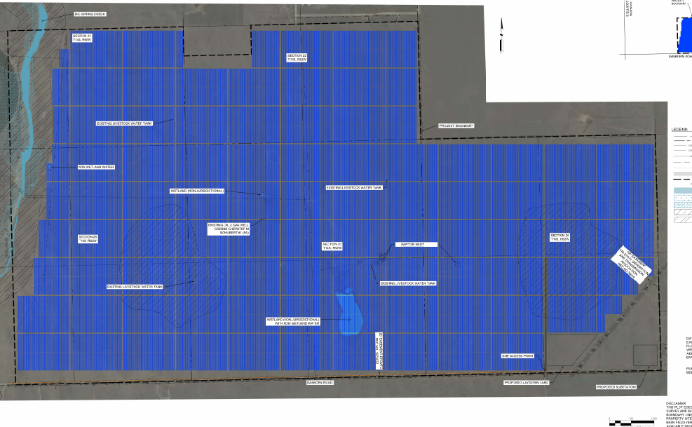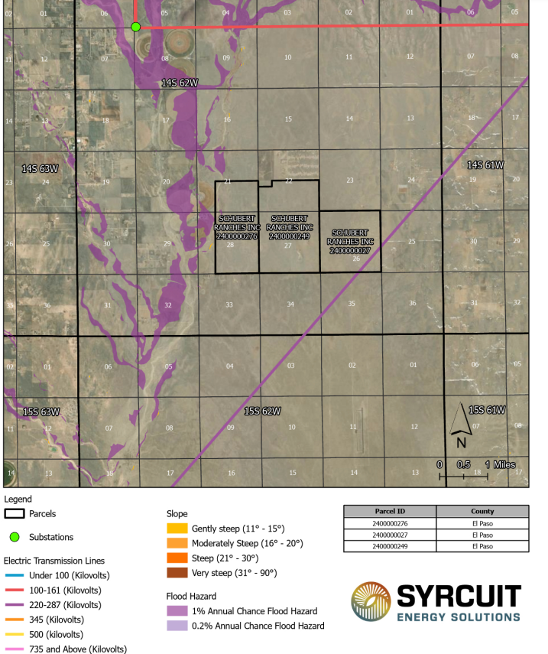
Power will serve outside of County

Zoning
Existing Zone(s)
Zone |  | Name
A35 |  | Agricultural
Proposed Zone(s)
Zone |  | Name
WSEO |  | Wind & Solar Energy Overlay

Zone Map (existing conditions of approval)
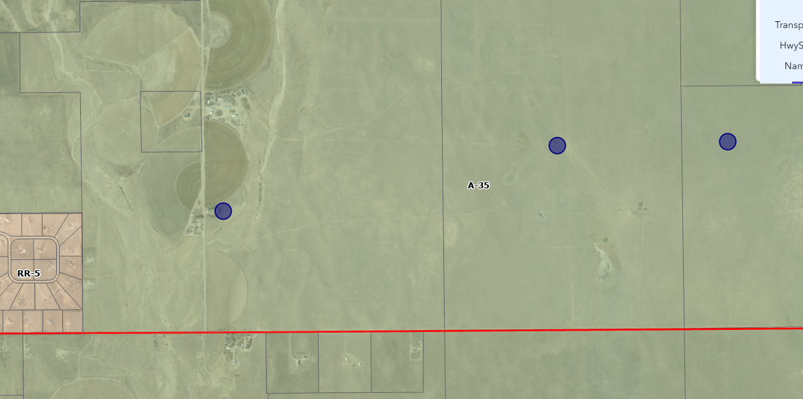

Zoning Analysis
WSE-O 4.3.5 LDC https://library.municode.com/co/el_paso_county/codes/land_development_code?nodeId=CH4SPPUOVOBZODI_4.3OVZODI

P-AR-034-11, Wind/Solar Energy Generation Plan Overlay (WSEO)Rezoning (Map Amendment), and Section S-PL-023-011 uploaded into EDARP EA file

Zoning District Requirements (density, lot size, lot design standards, building setbacks)
Provide the dev guidelines on face of WSEO do not refer to Code; WSEO is custom to each overlay. Customize the overlay- Heights of each item: arrays, substation, met poles, lines, battery storage, fencing, maintenance bldgs., setbacks, exact locations, and laydown areas identify in table

Plat Map or Parcel Map (conditions of approval): Unplatted

Processing Issues: Neighborhood meeting- upload notes to WSEO file

Application Type(s) Hearing: Required/ Optional/ No
WSEO & Development Agreement | Yes
1041 | Not if included notice at WSEO BOCC
PPR w/ CDS | No

Approval Criteria:
(G)Review Criteria for Approval of WSE-O Application. (1)Review Standards. In approving a Wind and/or Solar Energy Generation Overlay Plan Map Amendment, the following findings shall be made:
• The application is in general conformance with the El Paso County Master Plan, including applicable Small Area Plans or there has been a substantial change in character of the neighborhood since the land was last zoned;

The rezoning is in compliance with all applicable statutory provisions, including but not limited to C.R.S. § 30-28-111, § 30-28-113, and § 30-28-116;

• The site is suitable for the intended use(s), including the ability to meet the general development standards of the Land Development Code, except as otherwise amended by the specific overlay zoning district;

• The application is consistent with the specific development standards in the Land Development Code pertaining to wind and/or solar energy generation facilities;

• The application meets the air, water, light, odor or noise standards established by County, State, or federal regulations;

• The proposed use(s) will not be detrimental to the health, safety, or welfare of the inhabitants of the area and the County; and

• The proposed use(s) will not cause undue burden on existing infrastructure.

Processing Issues and Options
Neighborhood open house/ work with all Stakeholders and jurisdictions impacted by Haul routes/ Uses
WE WILL HAVE A MEETING BEFORE APPLICANT COMPLETES HAUL ROUTE TIS TO VERIFY ROUTES
Drainage improvements maybe; wetlands on site; rock outcroppings/ artifacts to be avoided and preserved
USAFA Bulls Eye Range- USAFA Base Planner matthew.fitzsimmons.4.ctr@us.af.mil

Peterson AFB elizabeth.dukes.4@spaceforce.mil (719) 556-1708
Schriever AFB darren.horstmeier@spaceforce.mil (719) 567-3186
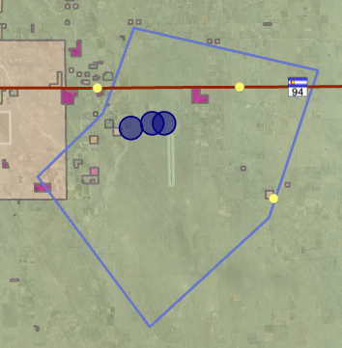

Water MP ,Parks MP, MTCP master Plan, mineral plan also must b addressed in 1041 answers and WSEO Letter on Intent (LOI)

Relevant Past History:
Ellicott Hwy New Paved- Highway 94 from north. assessment of roads PCI of roads used for hauling

Design and Landscaping

Site Design/Layout (Lot pattern, circulation/road design, open space, preservation of natural features, compatibility internally and with adjacent land uses)
natural features riparian wetlands cultural reports to protect- design around wetlands and drainages; buffer screen from residents; Haul route exists for gravel at Bagget Road to Sanborn Road, avoid Ellicott Hwy. S Calhan Hwy back up route secondary.
PPR234 Haul Route for Sand and Gravel
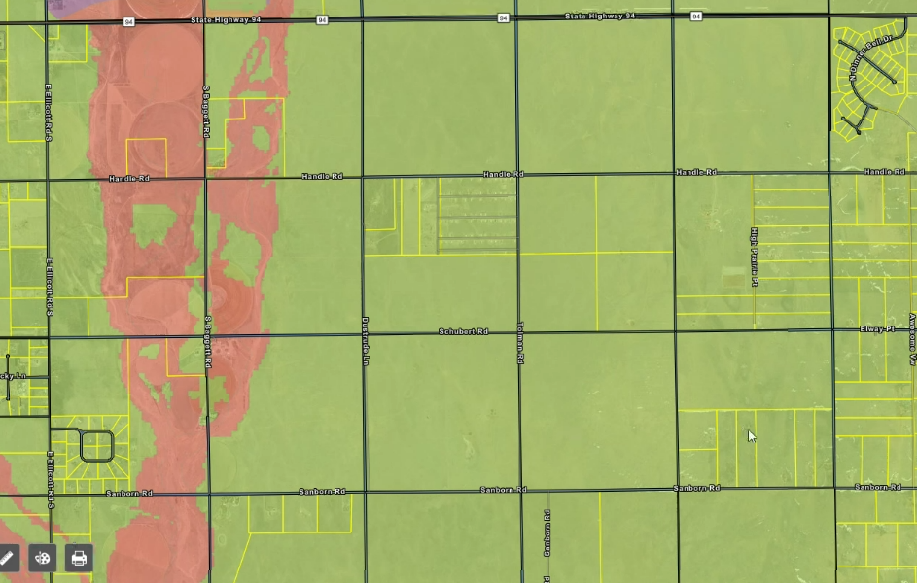

Landscaping
☐ | Expressway, Principal arterial area depth – 25’-Trees required 1 per 20’
☐ | Urban interchange/Intersection area depth – 25’- N/A
☐ | Minor arterial area depth 20’ – Trees required 1 per 25’
☐ | Non-arterial area depth 10’ – Trees required 1 per 30’
☐ | Parking lot landscaping required
☐ | Buffer between non-residential and residential districts separated by a non-arterial road or public alley

Reseed mix- Work with EPC Conservation District

Signage:
Depict on site development plans

Parking Requirements:
For maintenance area: 1 Handicap

Lighting:
Provide Lighting Plan with WSEO plan set ; Maximum 0.1 foot candle at property boundaries where adjacent to County Right of Way or residential land use
Photometric Plan Required | ☒

Site Characteristics\ Constraints\ Environmental Standards:
Raptor Nest – Study will be required at 1041
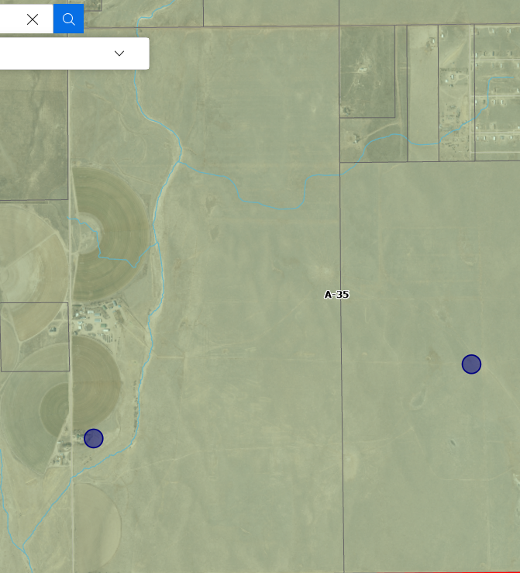

☐ | 30% or greater slope | Topography:
☒ | CGS review required (separate fee to CGS) | Soils/geology: |  | 1041 required CGS review and fee paid- Do at WSEO so sites are not amended
☒ | Floodplain | Floodplain comment: |  |  | West- Check with Floodplain Administer for updated mapping
☐ | Noise mitigation required | Noise comment: |  |  |  | Study Required
☒ | Preble’s mouse  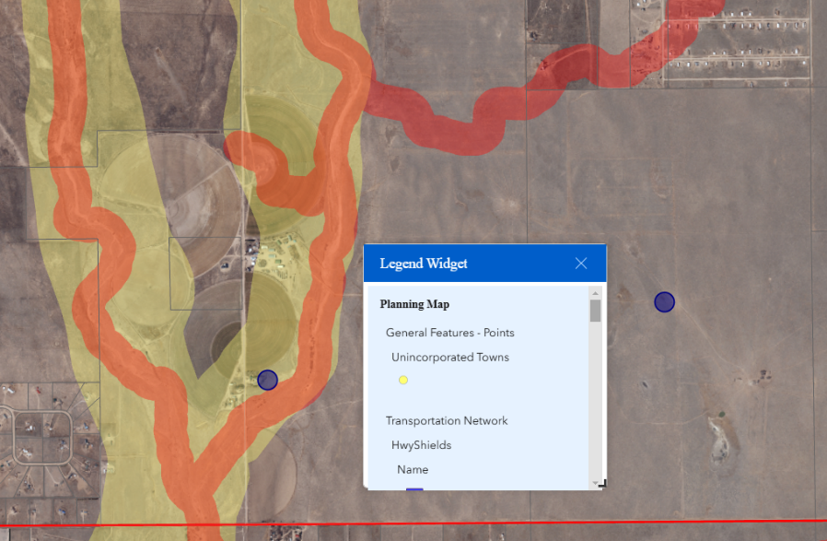  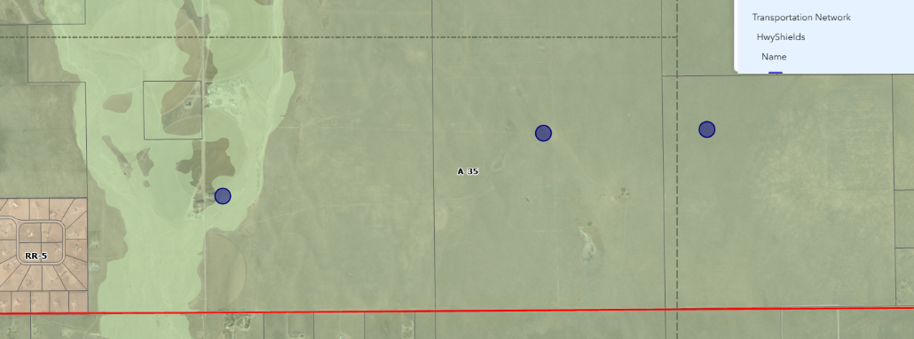

Air/Visual Quality:
Provide a visual impact analysis photos sims from roads and adj residents

Districts

Taxing Entities

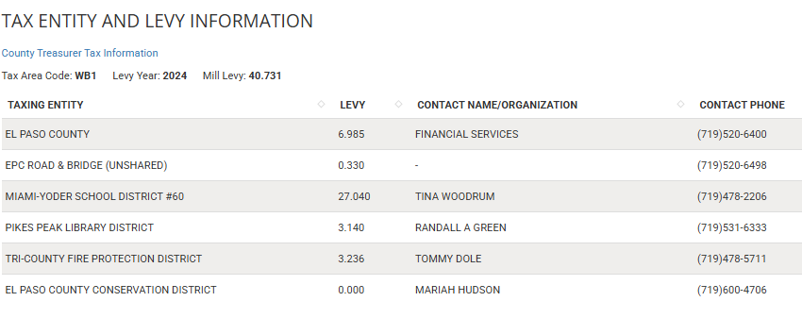

Proposed source of water |  |  | Proposed method of wastewater disposal
☐ | Central System |  | ☐ | Central System
District Name: |  |  | District Name:

Water/wastewater comments
Letter at 1041 for water truck ability to keep dust down at construction and maintenance if not using well. Water Rights for well for WSEO use provide.

Negotiation for lease water rights… provide at 1041

Fire District:
Work with Fire District ON response plan- equipment provisions

Emergency Services Issues:
Grass fires- battery storage

Commissioner District: 4

Code Waivers:

Parks and trails:
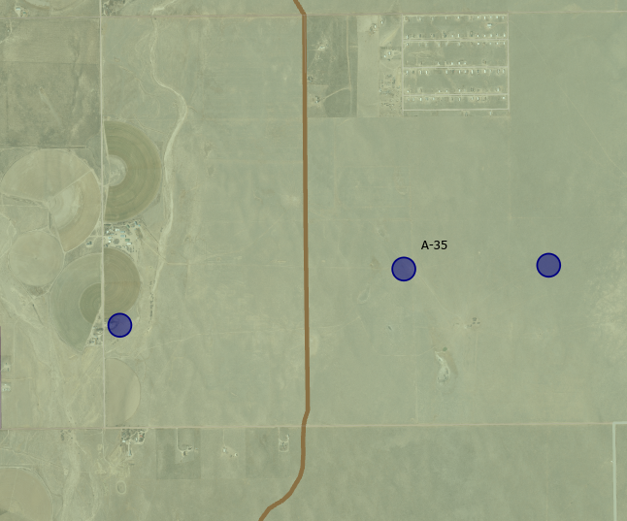
DEPICT Trail Easement- re-route Great Plains Regional Trail 25’ dedicated easement- Plus north side of Sanborn Road, then west, then north along Big Springs Creek to Handle Road- Ross Willams 7195206984. Contours w/ exhibit.

Annexations/Intergovernmental/ Jurisdictional Access issues:
CDOT HWY 94

Road Impact Fee Program (PID Inclusion):
Address in TIS

Your El Paso Master Plan

Placetype: Rural
Character:
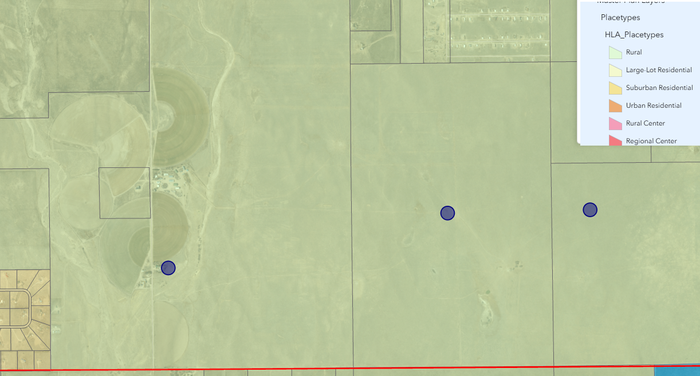

Recommended Land Uses:
- 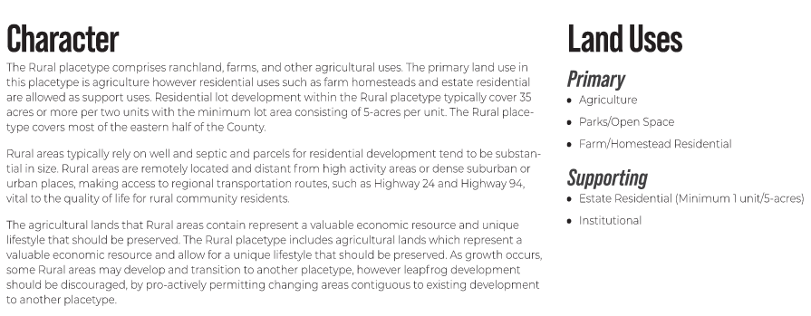

Goals, Objectives, Strategies:
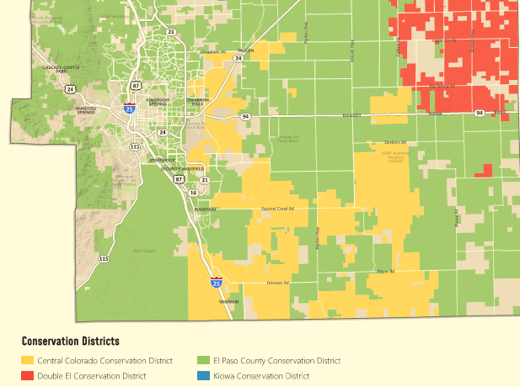

Area of Change Designation:
Description: Minimal Change: Undeveloped
The character of these areas is defined by a lack
of development and presence of significant
natural areas. These areas will experience some
redevelopment of select underutilized or vacant
sites adjacent to other built-out sites, but such
redevelopment will be limited in scale so as to
not alter the essential character. New development
may also occur in these areas on previously
undeveloped land, but overall there will be no
change to the prioritized rural and natural environments
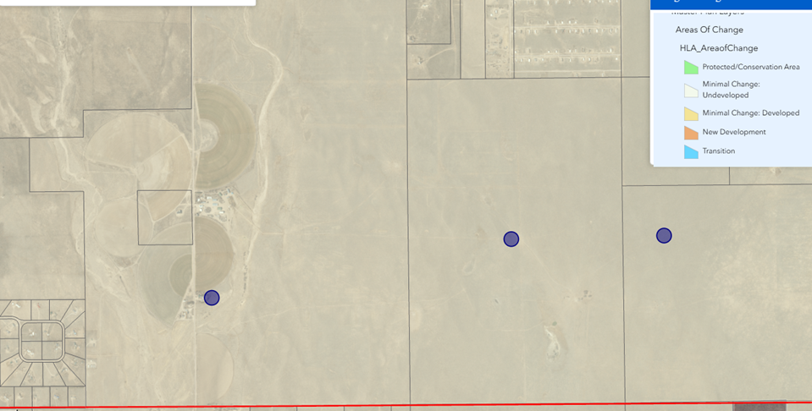

Goals, Objectives, Strategies:
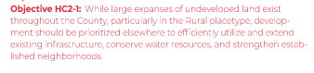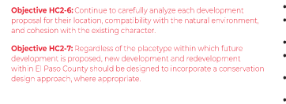

Key Area: Not Within but Military Buffer Area

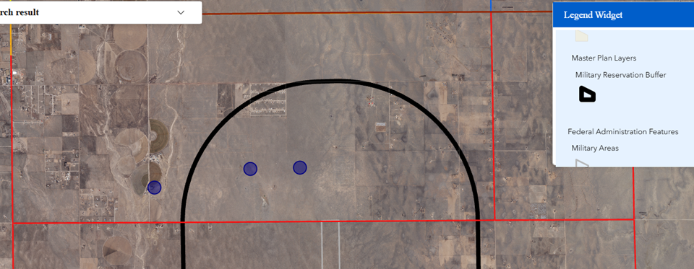

Goals, Objectives, Strategies:
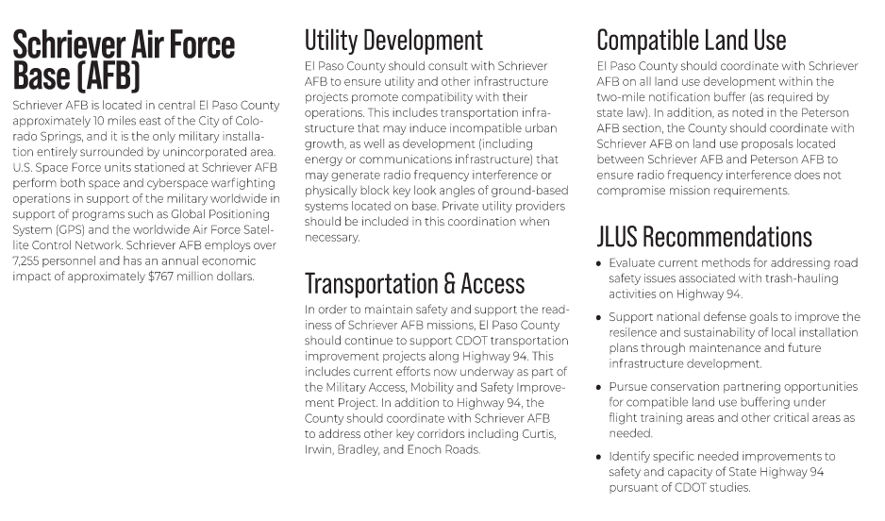

Water Master Plan Area: 4C (west)and 6 (east half)
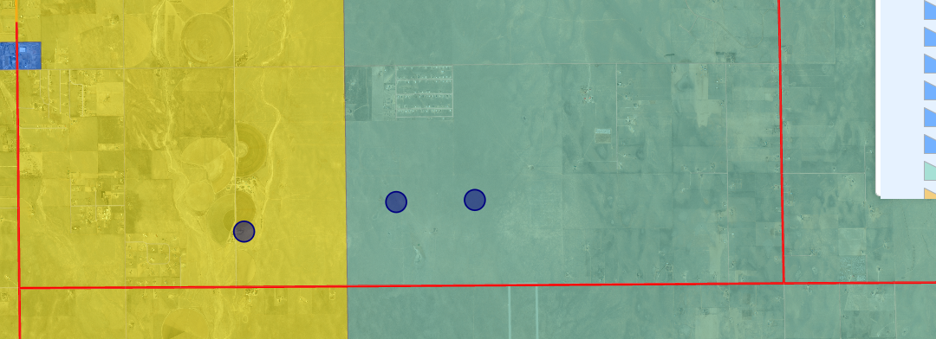

Recommendations:
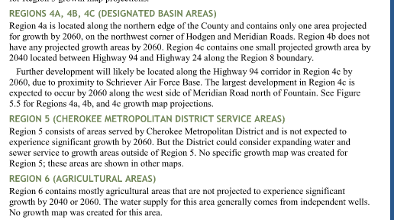

Wildlife impact: Moderate - Low
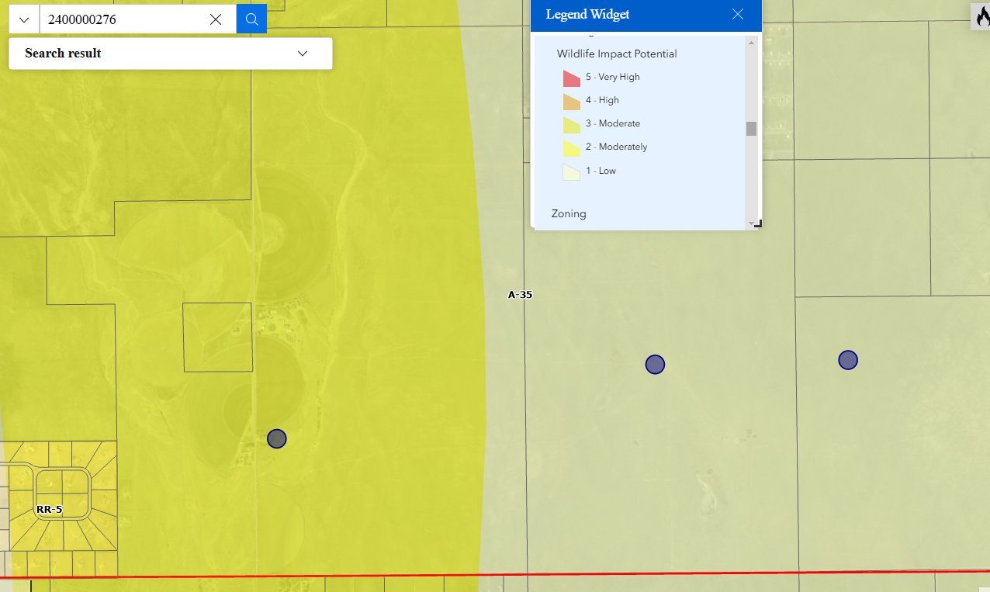

Parks Master Plan: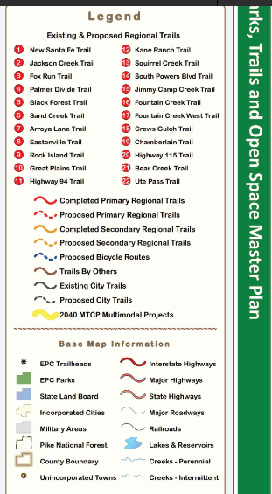
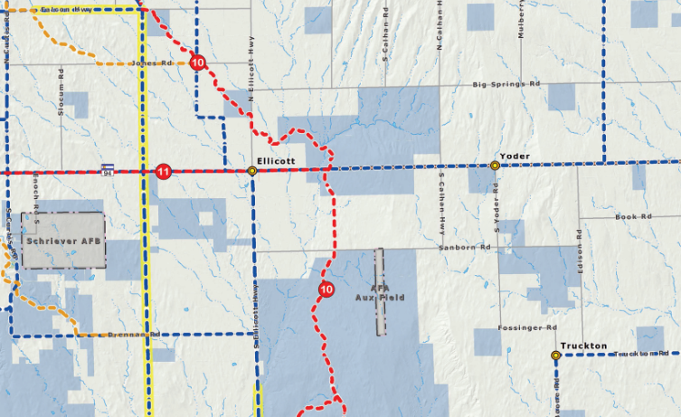

Helpful Links

Planning Website: https://planningdevelopment.elpasoco.com/

El Paso County Master Plan: https://planningdevelopment.elpasoco.com/#1510603950097-f5d985dc-35b2
Parks, Mineral and Water Master Plan: https://planningdevelopment.elpasoco.com/resources-and-references/#1516982531779-52cc0e87-01af

Forms and Templates: https://planningdevelopment.elpasoco.com/planning-development-forms/#1510677560407-ff8cfff5-69b2716b-00f9cbba-0c21

Land Development Code: https://library.municode.com/co/el_paso_county/codes/land_development_code

EDARP: https://epcdevplanreview.com/

Public GIS: https://elpasoco.maps.arcgis.com/apps/View/index.html?appid=5be6431018594c67b035ad0aad3e7e8a

Wrap Up
-If subdivision is proposed, recording fees, park and school fees and road impact fees apply.
-Fees are subject to change. The fees at the time of application apply.
-Pursuant to the adopted El Paso County Road Impact Fee Program (Resolution No. 24-337), a transportation impact fee, calculated on a per trip basis, may be due at the time of building permit issuance. Starting January 1, 2020 the transportation impact fee will be due for all new construction (Resolution No. 19-471).
-The fee for any additional waiver/deviation requests (more than two) - $550.00 each. Please note that requests for waivers and/or deviations may result in additional processing/review delay.
-All items requested must accompany the submittal for it to be complete, prior to payment request or the submittal will not be complete and ready for review agencies.
-A temporary use permit shall be applied for and approved for any staging area associated with development, such as a sales office, construction trailer, or contractor's equipment yard, prior to scheduling of the pre-construction meeting with El Paso County Planning and Community Development. If a Planned Unit Development is proposed, the temporary staging area should be shown on the development guideline and phasing plan.
-All prospective timelines for review are subject to departmental staffing and workload.
-Early Assistance is valid for 12 months from submittal of the EA application. If a project submittal is not received within 12 months, a new EA meeting may be required. An audio/video copy of the meeting is available in EDARP within the EA folder.
- Applications scheduled for public hearings may be heard as a regular item at the request of staff or a hearing body member.
- Any comments or commitments made by any member of the County Staff during this early assistance meeting are only preliminary in nature and should not be relied upon by the applicant. All prospective applicants should be informed that formal comments cannot be made by staff until after the application is submitted.

