
May 28, 2025

El Paso County
Development Services Division

2880 International Circle
Colorado Springs, CO 80910

RE: Sterling Ranch Filing No. 5 – Public Storm Sewer

The public storm drainage facilities for Sterling Ranch Filing 5 consist of the following facilities:

- (1) 5’ Type R Inlet - (1) 10’ Type R Inlet s
- (1) 15’ Type R Inlet - (212 LF) 18” RCP Storm Drain
- (3) CDOT Type C Inlet - (626 LF) 24” RCP Storm Drain
- (1) CDOT Type D Inlet - (24 LF) 36” RCP Storm Drain
- (6) Storm Manholes Box Base

The above listed storm system was recently installed by Classic SRJ Land, LLC and per the approved drainage report, the storm system drains to Pond W-5 constructed with Sterling Ranch Filing No. 2 which is subject to a separate certification.

The site and adjacent properties (as affected by work performed under the County permit) appear to be stable with respect to settlement and subsidence, sloughing of cut and fill slopes, revegetation or other ground cover, and the improvements (public improvements, common development improvements, site grading and paving) meet or exceed the minimum design requirements.

Based upon information gathered during periodic site visits to the project and the as-built drawings, JR Engineering is of the opinion that the storm drainage facilities have been constructed in general compliance with the approved design plans and specifications as filed with the County.

On behalf of Classic SRJ Land, LLC, JR Engineering hereby requests probationary inspection of these facilities by County Engineering so that the warranty period can begin.

Statement Of Engineer In Responsible Charge:
To the best of my knowledge, information and belief, the referenced public storm drainage facilities have been constructed in general compliance with the approved design plans and specifications as filed with El Paso County.

Respectfully submitted,

JR ENGINEERING, LLC

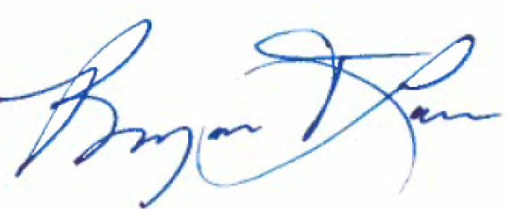
Bryan Law, PE
Colorado No. 25043

