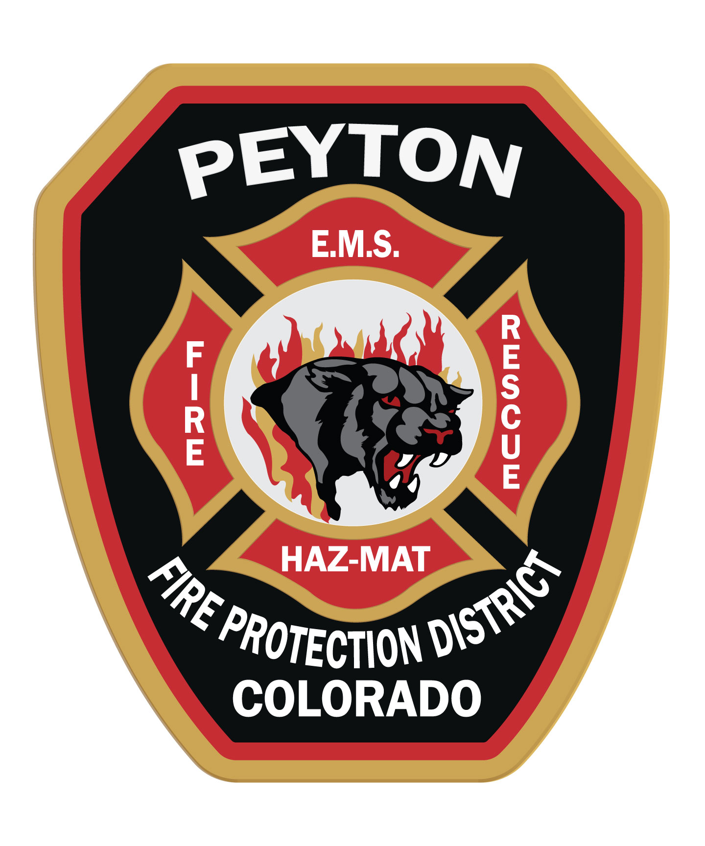
Peyton Fire Protection District
P.O. Box 98, Peyton Colorado, 80831
719-749-2255
Fax: 719-749-9005

30 December 2019
LETTER OF COMMITMENT

PROJECT: mountains Edge
To Whom it may Concern:

Mountains Edge is located within the District Boundaries of the Peyton Fire Protection District, “the District”. The District agrees to provide EMS services to the Mountains Edge Development. The District requires access roads to be 20 ft. wide with 13.5 ft. vertical clearance and hard packed to carry rescue and fire apparatus. The district requirements are outlined in NFPA 1 Uniform Fire Code 2006 Edition, Chapter 18.
The district will require a 30,000-gallon cistern and centrally accessible off of McClelland road for fire protection if no centralized water system is available prior to the time home construction starts. The cost of the cistern and maintenance thereof will be the sole responsibility of the developer. The developer will also be responsible for filling the first time. Thereafter, The District will be responsible for maintaining adequate water levels.
The District will provide both Structural and Wildland Fire Suppression, Emergency Medical Services and Basic Life Support Services, community fire safety education. We also respond to both traffic and medical situations as well as Search and Rescue.
If you have any further questions, please don’t hesitate to contact me.
Sincerely,

Chief Jeffery Turner
Peyton Fire Protection District
Cell (719)728-9871
Station (719) 749-2255

