Early Assistance Meeting Number: EA25129
Project Name: 12057 E. Highway 24 Map Amendment (Rezoning)
Project Location: 12057 E. Highway 24
Project Parcel No.: 430700007
Project Description: The property owner, James Kyle, is proposing a map amendment (rezoning) of parcel no. 4307200007 from RR-5 (Residential Rural) to RM-30 (Residential Multi-Dwelling) to allow for development of multi-family residential dwellings. The property takes direct access from the south side of Highway 24 between Old Meridian Road and Woodmen Road. Your El Paso County Master Plan identifies the property as being within the Transition Area of Change and the Regional Center Placetype, which specifically identifies "Multifamily Residential" as a Primary land use. More specifically, the Character description of the Regional Center Placetype states that this area "can include multifamily housing elements in their design as standalone apartments or part of mixed-use developments" and that "Multifamily apartments provide commercial businesses direct access to potential customers."
Meeting Date: December 2, 2025, at 10:30 AM

El Paso County Planning & Community Development Planning Checklist

Request – Map Provided by Applicant
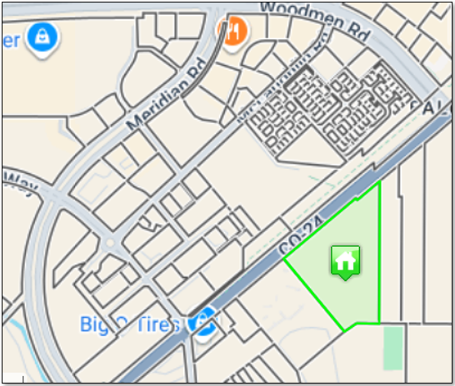

Zoning
Existing Zone(s)
Zone |  | Name
RR-5 |  | Residential Rural
Proposed Zone(s)
Zone |  | Name
RM-30 |  | Residential Multi-Dwelling

Zone Map (existing conditions of approval)
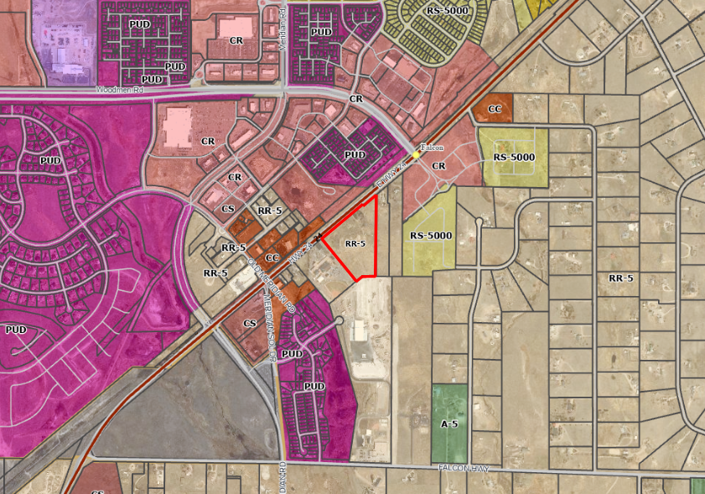

Zoning Analysis
The Land Development Code (LDC) Sec. 3.2.4(B) describes the RM-30, Residential Multi-Dwelling District as a 30-dwelling unit per acre district primarily intended to accommodate moderate-density multi-dwelling development.

The maximum density in the RR-5 zoning district would be one dwelling on a 5 acres lot. The request would significantly increase the allowable density. While there is no RM-30 zoning in the immediate vicinity, the area is characterized by a variety of housing types and densities Including RR-5, RR-0.5, RS-5000, RM-12 and PUD zoning.

Depending on the proposed density, RM-12 may be a more appropriate request due to nearby RM-12 zoning. This would impact how the proposal is reviewed based on reviewing for ‘highest and best’ use based on proposed zone district.

Zoning District Requirements (density, lot size, lot design standards, building setbacks)
Zone District | Max Density (DU/ac) | Min. Lot Size | Min. Setbacks |  |  | Max. Lot Coverage | Max. Height
Zone District | Max Density (DU/ac) | Min. Lot Size | Front | Rear | Side | Max. Lot Coverage | Max. Height
RR-5 | - | 5 acres | 25’ | 25’ | 25’ | 25% | 30’
RM-30 | 30 | 5,000 sf ^{9,13} | 25’ ^{10,13} | 15’ ^{10,13} | 15’ ^{10,13} | 60% | 40’
RM-12 | 12 | 3,500 sf ^{8,13} | 20’ ^{10,13} | 15’ ^{10,13} | 5’ ^{10,13} | 70% | 40’

⁸ The minimum lot area of 3,500 square feet applies to single family attached dwellings. The minimum lot area for single-family detached dwelling units is 3,500 square feet. The minimum lot area for two-family dwellings and all other allowed uses is 7,000 square feet. Central water and wastewater services are required regardless of lot size or conforming status.

⁹ Minimum lot area of 5,000 square feet applies to single-family detached dwellings, Two-family dwellings and the first 2 units of a multi-family development. An additional 1,000 square feet of lot area is required each additional dwelling unit within a multi-family development. The maximum multi-family density may not exceed 30 dwelling units per acre. All other uses are subject to a minimum lot area of 7,000 square feet. Central water and wastewater services are required regardless of lot size or conforming status.

¹⁰ The minimum distance between buildings shall be 10 feet.

¹³ If the building is established as or converted to condominium or townhome units in accordance with Chapter 7 of this Code, the building and lot shall meet the minimum lot area and setbacks requirements, but the individual units are not required to meet the minimum lot area, maximum lot coverage, or setback requirements. Within the zoning district, a 25 foot perimeter boundary setback shall be maintained around the entire development, but a zero foot setback is allowed along any internal lot line within the development.

Application Type(s)
Final Plat | Public Hearing is Required
Map Amendment (Rezoning) | Public Hearing is Required
Site Development Plan | Public Hearing is NOT Required

Approval Criteria:
LDC Sec. 7.2.1(3) Final Plat
(f) Criteria for Approval. In approving a final plat, the approving authority shall find that:
- The subdivision is in conformance with the goals, objectives, and policies of the Master Plan;
- The subdivision is in substantial conformance with the approved preliminary plan;
- The subdivision is consistent with the subdivision design standards and regulations and meets all planning, engineering, and surveying requirements of the County for maps, data, surveys, analyses, studies, reports, plans, designs, documents, and other supporting materials;
- Either a sufficient water supply has been acquired in terms of quantity, quality, and dependability for the type of subdivision proposed, as determined in accordance with the standards set forth in the water supply standards [C.R.S. § 30-28-133(6)(a)] and the requirements of Chapter 8 of this Code, or, with respect to applications for administrative final plat approval, such finding was previously made by the BoCC at the time of preliminary plan approval;
- A public sewage disposal system has been established and, if other methods of sewage disposal are proposed, the system complies with State and local laws and regulations, [C.R.S. § 30-28-133(6)(b)] and the requirements of Chapter 8 of this Code;
- All areas of the proposed subdivision which may involve soil or topographical conditions presenting hazards or requiring special precautions have been identified and that the proposed subdivision is compatible with such conditions [C.R.S. § 30-28-133(6)(c)];
- Adequate drainage improvements are proposed that comply with State Statute [C.R.S. § 30-28-133(3)(c)(VIII)] and the requirements of this Code and the ECM;
- Legal and physical access is provided to all parcels by public rights-of-way or recorded easement, acceptable to the County in compliance with this Code and the ECM;
- Necessary services, including police and fire protection, recreation, utilities, and transportation systems, are or will be made available to serve the proposed subdivision;
- The final plans provide evidence to show that the proposed methods for fire protection comply with Chapter 6 of this Code;
- Off-site impacts were evaluated and related off-site improvements are roughly proportional and will mitigate the impacts of the subdivision in accordance with applicable requirements of Chapter 8;
- Adequate public facilities or infrastructure, or cash-in-lieu, for impacts reasonably related to the proposed subdivision have been constructed or are financially guaranteed through the SIA so the impacts of the subdivision will be adequately mitigated;
- The subdivision meets other applicable sections of Chapter 6 and 8; and
- The extraction of any known commercial mining deposit shall not be impeded by this subdivision [C.R.S. §§ 34-1-302(1), et seq.]

Land Development Code Section 5.3.5. Map Amendment (Rezoning)
(B) Criteria for Approval. In approving a Map Amendment, the following findings shall be made:
- The application is in general conformance with the El Paso County Master Plan including applicable Small Area Plans or there has been a substantial change in the character of the neighborhood since the land was last zoned;
- The rezoning is in compliance with all applicable statutory provisions, including but not limited to C.R.S. § 30-28-111 § 30-28-113, and § 30-28-116;
- The proposed land use or zone district is compatible with the existing and permitted land uses and zone districts in all directions; and
- The site is suitable for the intended use, including the ability to meet the standards as described in Chapter 5 of the Land Development Code, for the intended zone district.

Processing Issues and Options
This use will require central water and wastewater services.

A second access may be required due to unit count and design which will necessitate collaboration with neighbors. The Commons at Falcon Field Filing 3 is planning for a connection that may be a viable if you can work with the two properties in between. Alternatively, it may be an option to work with the school property to the west.

Platting is strongly recommended due to density. Platting would benefit the developer in that the process will address potential tracts, easements, HOA, and maintenance agreements.

Relevant Past History:
This property is considered a legal lot as it was created in 1961 prior to the 1972 subdivision regulations.
Design and Landscaping

Site Design/Layout (Lot pattern, circulation/road design, open space, preservation of natural features, compatibility internally and with adjacent land uses)
Access – coordination with CDOT and/or adjacent property owner(s).

Staff recommend looking into pedestrian connections to the adjacent school site.

Landscaping
☒ | Expressway, Principal arterial area depth – 25’-Trees required 1 per 20’
☐ | Urban interchange/Intersection area depth – 25’- N/A
☐ | Minor arterial area depth 20’ – Trees required 1 per 25’
☐ | Non-arterial area depth 10’ – Trees required 1 per 30’
☒ | Parking lot landscaping required
☐ | Buffer between non-residential and residential districts separated by a non-arterial road or public alley

Landscaping is not reviewed with the rezoning application but will be part of the site development plan. Please review LDC Sec. 6.2.2 for specific requirements.

Signage:
Signage is not reviewed with the rezoning application but will be part of the site development plan. Please review LDC Sec. 6.2.10 for specific requirements.

Parking Requirements:
Parking is not reviewed with the rezoning application but will be part of the site development plan. Please review LDC Sec. 6.2.5 for specific requirements. Multi-Family Residential parking is calculated based on bedrooms.

Studio or Efficiency | 1.1 spaces per dwelling unit
1 Bedroom | 1.5 spaces per dwelling unit
2 Bedroom | 1.7 spaces per dwelling unit
3 Bedroom | 2.0 spaces per dwelling unit
Guest | 1 space per 3 dwelling units
Elderly (60 or over) | 0.6 spaces per dwelling unit

Lighting:
Lighting is not reviewed with the rezoning application but will be part of the site development plan. Please review LDC Sec. 6.2.3 for specific requirements.

Site Characteristics\ Constraints\ Environmental Standards:
Potential habitat for the Preble’s mouse. Due to extremely limited impact, staff would not be looking for a clearance letter with the plat.
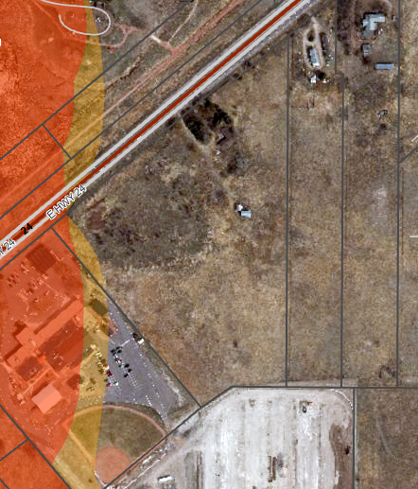

Some slope in the center of the property:
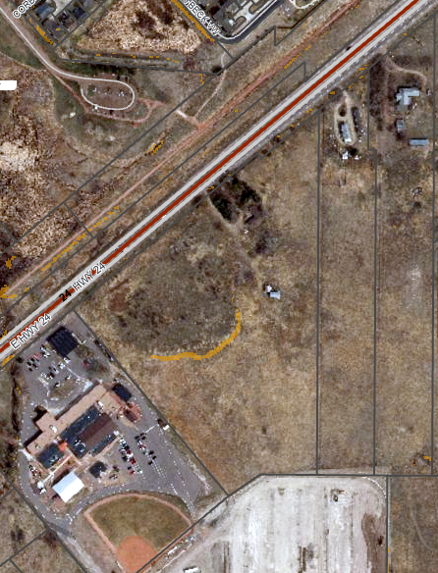

☒ | 30% or greater slope | Comment: |  | None
☐ | CGS review required (separate fee to CGS) | Comment: |  | None
☐ | Floodplain | Comment: |  | None
☐ | Noise mitigation required | Comment: |  | None
☒ | Preble’s mouse | Comment: | Letter not required

Districts
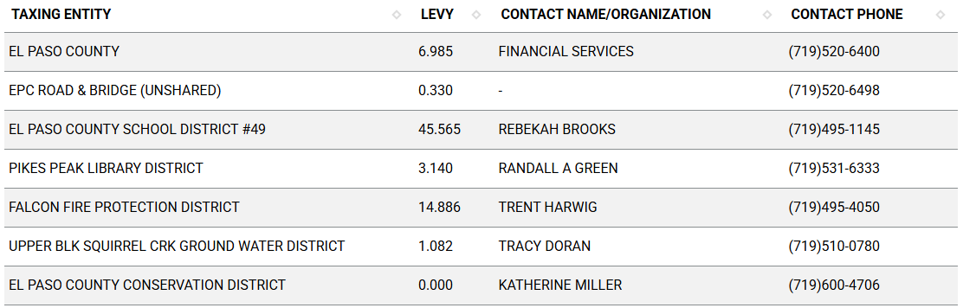
Proposed source of water |  |  | Proposed method of wastewater disposal
☐ | Central System |  | ☐ | Central System
District Name: |  |  | District Name:

Water/wastewater comments
The site is currently served by well and septic. In order to develop as multi-family, central services will need to be provided. It appears that Woodmen Hills is the closest Metro District providing water/wastewater near this property.

Fire District:
Falcon Fire, Fire Marshal Curtis Kauffman ckauffman@falconfirepd.org

Multi-family is required to be sprinklered by the International Building Code.
Water for fire suppression and access for fire apparatus are required.

Wildland Fire and Hazard Mitigation Plan:
The site is not shown as vegetated on the County GIS but is in a Low Hazard area for the Colorado Wildfire Resiliency Code map. This will require hardened structure and landscaping to match the hazard upon code implementation on July 1, 2026.

Roland Peterson
Fire Safety and Wildfire Mitigation Program Manager
Planning & Community Development
719.520.6075
rolandpeteson@elpasoco.com

Commissioner District: District 2; Commissioner Geitner

Parks and trails:
The 2022 El Paso County Parks Master Plan shows no impacts to existing or proposed parks, trails, or open space. As such no trail easement dedications will be necessary for this project. Regional park fees will be assessed upon review of the forthcoming platting actions.
However, if this project is to be rezoned and then go into a Site Development Plan application without being platted, El Paso County Parks staff must review and assess the project for parks fees which would be required at the Site Development Plan stage.
Contact:
Ashlyn Mathy
Parks Planner
Park Planning Division
El Paso County Parks Department
Office 719.520.6999

Annexations/Intergovernmental/ Jurisdictional Access issues:
This property is identified in the master plan as an area that is likely to be annexed, however it is not directly adjacent to city limits at this time. The Colorado Springs Planning & Community Development department was invited to the meeting and has not provided comment at this time.

Wildlife impact
This property is considered to have a low wildlife impact potential.

Your El Paso Master Plan

Placetype: Regional Center
Character:
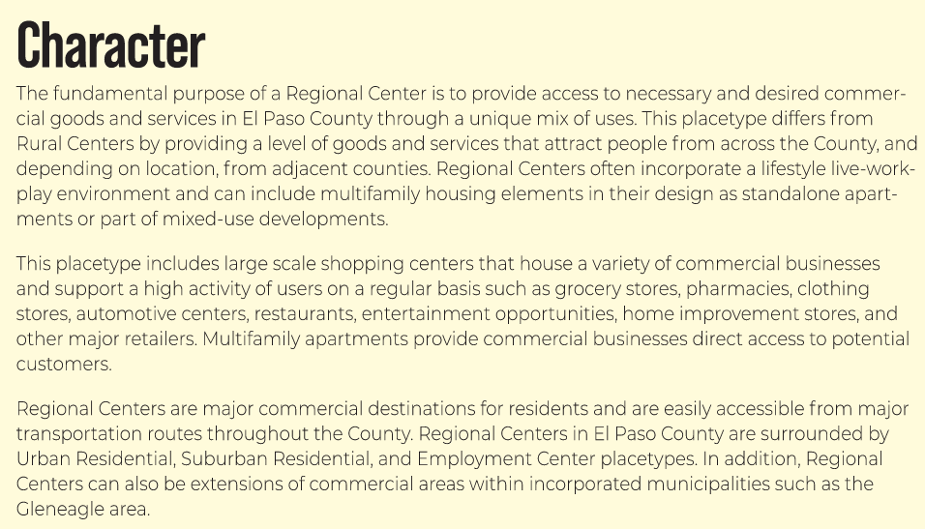

Recommended Land Uses:
- Primary: Restaurant, Commercial Retail, Commercial Service, Entertainment, Multifamily Residential

Support: Office, Institutional, Mixed Use, Single-Family Attached Residential

Area of Change Designation: Transition
Description:
Transition areas are fully developed parts of the County that may completely or significantly change in character. In these areas, redevelopment is expected to be intense enough to transition the existing development setting to an entirely new type of development. For example, a failing strip of commercial development could be redeveloped with light industrial or office uses that result in a transition to an employment hub or business park. Another example of such a transition would be if a blighted suburban neighborhood were to experience redevelopment with significant amounts of multifamily housing or commercial development of a larger scale in line with commercial center.

Key Area: Potential Areas for Annexation

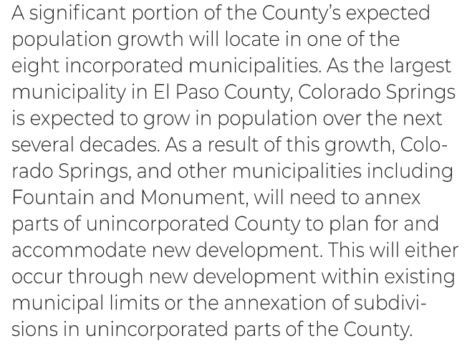
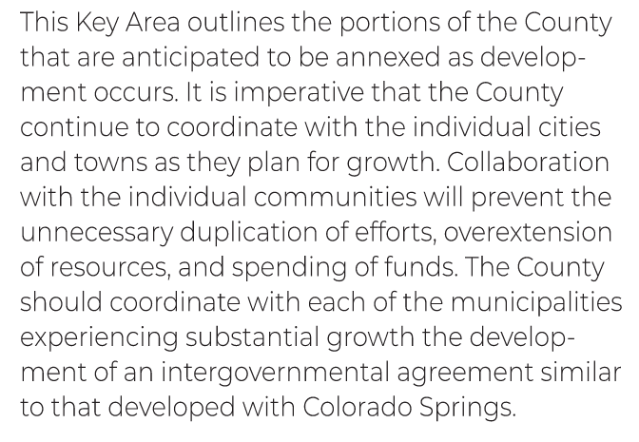

Helpful Links

Planning Website: https://planningdevelopment.elpasoco.com/

El Paso County Master Plan: https://planningdevelopment.elpasoco.com/#1510603950097-f5d985dc-35b2
Parks, Mineral and Water Master Plan: https://planningdevelopment.elpasoco.com/resources-and-references/#1516982531779-52cc0e87-01af

Forms and Templates: https://planningdevelopment.elpasoco.com/planning-development-forms/#1510677560407-ff8cfff5-69b2716b-00f9cbba-0c21

Land Development Code: https://library.municode.com/co/el_paso_county/codes/land_development_code

EDARP: https://epcdevplanreview.com/

Public GIS: https://elpasoco.maps.arcgis.com/apps/View/index.html?appid=5be6431018594c67b035ad0aad3e7e8a

Wrap Up
-If subdivision is proposed, recording fees, park and school fees and road impact fees may apply.

-Fees are subject to change. The fees at the time of application apply.

-Road Impact Fees
Please see the following website for information on the EPC Road Impact Fee Project. https://publicworks.elpasoco.com/road-impact-fees/ to include fee schedule.
As of December 15, 2016, per Resolution 16-454, on and after January 1, 2020, property in the unincorporated area of the county that receives a Land Use Approval either in a public hearing or administratively, is subject to the payment of Road Impact Fees. After December 31, 2024, in accordance with BoCC Resolution 24-377 the fee is paid for new residential and non-residential uses and structures and expansions of non-residential uses and structures. Road Impact fees are typically paid at time of building permit. If no building permit is being obtained for a particular Land Use application, then Road Impact Fees must be paid at the time of Site Development Plan or Special Use approval. If there are questions about EPC Road Impact program or fees, please contact DPW Development Review Services and the Engineer of the Day.

- Engineering Criteria Manual (ECM) Deviations.
The fee for any additional ECM deviation requests (more than two per land use application) - $1483.00 each per current Fee Schedule. Please note ECM deviation requests may result in additional processing and project review time. ECM Deviations should be submitted prior to the initial Site Development Plan or Final Plat submittal to preclude changes having to be made to engineering plans and documents if the deviation is not approved. Submission of an ECM deviation request does not imply or guarantee that the deviation will be approved. An ECM Deviation form must be submitted to include complete exhibits and justification excluding cost with supporting engineering criteria. If there are questions about ECM Deviation requests, please contact DPW Development Review Services and the Engineer of the Day.

-The fee for any additional waiver/deviation requests (more than two) - $550.00 each. Please note that requests for waivers and/or deviations may result in additional processing/review delay.

-All items requested must accompany the submittal for it to be complete, prior to payment request or the submittal will not be complete and ready for review agencies.

-A temporary use permit shall be applied for and approved for any staging area associated with development, such as a sales office, construction trailer, or contractor's equipment yard, prior to scheduling of the pre-construction meeting with El Paso County Planning and Community Development. If a Planned Unit Development is proposed, the temporary staging area should be shown on the development guideline and phasing plan.

-All prospective timelines for review are subject to departmental staffing and workload.

-Early Assistance is valid for 12 months from submittal of the EA application. If a project submittal is not received within 12 months, a new EA meeting may be required. An audio/video copy of the meeting is available in EDARP within the EA folder.

- Applications scheduled for public hearings may be heard as a regular item at the request of staff or a hearing body member.

- Any comments or commitments made by any member of the County Staff during this early assistance meeting are only preliminary in nature and should not be relied upon by the applicant. All prospective applicants should be informed that formal comments cannot be made by staff until after the application is submitted.

