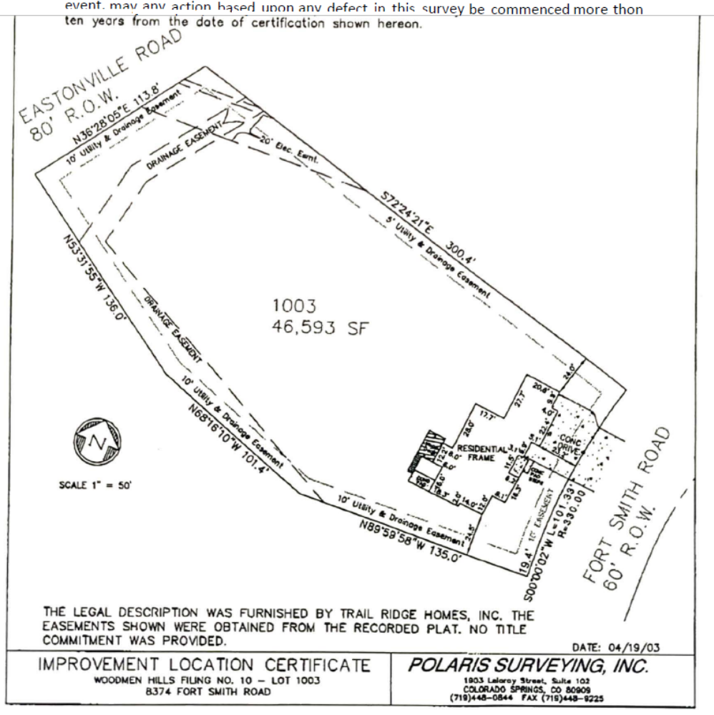
Existing
4’ tall x 12’ wide
Vehicle gate
(picture pg4)
Concrete apron
14’W x 20’L
Concrete apron
50’W x 20’L
Concrete apron 10’W x 5’L
60’
50’
48’ 11” to fence
48’ 5”
to fence
48’ 6” to fence
48’ 11” to fence
Proposed 3000’ sq ft garage/workshop
60’W x 50’L x18’H
84’ 7” to fence

95’ 3” house to apron

Proposed Structure Site Plan
- The proposed structure will sit almost in the center of the lot.
- No electricity will be added at this time
- No water or wastewater systems will be added at this time
- There are no above ground utility lines on the property
- Lot size is 1.069 acres
- There are no sidewalks or trails
- Entire back yard is surrounded by 4’ vinyl split rail fence
- No signage required
- Color scheme will match the residence, light tan with dark brown trim
- Landscaping is intended soon that will comply with existing covenants and compliment surrounding homes

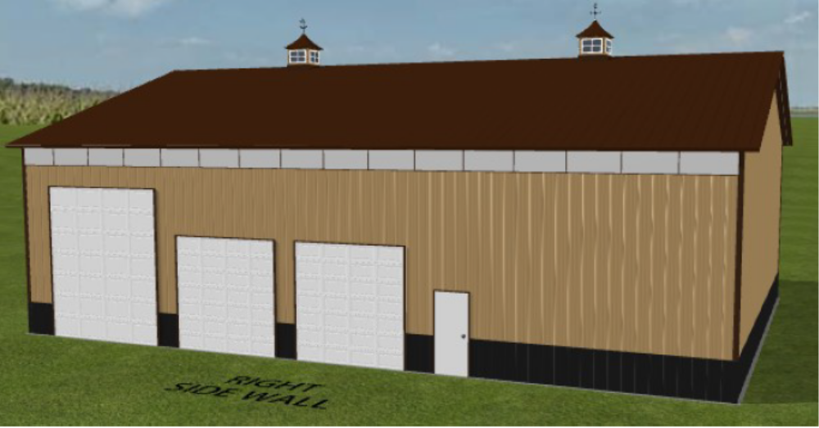

Existing
4’ tall x 12’ wide
Vehicle gate
(picture pg4)
Driveway
Gas Service Line
Gas Meter
Phone Line
Phone Line Box

Proposed Structure Site Plan
- There is currently a 12’ vehicle gate
- The proposed driveway will be composed of recycled asphalt
- Existing vehicle gate is 20yrs old installed by a professional fencing company. The gate is 3’5” tall x 12’ wide, picture of gate on page 4.

Vehicle gate is 4’ tall 12’ wide.
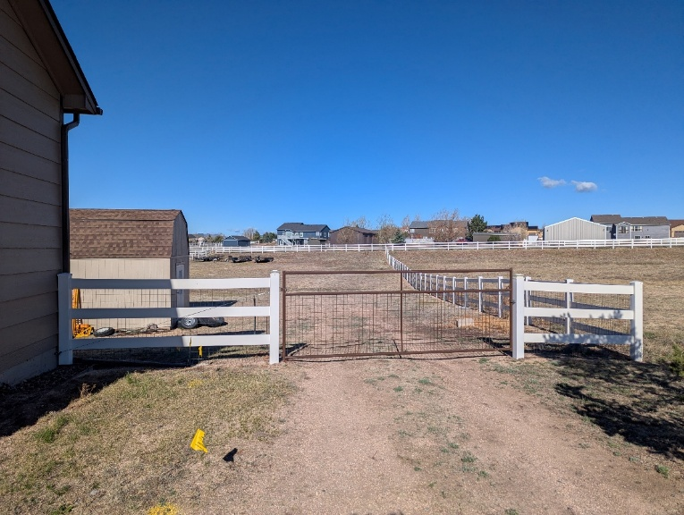

Top view simulation, not to scale.
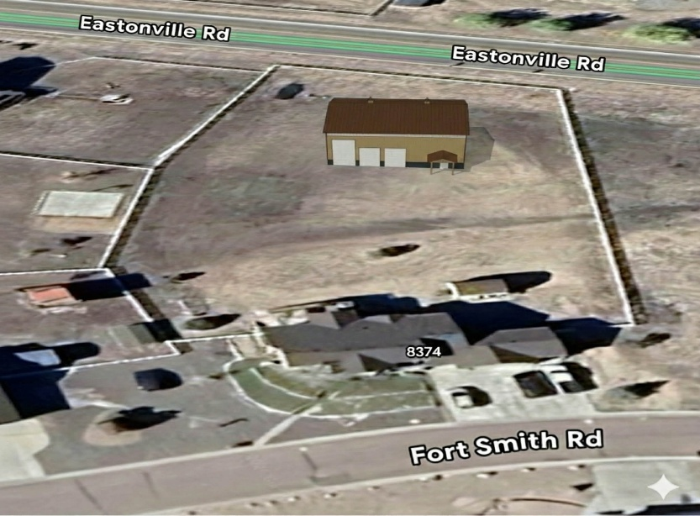
Existing
4’ tall x 12’ wide
Vehicle gate

