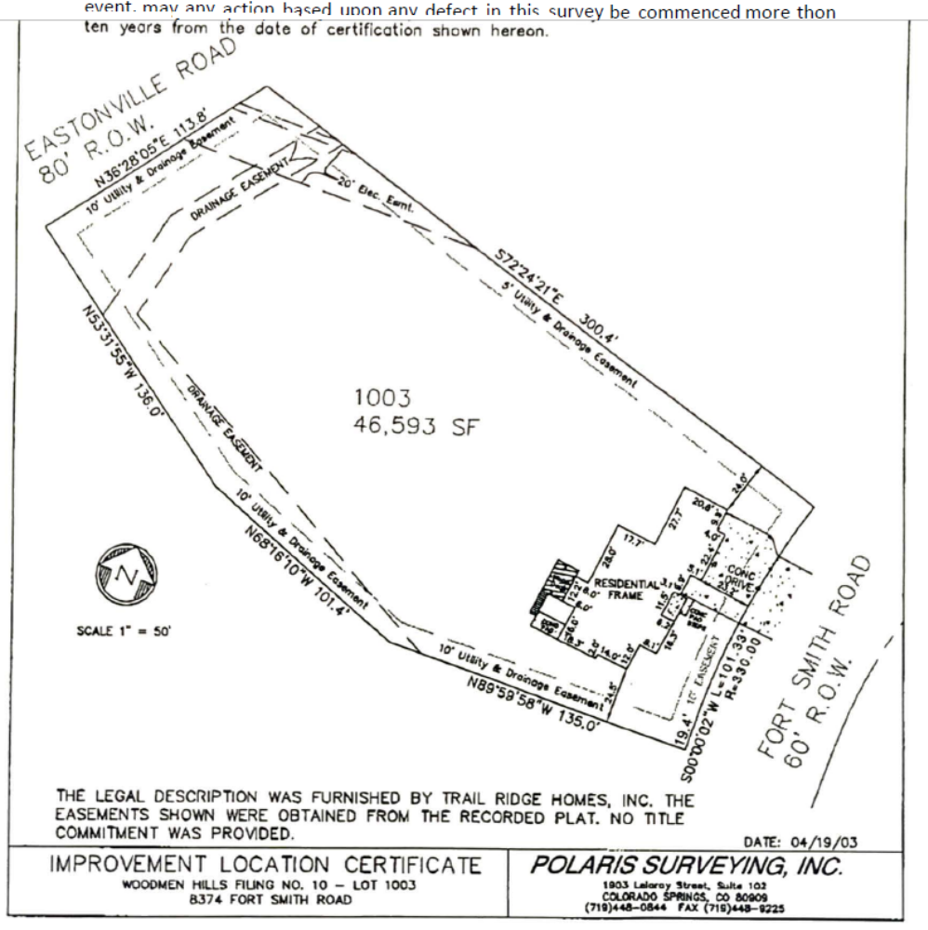
Concrete apron
14’W x 20’L
12’ Vehicle gate
Concrete apron
50’W x 20’L
Concrete apron 10’W x 5’L
60’
50’
48’ 11” to fence
48’ 5”
to fence
48’ 6” to fence
48’ 11” to fence
Proposed 3000’ sq ft garage/workshop
60’W x 50’L x18’H
84’ 7” to fence

95’ 3” house to apron

Proposed Structure Site Plan
- The proposed structure will sit almost in the center of the lot.
- No electricity will be added at this time
- No water or wastewater systems will be added at this time
- There are no above ground utility lines on the property
- Lot size is 1.069 acres
- There are no sidewalks or trails
- Entire back yard is surrounded by 4’ vinyl split rail fence
- No signage required
- Color scheme will match the residence, light tan with dark brown trim
- Landscaping is intended soon that will comply with existing covenants and compliment surrounding homes

