Early Assistance Meeting Number: EA2599
Project Name: Pallas and Davids
Project Location: 38435 JUDGE ORR RD
CALHAN, CO 80808
Project Parcel Nos. 300000005
Project Description: Building our house on this property. Building an animal rescue and camping for RV's and tiny homes for veterans that will gain therapy from working with the rescue. MVEA 3 meter boxes; RV pads for guests and volunteers.
Meeting Date:

El Paso County Planning & Community Development Planning Checklist

Request – Map Provided by Applicant
No Map Provided
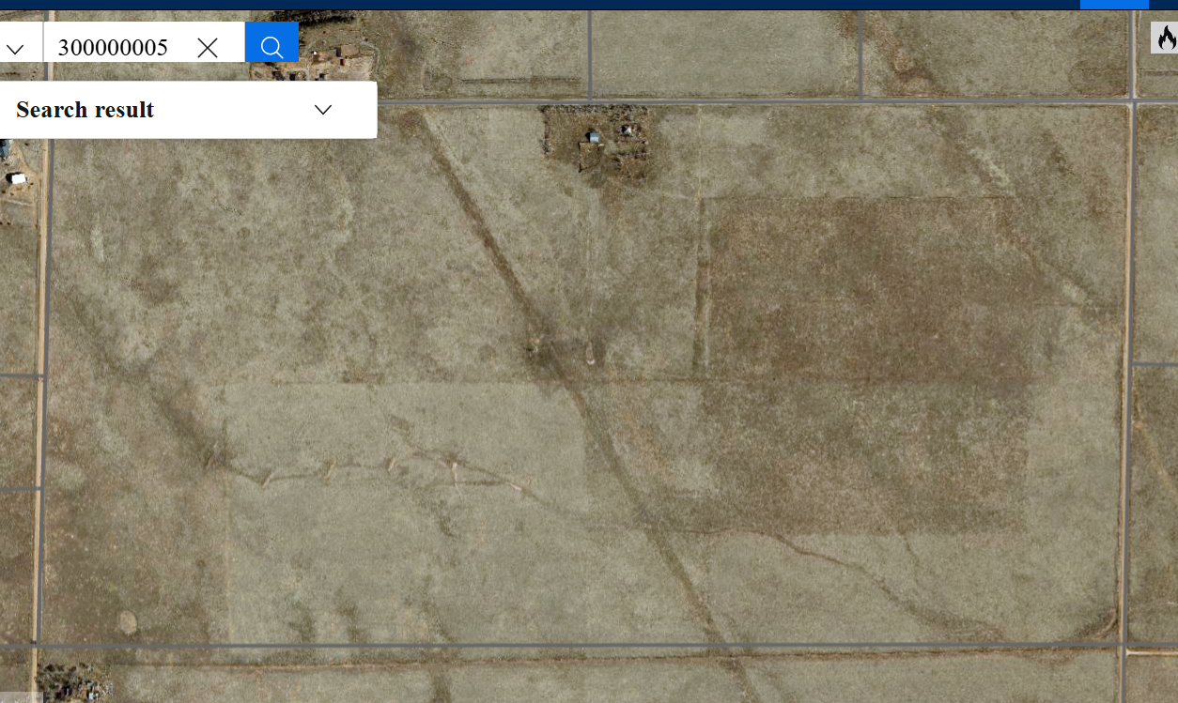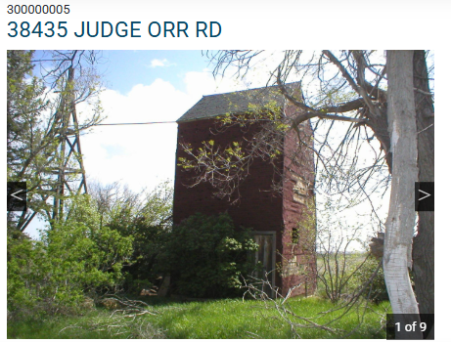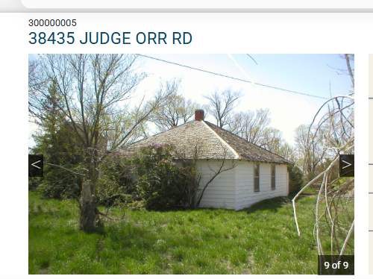Demolish house; keeping barn

Zoning
Existing Zone(s)
Zone |  | Name
A35 |  | Agricultural
Proposed Zone(s)
Zone |  | Name
Unlikely to be rezoned

Zone Map (existing conditions of approval)
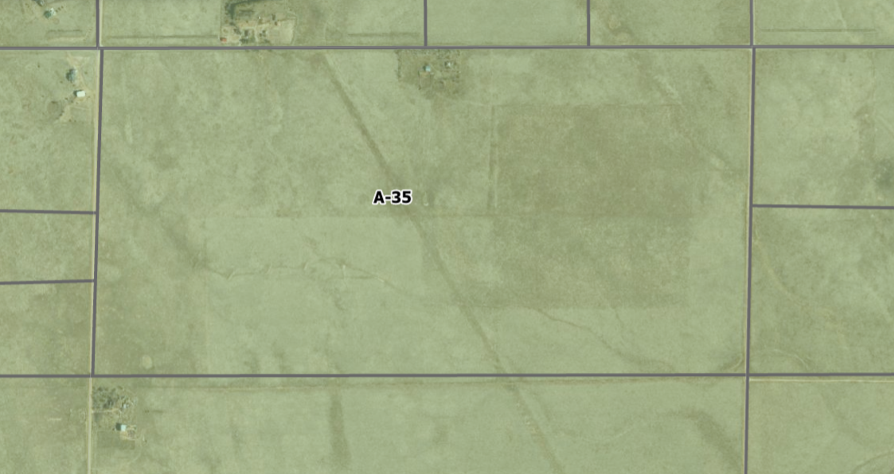

Zoning Analysis
A-35 Principal uses

2 SF homes allowed and one ALQ not full time & not for numeration (rent)

Animal Refuge is a special use

Animal Keeping — The activity of having, owning, or caring for domesticated animals, including animals not commonly regarded as household pets.

Animal Refuge — A facility, other than a veterinary hospital, for the care and keeping of abandoned, injured, or confiscated animals, including domesticated or exotic species. Also includes what is commonly considered animal rescue or similar type facilities.

Outdoor kennel – perimeter fencing 10’ max.
PACFA - Pet Animal Care and Facilities Act

Recreation Camp is a special use

Recreation Camp — A place used as a destination point for visitors, for vacationing or other recreational purposes which may include permanent structures and temporary facilities such as tents or yurts for the use of guests which facilities may contain cooking facilities and are used for temporary occupancy(not to exceed 30 consecutive days or a total of 90 days in 1 calendar year). This term shall not be interpreted to include hotels, motels, restaurants, and theaters but would include land uses commonly considered as campgrounds, dude ranches, resorts or retreats.

Recreational Vehicle Park — An area within the RVP zoning district planned exclusively for the parking or temporary storage of 2 or more recreational vehicles for temporary or long term occupancy as a housing unit.

Accessory uses post SF home
Kennel, Major Allowed Accessory in A-35

Kennel, Major — Any place or premises used in whole or in part for the purpose of keeping, training, boarding, breeding or sale of domesticated dogs or cats in which 9 or more dogs or cats exist, and all of which exceed 4 months in age, to include animal pounds, animal daycare facilities, and shelters. Establishments where animals are offered for sale as the primary use, such as pet stores, are not classified as kennels.

Wildlife Rehabilitation Accessory Use Allowed in A-35

Wildlife Rehabilitation — The act of rehabilitating sick, injured, or orphaned wildlife by a person licensed by the Colorado Division of Wildlife, but excluding veterinarians, for the purpose of returning them back to the wild.

Temp use for RV living if building permit is active….
Shipping Container allowed if the principal use is active
Shipping Container Temporary Allowed

Zoning District Requirements (density, lot size, lot design standards, building setbacks)
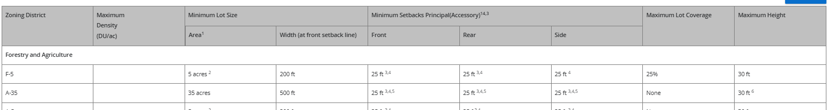

Plat Map or Parcel Map (conditions of approval):
Land Survey Deposit
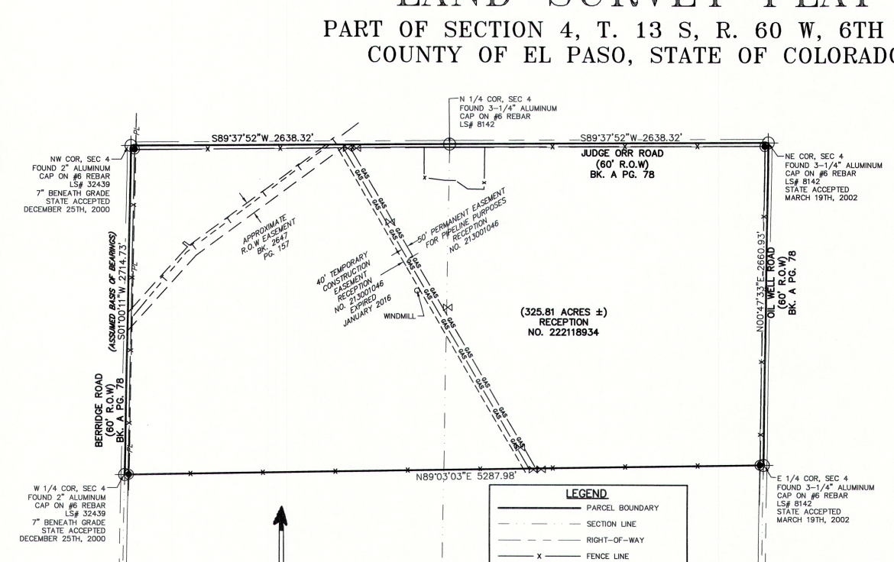

Application Type(s) Hearing: Required/ Optional/ No
May be Special Use | If Opposition
Site Dev Plan | NO

Approval Criteria:
If Special Use:

5.3.2. Special Use

(A)Purpose. The purpose of the special use process is to address potential impacts of certain land uses on existing and allowed uses in the same neighborhood. The special use process considers the location, design, configuration, intensity, density, natural hazards and other relevant factors pertaining to the proposed use.(B)Applicability. No special use application shall be considered unless the underlying land is located within a particular zoning district which allows the proposed special use.(C)Criteria. In approving a special use, the following criteria may be considered:
• The special use is generally consistent with the applicable Master Plan;

• The special use will be in harmony with the character of the neighborhood, and will generally be compatible with the existing and allowable land uses in the surrounding area;

• The impact of the special use does not overburden or exceed the capacity of public facilities and services, or, in the alternative, the special use application demonstrates that it will provide adequate public facilities in a timely and efficient manner;

• The special use will not create unmitigated traffic congestion or traffic hazards in the surrounding area, and has adequate, legal access;

• The special use will comply with all applicable local, state, and federal laws and regulations regarding air, water, light, or noise pollution;

• The special use will not otherwise be detrimental to the public health, safety and welfare of the present or future residents of El Paso County; and/or

• The special use conforms or will conform to all other applicable County rules, regulations or ordinances.

4.2.5. RVP, Recreational Vehicle Park District
(A)
Purpose. The RVP district is intended to accommodate recreational vehicle parks, which are sites used for the location of occupied recreational vehicles.
(B)
Allowed, Special, Accessory, and Temporary Uses. The allowed, special, accessory, and temporary uses in the RVP district are shown in the use table in Chapter 5.
(C)
Use and Dimensional Standards. All uses and development in the RVP district are subject to following standards.
(1)
Minimum Area of Park. Recreational vehicle parks shall have a minimum area of 5 acres.
(2)
Density. No more than 25 recreational vehicles are allowed per acre of land.
(3)
Road Frontage. Recreational vehicle parks shall have at least 60 feet of frontage on a public road.
(4)
Height. Buildings and structures in the RVP district shall not exceed 30 feet in height.
(5)
Access. Recreational vehicle spaces shall access the interior roadway system within the park. No road access to any space from a public right-of-way is allowed.
(6)
Internal Roads and Sidewalks. The internal road system in a recreational vehicle park shall be privately owned, constructed and maintained, and shall be designed for safe and convenient access to all spaces and to facilities for common use by park occupants, and comply with the fire department or authority requirements. The roads shall be at least 25 feet in width for 2-way and 18 feet in width for 1-way travel. The radius on all curves shall be at least 40 feet. If cul-de-sacs are used, adequate vehicular turning space shall be provided, with a minimum turning radius of 40 feet. Road grades shall not exceed 6%. Sidewalks shall be provided to serve, accessory, and recreational buildings. Road and sidewalks shall be adequately lighted, in conformance with Chapter 6 and shall be hard-surfaced.
(7)
Water and Sewer. Water and wastewater facilities, including any sanitation dump stations, serving the recreational vehicle park shall comply with CDPHE and EPCPH regulations. If tent camping is allowed, provisions shall be made for appropriate sanitary facilities, to the satisfaction of the EPCPH.
(8)
Fire Protection. The recreational vehicle park shall comply with fire code regulations of the appropriate fire department or authority. Fires may only be made in stoves and other equipment intended for such purposes. The recreational vehicle park shall be kept free of litter, rubbish, and other inflammable materials.
(9)
Landscaping. Landscaping shall be in conformance with the requirements of Chapter 6. The boundary of the recreational vehicle park shall be buffered with, landscaping, hedges, evergreens, shrubbery or a 6-foot screening wall or fence installed to serve as a buffer from adjacent property. The landscaping, fences, or walls and adjacent setback areas shall be privately owned, constructed and maintained.
(10)
Recreation Area Requirements. At least 8% of the total area of a recreational vehicle park shall be set aside as open space for recreational purposes for park users. This area may not include area reserved for service facilities, setbacks, or other non-useable areas.
(11)
Storage Areas. Separate areas for temporary storage of boats, pull behind trailers, etc, if requested by PCD shall be reflected on the site development plan.
(12)
Recreational Vehicle Setback Standards. All recreational vehicles shall meet the setbacks in Table 4-6. Recreation vehicle park spaces shall be designed and located to ensure the setbacks will be met.
Table 4-6. Recreational Vehicle Setback Standards
Description | Standard
Minimum Recreational Vehicle Setbacks
From All Property Lines | 15 feet
From Other Recreational Vehicles | 20 feet
From Local or Collector Roads | 25 feet
From Arterial or Expressway | 50 feet
From Any Building or Structure | 20 feet
Minimum Accessory Structure Setbacks
From Exterior Lot Line of Park | 25 feet

(13)
Private Towers. Private towers, except crank up towers attached to vehicles, shall not be located upon recreational vehicle spaces. Private towers may be located within common areas, subject to the requirements of Chapter 5.
(14)
Animals. The occupants of each recreational vehicle may keep a maximum of 4 dogs or cats, subject to the requirements of Chapter 5.
(15)
Site Development Plan. Site development plan approval is required for all recreational vehicle parks prior to occupancy of the park. Any locations proposed for temporary events, storage or tent camping shall be reflected on the site development plan.
(16)
Maintenance Plan. A maintenance statement addressing ownership and maintenance shall be submitted with the rezoning request, in accordance with Chapter 6. The maintenance plan shall be submitted concurrently with the plat and recorded in conjunction with the plat. If the recreational vehicle park is exempted from subdivision, then the maintenance plan shall be submitted and recorded prior to approval of the site development plan.
(17)
Platting. Occupancy of a recreational vehicle is not allowed until the property is platted in accordance with the requirements of this Code, unless otherwise exempted by State Statute.
(18)
Signage. Any signage associated with the recreational vehicle park, and any temporary events shall conform to the requirements of Chapter 6.
(D)
General Development Standards. All uses and development in the RVP district are subject to the General Development Standards in Chapter 6.

Site Development Plan- Meets Chapter 6 of Code

Processing Issues and Options
Determine exactly which other uses to be requested- Special Use and Site Development Plan post Residential Site Plan, Driveway access BESQCP; septic system install (Do this first to clear Code Violation)

RVP zoning would require zone change for a portion of property-

Temp use for RV living if building permit is active….
Shipping Container allowed if the principal use is active
Shipping Container Temporary Allowed

Relevant Past History:
CE25948 Inspection photos show that the property has had unapproved shipping containers added, and there may be an occupied RV.

Design and Landscaping

Site Design/Layout (Lot pattern, circulation/road design, open space, preservation of natural features, compatibility internally and with adjacent land uses)
Of question IF RVP further discussions are needed.
Fencing for Animals? DOW input

Biggest disturbance- home and septic
Pole barns on property; 10 RV Pads

Conservation Easement? Didn’t show in our GIS

Landscaping
☐ | Expressway, Principal arterial area depth – 25’-Trees required 1 per 20’
☐ | Urban interchange/Intersection area depth – 25’- N/A
☐ | Minor arterial area depth 20’ – Trees required 1 per 25’
☐ | Non-arterial area depth 10’ – Trees required 1 per 30’
☐ | Parking lot landscaping required
☐ | Buffer between non-residential and residential districts separated by a non-arterial road or public alley

Rural no roadway LS anticipated

Signage:

Parking Requirements:
Must meet Chapter 6 standards

Lighting:
Must meet Chapter 6 standards with Site dev plan
Photometric Plan Required | ☒

Site Characteristics\ Constraints\ Environmental Standards: NO Concerns
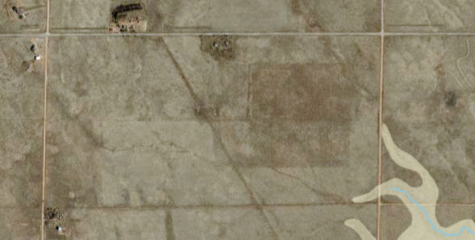

☐ | 30% or greater slope | Topography:
☐ | CGS review required (separate fee to CGS) | Soils/geology:
☐ | Floodplain | Floodplain comment:
☐ | Noise mitigation required | Noise comment:
☐ | Preble’s mouse

Air/Visual Quality:
Fencing – Animal waste- kennels; trash receptacles; pump out for RVP?

Districts

Taxing Entities
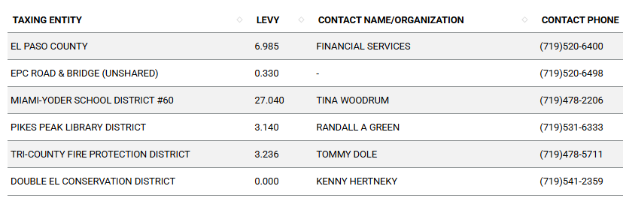

Proposed source of water |  |  | Proposed method of wastewater disposal
☐ | Central System |  | ☐ | Central System
District Name: |  |  | District Name:

Water/wastewater comments
Well and Septic-
Verify well permit supports uses; If RVP park than well per it may need to be modified? Well has been redone 2 w/ a filtration ---1 was closed. Ag well was converted to domestic and Ag. Want to connect well to cisterns to serve homes- 15 gallons per minute well.

Use of structure is what sets the septic system design
Rvs 50-100 gallons per day per RV
3 bedroom home 450
30 gallons per day per kennel space (structured space or building to maintain clean and water use)

Septic for homes sized appropriately- RVP commercial Septic defer to Health Dept.
EPC Health
Kat- Occupying RV while building home – install septic for home and connect RV to system while building home; then disconnect RV; septic system must be fully designed to handle the home; use licensed with EPC Public Health installer and designer- Plumbers not always licensed . Soil Pit Profiles required; system design factors: structure, bedrooms, soils, most require engineered design,

Once we talk multiple uses: can do separate septic systems per EPC Health not more than combined than 6000 gallons or 1 system that’s more than 2000 gallons involves STATE involvement. House; kennel; RV pads (bio chemical demand testing suspended solids) for treatment into soil- adds up. An advanced treatment system may be needed for a commercial project for wastewater. Connect with Licensed installer. O and M contract on system long term

Fire District:
Tri County Fire District –

Wildland Fire and Hazard Mitigation Plan: Notes while RP was speaking: SF home Fire Protection Report for pole barns or SF home per Chapter 6 (RP) Water for Fire SF Home – “water on wheels” type 1 engines fire brush trucks” RVP park will require 30000 gallon cistern per Tri County Fire District. Roland will talk to Director about a waiver for reports with SF home building permit…
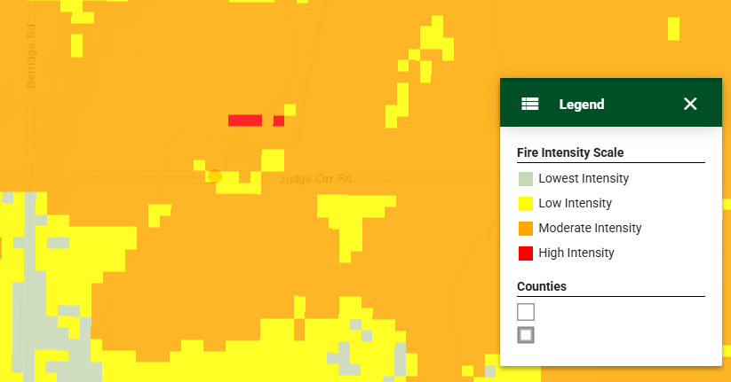

Emergency Services Issues:
RVP will require additional conversations with District

Commissioner District: 2

Code Waivers: Not Anticipated

Parks and trails: EPC Parks Department El Paso County Parks Department Comment:

The El Paso County Parks Department has reviewed this rezone proposal for the Early Assistance meeting and has no objections to this proposal. The 2022 Parks Master Plan shows no impacts to existing or proposed parks, trails, or open space. Regional park fees will assessed upon review of potential forthcoming final plat(s).

It is not necessary for EPC Parks staff to attend this early assistance meeting.

Thank you!

Ashlyn Mathy
Parks Planner
Park Planning Division
El Paso County Parks Department
Office: 719.520.6999
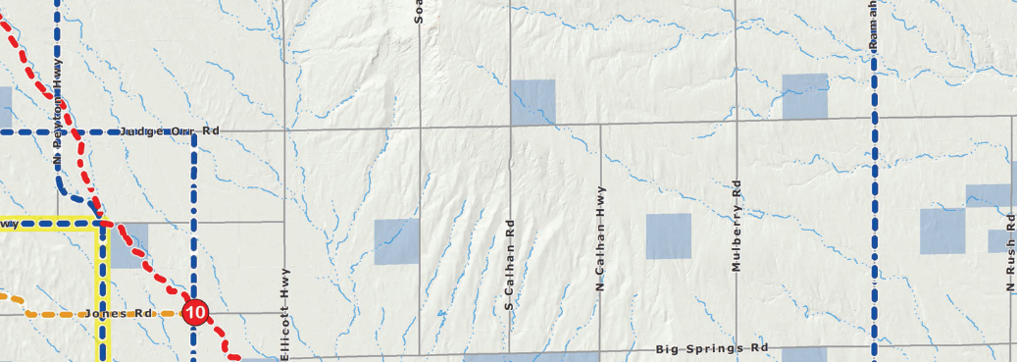

Annexations/Intergovernmental/ Jurisdictional Access issues:
N/A

Road Impact Fee Program (PID Inclusion):
Applicable

Your El Paso Master Plan

Placetype: Rural
Character:
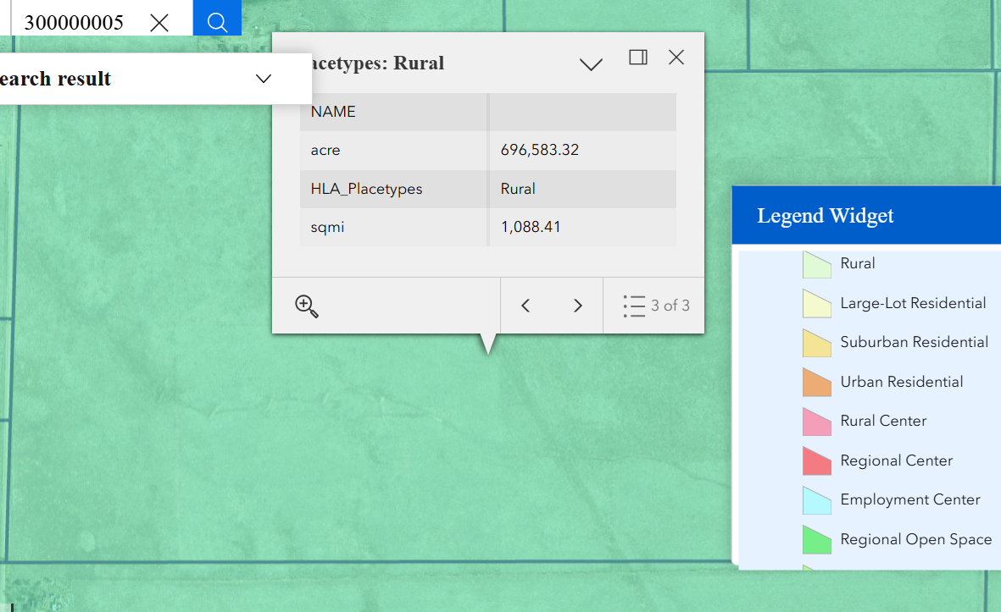

Recommended Land Uses:
- 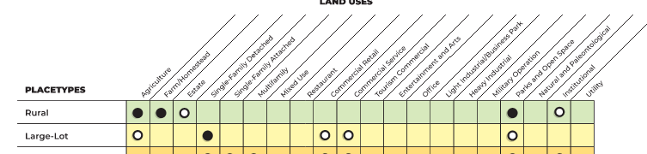

Goals, Objectives, Strategies:
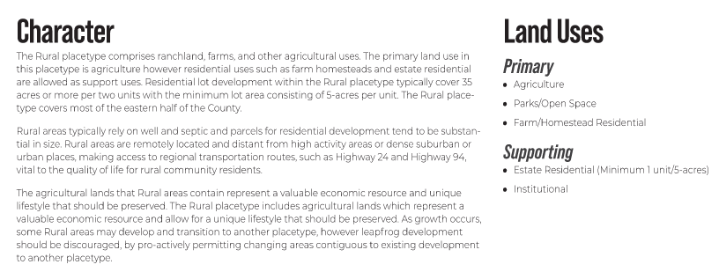

Area of Change Designation: Minimal Change Undeveloped
Description:
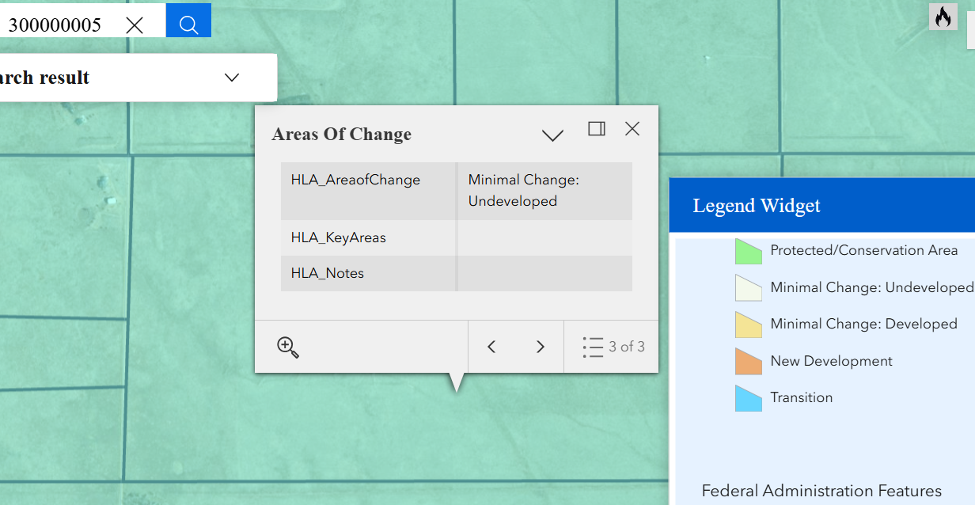

Goals, Objectives, Strategies:
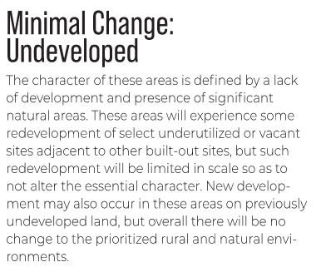

Key Area: N/A

Goals, Objectives, Strategies:

Water Master Plan Area:
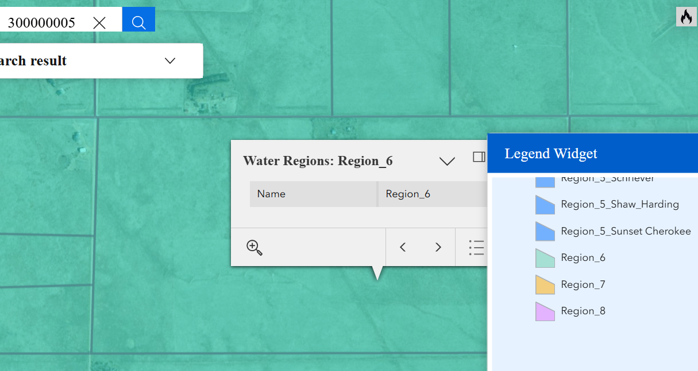

Recommendations:
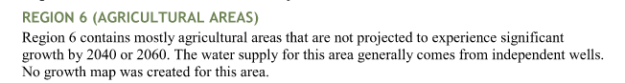

Wildlife impact
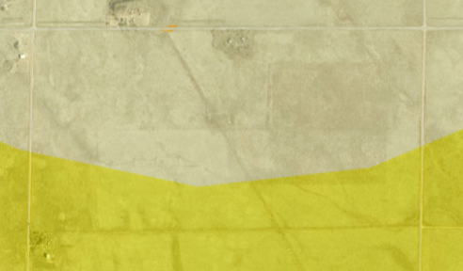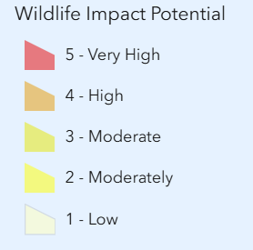

Helpful Links

Planning Website: https://planningdevelopment.elpasoco.com/

El Paso County Master Plan: https://planningdevelopment.elpasoco.com/#1510603950097-f5d985dc-35b2
Parks, Mineral and Water Master Plan: https://planningdevelopment.elpasoco.com/resources-and-references/#1516982531779-52cc0e87-01af

Forms and Templates: https://planningdevelopment.elpasoco.com/planning-development-forms/#1510677560407-ff8cfff5-69b2716b-00f9cbba-0c21

Land Development Code: https://library.municode.com/co/el_paso_county/codes/land_development_code

EDARP: https://epcdevplanreview.com/

Public GIS: https://elpasoco.maps.arcgis.com/apps/View/index.html?appid=5be6431018594c67b035ad0aad3e7e8a

Wrap Up
-If subdivision is proposed, recording fees, park and school fees and road impact fees may apply.

-Fees are subject to change. The fees at the time of application apply.

-Road Impact Fees
Please see the following website for information on the EPC Road Impact Fee Project. https://publicworks.elpasoco.com/road-impact-fees/ to include fee schedule.
As of December 15, 2016, per Resolution 16-454, on and after January 1, 2020, property in the unincorporated area of the county that receives a Land Use Approval either in a public hearing or administratively, is subject to the payment of Road Impact Fees. After December 31, 2024, in accordance with BoCC Resolution 24-377 the fee is paid for new residential and non-residential uses and structures and expansions of non-residential uses and structures. Road Impact fees are typically paid at time of building permit. If no building permit is being obtained for a particular Land Use application, then Road Impact Fees must be paid at the time of Site Development Plan or Special Use approval. If there are questions about EPC Road Impact program or fees, please contact DPW Development Review Services and the Engineer of the Day.

- Engineering Criteria Manual (ECM) Deviations.
The fee for any additional ECM deviation requests (more than two per land use application) - $1483.00 each per current Fee Schedule. Please note ECM deviation requests may result in additional processing and project review time. ECM Deviations should be submitted prior to the initial Site Development Plan or Final Plat submittal to preclude changes having to be made to engineering plans and documents if the deviation is not approved. Submission of an ECM deviation request does not imply or guarantee that the deviation will be approved. An ECM Deviation form must be submitted to include complete exhibits and justification excluding cost with supporting engineering criteria. If there are questions about ECM Deviation requests, please contact DPW Development Review Services and the Engineer of the Day.

-The fee for any additional waiver/deviation requests (more than two) - $550.00 each. Please note that requests for waivers and/or deviations may result in additional processing/review delay.

-All items requested must accompany the submittal for it to be complete, prior to payment request or the submittal will not be complete and ready for review agencies.

-A temporary use permit shall be applied for and approved for any staging area associated with development, such as a sales office, construction trailer, or contractor's equipment yard, prior to scheduling of the pre-construction meeting with El Paso County Planning and Community Development. If a Planned Unit Development is proposed, the temporary staging area should be shown on the development guideline and phasing plan.

-All prospective timelines for review are subject to departmental staffing and workload.

-Early Assistance is valid for 12 months from submittal of the EA application. If a project submittal is not received within 12 months, a new EA meeting may be required. An audio/video copy of the meeting is available in EDARP within the EA folder.

- Applications scheduled for public hearings may be heard as a regular item at the request of staff or a hearing body member.

- Any comments or commitments made by any member of the County Staff during this early assistance meeting are only preliminary in nature and should not be relied upon by the applicant. All prospective applicants should be informed that formal comments cannot be made by staff until after the application is submitted.

