

FALCON FIRE PROTECTION DISTRICT
Fire Prevention Division
7030 Old Meridian Road
Falcon, Colorado 80831
Business Number: 719-495-4050 Business Fax: 719-495-3112



Lieutenant/Fire Marshal Curtis L. Kauffman
Email: ckauffman@falconfirepd.org Cell #: 719-641-2139

Date: September 4, 2026

To: EDARP
C/O: Justin Kilgore
Planning & Community Development
2882 International Circle, Suite 110
Colorado Springs, CO 80910
Phone: 719-520-6313
Email: justinkilgore@elpasoco.com

Project Name: Church Bent Grass Meadows Site Development Plan
File Prefix: PPR-Plot Plan Review
Parcel/s: 5301000026 & 5301000033
File Number: PPR2622
Review: #1

This letter serves as comments for the plot plan review. You are responsible for complying with all sections, codes and references with the fire code based on the 2021 International Fire Code, local amendments, and NFPA Standards.

Black: No changes.
Red: Local change.
Blue: Comments.

PLEASE READ THIS ENTIRE DOCUMENT, YOU ARE RESPONSIBLE FOR EVERYTHING CONTAINED HERIN!

The following are ACTION ITEMS that need to be completed.

101.1 Title. These regulations shall be known as the Fire Code of the Falcon Fire Protection District, hereinafter referred to as this Code.

101.2 Scope. This code establishes regulations affecting or relating to structures, processes, premises and safeguards regarding all of the following:

1. The hazard of fire and explosion arising from the storage, handling or use of structures, materials or devices.
2. Conditions hazardous to life, property or public welfare in the occupancy of structures or premises.
3. Fire hazards in the structure or on the premises from occupancy or operation.
4. Matters related to the construction, extension, repair, alteration or removal of fire protection systems.
5. Conditions affecting the safety of fire fighters and emergency responders during emergency operations.

101.3 Purpose. The purpose of this code is to establish the minimum requirements consistent with nationally recognized good practice for providing a reasonable level of life safety and property protection from the hazards of fire, explosion or dangerous conditions in new and existing buildings,
structures and premises, and to provide a reasonable level of safety to fire fighters and emergency responders during emergency operations.

102.4 Application of building code. The design and construction of new structures shall comply with the International Building Code, and any alterations, additions, changes in use or changes in structures required by this code, which are within the scope of the International Building Code, shall be made in accordance therewith.

104.6 Official records. The fire code official shall keep official records as required by Sections 104.6.1 through 104.6.4. Such official records shall be retained for not less than 5 years seven (7) years or for as long as the structure or activity to which such records relate remains in existence, unless otherwise provided by other regulations.

105.1.2 Types of Permits. There shall be three types of permits as follows:
- Operational Permit. An operational permit allows the applicant to conduct an operation or a business for which a permit is required by Section 105.5 for either:
1.1 A prescribed period.
1.2 Until renewed or revoked.
- Construction permit. A construction permit allows the applicant to install or modify systems and equipment for which a permit is required by section 105.6.
- Administrative permit. An administrative permit allows the applicant to modify fire protection or life safety systems and equipment, having a limited scope of work, for which a construction permit would otherwise be issued. Administrative permits apply to the following:
    - 20-Head letters.
    - 5-device letters.
    - Temporary removal of equipment during construction activities.
    - Others as approved by the fire code official.

106.1 Submittals. Construction documents and supporting data shall be submitted in two or more sets with each application for a permit and in such form and detail as required by the fire code official. The construction documents shall be prepared by a registered an approved design professional where required by the statutes of the jurisdiction in which the project is to be constructed.
Exception: The fire code official is authorized to waive the submission of construction documents and supporting data not required to be prepared by a registered an approved design professional if it is found that the nature of the work applied for is such that review of construction documents is not necessary to obtain compliance with this code.

106.3 Amended construction documents. Work shall be installed in accordance with the approved construction documents, and any changes made during construction that are not in compliance with the approved construction documents shall be resubmitted for approval as an amended set of construction documents. Where field conditions necessitate any substantial change from the approved construction documents, the fire code official shall have the authority to require the amended construction documents to be submitted for approval. Fees may be assessed for time spent on the review of corrected documents in accordance with Section 107 and the adopted fee schedule.

501.1 Scope. Fire service features for buildings, structures, and premises shall comply with this chapter and Appendix D.

501.2 Permits. A permit shall be required as set forth in Sections 105.5 and 105.6.

501.3 Construction documents. Construction documents for proposed fire apparatus access, location of fire lanes, security gates across fire apparatus access roads and construction documents and hydraulic calculations for fire hydrant systems shall be submitted to the fire
department for review and approval prior to construction.

501.3.1 Site safety plan. The owner or owner's authorized agent shall be responsible for the development, implementation and maintenance of an approved written site safety plan in accordance with Section 3308,

501.4 Timing of installation. Where fire apparatus access roads or a water supply for fire protection are required to be installed, such protection shall be installed and made serviceable prior to and during the time of construction except where approved alternative methods of protection are provided. Temporary street signs shall be installed at each street intersection where construction of new roadways allows passage by vehicles in accordance with Section 505.2.

503.1 Where required. Fire apparatus access roads shall be provided and maintained in accordance with Sections 503.1.1 through 503.1.3 and Appendix D.

503.1.1 Buildings and facilities. Approved fire apparatus access roads shall be provided for every facility, building or portion of a building hereafter constructed or moved into or within the jurisdiction. The fire apparatus access road shall comply with the requirements of this section
and shall extend to within 150 feet (45 720 mm) of all portions of the facility and all portions of the exterior walls of the first story of the building as measured by an approved route around the exterior of the building or facility.
Exceptions:
1. The fire code official is authorized to increase the dimension of 150 feet (45 720 mm) where any of the following conditions occur:
1.1. The building is equipped throughout with an approved automatic sprinkler
system installed in accordance with Section 903.3.1.1, 903.3.1.2 or 903.3.1.3.
1.2. Fire apparatus access roads cannot be installed because of location on
property, topography, waterways, nonnegotiable grades or other similar
conditions, and an approved alternative means of fire protection is provided.
1.3. There are not more than two Group R-3 or Group U occupancies.
2. Where approved by the fire code official, fire apparatus access roads shall be
permitted to be exempted or modified for solar photovoltaic power generation
facilities.

503.2 Specifications. Fire apparatus access roads shall be installed and arranged in accordance with Sections 503.2.1 through 503.2.8 and Appendix D.

503.2.1 Dimensions. Fire apparatus access roads shall have an unobstructed width of not less than 20 feet (6096 mm), exclusive of shoulders, except for approved security gates in accordance with Section 503.6, and an unobstructed vertical clearance of not less than 13 feet 6 inches (4115 mm). modifications to the required access widths where they are inadequate for fire or rescue operations or where necessary to meet the public safety objectives of the jurisdiction.

503.2.2 Authority. The fire code official shall have the authority to require or permit modifications to the required access widths where they are inadequate for fire or rescue operations or where necessary to meet the public safety objectives of the jurisdiction.

Section 503.2.3 Surface. Fire apparatus access roads shall be designed and maintained to support the imposed loads of fire apparatus and shall be surfaced so as to provide all-weather driving capabilities.

503.2.4 Turning radius. The required turning radius of a fire apparatus access road shall be determined by the fire code official. 33’ inside and 53’ outside radius. Resubmit the site plan showing the turning radius.

503.2.7 Grade. The grade of the fire apparatus access road shall be within the limits established by the fire code official based on the fire department’s apparatus. 10% maximum.

503.2.8 Angles of approach and departure. The angles of approach and departure for fire apparatus access roads shall be within the limits established by the fire code official based on the fire department’s apparatus. Less than 8° degrees (not % percent).

Section 503.4 Obstruction of fire apparatus access roads. Fire apparatus access roads shall not be obstructed in any manner, including the parking of vehicles. The minimum widths and clearances established in Section 503.2.1, and 503.2.2, Appendix D, and any area marked as a fire lane as described in Section 503.3 shall be maintained at all times.

505.1 Address identification. New and existing buildings shall be provided with approved address identification. The address identification shall be legible and placed in a position that is visible from the street or road fronting the property. Address identification characters shall contrast with their background. Address numbers shall be Arabic numbers or alphabetical letters. Numbers shall not be spelled out. Each character shall be not less than 4 (four) inches (102 mm) high with a minimum stroke width of 1/2 inch (12.7 mm). Address size based on distance from the street: up to 75 feet is 5 inches, greater than 75 to 150 feet is 6 inches; greater than 150 feet to 250 feet is 8 inches; and greater than 250 feet is 10 inches 5 inches high with a minimum stroke width of 1/2 inch. Where required by the fire code official, address identification shall be provided in additional approved locations to facilitate emergency response. Where access is by means of a private road and the building cannot be viewed from the public way, a monument, pole, or other sign or means shall be used to identify the structure. Address identification shall be maintained. Address numbers shall be visible from the street side and in both directions of road travel.

506.1 Where required. Where access to or within a structure or an area is restricted because of secured openings or where immediate access is necessary for lifesaving, or fire-fighting purposes, or where monitored fire protection systems or elevators exist in the building, the fire code official is authorized to require a key box to be installed on new and existing buildings; and in an approved location. The key box shall be of an approved type listed in accordance with UL 1037 and shall contain keys to gain necessary access as required by the fire code official. A Knox Box shall be installed for this building. Please contact me for model.

507.1 Required water supply. An approved water supply capable of supplying the required fire flow for fire protection shall be provided to premises on which facilities, buildings or portions of buildings are hereafter constructed or moved into or within the jurisdiction.

507.2 Type of water supply. A water supply shall consist of reservoirs, pressure tanks, elevated tanks, water mains or other fixed systems capable of providing the required fire flow.

507.3 Fire Flow. Fire flow requirements for buildings or portion of buildings and facilities shall be determined by an approved method as outlined in Appendix B of this code.

507.4 Water supply test. The fire code official shall be notified prior to the water supply test. Water supply tests shall be witnessed by the fire code official or approved documentation of the test shall be provided to the fire code official prior to final approval of the water supply system.

507.5 Fire hydrant systems. Fire hydrant systems shall comply with Sections 507.5.1 through 507.5.6, NFPA 24, and Appendix C.

507.5.1 Where required. Where a portion of the facility of building hereafter constructed or moved into or within the jurisdiction is more than 400 feet from a hydrant on a fire apparatus access road, as measured by an approved route around the exterior of the facility or building, on-site fire hydrants and mains shall be provided where required by the fire code official.
Exceptions:
- For Group R3 and Group U occupancies, the distance requirement shall be 600 500 feet.
- For buildings equipped throughout with an approved automatic sprinkler system installed in accordance with Section 903.3.1.1 or 903.3.1.2, the distance requirement shall be 600 500 feet.
- Use of alternative water supply per NFPA 1142 or the International Wildland-Urban Interface Code as authorized by the fire code official.

507.5.4 Obstruction. Unobstructed access to fire hydrants shall be maintained at all times. The fire department shall not be deterred or hindered from gaining immediate access to fire protection equipment or fire hydrants.

507.5.5 Clear space around hydrants. A 3-foot (914 mm) clear space shall be maintained around the circumference of fire hydrants, except as otherwise required or approved.

507.5.6 Physical protection. Where fire hydrants are subject to impact by a motor vehicle, guard posts or other approved means shall comply with Section 312.

509.1.1 Utility identification. Where required by the fire code official, gas shutoff valves, electric meters, service switches and other utility equipment shall be clearly and legibly marked to identify the unit or space that it serves. Identification shall be made in an approved manner, readily visible and shall be maintained.

510.1 Emergency responder communication coverage in new buildings. Approved inbuilding, two-way emergency responder communication coverage for emergency responders shall be provided in all new buildings. In-building, two-way emergency responder communication coverage within the building shall be based on the existing coverage levels of the public safety communication systems utilized by the jurisdiction, measured at the exterior of the building. This
section shall not require improvement of the existing public safety communication systems.
Exceptions:
1. Where approved by the building official and the fire code official, a wired
communication system in accordance with Section 907.2.13.2 shall be permitted to be installed or maintained instead of an approved radio coverage system.
2. Where it is determined by the fire code official that the radio coverage system is not needed.
3. In facilities where emergency responder radio coverage is required and such systems, components or equipment required could have a negative impact on the normal operations of that facility, the fire code official shall have the authority to accept an automatically activated emergency responder radio coverage system. An Emergency Responder Communication Enhancement System (ERCES) shall be installed. Falcon Fire Protection District Fire Marshal will complete plan review.

510.4 Technical requirements. Systems, components, and equipment required to provide the emergency responder radio coverage system shall comply with Section 510.4.1 through 510.4.2.5 this section, the published technical and performance rules and regulations of the Pikes Peak Radio Communications Network and NFPA 1225 Standard for Emergency Services Communications.

510.4.1 Emergency responder communication coverage system signal strength. The building shall be considered to have acceptable in-building, two-way emergency responder communication system coverage where signal strength measurements in 95 percent of all areas and 99 percent of areas designated as critical areas by the fire code official on each floor of the building meet the signal strength requirements in Sections 510.4.1.1 through 510.4.1.3.

510.4.1.1 Minimum signal strength into the building. The minimum inbound signal strength shall be sufficient to provide usable voice communications throughout the coverage area as specified by the fire code official. The inbound signal level shall be a minimum of -95dBm throughout the coverage area and sufficient to provide not less than a Delivered Audio Quality (DAQ) of 3.0 or an equivalent Signal-to-Interference-Plus-Noise Ratio (SINR) applicable to the technology for either analog or digital signals.

510.4.1.2 Minimum signal strength out of the building. The minimum outbound signal strength shall be sufficient to provide usable voice communications throughout the coverage area as specified by the fire code official. The outbound signal level shall be sufficient to provide not less than a DAQ of 3.0 or an equivalent SINR applicable to the technology for either analog or digital signals.

510.4.1.3 System performance. Signal strength shall be sufficient to meet the
requirements of the applications being utilized by public safety for emergency operations through the coverage area as specified by the fire code official in Section 510.4.2.2.

603.4 Working space and clearances. Working space around electrical equipment shall be provided in accordance with Section 110.26 of NFPA 70 for electrical equipment rated 1,000 volts or less, and Section 110.33 of NFPA 70 for electrical equipment rated over 1,000 volts. The minimum required working space shall be not less than 30 inches (762 mm) in width, 36 inches (914 mm) in depth and 78 inches (1981 mm) in height in front of electrical service equipment. Where the electrical service equipment is wider than 30 inches (762 mm), the minimum working space shall be not less than the width of the equipment. Storage of materials shall not be located within the designated working space.

603.4.1 Labeling. Doors into electrical control panel rooms shall be marked with a plainly visible and legible sign stating “ELECTRICAL ROOM” or similar approved wording. The disconnecting means for each service, feeder or branch circuit originating on a switchboard or panelboard shall be legibly and durably marked to indicate its purpose unless such purpose is clearly evident. Where buildings or structures are supplied by more than one power source,
markings shall be provided at each service equipment location and at all interconnected electric power production sources identifying all electric power sources at the premises in accordance with NFPA 70.

901.1 Scope. The provisions of this chapter shall specify where fire protection and life safety systems are required and shall apply to the design, installation, inspection, operation, testing and maintenance of all fire protection and life safety systems.

901.1.1 Approved Contractors. All fire protection systems and appliances referenced by this code shall be designed, installed, repaired, inspected, tagged, and maintained by an approved licensed contractor. Private fire hydrants shall be inspected and maintained by an approved licensed contractor.
Exceptions:
- Non-rechargeable portable fire extinguishers are permitted to be inspected by a property owner or management company representative. These individuals are not required to maintain an FSC-D license or Service Technician D. Companies conducting inspections on fire extinguishers shall maintain a current copy of NFPA 10 Standard for Portable Fire Extinguishers as a reference for inspection requirements and shall maintain records of annual inspections as required by NFPA 10.
- New portable fire extinguishers may be installed and tagged by a general contractor, or a business owner/manager without requiring a fire suppression contractor license.
- The monthly inspection of portable fire extinguishers required by NFPA 10 Standard for Portable Fire Extinguishers, does not have to be performed by a licensed fire suppression contractor.

901.2 Construction documents. The fire code official shall have the authority to require construction documents and calculations for all fire protection and life safety systems and to require permits be issued for the installation, rehabilitation or modification of any fire protection and life safety systems. Construction documents for fire protection and life safety systems shall be
submitted for review and approval prior to system installation.

901.2.1 Statement of compliance. Before requesting final approval of the installation, where required by the fire code official, the installing contractor shall furnish a written statement to the fire code official that the subject fire protection or life safety system has been installed in accordance with approved plans and has been tested in accordance with the manufacturer’s specifications and the appropriate installation standard. Any deviations from the design
standards shall be noted and copies of the approvals for such deviations shall be attached to the written statement.

906.1 Where required. Portable fire extinguishers shall be installed in all of the following locations:
- In new and existing Group A, B, E, F, H, I, M, R-1, R-2, R-4 and S occupancies.
Exceptions:
      - In group R-2 occupancies, portable fire extinguishers shall be required only in locations specified in Items 2 through 6 where each dwelling unit is provided with a portable fire extinguisher having a minimum rating of 1-A:10-B:C.
      - In Group E occupancies portable fire extinguishers shall be required only in locations specified in Items 2 through 6 where each classroom is provided with a portable fire extinguisher having a minimum rating of 2-A:20-B:C.
      - In storage areas of Group S occupancies where forklift powered industrial truck or powered cart operators are the primary occupants, fixed extinguishers, as specified in NFPA 10, shall not be required where in accordance with all of the following:
  - Use of vehicle-mounted extinguishers shall be approved by the by the fire code official.
  - Each vehicle shall be equipped with a 10-pound, 40A:80B:C extinguisher affixed to the vehicle using a mounting bracket approved by the extinguisher manufacturer of the fire code official for vehicular use.
  - Not less than two spare extinguishers of equal or greater rating shall be available on site to replace a discharged extinguisher.
  - Vehicle operators shall be trained in the proper operation, use and inspection of extinguishers.
  - Inspections of vehicle-mounted extinguishers shall be performed daily.
- Within 30 feet (9144 mm) distance of travel from commercial cooking equipment and from domestic cooking equipment in Group I-1; I-2, Condition 1; and R-2 college dormitory occupancies.
- In areas where flammable or combustible liquids are stored, used or dispensed.
- On each floor of structures under construction, except Group R-3 occupancies, in accordance with Section 3316.1
- Where required by the sections indicated in Table 906.1.
- Special-hazard areas, including but not limited to laboratories, computer rooms and generator rooms, where required by the fire code official.
- Main electrical rooms not provided with fire sprinklers.

906.2 General requirements. Portable fire extinguishers shall be selected, installed and maintained in accordance with this section and NFPA 10.
Exceptions:
1. The distance of travel to reach an extinguisher shall not apply to the spectator seating portions of Group A-5 occupancies.
2. Thirty-day inspections shall not be required and maintenance shall be allowed to be once every 3 years for dry-chemical or halogenated agent portable fire extinguishers that are supervised by a listed and approved electronic monitoring device, provided that all of the following conditions are met:
2.1. Electronic monitoring shall confirm that extinguishers are properly positioned, properly charged and unobstructed.
2.2. Loss of power or circuit continuity to the electronic monitoring device shall initiate a trouble signal.
2.3. The extinguishers shall be installed inside of a building or cabinet in a noncorrosive environment.
2.4. Electronic monitoring devices and supervisory circuits shall be tested every 3 years when extinguisher maintenance is performed.
2.5. A written log of required hydrostatic test dates for extinguishers shall be maintained by the owner to verify that hydrostatic tests are conducted at the frequency required by NFPA 10.
3. In Group I-3, portable fire extinguishers shall be permitted to be located at staff locations.

906.2.1 Certification of service personnel for portable fire extinguishers. Service personnel providing or conducting maintenance on portable fire extinguishers shall possess a valid certificate issued by an approved governmental agency, or other approved organization for the type of work performed.
Exception: Certification or licensing is not required for fire authorities or their employees who are maintaining and recharging air-pressurized-water (APW) extinguishers which are the property of the fire authority. All fire extinguishers shall have a current test tag in place at the time of fire final.

906.5 Conspicuous location. Portable fire extinguishers shall be located in conspicuous locations where they will have ready access and be immediately available for use. These locations shall be along normal paths of travel, unless the fire code official determines that the hazard posed indicates the need for placement away from normal paths of travel.

907.1 General. This section covers the application, installation, performance, and maintenance of fire alarm systems and their components in new and existing buildings and structures. The requirements of Section 907.2 apply new buildings and structures, new fire alarm systems in existing buildings, and complete fire alarm system replacements. The requirements of Section 907.9 are applicable to new and existing buildings and structures.

907.1.1 Construction documents. Construction documents for fire alarm systems shall be of sufficient clarity to indicate the location, nature and extent of the work proposed and show in detail that it will conform to the provisions of this code; the International Building Code ; and relevant laws, ordinances, rules and regulations, as determined by the fire code official .

907.1.2 Fire alarm shop drawings. Shop drawings for fire alarm systems shall be prepared in accordance with NFPA 72 and submitted for review and approval prior to system installation.

907.1.3 Equipment. Systems and components shall be listed and approved for the purpose for which they are installed.

907.2 Where required – new buildings and structures. An approved fire alarm system installed in accordance with the provisions of this code and NFPA 72 shall be provided in new buildings and structures in accordance with Sections 907.2.1 through 907.2.23 907.2.25.1 and provide occupant notification in accordance with Section 907.5 unless other requirements are provided by another section of this code.

Not fewer than one manual fire alarm box shall be provided in an approved location to initiate a fire alarm signal for fire alarm systems employing automatic fire detectors or waterflow detection devices. Where other sections of this code allow the elimination of fire alarm boxes due to sprinklers, a single fire alarm box shall be installed.
Exceptions:
- The manual fire alarm box is not required for fire alarm systems dedicated to elevator recall control and supervisory service.
- The manual fire alarm box is not required for Group R-2 occupancies unless required by the fire code official to provide a means for fire watch personnel to initiate an alarm during a sprinkler system impairment event. Where provided, the manual fire alarm box shall not be located in an area that is open to the public.

912.1 Installation. Fire department connections shall be installed in accordance with the NFPA standard applicable to the system design and shall comply with Sections 912.2 through 912.7.

912.2 Location. With respect to hydrants, driveways, buildings and landscaping, fire department connections shall be so located that fire apparatus and hose connected to supply the system will not
obstruct access to the buildings for other fire apparatus. The location of fire department connections shall be approved by the fire code official .

912.2.1 Visible location. Fire department connections shall be located on the street side of buildings or facing approved fire apparatus access roads, fully visible and recognizable from the street, fire apparatus access road or nearest point of fire department vehicle access or as
otherwise approved by the fire code official .

Section 912.2.3 Multiple Fire Departments Connections (FDC). Add a new Section 912.2.3 to read as follows: 912.2.3 Multiple Fire Department Connections (FDC). When the demand of a sprinkler system exceeds 1,500 gallons per minute, additional fire department connections shall be provided and located as required by the fire code official. All FDC’s shall be of equal capacity.

912.3 Fire hose threads. Fire hose threads used in connection with standpipe systems shall be approved and shall be compatible with fire department hose threads.

912.4 Access. Immediate access to fire department connections shall be maintained at all times and without obstruction by fences, bushes, trees, walls or any other fixed or moveable object. Access to fire department connections shall be approved by the fire code official .
Exception: Fences, where provided with an access gate equipped with a sign complying with the legend requirements of Section 912.5 and a means of emergency operation. The gate and the means of emergency operation shall be approved by the fire code official and maintained operational at all times.

912.4.1 Locking fire department connection caps. The fire code official is authorized to require locking caps on fire department connections for water-based fire protection systems where the responding fire department carries appropriate key wrenches for removal. Knox locking FDC caps shall be purchased prior to the fire final, contact Falcon Fire Protection District Fire Marshal for model number and more information.

912.4.2 Clear space around connections. A working space of not less than 36 inches (914 mm) in width, 36 inches (914 mm) in depth and 78 inches (1981 mm) in height shall be provided and maintained in front of and to the sides of wall-mounted fire department connections and around the circumference of free-standing fire department connections, except as otherwise required or approved by the fire code official .

912.4.3 Physical protection. Where fire department connections are subject to impact by a motor vehicle, vehicle impact protection shall be provided in accordance with Section 312.

912.5 Signs. A metal sign with raised letters not less than 1 inch (25 mm) in size shall be mounted on all fire department connections serving automatic sprinklers, standpipes or fire pump connections. Such signs shall read: “AUTOMATIC SPRINKLERS” or “STANDPIPES” or “TEST CONNECTION” or a combination thereof as applicable. Where the fire department connection does not serve the entire building, a sign shall be provided indicating the portions of the building served.

1001.1 General. Buildings or portions thereof shall be provided with a means of egress system as required by this chapter. The provisions of this chapter shall control the design, construction and arrangement of means of egress components required to provide an approved means of egress from structures and portions thereof. Sections 1003 through 1031 shall apply to new construction. Section 1032 shall apply to existing buildings.
Exception: Detached one- and two-family dwellings and multiple single-family dwellings (townhouses) not more than three stories above grade plane in height with a separate means of egress and their accessory structures shall comply with the International Residential Code .

1001.2 Minimum requirements. It shall be unlawful to alter a building or structure in a manner that will reduce the number of exits or the capacity of the means of egress to less than required by this code.

1003.1 Applicability. The general requirements specified in Sections 1003 through 1015 shall apply to all three elements of the means of egress system, in addition to those specific requirements for the exit access, the exit and the exit discharge detailed elsewhere in this chapter.

1004.1 Design occupant load. In determining means of egress requirements, the number of occupants for whom means of egress facilities are provided shall be determined in accordance with this section.

1005.1 General. All portions of the means of egress system shall be sized in accordance with this section.
Exception: Aisles and aisle accessways in rooms or spaces used for assembly purposes complying with Section 1030.

1006.1 General. The number of exits or exit access doorways required within the means of egress system shall comply with the provisions of Section 1006.2 for spaces, including mezzanines, and Section 1006.3 for stories or occupied roofs.

1007.1 General. Exits, exit access doorways, and exit access stairways and ramps serving spaces, including individual building stories, shall be separated in accordance with the provisions of this section.

1008.1 Means of egress illumination. Illumination shall be provided in the means of egress in accordance with Section 1008.2. Under emergency power, means of egress illumination shall comply with Section 1008.3.

1009.1 Accessible means of egress required. Accessible means of egress shall comply with this section. Accessible spaces shall be provided with not less than one accessible means of egress. Where more than one means of egress is required by Section 1006.2 or 1006.3 from any accessible space, each accessible portion of the space shall be served by not less than two
accessible means of egress.
Exceptions:
1. One accessible means of egress is required from an accessible mezzanine level in accordance with Section 1009.3, 1009.4 or 1009.5.
2. In assembly areas with ramped aisles or stepped aisles, one accessible means of egress is permitted where the common path of travel is accessible and meets the requirements in Section 1030.8.

1010.1 Doors. Doors in the means of egress shall comply with the requirements of Sections 1010.1.1 through 1010.3.4. Exterior exit doors shall also comply with the requirements of Section 1022.2. Gates in the means of egress shall comply with the requirements of Sections 1010.4 and 1010.4.1. Turnstiles in the means of egress shall comply with the requirements of Sections 1010.5 through 1010.5.4. Doors, gates and turnstiles provided for egress purposes in numbers greater than required by this code shall comply with the requirements of this section. Doors in the means of egress shall be readily distinguishable from the adjacent construction and finishes such that the doors are easily recognizable as doors. Mirrors or similar reflecting materials shall not be used on means of egress doors. Means of egress doors shall not be concealed by curtains, drapes, decorations or similar materials.

1013.1 Where required. Exits and exit access doors shall be marked by an approved exit sign readily visible from any direction of egress travel. The path of egress travel to exits and within exits shall be marked by readily visible exit signs to clearly indicate the direction of egress travel
in cases where the exit or the path of egress travel is not immediately visible to the occupants. Intervening means of egress doors within exits shall be marked by exit signs. Exit sign placement shall be such that any point in an exit access corridor or exit passageway is within 100 feet (30 480 mm) or the listed viewing distance of the sign, whichever is less, from the nearest visible exit sign.
Exceptions:
1. Exit signs are not required in rooms or areas that require only one exit or exit access.
2. Main exterior exit doors or gates that are obviously and clearly identifiable as exits need not have exit signs where approved by the fire code official.
3. Exit signs are not required in occupancies in Group U and individual sleeping units or dwelling units in Group R-1, R-2 or R-3.
4. Exit signs are not required in dayrooms, sleeping rooms or dormitories in occupancies in Group I-3.
5. In occupancies in Groups A-4 and A-5, exit signs are not required on the seating side of vomitories or openings into seating areas where exit signs are provided in the concourse that are readily apparent from the vomitories. Egress lighting is provided to identify each vomitory or opening within the seating area in an emergency.

1016.1 General. The exit access shall comply with the applicable provisions of Sections 1003 through 1015. Exit access arrangement shall comply with Sections 1016 through 1021.

1017.1 General. Travel distance within the exit access portion of the means of egress system shall be in accordance with this section.

1018.1 General. Aisles and aisle accessways serving as a portion of the exit access in the means of egress system shall comply with the requirements of this section. Aisles or aisle accessways shall be provided from all occupied portions of the exit access that contain seats, tables, furnishings, displays and similar fixtures or equipment. The minimum width or required capacity of aisles shall be unobstructed.
Exception: Encroachments complying with Section 1005.7.

1020.1 General. Corridors serving as an exit access component in a means of egress system shall comply with the requirements of Sections 1020.2 and 1020.7.

1022.1 General. Exits shall comply with Sections 1022 through 1027 and the applicable requirements of Sections 1003 through 1015. An exit shall not be used for any purpose that interferes with its function as a means of egress. Once a given level of exit protection is achieved, such level of protection shall not be reduced until arrival at the exit discharge. Exits shall be continuous from the point of entry into the exit to the exit discharge.

1024.1 General. Exit passageways serving as an exit component in a means of egress system shall comply with the requirements of this section. An exit passageway shall not be used for any purpose other than as a means of egress and a circulation path.

1028.1 General. The exit discharge shall comply with Sections 1028 and 1029 and the applicable requirements of Sections 1003 through 1015.

1032.1 General. The means of egress for buildings or portions thereof shall be maintained in accordance with this section.

B104.1 General. The fire-flow calculation area shall be the total floor area of all floor levels within the exterior walls, and under the horizontal projections of the roof of a building, except as modified in Section B104.3 and B104.4.

B104.3 Type IA and Type IB construction. The fire-flow calculation area of buildings constructed of Type IA and Type IB construction shall be the area of the three largest successive floors.
Exception: Fire-flow calculation area for open parking garages shall be determined by the area of the largest floor.

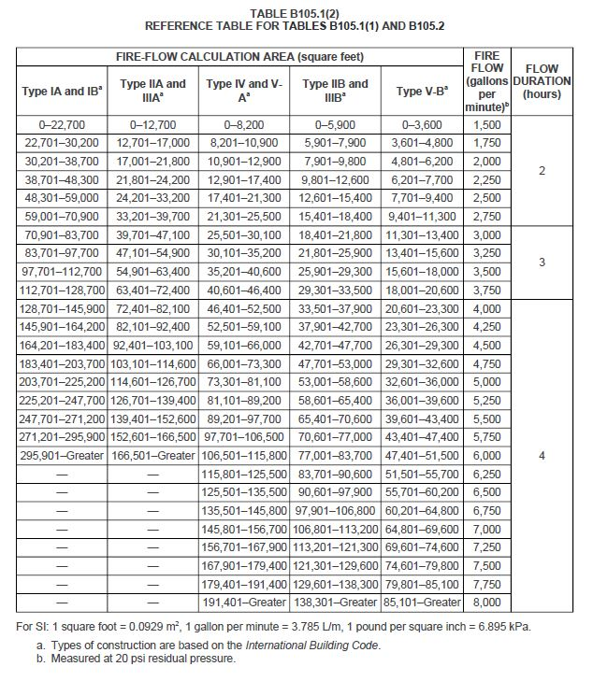

B105.2 Buildings other than one- and two-family dwellings, Group R-3 and R-4 buildings and townhouses. The minimum fire-flow and flow duration for buildings other than one- and two-family dwellings, Group R-3 and R-4 buildings and townhouses shall be as specified in Tables B105.1(2) and B105.2.

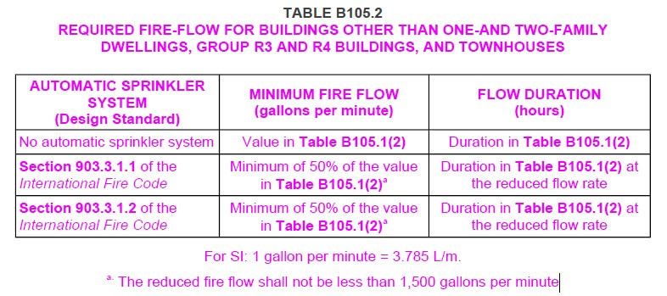

B105.4 Simultaneous flows. Any hydrant must produce a minimum flow of 1,500 gallons per
minute at 20 psi of residual pressure when flowing individually, or a minimum of 750 gallons per minute at 20 psi residual pressure when flowing simultaneously to be considered by Table C102.1 or by Table C102.1’s footnotes as one of the minimum hydrants required to protect any structure, hazard, or potential hazard.

C101.1 Scope. In addition to the requirements of Section 507.5.1, fire hydrants shall be provided in accordance with this appendix for the protection of buildings, or portions of buildings, hereafter constructed or moved into the jurisdiction.

C102.1 Minimum number of fire hydrants for a building. The number of fire hydrants available to a building shall be not less than the minimum specified in Table C102.1.

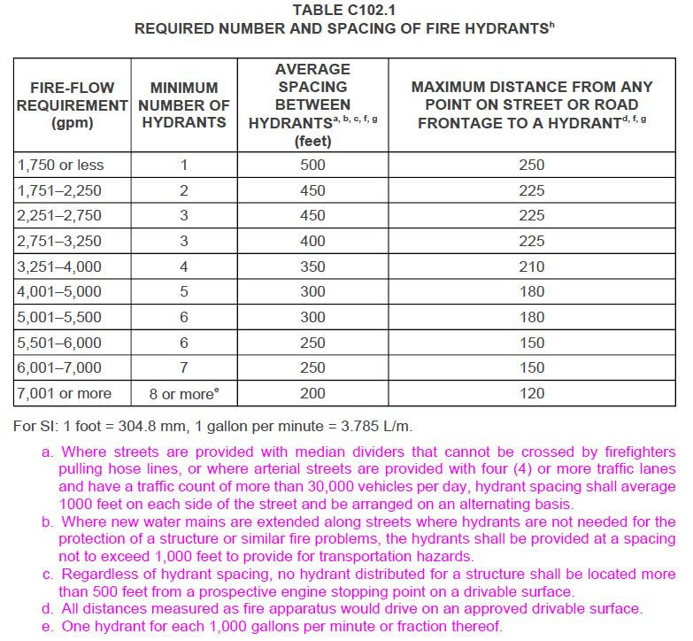

C103.1 Hydrant spacing. Fire apparatus access roads and public streets providing required access to buildings in accordance with Section 503 shall be provided with one or more fire hydrants, as determined by Section C102.1. Where more than one fire hydrant is required, the distance between required fire hydrants shall be in accordance with Sections C103.2 and C103.3.

C104.1 Existing fire hydrants. Existing fire hydrants on public streets are allowed to be considered as available to meet the requirements of Sections C102 and C103. Existing fire hydrants on adjacent properties are allowed to be considered as available to meet the requirements of Sections C102 and C103 provided that a fire apparatus access road extends between properties and that an easement is established to prevent obstruction of such roads.

D101.1 Scope. Fire apparatus access roads shall be in accordance with this appendix and all other applicable requirements of the International Fire Code.
Section D102.1 Access and loading. Amend Section D102.1 to read as follows:
D102.1 Access and loading. Facilities, buildings, or portions of buildings hereafter constructed shall be accessible to fire department apparatus by way of an approved fire apparatus access road with asphalt, concrete, or other approved driving surface capable of supporting the imposed load of fire apparatus weighing up to 75,000 pounds with a minimum single axle weight of 27,000 pounds. Alternative methods such as brick pavers, road, base, and gravel as approved by the fire code official.

D103.4 Dead ends. Dead-end fire apparatus access roads in excess of 150 feet (45 720 mm) shall be provided with width and turnaround provisions in accordance with Table D103.4.

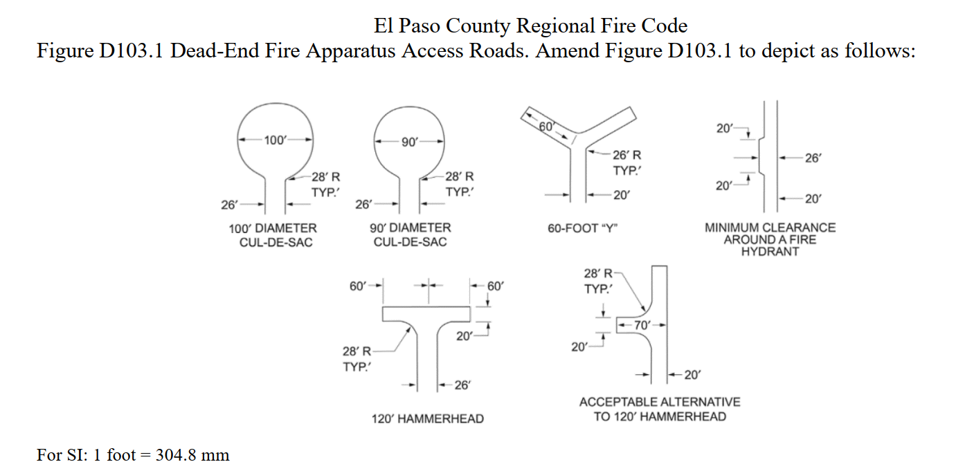

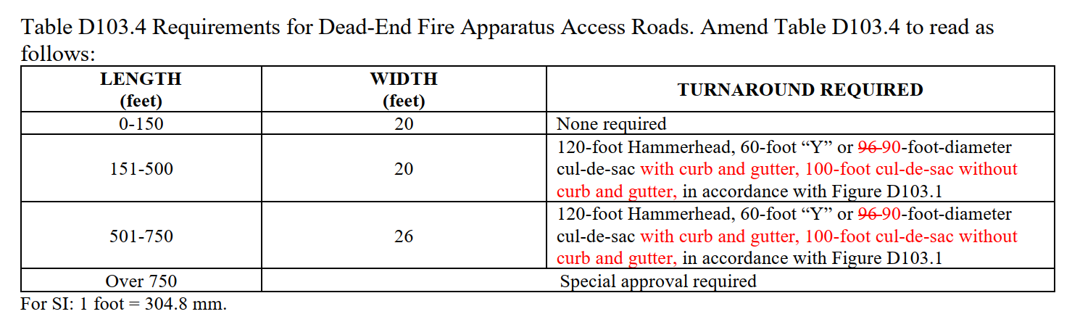

D103.6 Signs. Where required by the fire code official, fire apparatus access roads shall be marked with permanent “NO PARKING – FIRE LANE” signs complying with Figure D103.6 or Figure D103.6.1. Signs shall have a minimum dimension of 12 inches (305 mm) wide by 18 inches (457 mm) high and have red letters on a white reflective background. Signs shall be posted on one or both sides of the fire apparatus road as required by Section D103.6.1 or D103.6.2.

Figure D103.6.1 to read as follows:
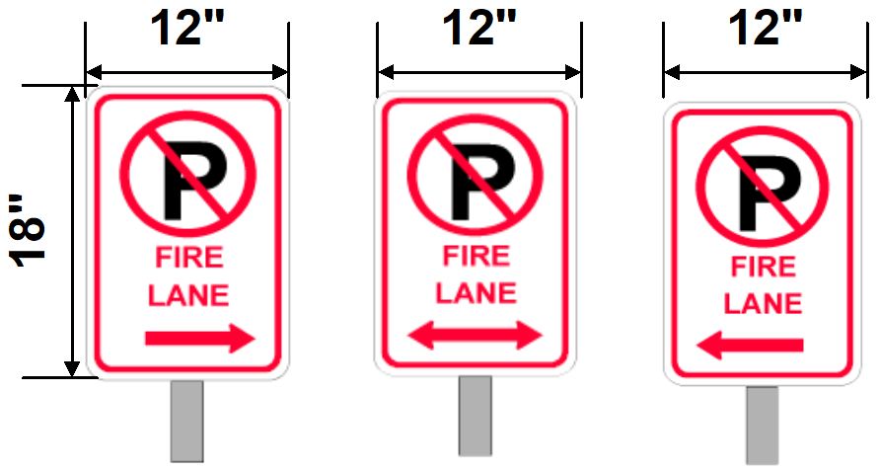

Section D103.6.3 Striping. Add a new section D103.6.3 to read as follows:
D103.6.3 Striping. The curb or edge of the fire apparatus access roads shall be marked by painted lines of red traffic paint six (6) inches in width to show the boundaries of the lane. Where a posted fire lane sign is not used by the approval of the fire code official. The words “NO PARKING FIRE LANE” shall appear in four (4) inch white reflective letters at thirty (30) feet intervals on the red border marking complying with Figure D103.6.3.1. Where a curb is available, the striping shall be on the vertical face of the curb.

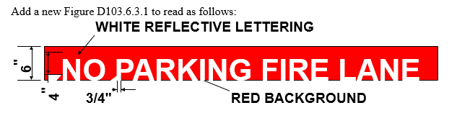

D105.1 Where required. Where the vertical distance between the grade plane and the highest roof surface exceeds 30 feet (9144 mm), approved aerial fire apparatus access roads shall be provided. For purposes of this section, the highest roof surface shall be determined by measurement to the eave of a pitched roof, the intersection of the roof to the exterior wall, or the
top of parapet walls, whichever is greater.
Exception: Where approved by the fire code official, buildings of Type IA, Type IB or Type IIA construction equipped throughout with an automatic sprinkler system in accordance with

Section 903.3.1.1 and having fire fighter access through an enclosed stairway with a Class I standpipe from the lowest level of fire department vehicle access to all roof surfaces.

D105.2 Width. Aerial fire apparatus access roads shall have a minimum unobstructed width of 26 feet (7925 mm), exclusive of shoulders, in the immediate vicinity of the building or portion thereof.

D105.3 Proximity to building. One or more of the required access routes meeting this condition shall be located not less than 15 feet (4572 mm) and not greater than 30 feet (9144 mm) from the building, and shall be positioned parallel to one entire side of the building. The side of the building on which the aerial fire apparatus access road is positioned shall be approved by the fire code official.

D105.4 Obstructions. Overhead utility and power lines shall not be located over the aerial fire apparatus access road or between the aerial fire apparatus road and the building. Other obstructions shall be permitted to be placed with the approval of the fire code official .

The following are ATTENTION ITEMS that apply to this review.

Section 1402.1 Temporary Fire Access Road. Temporary access roads shall be an all-weather surface comprised of either the first lift of asphalt or concrete/compacted gravel to a thickness capable of supporting the imposed loads of fire department apparatus. A 20-foot minimum width shall be maintained unless the permanent road is designed less than 20 feet, in which case the temporary road shall be the intended width of the permanent road. Adequate street signs and fire lane signs shall be installed where applicable. Temporary access roads must be maintained in accordance with this section. Temporary roads serving as fire lanes shall not be in place more than 6 months without special approval from the fire department.”

TIMING OF INSTALLATION: Fire department access roads shall be made serviceable prior to and during the time of construction except when approved alternative methods of protection are provided.

ACCESS FOR FIREFIGHTING: Approved vehicle access for firefighting shall be provided to all construction/demolition sites. Vehicle access shall be provided by either temporary or permanent roads capable of supporting vehicle loading under all weather conditions. Vehicle access shall be maintained until permanent fire apparatus access roads are available.

Attention Contractor/Applicant:

YOU ARE RESPONSIBLE TO COMPLETE THE FOLLOWING ITEMS.

Please complete the following items:

- Permits – Ensure all applicable permits are obtained from the Pikes Peak Regional Building Department (PPRBD) and the Colorado Springs Fire Department (CSFD) construction services.
- A water plan shall be submitted to Falcon Fire Protection District Fire Marshal for approval.
- All plans (building, fire alarm system, fire sprinkler system, hazardous materials, etc.) submitted to PPRBD and CSFD shall be submitted to Falcon Fire Protection District Fire Marshal as we are the AHJ.
- Follow the Colorado State Forest Service for all plants and trees (low flammability and low ignition) guidelines.
- Review of the comment letter from Falcon Fire Protection District. You are responsible for complying with the entire fire code, local amendments and any applicable NFPA standard references.
- Ensure all Action Items have been addressed.
- If a kitchen is installed, will it be just warming or will there be a full kitchen with fire suppression system?
- Is the church going to be used as school?

Please let me know if there are any questions and/or concerns. You may contact me via email at the top of the letter.

Sincerely,

Curtis L. Kauffman

Curtis L. Kauffman
Fire Prevention Division
Lieutenant/Fire Marshal

