STAGE 2 DRAINAGE REPORT

PPR _________

Schubert Ranch Sand Resource Pit Ellicott Sand and Gravel
1-7-2026
Prepared by: Environment, Inc.
Regulatory Permits Management, Inc.
EME Solutions, Inc.

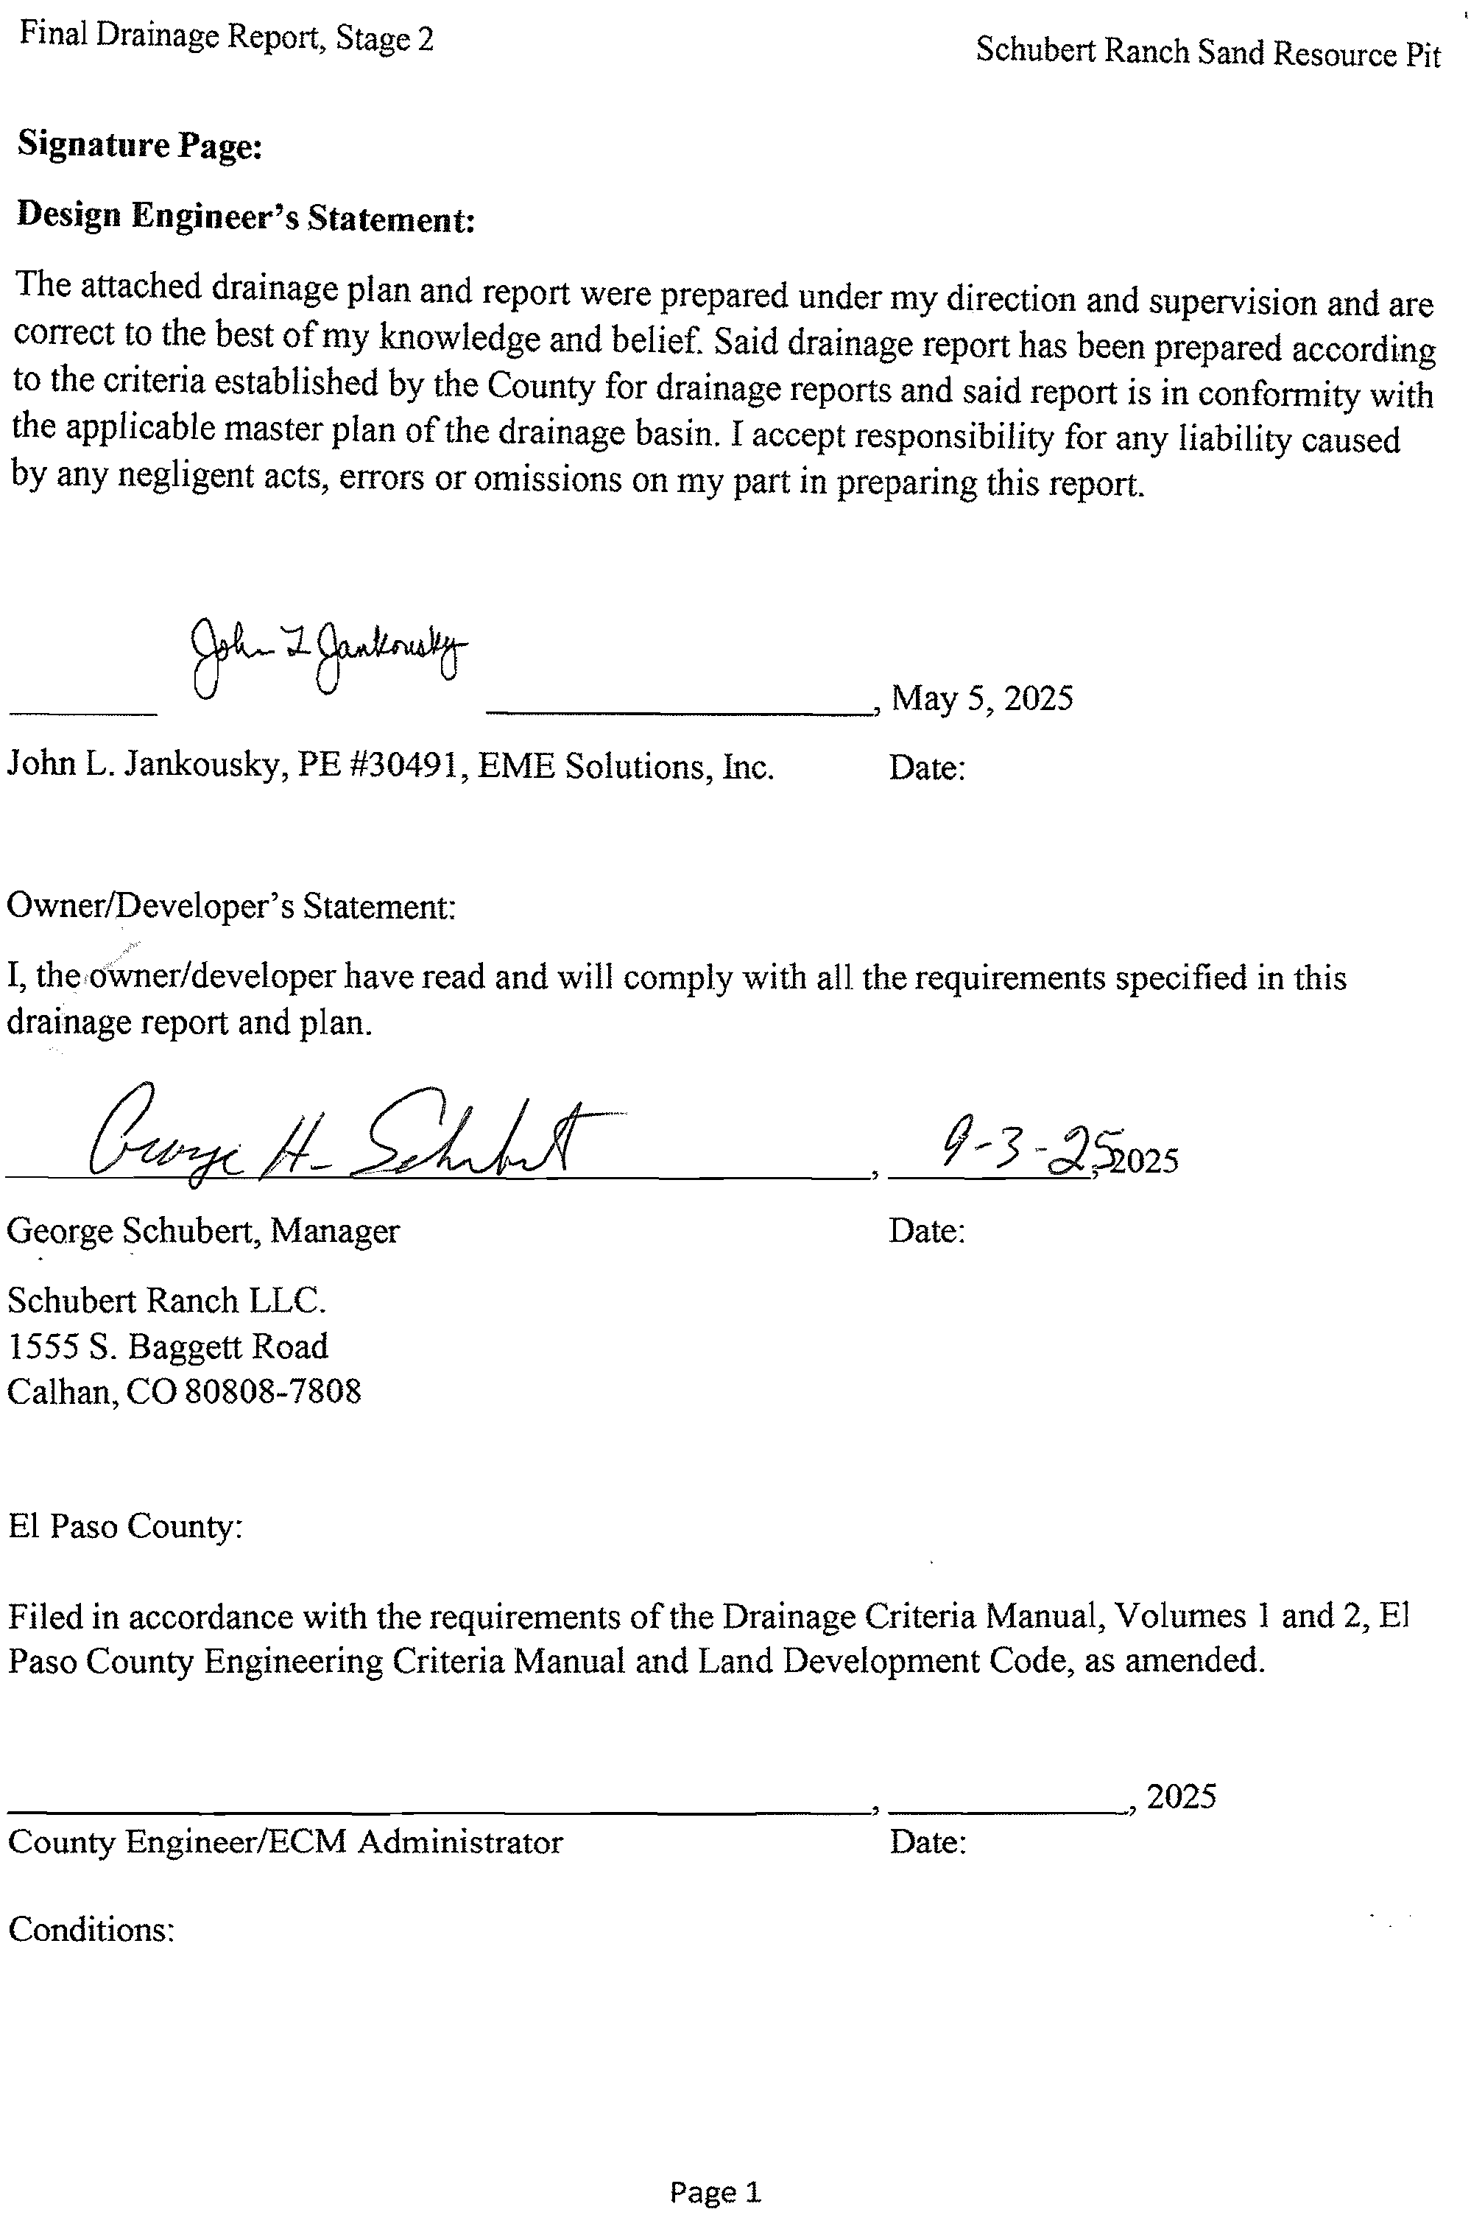
Final Drainage Report, Stage 2

Table of Contents
- Introduction: 3
- General Location: 3
- Description of Property: 4
- Major Basin Descriptions: 8
- Sub-Basin Description: 11
- Drainage Design Criteria 11
- Four Step Process: 13
- Hydrologic Criteria 15
- Drainage Facility Design – General Concept: 16
- Drainage Facility Design – Specific Details: 18
- Other Government Agency Requirements: 20
- References: 27
- Drawings: 28

Attachments:
Attachment 1. FEMA Flood Insurance Permit Attachment 2. Flood Plain Development Permit

Appendix A:
The Table of Contents for Appendix A is at the start of the appendix.

Introduction:
This Final Drainage Report meets the El Paso County requirements. Please note that the Proposed Project is a sand and gravel mine, not a commercial development or a subdivision.
  - No structures, residential or commercial developments or associated infrastructures are proposed.
  - We provided a Landscape Plan, Grading and Erosion Control Plan and a Reclamation Plan which show the interim and final configuration of the site once mining and site reclamation are complete. No additional drainage controls will be installed other than those which are in the above-referenced documents.
  - We have provided a Grading and Erosion Control Plan Checklist with associated maps. These documents show the engineering designs for ditches and berms which will be removed during site reclamation.
  - All post mining drainage will be internal to Stage 2. The runoff into Stage 2 will infiltrate into the floor of the reclaimed pit.
  - No drainage will be mined through or receive additional stormwater runoff from the reclaimed Stage 2. We will need to provide access from Stage 2-West to Stage 2-East. The method of access will be provided prior to Stage 2 West access once approved by the Division of Reclamation, Mining and Safety.

General Location:
- City and County, and local streets within and adjacent to the subdivision:
  - Response:
    - This is a mineral extraction operation and not a subdivision. The nearest municipality is Ellicott, Colorado. It is not adjacent to the proposed mineral extraction operation and lies to the north of the proposed operation.
    - The adjacent road is Sanborn Road to the north. Sanborn Road is a rural dirt road.
    - The proposed operation is in eastern El Paso County, about 2 miles south of Colorado State Highway 94 and about 1.5 miles east of Ellicott Highway to the point of Stage 2 access. Access will be from Stage 1 internal haul road on the south of Stage 1, across Sandborn Road to the northside of Stage 2-West.
- Township, Range, Section, and Quarter-section:
Located in the SW¼NE¼, N½NW¼SE¼, N½NE¼SW¼, SE¼NW¼ and Parts of the NE¼NE¼, SE¼NE¼, NW¼NE¼, NE¼SE¼, and NE¼NW¼, Section 32, T-14-S, R-62-W, 6th P.M., El Paso County, Colorado.
- Major drainageways and existing facilities:
  - The major drainageway is Black Squirrel Creek, an ephemeral drainage. Stage 2 will not impact Black Squirrel Creek. Black Squirrel Creek bisects the project area between Stage 2-West and Stage 2-East. However, no mineral extraction will occur within the Creek’s drainageway.

  - There are no existing facilities in Stage 2
- Names of surrounding platted developments:
  - There are no adjacent platted developments. The attached map shows the adjacent property owners associated with Stage 2. The red E is the proposed Stage 2 entrance.

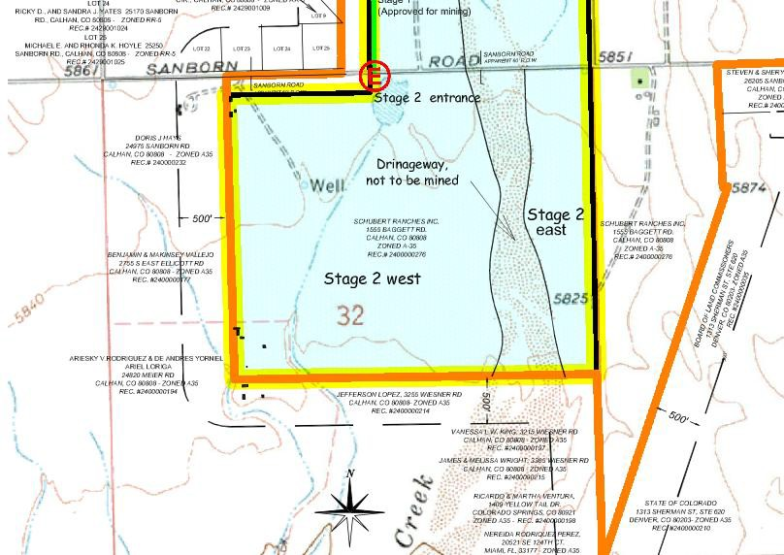

Figure 2-1. Stage 2 Site Location Map with Site Entrance

Description of Property:
- Area in acres:
  - Stage 2 is 268.4 acres, more or less.
- Ground cover, (type of trees, shrubs, vegetation):
  - A mix of range land grasses, turf grass farm and shrubs.
- General topography:
  - Gently rolling topography with incised drainages.
- General soil conditions: (The following information is from the NRCS, Web Soil Survey, National Cooperative Soil Survey, 3/27/2018)

  - The attached portion of the soils map shows the soil in Stage 2. These include Bijou loamy sand (Unit 5), Bijou sandy loam (Unit 6), Ellicott loamy coarse sand (28), Sampson loam (Unit 78), Truckton sandy loam (Unit 97), and Ustic Torrifluvents, loamy (Unit 101).
  - Soils Unit 5:
    - “The Bijou component makes up 85 percent of the map unit. Slopes are 1 to 8 percent. This component is on plains, stabilized sand sheets. The parent material consists of eolian sands. The depth to a root restrictive layer is greater than 60 inches. The natural drainage class is somewhat excessively drained. Water movement in the most restrictive layer is high. Available water to a depth of 60 inches (or restricted depth) is low. This soil is not flooded. It is not ponded. There is no zone of water saturation within a depth of 72 inches.”
    - Properties and Qualities:
      - Runoff Class: Somewhat excessively drained.
      - Ksat: High (2.00 to 6.00 inches/hr.).
      - Available water storage in profile: Low (about 5.6 inches).
      - Hydrologic Soil Group: A.”

  - Soils Unit 6:
    - “The Bijou component makes up 85% of the map unit. Slopes are 0 to 3 percent. This component is on stabilized sand sheets, swales, plains. The parent material consists of eolian sands. Depth to a root restrictive layer is greater than 60 inches. The natural drainage class is somewhat excessively drained. Water movement in the most restrictive layer is high. Available water to a depth of 60 inches (or restrictive depth) is low. Shrink-swell potential is low. This soil is not flooded. It is not ponded. There is no zone of water saturation within a depth of 72 inches.”
    - Properties and Qualities:
      - Runoff Class: Somewhat excessively drained.
      - Ksat: High (2.00 to 6.00 inches/hr.).
      - Available water storage in profile: Low (about 5.0 inches).
      - Hydrologic Soil Group: A.”

  - Soils Unit 28:
    - “The Ellicott component makes up 85 percent of the map unit. Slopes are 0 to 5 percent. This component is on stream terraces and flood plains. The parent material consists of sandy alluvium. Depth to a root restrictive layer is greater than 60 inches. The natural drainage class is somewhat excessively drained. Water movement in the most restrictive layer is high. Available water to a depth of 60 inches (or restricted depth) is low. Shrink-swell potential is low. This soil is frequently flooded. It is not ponded. There is no zone of water saturation within a depth of 72 inches.”

    - Properties and Qualities:
      - Runoff Class: Very low.
      - Ksat: High to very high (5.95 to 19.98 in/hr.).
      - Available water storage in profile: Low (about 4.1 inches).
      - Hydrologic Soil Group: A.”

  - Soil Unit 97:
    - “The Truckton component makes up 85 percent of the map unit. Slopes are 3 to 9 percent. This component is on back slopes or hills on uplifted piedmonts, side slopes of interfluves on uplifted piedmonts. The parent material consists of re- worked alluvium derived from arkose. Depth to a restrictive layer is greater than 60 inches. The natural drainage class is well drained. Water movement in the most restrictive layer is high. Available water to a depth of 60 inches (or restricted depth) is moderate. Shrink-swell potential is low. This soil is not flooded. It is not ponded. There is no zone of water saturation within a depth of 72 inches.”
    - Properties and Qualities:
      - Runoff Class: Low.
      - Ksat: High (2.00 to 6.00 inch/hr.)
      - Available water storage in profile: Moderate (about 6.6 inches)
      - Hydrologic Soil Group: A.”

  - Soil Unit 101:
    - “The Ustic Torrifluvents components makes up 85 percent of the map unit. Slopes are 0 to 3 percent. This component is on stream terraces, flood plains. The parent material consists of sandy, clayey, stratified loam. Depth to a restrictive layer is greater than 60 inches. The natural drainage class is well drained. Water movement in the most restrictive layer is moderately high. Available water to a depth of 60 inches (or restrictive depth) is moderate. Shrink-swell potential is low. This soil is not flooded. It is not ponded. There is no zone of water saturation within a depth of 72 inches.
    - Properties and Qualities:
      - Runoff Class: Low.
      - Ksat: Moderately high to high (0.20 to 2.00 in/hr.).
      - Available water storage in profile: Moderate (about 8.6 inches).
      - Hydrologic Soil Group: B.

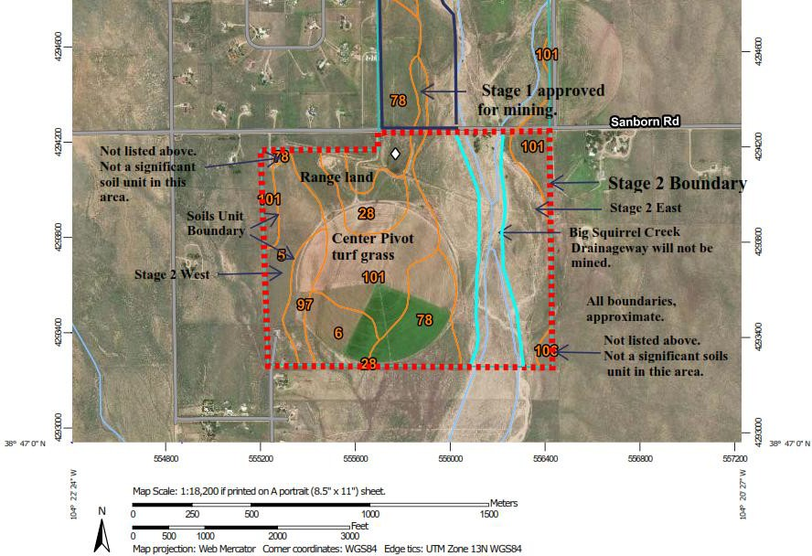
Figure 3-1. Soil Survey Map
From: NRCS Web Soil Survey, National Cooperative Soil Survey, 3/27/2018.
- Major Drainages:
  - Black Squirrel Creek
  - Big Spring Creek flows into Black Squirrel Creek in Stage 2.
  - Both are ephemeral drainages.
- Irrigation facilities:
  - There is center pivot irrigation in Stage 2 - West.
- Utilities and other encumbrances:
  - On the north side of proposed Stage 2 East and West, along the southside of Sanborn Road, within the road right-of-way are overhead power lines, and buried telephone/communication lines on the north side of the road. (Please see the Ellicott Sand and Gravel LLC- Site Development Plan, Stage 2 – Grading and Erosion Control Plans, Sheet 2 of 6.)

Major Basin Descriptions:
- Reference should be made to major drainageway planning studies, such as drainage basin planning studies, flood hazard delineation reports, and flood insurance studies and maps if available:
The Project site is in the major drainage basin of Upper Black Squirrel Creek (Colorado Department of Natural Resources, 2024). The Project site is in subbasin Ellicott Drainage Basin, and Lower Big Spring Creek Drainage Basin (El Paso County Planning Department, 1989). No drainage basin planning studies were provided or discovered for these basins.
There is a flood insurance Rate Map (FIRM) for the Project area. (See the first bullet point below.) The floodplain in this vicinity ranges in width from about 3,500 feet to about 1,800 feet. Part of the proposed Project is in flood plain designation type Zone AE.
The following references were available:
  - Flood Insurance Rate Map (FIRM). Attachment 1, 0841C0840G, effective on 12/7/2018.
  - Schuber Ranch Sand Resource Floodplain, Modeling Technical Memorandum for Black Squirrel Creek, El Paso County, Colorado, EME Solutions, Inc., J. L. Jankousky, P.E. 02/25/2020.
  - Groundwater Quality, Age, and Susceptibility, and Vulnerability to Nitrate Contamination with Linkages to Land Use and Groundwater Flows, Upper Black Squirrel Creek Basin, Colorado 2013, Scientific Investigations Report 2016-5020, USDA, USGS, TP Wellman and, MG Rupert, 2016. (Sourced for “Major Basin Description”).
- A floodplain statement shall be provided indicating whether any portion of the development is in a designated floodplain on the current FEMA mapping:
  - Part of the proposed Project is in flood zone designation type Zone AE. See FIRM 0841C0840G, effective on 12/7/2018 (FIRM 2018).
  - The proposed Project will consist of cutting material from the floodplain and not filling in the floodplain.
  - No residential or commercial development is planned. The Project consists of a sand and gravel mine. There will be no structures associated with mining activities. Mining will occur within the designated flood plain. There will be no rise in water surface elevation due to the mining activities.
  - A Flood Plain Development Permit for the entire Project is presented in the previous Drainage Repot for Stage 1. The Flood Plain Development Permit was originally issued on February 25, 2020, and was re-issued on January 18, 2024.
(Please let us know if the existing Flood Plain Development Permit is sufficient for Stage 2.)
- Major basin drainage characteristics:
Geology (Note: the following information is derived from the USGS Scientific Investigations Report 2016-5020, as noted above. (Page 5, and 17) Please refer to that report for listed author citations for the following information.
  - “Consolidated geologic deposit of the Upper Black Squirrel Creek Basin in ascending stratigraphic order include the Cretaceous Pierre Shale. Fox Hills Sandstone, Laramie, and Arapahoe Formations, Cretaceous, and Tertiary Denver Formation, and the Dawson Arkose, all of which are important aquifers (Buckles and Watts, 1988).”
  - “Unconsolidated alluvium and aeolian deposits of Quaternary age overlie the slightly dipping sedimentary rocks of Teritiary and Cretaceous age in the Upper Black Squirrel Creek Basin (Banta, 1989). The unconsolidated Quaternary deposits are the primary source of groundwater pumped by irrigation, municipal, and domestic wells in the study area. They consist of modern flood-plain alluvium and Piney Creek alluvium along stream channels; reworked aeolian deposits of sand, silt, and loess; and older valley-fill alluvium. Flood-plain alluvium along stream channels consists of less than 4.5 m of poorly sorted clay, silt, sand and gravel. The Piney Creek alluvium of Holocene age ranges in thickness up to 4.5 m and consists of clayey and sandy silt and silty sand. In some areas, the Piney Creek alluvium overlies aeolian deposits and in the other areas, overlies valley-fill alluvium. The aeolian deposits of Holocene age range in thickness up to 12 m and consist of fine to very coarse ground sand (Soister, 1968). The valley-fill alluvium of Pleistocene age ranges in thickness up to about 60 m and consists of sand and gravel. The consolidated water-bearing sandstones, and conglomerates, which intersect the unconsolidated Quaternary deposits and overlie the Pierre Shale.”
“The geologic deposits are generally elongate in shape, often following creek drainages, and trend in a north-south to northwest-southeast direction.”
“Classifications were defined as (1) modern flood plain or Piney Creek deposits, (2) aeolian deposits, or (3) intermediate to late alluvium, Louviers Alluvium, Slocum Alluvium, or Rocky Flats Alluvium).”
“Modern flood plain or Piney Creek deposits were deposited mainly along the stream channels and near the northwest aquifer boundary.”
“As a general overview, major soil orders overlying the primary aquifer are alfisols, aridisols, entisols, and mollisols. (Figure 9). The main soil order is a mollisol, which forms in semiarid to semi humid areas, typically under a grassland cover, and are characterized by a thick, dark surface horizon with organic materials, derived from plant roots (Soil Survey Staff, 1999). The second most abundant soil is an entisol, which has no diagnostic horizons and is generally unaltered parent material, such as unconsolidated sediment or rock. Remaining soils (aridisols and alfisols) are minor in spatial distribution and occur mainly to the south and in small, isolated areas to the north.”

“Areas with highest soil porosity are concentrated in the central part of the study area and to a lesser degree along stream channels to the northwest. Soil clay content is an important factor controlling infiltration, commonly ranging from a few percent to more than 20 percent by weight (fig.12). Soils can possess greater porosity because of greater clay content, but also have lower permeability to water movement under saturated conditions. Areas with moderate to high clay content are typically located in the central part of the study area, while areas with the highest clay components are usually located within 1 km of stream channels. The soil is classified as generally well drained to excessively drained (fig. 13), although wetlands are present in small, isolated areas. The majority of excessively drained soils reside in the southern part of the study area with somewhat excessively drained soils trending along a northwest- southwest direction, mainly near stream channels to the west.”
Hydrology
    - “Black Squirrel Creek is ephemeral and a tributary to Chico Creek located south of the study area. Chico Creek is tributary to the Arkansas River (fig. 1). Streambeds are composed primarily of sand which allows for rapid infiltration of water. Dry conditions persist during most times of the year. Focused runoff generally infiltrates into the sandy streambeds and directly recharges the primary aquifer. Occasionally, after intense precipitation, the available water exceeds infiltration capacity and surface water is discharged from the study area. Infiltration of precipitation and surface water is the main source of recharge to the groundwater and represents about 93 percent of total recharge (Watts, 1995).”
For the Stage 2 Project, there will be approximately zero flow from the Project area. At the southern edge of the Project area there is a large expanse of unaffected, unmined area south of the Project area. Any runoff north of the Project area will either flow into the active pit and/or be diverted, in part by the Sanborn Road drainage ditches, into the Black Squirrel Creek drainage to the east of Stage 2-West. The combination of the Sanborn Road ditches, and the active pit depressed area should result in little or no runoff south of Stage 2. In addition, the presence of Stage 1 mining area will capture a significant amount of overland flow to the north of Stage
2. Under the existing conditions, there is some potential for some flow from the Stage 2 project area to Black Squirrel Creek (Calculated at less than 100 cubic feet per second (cfs) for the 100 -year, 24-hour storm). The proposed Project will result in reduced flow from the Project area to Black Squirrel Creek.

- Identification of all nearby irrigation facilities and other obstructions which could influence or be influenced by local drainage.
  - Stage 2-West includes a large center pivot irrigation system. Stage-East is rangeland.
  - To the north of Stage 2 East and West is Sanborn Road with its associated roadside drainage ditches. In addition, there are residential properties on the north side of Sanborn Road. Sanborn Road, roadside diversion ditches will intercept runoff from the properties to the north, and runoff from Sanborn Road. The roadside diversion ditches deliver runoff into Black Squirrel Creek.

Sub-Basin Description:
- Discussion of historic drainage pattern of the property in question:
One ephemeral drainageway enters the Stage 2 site. Black Squirrel Creek enters the northeast side of Stage 2, and runs south, the length of Stage 2. Big Springs Creek flows into Black Squirrel Creek from the east, about one-quarter mile north of Stage 2.
- Discussion of offsite drainage flow patterns and their impact on the development:
Offsite drainage patterns will not impact the project.
On the western side of Stage 1, the offsite basin OFF-1 may have flows that flow to the western edge of Stage 1. See Sheet 3. Flows from Basin OFF-1 and Basin OFF-2 will continue into the pit, just as they now flow from Basin OFF-1 and Basin OFF-2 into the proposed project area. For Basin OFF-1, existing and proposed conditions, the calculated 5- year flow is 80.2 cfs and the 100-year flow is 167.3 cfs. For Basin OFF-2, existing and proposed conditions, the calculated 5-year flow is 114.8 cfs and the 100-year flow is 239.6 cfs. It is believed that these calculations, using runoff coefficients for Soil Hydrologic Group A, significantly overestimate the flows. The soils in this area include loamy coarse sands and sandy loams and runoff classes are very low to low. Observations in the project area and vicinity lead to the conclusion that under most storm conditions, there is very little runoff.
Through the center of Stage 2, Black Squirrel Creek is an ephemeral drainage located to the east and north. Under almost all conditions, Black Squirrel Creek will stay in its banks. For the 100-year flood, Black Squirrel Creek leaves its bank and will encroach upon the project area. Armoring will be placed to minimize erosion during the 100-year event. The mine pit will temporarily flood but will drain within a few days.

Drainage Design Criteria:
- Reference all criteria master plans, and technical information used for report preparation and design; any deviation from such material must be discussed and justified:

Please see “Major Basin Descriptions” Item 1 above for a list of such items. We supplied the information as reported and did our best to not deviate from what was presented in the documents.
- Discussion of provisions drainage studies (i.e., PDR, drainage basin planning studies, mater plans, flood insurance studies) for the site in question that influence or are influenced by the drainage design and how the studies affect drainage design for the site:
There are no previous drainage studies for the Stage 2 site. A Floodplain Modeling Technical Memorandum was prepared in 2020 (EME 2020), and a floodplain permit has been issued by the County. A drainage report was prepared for the Stage 1 project (Environment, Inc. et. al. 2024).

Four Step Process:
- Runoff reduction proposed:
Topsoil stockpiles will be stabilized (seeded) per the commitments made in our approved Colorado Mined Land Reclamation Division (CMLRD) permit application.
Silt fence is included as a potential Control Measure on the Grading and Erosion Control Plan. The actual placement of silt fence and whether it is necessary will be determined in the field using best engineering judgment. The Stormwater Management Plan (SWMP) will be updated as necessary to show the actual placement.
Stormwater runoff in the Project area will flow into the active and reclaimed Stage 2 pit. The runoff will then infiltrate into the Stage 2 pit floor.
Upon completion of Stage 2 mining, the slopes will be graded to 3H:1V or less, topsoil replaced, the area seeded, then mulch applied per our approved Colorado Mined Land Reclamation Division (CMLRD) permit application.
When reclamation is completed, Stage 2 slopes will slope into the mined area. Stormwater runoff will flow into the active and reclaimed Stage 2 pit. The runoff will then infiltrate into the Stage 2 pit floor. It is expected that under almost all conditions, this runoff will infiltrate into the ground. Colorado Division of Water Resources guidelines state that 97 percent of the water runoff from a rainfall event that is equal to or less than a five-year storm should infiltrate within 72 hours of the end of the rainfall event. For events greater than the five- year storm, the pit should be able to infiltrate at least 99 percent of the water within 120 hours of the end of the rainfall event (Colorado Division of Water Resources 2016). For the vast majority of conditions, no water rights are needed to retain and infiltrate the runoff because open water will not be maintained in the pit past the allowable time frames.
Under certain rare conditions, there may be open water in the pit for a period longer than 72 or 120 hours. To discuss water rights for captured water, we met with the Upper Black Squirrel Creek (UBSC) Groundwater Commission’s board and presented the plan and explained the concern about capturing the excess flow. The consensus of the Board was that the presence of the pit would increase the ground water capture, allowing for more recharge and due to the nature of the sand would soak in fast enough to present little problem. The UBSC Groundwater Commission’s board felt that if the channel can be preserved, the capturing of the water and soaking in of said water (recharge) would be a benefit to the basin. One idea was that this would be a fairly short time, and that Mr. Schubert (the landowner) had enough water rights to provide evaporative losses for that period. This may be done by not pumping from his well until the captured water has soaked into the ground and show that the volume of the water lost to evaporation would be accounted for as if it were actually pumped from the ground. They also thought because of the uncertainty, it would be impractical to try to plan for such an event, until it happens. The Upper Black Squirrel Drainage Board asked Ellicott Sand & Gravel LLC to stay at least 10 feet above the ground water table. The mining plan has been revised to show this separation as they suggested.

Ellicott Sand & Gravel LLC has committed to obtaining any necessary well permits and a replacement water plan for exposed ground water if needed.
At the present time, there is a culvert located at the existing driveway into the approved Stage 1 mining area. We will need a road crossing approval and driveway with its associated culvert to Stage 2 mining area. Flows at Black Squirrel Creek cross Sanborn Road at a low water crossing. The low water crossing is an unimproved ford. This Proposed Project will result in a small decrease in flows at Black Squirrel Creek (the Proposed Project area is small compared to the entire basin area). Leaving the status quo at the ford is an acceptable solution.
For the existing condition, at the Project Area (west and east of Black Squirrel Creek), there may be small flows that either pool on the north side of Sanborn Road or small flows that cross Sanborn Road. These flows will be greatly reduced due to the implementation of Stage 1 which has been approved. Almost all these flows will go to the pit. As stated above, there will be a culvert on the north and south sides of the crossing from Stage 1 to Stage 2-West, across Sanborn Road.
- Stabilization of drainageways proposed/discussed:
Black Squirrel Creek (an ephemeral drainage) runs through Stage 2 East and West. Following is the proposed bank protection plan from the approved CMLRD permit application.
To be able to do this we needed to know if the U.S. Army Corps of Engineers had jurisdiction for Black Squirrel Creek. Steve O’Brian of Environment, Inc. met with Tony Martinez with the U.S. Army Corps of Engineers on June 20, 2019, to determine what jurisdiction they had along this stretch of the creek within the boundary that had been placed on the maps. Mr.
Martinez said the Ordinary High Water (OHW) line was the area that is scoured and has little or no vegetation from past normal water flow events. Map Exhibit C has been revised to show the OHW line defined by Mr. Martinez. This means that for most of the permit area, construction along the banks is outside Corps jurisdiction and can be built without a 404 permit.
The Mining Plan and Reclamation Plan Maps have been revised to show the revised setback and approximate location of the armoring areas and the OHW line as mapped by the Corps of Engineers. A detailed Bank Protection Plan is supplied with this response and explains how the armoring will be done and has a typical cross section showing how the armoring will be placed. The height will vary but along each side, the bottom of the armoring will be 5 feet below the creek bed on the outside bank and 3 feet below the creek bed on the inside bank.
The material to be used will be broken concrete rubble that meets the definition of Inert Material. Sufficient Material will be stockpiled on the site to place up to 500 feet at a time. This amounts to approximately 2500 cubic yards of inert material rubble. This material will be stored in the setback area, so it runs parallel to the drainage as shown on the Mining Plan Map. As mining progresses, armoring will be done when mining gets within 350 feet of the outside bank. It will be armored as well as a couple of hundred feet in front of the area to be

stripped and mined. When the inner slopes are being shaped that area will then be armored. We believe that in combination with the increased setbacks and bank armoring the channel can be kept in its present location. Please see Map ESG GES for details.
Calculations for the riprap sizing are shown in Appendix A.
- Proposed Stormwater Quality Capture Volume (WQCV) proposed:
The Stage 2 Project is not required to provide Stormwater Quality Capture Volume (WQCV). The requirements for post-construction stormwater management, including WQCV, are presented in the Engineering Criteria Manual (El Paso County Colorado 2020) in Appendix
I.7.1. The final Stage 2 project meets the conditions required for an exclusion from these requirements as outlined in Appendix I.7.1.B.6, “Non-Residential and Non-Commercial Infiltration Conditions.” This exclusion applies to applicable development sites for which post-development surface conditions do not result in concentrated stormwater flow during the 80th percentile stormwater runoff event. In addition, post development surface conditions must not be projected to result in a surface water discharge from the 80th percentile stormwater runoff events.” (El Paso County Colorado 2020). See Appendix A for the calculations related to the 80th percentile stormwater runoff events. Stormwater runoff will be captured in the Stage 2 pit and infiltrate into the pit floor.

- Identify Best Management Practices (BMP’s) to be used to control industrial and commercial pollutants:
  - Please see Map set PPR -ESG GEC for details.
  - We have a Stormwater Management Plan.
  - We have an SPCC Plan.
  - The excavated and reclaimed pits will be able to hold up to 7,890 acre-feet of runoff, if fully excavated. This amount is greater than the storage necessary for WQCV and detention.

Hydrologic Criteria:
- Identify design rainfall:
The design rainfall was defined using NOAA Atlas 14, Volume 8, Version 2.
- Identify runoff calculation method:
The Rational Method was used to calculate runoff.
- Identify design storm recurrence intervals:
The Site was evaluated for the 5-year and 100-year rainfall events for the conveyance of runoff.

- Identify detention discharge and storage calculation method:
The site will be a mine pit. The sizes of the mine pits are adequate to retain the entire volume of stormwater runoff from Stage 2. The retained runoff will soak into the subsurface quickly because of the high infiltration rates of the soils and subsurface materials.
- Note ECM Appendix I Full Spectrum Detention (FSD) requirement:
This provision is not applicable. The site once reclaimed and during mining will function as a retention basin receiving regulated stormwater runoff. The floor of the pit will allow for infiltration of regulated stormwater into the substrate. There will be no designated or control measures because the Stage 2 site is excluded from needing WQCV treatment (Exclusion F on the PBMP Applicability form) and detention (because there is no increase in flows from the pre-development to post-development conditions).

Drainage Facility Design – General Concept:

Discussion of compliance with offsite considerations:
  - All regulated Stormwater runoff will be captured by the Stage 2 Pit during active mining, and through site reclamation.
  - No drainage facilities are proposed for Stage 2.
- Discussion of anticipated and proposed drainage patterns:
We do not anticipate or propose any significant changes to drainage patterns. Once Stage 2 begins, it will intercept precipitation which falls on the affected area and ends up on the floor of the Stage 2 Pit. It will then infiltrate into the highly pervious pit floor and enter the ground water system.
- Discussion of the content of tables, charts, figures, plates of drawings presented in the report:
  - The following are presented in the Attachments:
    - FIRM
    - Floodplain Development Permit
  - The following tables, charts, and figures are presented in Appendix A:
    - Table 1. Areas, Lengths, and Elevation Changes from Site Map
    - Table 2. Percent Impervious Calculations and Rational Method “C” Calculations
    - Table 3. Time of Concentration
    - Table 4. Rational Method Procedure – 5-year Design Storm
    - Table 5. Rational Method Procedure – 100-year Desing Storm
    - Table 6. Required Cross-Sectional Areas for Channel Flow
    - Table 7. Riprap Calculations

    - Table 8. Retention Basin Calculations
Flows for Basin 2-West and Basin 2-East (the Stage 2 project areas) were calculated for the existing conditions and proposed conditions for the 5-year design storm and the 100-year design storm. Flows from the offsite basins, Basin OFF-1 and Basin OFF-2, were calculated for the same storms for the proposed conditions (no change from the existing conditions). For Basin 2-West, existing conditions, the 5-year flow is 19.8 cubic feet per second (cfs) and the 100-year flow is 41.2 cfs. For Basin 2-West, proposed conditions, the 5-year flow is 36.4 cfs and the 100-year flow is 76.0 cfs. For Basin 2-East, existing conditions, the 5-year flow is 4.6 cfs and the 100-year flow is 9.6 cfs. For Basin 2-East, proposed conditions, the 5-year flow is 9.0 cfs and the 100-year flow is 18.1 cfs. For Basin OFF-1, existing and proposed conditions, the 5-year flow is 80.2 cfs and the 100-year flow is 167.3 cfs. For Basin OFF-2, existing and proposed conditions, the 5-year flow is 114.8 cfs and the 100-year flow is 239.6 cfs.
Note that the flows for Basin 2-West and Basin 2-East, for the proposed conditions, are greater than the flows for the existing conditions. The existing conditions in these basins have a fairly uniform 1% slope. The proposed conditions have a slope of 20% on the pit walls and a slope of about 1% on the pit floor. Because of the slope of the pit walls, the proposed conditions basins have a shorter time of concentration than the existing conditions basins. See Table 1 and Table 3 in Appendix A. The Rational Formula is Q = C x i x A, where Q is the flow in cfs, i is rainfall intensity in inches per hour, and A is the area in acres. The intensity, i, in the Rational Formula is the rainfall intensity for the time of concentration. Therefore, the proposed conditions, with a shorter time of concentration, have a greater expected flow than the existing conditions basins. See Rainfall Intensity Curve, Page A-11, Table 4, page A-12, and Table 5, page A-13. Please note that these flows are in the pit only. The flows will not leave the pit and cannot impact any offsite areas.
The flows in Basin 2-West and Basin 2-East for the proposed conditions were evaluated for channel flow in a shallow swale (50:1 side slopes). For Basin 2-West, for the 5-year storm, the swale will have a flow depth of 0.46 feet and a flow top width of 52.0 feet. For the 100- year storm, the swale will have a flow depth of 0.63 feet and a flow top width of 69.0 feet. For Basin 2-East, for the 5-year storm, the swale will have a flow depth of 0.25 feet and a flow top width of 31.0 feet. For the 100-year storm, the swale will have a flow depth of
0.33 feet and a flow top width of 39.0 feet.
Riprap was sized for Black Squirrel Creek at the Stage 2 project area. The model results from a HEC-RAS model were used to provide the depth of flow and slope of the channel during the 100-year storm flow (EME Solutions 2020). The riprap size was calculated using allowable shear stress calculations. The calculations indicate that at Stage 2 locations, riprap with a d50 of 6 inches is adequate. To be conservative, and also because concrete materials are proposed as riprap, EME recommends that a d50 of 12 inches is used for the entire length of channel along Stage 2.

The Basin 2-West pit will act as a retention pond for Basin 2-West and Basin OFF-1. The Basin 2-East pit will act as a retention pond for Basin 2-East and Basin OFF-2. The site once reclaimed and during mining will function as a retention basin receiving stormwater runoff. The floor of the pit will allow for infiltration of regulated stormwater into the substrate. There will be no designed or constructed outlet structure. This “retention basin” is not considered a Post-Construction Control measure because the Stage 2 site is excluded from needing WQCV treatment (Exclusion F on the PBMP Applicability form) and detention (because there is no increase in flows from the pre-development to post- development conditions).

Drainage Facility Design – Specific Details:
- Presentation of existing and proposed hydraulic conditions including approximate flow rates entering and exiting the subdivision with all necessary calculations:
  - This is not a subdivision or commercial development.
  - Given the mining plan, any stormwater runoff which enters the site will infiltrate into the highly permeable pit floor.
  - Flow rates before and after the Project implementation will be identical. No increase in the impervious area is planned.
- Presentation of approach to accommodate drainage impacts on existing or proposed improvements and facilities:
  - We will not significantly impact existing drainages which are ephemeral in nature.
  - No existing facilities exist which could be impacted.
- Presentation of proposed facilities with regard to alignment, material, and structure type:
  - No such facilities are planned.
- Discussion of drainage impact of site constraints such as streets, utilities, existing and proposed structures:
  - There will be no permanent structures part of the mineral extraction operation. Previously approved Stage 1 includes a portable scale and scale house, and a crusher and screen which may be moved to Stage 2.
  - No new streets are planned. We will have earthen and aggregate, internal haul roads and will also use the existing internal ranch roads.
  - We do not plan at this time any utilities.
  - We do not expect any negative impacts to or from adjacent or internal drainages.
  - There is an existing culvert on the north side of Sanborn Road where a Ranch driveway allows access to Ranch property (Stage 1) was installed. The culvert was installed when we originally proposed exiting and entering the site for

commercial operations at that location. The access point was changed and approved for Baggett Road.
However, we will need to use the existing access onto Sanborn Road for access to Stage 2. We will therefore need to install a culvert on the south side of Sanborn Road, similar to the existing culvert on the north side of Sandborn Road. We will also need a driveway into Stage 2, roughly across from the existing Ranch driveway.
  - The proposed Project (which includes all Stages) will result in a small decrease to flows in Black Squirrel Creek (the proposed Project area is small when compared to the entire basin area).
  - The two culverts will deliver runoff into Black Squirrel Creek. This runoff may include Sanborn Road runoff and runoff to the west of Stage 1 which does not flow into Stage 1.
- Environmental features and issues shall be addressed, if applicable:
  - We know of no environmental features or issues which would be applicable.
- Discussions of maintenance access and aspects of design:
  - There are no facilities or structures which will require maintenance.
  - However, access will be via the existing ranch roads. These existing ranch roads are of native material and will not be significantly upgraded. They will, however, be maintained as necessary to facilitate operational needs.
- Discussion and analysis of existing and proposed downstream drainage facilities and their ability to convey developed runoff from the proposed development:
  - Since all regulated stormwater runoff will be retained in the Stage 2 pit, as it infiltrates in the pit floor substrate, no downstream drainage facilities should be negatively impacted.
- Presentation of detention storage and outlet design (including reservoir routings) when applicable. Note that the Engineering Criteria Manual Appendix I requires Full Spectrum Detention.
  - There will be retention storage within the Stage 2 Pit. The outlet will be through the floor of the sandy/gravelly pit floor. Thie “retention basin” is not considered a Post-Construction Control measure because Stage 2 is excluded from needing WQCV treatment (Exclusion F on the PBMP Applicability form) and detention (because there is no increase in flows from the pre-development to post- development conditions).

- Presentation of all hydrologic calculations including hydraulic grade line computations as appropriate. Recommended use of Mile High Flood District (MHFD/UDFCD) spreadsheets and calculations to properly meet this requirement , however other commonly used software may be acceptable:
  - Please see the calculations presented in Appendix A.
- Presentation of an accurate, complete current of cost of proposed facilities:
  - No facilities are planned.
  - The cost of the reclaimed pit (which will act as a temporary detention pond) is the approved CDRMS reclamation bond.
- Presentation of all drainage basin fees and bridge fees for the property in question as applicable:
  - We know of no drainage basin fees or bridge fees for the property in question.

Other Government Agency Requirements:
- Federal Emergency Management Agency (FEMA):
  - Our FEMA Permit is attached.
- Army Corps of Engineers (COE):
  - No Corp of Engineers requirements are necessary since no Waters of the US or wetlands will be impacted.
- Colorado Office of the State Engineer:
  - No well permit is needed since no ground water will be exposed. (We have committed to staying at least 10 feet above the prevailing ground water table.)
  - No tributary ground water will be impacted.
  - The following is from the Division of Water Resources, 12/1/2021.
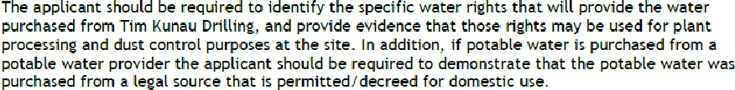

- Colorado Water Conservation Board (CWCB):
  - As of the date of this document, no CWCB comments have been provided.
- Others:
  - Colorado Department of Transportation (CDOT) 12/14/2021:

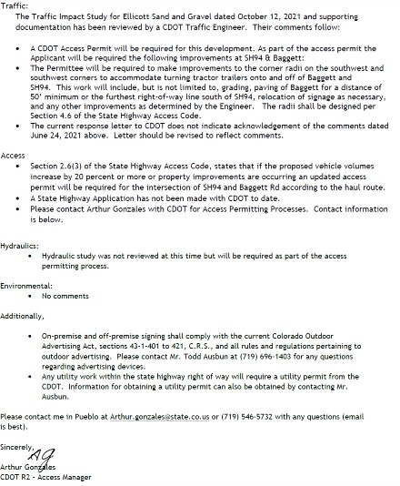

  - Colorado Division of Parks and Wildlife, 11/29/2021:
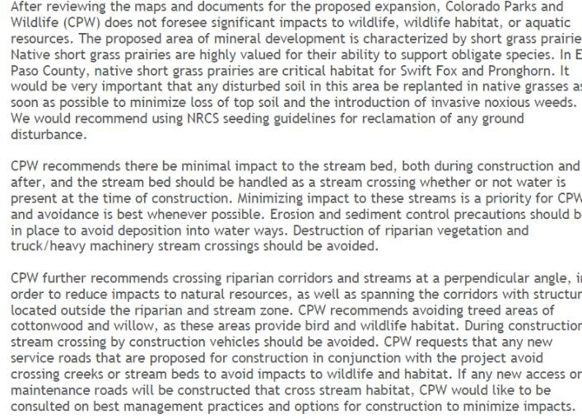

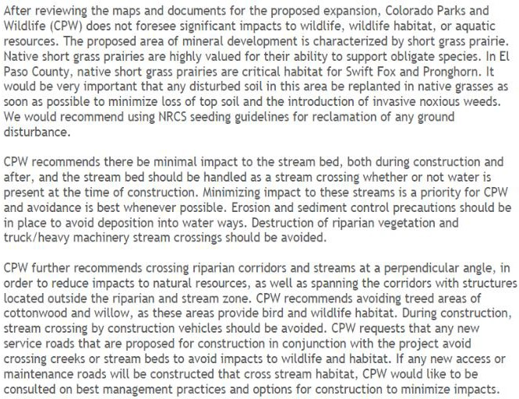

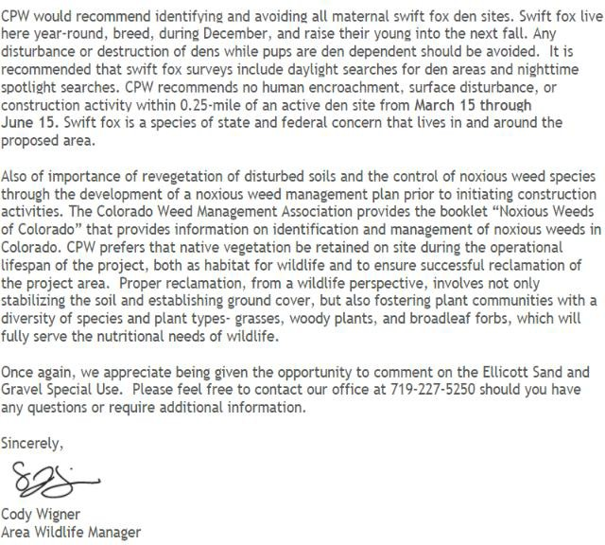

  - El Paso County Public Health, 7/8/2020:
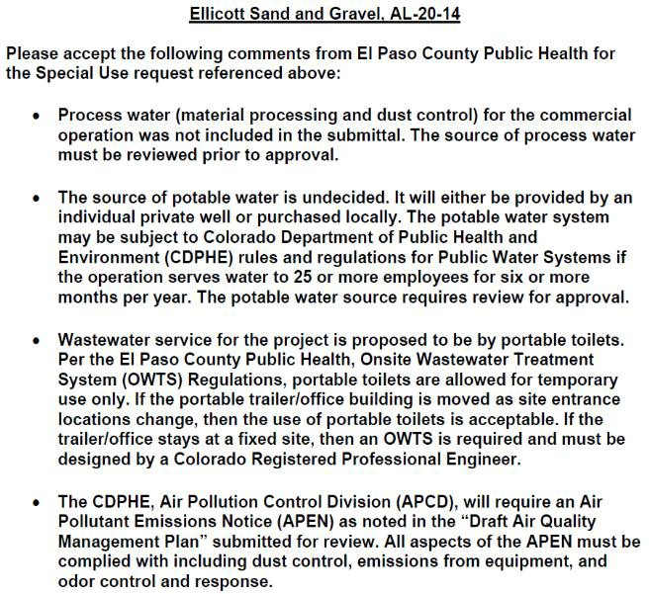


  - Colorado Geological Survey, (CGS), about 7/29/2022:

  - Note: The Mined Land Reclamation Board (CMLRD) permit has been issued for the entire Project, including Stage 2.
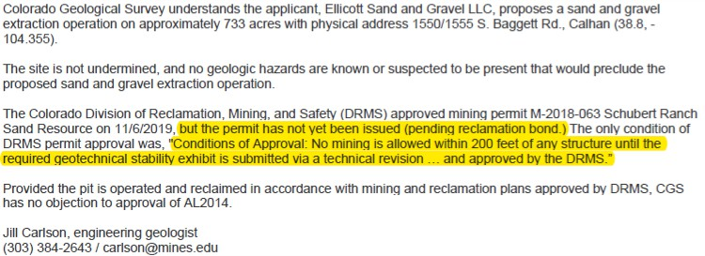

References:
City of Colorado Springs Colorado 2021. City of Colorado Springs Drainage Criteria Manual. May 2014. Revised January 2021. Accessed on January 23, 2024 at https://coloradosprings.gov/document/dcmvolume1revjan2021.pdf.
Colorado Department of Natural Resources 2024. Colorado’s Decision Support Services Map Viewer, accessed on January 9, 2024 at https://maps.dnrgis.state.co.us/dwr/Index.html?viewer=mapviewer.
Colorado Division of Water Resources 2016. Administrative Statement Regarding the Management of Storm Water Detention Facilities and Post-Wildland Fire Facilities in Colorado. February 11, 2016.
El Paso County Colorado 2018. El Paso County Colorado Drainage Criteria Manual. Version October 31, 2018. Accessed on January 22, 2024 at https://library.municode.com/co/el_paso_county/codes/drainage_criteria_manual?nodeId=DRCR MAVO1ELPACO.
El Paso County Colorado 2020. El Paso County Colorado Engineering Criteria Manual. Version October 14, 2020. Accessed on January 18, 2024 at https://library.municode.com/co/el_paso_county/codes/engineering_criteria_manual_?nodeId=E NCRMA_APXISTQUPOPR_I.7PONSSTMA.
El Paso County Planning Department 1989. Ellicott Valley Comprehensive Plan. March 1989.
EME Solutions 2020. Schubert Ranch Sand Resource Floodplain Modeling Technical Memorandum for Black Squirrel Creek, El Paso County, Colorado, EME Solutions, Inc., J.L. Jankousky. P.E., 02/25/2020.
Environment, Inc. et. al. 2024. Environment, Inc., Regulatory Permits Management, Inc., EME Solutions, Inc. Final Drainage Report, PPR 234. Schubert Ranch Sand Resource Pit, Ellicott Sand and Gravel. May 23, 2023. Revised January 31, 2024. Revised March 13, 2024.
FEMA 2018. Flood Insurance Rate Map (FIRM). FIRM 0841C0840G, effective on 12/7/2018.
FHWA 2005. Hydraulic Engineering Circular No. 11, Design of Riprap Revetment. U.S. Department of Transportation Federal Highway Administration. Publication No. FHWA-IP-89-
016. March 1989.
FHWA 1989. Hydraulic Engineering Circular No. 15, Third Edition. Design of Roadside Channels with Flexible Linings. U.S. Department of Transportation Federal Highway Administration. Publication No. FHWA-NHI-05-114. September 2005.

Drawings:
Drawing Contents, two maps/plans are required, existing conditions & the proposed plans:
- General Location Map: A Map shall be provided in sufficient detail to identify drainage flows entering and leaving the development and general drainage patterns. The map should be at a scale of 1” = 50’ to 1” = 2,000’. The map shall identify any major construction (i.e., development, irrigation ditches, existing detention facilities, culverts, storm sewers, etc.) that shall influence or be influenced by the subdivision.
  - Please note, this is not a commercial or residential development. The only structures are culverts along Sanborn Road where the two access points (road crossing) from Stage 1 to Stage 2 cross Sanborn Road. The two culverts will allow for the continued flow along Sanborn Road and into Black Squirrel Creek, to the east.
- Drainage Plan: Map(s) of the proposed development at a scale 1” =20’ to 1” = 200’ shall be included to identify existing condition on or adjacent to the site in question. It shall include a minimum of:
- Existing and proposed contours at 2 feet maximum intervals. For subdivisions involving rural lots greater than 1.0 acre, the maximum interval may be 5 feet where approved. In terrain greater than 10% the intervals should be 10-foot intervals.
- Property lines and existing or proposed easements with purpose noted.
- All streets.
  - Only temporary mine operations roads, and existing ranch roads will be used.
- Existing drainage facilities and structures, including irrigation ditches, roadside ditches, drainageways, gutters and culverts, all indicating flow directions. All pertinent information such as material, size, shape, and locations shall be included.
- Proposed type of street sections (i.e., vertical or ramp curb and gutters, roadside ditch, gutter flow and/or cross pans).
  - No proposed streets or other such structures or facilities are planned.
- Proposed storm sewers and open drainageways, including inlets, manholes, culverts, and other appurtenances.
  - No storm sewers or other similar structures are planned.
- Proposed outfalls point for runoff from the development area and facilities to convey flows to the final outfall point without damage to downstream properties.
  - There will be no designated outfall points or associated damage since all regulated stormwater runoff will be internal to the operation and will infiltrate into the highly permeable pit floor. Therefore, the following items are not applicable.
- Routing and summary of initial and major flow rates at the various design points for all storm runoff associated with the property.
- Path(s) chosen for computation of the time of concentration.
- Details of and design for computations for detention storage facilities including outlet.
- Location and elevations of all defined 100-year floodplains affecting the property.
- Location of all existing and proposed utilities affected by or affecting the drainage design.

ELLICOTT SAND AND GRAVEL LLC SCHUBER RANCH SAND RESOURCE DRAINAGE PLAN - STAGE 1 GENERAL LOCATION MAP

SCHUBERT RANCH SAND RESOURCE STAGE 1 (APPROVED)

SCHUBERT RANCH PROPERTY BOUNDARY

SCHUBERT RANCH PROPERTY BOUNDARY

SCHUBERT RANCH SAND RESOURCE STAGE 2

1SHEET

213.7 ACRES ±

54.2 ACRES ±

DP 2-E
BLACK SQUIRREL CREEK
GRAVEL RANCH ROAD
GRAVEL RANCH ROAD

DP 2-W

GRAVEL RANCH ROAD

DESIGN POINT BASIN DESCRIPTION
SUMMARY RUNOFF TABLE CONTRIBUTING AREA
(ACRES) 5-YEAR RUNOFF (CFS) 100-YEAR RUNOFF (CFS)

LEGEND
SCHUBERT RANCH PROPERTY LINE STAGE II DEVELOPMENT AREA RANCH ROADS (TYP.)
FENCE
BURIED TELEPHONE/COMMUNICATION LINES OVERHEAD ELECTRIC LINES
BUILDING
2 FOOT CONTOURS
5 FOOT CONTOURS

EXISTING CONDITIONS BEFORE PROJECT IMPLEMENTATION

2-W | Basin 2-West | 175.88 | 19.8 | 41.2
2-E | Basin 2-East | 41.04 | 4.6 | 9.6
OFFSITE BASINS ARE UNCHANGED BY PROJECT. OFFSITE BASIN CALCULATIONS ARE BELOW PROPOSED CONDITIONS AFTER PROJECT IMPLEMENTATION

2-W | Basin 2-West | 175.88 | 36.4 | 76.0
2-E | Basin 2-East | 41.04 | 9.0 | 18.1
OFF-1 | Basin OFF-1 | 653.60 | 80.2 | 167.3
OFF-2 | Basin OFF-2 | 1141.80 | 114.8 | 239.6

TOPO CONTOUR
5840

EPHEMERAL DRAINAGE

FLOOD PLAIN (100 YR)
ORDINARY HIGH-WATER LINE 2019

BANK ARMORING
FLOW DIRECTION
DRAINAGE BASIN BOUNDARY
DESIGN POINT
FLOW PATH PPR
FILE NAME:
ESG-DP DRAINAGE 2
CHECKED BY:
JJ

____

EL PASO COUNTY DEVELOPMENT PLAN
PROJECT #:
ESG-COUNTY-S2
3
REVISIONS:

DATE:

ELLICOTT SAND AND GRAVEL LLC

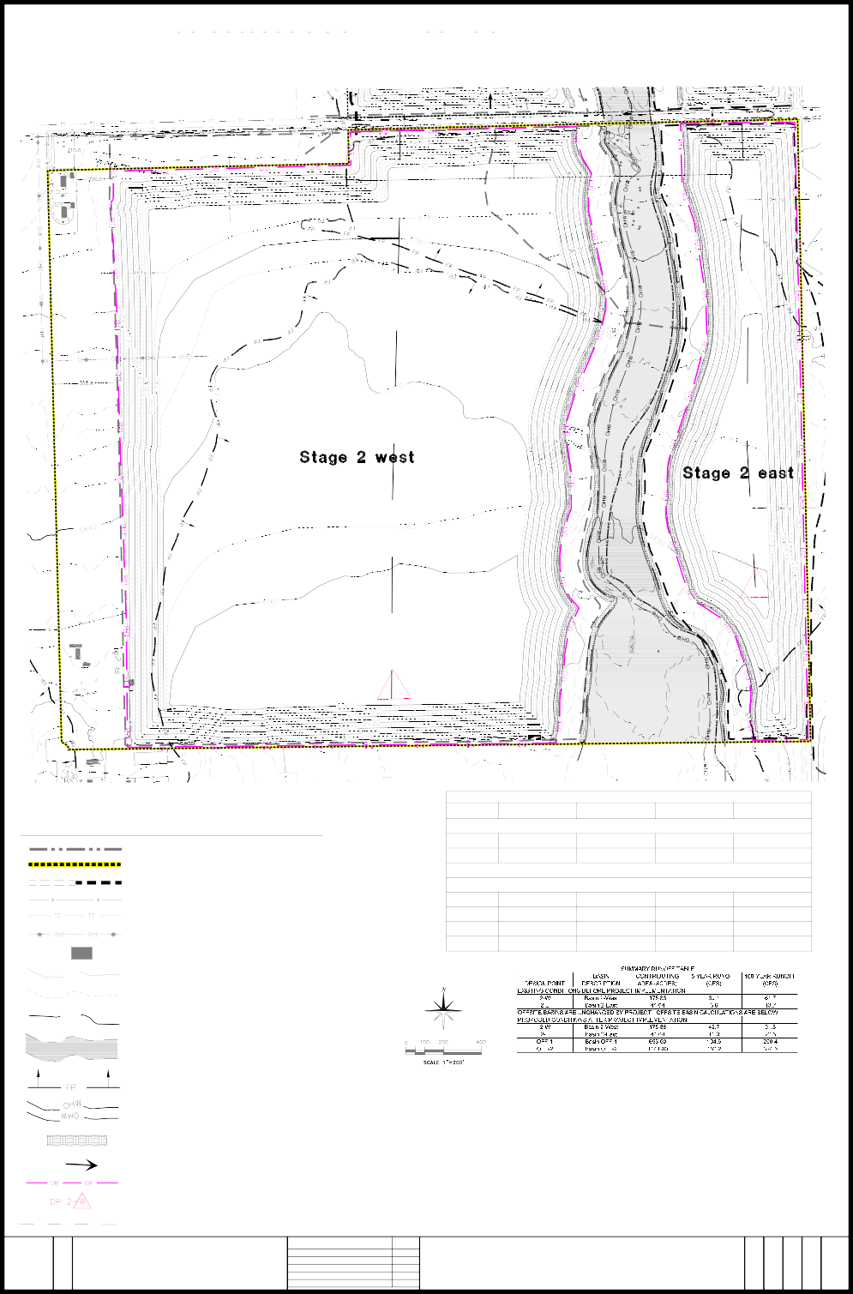
GRAVEL RANCH ROAD
BLACK SQUIRREL CREEK
GRAVEL RANCH ROAD
3H:1V
5849

SHEET
DATE:
04/05/2024
SCALE:
AS NOTED
DRAWN BY:
ENV/slo
PROPOSED CONDITIONS
FOR
SCHUBERT RANCH SAND RESOURCE
ELLICOTT, COLORADO
SPECIAL USE PERMIT APPROVAL - BCC 08-02-2022
STAGE I - DEVELOPMENT PLAN - ISSUED 07/31/2024 STAGE II - DEVELOPMENT PLAN
235 Franceville Coal Mine Road | Colorado Springs Co 80929 phone: (602) 558-0846

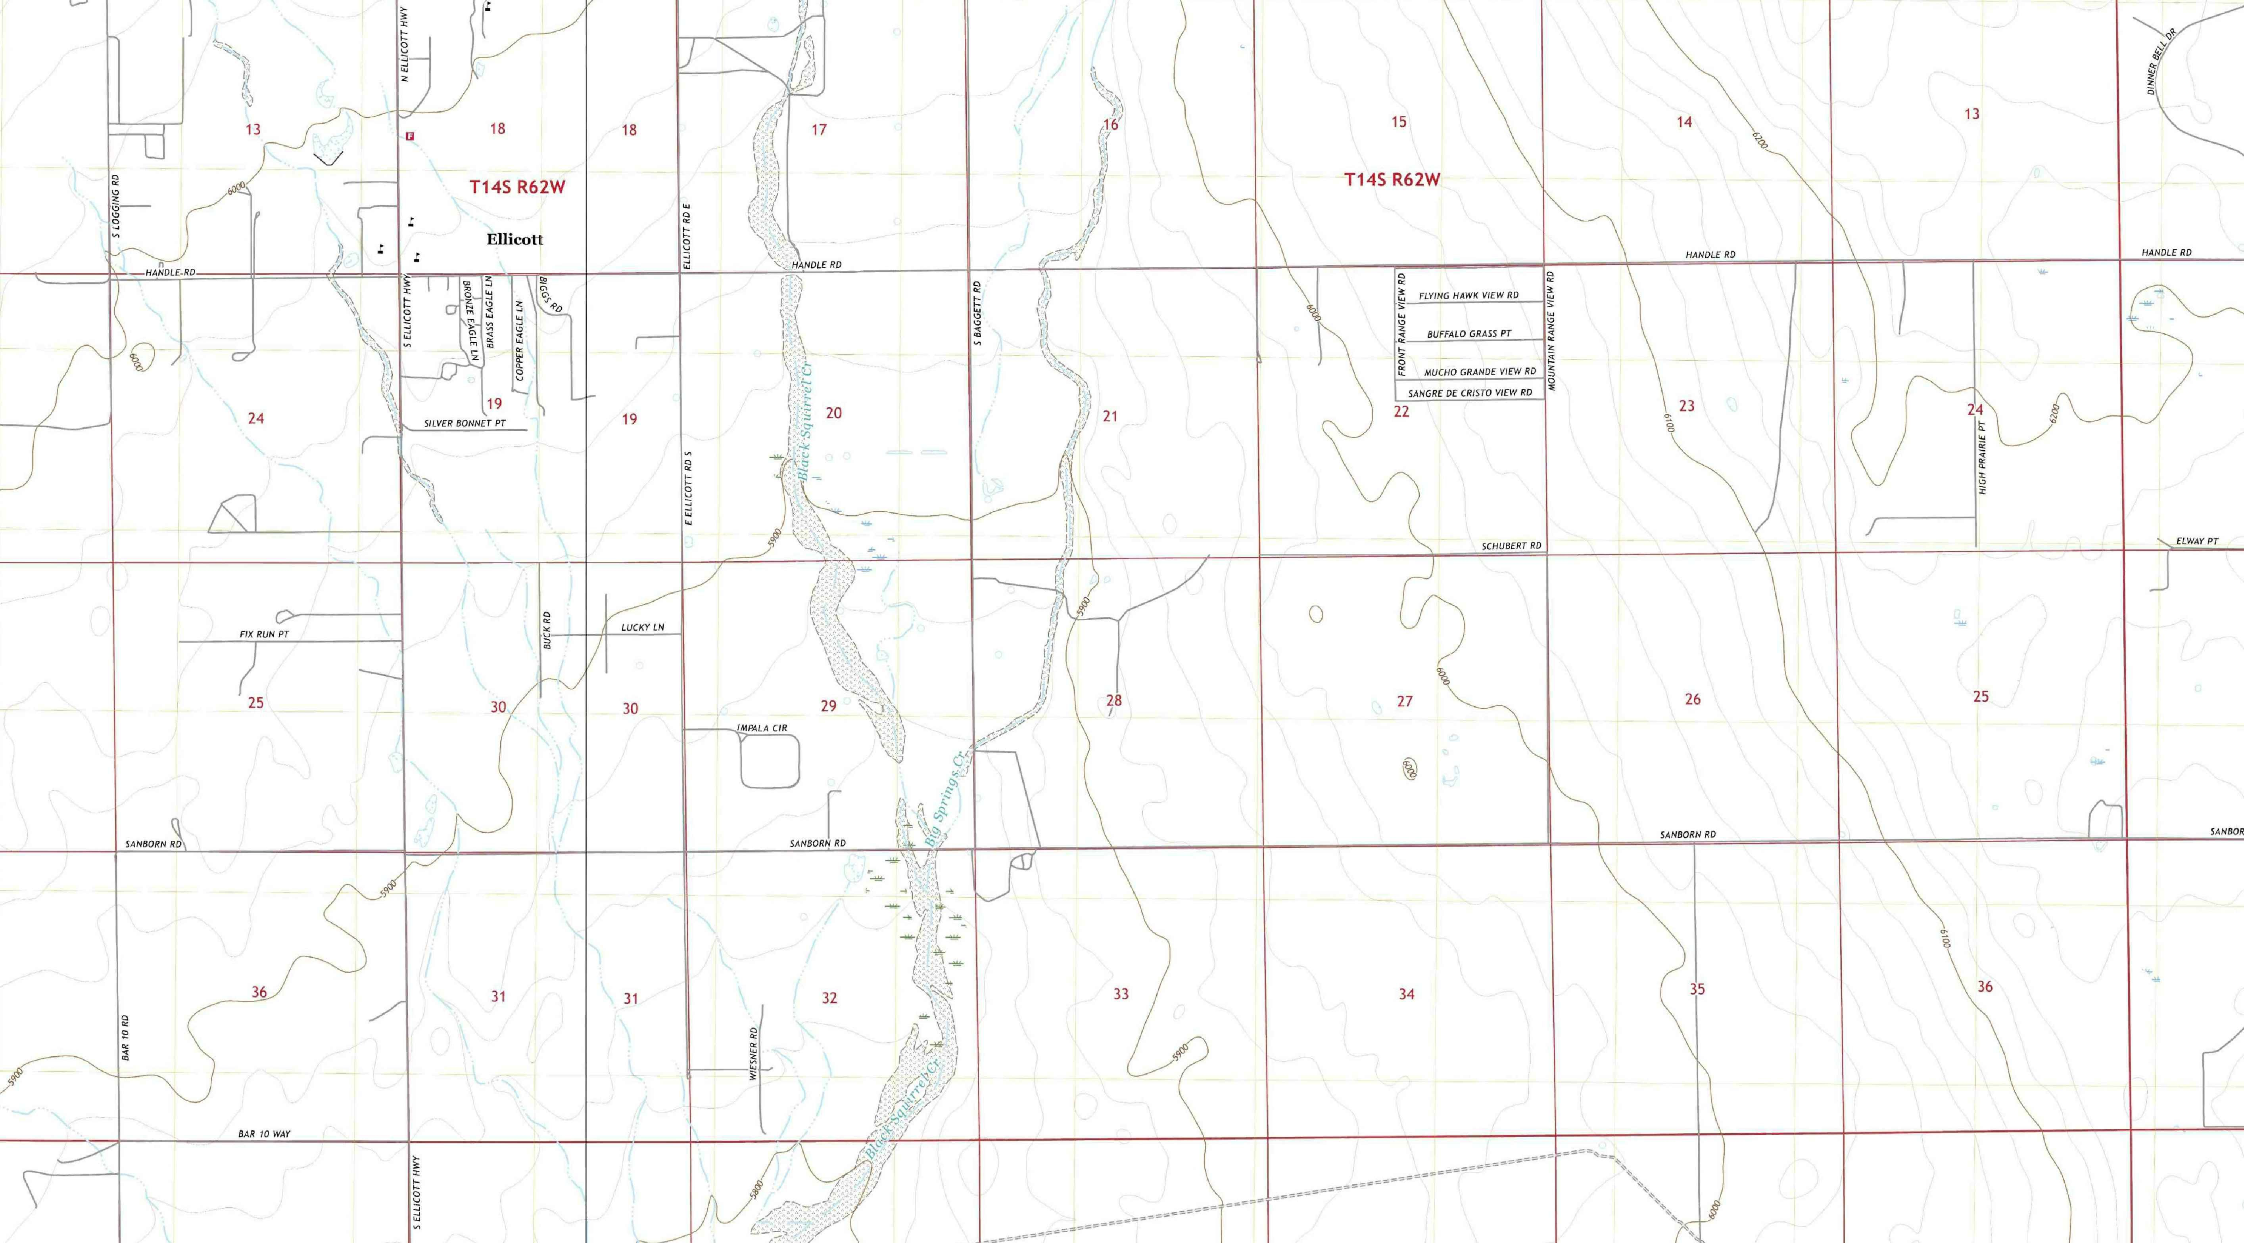
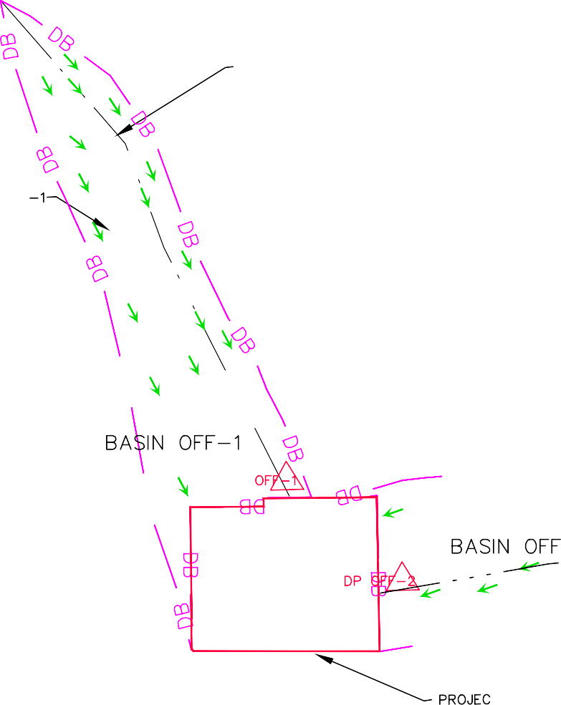
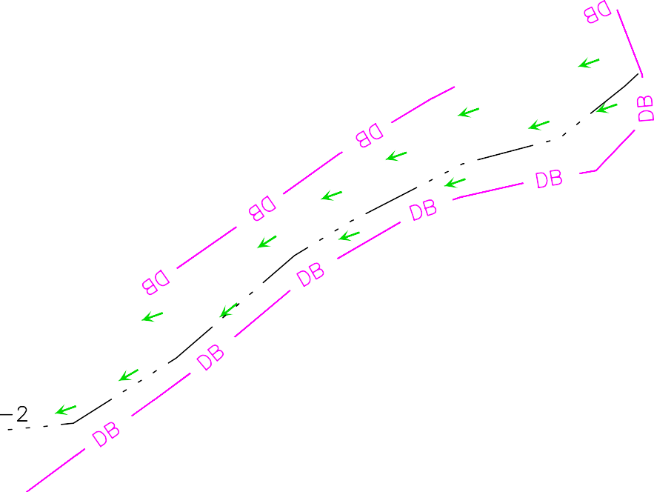
ELLICOTT SAND AND GRAVEL LLC - SITE DEVELOPMENT PLAN
The E¹NE¹, SW¹NE¹, N¹N¹SE¹, N¹NE¹SW¹, SE¹NW¹ and parts of the NW¹NE¹, and NE¹NW¹, Section 32, T-14-S, R-62-W, 6th P.M., El Paso County,

2 4 4
4 2 2 4 2 4 4 4 4
4 4 4 4

Colorado. - Containing 267.9 acres more or less.
STAGE 2 OF 5 - DRAINAGE PLAN

DATE:
04/03/2024
FILE NAME:
ESG-DP DRAINAGE 3
SCALE:
AS NOTED

4
REVISED:
SHEET

EL PASO COUNTY DEVELOPMENT PLAN
FOR
PROJECT #:
ESG-DRAINAGE PLAN
SCHUBERT RANCH SAND RESOURCE
ELLICOTT, COLORADO

ELLICOTT SAND AND GRAVEL LLC
SUMMARY RUNOFF TABLE
DESIGN POINT | BASIN DESCRIPTION | CONTRIBUTING AREA (ACRES) | 5-YEAR RUNOFF (CFS) | 100-YEAR RUNOFF (CFS)
EXISTING CONDITIONS BEFORE PROJECT IMPLEMENTATION
2-W | Basin 2-West | 175.88 | 19.8 | 41.2
2-E | Basin 2-East | 41.04 | 4.6 | 9.6
OFFSITE BASINS ARE UNCHANGED BY PROJECT. OFFSITE BASIN CALCULATIONS ARE BELOW
PROPOSED CONDITIONS AFTER PROJECT IMPLEMENTATION
2-W | Basin 2-West | 175.88 | 36.4 | 76.0
2-E | Basin 2-East | 41.04 | 9.0 | 18.1
OFF-1 | Basin OFF-1 | 653.60 | 80.2 | 167.3
OFF-2 | Basin OFF-2 | 1141.80 | 114.8 | 239.6

235 Franceville Coal Mine Road | Colorado Springs Co 80929
DRAWN BY:
ENV/slo
CHECKED BY:
JJ
REVISIONS: | DATE:
SPECIAL USE PERMIT APPROVAL - BCC | 08/02/2022
STAGE I - DEVELOPMENT PLAN | 07/31/2024
STAGE II - DEVELOPMENT PLAN | 04/16/2025

phone: (602) 558-0846
PPR
___

Attachments
Attachment 1:
FEMA Flood Insurance Rate Map (FIRM)

NOTES TO USERS  This m8p iS for use·in adminiStering the National Flood lnsuiance Pi-ogram It does 110t.necessarily.identify alJ-.areas subject to-flooding, particufarly from local drainage  59urces of small size. The c_omml!rnty_map repository should Pe consulted for possible updated or additional flood hazard information. | 1355000FT  1350000 FT  1345000 FT | 104"22'30.00" | 19  30 | LUCKY I | 20 | 3325000 Fl | Jj,wer Big Spring,\' Creek�  / Ri!(hl Split Flowl'ath  3330000 FT 3335000FT  JOlNS PANEL08;:_30:. -;------------, r,  21 t- 22 + 23  l<�L PASO COI.Ji\TY  c;,,:1,coRPORATEU AR�:AS 08(105,9  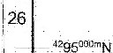  27  28  +  33 34  ···�  �.'Z  . STAGE•� SITE  �-._�• | LEGEND  SPECIAL FLOOD HAZARD AREAS {SFHAS) SUBJECT TO INUNDATION BY THE 1% ANNUAL CHANCE FLOOD  The .1"/o ann.ual thilnef!_flOP-(dtOO-year flood), also known- as the-base flood,.i5 the flOQd  thathi!s·a-1% chimceofbeirig"{1ualedorex�d!'dinanygiv!'llyedr. The-Spedalflood  Hazard Areaislhei!rea SlibJect to rloodiMgby the 1% annual cm:m<:eflcod. Areas of  �I Rood H�,a,d indude-Zones A, AE, AH, AO, AR, A99, V, irnd VE. The &se Flood Bevat>OOis the wate•--surface elevation of the 1%.�nnual chance "90d  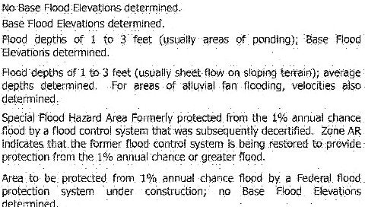  ZONEAE ZONE AH  ZONE V Coastal fiood zone with velocity ·h.izard {wa,e actioo); �o Base Rood Hevationsdetermined.  Coa_stal_floaxl zone with_ v�ity_hilzard (wave action); Base Flood  Etevaticinsdett'.rmined  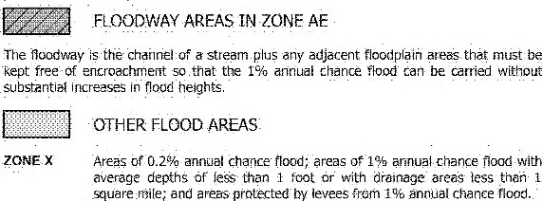  {==:J OTHER AREAS  ZONE X A,eas·cte\ermined to be Ot;l';ide the 0.2% linni.lai chance Modplaili, ZONED Areas in which flood l'mards �re uridetermined;·b1,t possibre.  � COASTAL BARRIER RESOURCES SYSTEM (CT!RS) AREAS  � OTHERWISE PROTECTED AREAS(OPAs)  CBRSareasandOPAs"arenormiifly!ocatedw!thlnoradjacenttoSpecii!lFloodHazardAroi!ls.  _Aoodpl,1lnboundilr'f Flooc!wayOOl.lndary  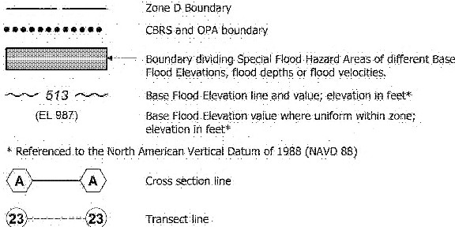  .97°07'3000" _(,eograp.hk.coordinatesreferen_,:edtOthcNorthAmi!ricen  32°22' 3000" Dilturnof\9S3(NAD83}  lOOfr-m�terUniversaJTransverse Mercator grid ticks, zonel3  5000-·footgridtic:ks: Co1orildoStarePlanecoordinate sysi:em.cerrtra:zone_{FIPSZONE0502), LambertConformaJConicProjectioh  DX551_Qx Bench _rl"l<lr�(5ee.e><p!anation ir. Notes to Users section of  thJsFIRMpa_nel}  M1.5  Refer to Ma;, RepOsit-oiiet hit.on Map+nd�x  EFFECT!VE OATE OF COUNTYWIOE FLOOD INSURANCE RATEMAP MARCH 17, 1997  EFFEC'llVE D-ATE(S) Of RE.VISlON(S)TO H-t:S PANil  OECEMBER 7,2!116 - !_o update crnwrate limits,lo change Ba$,:_Flqod Eli,vatiQns and Speciill Flcod Hazard Areas, tc update map foimal, to Md 1oads and roa<l names, andIi.> 1�eo1pora10 prev>0usty iS�lie:d Letters QI Map ReWl\ion  For community_map revision history prior to_c.ouotyw:de mapping, refer to the Community    Map Hlstory Table located ln the Flood Insurance Sl:ud� rel)()rt fO('tl"llSJurisd.Ction
To Obtain more deiaited infoTITlation in areas where BaSe Fiood Elevaticins·{BFEs) and/or-floodways nave been-determined, users are encouraged to consult the Flood Profiles- and Floodway Data afld/or Summ,;iry -of Stillwater Elevc1tions tables contaired within .the _flood Insurance Study (FIS) report that accompanies this PIRM. Users should be_aware ihat BFEs shown on the FIRM represent rounded wliole•foot eIe"vations:• Th!!se BFEs are intended for flood imiurance ratirig purpOses onjy and shoufd not be used" as-the sore Source of flood· elevation information. Accbrdfng!y,
-flood elevation data presented in the FISreport should be utilized .in i;:dnjunciionwfth the FIRM for purposes of construction and/or floodplain management
CoaStalBase Fiood EteVations shown on this map apply only landward of O 0' North American Vertical Datum cf 1988 (NAVD88). Users of this FIRM should be aware that_c;oastal flood elevations are also provided in the Summary of StiUwate, Elevations table in the Flood Insurance Study r_eportfofthis-jurisdiction. _Elevations shown-in the Summary cif_Stillwater _(::levat_ions_table should be used for c;om,truction and/er floodplain management purposes wfien they are higher than the elevations shown on thisFlRM.
Boundaries of the_ floodways were computed at cross -sections an.d lnterpolated be_Meen cross sections. The floodways were ba_sed on hydraulic ccmsiderations with regard to requirerrients of the National Fiood Insurance Program. Floodway widths and other pertirient flOOdv.'ay' data are provided in the·Flood Insurance Study fepbrt fer this jurisdiction.
Certain areas not in _Special Flood Haza.rd Areas may be pcotecte,J by flood control structures. Refer to section 2.4 '"Flood Protection Measures" of tl1e Flood Insurance Study refX)rt ror information on flood control structures f-or this jurisdiction.
The projection used in !he pref)araticm of -this map was Universal Transverse Men;ator {UTM)-zone 13, The ho_rizontal datvm was NA08-3, GR..880 spheroid, Differences in .datum, spheroid, pr_ojecti_on_or UTM zones zones_ used in the production of FIRMs for • adjacent jurisdictions· rilay result in slight positional
differences in map features across jurisdiction boundaries. These differences do not affect-the accuracy of this FIRM.
Flood elevations on this map a_re referenced to the North_American V_ertical Datum of 1988 (NAV088). These flood elevations must be compared lo structure and ground etevaiioris referenced to the sarrie vertical datum For inforniation regarding conversion .between the NaliohaT Geodetic Vertical Datum cf 1929 and the North American Ver_lical Datum -of 1MB, vfsil the·National Geode'.ic Survey website at http://www.ngs.noaa.gov/ or contact the National Geodetic Survey at the following address
NGS Information Services NOAA;N/NGS12
National Geodetic Survey SSMC-3, #9202
1315 East-West Highw-ay Silver Spring, MD 20910-�282_
To·obt8"11Jcurrent elevation, ·det;cription, and/cir localioriinformatior for bench marks shown On tliiS map. please·contact the fnforn'raJion Servir.es Brani::h of the- Naticiilal Geodetic SI..HVey at (301)713-'3242orvisilits website athttp://Ww-N;ngs..noaa.gov/.
Base Map information shown on this FIRM was provide<I in.digital format by El Paso County, Colorado Springs l).tilities, and Anderson Consulting Eng'ineers, Lnc. These data are current as cif 2008.
Ttiis map reflects more detailed and up-lo-date stream channel-configurations and floodplain delineations than !hose shown on the_previous FIRM for this. jurisdiction. The floodplains and flqodways that were t_ransferred from the prevj:ous FJRM may tiaVe• been 8dJusted to ccinform to tti!ise new stream cha'nnel conf;gt.iratfOnK As a result, the Flood Profiles and Floodway-Data tables in the Flood insurance Study Report (vlhic,t.)contains- authoritative hydraulic data) may reflect stream channel dislances that dlffer from what is shown on this map.- The.pro[iJe baselines depicted on this map represent tr,e hydraulic mod_e:!ing baselinfls that match the flood profiles and Ftoodway Data Tclbtes if applicable·,in the FIS report. AS a result, the prcifile basetines may deviate significantly from the new base map .dianrie! representation and may appear outside oftt1e floodplain
Corpor.ite lir11its shown on this map are based cm the bes_! data av,ailable at the time of public"atioli. Because changes dtie to annexatioris or de-annexations may have occurted after this map was published; rnnp users should conlact appropriate coinmt.inity officials to verify current corporate limit locations
Please _refer lo ttie separ_ate!y printed M.;ip lnd8?< f-9r an overview map of tt,e county shOwing the layout of map panels; co·mmunity map repository addresses: ana• a Listing of Cornmuniti_es table containing ·NaUOf\aJFlood·Jnsurance Program dates for
each community· as well as a listing of the panels On whid1 each community is
located.
Contact FEMA Map Service .Center (MSC) via the FEMA Map Information eXcharige (FMIX) l-877-336-2627 for information on available products associated with this FIRM._Ava.Hable prOducts may Include previously issued LE:iitei"·Sof Map Change: a Flood lnSurar:ce S:udy Report; .and/or digital versions of this.map. The MSC.may also_ be reached by Fax at 1-800-358-9620 and its website at http://www.mscJema.gov/
If you hs>ve question's abtiut this map or questions coilcerning the National Flood fnsurance Program in general. please call 1-8TT-FEMA MAP (1-877-336-2627) or
visit theFEMA website atl)ttp://v;_wwJei:na.gov/businesstnfip
El Paso County Vertical Datum Offset Table  Vertiea1-oa-1um Offset ft |  |  |  |  |  |  |  | MAP SCALE 1" = 1000'  2000  fff..T
REFER TO SECTION 3,3 OF THE El PASO COUNTY FLOOD !NSURANCE STUOY fOR STRWI BY STREAM \iERTICALDATUM-CON'iERSlbN INFORMAT!Ott
 | 1340000FT |  |  |  |  | 17 | +  EL PASO COUNTY  l!.'ilNCORl'ORATE-DAREAS  080059  10    16 15 | FIRM  FLOOD INSURANCE RATE MAP  EL PASO COUNTY, COLORADO  AND INCORPORATED AREAS  PANEL 840 OF 1300  (SEE MAP INDEX FOR FlRMPANEL LAYQUT}  �-T.f,-�§_  g)J.1MUNJI).'. !'!Jl.M.i?@.  MAP.NUMBER 08041C0840G
Pane!'Location Map

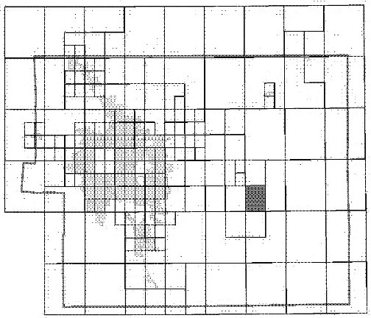

This Digital Flood Insurance Rate Map (DF!RMJ was produced through a Cooperating Techntc:al Partner (CTP) agreement betweerUhe State of Colorado Water Ccinservaticil Board (CWCB) a'i"ld the Federal Emergency Management Agency (FEMA),

Additional F=ioodHezard information and resources are
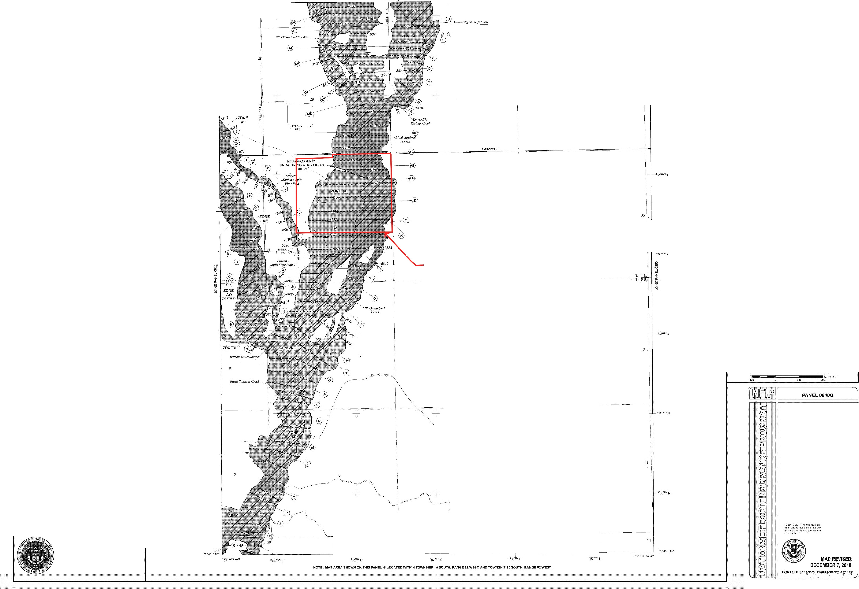
available .from local communities and the .Colorado Water Conservation Board
JOINS PANEL 1030

Attachment 2:
Flood Plain Development Permit:

Pikes Peak Regional Building Department

Permit# 20017 FLOOD PLAIN DEVELOPMENT PERMIT

Date 18-Jan-2024

Name: SCHUBERT RANCHES, LNC.

Address: 1555 S. BAGGETT ROAD CALHAN, CO 80808
Attention: GEORGE SCHUBERT

Address: ELLICOTT SAND & GRAVEL

Owner Information
Phone:

Project Location

Location/Directions: Ellicott Sand & Grdvel Contractor/Engineer: Ellicott Sand & Gravel, Christine Wilson

Phone: (719) 568-3164

Single Family Residential: Multi-Family Residential: Manufactured Home:
Non-Residential
New Construction Watercourse Modification: Project Cost: $0.00
Creek: black squirrel

l
l
[ l
[X]
[ l
[ l
Project Description Addition/Remodel (<50%): Rehabilitation
Subst. (>50 Appraisal) lmprv: Fill
Bridge/Culvert
Levee:
Structure Market Value: $0.00

Description of work: ELLICOTT SAND & GRAVEL
sand mine The mine pennit area is 733.7 acres, with a maximum of 561.7 acres disturbed by the mining operation over the life of the mine. o-Risc attached

Flood Hazard Data
Location: Flood Fringe
Base ( I%) Flood Elevation: varies Lowest Floor Elevation: Floodproofing Level:
Source Documem: 08041C0830G, 08041C0840G

Permit Action
Pcnnit Granted (YIN): Yes Variance Granted (YIN): No Action Comments: contractor is permit owner : Ellicott Sand & Gravel,
No-Rise attached
reissued good through 1/18/2025

Compliance Section
Elevation Certificate: Date:

LOMA: Date:

Site Inspection:
Preliminary Required: N Final Required: Y

CLOMR: N Date:

Date: Date:

LOMR: Date:
For Inspection Requests call: Keith 327-2898

Compliance Comments: o-Rise attached

Regional Floodplain Division: Date 18-Jan-2024

NOTE:This pennit expires twelve (12) months from the date it is issued.

APPENDIX A

APPENDIX A TABLE OF CONTENTS
Table 1. Areas, Lengths, and Elevation Changes from Site Map A-1
Table 2. Percent Impervious Calculations and Rational Method "C" Calculations..................A-2 Table 3. Time of Concentration ................................................................................................A-4
NOAA Atlas information ..........................................................................................................A-5
Table 4. Rational Method Procedure -- 5-year Design Storm ................................................A-12
Table 5. Rational Method Procedure -- 100-year Design Storm ............................................A-13
Table 6. Required Cross-Sectional Areas for Channel Flow ..................................................A-14 Manning’s n Values.................................................................................................................A-16
Table 7. Riprap Calculations...................................................................................................A-21
Table 8. Retention Basin Calculations ...................................................................................A-27

Table 1. Areas, Lengths, and Elevation Changes from Site Map Schubert Ranch Sand Resource Pit Stage 2
Final Drainage Report
Calculated by: John Jankousky Revision: 5/5/2025
Design Point Number | Basin Designation | Area (ft²) | Area (acres) | Area (mi²) | Flow Length, L (ft) | Flow Length, L (mi) | Length of Overland Flow, L(OL) (ft) | Length of Concentrated Flow, L(P) (ft) | Top Elevation (ft) | Bottom Elevation (ft) | Change in elevation, H (ft) | Overall Slope, S = H/L (ft/ft) | Overland Flow Top Elevation (ft) | Overland Flow Bottom Elevation (ft) | Overland Change in elevation, H (ft) | Overland Flow Slope, S = H/L (ft/ft) | Concentrated Flow Top Elevation (ft) | Concentrated Flow Bottom Elevation (f | Concentrated Change in elevation, H ( | Concentrated Flow Slope, S = H/L (ft/ft
EXISTING CONDITIONS |  |  |  |  |  |  |  |  |  |  |  |  |  |  |  |  |  |  |  | )
ONSITE BASINS
2-W | Basin 2-West | 7,661,188 | 175.88 | 0.2748 | 3,641 | 0.69 | 300 | 3341 | 5850.0 | 5820.0 | 30.0 | 0.0082 | 5850.0 | 5846.0 | 4.0 | 0.0133 | 5846.0 | 5820.0 | 26.0 | 0.0078
2-E | Basin 2-East | 1,787,502 | 41.04 | 0.0641 | 3,256 | 0.62 | 300 | 2956 | 5850.0 | 5827.0 | 23.0 | 0.0071 | 5850.0 | 5847.0 | 3.0 | 0.0100 | 5847.0 | 5827.0 | 20.0 | 0.0068
OFFSITE BASINS
 | Basins OFF-1 and OFF-2 are the same for Existing and Proposed Conditions. See the calculations below
PROPOSED CONDITIONS
ONSITE BASINS
2-W | Basin 2-West | 7,661,188 | 175.88 | 0.2748 | 3,009 | 0.57 | 210 | 2799 | 5850.0 | 5760.0 | 90.0 | 0.0299 | 5850.0 | 5790.0 | 60.0 | 0.2857 | 5790.0 | 5760.0 | 30.0 | 0.0107
2-E | Basin 2-East | 1,787,502 | 41.04 | 0.0641 | 2,460 | 0.47 | 210 | 2250 | 5850.0 | 5770.0 | 80.0 | 0.0325 | 5850.0 | 5790.0 | 60.0 | 0.2857 | 5790.0 | 5770.0 | 20.0 | 0.0089
OFFSITE BASINS
OFF-1 | Basin OFF-1 | 28,470,806 | 653.60 | 1.0212 | 12,618 | 2.39 | 1000 | 11618 | 5960.0 | 5855.0 | 105.0 | 0.0083 |  |  | 0.0 | 0.0083 |  |  | 0.0 | 0.0083
OFF-2 | Basin OFF-2 | 49,736,624 | 1141.80 | 1.7841 | 19,775 | 3.75 | 1000 | 18775 | 6206.0 | 5850.0 | 356.0 | 0.0180 |  |  | 0.0 | 0.0180 |  |  | 0.0 | 0.0180
The Site is evaluated as two basins. Basin 2-West and Basin 2-East flow to their respective pits. See the site plan. Water quality at the Site edges will be protected by the installation of silt fence as needed.
Note: If no large slope difference between overland flow area and concentrated flow area, use overall slope value only. Source: Site AutoCAD drawings

hydrology-Schubert-Ranch-Rev0-5-5-2025.xlsx a2 Tbl2Basin dimensions

Table 2. Percent Impervious Calculations and Rational Method "C" Calculations Schubert Ranch Sand Resource Pit Stage 2
Final Drainage Report

Calculated by: John Jankousky Revision: 5/5/2025
Soil Hydrologic Group A
Land Use | % Imp. | C2 | C5 | C10 | C100
Greenbelt, Agriculture | 2 | 0.03 | 0.09 | 0.17 | 0.36
Residential, One Acre | 20 | 0.12 | 0.20 | 0.27 | 0.44
Railroad Yard Area | 40 | 0.23 | 0.30 | 0.36 | 0.50
Street, Gravel | 80 | 0.57 | 0.59 | 0.63 | 0.70
Light Industrial | 80 | 0.57 | 0.59 | 0.63 | 0.70
Building/Roof Area | 90 | 0.73 | 0.75 | 0.77 | 0.81
Pavement Area | 100 | 0.84 | 0.86 | 0.87 | 0.89
Source: City of Colorado Springs Drainage Criteria Manual. May 2014. Revised January 2021. Volume 1. Table 6-6.
Design Point | Basin Designation | Total Area (ft²) | Total Area (acres) | Greenbelt, Agriculture (ft²) | Residential, One Acre (ft²) | Railroad Yard Area (ft²) | Street, Gravel (ft²) | Light Industrial Area (ft²) | Building/Roof Area (ft²) | Pavement Area (ft²) | Combined % Impervious | Combined C2 | Combined C5 | Combined C10 | Combined C100
EXISTING CONDITIONS (HISTORIC, PRIOR TO DEVELOPMENT)
ONSITE BASINS
2-W | Basin 2-West | 7,661,188 | 175.88 | 7,661,188 |  |  |  |  |  |  | 2.00 | 0.03 | 0.09 | 0.17 | 0.36
2-E | Basin 2-East | 1,787,502 | 41.04 | 1,787,502 |  |  |  |  |  |  | 2.00 | 0.03 | 0.09 | 0.17 | 0.36
OFFSITE BASINS
 | Basin OFF-1 is the same for Existing and Proposed Conditions. See the calculation below
PROPOSED CONDITIONS AFTER PROJECT IMPLEMENTATION
ONSITE BASINS
2-W | Basin 2-West | 7,661,188 | 175.88 | 7,661,188 |  |  |  |  | 0 | 0 | 2.00 | 0.03 | 0.09 | 0.17 | 0.36
2-E | Basin 2-East | 1,787,502 | 41.04 | 1,787,502 |  |  |  |  |  |  | 2.00 | 0.03 | 0.09 | 0.17 | 0.36
OFFSITE BASINS
OFF-1 | Basin OFF-1 | 28,470,806 | 653.60 | 17,262,090 | 11,208,716 |  |  |  |  |  | 9.09 | 0.07 | 0.13 | 0.21 | 0.39
OFF-2 | Basin OFF-2 | 49,736,624 | 1141.80 | 41,008,334 | 8,728,290 |  |  |  |  |  | 5.16 | 0.05 | 0.11 | 0.19 | 0.37

hydrology-Schubert-Ranch-Rev0-5-5-2025.xlsx a2 %Imp

Table 6-6. Runoff Coefficients for Rational Method
(Source: UDFCD 2001)

Land Use or Surface Characteristics | Percent Impervious | Runoff Coefficients
Land Use or Surface Characteristics | Percent Impervious | 2-year |  | 5-year |  | 10-year |  | 25-year |  | 50-year |  | 100-year
 |  | HSG A&B | HSG C&D | HSG A&B | HSG C&D | HSG A&B | HSG C&D | HSG A&B | HSG C&D | HSG A&B | HSG C&D | HSG A&B | HSG C&D
Business
Commercial Areas | 95 | 0.79 | 0.80 | 0.81 | 0.82 | 0.83 | 0.84 | 0.85 | 0.87 | 0.87 | 0.88 | 0.88 | 0.89
Neighborhood Areas | 70 | 0.45 | 0.49 | 0.49 | 0.53 | 0.53 | 0.57 | 0.58 | 0.62 | 0.60 | 0.65 | 0.62 | 0.68
Residential
1/8 Acre or less | 65 | 0.41 | 0.45 | 0.45 | 0.49 | 0.49 | 0.54 | 0.54 | 0.59 | 0.57 | 0.62 | 0.59 | 0.65
1/4 Acre | 40 | 0.23 | 0.28 | 0.30 | 0.35 | 0.36 | 0.42 | 0.42 | 0.50 | 0.46 | 0.54 | 0.50 | 0.58
1/3 Acre | 30 | 0.18 | 0.22 | 0.25 | 0.30 | 0.32 | 0.38 | 0.39 | 0.47 | 0.43 | 0.52 | 0.47 | 0.57
1/2 Acre | 25 | 0.15 | 0.20 | 0.22 | 0.28 | 0.30 | 0.36 | 0.37 | 0.46 | 0.41 | 0.51 | 0.46 | 0.56
1 Acre | 20 | 0.12 | 0.17 | 0.20 | 0.26 | 0.27 | 0.34 | 0.35 | 0.44 | 0.40 | 0.50 | 0.44 | 0.55
Industrial
Light Areas | 80 | 0.57 | 0.60 | 0.59 | 0.63 | 0.63 | 0.66 | 0.66 | 0.70 | 0.68 | 0.72 | 0.70 | 0.74
Heavy Areas | 90 | 0.71 | 0.73 | 0.73 | 0.75 | 0.75 | 0.77 | 0.78 | 0.80 | 0.80 | 0.82 | 0.81 | 0.83
Parks and Cemeteries | 7 | 0.05 | 0.09 | 0.12 | 0.19 | 0.20 | 0.29 | 0.30 | 0.40 | 0.34 | 0.46 | 0.39 | 0.52
Playgrounds | 13 | 0.07 | 0.13 | 0.16 | 0.23 | 0.24 | 0.31 | 0.32 | 0.42 | 0.37 | 0.48 | 0.41 | 0.54
Railroad Yard Areas | 40 | 0.23 | 0.28 | 0.30 | 0.35 | 0.36 | 0.42 | 0.42 | 0.50 | 0.46 | 0.54 | 0.50 | 0.58
Undeveloped Areas
Historic Flow Analysis--  Greenbelts, Agriculture | 2 | 0.03 | 0.05 | 0.09 | 0.16 | 0.17 | 0.26 | 0.26 | 0.38 | 0.31 | 0.45 | 0.36 | 0.51
Pasture/Meadow | 0 | 0.02 | 0.04 | 0.08 | 0.15 | 0.15 | 0.25 | 0.25 | 0.37 | 0.30 | 0.44 | 0.35 | 0.50
Forest | 0 | 0.02 | 0.04 | 0.08 | 0.15 | 0.15 | 0.25 | 0.25 | 0.37 | 0.30 | 0.44 | 0.35 | 0.50
Exposed Rock | 100 | 0.89 | 0.89 | 0.90 | 0.90 | 0.92 | 0.92 | 0.94 | 0.94 | 0.95 | 0.95 | 0.96 | 0.96
Offsite Flow Analysis (when  landuse is undefined) | 45 | 0.26 | 0.31 | 0.32 | 0.37 | 0.38 | 0.44 | 0.44 | 0.51 | 0.48 | 0.55 | 0.51 | 0.59
Streets
Paved | 100 | 0.89 | 0.89 | 0.90 | 0.90 | 0.92 | 0.92 | 0.94 | 0.94 | 0.95 | 0.95 | 0.96 | 0.96
Gravel | 80 | 0.57 | 0.60 | 0.59 | 0.63 | 0.63 | 0.66 | 0.66 | 0.70 | 0.68 | 0.72 | 0.70 | 0.74
Drive and Walks | 100 | 0.89 | 0.89 | 0.90 | 0.90 | 0.92 | 0.92 | 0.94 | 0.94 | 0.95 | 0.95 | 0.96 | 0.96
Roofs | 90 | 0.71 | 0.73 | 0.73 | 0.75 | 0.75 | 0.77 | 0.78 | 0.80 | 0.80 | 0.82 | 0.81 | 0.83
Lawns | 0 | 0.02 | 0.04 | 0.08 | 0.15 | 0.15 | 0.25 | 0.25 | 0.37 | 0.30 | 0.44 | 0.35 | 0.50
3.2 Time of Concentration
One of the basic assumptions underlying the Rational Method is that runoff is a function of the average rainfall rate during the time required for water to flow from the hydraulically most remote part of the drainage area under consideration to the design point. However, in practice, the time of concentration can be an empirical value that results in reasonable and acceptable peak flow calculations.
For urban areas, the time of concentration (tc) consists of an initial time or overland flow time (ti) plus the travel time (tt) in the storm sewer, paved gutter, roadside drainage ditch, or drainage channel. For non- urban areas, the time of concentration consists of an overland flow time (ti) plus the time of travel in a concentrated form, such as a swale or drainageway. The travel portion (tt) of the time of concentration can be estimated from the hydraulic properties of the storm sewer, gutter, swale, ditch, or drainageway.
Initial time, on the other hand, will vary with surface slope, depression storage, surface cover, antecedent rainfall, and infiltration capacity of the soil, as well as distance of surface flow. The time of concentration is represented by Equation 6-7 for both urban and non-urban areas.

May 2014 City of Colorado Springs 6-17

Table 3. Time of Concentration Schubert Ranch Sand Resource Pit Stage 2
Final Drainage Report
Calculated by: John Jankousky Revision: 5/5/2025
 | Sub-Basin Data |  |  | Initial Overland Time (t_{o}) |  |  | Travel Time (t_{t}) |  |  |  |  | t_{c} = t_{i} + t_{t} | tc Check (urbanized) |  | Final t_{c} | Remarks
Number | Designation | Area, Ac | C5 | Overlan d Flow Length, Ft. | Slope,  % | t_{o}, min* | Concen-  trated Flow Length, Ft. | Slope, % | K  Conveya nce Factor | Velocity, FPS ** | t_{t}, min | Comp. t_{c}, min | Total Length, Ft. | t_{c} = (L/180)  +10,  min | Final t_{c}, min
 | (1) | (2) | (3) | (4) | (5) | (6) | (7) | (8) |  | (9) | (10) | (11) | (12) | (13) | (14)
EXISTING CONDITIONS (HISTORIC, PRIOR TO DEVELOPMENT)
ONSITE BASINS
2-W | Basin 2-West | 175.88 | 0.09 | 300 | 1.33 | 29.1 | 3341 | 0.7782 | 15.00 | 1.3 | 42.1 | 71.2 | 3641 | 30.2 | 71.2
2-E | Basin 2-East | 41.04 | 0.09 | 300 | 1.00 | 32.0 | 2956 | 0.6766 | 15.00 | 1.2 | 39.9 | 72.0 | 3256 | 28.1 | 72.0
OFFSITE BASINS
 | Basin OFF-1 is the same for Existing and Proposed Conditions. See the calculation below
PROPOSED CONDITIONS AFTER PHASE I IMPLEMENTATION
ONSITE BASINS
2-W | Basin 2-West | 175.88 | 0.09 | 210 | 28.57 | 8.8 | 2799 | 1.07 | 15.00 | 1.6 | 30.0 | 38.8 | 3009 | 26.7 | 26.7
2-E | Basin 2-East | 41.04 | 0.09 | 210 | 28.57 | 8.8 | 2250 | 0.89 | 15.00 | 1.4 | 26.5 | 35.3 | 2460 | 23.7 | 23.7
OFFSITE BASINS
OFF-1 | Basin OFF-1 | 653.60 | 0.13 | 1000 | 0.83 | 59.5 | 11618 | 0.83 | 15.00 | 1.4 | 141.5 | 201.0 | 12618 | 80.1 | 201.0
OFF-2 | Basin OFF-2 | 1141.80 | 0.11 | 1000 | 1.80 | 47.2 | 18775 | 1.80 | 15.00 | 2.0 | 155.5 | 202.6 | 19775 | 119.9 | 202.6
* Calculated using formula: t_{i} = (0.395 * (1.1 - C5) * L^0.5) / (S^0.333) (Urban Drainage Manual, Equation 6-3) Where:
t i = overland (initial) flow time (minutes)
C 5 = runoff coefficient for 5-year frequency (from Table 6-4)
L i = length of overland flow (ft)
S o = average slope along the overland flow path (ft/ft).
** For travel time velocity, channelized flow time equation 6-4: tt = Lt /60Vt Where:
t t = channelized flow time (travel time, min)
L t = waterway length (ft) So = waterway slope (ft/ft)
V t = travel time velocity (ft/sec) = K√So
K = NRCS conveyance factor (ft/sec) (see Table 6-2).

Table 6-2. NRCS Conveyance factors, K
Type of Land  Surface | Conveyance  Factor, K
Heavy meadow | 2.5
Tillage/field | 5
Short pasture  and lawns | 7
Nearly bare  ground | 10
Grassed  waterway | 15
Paved areas  and shallow paved swales | 20

hydrology-Schubert-Ranch-Rev0-5-5-2025.xlsx tc



NOAA Atlas 14, Volume 8, Version 2 Location name: Calhan, Colorado, USA* Latitude: 38.797°, Longitude: -104.3569°
Elevation: 5851 ft**
- source: ESRI Maps
•• source: USGS

POINT PRECIPITATION FREQUENCY ESTIMATES

Sanja Perica, Deborah Martin, Sandra Pavlovic, lshani Roy, Michael St. Laurent, Carl Trypaluk, Dale Unruh, Michael Yekta, Geoffery Bonnin
NOAA, National Weather Service, Silver Spring, Maryland
PF tabu ar I PF_graphic I Maps & aerials

PF tabular

PDS-based point precipitation frequency estimates with 90% confidence intervals (in inches)1
 | I Average recurrence interval (years)
 | I | II 2 |  | II 5 |  | II 10 |  | 11 |  | 25 | 11 |  | 50 | 11 100 11 |  |  | 200 | 500 | 1000
I | 0.243  (0.194-0.3I |  | 0.2  (0.238-0 I |  | 0.392  (0.312-0.49 |  | I 0.476  (0.378-0.6 |  | 0.601  (0.464-0.79 |  |  | 0.703  (0.529-0.9I |  |  | 0.811  (0.591-1.11I | 0.926  (0.648-1.3 |  | 1.09  (0.732-1.5 | 1.22  (0.796-1.7
I | 0.355  (0.284-0.45I |  | 0.435  (0.348-0.551 I |  | 0.574  (0.458-0.72 |  | 0.697  (0.553-0.88 |  | 0.879  (0.679-1.17) |  | 1.03  (0.775-1.38) |  |  | 1.19  (0.865-1. |  | 1.36  (0.949-1.9 |  | 1.59  (1.07-2.28) | 1.78  (1.16-2.58)
I | 0.433  (0.347-0.54 |  | (0.424-0. |  | 0.700  (0.558-0.88 |  | 0.850  (0.674-1.08) | 1.07  (0.829-1.42) |  |  | 1.26  (0.945-1.68) |  |  | 1.45  (1.06-1.98) |  | 1.65  (1.16-2.32) |  | 1.94  (1.31-2.79) | 2.17  (1.42-3.14)
 | 0.656 |  | 0.801 | 1.05 |  | 1.28 |  | 1.61 |  |  | 1.88 |  |  | 2.17 |  | 2.48 |  | 2.92 | 3.26
 | (0.525-0.831 |  | (0.640-1.02) | (0.840-1.34) |  | (1.01-1.63) |  | (1.24-2.14) |  |  | (1.42-2.53) |  |  | (1.58-2.98) |  | (1.74-3.48) |  | (1.96-4.18) | (2.13-4.72)
 | 0.834 | 1.03 |  | 1.37 |  | 1.67 |  | 2.11 |  |  | 2.47 |  |  | 2.85 |  | 3.26 |  | 3.82 | 4.26
 | (0.668-1.06) | (0.825-1.31) |  | (1.09-1.74) |  | (1.33-2.13) |  | (1.63-2.81) |  |  | (1.86-3.32) |  |  | (2.08-3.90) |  | (2.28-4.56) |  | (2.57-5.47) | (2.79-6.16)
 | 1.01 | 1.26 |  | 1.69 |  | 2.07 |  | 2.62 |  |  | 3.06 |  |  | 3.53 |  | 4.03 |  | 4.72 | 5.26
 | (0.815-1.27) | (1.02-1.59) |  | (1.36-2.14) |  | (1.65-2.62) |  | (2.03-3.45) |  |  | (2.32-4.08) |  |  | (2.59-4.80) |  | (2.83-5.60) |  | (3.19-6.71) | (3.47-7.56)
 | 1.08 | 1.35 |  | 1.83 |  | 2.24 |  | 2.84 |  |  | 3.33 |  |  | 3.84 |  | 4.37 |  | 5.11 | 5.70
 | (0.870-1.35) | (1.09-1.70) |  | (1.47-2.30) |  | (1.79-2.83) |  | (2.21-3.73) |  |  | (2.53-4.41) |  |  | (2.82-5.19) |  | (3.08-6.05) |  | (3.48-7.24) | (3.77-8.15)
 | 1.24 | 1.48 |  | 1.92 |  | 2.33 |  | 2.93 |  |  | 3.45 |  |  | 4.00 |  | 4.59 |  | 5.44 | 6.12
 | (1.00-1.54) | (1.20-1.85) |  | (1.56-2.40) |  | (1.87-2.92) |  | (2.31-3.85) |  |  | (2.64-4.56) |  |  | (2.96-5.40) |  | (3.27-6.34) |  | (3.74-7.69) | (4.08-8.70)
 | 1.35 | 1.59 |  | 2.02 |  | 2.42 |  | 3.04 |  |  | 3.56 |  |  | 4.12 |  | 4.73 |  | 5.60 | 6.31
 | (1.10-1.67) | (1.30-1.97) |  | (1.64-2.51) |  | (1.96-3.02) |  | (2.41-3.96) |  |  | (2.75-4.68) |  |  | (3.08-5.53) |  | (3.40-6.50) |  | (3.88-7.87) | (4.24-8.91)
 | 1.44 | 1.69 |  | 2.14 |  | 2.56 |  | 3.20 |  |  | 3.75 |  |  | 4.34 |  | 4.98 |  | 5.90 | 6.65
 | (1.18-1.77) | (1.39-2.08) |  | (1.75-2.64) |  | (2.08-3.17) |  | (2.56-4.15) |  |  | (2.91-4.90) |  |  | (3.26-5.78) |  | (3.60-6.79) |  | (4.11-8.23) | (4.50-9.32)
 | 1.60 | 1.85 |  | 2.30 |  | 2.73 |  | 3.39 |  |  | 3.96 |  |  | 4.58 |  | 5.26 |  | 6.23 | 7.03
 | (1.32-1.96) | (1.52-2.26) |  | (1.89-2.82) |  | (2.23-3.36) |  | (2.73-4.37) |  |  | (3.10-5.14) |  |  | (3.47-6.07) |  | (3.83-7.13) |  | (4.38-8.64) | (4.80-9.79)
 | 1.74 | 2.03 |  | 2.54 |  | 3.02 |  | 3.73 |  |  | 4.33 |  |  | 4.98 |  | 5.68 |  | 6.68 | 7.49
 | (1.44-2.12) | (1.68-2.47) |  | (2.10-3.10) |  | (2.47-3.69) |  | (3.00-4.77) |  |  | (3.40-5.59) |  |  | (3.78-6.56) |  | (4.15-7.65) |  | (4.71-9.21) | (5.13-10.4)
 | 1.88 | 2.20 |  | 2.76 |  | 3.27 |  | 4.02 |  |  | 4.66 |  |  | 5.33 |  | 6.05 |  | 7.07 | 7.89
 | (1.56-2.28) | (1.82-2.67) |  | (2.28-3.36) |  | (2.69-3.99) |  | (3.24-5.12) |  |  | (3.66-5.98) |  |  | (4.05-6.98) |  | (4.43-8.12) |  | (5.00-9.71) | (5.42-10.9)
 | 2.26 | 2.62 |  | 3.25 |  | 3.81 |  | 4.64 |  |  | 5.33 |  |  | 6.05 |  | 6.83 |  | 7.92 | 8.80
 | (1.89-2.73) | (2.18-3.16) |  | (2.70-3.93) |  | (3.15-4.63) |  | (3.75-5.86) |  |  | (4.20-6.79) |  |  | (4.63-7.88) |  | (5.03-9.10) |  | (5.63-10.8) | (6.09-12.1)
 | 2.57 | 2.97 |  | 3.66 |  | 4.28 |  | 5.17 |  |  | 5.91 |  |  | 6.68 |  | 7.51 |  | 8.66 | 9.57
 | (2.15-3.09) | (2.48-3.58) |  | (3.05-4.42) |  | (3.54-5.17) |  | (4.18-6.50) |  |  | (4.67-7.49) |  |  | (5.12-8.66) |  | (5.54-9.96) |  | (6.17-11.8) | (6.65-13.1)
 | 3.33 | 3.90 |  | 4.85 |  | 5.65 |  | 6.77 |  |  | 7.66 |  |  | 8.55 |  | 9.47 |  | 10.7 | 11.7
 | (2.80-3.97) | (3.28-4.66) |  | (4.06-5.81) |  | (4.71-6.79) |  | (5.48-8.38) |  |  | (6.07-9.59) |  |  | (6.58-10.9) |  | (7.02-12.4) |  | (7.68-14.4) | (8.17-15.9)
 | 3.98 | 4.68 |  | 5.81 |  | 6.74 |  | 8.01 |  |  | 8.98 |  |  | 9.94 |  | 10.9 |  | 12.2 | 13.1
 | (3.36-4.73) | (3.94-5.56) |  | (4.88-6.92) |  | (5.63-8.06) |  | (6.48-9.83) |  |  | (7.13-11.2) |  |  | (7.67-12.6) |  | (8.12-14.2) |  | (8.76-16.3) | (9.24-17.8)
 | 4.88 | 5.69 |  | 6.98 |  | 8.02 |  | 9.42 |  |  | 10.5 |  |  | 11.5 |  | 12.5 |  | 13.7 | 14.7
 | (4.13-5.78) | (4.81-6.74) |  | (5.88-8.29) |  | (6.73-9.56) |  | (7.64-11.5) |  |  | (8.32-12.9) |  |  | (8.86-14.5) |  | (9.30-16.1) |  | (9.90-18.2) | (10.4-19.8)
 | 5.72 | 6.58 |  | 7.95 |  | 9.05 |  | 10.5 |  |  | 11.6 |  |  | 12.6 |  | 13.6 |  | 14.8 | 15.7
 | (4.84-6.75) | (5.57-7.77) |  | (6.72-9.42) |  | (7.60-10.8) |  | (8.52-12.7) |  |  | (9.22-14.2) |  |  | (9.75-15.8) |  | (10.2-17.5) |  | (10.7-19.6) | (11.2-21.2)
1 Precipitation frequency (PF) estimates In this table are based on frequency analysis of partial duration series (PDS).
Numbers in parenthesis are PF estimates at lower and upper bounds of the 90% confidence interval. The probability that precipitation frequency estimates (for a given duration and average recurrence interval) will be greater than the upper bound (or less than the lower bound) is 5%. Estimates at upper bounds are not checked against probable maximum precipitation (PMP) estimates and may be higher than currently valid PMP values.
Please refer to NOAA Atlas 14 document for more information.
Back to Top

PF graphical

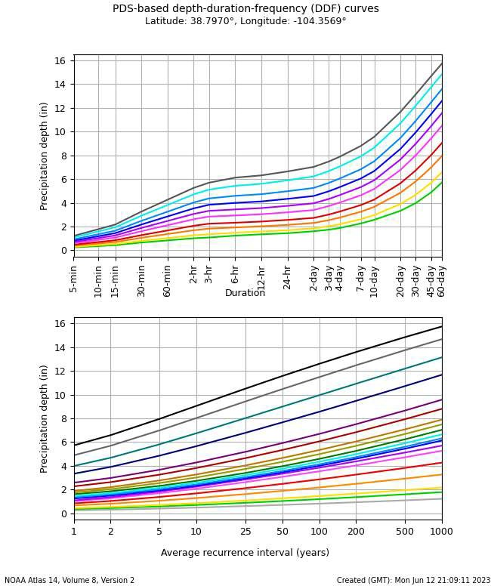
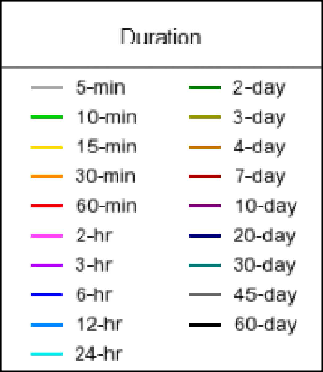

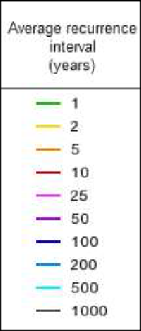

Back to Top

Maps & aerials
Small scale terrain


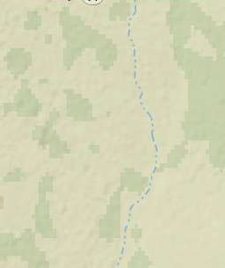

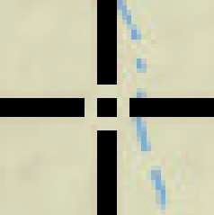
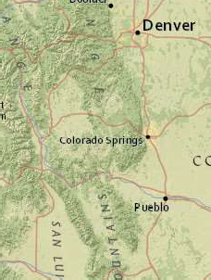
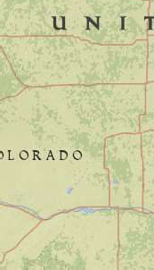
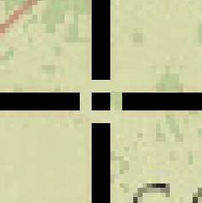
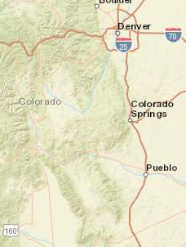
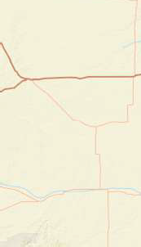


6/12/23, 3:09 PM Precipitation Frequency Data Server
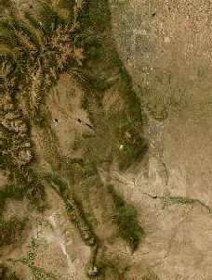
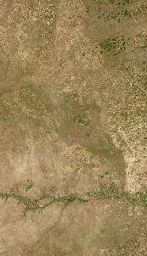

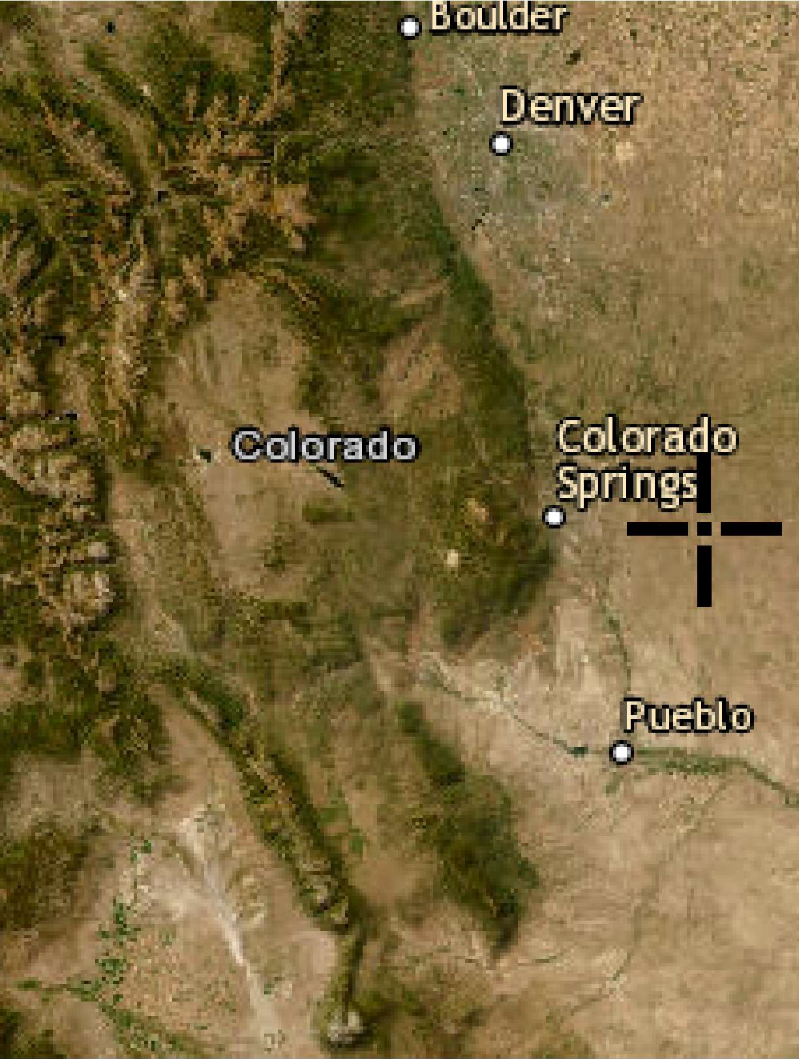
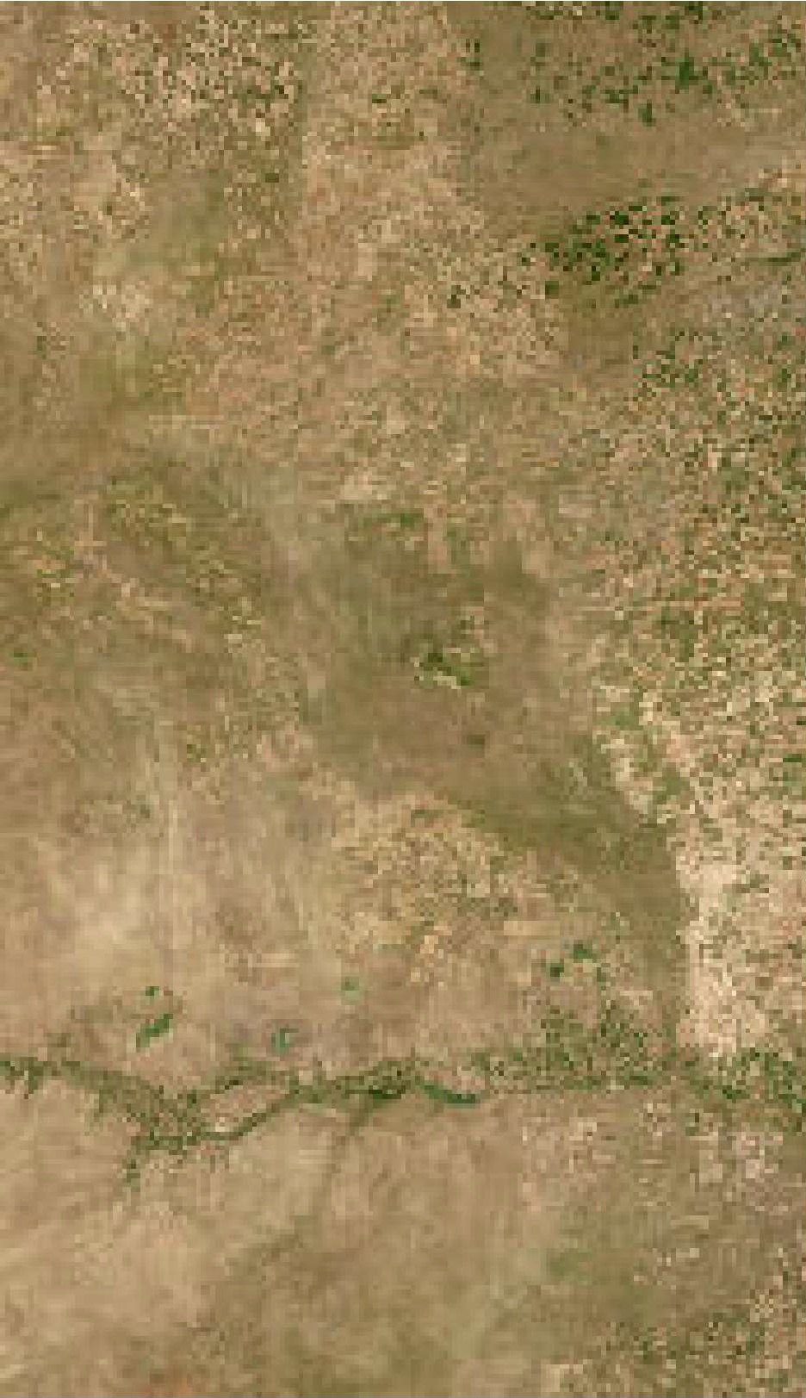
+
100km

Back to Top

US Department of Commerce
Nation Oceanic and Atmospheric Administration
National Weather Service
Nation Water Center
1325 East West Highway Silver Spring, MD 20910
Questions?: HDSC.Questions@noaa.g ov

Disclaimer

Rainfall Amounts and Rainfall Intensity from NOAA Atlas

Ellicott Sand Stage 2 Latitude Longitude
38.79701 -104.356873

Rainfall From NOAA Atlas
 | One-hour  Rainfall (inches) | Duration (minutes)
 |  | 5 | 10 | 15 | 30 | 60 | 120
2-year
5-year | 1.37 | 0.39 | 0.57 | 0.70 | 1.05 | 1.37 | 1.69
10-year
50-year
100-year | 2.85 | 0.81 | 1.19 | 1.45 | 2.17 | 2.85 | 3.53

Rainfall Amount
Minutes | 5-year | 100-year
5 | 0.39 | 0.81
10 | 0.57 | 1.19
15 | 0.70 | 1.45
30 | 1.05 | 2.17
60 | 1.37 | 2.85
120 | 1.69 | 3.53
180 | 1.83 | 3.84
360 | 1.92 | 4.00

Rainfall Intensity (inches/hour)
Minutes | 5-year | 100-year
5 | 4.70 | 9.73
10 | 3.44 | 7.14
15 | 2.80 | 5.80
30 | 2.10 | 4.34
60 | 1.37 | 2.85
120 | 0.85 | 1.77
180 | 0.92 | 1.92
360 | 0.96 | 2.00

5/5/2025
hydrology-Schubert-Ranch-Rev0-5-5-2025.xlsx intensity-ellicott
Page A-9

Rainfall Amounts (inches)

4.50

4.00

3.50

3.00

2.50
5-year
100-year
2.00

1.50

1.00

0.50

0.00
0 50 100 150 200 250 300 350 400

Rainfall Intensity Curves
12.00

10.00
5, 9.73

8.00

10, 7.14
Intensity (inches/hour)

6.00
15, 5.80

5, 4.70

5-year 100-year

4.00

2.00
30, 4.34

10, 3.44
15, 2.80

30, 2.10

60, 2.85

60, 1.37

120, 1.77 180, 1.92 360, 2.00

120, 0.85 180, 0.92 360, 0.96

0.00
0 50 100 150 200 250 300 350 400
Time of Concentration (minutes)

I
Street |  | Design Point | DIRECT RUNOFF |  |  |  |  |  |  | TOTAL RUNOFF |  |  |  | SWALE |  | PIPE |  |  | TRAVEL TIME
 |  | Design Point | Area Designation | Area (ac) | Runoff Coeff., C | tc (min) | C*A (AC) | Intensity, I (in/hr) | Q (cfs) | t_{c} (min) | sum(C*A) (AC) | Intensity, I (in/hr) | Q (cfs) | Slope (%) | Swale Flow (cfs) | Design Flow (cfs) | Slope (%) | Pipe Size (in) | Length (ft) | Veloctiy (fps) | t_{t} (min) | REMARKS
 | (1) | (2) | (3) | (4) | (5) | (6) | (7) | (8) | (9) | (10) | (11) | (12) | (13) | (14) | (15) | (16) | (17) | (18) | (19) | (20) | (21) | (22)
HISTORIC CONDITIONS (PRE-DEVELOPMENT)
ONSITE BASINS
1 |  | 2-W | Basin 2-West | 175.88 | 0.09 | 71.2 | 15.8 | 1.25 | 19.8
2 |  | 2-E | Basin 2-East | 41.04 | 0.09 | 72.0 | 3.69 | 1.24 | 4.6
OFFSITE BASINS
 | Basin OFF-1 is the same for Existing and Proposed Conditions. See the calculation below
PROPOSED |  | COND | TIONS AFTER PROJECT IMPL |  |  | EMEN | TATIO | N
ONSITE BA |  | SINS
3 |  | 2-W | Basin 2-West | 175.88 | 0.09 | 26.7 | 15.8 | 2.30 | 36.4
4 |  | 2-E | Basin 2-East | 41.04 | 0.09 | 23.7 | 3.69 | 2.45 | 9.0
OFFSITE B |  | ASINS
5 |  | OFF-1 | Basin OFF-1 | 653.60 | 0.13 | 201.0 | 87.1 | 0.92 | 80.2
6 |  | OFF-2 | Basin OFF-2 | 1141.80 | 0.11 | 202.6 | 125 | 0.92 | 114.8

I
Street |  | Design Point | DIRECT RUNOFF |  |  |  |  |  |  | TOTAL RUNOFF |  |  |  | SWALE |  | PIPE |  |  | TRAVEL TIME
 |  | Design Point | Area Designation | Area (ac) | Runoff Coeff., C | tc (min) | C*A (AC) | Intensity, I (in/hr) | Q (cfs) | t_{c} (min) | sum(C*A) (AC) | Intensity, I (in/hr) | Q (cfs) | Slope (%) | Swale Flow (cfs) | Design Flow (cfs) | Slope (%) | Pipe Size (in) | Length (ft) | Veloctiy (fps) | t_{t} (min) | REMARKS
 | (1) | (2) | (3) | (4) | (5) | (6) | (7) | (8) | (9) | (10) | (11) | (12) | (13) | (14) | (15) | (16) | (17) | (18) | (19) | (20) | (21) | (22)
HISTORIC CONDITIONS (PRE-DEVELOPMENT)
ONSITE BASINS
1 |  | 2-W | Basin 2-West | 175.88 | 0.09 | 71.2 | 15.8 | 2.60 | 41.2
2 |  | 2-E | Basin 2-East | 41.04 | 0.09 | 72.0 | 3.69 | 2.59 | 9.6
OFFSITE BASINS
 | Basin OFF-1 is the same for Existing and Proposed Conditions. See the calculation below
PROPOSED |  | COND | TIONS AFTER PROJECT IMPL |  |  | EMEN | TATIO | N
ONSITE BA |  | SINS
3 |  | 2-W | Basin 2-West | 175.88 | 0.09 | 26.7 | 15.8 | 4.80 | 76.0
4 |  | 2-E | Basin 2-East | 41.04 | 0.09 | 23.7 | 3.69 | 4.90 | 18.1
OFFSITE B |  | ASINS
5 |  | OFF-1 | Basin OFF-1 | 653.60 | 0.13 | 201.0 | 87.1 | 1.92 | 167.3
6 |  | OFF-2 | Basin OFF-2 | 1141.80 | 0.11 | 202.6 | 125 | 1.92 | 239.6

hydrology-Schubert-Ranch-Rev0-5-5-2025.xlsx Rational-100YR
Page A-13

Description | Shallow channel flow,  Basin 2-West |  | Shallow channel flow,  Basin 2-West
Flows Collected in Channel | Basin 2-West |  | Basin 2-West
Length of Channel (ft) | 2240 |  | 2240
Change in Elevation (ft) | 15.00 |  | 15.00
Slope, S (ft/ft) | 0.0067 |  | 0.0067
Roughness Factor, n (dimension-less),  for sandy swale | 0.0180 |  | 0.0180
FLOW IN SWALE IN PIT BOTTOM
Design Storm | 5 year, 24 hour |  | 100 year, 24 hour
Required Peak Flow (cfs) | 36.41 |  | 75.98
Manning Formula Peak Flow (cfs) | 36.46 |  | 78.29
Left Side Slope factor, Z (Z:1) | 50.00 |  | 50.00
Right Side Slope factor, Z (Z:1) | 50.00 |  | 50.00
Cross-sectional Area, A (ft²) | 13.3 |  | 23.6
Wetted Perimeter, P (ft) | 52.0 |  | 69.0
Hydraulic Radius, R (ft²/ft) | 0.26 |  | 0.34
Slope, S (ft/ft) | 0.007 |  | 0.007
Flow Depth, Y (ft) | 0.46 |  | 0.63
Top Width, T (ft), without freeboard | 52.0 |  | 69.0
Bottom Width, W (ft) | 6 |  | 6
Flow Velocity, V (fps) | 2.7 |  | 3.3
Hydraulic Mean Depth, D | 0.26 |  | 0.34
Froude Number, F | 0.95 |  | 1.00
Subcritical/Supercritical | Subcritical |  | Subcritical
Source for Manning's n: Chow, 1959. 4. Excavated or Dredged  1. clean, recently completed |  | Channels, | a. Earth, straight, and uniform,
Note: this is flow in a large mine pit, no freeboard needed  Total depth (ft) = |  | 0.46 | 0.63
Top Width, T (ft) |  | 52.00 | 69.00
Equations:
Slope, S = Change in Elevation / Length of Channel
Area, A = Z x Y² + Y x W
Wetted Perimeter, P = 2 x Y x (1 + Z²)^{0.5} + W
Hydraulic Radius, R = A / P Top Width, T = 2 x Z x Y + W
Flow, Q = (1.49 x A x R^{0.667} x S^{0.5}) / n
Flow Velocity, V = Q / A
Bottom Width, W = initial assumption Height, Y = trial and error input Hydraulic Mean Depth, D = A / T
Froude Number, F = V / (g x D)^{0.5}
where: g = gravity acceleration = 32.2 ft/sec²

Description | Shallow channel flow,  Basin 2-East |  | Shallow channel flow,  Basin 2-East
Flows Collected in Channel | Basin 2-East |  | Basin 2-East
Length of Channel (ft) | 1850 |  | 1850
Change in Elevation (ft) | 15.00 |  | 15.00
Slope, S (ft/ft) | 0.0081 |  | 0.0081
Roughness Factor, n (dimension-less),  for sandy swale | 0.0180 |  | 0.0180
FLOW IN SWALE IN PIT BOTTOM
Design Storm | 5 year, 24 hour |  | 100 year, 24 hour
Required Peak Flow (cfs) | 9.05 |  | 18.10
Manning Formula Peak Flow (cfs) | 9.69 |  | 18.30
Left Side Slope factor, Z (Z:1) | 50.00 |  | 50.00
Right Side Slope factor, Z (Z:1) | 50.00 |  | 50.00
Cross-sectional Area, A (ft²) | 4.6 |  | 7.4
Wetted Perimeter, P (ft) | 31.0 |  | 39.0
Hydraulic Radius, R (ft²/ft) | 0.15 |  | 0.19
Slope, S (ft/ft) | 0.008 |  | 0.008
Flow Depth, Y (ft) | 0.25 |  | 0.33
Top Width, T (ft), without freeboard | 31.0 |  | 39.0
Bottom Width, W (ft) | 6 |  | 6
Flow Velocity, V (fps) | 2.1 |  | 2.5
Hydraulic Mean Depth, D | 0.15 |  | 0.19
Froude Number, F | 0.96 |  | 1.00
Subcritical/Supercritical | Subcritical |  | Subcritical
Source for Manning's n: Chow, 1959. 4. Excavated or Dredged  1. clean, recently completed |  | Channels, | a. Earth, straight, and uniform,
Note: this is flow in a large mine pit, no freeboard needed  Total depth (ft) = |  | 0.25 | 0.33
Top Width, T (ft) |  | 31.00 | 39.00
Equations:
Slope, S = Change in Elevation / Length of Channel
Area, A = Z x Y² + Y x W
Wetted Perimeter, P = 2 x Y x (1 + Z²)^{0.5} + W
Hydraulic Radius, R = A / P Top Width, T = 2 x Z x Y + W
Flow, Q = (1.49 x A x R^{0.667} x S^{0.5}) / n
Flow Velocity, V = Q / A
Bottom Width, W = initial assumption Height, Y = trial and error input Hydraulic Mean Depth, D = A / T
Froude Number, F = V / (g x D)^{0.5}
where: g = gravity acceleration = 32.2 ft/sec²

Show
Manning's n Values

Reference tables for Manning's n values for Channels, Closed Conduits Flowing Partially Full, and Corrugated Metal Pipes.

Manning's n for Channels (Chow, 1959).
Type of Channel and Description | Minimum | Normal | Maximum
Natural streams - minor streams (top width at floodstage < 100 ft)
1. Main Channels
a. clean, straight, full stage, no rifts or deep pools | 0.025 | 0.030 | 0.033
b. same as above, but more stones and weeds | 0.030 | 0.035 | 0.040
c. clean, winding, some pools and shoals | 0.033 | 0.040 | 0.045
d. same as above, but some weeds and stones | 0.035 | 0.045 | 0.050
e. same as above, lower stages, more ineffective slopes and sections | 0.040 | 0.048 | 0.055
f. same as "d" with more stones | 0.045 | 0.050 | 0.060
g. sluggish reaches, weedy, deep pools | 0.050 | 0.070 | 0.080
h. very weedy reaches, deep pools, or floodways with heavy stand of timber and underbrush | 0.075 | 0.100 | 0.150
2. Mountain streams, no vegetation in channel, banks usually steep, trees and brush along banks submerged at high stages
a. bottom: gravels, cobbles, and few boulders | 0.030 | 0.040 | 0.050
b. bottom: cobbles with large boulders | 0.040 | 0.050 | 0.070
3. Floodplains
a. Pasture, no brush
1.short grass | 0.025 | 0.030 | 0.035
2. high grass | 0.030 | 0.035 | 0.050
b. Cultivated areas
1. no crop | 0.020 | 0.030 | 0.040
2. mature row crops | 0.025 | 0.035 | 0.045
3. mature field crops | 0.030 | 0.040 | 0.050
c. Brush
1. scattered brush, heavy weeds | 0.035 | 0.050 | 0.070
2. light brush and trees, in winter | 0.035 | 0.050 | 0.060
3. light brush and trees, in summer | 0.040 | 0.060 | 0.080
4. medium to dense brush, in winter | 0.045 | 0.070 | 0.110
5. medium to dense brush, in summer | 0.070 | 0.100 | 0.160
d. Trees
1. dense willows, summer, straight | 0.110 | 0.150 | 0.200

2. cleared land with tree stumps, no sprouts | 0.030 | 0.040 | 0.050
3. same as above, but with heavy growth of sprouts | 0.050 | 0.060 | 0.080
4. heavy stand of timber, a few down trees, little undergrowth, flood stage below branches | 0.080 | 0.100 | 0.120
5. same as 4. with flood stage reaching branches | 0.100 | 0.120 | 0.160
4. Excavated or Dredged Channels
a. Earth, straight, and uniform
1. clean, recently completed | 0.016 | 0.018 | 0.020
2. clean, after weathering | 0.018 | 0.022 | 0.025
3. gravel, uniform section, clean | 0.022 | 0.025 | 0.030
4. with short grass, few weeds | 0.022 | 0.027 | 0.033
b. Earth winding and sluggish
1. no vegetation | 0.023 | 0.025 | 0.030
2. grass, some weeds | 0.025 | 0.030 | 0.033
3. dense weeds or aquatic plants in deep channels | 0.030 | 0.035 | 0.040
4. earth bottom and rubble sides | 0.028 | 0.030 | 0.035
5. stony bottom and weedy banks | 0.025 | 0.035 | 0.040
6. cobble bottom and clean sides | 0.030 | 0.040 | 0.050
c. Dragline-excavated or dredged
1. no vegetation | 0.025 | 0.028 | 0.033
2. light brush on banks | 0.035 | 0.050 | 0.060
d. Rock cuts
1. smooth and uniform | 0.025 | 0.035 | 0.040
2. jagged and irregular | 0.035 | 0.040 | 0.050
e. Channels not maintained, weeds and brush uncut
1. dense weeds, high as flow depth | 0.050 | 0.080 | 0.120
2. clean bottom, brush on sides | 0.040 | 0.050 | 0.080
3. same as above, highest stage of flow | 0.045 | 0.070 | 0.110
4. dense brush, high stage | 0.080 | 0.100 | 0.140
5. Lined or Constructed Channels
a. Cement
1. neat surface | 0.010 | 0.011 | 0.013
2. mortar | 0.011 | 0.013 | 0.015
b. Wood
1. planed, untreated | 0.010 | 0.012 | 0.014
2. planed, creosoted | 0.011 | 0.012 | 0.015
3. unplaned | 0.011 | 0.013 | 0.015
4. plank with battens | 0.012 | 0.015 | 0.018
5. lined with roofing paper | 0.010 | 0.014 | 0.017
c. Concrete
1. trowel finish | 0.011 | 0.013 | 0.015

2. float finish | 0.013 | 0.015 | 0.016
3. finished, with gravel on bottom | 0.015 | 0.017 | 0.020
4. unfinished | 0.014 | 0.017 | 0.020
5. gunite, good section | 0.016 | 0.019 | 0.023
6. gunite, wavy section | 0.018 | 0.022 | 0.025
7. on good excavated rock | 0.017 | 0.020
8. on irregular excavated rock | 0.022 | 0.027
d. Concrete bottom float finish with sides of:
1. dressed stone in mortar | 0.015 | 0.017 | 0.020
2. random stone in mortar | 0.017 | 0.020 | 0.024
3. cement rubble masonry, plastered | 0.016 | 0.020 | 0.024
4. cement rubble masonry | 0.020 | 0.025 | 0.030
5. dry rubble or riprap | 0.020 | 0.030 | 0.035
e. Gravel bottom with sides of:
1. formed concrete | 0.017 | 0.020 | 0.025
2. random stone mortar | 0.020 | 0.023 | 0.026
3. dry rubble or riprap | 0.023 | 0.033 | 0.036
f. Brick
1. glazed | 0.011 | 0.013 | 0.015
2. in cement mortar | 0.012 | 0.015 | 0.018
g. Masonry
1. cemented rubble | 0.017 | 0.025 | 0.030
2. dry rubble | 0.023 | 0.032 | 0.035
h. Dressed ashlar/stone paving | 0.013 | 0.015 | 0.017
i. Asphalt
1. smooth | 0.013 | 0.013
2. rough | 0.016 | 0.016
j. Vegetal lining | 0.030 |  | 0.500

Manning's n for Closed Conduits Flowing Partly Full (Chow, 1959).
Type of Conduit and Description | Minimum | Normal | Maximum
1. Brass, smooth: | 0.009 | 0.010 | 0.013
2. Steel:
Lockbar and welded | 0.010 | 0.012 | 0.014
Riveted and spiral | 0.013 | 0.016 | 0.017
3. Cast Iron:
Coated | 0.010 | 0.013 | 0.014
Uncoated | 0.011 | 0.014 | 0.016
4. Wrought Iron:
Black | 0.012 | 0.014 | 0.015
Galvanized | 0.013 | 0.016 | 0.017
5. Corrugated Metal:
Subdrain | 0.017 | 0.019 | 0.021
Stormdrain | 0.021 | 0.024 | 0.030
6. Cement:

Neat Surface | 0.010 | 0.011 | 0.013
Mortar | 0.011 | 0.013 | 0.015
7. Concrete:
Culvert, straight and free of debris | 0.010 | 0.011 | 0.013
Culvert with bends, connections, and some  debris | 0.011 | 0.013 | 0.014
Finished | 0.011 | 0.012 | 0.014
Sewer with manholes, inlet, etc., straight | 0.013 | 0.015 | 0.017
Unfinished, steel form | 0.012 | 0.013 | 0.014
Unfinished, smooth wood form | 0.012 | 0.014 | 0.016
Unfinished, rough wood form | 0.015 | 0.017 | 0.020
8. Wood:
Stave | 0.010 | 0.012 | 0.014
Laminated, treated | 0.015 | 0.017 | 0.020
9. Clay:
Common drainage tile | 0.011 | 0.013 | 0.017
Vitrified sewer | 0.011 | 0.014 | 0.017
Vitrified sewer with manholes, inlet, etc. | 0.013 | 0.015 | 0.017
Vitrified Subdrain with open joint | 0.014 | 0.016 | 0.018
10. Brickwork:
Glazed | 0.011 | 0.013 | 0.015
Lined with cement mortar | 0.012 | 0.015 | 0.017
Sanitary sewers coated with sewage slime  with bends and connections | 0.012 | 0.013 | 0.016
Paved invert, sewer, smooth bottom | 0.016 | 0.019 | 0.020
Rubble masonry, cemented | 0.018 | 0.025 | 0.030

Manning's n for Corrugated Metal Pipe (AISI, 1980).
Type of Pipe, Diameter and Corrugation  Dimension | n
1. Annular 2.67 x 1/2 inch (all diameters) | 0.024
2. Helical 1.50 x 1/4 inch
8" diameter | 0.012
10" diameter | 0.014
3. Helical 2.67 x 1/2 inch
12" diameter | 0.011
18" diameter | 0.014
24" diameter | 0.016
36" diameter | 0.019
48" diameter | 0.020
60" diameter | 0.021
4. Annular 3x1 inch (all diameters) | 0.027
5. Helical 3x1 inch
48" diameter | 0.023
54" diameter | 0.023
60" diameter | 0.024
66" diameter | 0.025
72" diameter | 0.026
78" diameter and larger | 0.027
6. Corrugations 6x2 inches
60" diameter | 0.033
72" diameter | 0.032
120" diameter | 0.030
180" diameter | 0.028


FishXing Version 3.0 Beta, 2006

Table 7. Riprap Calculations For Black Squirrel Creek at Stage 2 Project

Riprap calculations for Black Squirrel Creek at Stage 2 area. From HEC-RAS model results, find the following information: d = maximum depth of flow (m)
S = slope of channel (m/m)

Source of flow depth and slope is Schubert Ranch Sand Resource Floodplain Modeling Technical Memorandum for Black Squirrel Creek, El Paso County, Colorado, EME Solutions, Inc., J.L. Jankousky. P.E., 02/25/2020.

Cross Sections at Stage 2 (from North to South) | Water Surface Elevation (ft) | Channel Bottom Elevation at Bank (ft) | d = maximum depth of flow (ft) | d = maximum depth of flow (m) | S = slope of channel (m/m) | Maximum Shear Stress (N/m²) = | Allowable Shear Stress > Max Shear Stress? | Required Riprap d50
24726 | 5845.23 | 5840 | 5.23 | 1.594 | 0.004826 | 75.470 | Yes, okay | d50 = 6 inches OK
24167 | 5841.92 | 5835.77 | 6.15 | 1.875 | 0.004336 | 79.735 | Yes, okay | d50 = 6 inches OK
23955 | 5840.35 | 5835.74 | 4.61 | 1.405 | 0.004951 | 68.246 | Yes, okay | d50 = 6 inches OK
23557 | 5837.79 | 5833.34 | 4.45 | 1.356 | 0.006318 | 84.067 | Yes, okay | d50 = 6 inches OK
23156 | 5834.7 | 5830 | 4.7 | 1.433 | 0.00752 | 105.682 | Yes, okay | d50 = 6 inches OK
22579 | 5832.06 | 5826 | 6.06 | 1.847 | 0.003734 | 67.660 | Yes, okay | d50 = 6 inches OK
22196 | 5829.91 | 5825.71 | 4.2 | 1.280 | 0.007308 | 91.777 | Yes, okay | d50 = 6 inches OK
21870 | 5828.36 | 5824 | 4.36 | 1.329 | 0.003826 | 49.879 | Yes, okay | d50 = 6 inches OK

Convert Feet to Meters, Divide by: 3.28084

For riprap d50 = For riprap d50 =

Shear Stress
0.3 m = 12
inches
0.15 m = 6
inches

Allowable Shear Stress (N/m²) 227 113
Page A-21
Maximum Shear Stress (N/m²) = Tau(depth) = gamma x d x S Where
gamma = unit mass of water (N/m³) 9810
d = maximum depth of flow (m) See table above
S = slope of channel (m/m) See table above
Calculate Maximum Shear Stress (N/m²) = See table above
Allowable Shear Stress > Max Shear Stress? Check whether Allowable Shear Stress is greater than Maximum Shear Stress

Riprap Shear Stress Reference: US Department of Transportation, Federal Highway Administration Publication FHWA-NHI-05-114, Sept. 2005

Schubert Ranch Sand Resource Floodplain Modeling
Technical Memorandum For
Black Squirrel Creek El Paso County, Colorado

Prepared For:
Perry Hastings Ellicott Sand and Gravel

Prepared By:
EME Solutions, Inc.
15248 W. Ellsworth Drive Golden, CO 80401
John L. Jankousky, P.E. Phone: 303-279-1707

February 25, 2020

FENCE (TYP.)

34180

33533
ROAD (TYP.)
S. BAGGETT ROAD

33001
5899

W WW-239897
5910
5904
LEGEND
PERMIT BOUNDARY/ AFFECTED LANDS 200 FOOT LIMIT
STAGE LINE
ROADS (HAUL, ACCESS) (TYP.) FENCE
BURIED TELEPHONE/COMMUNICATION LINES OVERHEAD ELECTRIC LINES
BUILDING WATER WELL
2 FOOT CONTOURS TOPO CONTOUR

IRRIGATION PIVOT
ROAD (TYP.)
FENCE (TYP.)
5897

FENCE (TYP.)
(ROAD (TYP.)
32643
EPHEMERAL DRAINAGE

FENCE (TYP.)

FENCE (TYP.)

IRRIGATION PIVOT
5893
5889
5885
5883

BUILDING GROUP (TYP.)

31940
31669
31339

30866
S. BAGGETT ROAD
30340
29984
29665
29338

30340
5881
5878

FLOOD PLAIN (100 YR)

FLOOD PLAIN (100 YR) REVISED ORDINARY HIGH-WATER LINE 2019
REVEGETATED AREA BANK ARMORING
HEC-RAS CROSS SECTION

IRRIGATION PIVOT
ROAD (TYP.)
5874
5874
5872
29058
28752
5872

BUILDING GROUP (TYP.)
5869
28260
27887
5868
S. BAGGETT ROAD

27503
5865

FENCE (TYP.)
5863

26962
ROAD (TYP.)
5859

BUILDING GROUP (TYP.)

26498
5856

TELEPHONE LINES (TYP.)
25826
255+13.25 US SANBORN RD
S. BAGGETT ROAD
5853
254+50.59 DS SANBORN RD

FENCE (TYP.)
FENCE (TYP.)
5849

BUILDING GROUP (TYP.)
5845
24726

24167
ROAD (TYP.)
23955
ROAD
5841

23557

23156
5837

IRRIGATION PIVOT

FENCE (TYP.)
5833
5831
22579

BUILDING GROUP (TYP.)
22196
21870

FENCE (TYP.)
21514

21063
5827

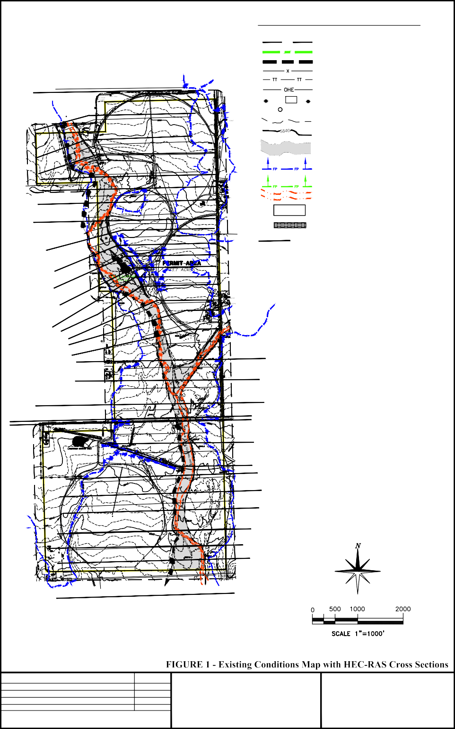
REVISIONS:

SCALE 1" = 1000' ORIG. DATE 2/18/2020
DATE:
PREPARED FOR: ELLICOTT SAND AND GRAVEL LLC

PROJECT:
SCHUBERT RANCH SAND RESOURCE

Page A-23
PREPARED BY: ENVIRONMENT, INC. STEVE O'BRIAN
ENVIRONMENT-INC@OUTDRS.NET AND
EME SOLUTIONS, INC. JOHN JANKOUSKY
JOHN.JANKOUSKY@EME-SOLUTIONS.COM

E.G. Elev (ft) | 5845.91 | Element | Left OB | Channel | Right OB
Vel Head (ft) | 0.68 | Wt. n-Val. | 0.040 | 0.030 | 0.040
W.S. Elev (ft) | 5845.23 | Reach Len. (ft) | 568.78 | 559.66 | 318.68
Crit W.S. (ft) | 5845.23 | Flow Area (sq ft) | 977.19 | 1621.09 | 3579.53
E.G. Slope (ft/ft) | 0.004826 | Area (sq ft) | 20873.83 | 1621.09 | 134418.50
Q Total (cfs) | 29100.00 | Flow (cfs) | 3135.37 | 14289.23 | 11675.40
Top Width (ft) | 3584.02 | Top Width (ft) | 688.26 | 394.98 | 2500.78
Vel Total (ft/s) | 4.71 | Avg. Vel. (ft/s) | 3.21 | 8.81 | 3.26
Max Chl Dpth (ft) | 60.23 | Hydr. Depth (ft) | 1.42 | 4.10 | 1.43
Conv. Total (cfs) | 418907.3 | Conv. (cfs) | 45135.0 | 205699.7 | 168072.5
Length Wtd. (ft) | 469.48 | Wetted Per. (ft) | 704.83 | 395.35 | 2518.97
Min Ch El (ft) | 5840.00 | Shear (lb/sq ft) | 0.42 | 1.24 | 0.43
Alpha | 1.96 | Stream Power (lb/ft s) | 1.34 | 10.89 | 1.40
Frctn Loss (ft) | 2.15 | Cum Volume (acre-ft) | 1726.36 | 927.35 | 9677.28
C & E Loss (ft) | 0.01 | Cum SA (acres) | 179.07 | 296.52 | 404.04

Plan: Plan 02 BlackSquirrelCrk LBS to ROB Split RS: 24167 Profile: 100yr
E.G. Elev (ft) | 5842.56 | Element | Left OB | Channel | Right OB
Vel Head (ft) | 0.64 | Wt. n-Val. | 0.040 | 0.030 | 0.040
W.S. Elev (ft) | 5841.92 | Reach Len. (ft) | 195.53 | 211.79 | 527.93
Crit W.S. (ft) | 5841.84 | Flow Area (sq ft) | 686.19 | 2073.18 | 3355.91
E.G. Slope (ft/ft) | 0.004336 | Area (sq ft) | 17652.44 | 2073.18 | 116322.90
Q Total (cfs) | 29100.00 | Flow (cfs) | 2060.28 | 16737.79 | 10301.93
Top Width (ft) | 3393.76 | Top Width (ft) | 486.75 | 531.00 | 2376.01
Vel Total (ft/s) | 4.76 | Avg. Vel. (ft/s) | 3.00 | 8.07 | 3.07
Max Chl Dpth (ft) | 61.92 | Hydr. Depth (ft) | 1.41 | 3.90 | 1.41
Conv. Total (cfs) | 441901.5 | Conv. (cfs) | 31286.7 | 254173.7 | 156441.2
Length Wtd. (ft) | 331.81 | Wetted Per. (ft) | 504.63 | 532.36 | 2387.27
Min Ch El (ft) | 5835.77 | Shear (lb/sq ft) | 0.37 | 1.05 | 0.38
Alpha | 1.83 | Stream Power (lb/ft s) | 1.11 | 8.51 | 1.17
Frctn Loss (ft) | 1.54 | Cum Volume (acre-ft) | 1474.83 | 903.62 | 8760.09
C & E Loss (ft) | 0.00 | Cum SA (acres) | 171.40 | 290.57 | 386.20

Plan: Plan 02 BlackSquirrelCrk LBS to ROB Split RS: 23955 Profile: 100yr
E.G. Elev (ft) | 5841.02 | Element | Left OB | Channel | Right OB
Vel Head (ft) | 0.67 | Wt. n-Val. | 0.040 | 0.030 | 0.040
W.S. Elev (ft) | 5840.35 | Reach Len. (ft) | 391.60 | 397.78 | 392.04
Crit W.S. (ft) | 5840.35 | Flow Area (sq ft) | 970.82 | 1597.56 | 3614.45
E.G. Slope (ft/ft) | 0.004951 | Area (sq ft) | 18866.67 | 1597.56 | 143852.20
Q Total (cfs) | 29100.00 | Flow (cfs) | 2978.81 | 14069.18 | 12052.01
Top Width (ft) | 3631.93 | Top Width (ft) | 744.66 | 396.81 | 2490.46
Vel Total (ft/s) | 4.71 | Avg. Vel. (ft/s) | 3.07 | 8.81 | 3.33
Max Chl Dpth (ft) | 65.35 | Hydr. Depth (ft) | 1.30 | 4.03 | 1.45
Conv. Total (cfs) | 413577.9 | Conv. (cfs) | 42335.7 | 199955.4 | 171286.8
Length Wtd. (ft) | 394.78 | Wetted Per. (ft) | 763.28 | 397.70 | 2508.56
Min Ch El (ft) | 5835.74 | Shear (lb/sq ft) | 0.39 | 1.24 | 0.45
Alpha | 1.94 | Stream Power (lb/ft s) | 1.21 | 10.93 | 1.48
Frctn Loss (ft) | 2.20 | Cum Volume (acre-ft) | 1392.87 | 894.69 | 7183.48
C & E Loss (ft) | 0.00 | Cum SA (acres) | 168.63 | 288.32 | 356.71

E.G. Elev (ft) | 5838.45 | Element | Left OB | Channel | Right OB
Vel Head (ft) | 0.65 | Wt. n-Val. | 0.040 | 0.030 | 0.040
W.S. Elev (ft) | 5837.79 | Reach Len. (ft) | 393.92 | 401.37 | 367.59
Crit W.S. (ft) | 5837.79 | Flow Area (sq ft) | 931.73 | 1661.20 | 3245.63
E.G. Slope (ft/ft) | 0.006318 | Area (sq ft) | 25829.36 | 1661.20 | 134487.20
Q Total (cfs) | 29100.00 | Flow (cfs) | 3040.89 | 14183.00 | 11876.12
Top Width (ft) | 3635.45 | Top Width (ft) | 783.52 | 519.48 | 2332.44
Vel Total (ft/s) | 4.98 | Avg. Vel. (ft/s) | 3.26 | 8.54 | 3.66
Max Chl Dpth (ft) | 62.79 | Hydr. Depth (ft) | 1.19 | 3.20 | 1.39
Conv. Total (cfs) | 366112.9 | Conv. (cfs) | 38258.0 | 178439.1 | 149415.8
Length Wtd. (ft) | 385.99 | Wetted Per. (ft) | 801.91 | 520.16 | 2352.63
Min Ch El (ft) | 5833.34 | Shear (lb/sq ft) | 0.46 | 1.26 | 0.54
Alpha | 1.69 | Stream Power (lb/ft s) | 1.50 | 10.75 | 1.99
Frctn Loss (ft) | 2.66 | Cum Volume (acre-ft) | 1191.97 | 879.81 | 5930.95
C & E Loss (ft) | 0.00 | Cum SA (acres) | 161.77 | 284.13 | 335.00

Plan: Plan 02 BlackSquirrelCrk LBS to ROB Split RS: 23156 Profile: 100yr
E.G. Elev (ft) | 5835.36 | Element | Left OB | Channel | Right OB
Vel Head (ft) | 0.65 | Wt. n-Val. | 0.040 | 0.030 | 0.040
W.S. Elev (ft) | 5834.70 | Reach Len. (ft) | 530.91 | 577.18 | 509.09
Crit W.S. (ft) | 5834.70 | Flow Area (sq ft) | 1032.28 | 1346.21 | 3255.02
E.G. Slope (ft/ft) | 0.007520 | Area (sq ft) | 32314.00 | 1346.21 | 127671.30
Q Total (cfs) | 29100.00 | Flow (cfs) | 4048.09 | 11995.84 | 13056.07
Top Width (ft) | 3523.86 | Top Width (ft) | 750.12 | 449.86 | 2323.87
Vel Total (ft/s) | 5.17 | Avg. Vel. (ft/s) | 3.92 | 8.91 | 4.01
Max Chl Dpth (ft) | 59.70 | Hydr. Depth (ft) | 1.38 | 2.99 | 1.40
Conv. Total (cfs) | 335578.1 | Conv. (cfs) | 46682.1 | 138334.8 | 150561.2
Length Wtd. (ft) | 543.38 | Wetted Per. (ft) | 768.55 | 450.50 | 2342.71
Min Ch El (ft) | 5830.00 | Shear (lb/sq ft) | 0.63 | 1.40 | 0.65
Alpha | 1.58 | Stream Power (lb/ft s) | 2.47 | 12.50 | 2.62
Frctn Loss (ft) | 2.79 | Cum Volume (acre-ft) | 929.07 | 865.96 | 4824.81
C & E Loss (ft) | 0.06 | Cum SA (acres) | 154.83 | 279.67 | 315.36

Plan: Plan 02 BlackSquirrelCrk LBS to ROB Split RS: 22579 Profile: 100yr
E.G. Elev (ft) | 5832.50 | Element | Left OB | Channel | Right OB
Vel Head (ft) | 0.44 | Wt. n-Val. | 0.040 | 0.030 | 0.040
W.S. Elev (ft) | 5832.06 | Reach Len. (ft) | 358.55 | 383.00 | 362.63
Crit W.S. (ft) | 5831.76 | Flow Area (sq ft) | 1093.26 | 2189.03 | 3578.84
E.G. Slope (ft/ft) | 0.003734 | Area (sq ft) | 27340.91 | 2189.03 | 140521.00
Q Total (cfs) | 29100.00 | Flow (cfs) | 3304.77 | 14953.81 | 10841.42
Top Width (ft) | 3638.49 | Top Width (ft) | 693.46 | 644.94 | 2300.09
Vel Total (ft/s) | 4.24 | Avg. Vel. (ft/s) | 3.02 | 6.83 | 3.03
Max Chl Dpth (ft) | 72.06 | Hydr. Depth (ft) | 1.58 | 3.39 | 1.56
Conv. Total (cfs) | 476229.3 | Conv. (cfs) | 54083.5 | 244723.1 | 177422.7
Length Wtd. (ft) | 373.72 | Wetted Per. (ft) | 711.40 | 645.55 | 2321.37
Min Ch El (ft) | 5826.00 | Shear (lb/sq ft) | 0.36 | 0.79 | 0.36
Alpha | 1.58 | Stream Power (lb/ft s) | 1.08 | 5.40 | 1.09
Frctn Loss (ft) | 1.90 | Cum Volume (acre-ft) | 565.53 | 842.54 | 3257.62
C & E Loss (ft) | 0.02 | Cum SA (acres) | 146.03 | 272.41 | 288.34

E.G. Elev (ft) | 5830.59 | Element | Left OB | Channel | Right OB
Vel Head (ft) | 0.67 | Wt. n-Val. | 0.040 | 0.030 | 0.040
W.S. Elev (ft) | 5829.91 | Reach Len. (ft) | 314.79 | 325.49 | 318.98
Crit W.S. (ft) | 5829.91 | Flow Area (sq ft) | 402.81 | 2225.13 | 2797.92
E.G. Slope (ft/ft) | 0.007308 | Area (sq ft) | 8337.21 | 2225.13 | 141942.30
Q Total (cfs) | 29100.00 | Flow (cfs) | 1400.38 | 17671.98 | 10027.64
Top Width (ft) | 3515.24 | Top Width (ft) | 337.16 | 865.68 | 2312.40
Vel Total (ft/s) | 5.36 | Avg. Vel. (ft/s) | 3.48 | 7.94 | 3.58
Max Chl Dpth (ft) | 69.91 | Hydr. Depth (ft) | 1.19 | 2.57 | 1.21
Conv. Total (cfs) | 340392.8 | Conv. (cfs) | 16380.8 | 206715.2 | 117296.7
Length Wtd. (ft) | 322.22 | Wetted Per. (ft) | 351.68 | 866.24 | 2333.79
Min Ch El (ft) | 5825.71 | Shear (lb/sq ft) | 0.52 | 1.17 | 0.55
Alpha | 1.51 | Stream Power (lb/ft s) | 1.82 | 9.31 | 1.96
Frctn Loss (ft) | 1.66 | Cum Volume (acre-ft) | 418.69 | 823.13 | 2081.88
C & E Loss (ft) | 0.10 | Cum SA (acres) | 141.79 | 265.77 | 269.14

Plan: Plan 02 BlackSquirrelCrk LBS to ROB Split RS: 21870 Profile: 100yr
E.G. Elev (ft) | 5828.69 | Element | Left OB | Channel | Right OB
Vel Head (ft) | 0.32 | Wt. n-Val. | 0.040 | 0.030 | 0.040
W.S. Elev (ft) | 5828.36 | Reach Len. (ft) | 350.43 | 355.93 | 352.22
Crit W.S. (ft) | 5827.79 | Flow Area (sq ft) | 499.54 | 2306.79 | 4230.15
E.G. Slope (ft/ft) | 0.003826 | Area (sq ft) | 5109.82 | 2306.79 | 122329.60
Q Total (cfs) | 29100.00 | Flow (cfs) | 1409.03 | 13085.39 | 14605.58
Top Width (ft) | 3549.98 | Top Width (ft) | 356.48 | 915.34 | 2278.16
Vel Total (ft/s) | 4.14 | Avg. Vel. (ft/s) | 2.82 | 5.67 | 3.45
Max Chl Dpth (ft) | 63.36 | Hydr. Depth (ft) | 1.40 | 2.52 | 1.86
Conv. Total (cfs) | 470453.2 | Conv. (cfs) | 22779.5 | 211548.5 | 236125.2
Length Wtd. (ft) | 354.05 | Wetted Per. (ft) | 367.29 | 915.63 | 2296.57
Min Ch El (ft) | 5824.00 | Shear (lb/sq ft) | 0.32 | 0.60 | 0.44
Alpha | 1.22 | Stream Power (lb/ft s) | 0.92 | 3.41 | 1.52
Frctn Loss (ft) | 1.54 | Cum Volume (acre-ft) | 370.10 | 806.20 | 1114.28
C & E Loss (ft) | 0.02 | Cum SA (acres) | 139.29 | 259.12 | 252.33

Plan: Plan 02 BlackSquirrelCrk LBS to ROB Split RS: 21514 Profile: 100yr
E.G. Elev (ft) | 5827.12 | Element | Left OB | Channel | Right OB
Vel Head (ft) | 0.52 | Wt. n-Val. |  | 0.030 | 0.040
W.S. Elev (ft) | 5826.60 | Reach Len. (ft) | 433.05 | 451.69 | 437.90
Crit W.S. (ft) | 5825.81 | Flow Area (sq ft) |  | 2565.72 | 2544.67
E.G. Slope (ft/ft) | 0.005023 | Area (sq ft) |  | 2565.72 | 7623.99
Q Total (cfs) | 29100.00 | Flow (cfs) |  | 16327.36 | 12772.63
Top Width (ft) | 3070.38 | Top Width (ft) |  | 1050.69 | 2019.69
Vel Total (ft/s) | 5.69 | Avg. Vel. (ft/s) |  | 6.36 | 5.02
Max Chl Dpth (ft) | 7.65 | Hydr. Depth (ft) |  | 2.44 | 2.63
Conv. Total (cfs) | 410594.1 | Conv. (cfs) |  | 230375.3 | 180218.9
Length Wtd. (ft) | 446.54 | Wetted Per. (ft) |  | 1051.19 | 966.68
Min Ch El (ft) | 5821.60 | Shear (lb/sq ft) |  | 0.77 | 0.83
Alpha | 1.04 | Stream Power (lb/ft s) |  | 4.87 | 4.14
Frctn Loss (ft) | 2.94 | Cum Volume (acre-ft) | 349.55 | 786.29 | 588.89
C & E Loss (ft) | 0.04 | Cum SA (acres) | 137.85 | 251.09 | 234.95

Appendix B Material Specifications

TABLE MT-1
Gradation Requirements for Riprap

 | Pay Item  Type | Stone Size d50 (inches) | Percent of Material Smaller Than Typical Stone | Typical Stone Dimensions (inches) | Typical Stone Weight (Pounds)
 |  |  | 70-100 | 12 | 85
Riprap | VL | 6 | 50-70 | 9 | 35
 |  |  | 35-50 | 6 | 10
 |  |  | 2-10 | 2 | 0.4
Riprap |  |  | 70-100 | 15 | 160
 | L | 9 | 50-70 | 12 | 85
 |  |  | 35-50 | 9 | 35
 |  |  | 2-10 | 3 | 1.3
Riprap |  |  | 70-100 | 21 | 440
 | M | 12 | 50-70 | 18 | 275
 |  |  | 35-50 | 12 | 85
 |  |  | 2-10 | 4 | 3
Riprap |  |  | 100 | 30 | 1,280
 | H | 18 | 50-70 | 24 | 650
 |  |  | 35-50 | 18 | 275
 |  |  | 2-10 | 6 | 10
Riprap |  |  | 100 | 42 | 3,500
 | VH | 24 | 50-70 | 33 | 1,700
 |  |  | 35-50 | 24 | 650
 |  |  | 2-10 | 9 | 35
Table taken from CDOT’s Standard Specifications for Road and Bridge Construction, 1999 and City of Colorado Springs/El Paso County Drainage Criteria Manual.

Table 8. Retention Basin Calculation Schubert Ranch Sand Resource Pit Phase I

Designer: John Jankousky Revision: 5/5/2025

The software (Excel spreadsheet with macros) MHFD-Detention, Version 4.06 (July 2022) from UDFCD was used to calculate the runoff volumes for Basin 1 and Basin OFF-1. These runoff volumes for the WQCV, the 5-year storm, and the 100-year storm are presented below and compared to the volume of the reclaimed pit. The results from the MHFD-Detention spreadsheet are attached.

The volume of available storage is much greater that the expected runoff volumes.

Note: The water quality capture volume (WQCV) is equivalent to the runoff from an 80th percentile storm. Providing a WQCV means that 80 percent of the most frequently occurring storms are fully captured and treated and larger events are partially treated.
Areas Draining to Basin 2-West
Basin Designation | Runoff Volume, WQCV (acre-feet) | Runoff Volume, 5-year storm (acre-feet) | Runoff Volume, 100- year storm (acre-feet) | Volume of Available Storage (acre-feet)
Basin 2-West | 0.177 | 0.135 | 11.109 | 6,843
Basin OFF-1 | 2.691 | 3.166 | 56.183 | 6,843
Sum of Basins Draining to Basin 2-West | 2.868 | 3.301 | 67.292 | 6,843
Volume of Available Storage = The excavated and reclaimed pit will hold (in acre-feet): 6,843
Areas Draining to Basin 2-East
Basin Designation | Runoff Volume, WQCV (acre-feet) | Runoff Volume, 5-year storm (acre-feet) | Runoff Volume, 100- year storm (acre-feet) | Volume of Available Storage (acre-feet)
Basin 2-East | 0.041 | 0.032 | 2.592 | 1,049
Basin OFF-2 | 2.832 | 2.832 | 91.435 | 1,049
Sum of Basins Draining to Basin 2-East | 2.873 | 2.864 | 94.027 | 1,049
Volume of Available Storage = The excavated and reclaimed pit will hold (in acre-feet): 1,049

hydrology-Schubert-Ranch-Rev0-5-5-2025.xlsx Detention-Ellicott

MHFD-Detention, Versio
Project: Schubert Ranch Basin ID: Basin 2-West

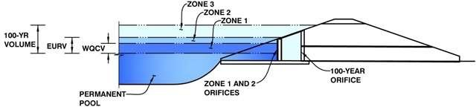
Depth Increment =

Example Zone Configuration (Retention Pond)

Watershed Information

Selected BMP Type = Watershed Area = Watershed Length =
RP
175.88
3,009
1,505
0.030
2.00%
100.0%
0.0%
0.0%
12.0

acres ft
Stage - Storage Description
Permanent Pool

Watershed Length to Centroid =
Watershed Slope = Watershed Imperviousness = Percentage Hydrologic Soil Group A = Percentage Hydrologic Soil Group B = Percentage Hydrologic Soil Groups C/D =
Target WQCV Drain Time =
Location for 1-hr Rainfall Depths = User Input
ft ft/ft
percent percent percent percent hours

After providing required inputs above including 1-hour rainfall depths, click 'Run CUHP' to generate runoff hydrographs using the embedded Colorado Urban Hydrograph Procedure.

Optional User Overrides
1.03
1.37
1.67
2.11
2.47
2.85
3.82

Water Quality Capture Volume (WQCV) = Excess Urban Runoff Volume (EURV) = 2-yr Runoff Volume (P1 = 1.03 in.) = 5-yr Runoff Volume (P1 = 1.37 in.) = 10-yr Runoff Volume (P1 = 1.67 in.) = 25-yr Runoff Volume (P1 = 2.11 in.) = 50-yr Runoff Volume (P1 = 2.47 in.) =
0.177
0.165
0.040
0.135
0.220
3.197
6.425
11.109
23.931
0.080
0.120
0.178
0.295
0.759
2.149

100-yr Runoff Volume (P1 = 2.85 in.) = 500-yr Runoff Volume (P1 = 3.82 in.) = Approximate 2-yr Detention Volume = Approximate 5-yr Detention Volume = Approximate 10-yr Detention Volume = Approximate 25-yr Detention Volume = Approximate 50-yr Detention Volume = Approximate 100-yr Detention Volume =
acre-feet acre-feet acre-feet acre-feet acre-feet acre-feet acre-feet acre-feet acre-feet acre-feet acre-feet acre-feet acre-feet acre-feet acre-feet
acre-feet acre-feet inches inches inches inches inches inches inches

n 4.06 (July 2022)

 | ft
Stage (ft) | Optional  Override Stage (ft) | Length (ft) | Width (ft) | Area (ft ²) | Optional  Override  Area (ft ²) | Area (acre) | Volume (ft ³) | Volume (ac-ft)

Project: Schubert Ranch Basin ID: Basin OFF-1

Example Zone Configuration (Retention Pond)
MHFD-Detention, Versio

Watershed Information Area > 1 sq.mi. for WQ Facility
RP
653.60
12,618
6,309
0.008
9.09%
90.0%
10.0%
0.0%
12.0

Selected BMP Type =
Depth Increment =

Watershed Area = Watershed Length =
Watershed Length to Centroid =
Watershed Slope = Watershed Imperviousness = Percentage Hydrologic Soil Group A = Percentage Hydrologic Soil Group B = Percentage Hydrologic Soil Groups C/D =
Target WQCV Drain Time =
Location for 1-hr Rainfall Depths = User Input
acres ft
ft
Stage - Storage Description
Permanent Pool

ft/ft percent percent percent percent hours

After providing required inputs above including 1-hour rainfall depths, click 'Run CUHP' to generate runoff hydrographs using the embedded Colorado Urban Hydrograph Procedure.

Optional User Overrides
1.03
1.37
1.67
2.11
2.47
2.85
3.82

Water Quality Capture Volume (WQCV) = Excess Urban Runoff Volume (EURV) = 2-yr Runoff Volume (P1 = 1.03 in.) = 5-yr Runoff Volume (P1 = 1.37 in.) = 10-yr Runoff Volume (P1 = 1.67 in.) = 25-yr Runoff Volume (P1 = 2.11 in.) = 50-yr Runoff Volume (P1 = 2.47 in.) =
2.691
4.379
1.462
3.166
4.811
21.827
35.187
56.183
105.547
2.278
3.374
5.107
7.761
10.485
17.358

100-yr Runoff Volume (P1 = 2.85 in.) = 500-yr Runoff Volume (P1 = 3.82 in.) = Approximate 2-yr Detention Volume = Approximate 5-yr Detention Volume = Approximate 10-yr Detention Volume = Approximate 25-yr Detention Volume = Approximate 50-yr Detention Volume = Approximate 100-yr Detention Volume =
acre-feet acre-feet acre-feet acre-feet acre-feet acre-feet acre-feet acre-feet acre-feet acre-feet acre-feet acre-feet acre-feet acre-feet acre-feet
acre-feet acre-feet inches inches inches inches inches inches inches

n 4.06 (July 2022)

 | ft
Stage (ft) | Optional  Override Stage (ft) | Length (ft) | Width (ft) | Area (ft ²) | Optional  Override  Area (ft ²) | Area (acre) | Volume (ft ³) | Volume (ac-ft)

MHFD-Detention, Versio
Project: Schubert Ranch Basin ID: Basin 2-East

Depth Increment =

Example Zone Configuration (Retention Pond)

Watershed Information

Selected BMP Type = Watershed Area = Watershed Length =
RP
41.04
2,460
1,230
0.033
2.00%
100.0%
0.0%
0.0%
12.0

acres ft
Stage - Storage Description
Permanent Pool

Watershed Length to Centroid =
Watershed Slope = Watershed Imperviousness = Percentage Hydrologic Soil Group A = Percentage Hydrologic Soil Group B = Percentage Hydrologic Soil Groups C/D =
Target WQCV Drain Time =
Location for 1-hr Rainfall Depths = User Input
ft ft/ft
percent percent percent percent hours

After providing required inputs above including 1-hour rainfall depths, click 'Run CUHP' to generate runoff hydrographs using the embedded Colorado Urban Hydrograph Procedure.

Optional User Overrides
1.03
1.37
1.67
2.11
2.47
2.85
3.82

Water Quality Capture Volume (WQCV) = Excess Urban Runoff Volume (EURV) = 2-yr Runoff Volume (P1 = 1.03 in.) = 5-yr Runoff Volume (P1 = 1.37 in.) = 10-yr Runoff Volume (P1 = 1.67 in.) = 25-yr Runoff Volume (P1 = 2.11 in.) = 50-yr Runoff Volume (P1 = 2.47 in.) =
0.041
0.038
0.009
0.032
0.051
0.746
1.499
2.592
5.583
0.019
0.028
0.042
0.069
0.177
0.502

100-yr Runoff Volume (P1 = 2.85 in.) = 500-yr Runoff Volume (P1 = 3.82 in.) = Approximate 2-yr Detention Volume = Approximate 5-yr Detention Volume = Approximate 10-yr Detention Volume = Approximate 25-yr Detention Volume = Approximate 50-yr Detention Volume = Approximate 100-yr Detention Volume =
acre-feet acre-feet acre-feet acre-feet acre-feet acre-feet acre-feet acre-feet acre-feet acre-feet acre-feet acre-feet acre-feet acre-feet acre-feet
acre-feet acre-feet inches inches inches inches inches inches inches

n 4.06 (July 2022)

 | ft
Stage (ft) | Optional  Override Stage (ft) | Length (ft) | Width (ft) | Area (ft ²) | Optional  Override  Area (ft ²) | Area (acre) | Volume (ft ³) | Volume (ac-ft)

Project: Schubert Ranch Basin ID: Basin OFF-2

Example Zone Configuration (Retention Pond)
MHFD-Detention, Versio

Watershed Information Area > 1 sq.mi. for WQ Facility
RP
1141.80
19,775
9,919
0.018
5.16%
90.0%
10.0%
0.0%
12.0

Selected BMP Type =
Depth Increment =

Watershed Area = Watershed Length =
Watershed Length to Centroid =
Watershed Slope = Watershed Imperviousness = Percentage Hydrologic Soil Group A = Percentage Hydrologic Soil Group B = Percentage Hydrologic Soil Groups C/D =
Target WQCV Drain Time =
Location for 1-hr Rainfall Depths = User Input
acres ft
ft
Stage - Storage Description
Permanent Pool

ft/ft percent percent percent percent hours

After providing required inputs above including 1-hour rainfall depths, click 'Run CUHP' to generate runoff hydrographs using the embedded Colorado Urban Hydrograph Procedure.

Optional User Overrides
1.03
1.37
1.67
2.11
2.47
2.85
3.82

Water Quality Capture Volume (WQCV) = Excess Urban Runoff Volume (EURV) = 2-yr Runoff Volume (P1 = 1.03 in.) = 5-yr Runoff Volume (P1 = 1.37 in.) = 10-yr Runoff Volume (P1 = 1.67 in.) = 25-yr Runoff Volume (P1 = 2.11 in.) = 50-yr Runoff Volume (P1 = 2.47 in.) =
2.832
3.762
1.187
2.832
4.479
32.664
55.249
91.435
177.235
1.901
2.877
4.858
7.755
11.498
22.275

100-yr Runoff Volume (P1 = 2.85 in.) = 500-yr Runoff Volume (P1 = 3.82 in.) = Approximate 2-yr Detention Volume = Approximate 5-yr Detention Volume = Approximate 10-yr Detention Volume = Approximate 25-yr Detention Volume = Approximate 50-yr Detention Volume = Approximate 100-yr Detention Volume =
acre-feet acre-feet acre-feet acre-feet acre-feet acre-feet acre-feet acre-feet acre-feet acre-feet acre-feet acre-feet acre-feet acre-feet acre-feet
acre-feet acre-feet inches inches inches inches inches inches inches

n 4.06 (July 2022)

 | ft
Stage (ft) | Optional  Override Stage (ft) | Length (ft) | Width (ft) | Area (ft ²) | Optional  Override  Area (ft ²) | Area (acre) | Volume (ft ³) | Volume (ac-ft)

