Early Assistance Meeting Number: EA2620
Project Name: Charging Yak BESS
Project Location: 31325 Funk Road
Project Parcel Nos. 1200000339
Project Description: Charging Yak Energy Storage is a proposed 250-megawatt, 4-hour battery energy storage facility located adjacent to and interconnecting to the Golden West Wind electric substation in unincorporated El Paso County. Project facilities would include energy storage units, inverters, supervisory control and data acquisition system (SCADA) equipment, a collector substation, and a generation tie transmission line connecting to the Golden West Wind substation. The Project also proposes to include on-site service roads, drainage and stormwater facilities, temporary laydown and construction areas, and security fencing.
Meeting Date: 2/25/26

El Paso County Planning & Community Development Planning Checklist

Request – Map Provided by Applicant
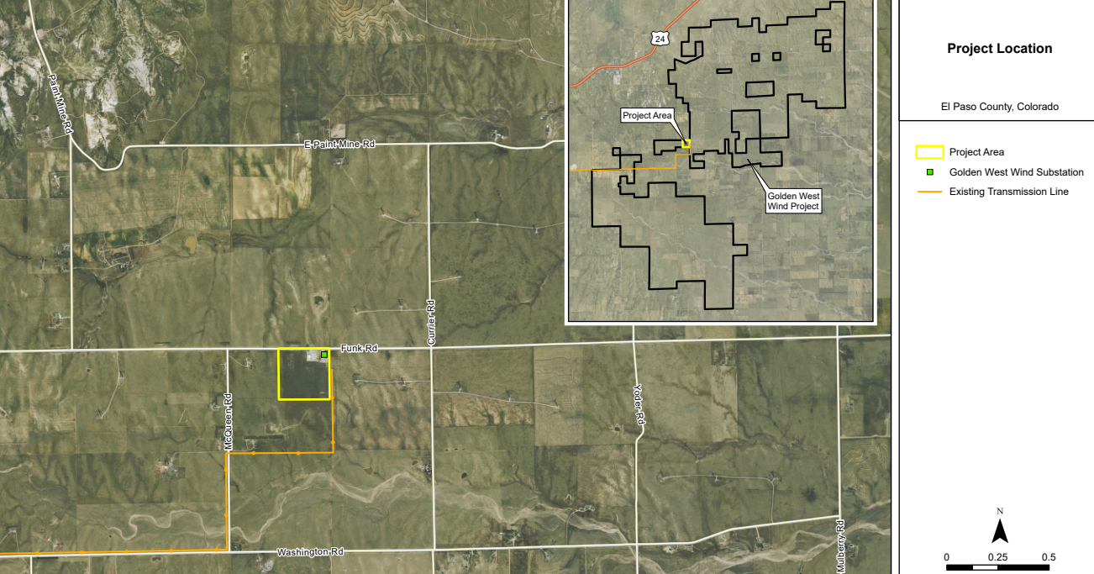

Zoning
Existing Zone(s)
Zone |  | Name
A35 |  | Agricultural
Proposed Zone(s)
Zone |  | Name
A35 |  | Agricultural

Zone Map (existing conditions of approval)
AASI131 Golden west Permit conditions https://epcdevplanreview.com/Public/ProjectDetails/14441

AASI145 Golden West amended permit

https://epcdevplanreview.com/Public/ProjectDetails/17261

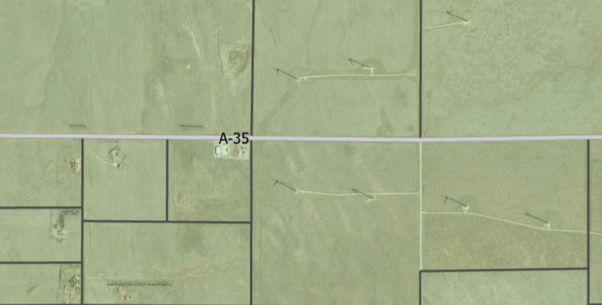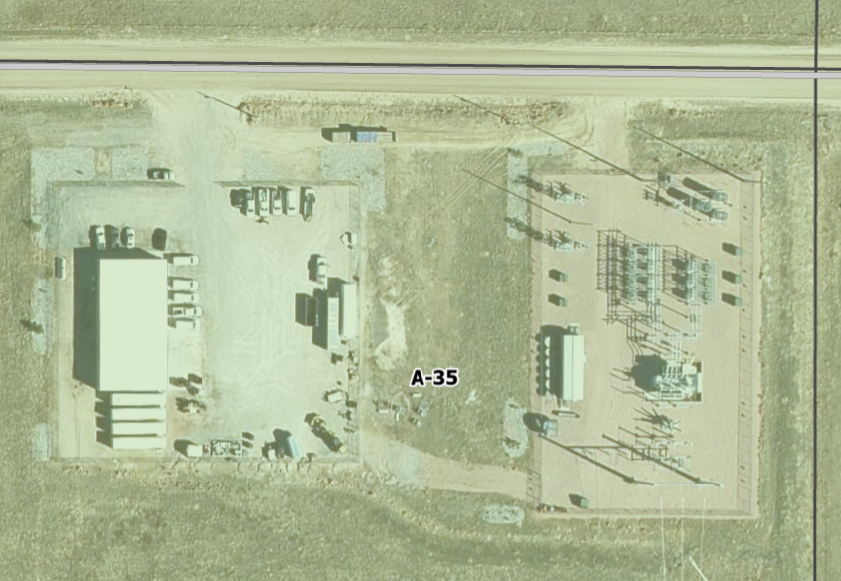

Zoning Analysis as 1041 currently allowed:
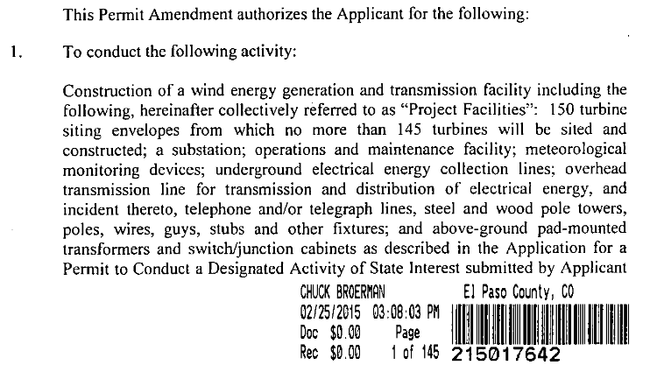

Zoning District Requirements (density, lot size, lot design standards, building setbacks)

Plat Map or Parcel Map (conditions of approval):
Unplatted

Application Type(s) Hearing: Required/ Optional/ No
1041 | yes
Site Dev Plan | No
2/25/26 NEXT STEP: submit a list of equipment, loads, oversized vehicles, and proposed routes from the County border to site to staff for internal review and organize a neighborhood meeting

Processing Highlights APPENDIX B - GUIDELINES AND REGULATIONS FOR AREAS AND ACTIVITIES OF STATE INTEREST
Chapter 1. Administrative Regulations
Application is the Exhibit B in appendix

Chapter 2. Permit Regulations
2.303. Submission Requirements for All Permit Applications; Waivers
2.405. Review Criteria for All Applications

Chapter 5. Site Selection and Construction of Major Facilities of a Public Utility
5.201. Application Submission Requirements
5.202. Review Criteria

EDARP submission list:
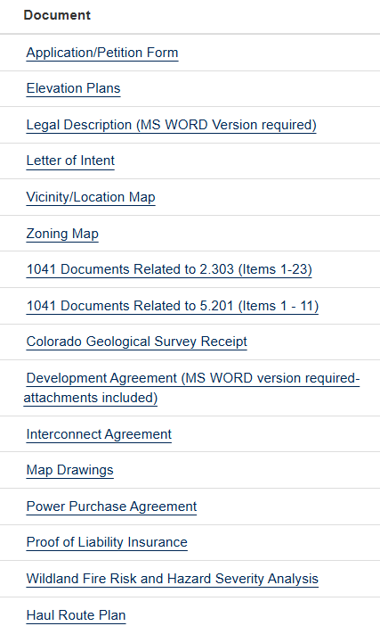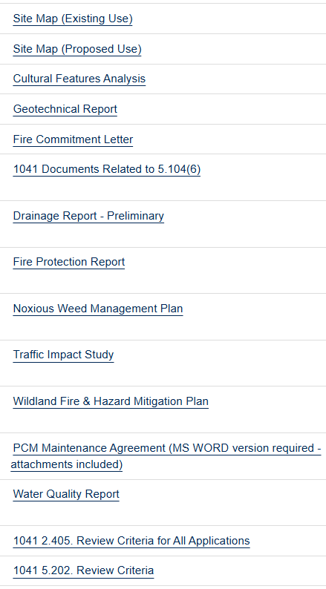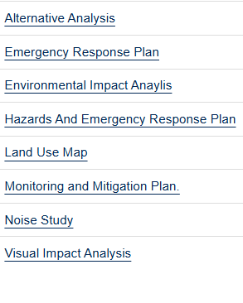
And any other docs applicants submit to support above sections of 1041

Relevant Past History:
AASI131 Golden west Permit conditions https://epcdevplanreview.com/Public/ProjectDetails/14441

AASI145 Golden West amended permit

https://epcdevplanreview.com/Public/ProjectDetails/17261

Design and Landscaping

Site Design/Layout (Lot pattern, circulation/road design, open space, preservation of natural features, compatibility internally and with adjacent land uses)
Fire break? Access…

Landscaping
☐ | Expressway, Principal arterial area depth – 25’-Trees required 1 per 20’
☐ | Urban interchange/Intersection area depth – 25’- N/A
☐ | Minor arterial area depth 20’ – Trees required 1 per 25’
☐ | Non-arterial area depth 10’ – Trees required 1 per 30’
☐ | Parking lot landscaping required
☐ | Buffer between non-residential and residential districts separated by a non-arterial road or public alley

utility electric project- Gravel likely required for fire mitigation
(d)Water Storage Tank and Utility Facilities Landscape Requirements.
(i)Site-Specific Landscaping Required. PCD Director approval of site-specific landscaping is required for a water storage tank and utility facilities. Installation of approved site-specific landscaping is required prior to putting a water storage tank or utility facility into operation. The site-specific landscaping is subject to the following standards:
• Rural and Remote Areas: In rural and remote areas landscaping, screening and erosion control measures shall be tailored to the nature and character of the area and the type of facility or structure contemplated. Site-specific landscaping shall, at a minimum, include revegetation of disturbed areas with materials indigenous to the site or otherwise adaptable.
• Urbanized and Developed Areas: In urbanized and developed areas, the site-specific landscaping shall address specific issues such as screening and visual impacts.

Signage:
Depict on site development plan

Parking Requirements:
Is any parking proposed

Lighting:
Photometric Plan to be provided at site dev plan stage if not at 1041
Photometric Plan Required | ☒

Site Characteristics\ Constraints\ Environmental Standards:
Dry Prairie grass; water source;

☐ | 30% or greater slope | Topography:
☒ | CGS review required (separate fee to CGS) | Soils/geology: |  | Fee to be paid to CGS 1041 review / Statute
☐ | Floodplain | Floodplain comment:
☒ | Noise mitigation required | Noise comment: |  |  | Analysis required w/ 1041
☐ | Preble’s mouse

Air/Visual Quality:
Visual simulation required w / 1041
6.3.1. Air Quality Standards

6.3.7(B)Noxious Weed Management.
(1)Noxious Weed Management and Plan Required. Noxious weed management shall be undertaken in association with a development application and permit when noxious weeds are identified on the Noxious Weed Map or by the Forestry and Noxious Weed Manager as being located on the subject property. Noxious weeds shall be addressed through the preparation of a noxious weed management plan.
(2)Early Consultation with ESD. The ESD should be consulted prior to submittal of a development application. The ESD input should be reflected in the design of the project.
(3)Site Control Measures. Topsoil stockpiles shall be managed and disturbance should be minimized to control noxious weeds.
(4)Limit of Noxious Weed Management Plan or Action. A noxious weed management plan or any action taken under this Section to control noxious weeds does not limit the County's authority to take appropriate action under the weed control acts.
(5)Implementation of Approved Plan.
(a)Recording of Plan. Implementation of the noxious weed management plan shall be accomplished by the recording of the development guide (in the case of a PUD) or the final plat and related documents (in the case of a subdivision that incorporate the recommendations of the plan.
(b)Plat Notes Required. Notice of any noxious weed issues may be required by the County through conditions of approval or notes placed on the face of the final plat.
(c)Mitigation Costs Included in Construction Financial Assurance. If the noxious weed issues are significant enough in the determination of the PCD Director to require mitigation associated with development construction activities, the cost of the mitigation shall be included in the construction financial assurance. Release of the financial assurance shall be consistent with the requirements of the ECM.

Districts

Taxing Entities
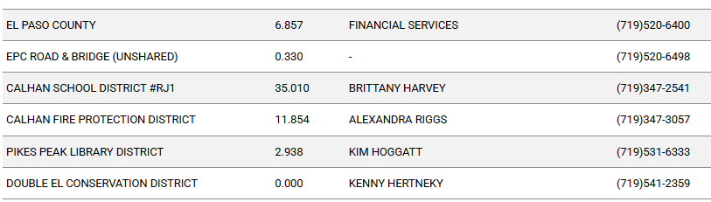

Proposed source of water |  |  | Proposed method of wastewater disposal
☐ | Central System |  | ☐ | Central System
District Name: |  |  | District Name:

Water/wastewater comments
Water for fire suppression and mitigation to be addressed in reports, Wildand Fire Plan/hazard analysis

Fire District:
Work directly with Fire Protection District for design guidance, Emergency Response Plan, cistern, Fire Mitigation and Hazard Plans and a commitment letter to serve the project.

Wildland Fire and Hazard Mitigation Plan and Wildland Fire Risk and Hazard Severity Analysis: https://planningdevelopment.elpasoco.com/#1746738110740-12f27e97-215c

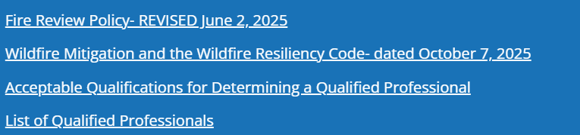

https://co-pub.coloradoforestatlas.org/#/

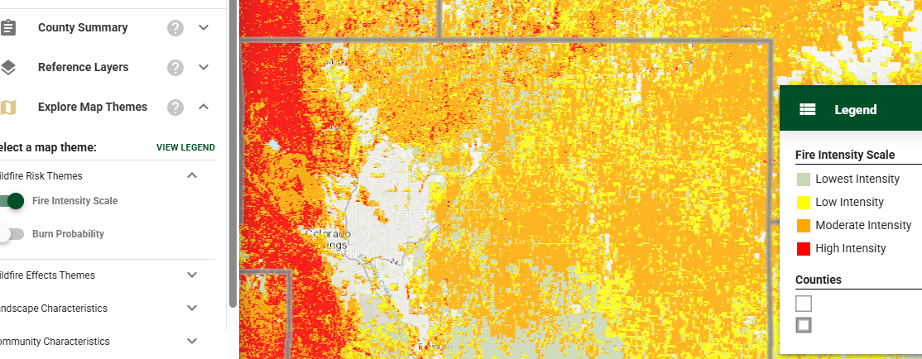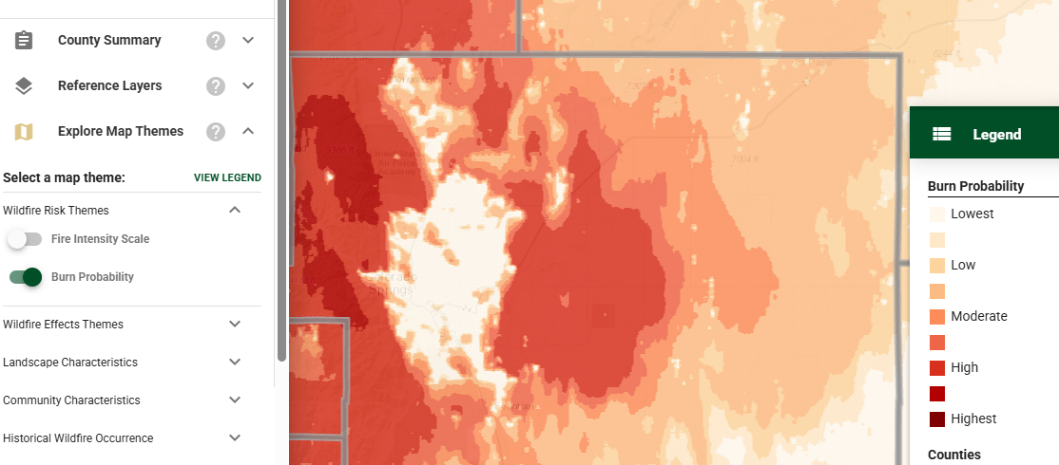
6.3.3. Fire Protection and Wildfire Mitigation
1 Fire protection report
(2)Wildland Fire and Hazard Mitigation Plan Required.
(3)Wildland Fire Risk and Hazard Severity Analysis Required.

(D)Construction in Wildland Fire Areas.
(1)
General.
(a)Applicability. All structures potentially threatened by wildland fire shall be designed, located, and constructed to comply with this Section.
(b)Risk Assessment Required. A wildland fire risk and hazard severity assessment shall be performed for all structures and groups of structures adjacent to wildland fuels.
(c)Maintenance of Property. After construction, continued maintenance of the grounds and storage of combustible materials shall be performed to maintain these requirements.
(d)Location of Buildings and Building Envelopes. Buildings located closer than 30 feet to a vegetated slope shall require special mitigation measures in accordance with NFPA 1144, Standard for Protection of Life and Property from Wildfire. Building envelopes shall not include gullies, fire chimneys, saddles, or other terrain conducive to wildfire spread.
(e)Roof Design and Materials. Only roof covering assemblies rated Class A shall be used in a wildland area. The specific class shall be consistent with the wildland fire risk and hazard severity assessment.
(f)Accessory Structures. Outbuildings, patio covers, gazebos, and other accessory structures shall be separated from the main structure by a minimum of 30 feet.
(g)Access to Structures. At least one approved means of vehicular access shall be provided to each structure or other nonstructural fire hazard in accordance with the following:
(i)For structures or nonstructural fire hazards exceeding two stories or 30 feet in height above average adjacent ground level, or 12,000 square feet of gross floor area, no less than 2 separate approved means of access shall be provided.
(ii)
Approved vehicular access shall be provided to within 150 ft of any point of the exterior wall of each structure.
(h)Access to Structures Not Protected by Automatic Sprinklers. An approved means of vehicular access shall be provided to within 30 feet of all points of at least 2 exterior walls for any structure not protected by automatic sprinklers that exceeds 2 stories or 30 feet in height above average adjacent ground elevation. Single and two-family dwellings are exempt from this requirement.
(i)Access to Structures Protected by Automatic Sprinklers. For any structure protected by an automatic sprinkler system, an approved means of vehicular access shall be provided to within 400 feet of any point of the exterior wall. For any structure exceeding 3 stories or 35 feet in height above average adjacent ground elevation and protected by an automatic sprinkler system, an approved means of vehicular access shall be provided to within 30 feet of all points of at least 2 exterior walls.
(j)Separation Between Structures. A structure in a planned building area shall be separated from another structure by at least 30 feet and shall be located at least 25 feet from a lot, parcel, or tract line. A structure in a planned building area that exceeds 2 stories or 30 feet in height above average adjacent ground elevation and is not protected by an automatic sprinkler system shall be separated from other structures by at least 50 feet and shall be located at least 25 feet from a lot, parcel, or tract line.

(5)Defensible Space Requirements. (a)General. The Defensible Space Requirements in Table 6.8 shall be implemented as minimum requirements in association with development in any Wildland Fire Area.
Table 6-8. Defensible Space Clearing and Structural Summary (Recommendations from NFPA by Wildland Fire Hazard Severity Analysis)
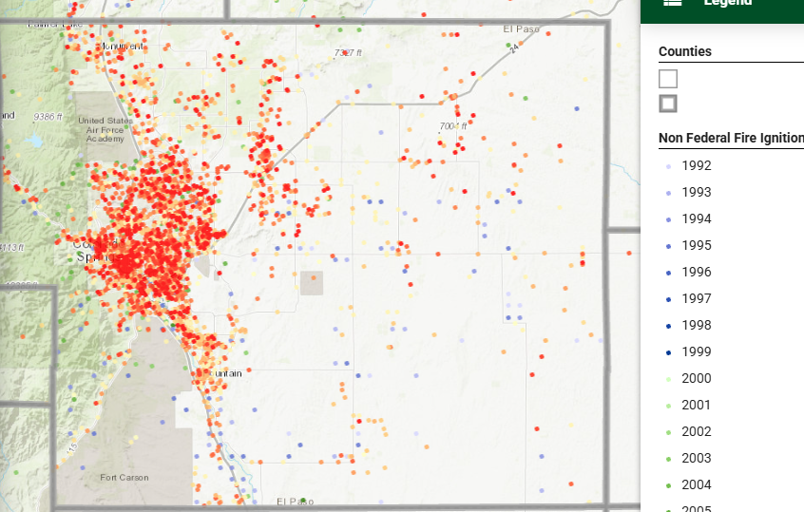

Emergency Services Issues:
Cameras; Water supply; equipment; chemical storage for suppression; training

Commissioner District: 2

Annexations/Intergovernmental/ Jurisdictional Access issues:
CDOT will need to know if there are any potential impacts to the state highway with regard to construction traffic.

Road Impact Fee Program :
Applicable at Site Development Plan

Your El Paso Master Plan

Placetype: Utility
Character:
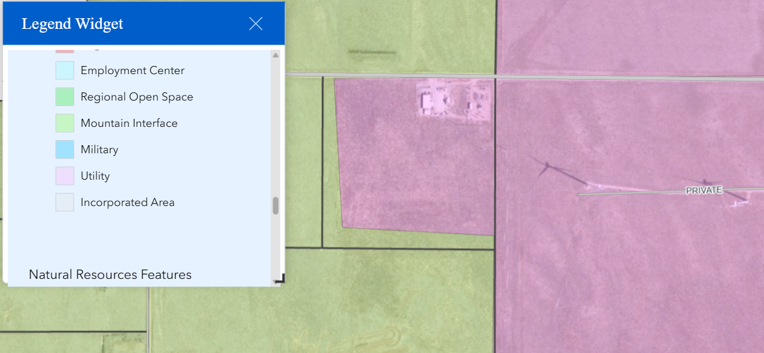

Recommended Land Uses:
- 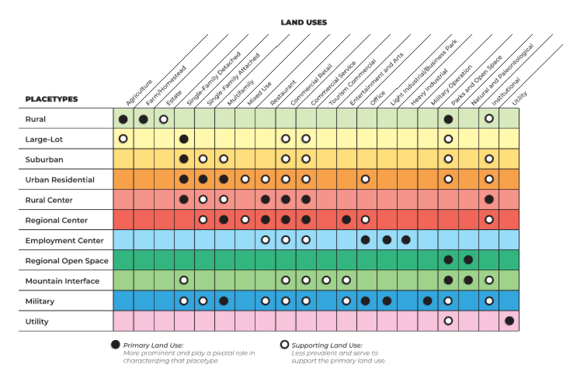

Goals, Objectives, Strategies:
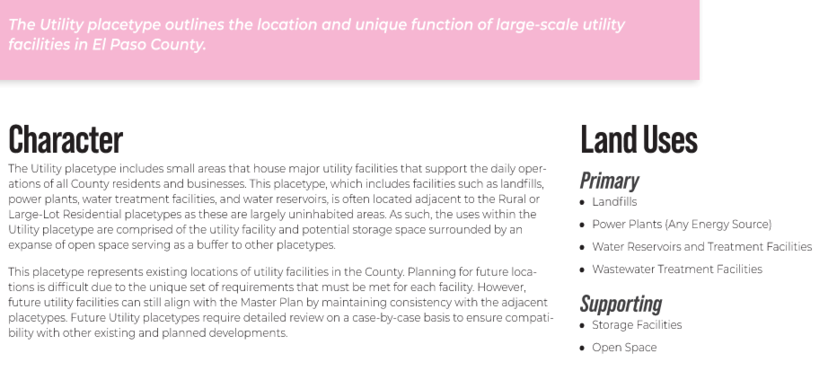

Area of Change Designation:
Description:
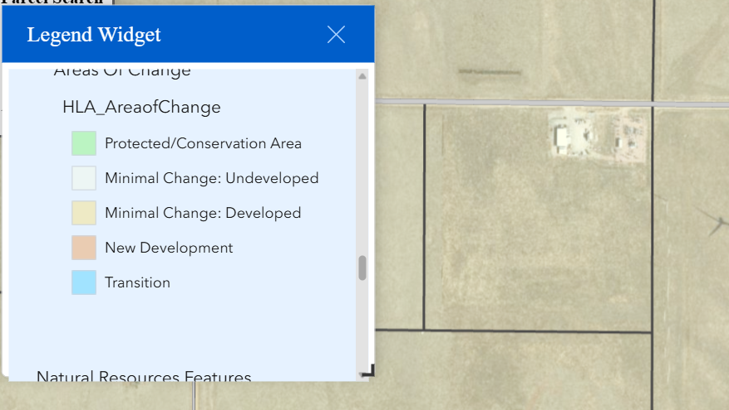

Goals, Objectives, Strategies:
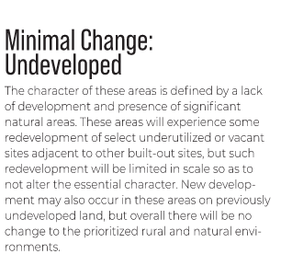

Key Area: Not In a Key Area

Water Master Plan Area:
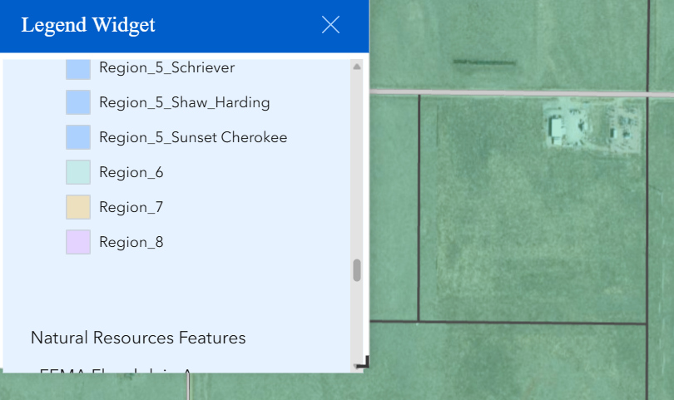

Recommendations:
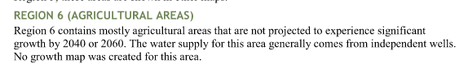

Wildlife impact
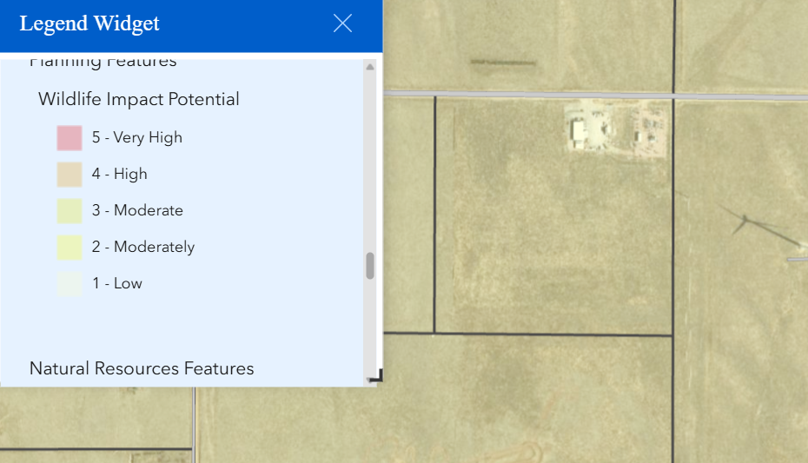

Parks Master Plan:
The 2022 El Paso County Parks Master Plan shows no impacts to existing or proposed parks, trails, or open space. As such no trail easement dedications will be necessary for this project. Regional park fees will be assessed upon review of the forthcoming platting actions.

It is not necessary for EPC Parks staff to attend this early assistance meeting.

Thank you!

Ashlyn Mathy
Parks Planner
Park Planning Division
El Paso County Parks Department
Office 719.520.6999

Helpful Links

Planning Website: https://planningdevelopment.elpasoco.com/

El Paso County Master Plan: https://planningdevelopment.elpasoco.com/#1510603950097-f5d985dc-35b2
Parks, Mineral and Water Master Plan: https://planningdevelopment.elpasoco.com/resources-and-references/#1516982531779-52cc0e87-01af

Forms and Templates: https://planningdevelopment.elpasoco.com/planning-development-forms/#1510677560407-ff8cfff5-69b2716b-00f9cbba-0c21

Land Development Code: https://library.municode.com/co/el_paso_county/codes/land_development_code

EDARP: https://epcdevplanreview.com/

Public GIS: https://elpasoco.maps.arcgis.com/apps/View/index.html?appid=5be6431018594c67b035ad0aad3e7e8a

Wrap Up
-If subdivision is proposed, recording fees, park and school fees and road impact fees may apply.

-Fees are subject to change. The fees at the time of application apply.

-Road Impact Fees
Please see the following website for information on the EPC Road Impact Fee Project. https://publicworks.elpasoco.com/road-impact-fees/ to include fee schedule.
As of December 15, 2016, per Resolution 16-454, on and after January 1, 2020, property in the unincorporated area of the county that receives a Land Use Approval either in a public hearing or administratively, is subject to the payment of Road Impact Fees. After December 31, 2024, in accordance with BoCC Resolution 24-377 the fee is paid for new residential and non-residential uses and structures and expansions of non-residential uses and structures. Road Impact fees are typically paid at time of building permit. If no building permit is being obtained for a particular Land Use application, then Road Impact Fees must be paid at the time of Site Development Plan or Special Use approval. If there are questions about EPC Road Impact program or fees, please contact DPW Development Review Services and the Engineer of the Day.

- Engineering Criteria Manual (ECM) Deviations.
The fee for any additional ECM deviation requests (more than two per land use application) - $1483.00 each per current Fee Schedule. Please note ECM deviation requests may result in additional processing and project review time. ECM Deviations should be submitted prior to the initial Site Development Plan or Final Plat submittal to preclude changes having to be made to engineering plans and documents if the deviation is not approved. Submission of an ECM deviation request does not imply or guarantee that the deviation will be approved. An ECM Deviation form must be submitted to include complete exhibits and justification excluding cost with supporting engineering criteria. If there are questions about ECM Deviation requests, please contact DPW Development Review Services and the Engineer of the Day.

-The fee for any additional waiver/deviation requests (more than two) - $550.00 each. Please note that requests for waivers and/or deviations may result in additional processing/review delay.

-All items requested must accompany the submittal for it to be complete, prior to payment request or the submittal will not be complete and ready for review agencies.

-A temporary use permit shall be applied for and approved for any staging area associated with development, such as a sales office, construction trailer, or contractor's equipment yard, prior to scheduling of the pre-construction meeting with El Paso County Planning and Community Development. If a Planned Unit Development is proposed, the temporary staging area should be shown on the development guideline and phasing plan.

-All prospective timelines for review are subject to departmental staffing and workload.

-Early Assistance is valid for 12 months from submittal of the EA application. If a project submittal is not received within 12 months, a new EA meeting may be required. An audio/video copy of the meeting is available in EDARP within the EA folder.

- Applications scheduled for public hearings may be heard as a regular item at the request of staff or a hearing body member.

- Any comments or commitments made by any member of the County Staff during this early assistance meeting are only preliminary in nature and should not be relied upon by the applicant. All prospective applicants should be informed that formal comments cannot be made by staff until after the application is submitted.

