Charging Yak Energy Storage - EDARP Early Assistance Meeting Request
Tt will input the following info for the EA Meeting Request:

Project Name: Charging Yak Energy Storage
Location: 31235 Funk Road, Calhan, CO 80808; adjacent to the Golden West Wind substation and operations building.
Parcel #: 1200000339
Project Description: Charging Yak Energy Storage is a proposed 250-megawatt, 4-hour battery energy storage facility located adjacent to and interconnecting to the Golden West Wind electric substation in unincorporated El Paso County. Project facilities would include energy storage units, inverters, supervisory control and data acquisition system (SCADA) equipment, a collector substation, and a generation tie transmission line connecting to the Golden West Wind substation. The Project also proposes to include on-site service roads, drainage and stormwater facilities, temporary laydown and construction areas, security fencing, and an Operation and Maintenance facility
Applicant and Owner Information
Applicant: Charging Yak Energy Storage, LLC. 700 Universe Blvd Juno Beach, Florida 33408
Owner: Golden West Power Partners. 700 Universe Blvd Juno Beach, Florida 33408

OTHER SUBMITTAL DOCUMENTS
Site Map
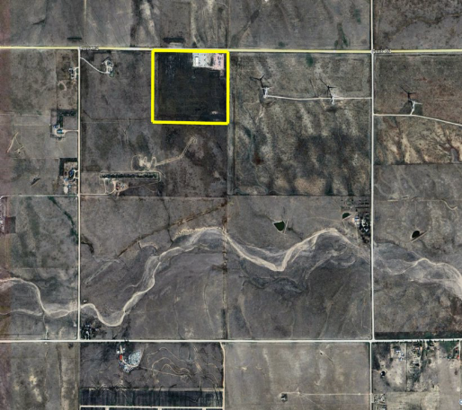

Meeting Availability
Feb 23 – end of day
Feb 24 – anytime
Feb 25 – anytime
March 18 – anytime
March 19 – anytime

