Letter of Notice to Adjacent Property Owners

December 4th, 2020

Dear Adjacent Property Owner,

This letter is being sent to you because CSpringsDesign LLC DBA Archadeck of Colorado Springs is proposing a pergola construction project in El Paso County at the referenced location: LOT 71 HOMESTEAD AT STERLING RANCH FIL NO 1 otherwise known as 9177 CUT BANK WAY COLORADO SPRINGS CO, 80908

Please direct any questions on the proposal to the referenced contacts below. Prior to any public hearing on this proposal (if required) a notification of the time and place of the public hearing will be sent to the adjacent property owners by the El Paso County Planning Department. At that point you will be given the El Paso County contact information, the file number, and an opportunity to respond either for, against or expressing no opinion in writing or in person

Adjacent properties requiring notification are lots 53,54,55, 70, 72 HOMESTEAD AT STERLING RANCH FIL NO 1

For questions specific to this project, please contact the contractor:

Archadeck of Colorado Springs
590 W Highway 105
Suite 162
Monument, CO 80132
work: (719) 793-9412
email: coloradosprings@archadeck.net
web site: https://coloradosprings.archadeck.com/
Pikes Peak Regional Building Department Contractor ID: 24178
(CSpringsDesign LLC DBA Archadeck of Colorado Springs)

Site Location:

The lot for which this notification is referencing is LOT 71 HOMESTEAD AT STERLING RANCH FIL NO 1 otherwise known as 9177 CUT BANK WAY COLORADO SPRINGS CO, 80908

Request and Justification:

The purpose for this application is to request administrative relief from the rear lot setback for LOT 71 HOMESTEAD AT STERLING RANCH FIL NO 1. The request asks for the rear setback requirement be reduced by ~2’ to ~23’ (vs. the required 25’) to allow for a pergola overhang slightly over the existing patio structure. This new setback allowance represents an approximate 8% or less encroachment for the pergola overhang, and allows for the proposed structure to simply cover the existing patio with a typical design for this type of structure. Not allowing would cause a non-standard design compared with pergolas of a similar nature over an existing patio, and would detract from the standard look and feel of an acceptable structure with a normal overhang from outside supporting posts

The requested adjustment of setback outlined above to consist of as follows:
Rear: 23.0’ (8% reduction)
Side: No change - 21.78’ (only 5’ required)

Existing and Proposed Facilities:
Subdivision infrastructure has been completed, including utility, roads and walk surrounding the lot.
No other waivers or requests are anticipated. Please see enclosed Vicinity Map showing Adjacent
property owners and site plan for further information.

Cordially,

Jim Shoff
Owner
Archadeck of Colorado Springs
590 W Highway 105
Suite 162
Monument, CO 80132
work: (719) 793-9412
email: coloradosprings@archadeck.net
web site: https://coloradosprings.archadeck.com/
Pikes Peak Regional Building Department Contractor ID: 24178
(CSpringsDesign LLC DBA Archadeck of Colorado Springs)

Enclosures:

Vicinity Map

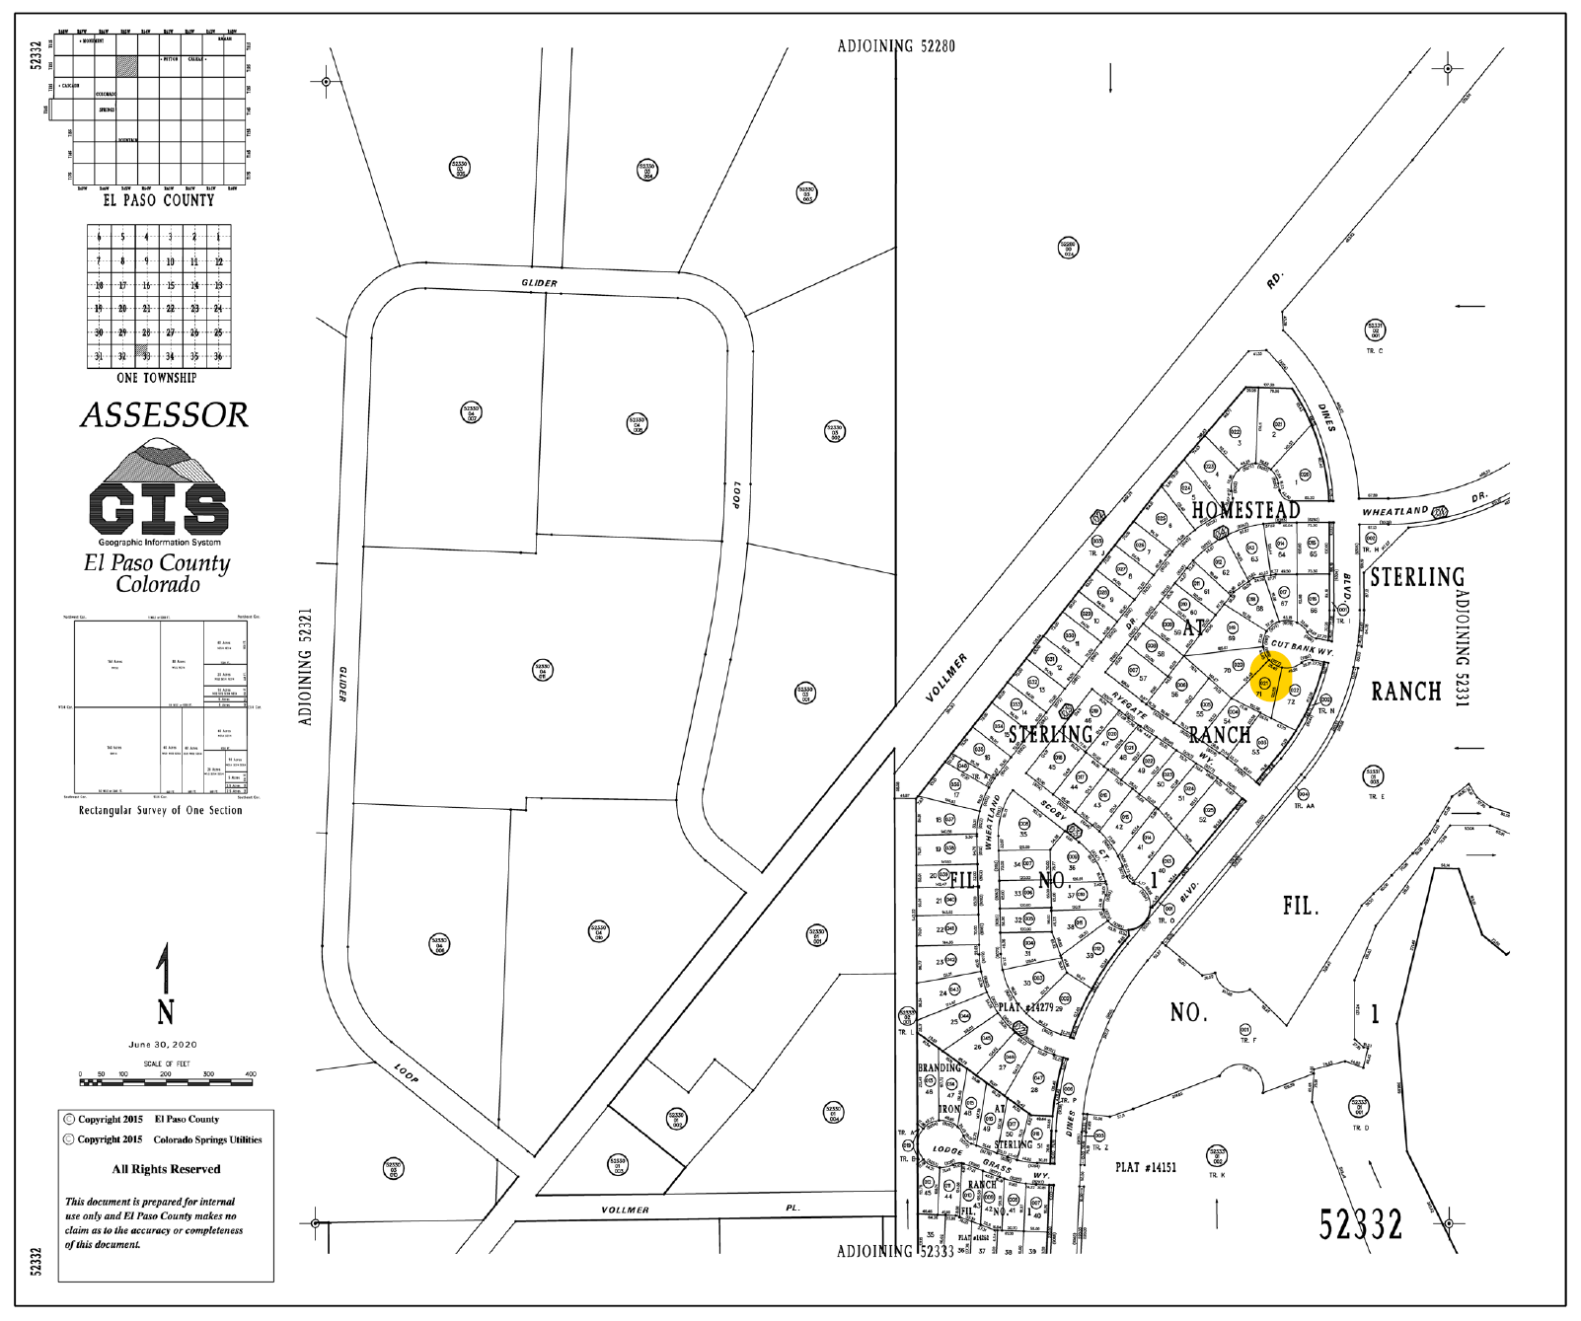

Plat Image
