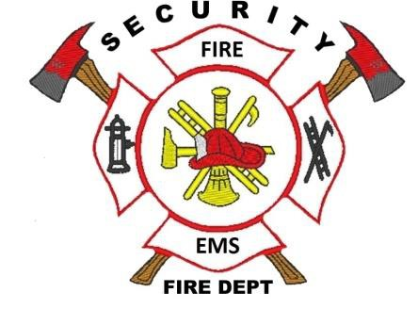

Security Fire Protection District
Fire Chief ~ David Girardin

Date:04/01/2022

To: Ryan Watson
Widefield Investment Group
3 Widefield Blvd Colorado Springs, CO 80911

This letter is being written to serve as a letter of commitment for emergency services coverage for: Glenn Filing No. 12

The service provided will include structure and wildland fire coverage, response to medical situations, plan reviews, and fire inspections. We have reviewed the plat already and it has met all standards needed for the Security Fire Protection District.

If you have any questions please feel free to contact me.

Thank you,
David Girardin
Fire Chief
Security Fire Protection District

CC:

Brandon Sullivan
Fire Marshal
Security Fire Protection District

400 Security Boulevard ~ Security, Colorado 80911 ~ (719) 392-3271 ~ securityfiredept.org

