Early Assistance Meeting Number: EA2629
Project Name: Jimmy Camp Creek Underground Tank storage
Project Location: 7760 SPRING GLEN DR
Project Parcel Nos. 5527003001;5522312004;5527200001
Project Description: Widefield Water and Sanitation District is planning to expand emergency underground storage basins at the Jimmy Camp lift station, intended to store sewage in the case of equipment failures or other emergencies.
The preferred alternative for the storage basins is to acquire additional land to the west of the existing lift station parcel to make space for the storage basins. The proposed storage basins cross into a 100-year floodplain and are near a designated wetland.
The first phase of underground storage basins is estimated to have a footprint of approximately 5,000 square feet and hold approximately 0.76 million gallons, with total footprint estimated to be 12,000 square feet holding approximately 1.75 million gallons.
The vacant lot across Glen Spring Drive from the lift station is an alternative location if the floodplain/wetland excludes the proposed location as a viable option but is not the preferred option. There are not any other reasonable locations for the emergency storage basins to be constructed.
The proposed storage basins are part of an overall effort for lift station improvements to accommodate new developments and increasing population that will be served by this lift station. The current capacity of the lift station is 0.8 MGD, projected buildout loading to the lift station will be 3.4 MGD.

Key topics of discussion:
• What are the County’s requirements for construction activities in the floodplain?
• What are the County’s requirements for permanent (below-grade) structures in the floodplain?
• Are there any specific County processes, permits, or submittals we should initiate for approval of structures in the floodplain?
Meeting Date:

El Paso County Planning & Community Development Planning Checklist

Request – Map Provided by Applicant
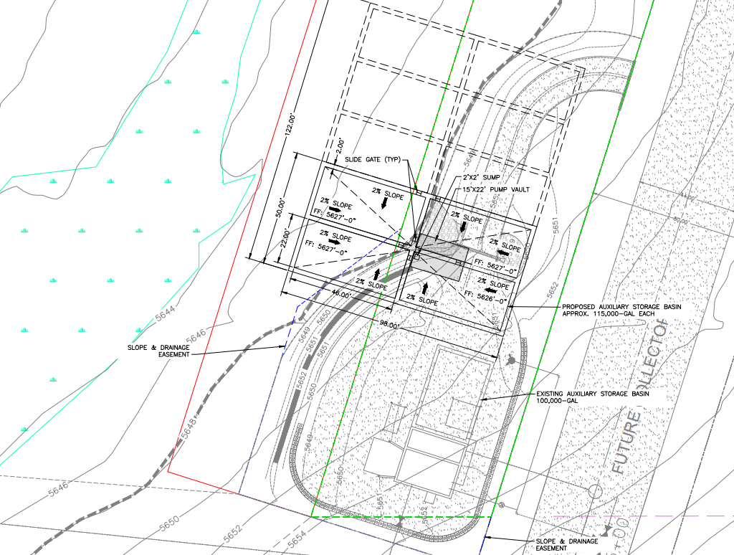

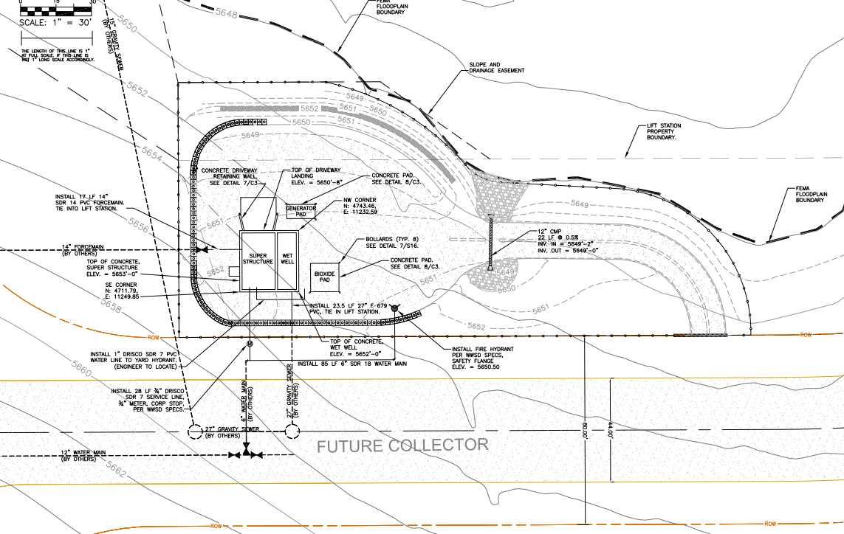

Zoning
Existing Zone(s)
Zone |  | Name
RS6000 CADO |  | Residential Suburban
Proposed Zone(s)
Zone |  | Name

Zone Map (existing conditions of approval)
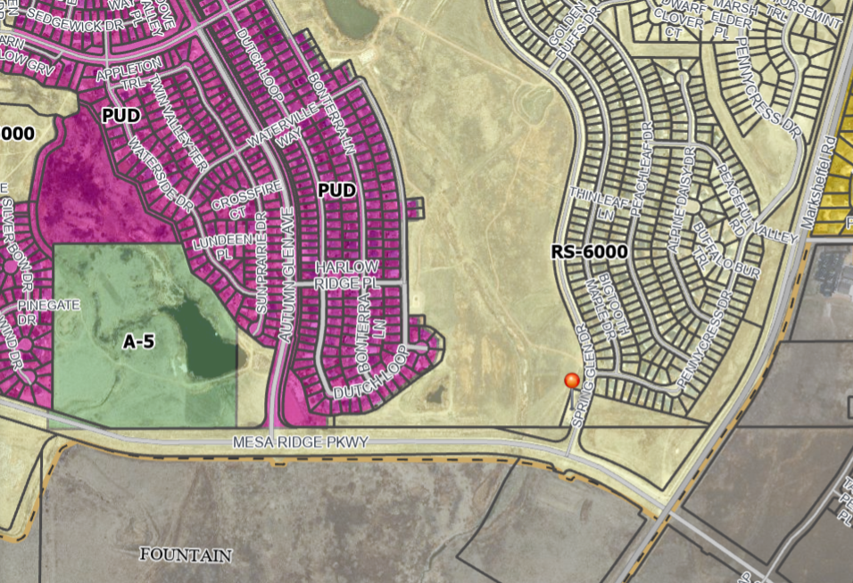

Zoning Analysis
1041 to site utility

Zoning District Requirements (density, lot size, lot design standards, building setbacks)
Establish in the 1041 in addition to the RS6000
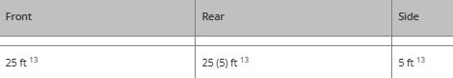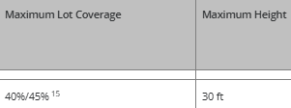

Plat Map or Parcel Map (conditions of approval):
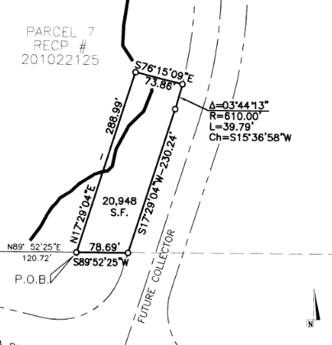Exemption Plat11937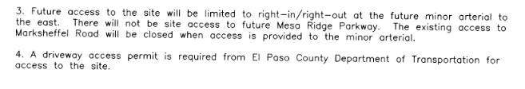

Application Type(s) Hearing: Required/ Optional/ No
Exemption plat to acquire adjacent property
1041
Site Development Plan

Approval Criteria:
Exemption Plat:
(5)Right-of-Way, Utility, and Open Space Exemptions.
(a)Purpose. The purpose of this Section is to establish a process for the PCD acknowledgement that the proposed or actual acquisition or conveyance action is in conformance with these regulations and to document the changes to the affected parcels to ensure that any resulting nonconformities are recognized and that the development rights of the lot or parcel owner is documented.
(b)Applicability. The acknowledgement provided by this Section shall be applicable to the division of a lot or parcel of land which is the direct result of the acquisition by condemnation or otherwise, of any federal, State or local government road rights-of-way, acquisition by federal, state, or local government of land for open space or parks, and any parcel of land divided into 2 or more separate interests, 1 being the interest of the fee owner of the parcel and the other being easements or land granted for purposes of public or private utility lines entering or crossing the parcel.
(c)Criteria for Approval. The PCD Director, in approving a right-of-way, utility or open space exemption, shall find:
• The request serves a legitimate government or utility purpose; and
• There will be no impact on the status of the lot or parcel as a conforming lot or parcel, and if a nonconformity will result that the nonconforming lot or parcel will be deemed conforming with respect to lot size and will be eligible to apply for a variance in the event they do not meet the development standards of the applicable zone district.
(d)Completed Action. The establishment of right-of-way, utilities easements, or open space parcels shall be considered completed and in effect when an approved deed and graphical depiction, and any nonconforming lot determination necessary to document the rights associated with any nonconforming lot or parcel created are formally accepted by the BoCC. The documents shall be filed for recording with the Clerk and Recorder.

Processing Issues and Options
1041 APPENDIX B - GUIDELINES AND REGULATIONS FOR AREAS AND ACTIVITIES OF STATE INTEREST

Chapter 2. Permit Regulations

Chapter 4. Site Selection & Construction of Major New Domestic Water and Sewage Treatment Systems and Major Extensions of Existing Domestic Water and Sewage Treatment Systems

Chapter 5. Site Selection and Construction of Major Facilities of a Public Utility

Chapter 6. Floodplain Natural Hazard Areas

Relevant Past History:
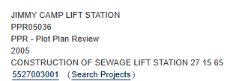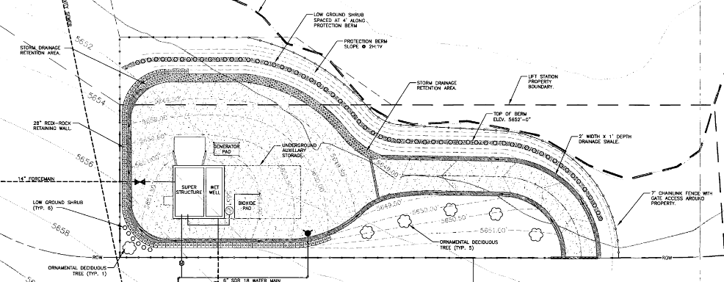

Design and Landscaping

Site Design/Layout (Lot pattern, circulation/road design, open space, preservation of natural features, compatibility internally and with adjacent land uses)
Restore wetland disturbance; residential in character for any above ground; construction hours

Landscaping
☐ | Expressway, Principal arterial area depth – 25’-Trees required 1 per 20’
☐ | Urban interchange/Intersection area depth – 25’- N/A
☐ | Minor arterial area depth 20’ – Trees required 1 per 25’
☐ | Non-arterial area depth 10’ – Trees required 1 per 30’
☐ | Parking lot landscaping required
☐ | Buffer between non-residential and residential districts separated by a non-arterial road or public alley

(d)Water Storage Tank and Utility Facilities Landscape Requirements. (i)Site-Specific Landscaping Required. PCD Director approval of site-specific landscaping is required for a water storage tank and utility facilities. Installation of approved site-specific landscaping is required prior to putting a water storage tank or utility facility into operation. The site-specific landscaping is subject to the following standards:
• Rural and Remote Areas: In rural and remote areas landscaping, screening and erosion control measures shall be tailored to the nature and character of the area and the type of facility or structure contemplated. Site-specific landscaping shall, at a minimum, include revegetation of disturbed areas with materials indigenous to the site or otherwise adaptable.

• Urbanized and Developed Areas: In urbanized and developed areas, the site-specific landscaping shall address specific issues such as screening and visual impacts.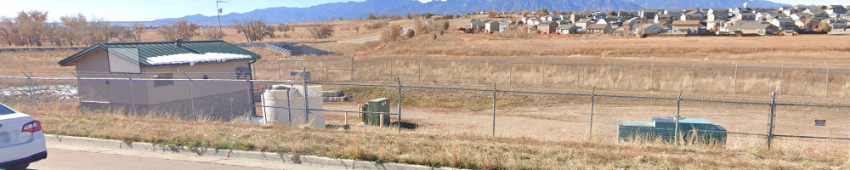

Signage:

Parking Requirements:
If parking then 1 ada.

Lighting:
If lighting then
(e)Measurement at Property Boundaries. Light levels measured at the property line of the development site adjacent to residential property or public right of way shall not exceed 0.1 foot candles as a direct result of the on-site lighting. All light fixtures mounted within 15' of any residential property line of the site shall be classified as IES Type II or Type III, or fixture demonstrated to provide similar distribution patterns and shielding properties. Fixtures shall be fitted with "house side shield" reflectors on the sides facing the residential property line.
(f)Light Standards and Fixtures. The style of light standards and fixtures shall be consistent with the style and character of architecture proposed on the site. Poles shall be anodized or coated to minimize glare from the light source. Bollards or similar light fixtures intended to illuminate landscape features or walkways are permitted which do not exceed 4 feet in height, 2 fixtures per bollard and 1 lamp not exceeding 900 lumens per fixture.

Photometric Plan Required | ☒

Site Characteristics\ Constraints\ Environmental Standards:
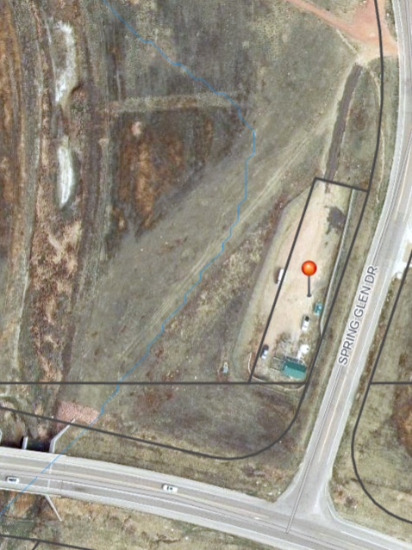

☐ | 30% or greater slope | Topography:
☒ | CGS review required (separate fee to CGS) | Soils/geology: |  | 1041 review by CGS
☒ | Floodplain | Floodplain comment:  Underground tanks in floodplain |  | 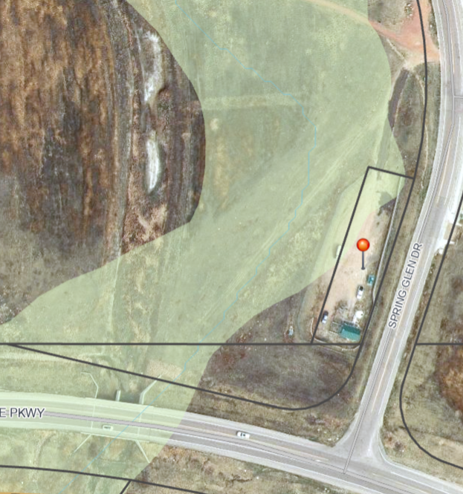
 |  |  |  | Base elevations on Exemption plat?
☒ | Noise mitigation required | Noise comment: |  |  | Address Noise in 1041
☒ | Preble’s mouse | Clearance letter from Federal Gov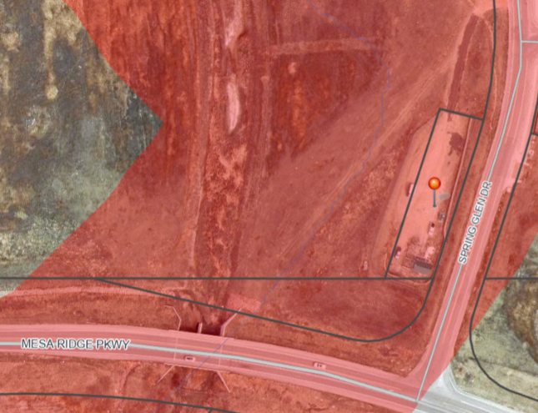

Air/Visual Quality:
Address permanent above ground from residents and parkland. Fence maintenance/ screening
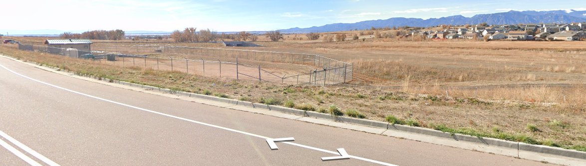

Districts

Taxing Entities
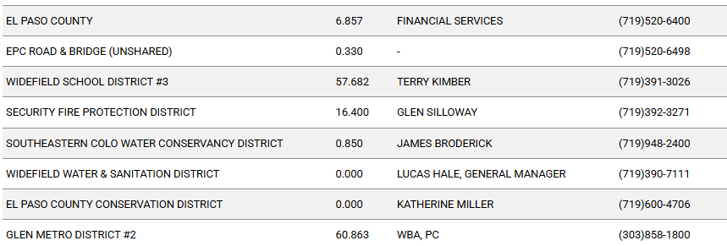

Proposed source of water |  |  | Proposed method of wastewater disposal
☒ | Central System |  | ☒ | Central System
District Name: |  | Widefield | District Name: |  | Widefield

Water/wastewater comments
Water sufficiency not reviewed w 1041 or exemption;
Has CDPHE process started ?

Fire District:
Security Fire

Wildland Fire and Hazard Mitigation Plan:
Provide with 1041; look at chapter 6

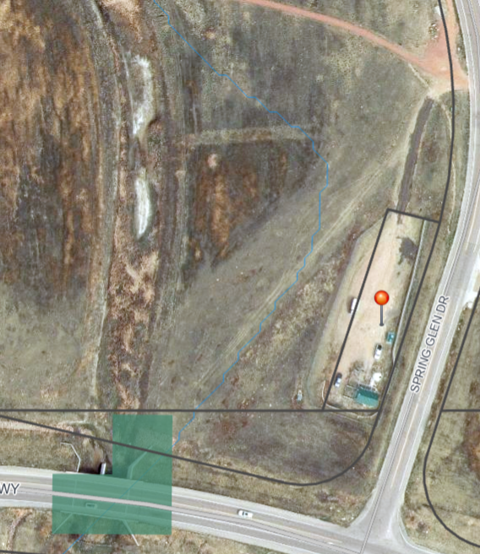

Emergency Services Issues:
Work with Fire District to develop ER plan during and post construction

Commissioner District: 4

Code Waivers:

Parks and trails:
Alternative detours during construction? Work with Parks maintenance for District.

The 2022 El Paso County Parks Master Plan shows no impacts to existing or proposed parks, trails, or open space. As such no trail easement dedications will be necessary for this project. Regional park fees will be assessed upon review of the forthcoming platting actions.
Ashlyn Mathy
Parks Planner
Park Planning Division
El Paso County Parks Department
Office 719.520.6999

Annexations/Intergovernmental/ Jurisdictional Access issues:
City of Fountain to south; declined EA; stated no issues

Road Impact Fee Program (PID Inclusion):
Address fee due in LOI for site development plan

Your El Paso Master Plan

Placetype:
Character: Suburban Residential
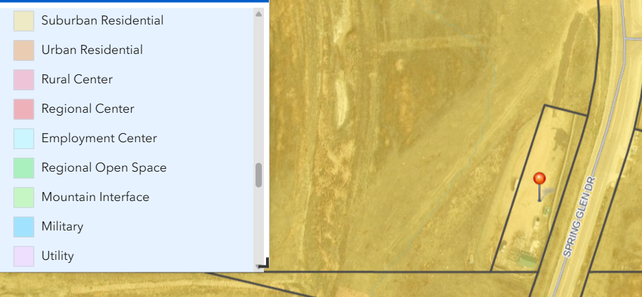

Recommended Land Uses:
- 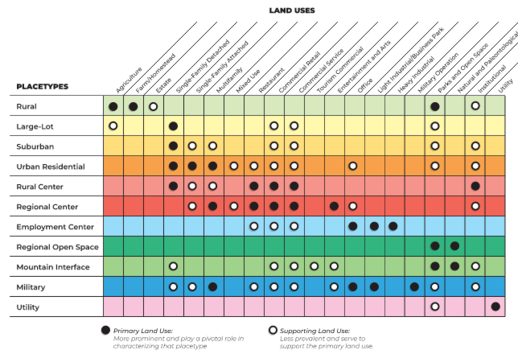

Goals, Objectives, Strategies:
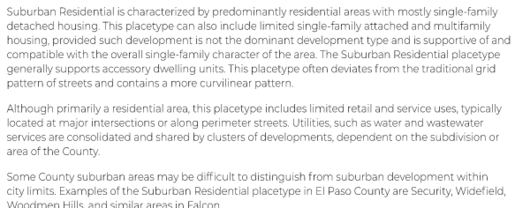
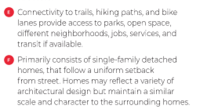

Area of Change Designation:
Description:
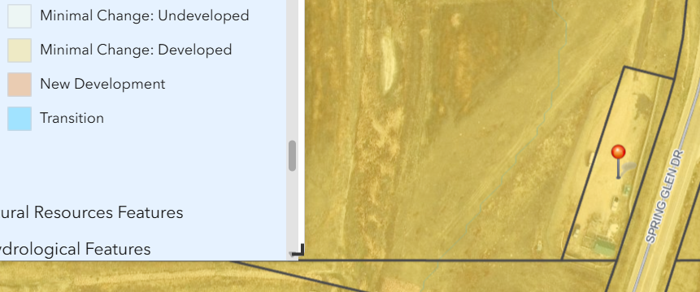

Goals, Objectives, Strategies:
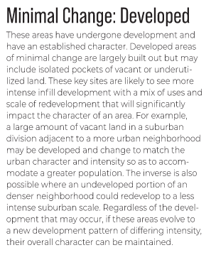

Key Area: None

Additional Placetype for comparison:
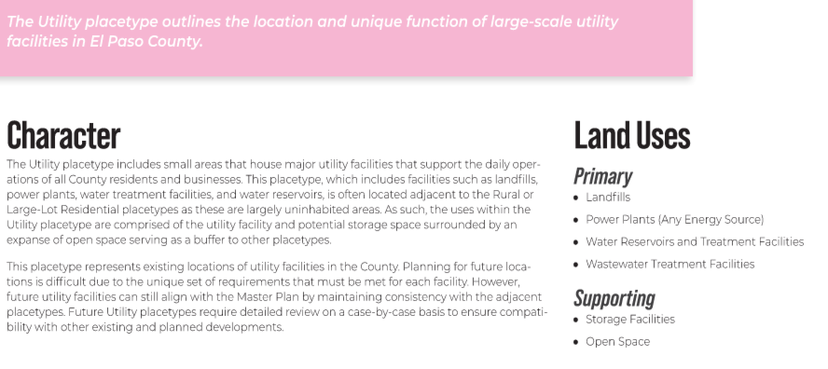

Water Master Plan Area:
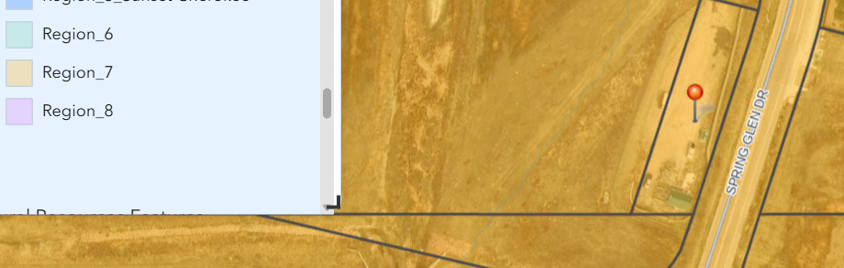

Recommendations:
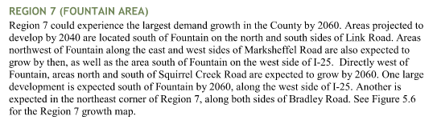

Wildlife impact
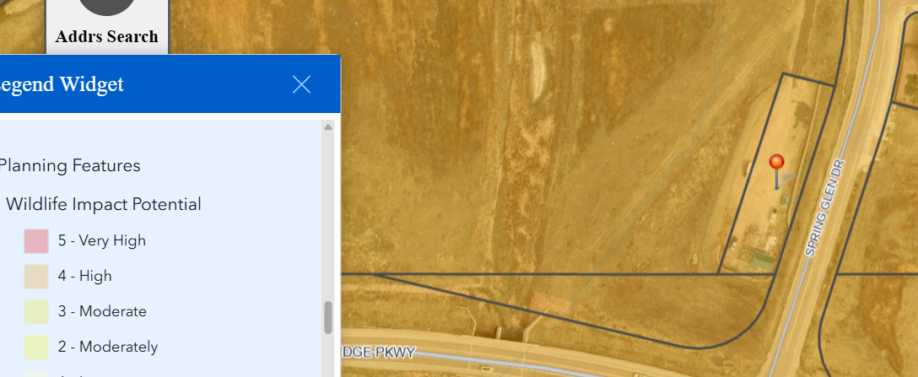

Helpful Links

Planning Website: https://planningdevelopment.elpasoco.com/

El Paso County Master Plan: https://planningdevelopment.elpasoco.com/#1510603950097-f5d985dc-35b2
Water Master Plan: https://planningdevelopment.elpasoco.com/#1515613078151-9a697e85-b1a7
Parks Master Plan: https://parks.elpasoco.com/parks-and-recreation/park-planning/
Mineral Extraction Master Plan: https://planningdevelopment.elpasoco.com/#1515613078151-9a697e85-b1a7

Forms and Templates: https://planningdevelopment.elpasoco.com/forms-and-affidavits/

Applications and Checklists: https://planningdevelopment.elpasoco.com/applications-and-checklists/

Land Development Code: https://library.municode.com/co/el_paso_county/codes/land_development_code

EDARP: https://epcdevplanreview.com/

Public GIS: https://experience.arcgis.com/experience/94cea8ccda3d4806a3fd500d2b5a4433?draft=true

Wrap Up
-If subdivision is proposed, recording fees, park and school fees and road impact fees may apply.

-Fees are subject to change. The fees at the time of application apply.

-Road Impact Fees
Please see the following website for information on the EPC Road Impact Fee Project. https://publicworks.elpasoco.com/road-impact-fees/ to include fee schedule.
As of December 15, 2016, per Resolution 16-454, on and after January 1, 2020, property in the unincorporated area of the county that receives a Land Use Approval either in a public hearing or administratively, is subject to the payment of Road Impact Fees. After December 31, 2024, in accordance with BoCC Resolution 24-377 the fee is paid for new residential and non-residential uses and structures and expansions of non-residential uses and structures. Road Impact fees are typically paid at time of building permit. If no building permit is being obtained for a particular Land Use application, then Road Impact Fees must be paid at the time of Site Development Plan or Special Use approval. If there are questions about EPC Road Impact program or fees, please contact DPW Development Review Services and the Engineer of the Day.

- Engineering Criteria Manual (ECM) Deviations.
The fee for any additional ECM deviation requests (more than two per land use application) - $1483.00 each per current Fee Schedule. Please note ECM deviation requests may result in additional processing and project review time. ECM Deviations should be submitted prior to the initial Site Development Plan or Final Plat submittal to preclude changes having to be made to engineering plans and documents if the deviation is not approved. Submission of an ECM deviation request does not imply or guarantee that the deviation will be approved. An ECM Deviation form must be submitted to include complete exhibits and justification excluding cost with supporting engineering criteria. If there are questions about ECM Deviation requests, please contact DPW Development Review Services and the Engineer of the Day.

-The fee for any additional waiver/deviation requests (more than two) - $550.00 each. Please note that requests for waivers and/or deviations may result in additional processing/review delay.

-All items requested must accompany the submittal for it to be complete, prior to payment request or the submittal will not be complete and ready for review agencies.

-A temporary use permit shall be applied for and approved for any staging area associated with development, such as a sales office, construction trailer, or contractor's equipment yard, prior to scheduling of the pre-construction meeting with El Paso County Planning and Community Development. If a Planned Unit Development is proposed, the temporary staging area should be shown on the development guideline and phasing plan.

-All prospective timelines for review are subject to departmental staffing and workload.

-Early Assistance is valid for 12 months from submittal of the EA application. If a project submittal is not received within 12 months, a new EA meeting may be required. An audio/video copy of the meeting is available in EDARP within the EA folder.

- Applications scheduled for public hearings may be heard as a regular item at the request of staff or a hearing body member.

- Any comments or commitments made by any member of the County Staff during this early assistance meeting are only preliminary in nature and should not be relied upon by the applicant. All prospective applicants should be informed that formal comments cannot be made by staff until after the application is submitted.

