DECLARATION
OF
COVENANTS, CONDITIONS, RESTRICTIONS AND EASEMENTS
FOR
SKYE VISTA SUBDIVISION

Skye Vista, LLC, a Colorado limited liability company (hereinafter called “Declarant”) is the sole owner of real property which is described on Exhibit “A” attached hereto and incorporated herein by this reference (hereinafter called the “Property”).

Declarant desires to place protective covenants, conditions, restrictions, reservations and easements upon the Property to protect the Property’s quality residential living environment and also to protect its desirability, attractiveness and value.

The Declarant hereby declares that all of the Property as hereinafter described, together with all appurtenances, facilities and improvements thereon, shall be held, sold, used, improved, occupied, owned, resided upon, hypothecated, encumbered, liened, and conveyed subject to the following easements, reservations, uses, limitations, obligations, restrictions, covenants, provisions and conditions, all of which are for the purpose of enhancing and protecting the value, desirability and attractiveness of the Property and all of which shall run with the land and be binding on and inure to the benefit of all parties having any right, title or interest in the Property or any part thereof, their heirs, successors and assigns.

The intent of these Covenants is to establish a general plan of development for the benefit of the entire Property and to preserve the Property as an exclusive, high quality residential area of lasting value, and these Covenants have been designed to that end. Notwithstanding any provision of these Covenants, neither the Declarant nor the Property shall be subject to the Colorado Common Interest Ownership Act (C.R.S. §38-33.3-101, et seq.), and so, pursuant to C.R.S. §38-33.3-116, the Skye Vista Homeowners Association, Inc., (the “Association”) and the Property shall be subject only to C.R.S. §38-33.3-105, §38-33.3-106 and §38-33.3-107, and no other sections of said Title 38, Article 33.3.

ARTICLE I

DEFINITIONS

Section 101. Definitions. The following words and expressions used in these Covenants have the meanings indicated below unless the context clearly requires another meaning:

(a) Accessory Building. Detached garages, guest houses, patios, swimming pools, spas, hot tubs, gazebos, recreation facilities and other buildings customarily used in connection with the single family residence as determined by the Board in its reasonable discretion.

(b) Approving Authority. The architectural review board established pursuant to Section 601 of these Covenants. The Association’s Board of Directors may appoint or may itself constitute the Approving Authority as provided by Section 601 of the Covenants.

(c) Association. Skye Vista Homeowners Association, Inc., a Colorado non-profit corporation, which has been organized under the laws of the State of Colorado, its successors and assigns.

(d) Building Site. The location within a Lot on which a Structure may be erected with the prior written approval of the Approving Authority, including the “building envelope” described herein.

(e) Common Area. Any tracts or parcels designated as such on any Plat of the Property or otherwise granted or conveyed to the Association, together with all improvements located thereon and all common property owned by the Association. Exhibit “B” hereto includes the Common Area designated as such upon the recording of these Covenants.

(f) Covenants. These Covenants and the provisions contained herein, and any amendments thereto.

(g) Declarant. Skye Vista, LLC, a Colorado limited liability company, its agents, employees, contractors, successors and assigns to whom it expressly transfers in writing all or any part of its rights as Declarant hereunder.

(h) Development Plan. The Development Plan shall mean and refer to that certain Skye Vista Development Plan and Development Guidelines approved by El Paso County, Colorado.

(i) Home. A residential dwelling Structure constructed on a Lot.

(j) Lot. Each area designated as a Lot in any recorded Plat of the Property. The Property subject to these Covenants contains thirteen (13) Lots and no “development rights” as described in these Covenants.

(k) Lot Lines. Front, side and rear Lot Lines shall be the same as defined in the zoning regulations of El Paso County in effect from time to time. In the absence of such a definition, a front Lot Line is each boundary line (whether one or more) between the Lot and any public street. A side Lot Line is any boundary line which meets and forms an angle with a public street except that for a corner Lot with two (2) front Lot Lines, the side Lot Line is the boundary which forms an angle with the street which affords the principal access to the Lot.

(l) Period of Declarant Rights. That period of time commencing with the recording of these Covenants and continuing until January 1, 2045.

(m) Plat. The Plat which has been or will be recorded for this Property in the real property records of El Paso County, Colorado, and is incorporated herein by this reference.

(n) Property. The area described in Exhibit “A”, attached hereto and incorporated herein by this reference, including any and all Lots, Common Area and Improvements thereon.

(o) Mortgagee. Any person or entity, or any successor or assign thereof, which holds or owns a deed of trust, mortgage or similar encumbrance. The term shall also include the Administrator of the Department of Veterans Affairs, an office of the United States of America, and his assigns under any executed land sales contract wherein the said Administrator is identified as the seller, whether such contract is recorded or not but if not recorded, then written Notice thereof shall be delivered to the Board. “First Mortgage” shall mean a mortgage upon a Lot having priority of record over all other recorded encumbrances and liens thereon, except those governmental liens made superior by statute (such as general ad valorem tax liens and special assessments). “First Mortgagee” means a mortgagee whose encumbrance is a First Mortgage.

(p) Owner. Person or entity having fee simple legal title to a Lot. If more than one person has such title, all such persons are referred to collectively as “Owner” and shall exercise their rights as an Owner through such one of them as they may designate from time to time. A vote of Owners shall be determined on the basis of one vote for each Lot.

(q) Rules. The rules and regulations established by the Board under Section 915 of these Covenants.

(r) Structure. Any thing or device, including related improvements, such as Accessory Buildings, fences, trees and landscaping, the placement of which upon any Building Site might affect its architectural appearance, including by way of illustration and not limitation, any Home, building, garage, porch, shed, greenhouse, driveway, walk, patio, swimming pool, tennis court, fence, wall, tent, covering, antenna, mailbox, solar collector or outdoor lighting. “Structure” shall also mean an excavation or fill the volume of which exceeds five (5) cubic yards or any excavation, fill, ditch, diversion dam or other thing or device which affects or alters the natural flow of surface waters upon or across any Lot or which affects or alters the flow of any waters in any natural or artificial stream, wash or drainage channel upon or across any Lot.

ARTICLE II

COVENANTS TO PRESERVE THE RESIDENTIAL
CHARACTER OF THE PROPERTY

Section 201. Property Uses.

(a) Except as provided herein, all Lots in the Property shall be used exclusively for private single family residential purposes, and no Structure erected or maintained within the Property shall be used or occupied for any purpose other than for a single family residential dwelling. No Lot shall be used or occupied for any group home, nursing home, half-way home or other occupancy by persons unrelated by blood or marriage as determined by the Association’s Board of Directors in its discretion. No trade, business, profession, commercial activity or other activity conducted for gain shall be carried on or within any Lot, except as provided in Section 207 and except that a home office for professional business, such as architects, accountants, lawyers, or as otherwise defined by the Approving Authority, may be permitted within a Home on a Lot so long as the operation or activity must not be apparent or detectable by sight, sound or smell, must conform to zoning codes, must be conducted by the Owner or a family member of Owner, must not generate excessive traffic or parked vehicles, must not have any commercial signs placed on the Lot, must not involve any retail, manufacturing, distribution, wholesale, storage or repair business, and must have received the prior written approval of the Approving Authority. The home office must not involve the solicitation of the residents of the Property and must not constitute an offensive use as determined by the Approving Authority in its sole discretion.

(b) All leases, or similar rental arrangements, must have terms of at least thirty (30) days. Short term rentals, as defined by the Board, are prohibited.

Section 202. Structures. No Structure shall be erected within the Property except a single family dwelling and those Accessory Buildings and other Structures which have been approved by the Approving Authority and allowable per zoning and other governmental codes and regulations. Other than a single family Home, no Structure, no trailer, tent or other similar or dissimilar temporary quarters may be used for living purposes. No Structure may be placed on any Lot except with the permission of the Approving Authority after its review and approval of the Structure’s location on the Building Site and the Structure’s compliance with these Covenants.

Section 203. Construction Type. All construction shall be new except for the existing home and detached four car garage. No building previously used at another location nor any building or Structure originally constructed as a mobile dwelling or manufactured housing may be moved onto a Lot, except as expressly hereinafter provided for temporary buildings. Notwithstanding any provision hereof, the existing home will be grandfathered in without needing to be updated to conform to these Covenants; however, any future changes and/or additions must be approved by the Approving Authority and will trigger the entire property to be updated to conform to the Covenants. In addition, the existing home and its owner shall be subject to the other provisions of the Covenants, including the use restrictions.

Section 204. Storage. No building materials shall be stored on any Lot except temporarily during continuous construction of a Structure or its alteration or improvement.

Section 205. Construction Commencement.

(a) Construction of a Home. A Structure shall not be occupied in the course of original construction until substantially completed and approved for occupancy by the appropriate governmental authorities. All work of construction shall be diligently and continuously undertaken from the time of commencement until fully completed.

(b) Construction of Detention Basin(s). Declarant, its developer or builder successor and assigns, hereby covenant to construct the Detention Basin(s) pursuant to the Detention Basin Agreement.

Section 206. Construction Completion. The exterior and interior of all buildings or other Structures must be completed within fifteen (15) months after the commencement of construction, as demonstrated by a final inspection or certificate of occupancy by the Pikes Peak Regional Building Department, except where such completion is impossible or would result in great hardship due to strikes, fires, national emergency or natural calamities. If not so completed, or if construction shall cease for a period of sixty (60) days without permission of the Approving Authority, the Approving Authority will give the Owner thereof Notice of such fact, and if construction on such Structure is not diligently commenced within thirty (30) days after such Notice, the unfinished Structure or unfinished portion thereof shall be deemed a nuisance and shall be removed forthwith by and at the cost of the Owner. Erosion control Structures must be installed prior to the commencement of any construction upon any Lot.

Section 207. Construction or Sales Offices. Temporary buildings for construction or administration purposes or for sales offices may be erected or maintained only by Declarant or with the written permission of the Approving Authority. Model Homes may be used and exhibited only by Declarant or with the permission of the Approving Authority.

Section 208. Drilling Structures and Tanks. The only drilling Structures and tanks permitted shall be during the construction phase of a single family residential Home, in order to install a domestic well and septic system. All tanks shall be installed underground and the surrounding area shall be left free and clear of debris and returned to its natural state.

Section 209. Easements.

(a) Development Easements. There are hereby reserved to Declarant, their successors and assigns, perpetual, alienable, divisible and releasable easements and the right from time to time to grant easements to others over the Property for the purposes of Declarant’s development of the Property, including the easements as described on the recorded Plat along and adjoining each and all Lot Lines of each Lot for use of all or part of such areas for lines for transmission of electric current or impulses or electronic signals, for heat and fuel lines, for utility lines, for drainage and for other similar or dissimilar facilities and purposes, and for any one or more of such purposes.

(b) Utilities and Other Easements. Easements and/or non-build area for installation and maintenance of utilities, roadways, irrigation and drainage purposes and such other purposes incident to development of the Property are reserved to the Declarant, the Owners and Association as shown on the recorded Plat or as described in these Covenants. If a purchaser buys contiguous Lots, or in the case of adjacent Owners where a desire exists to change such easements, such easements may be so changed only with the written approval of the Association, and such easements must still be legally vacated pursuant to El Paso County requirements, including compliance with all applicable zoning and Property requirements. New fencing or landscape elements may be constructed along property lines; however, such elements are subject to utility and drainage easements. In the event that a utility line or drainage feature requires maintenance, the respective authority may remove the Owner’s fence or landscape elements for access and maintenance and may not be required to replace such items.

Section 210. Underground Utilities. All utilities, except customary service devices for meters, transformers, access, control or use of utilities, shall be installed underground.

Section 211. Maintenance of Drainage Structures. Unless maintained by the Association, the Owners shall be responsible for the ownership and maintenance of the portion of any drainage Structure or easements, as shown on the recorded Plat, as located on those Lots. The Association shall perform any maintenance or other duties set forth under any detention or drainage agreement if required by El Paso County.

Section 212. Common Area. The Common Area includes the following:

(a) Open Spaces. The open spaces will be designated on the Plat as specific Tracts and may be owned by the Association as a Common Area for the common benefit and use, if allowed, of the Owners and others as provided herein. The Common Area shall be repaired, maintained and replaced by the Association through the assessments set forth in Article VIII of these Covenants. The Owners, family members and guests will use the Common Area at their own risk and liability, will comply with the Association’s Rules and these Covenants, and will hold the Declarant, the Association, the other Owners, successors and assigns harmless from any and all loss, costs, damages, injuries, liabilities, claims, liens, demands, causes of action whatsoever, whether at law or in equity arising from the construction, repair, maintenance, replacement and use of the Common Area. Each Owner shall be responsible and liable for any expense due to any damage done to the Common Area by the Owner, his/her family members, guests, contractors and/or invitees.

(b) Easements. The Common Area may also include those drainage easements and any other easements shown on the Plat to be maintained by the Association.

ARTICLE III

DENSITY, SETBACK AND QUALITY STANDARDS

Section 301. Resubdivision. No more than one Home and no more than two (2) Accessory Buildings shall be erected or maintained within any Lot. The Accessory Buildings shall be of comparable quality and have a similar exterior finish as the primary dwelling or as approved by the Approving Authority. No Lot shall be subdivided into additional Lots unless the Approving Authority grants its prior written approval.

Section 302. Setbacks and Other Restrictions. No building or Structure shall be erected, placed or altered unless it meets the following requirements:

- Minimum lot width: 200'
- Front setback: 25'
- Rear setback: 25'
- Side setback: 15'
- Minimum flag width: 30'
- Row width: 60'
- Maximum building height: 30'
- Landscape setback: 10' all sides

Notwithstanding the foregoing, the Approving Authority may authorize a variance to any of the setback requirements. Exceptions to the setback requirements are sometimes logical and may be made by the Approving Authority in cases where extenuating circumstances exist, provided, however, that any such exceptions must be requested in writing and granted by the Approving Authority in writing. For the purposes of this covenant, steps and open porches and decks shall be considered as part of the building. Setbacks shall also comply with any notes on the recorded Plat and zoning requirements. Declarant or the Approving Authority shall not have any obligation to protect or guarantee any views and shall not be liable for any obstruction or impairment of views. The setbacks and other restrictions must comply with planning and zoning requirements, including building heights.

Section 303. Dwelling Area Requirements.

A. No dwelling Structure shall be constructed unless the ground floor area, or footprint area, of the main Structure exclusive of open porches, basements, and garages, is more than two thousand (2,000) square feet for a one-story dwelling with a finished or unfinished lower level; twenty-eight hundred (2,800) square feet for a one story dwelling with no lower level; and more than three thousand (3,000) above ground square feet of a two story dwelling regardless of lower level. Each Home shall include an attached garage for at least three (3) cars.

B. All buildings and improvements shall be sited within Plat approved building setbacks. When the Home plans are submitted, there shall be submitted to the Approving Authority a separate plot plan showing the exact location of all improvements contemplated upon the Lot, and the Approving Authority may require that the building site be moved or deny construction if, in the opinion of the Approving Authority, the proposed site location would unduly interfere with adjoining Lots as to view, proximity and construction, the natural growth or terrain, or cause other potential interference with existing or proposed construction on adjoining Lots. Buildings should be located on Lots in such a way as to minimize damage to existing foliage and natural growth. No trees may be removed except as provided under the provisions of Section 409 hereof, and the Lots shall be maintained in the natural state as nearly as possible, except for landscaping approved by the Approving Authority.

Section 304. Height Restrictions. No building or other Structure shall exceed thirty (30) feet in height or the maximum height allowed by El Paso County zoning. Typically, the height shall be computed from the existing grade of the vacant ground prior to construction to the peak of the roof at its highest point, provided, however, the Approving Authority, in its sole discretion, may utilize any other form of measurement in determining height.

Section 305. Architectural Style Standards. Homes shall be of the following architectural styles: traditional Mountain Lodge, modern Mountain Lodge, traditional Farmhouse, modern Farmhouse, European Cottage, Mediterranean Villa, Craftsman or other styles approved by the Approving Authority. The Design Guidelines shall set forth more specific standards for exterior appearance and style of the Homes.

Section 306. Building Material Standards. All roof areas shall be of tile, slate, metal, impact-resistant high-definition asphalt shingles or other material approved by the Approving Authority. All wall areas shall be of acrylic stucco, genuine or cultured masonry, siding or other material approved by the Approving Authority as high quality siding or materials. Natural wood accents shall be permitted on a limited basis. The Design Guidelines may set forth more specific standards for building materials.

Section 307. Accessory Building and Yard Items. Accessory Buildings or Structures and yard items, whether movable or immovable, including children’s play or swing sets, basketball hoops, equipment or appliances, fountains, yard ornaments, or stone figures, shall be permitted only if approved by the Approving Authority in its sole discretion. Metal and pre-manufactured storage sheds will not be allowed. Accessory Buildings shall be located within setbacks and not be located closer to a road than the main building. Each Property is limited to two (2) Accessory Buildings with the following uses: garage, office, workshop, guest suite, RV/boat/etc. storage, gazebo/deck, play Structure. Accessory Buildings must match the architectural style and finish of the main dwelling.

Section 308. Antennas. No aerial, antenna, satellite dish (other than Dish or DirecTV) or other device for reception or transmission of radio or television or other electronic signals shall be maintained on the roof of any building, nor shall they be maintained at any other exterior location unless screened in a manner approved by the Approving Authority, which should determine, in its discretion, compliance with all Federal, State and County laws and regulations. Plans for such Structures must be submitted to and approved by the Approving Authority prior to installation. If the Approving Authority disapproves, the party requesting approval may modify its plans to eliminate the Authority’s objections and resubmit them for approval.

Section 309. Wildfire Mitigation. This Property is located within the Monument Fire Protection District (“Fire District”) which has adopted a Fire Code with fire mitigation requirements depending on the level of fire risk associated with the Property and Structures. Each Owner should contact the Fire District to determine the exact development requirements relative to the adopted Fire Code. Due to wildfire concerns, Owners are encouraged to incorporate wildfire fuel break provisions as recommended by the Fire District and Colorado State Forest Service, and illustrated through the publications available through the Fire District and Colorado State Forest Service. In addition, the Association and Owners must comply with any wildfire requirements contained in the Development Plan, the Design Guidelines, or other related planning documents.

Section 310. Owner Maintenance. Each Owner shall maintain the Lot (including any drainage easement and drainage Structures on the Owner’s Lot unless maintained by the Association) and the exterior of any Structure and/or improvement on the Lot, including any Home, Accessory Building, lawns and landscaping, walks and driveways, in good condition as determined by the Approving Authority, shall cause dead or diseased landscaping to be promptly removed and replaced and shall cause such other items to be repaired or replaced as the effects of damage or deterioration become apparent. Exterior building surfaces and trim shall be repainted, sealed or stained periodically and before the surfacing has a weather-beaten or worn appearance as determined by the Approving Authority.

Section 311. Rebuilding or Restoration. Any Home or other Structure which may be destroyed in whole or in part by fire, windstorm or from any other cause or act of God must be rebuilt or all debris must be removed and the Lot restored to a sightly condition; such rebuilding or restoration shall be completed with reasonable promptness as determined by the Approving Authority.

Section 312. Fences.

(a) Existing fencing on the perimeter of the Property must be maintained in its existing condition. Alternatively, with the Association’s permission, such existing fencing may be removed, replaced, or repaired at the Owner’s cost with fencing of similar or better condition and properly aligned with legal property boundaries. Fencing around the boundary of the Property shall not be removed without the prior written approval of the Approving Authority and the Declarant, neither of which shall be responsible for or obligated to defend any adverse possession lawsuits based upon exterior boundary survey differences or fence encroachments. No Owner shall install any fence or improvement which shall obstruct or inhibit use of any easement except with the prior written approval of the Approving Authority.

(b) No fencing shall be allowed on any Lot unless approved by the Approving Authority. Play areas and dog runs may be allowed by the Approving Authority but may not exceed an enclosed area of two thousand (2,000) square feet, unless otherwise approved by the Approving Authority, and not to exceed a maximum of six (6) feet in height. Invisible fencing for dogs shall be encouraged, but shall be located outside of any setback area as set forth in Section 302 hereof. Play area and dog run fencing may be constructed with the same materials as privacy fencing with the addition of wire screen but will not be permitted at the street side of the Structure. Fences shall not be placed in front yards.

Section 313. Chimneys. All fireplaces and chimneys or other devices for open flames will be equipped with a spark arresting screen or other similar device acceptable to the Approving Authority.

Section 314. Driveways. All drives, driveways and walks for vehicular or pedestrian ingress and egress shall be constructed of asphalt, pavers, or concrete and may require the approval of El Paso County and the Approving Authority.

Section 315. Approval by Approving Authority. Construction of any building, improvement, or Structure shall be subject to review and approval pursuant to Article V by the Approving Authority, which may require that a non-refundable filing fee be paid with each submission, plus a refundable compliance fee; such fees, if any, shall be set forth in the Association’s Rules. No Home may begin construction until plans are approved in writing by the Approving Authority and are in compliance with El Paso County’s Land Development Code and erosion control measures are in place that comply with El Paso County’s MS4 Permit and the 2019 Implementation Directive.

Section 316. Relief from Violations. If any object, including aerial, antenna, solar collection, satellite dish or other device or any fence, Accessory Building, improvements or vehicle, is installed or placed without the approval of the Approving Authority, or any action taken in violation of these Covenants, the Declarant or the Approving Authority or both shall have the right after Notice, but not the obligation, to enter the Lot in question and remove the object or correct the action at the Owner’s expense. Declarant and the Approving Authority shall not be liable for any losses, costs or damages to any Owner of the Lot on account of such removal of the offending object or correcting action, except for any such loss, cost or damage caused by Declarant’s or the Approving Authority’s gross negligence or willful misconduct. Declarant and the Approving Authority may delegate their entry and removal rights hereunder to agents and independent contractors. In the event Declarant or the Approving Authority elects to remove an object or correct the action pursuant to this section, Declarant or the Approving Authority will submit to the Owner of the Lot from which the object was removed, a written statement of the costs incurred by Declarant or the Approving Authority in removing the object or action corrected. These costs shall be paid to Declarant or the Approving Authority within twenty (20) days after receipt of such Notice. If the costs of Declarant or the Approving Authority have not been paid after expiration of this twenty-day period, Declarant or the Approving Authority may thereafter record a lien against the Lot involved for all costs (including reasonable attorneys’ fees) incurred by Declarant or the Approving Authority in removing the object or correcting the action and in collecting such costs and foreclosing upon the lien, which lien shall be junior to all other liens or encumbrances of records with respect to the Lot on the date this lien is recorded. This lien may thereafter be foreclosed upon in the manner provided by Colorado law for foreclosing upon real estate mortgages. This lien shall provide that all sums expended by Declarant or the Approving Authority in foreclosing the lien and collecting the amount due Declarant or the Approving Authority (including reasonable attorneys’ fees and other expenses) shall be additional indebtedness secured by the lien.

Section 317. Compliance with Zoning and Other Laws.

(a) In the construction of any Structure or use of any Lot, the Owner shall comply with any and all Federal, State and Local laws and regulations, all of which are incorporated herein by this reference and may be enforced as part of these Covenants. Such laws and regulations shall include the notes and restrictions of the recorded Plat and the Property regulations of El Paso County. All construction must also conform to the building codes, zoning codes and Property regulations of El Paso County and the Pikes Peak Regional Building Department, which regulations may vary from the provisions of these Covenants; in the event of any conflict, the most restrictive requirements shall prevail and control.

(b) Each Owner and the Association shall comply with the Development Plan filed with El Paso County. In addition, each Owner and the Association shall comply with any and all of the requirements of El Paso County as to planning documents and planning reports. The Association may enforce any and all governmental requirements, including the Development Plan, as part of these Covenants.

Section 318. Detention and Drainage.

(a) One (1) Detention Basin will be located within the Property (collectively the “Detention Basin”). A “Private Detention Basin Maintenance Agreement and Easement” (“Detention Basin Agreement”) has been required between and among the Declarant, the Association, and the Board of County Commissioners of El Paso County, Colorado, and the provisions of the Detention Basin Agreement shall be incorporated herein by this reference. The Declarant and the Association, their successors and assigns, hereby reserve an easement and right to enter upon any Lot or easement, detention area, or related area for the purpose of fulfilling the Detention Basin Agreement described above. One Detention Basin is included in the Subdivision at the location shown in the El Paso County planning documents and described in the Detention Basin Agreement. The Detention Basin Agreement shall be recorded in the real property records of the Clerk and Recorder of El Paso County, Colorado. A copy of the Detention Basin Agreement is attached hereto and incorporated herein as Exhibit “D”.

(b) Present and future drainage Structures may be placed in any area shown as a “drainage easement” or “no build area” on the Plat. The purpose of the facilities is to maintain historic drainage flows within the Property, because dwelling and road construction may slightly increase drainage flows. The Owners shall maintain all drainage Structures and facilities on their respective Lots, if any, located as shown on the Plat, including the on-Lot drainage easements themselves, which shall be maintained by the Owners of Lots on which those easements are located, except for Association maintained Structures and/or improvements, if any, as described on the Plat and Structures as described in the Detention Basin Agreement. Additionally, no Structures, fences, materials or landscaping or other materials shall be placed within any drainage easement which could impede storm water flow or runoff or the operation of any drainage easements as shown on the Plat unless approved in writing by the Approving Authority. It may be necessary to place driveways across certain portions of the drainage areas, and Owners may be given permission to do so by the Approving Authority, provided that the driveway is constructed in a manner that will not impede drainage flows. Owners are hereby put on Notice that drainage ways (even smaller drainage swells in lots) can have significant volumes of water during storms, and Owners are strongly encouraged to construct any building away from such drainage ways, whether identified on the Plat or not. Owners shall be responsible for their actions or omissions in relation to said drainage easements and drainage areas. The Declarant, El Paso County, Soil Conservation entities, the Association, and their successors and assigns reserve the right to enter upon the Lots and the easements and drainage areas periodically for purposes of inspection and related matters.

(c) Owners are responsible for constructing driveways, including necessary drainage culverts per Land Development Code Section 6.3.3.C.2. and 6.2.2.C.3. Due to their length, some of the driveways will need to be approved by the Fire District.

ARTICLE IV

LIVING ENVIRONMENT STANDARDS

Section 401. Building and Grounds Conditions. Each Owner shall prevent the development of any unclean, unsightly or unkempt conditions on building or grounds on his Lot which tends to substantially decrease the beauty of the neighborhood as determined by the Approving Authority in its sole discretion.

Section 402. Garage Doors. All garage doors shall be approved by the Approving Authority and shall be kept closed except when being used to permit immediate ingress or egress to or from the garage.

Section 403. Maintenance Equipment. All maintenance equipment shall be stored in an enclosed Structure or otherwise adequately screened so as not to be visible from neighboring property or adjoining streets. All Structures shall be approved by the Approving Authority.

Section 404. Clotheslines. All outdoor clothes poles, clotheslines or other facilities for drying or airing of clothing or household goods are prohibited unless allowed by applicable law.

Section 405. Refuse. No ashes, trash, rubbish, garbage, grass or shrub clippings, animal waste, scrap material or other refuse, or receptacles or containers therefor, shall be stored, accumulated or deposited outside the Structure or Accessory Building, except during refuse collections. Materials for refuse collection may be placed outside the morning of the collection day and not before.

Section 406. Nuisances. No noxious or offensive activity shall be carried on upon any Lot or anything done thereon tending to cause embarrassment, discomfort, annoyance or nuisance to the neighborhood. No offensive or hazardous activities may be carried on any Lot or in any Home. No annoying lights, sounds or odors shall be permitted to emanate from any Home. No noxious noise or polluting or otherwise offense activities or commercial business activities, or manufacturing activity shall be carried on upon any Lot. Any exterior lighting on any Lot shall either be indirect or of such controlled focus an intensity as not to unduly disturb resident of adjacent or nearby property. No activities shall be permitted which will generate a noise level sufficient to interfere with the peaceful and reasonable enjoyment of any person on any or nearby Lots. No hunting of any kind by any form or device, nor the discharge of any type of firearm, explosive or fireworks devices shall be permitted. In no case shall any activity cause noxious or offensive odors, or undue vehicle traffic.

Section 407. Sound Devices. No exterior speakers, horns, whistles, bells, chimes or other sound devices, except for built-in speakers on the decks and patios and for security devices used exclusively for security purposes, shall be located, used or placed on any Structure or within any Building Site.

Section 408. Weeds. All yards and open spaces and the entire area of every Lot whether or not a Structure has been constructed thereon, shall be kept free from plants, thistle or weeds infected with noxious insects or plant diseases and from weeds or thistle, which in the reasonable opinion of the Approving Authority or as specified by governmental authorities, including the Noxious Weed Report, are likely to cause the spread of infection or weeds to neighboring property and free from brush or other growth or trash which in the reasonable opinion of the Approving Authority may cause danger of fire, pests or vermin. The Association may annually spray for noxious weeds in the Common Area and will require Owners to spray for noxious weeds on their Lots. The Association has the power to come upon any Lot and remove noxious weeds at the Owner’s expense.

Section 409. Landscaping, Trees and Brush.

(a) Each Owner shall submit a landscaping plan for review by the Approving Authority with the Home plans; unless modified by the Approving Authority, such landscaping plan shall be started no later than six (6) months from completion of the Home and shall be completed no later than nine (9) months after completion of the Home.

(b) An Owner must obtain written approval from Declarant, or subsequently the Approving Authority, to cut down or clear any trees on any Lot, except dead trees, pruning or reasonable thinning of trees of a four inch (4”) diameter or less, or for infestation control. Owners of Lots shall dispose of such cleared trees in a way to prevent accumulations of brush, stumps, trash or other materials which may constitute a fire hazard or render a Lot unsightly, provided, however, that this shall not operate to restrict Owners from storing fireplace wood in neat stacks on their Lots behind fencing. Owners are responsible for prompt treatment or removal of trees infected by pine beetle or other insects which can kill trees within a year and might spread to adjacent trees and Lots, and to contain any trees with slow parasitic growth, such as mistletoe.

(c) In order to control pest, insect, weed and fire dangers and to prevent and remove nuisances, the Owner of any Lot whether or not a Structure has been constructed thereon, shall mow, cut, prune, clear and remove from the Lot any unsightly brush, weeds and other unsightly growth and shall remove any trash which may collect or accumulate on the Lot. The Approving Authority has the right (but not the duty) to enter any Lot and perform this work after Notice to the Owner, at such Owner’s expense.

(d) Owners shall have their Lots mowed at least twice per year.

Section 410. Grading Patterns. No material change may be made in the ground level, slope, pitch or drainage patterns of any Lot as fixed by any development or drainage plan approved by El Paso County or the Approving Authority for said Lot. Erosion control Structures shall be required prior to commencement of construction.

Section 411. Animals.

(a) No animals or livestock of any kind shall be housed, raised or kept on any Lot either temporarily or permanently, except that commonly accepted household pets, as defined by the Approving Authority in its sole discretion, such as dogs and cats, may be kept on each Lot, provided, however, that no horses, goats, cows, alpacas, llamas, pigs, chickens or private stables are allowed, and no animals may be kept or maintained in violation of any applicable governmental requirements nor for any commercial purposes. A maximum of four (4) household pets shall be allowed.

(b) Dogs will not be permitted to run loose and will be kept fenced in or under leash control of owners at all times. Fencing of dog runs and invisible dog fencing shall comply with Section 312. Kennels for the commercial raising, breeding and boarding of animals is prohibited. Owners are responsible for all actions of their animals or animals in their care, as well as the disposal of animal waste and debris and control of barking dogs.

(c) All animals shall be subject to the Rules of the Association, which may regulate, restrict, and/or prohibit any type of animal from the Property.

Section 412. Trailers, Campers, Boats and Other Vehicles. No boat, trailer, camper (on or off supporting vehicles), tractor, commercial vehicle, mobile home, motor home, recreational vehicle, motorcycle, ATV, snowmobile, any towed trailer unit or truck (excepting only pickup trucks solely for the private use of the residents of a Home) or similar type of vehicle shall be parked for more than fourteen (14) days per year, as determined by the Approving Authority in its sole discretion, on any street or within any Lot, except as located in an enclosed Structure approved by the Approving Authority or neatly parked upon an area of the Lot as approved by the Approving Authority and screened from view from any other Lot or any road. If any such vehicle is not removed from the Property within three (3) days after Notice is delivered to the Owner of the Lot on or adjacent to which the offending vehicle is parked, then Declarant or the Approving Authority or both shall have the right, but not the obligation to enter the Lot in question, remove or cause to be towed the offending vehicle and may store the same; any expenses, including reasonable attorneys’ fees, shall be promptly paid by the owner of the offending vehicle. Declarant and the Approving Authority shall not be liable for any losses, costs or damages to any Owner of the Lot or the owner of the vehicle on account of such removal of the offending vehicle, except for any such loss, cost or damage caused by Declarant’s or the Approving Authority’s gross negligence or wanton and willful misconduct.

Section 413. Vehicle Violations. No unlicensed motorized vehicles shall be operated on any road in the Property. No stripped down, abandoned, unlicensed, partially wrecked or junk motor vehicle or part thereof, as determined by the Approving Authority in its sole discretion, shall be permitted to be parked on any street or on any Lot in such a manner as to be visible from any neighboring property or street. Any vehicles violating this Section may be removed as provided by Section 412 of these Covenants.

Section 414. Vehicle Repairs. No maintenance, servicing, repair, dismantling or repainting of any type of vehicle, boat, machine or device may be carried on within the Property except within a completely enclosed Structure which screens the sight and sound of the activity from the street and from adjoining property.

Section 415. Signs. The only signs permitted on any Lot or Structure shall be:

(a) One (1) sign of a maximum of four (4) square feet for offering the signed Lot for sale or for rent;

(b) One (1) sign of a maximum of three (3) square feet for identification of the occupant and address of any Home;

(c) Multiple signs for information, sale, administration and directional purposes installed by, or with the permission of Declarant during development and sales of Lots and/or Homes and project identification signs installed by Declarant or builders authorized by Declarant;

(d) Signs as may be necessary to advise of rules and regulations or to caution or warn of danger;

(e) Such signs as may be required by law; and

(f) Signs approved by the Approving Authority.

Except for permitted signs, there shall not be used or displayed on any Lot or Structure any signs or any banners, streamers, flags, lights or other devices calculated to attract attention whether for sale or rental or otherwise unless approval thereof is granted by the Approving Authority. All permitted signs must be professionally painted, lettered and constructed. The Design Guidelines shall set forth more specific standards for the appearance of signs.

Declarant, its successors or assigns, reserves the right to erect and maintain entrance signs or monuments on Lots at either side of the street at the entry point into the Property, and may also erect gateways, fences, posts, walls, signs and other Structures both to permanently identify the Property and to market it. In addition, Declarant reserves the right to place signs on any Lot in the Property as Declarant deems necessary for marketing or traffic guidance, and Owners of such Lots in the Property agree thereto. Easements are hereby created for all signs, gateways, fences, posts, walls and Structures installed by Declarant and for their maintenance. The Association shall maintain all entrance signs, fences, monuments and related Structures and pay all utilities and other expenses related thereto.

Section 416. Common Mailbox. Each Owner shall have a slot in the community mailbox. An Owner may not install an individual mailbox. Declarant hereby reserves easements for the location of the common mailbox, any entrance signs, and any other permanent signs located by Declarant upon any Lot or Tract; sign easements or Tracts may be shown on the Plat or other recorded document.

Section 417. Solar Collectors. Solar collectors or other devices are permitted so long as they are designed and installed to blend in with the overall architecture of other improvements on the Lot. Any roof or wall-mounted collectors or solar devices must be built-in to the roof or wall, be flush with, and of the same pitch as, the adjacent portions of the building, and be architecturally compatible with the building upon which they are affixed. Ground level freestanding solar collectors or devices will be permitted so long as they are designed or screened in a manner accepted by the Approving Authority so as to be visually compatible with the buildings and landscaping on the Lot involved and to not impact views from adjacent Lots. Plans for any such solar collectors or other devices must be submitted to the Approving Authority for its review and approval prior to installation. If the Approving Authority disapproves, the party requesting approval may modify its plans to eliminate the Approving Authority’s objections and resubmit them for approval.

Section 418. Homeowners Association.

(a) Declarant has formed the Association as a non-profit corporation, to include managing, operating, cleaning, maintaining, and repairing the Detention Basins, administering and enforcing the covenants, conditions, restrictions, agreements, reservations and easements contained in these Covenants and levying, collecting and enforcing the assessments, charges, and liens imposed herein and under the Detention Basin Agreement.

(b) The Association shall operate as a Colorado non-profit corporation pursuant to its Articles of Incorporation and Bylaws, which may include provisions for the indemnification of officers and directors. Every Owner of a Lot shall automatically by such ownership be a member of the Association. Membership shall be appurtenant to and may not be separated from ownership of any Lot. If additional Lots are added to the Association, membership shall automatically be expanded thereby. Members shall have the right to cast votes on all matters to be voted on by the members as provided in the Association’s Articles of Incorporation and Bylaws, except as provided therein or herein. Each Lot shall be entitled to one vote. When more than one person holds an interest in any Lot, all such persons shall be members, and the vote for such Lot shall be exercised as they determine, but in no event shall more than one vote be cast with respect to any Lot. The Association’s Board of Directors shall appoint or may itself constitute the Approving Authority as provided by Section 601 of these Covenants. The Association’s Board of Directors may adopt Rules, including construction, use and design standards and procedures for architectural control appeals from the Approving Authority, and fines for violations of Rules and these Covenants, to supplement and interpret these Covenants, and any Rule or decision of the Board shall be final, conclusive and binding on all Owners and other persons or parties.

Section 419. Duties of the Homeowners’ Association. The Association shall be responsible for duties set forth in these Covenants, its Articles of Incorporation and/or Bylaws including managing, operating, cleaning, maintaining, and repairing of any Detention Basins and/or Common Area/open space; and administering and enforcing the covenants, conditions, restrictions, agreements, reservations and easements contained in these Covenants, including the Detention Basin Agreement.

ARTICLE V

ARCHITECTURAL CONTROL

Section 501. Building Approval. Owners shall comply with the requirements and procedures set forth in the Design Guidelines to be adopted by the Approving Authority. No Structure and no construction or improvement shall be commenced, erected or placed on any Lot, permitted to remain on any Lot or altered in any way so as to materially change the Lot’s previously existing exterior appearance, except in accordance with plans, specifications and other information submitted to the Approving Authority and approved by the Approving Authority; construction, alteration or installation must be commenced within six (6) months of the applicant receiving such approval. Matters which require the approval of the Approving Authority include: the exterior appearance, material, color, height and location of each Structure, and any construction or improvement on any Lot. In granting or withholding approval, the Approving Authority shall consider among other things: the adequacy of the materials for their intended use, the harmonization of the external appearance with the surroundings, the proper relation of the Structure, construction or improvement to the environment and to surrounding uses, the degree to which the proposed Structure preserves existing natural vegetation, the degree, if any, to which the proposed Structure or covering will cause intrusions of sound, light or other effect.

Section 502. Development Approval. No Structure and no construction or improvement shall be commenced, erected, or placed on any Lot, nor shall any land be graded or otherwise disturbed for purposes of development or any other purpose, unless such disturbance is undertaken in accordance with a plan submitted to the Approving Authority and approved by the Approving Authority no more than six (6) months before the start of the disturbance and erosion control Structures are in place. The requirements for the plans, including grading plan, erosion control and reclamation, and landscaping plans, and any other requirements, may be set forth in Rules and Design Guidelines adopted by the Association’s Board of Directors and must be consistent with the laws and regulations of El Paso County. The Lots shall be maintained in a state compatible with the natural surroundings, except for the landscaping plans as approved by the Approving Authority. The objectives of such plans may be set forth in the Rules adopted by the Board of Directors.

Section 503 Approval Process. All action required or permitted to be taken by the Approving Authority shall be in writing and any such written statement shall establish the action of the Approving Authority and shall protect any person relying on the statement. If the Approving Authority does not execute and acknowledge such a statement within thirty (30) days after the written receipt of delivery of all the required materials to the Approving Authority, the materials so delivered shall be deemed disapproved for the purpose of these Covenants. The Approving Authority may charge reasonable fees as set forth in the Design Guidelines to cover expenses incurred in review of plans, samples and materials submitted pursuant to these Covenants, exclusive of reimbursement to the members of the Approving Authority for their services. The Approving Authority shall be entitled to retain one copy of all approved plans as part of its files and records.

Section 504. Design Standards. The Design Guidelines may set forth design standards and procedures for architectural review; the Design Guidelines shall be reviewed and approved by the Association’s Board as Rules of the Association.

Section 505. Variances. The Approving Authority shall have the authority to grant a variance (but not to conflict with the zoning and land use regulations of El Paso County) from the terms of these Covenants, including Sections 206, 210, 302, 304, 305, 309, 310 and 312, subject to terms and conditions which may be fixed by the Approving Authority where, owing to exceptional and extraordinary circumstances, literal enforcement of any section will result in unnecessary hardship. Following an application for a variance:

(a) The Approving Authority should, within thirty (30) days after the written receipt of the request for the variance is delivered, determine whether to grant or deny the variance. If the Approving Authority fails to act on the request for a variance within this thirty (30) day period, the variance will be deemed denied and must be resubmitted.

(b) A variance granted thereunder shall run with the Lot for which granted.

(c) A variance shall not be granted unless the Approving Authority shall find, in its sole discretion, that all of the following conditions exist:

- The variance will not authorize the operation of a use other than private, single family residential use;

- Owing to the exceptional and extraordinary circumstances, literal enforcement of the section above enumerated will result in unnecessary hardship;

- The variance will not substantially or permanently injure the use of other property in the Property;

- The variance is required by any governmental authority in order to comply with the applicable law;

- the variance will not weaken the general purposes of these Covenants;

- the variance will be in harmony with the spirit and purpose of these Covenants;

- the circumstances leading the applicant to seek a variance are unique to the Lot or its Owner and are not applicable generally to Lots in the Property or their Owners.

(d) If the Approving Authority denies the request for a variance, the applicant may request that a meeting of the Owners be held to reconsider the denial. In that case, the Approving Authority shall call a meeting of Owners of Lots in the Property, to be held after Notice at the Approving Authority’s principal office, at which meeting all Owners shall have an opportunity to appear and express their views. Whether or not anyone appears at the meeting in support of or in opposition to the application for variance, the Approving Authority shall within one (1) week after the meeting either grant or confirm its denial of the variance. The decision to grant or deny the variance shall always rest with the Approving Authority.

(e) If a variance is denied, another application for a substantially similar variance for the same Lot may not be made for a period of one (1) year after submittal of the original request.

ARTICLE VI

APPROVING AUTHORITY

Section 601. Composition of the Approving Authority. The Approving Authority shall consist of three (3) individuals. Declarant reserves the right, until January 1, 2045, to appoint all members of the Approving Authority. Thereafter or sooner with Declarant’s written consent, the Board of Directors of the Association may, by majority vote, appoint or change the membership of the Approving Authority, so long as the members of the Approving Authority, which may consist of the Board itself, are Owners of Lots within the Property. Whenever a member shall be deceased or unwilling or unqualified to act, the Board of Directors of the Association shall appoint an Owner of a Lot within the Property as a member of the Approving Authority so as to fill the existing vacancies, except until January 1, 2045 any such vacancy may be filled by Declarant. The Association’s Board of Directors may appoint or may itself constitute the Approving Authority as provided by Section 601 of the Covenants.

Section 602. Authority of Approving Authority.

(a) The Approving Authority, subject to the zoning and land use regulations of El Paso County, is empowered to approve or disapprove in writing all matters delegated to it under these Covenants, including all plans for construction, site locations, clearing, plantings, fencing, additions to existing Structures, remodeling that alters the exterior, replacement of natural environment of Lots or appearance of Homes on the Property. Disapproval of submissions by the Approving Authority may be based upon any grounds, including purely aesthetic grounds. If such submissions are disapproved, the Approving Authority shall give written reasons for said requirements of the applicant including submission of additional plans, specifications, and material samples, and may require such changes as it deems necessary to conform to the overall intent as herein expressed.

(b) The Approving Authority shall have the right to alter site locations as shown on the submitted site plan, or deny construction if, in the opinion of the Approving Authority, the proposed site locations will unduly interfere with adjoining Lots as to intrusions or sound or light, sanitation, proximity or type of construction, actual or proposed, or unduly damage the natural growth and terrain.

(c) The Approving Authority may prohibit the construction of fences, Structures, Homes or any other improvements to any Lot, and is empowered to order their removal if written application was not made by the Owner, or if approval was not granted in accordance with these Covenants, or if actual construction is different from the approved plans.

(d) The Approving Authority shall be the sole and exclusive judge of whether or not plans or Structures comply with these Covenants. It is the intent of these Covenants that the Approving Authority shall exercise broad discretionary powers hereunder. The Association’s Board of Directors shall resolve all questions and interpretations of these Covenants which shall be interpreted in accordance with their general purpose and intent as herein expressed; the Board’s decisions shall be final and conclusive.

Section 603. Delivery of Items. Any item required or permitted to be delivered to the Approving Authority shall be deemed properly delivered when actually received by the Approving Authority at such address as it may from time to time designate.

Section 604. Non-Liability. Members of the Approving Authority and the Association’s Board of Directors shall not be liable to any party whatsoever for any act or omission unless the act or omission amounts to gross negligence or wanton and willful misconduct.

ARTICLE VII

RELEASES, DISCLAIMERS AND INDEMNITIES

Section 701. RELEASES, DISCLAIMERS AND INDEMNITIES. THIS SECTION IMPOSES AN ABSOLUTE BAR TO AND WAIVER OF THE RIGHT OF ANY OWNER AND/OR THE HOMEOWNERS ASSOCIATION TO PROCEED AGAINST DECLARANT FOR ANY DEFECT OR DEFICIENCY WHATEVER IN THE DESIGN OR CONSTRUCTION OF ANY HOME OR THE COMMON ELEMENTS.

A. THE PROVISIONS OF THIS SECTION 701 SHALL APPLY TO ANY “PROTECTED PARTY” WHICH IS DEFINED AS ANY PERSON OR PARTY, INCLUDING THE DECLARANT, ITS AGENTS, EMPLOYEES, SHAREHOLDERS, CONTRACTORS, BROKERS, SUCCESSORS, ASSIGNS OR ANY PERSON OR PARTY RELATED TO THEM OR ANY PRIOR OWNER OF THE PROPERTY, AGAINST WHOM IS ASSERTED ANY CLAIM, DEMAND, LIABILITY, OBLIGATION OR MATTER WHATSOEVER REGARDING THE CONSTRUCTION, PHYSICAL CONDITION, VALUE, ASSESSMENTS, RESERVES, ASSOCIATION, AND ANY OTHER MATTERS RELATED THERETO IN CONNECTION WITH THE PROPERTY. “COMMON ELEMENTS” REFER TO THE COMMON AREA, DETENTION BASINS, DRAINAGE EASEMENTS AND ANY COMMON ITEMS.

B. OWNERS ACKNOWLEDGE AND UNDERSTAND THAT CERTAIN PHYSICAL AND/OR ENVIRONMENTAL CONDITIONS, INCLUDING MOLD, LEAD, ASBESTOS, RADON GAS, OR ANY OTHER HAZARDOUS OR TOXIC SUBSTANCES, MAY AFFECT THIS PROPERTY AND THAT ANY PROTECTED PARTY DOES NOT WARRANT AND DISCLAIMS ANY LIABILITY FOR ANY EXISTING OR FUTURE SOIL, ECOLOGICAL OR ENVIRONMENTAL CONDITIONS AFFECTING THE PROPERTY. OWNERS ACKNOWLEDGE THAT NO ENVIRONMENTAL REPORTS WERE GIVEN TO THEM BUT THAT THEY HAD BEEN ADVISED AND GIVEN A FULL OPPORTUNITY TO INSPECT THE PROPERTY AND OBTAIN ANY PROFESSIONAL INSPECTION IF THEY SO DESIRED. BY ACCEPTANCE OF A DEED TO A LOT, EACH OWNER ACCEPTS THE PHYSICAL AND/OR ENVIRONMENTAL CONDITION OF THE PROPERTY AND ACKNOWLEDGES A FULL, ADEQUATE OPPORTUNITY TO CONDUCT ANY INSPECTIONS THEREOF AND RELEASES AND INDEMNIFIES THE PROTECTED PARTIES FROM ANY FAILURE TO UNDERTAKE SUCH INSPECTIONS. IN ADDITION, OWNERS UNDERSTAND THAT THE SOIL IN THE COLORADO AREA CONTAINS CLAY AND OTHER SUBSTANCES WHICH MAY CAUSE IT TO SWELL WHEN WET AND SO CAN CAUSE EARTH MOVEMENT AROUND A BUILDING’S FOUNDATION. OWNERS, FOR THEMSELVES, THEIR HEIRS, SUCCESSORS, ASSIGNS AND THEIR ASSOCIATION, WAIVE AND RELEASE THE PROTECTED PARTIES FROM ALL CLAIMS, LIABILITIES, LAWSUITS AND OTHER MATTERS ARISING FROM OR RELATED TO ANY PHYSICAL AND/OR ENVIRONMENTAL CONDITION AT THE PROPERTY.

C. THE OWNERS OR ASSOCIATION SHALL COMPLY WITH ALL DRAINAGE REQUIREMENTS SET FORTH IN THE PLAT AND OTHER PLANNING DOCUMENTS. THE OWNERS OR ASSOCIATION SHALL MAINTAIN THE LANDSCAPING AND DRAINAGE AREAS UPON THE PROPERTY IN SUCH A FASHION THAT THE SOIL SURROUNDING THE FOUNDATIONS OF THE BUILDINGS AND OTHER IMPROVEMENTS SHALL NOT BECOME SO IMPREGNATED WITH WATER THAT THEY CAUSE EXPANSION OF OR SHIFTING OF THE SOILS SUPPORTING THE IMPROVEMENTS OR OTHER DAMAGE TO THE IMPROVEMENTS AND DO NOT IMPEDE THE PROPER FUNCTIONING OF THE LANDSCAPING OR DRAINAGE AREAS AS ORIGINALLY INSTALLED. SUCH MAINTENANCE SHALL INCLUDE, WHERE NECESSARY THE REMOVAL OR REPLACEMENT OF IMPROPERLY FUNCTIONING LANDSCAPING OR DRAINAGE ELEMENTS AND SHALL ALSO INCLUDE REGRADING AND RESURFACING WHERE NECESSARY TO PROVIDE FOR ADEQUATE DRAINAGE AND TO PREVENT ANY PONDING; NO CHANGES OR OBSTRUCTIONS IN LANDSCAPING OR DRAINAGEWAYS SHALL BE MADE IN SUCH A WAY AS TO ENDANGER THE STRUCTURAL INTEGRITY OR THE STABILITY OF ANY OF THE BUILDINGS, HOMES, COMMON ELEMENTS, OR THE OTHER IMPROVEMENTS UPON THE PROPERTY. EACH OWNER SHALL REPAIR, MAINTAIN, AND REPLACE ALL DOWNSPOUTS SO THAT THEY COMPLETELY DRAIN AWAY FROM THE FOUNDATION OF THE HOME AND IMPROVEMENTS. AN OWNER SHALL NOT SHORTEN THE DOWNSPOUTS, COVER THEM WITH LANDSCAPING OR ALLOW THEM TO CLOG WITH SOIL OR DEBRIS. THE OWNERS AND/OR ASSOCIATION SHALL INDEMNIFY ANY PROTECTED PARTY FROM ANY LIABILITY, CLAIMS AND EXPENSES, INCLUDING REASONABLE ATTORNEYS’ FEES, RESULTING FROM ANY BREACH OF THIS SECTION.

D. THE U.S. ENVIRONMENTAL PROTECTION AGENCY (“EPA”) STATES THAT EXPOSURE TO ELEVATED LEVELS OF RADON GAS CAN BE INJURIOUS. ANY TEST TO MEASURE THE LEVEL OF RADON GAS CAN ONLY SHOW THE LEVEL AT A PARTICULAR TIME UNDER THE CIRCUMSTANCES OCCURRING AT THE TIME OF TESTING. NO PROTECTED PARTY IS QUALIFIED TO MEASURE RADON GAS OR TO EVALUATE ALL ASPECTS OF THIS COMPLEX AREA OF CONCERN. PRIOR OR SUBSEQUENT TO CLOSING OF THE OWNER’S PURCHASE OF THE HOME, THE OWNER MAY WISH TO TEST FOR THE PRESENCE OF RADON GAS AND TO PURCHASE OR INSTALL DEVICES THAT MAY BE RECOMMENDED BY A QUALIFIED INSPECTOR. ALL PROTECTED PARTIES EXPRESSLY DISCLAIM AND THE OWNER AND THE ASSOCIATION AGREE TO WAIVE AND RELEASE ANY AND ALL PROTECTED PARTIES FROM ANY CLAIMS OF LIABILITY OR RESPONSIBILITY WITH RESPECT TO RADON GAS AND RELATED MATTERS AND TO HOLD HARMLESS ANY PROTECTED PARTY FROM ANY CLAIMS OR LIABILITY WITH RESPECT TO RADON GAS AND RELATED MATTERS.

E. EACH OWNER FURTHER COVENANTS AND AGREES THAT NO REPRESENTATION, PROMISE OR WARRANTY, HAS BEEN MADE BY ANY OF THE PROTECTED PARTIES REGARDING THE DEVELOPMENT OF ADJACENT PROPERTIES, THE INVESTMENT POTENTIAL OF THE HOME, ANY ECONOMIC BENEFITS TO THE OWNERS, THEIR HEIRS, SUCCESSORS AND ASSIGNS, TO BE DERIVED FROM THE MANAGERIAL OR OTHER EFFORTS OF THE RELEASED PARTIES, OR ANY OTHER THIRD PARTY DESIGNATED OR ARRANGED BY ANY PROTECTED PARTY, RELATED TO THE OWNERSHIP OR RENTAL OF THE HOME, OR REGARDING THE CONTINUED EXISTENCE OF ANY VIEW FROM THE HOME. THE OWNERS, THEIR HEIRS, SUCCESSORS AND ASSIGNS, UNDERSTAND THAT THE PROTECTED PARTIES ARE UNDER NO OBLIGATION WITH RESPECT TO FUTURE PLANS, ZONING OR DEVELOPMENT OF ADDITIONAL PROPERTY IN THE AREA. THE OWNERS, THEIR HEIRS, SUCCESSORS AND ASSIGNS, UNDERSTAND THAT THE SQUARE FOOTAGES, SIZES AND TYPE OF HOMES HAVE BEEN SET FORTH AT THE SOLE DISCRETION OF THE DECLARANT, AND THAT THE SALES PRICES MAY DECREASE OR INCREASE AT THE SOLE DISCRETION OF THE DECLARANT.

F. THE OWNERS, THEIR HEIRS, SUCCESSORS AND ASSIGNS COVENANT AND AGREE THAT THE PROTECTED PARTIES MAKE NO REPRESENTATIONS OR WARRANTIES, EXPRESS OR IMPLIED, OF ANY NATURE REGARDING THE PROPERTY (ALL OF WHICH ARE HEREBY DISCLAIMED BY THE PROTECTED PARTIES), INCLUDING ANY AS TO THE FITNESS, WORKMANLIKE CONSTRUCTION, MERCHANTABILITY, DESIGN, CONDITION, QUALITY, OR HABITABILITY OF THE PROPERTY, OR THE COMMON AREA OR IMPROVEMENTS RELATED THERETO OR ANY ELECTRICAL, PLUMBING, HEATING, GAS, WATER, SEWER, STRUCTURAL COMPONENTS, OR OTHER MECHANICAL OR UTILITY SYSTEMS OR COMPONENTS OR APPLIANCES OR FIXTURES RELATED THERETO. THE OWNERS AND THE ASSOCIATION ACCEPT THE FOREGOING DISCLAIMER OF WARRANTIES AND WAIVE, RELEASE AND INDEMNIFY THE PROTECTED PARTY FROM ALL CLAIMS RELATED THERETO, AND ANY EXPENSES AND ATTORNEYS’ FEES INCURRED BY ANY PROTECTED PARTY, TOGETHER WITH ANY CLAIMS FOR BODILY INJURY, PROPERTY DAMAGE AND INCIDENTAL OR CONSEQUENTIAL DAMAGES MADE BY ANY PERSON OR PARTY.

G. NO PROTECTED PARTY SHALL BE LIABLE FOR CLAIMS FOR CONSEQUENTIAL AND/OR PUNITIVE DAMAGES OR FOR CLAIMS RELATING TO THE HOME, THE LOT, OR TO THE COMMON AREA OR ANY IMPROVEMENTS ARISING OR RELATING TO ANY DEFECT IN WORKMANSHIP OR IN ANY MATERIAL USED IN CONSTRUCTION, AND THE OWNERS, THEIR HEIRS, SUCCESSORS AND ASSIGNS, AND THE ASSOCIATION, EXPRESSLY WAIVE AND RELEASE ALL RIGHTS TO SUE FOR A DEFECT IN CONSTRUCTION OF THE HOME OR THE LOT OR COMMON AREA OR IMPROVEMENTS OR BOTH AND SHALL RELY SOLELY ON THE OWNER’S OWN INSPECTION AND EXAMINATION OF THE PROPERTY AND NOT ON ANY REPRESENTATIONS OR WARRANTIES OF ANY PROTECTED PARTY. THE OWNERS, THEIR HEIRS, SUCCESSORS AND ASSIGNS COVENANT AND AGREE THAT THESE COVENANTS WAIVE AND/OR LIMIT RIGHTS AND REMEDIES AND THAT THE SALES PRICES OF THE PROPERTIES ARE BASED IN PART UPON THE RELEASES, WAIVERS AND INDEMNITY CONTAINED IN THIS SECTION AND THE OTHER PROVISIONS OF THE COVENANTS.

H. THE RELEASES, DISCLAIMERS AND PROVISIONS OF THIS SECTION 701 MAY BE MODIFIED OR CHANGED ONLY BY TO THE EXTENT THAT THE DECLARANT EXECUTES AND DELIVERS A WRITTEN AMENDMENT, MODIFICATION OR CHANGE TO ANY OWNER, AND NO OTHER AMENDMENT, MODIFICATION, OR CHANGE OF THIS SECTION AND/OR THE DECLARANT’S RIGHTS UNDER THESE COVENANTS SHALL BE VALID OR ENFORCED WITHOUT THE DECLARANT’S PRIOR WRITTEN CONSENT.

Section 702. RESOLUTION OF DISPUTES.

A. DISPUTE RESOLUTION. ANY ACTION, DISPUTE, CLAIM OR CONTROVERSY BETWEEN ANY PERSON OR ENTITY (INCLUDING ANY OWNER AND/OR THE ASSOCIATION) AND THE DECLARANT, ITS AGENTS, CONTRACTORS, SUCCESSORS AND ASSIGNS, WHETHER IN CONTRACT, TORT OR OTHERWISE, AND WHETHER OR NOT CONCERNING AN INDIVIDUAL LOT OR THE COMMON ELEMENTS MAY BE SUBMITTED BY THE EITHER PARTY, AT ITS OPTION, TO BE RESOLVED EITHER BY THE PROCEDURES AS SET FORTH IN THIS SECTION AND/OR AS SET FORTH IN ANY AGREEMENT OR STATUTE APPLICABLE, AND SHALL INCLUDE ALL DISPUTES ARISING OUT OF OR IN CONNECTION WITH THESE COVENANTS, ANY CONSTRUCTION OF A LOT OR COMMON ELEMENT, AND ANY RELATED AGREEMENTS OR INSTRUMENTS AND ANY TRANSACTION CONTEMPLATED HEREBY. IF SO SUBMITTED, SUCH DISPUTES SHALL BE RESOLVED AS FOLLOWS:

B. INITIAL NOTIFICATION. DECLARANT OR OTHER PROTECTED PARTY MAY REQUIRE ANY OWNER TO COMPLY WITH ANY NOTIFICATION AND/OR DISPUTE RESOLUTION PROCESS SET FORTH IN ANY APPLICABLE STATUTE, LIMITED WARRANTY (IF ANY), OR ANY APPLICABLE AGREEMENT BETWEEN DECLARANT AND ANY OWNER, HIS/HER HEIRS, SUCCESSORS, OR ASSIGNS, INCLUDING THE RIGHT OF DECLARANT OR THE PROTECTED PARTY TO CORRECT, REMEDY OR REPAIR ANY ITEM IN DISPUTE.

C. MEDIATION. IF A DISPUTE ARISES, AND IS NOT RESOLVED AS PROVIDED ABOVE, OWNER AND DECLARANT SHALL FIRST PROCEED IN GOOD FAITH TO SUBMIT THE MATTER TO MEDIATION. MEDIATION IS A PROCESS IN WHICH THE PARTIES MEET WITH AN IMPARTIAL PERSON WHO HELPS TO RESOLVE THE DISPUTE FORMALLY AND CONFIDENTIALLY. MEDIATORS CANNOT IMPOSE BINDING DECISIONS. THE PARTIES TO THE DISPUTE MUST AGREE BEFORE ANY SETTLEMENT IS BINDING. DECLARANT WILL APPOINT A MEDIATOR FROM A LIST SUPPLIED BY THE AMERICAN ARBITRATION ASSOCIATION IN DENVER, COLORADO (“AAA”), AND THE PARTIES WILL SHARE EQUALLY IN THE COST OF SUCH MEDIATION. THE MEDIATION, UNLESS OTHERWISE AGREED, SHALL TERMINATE IN THE EVENT THAT THE ENTIRE DISPUTE IS NOT RESOLVED WITHIN THIRTY (30) CALENDAR DAYS FROM THE DATE WRITTEN NOTICE REQUESTING MEDIATION IS SENT BY DECLARANT TO OWNER.

D. ARBITRATION. IF THE ABOVE PROCEDURE FAILS TO RESOLVE THE DISPUTE OR CLAIM OF DEFECT, THE DECLARANT, ITS SUCCESSORS AND ASSIGNS MAY SUBMIT THE DISPUTE OR CLAIM OF DEFECT TO ARBITRATION BY WRITTEN NOTICE TO OWNER OR OTHER CLAIMANT UNDER THE FOLLOWING PROCEDURE, AND THE PARTIES SHALL THEN PROCEED TO BINDING ARBITRATION AS FOLLOWS:

(i) ARBITRATION SHALL PROCEED UNDER TITLE 9 OF THE U.S. CODE, THE COLORADO UNIFORM ARBITRATION ACT, COLO. REV. STAT. 13-22-201, ET SEQ., AND THE CONSTRUCTION INDUSTRY ARBITRATION RULES OF THE AAA AS THEN IN EFFECT. IN THE EVENT ANY INCONSISTENCY BETWEEN SUCH RULES AND THESE ARBITRATION PROVISIONS, THESE PROVISIONS SHALL SUPERSEDE SUCH RULES. ALL STATUTES OF LIMITATIONS THAT WOULD OTHERWISE BE APPLICABLE SHALL APPLY TO ANY ARBITRATION PROCEEDING UNDER THIS SECTION. SHOULD AN ACTION, DISPUTE, CLAIM OR CONTROVERSY BE BROUGHT AGAINST DECLARANT AND/OR BUILDER BY A THIRD PARTY WHO IS NOT BOUND BY A BINDING ARBITRATION PROVISION SIMILAR TO THE ARBITRATION PROVISION CONTAINED HEREIN, THE TERMS OF THIS SECTION SHALL APPLY TO SUCH ACTION, DISPUTE, CLAIM OR CONTROVERSY. LITIGATION, EXCEPT TO ENFORCE THE PROVISIONS HEREOF, SHALL NOT BE COMMENCED OR CONTINUED IF ARBITRATION HAS BEEN REQUESTED.

(ii) THE DECLARANT SHALL SELECT THE ARBITRATOR FROM A LIST SUBMITTED BY THE AMERICAN ARBITRATION ASSOCIATION IN DENVER, COLORADO, OR ANY SUCCESSOR OR COMPARABLE ENTITY. THE ARBITRATOR SHALL BE KNOWLEDGEABLE IN THE SUBJECT MATTER OF THE DISPUTE AND HAVE NO SELF-INTEREST, BIAS OR RELATIONSHIP WITH THE DISPUTE OR THE PARTIES.

(iii) THE PARTIES SHALL SHARE EQUALLY IN THE ARBITRATOR’S FEES AND EXPENSES. EACH PARTY TO THE ARBITRATION SHALL BEAR ALL OF ITS OWN COSTS INCURRED PRIOR TO AND DURING THE PROCEEDINGS. THIS SHALL INCLUDE THE FEES OF ITS ATTORNEY OR CONSULTANTS AND THE COSTS OF THE ARBITRATION PROCEEDING, INCLUDING ALL ANCILLARY COSTS, SUCH AS STENOGRAPHIC REPORTERS.

(iv) THE PARTIES SHALL BE ENTITLED TO CONDUCT DISCOVERY AS IF THE DISPUTE WERE PENDING IN A DISTRICT COURT IN THE STATE OF COLORADO. IN ANY ARBITRATION PROCEEDING SUBJECT TO THESE PROVISIONS, THE ARBITRATOR IS SPECIFICALLY EMPOWERED TO DECIDE PRE-HEARING MOTIONS THAT ARE SUBSTANTIALLY SIMILAR TO PRE-HEARING MOTIONS TO DISMISS AND MOTIONS FOR SUMMARY ADJUDICATION. A STENOGRAPHIC RECORD OF THE ARBITRATION SHALL BE MADE, PROVIDED THAT THE RECORD SHALL REMAIN CONFIDENTIAL EXCEPT AS MAY BE NECESSARY FOR POST-HEARING MOTIONS AND APPEALS. THE ARBITRATOR’S DECISION SHALL CONTAIN FINDINGS OF FACT AND CONCLUSIONS OF LAW TO THE EXTENT APPLICABLE AND THE ARBITRATOR SHALL HAVE THE AUTHORITY TO RULE ON ALL POST-HEARING MOTIONS IN THE SAME MANNER AS A TRIAL JUDGE. THE STATEMENT OF DECISION OF THE ARBITRATOR UPON ALL OF THE ISSUES CONSIDERED BY THE ARBITRATOR IS CONCLUSIVE, FINAL AND BINDING UPON THE PARTIES, AND UPON FILING OF THE STATEMENT OF DECISION, WITH THE CLERK OF THE COURT, OR WITH THE JUDGE WHERE THERE IS NO CLERK, JUDGMENT MAY BE ENTERED THEREON. JUDGMENT UPON ANY AWARD RENDERED BY THE ARBITRATOR MAY BE ENTERED BY ANY STATE OR FEDERAL COURT, AS APPROPRIATE. THE DECISION OF THE ARBITRATOR SHALL BE FINAL, AND NOT APPEALABLE, EXCEPT AS PROVIDED UNDER C.R.S., §13-22-201, ET SEQ.

E. STANDARDS OF CONSTRUCTION. IF ANY CLAIM REGARDING DEFECTS IN CONSTRUCTION IS MADE, EACH CLAIM SHALL BE SPECIFIED WITH PARTICULARITY. EACH LOCATION OF ANY CLAIMED DEFECT MUST BE IDENTIFIED AND ALL EVIDENCE SUPPORTING EACH CLAIM, ALONG WITH ALL REPAIR METHODOLOGIES AND COSTS OF REPAIR, MUST BE PROVIDED BY THE CLAIMANT IN ADVANCE OF ANY MEDIATION HEREUNDER. IN ANY ARBITRATION OR ANY OTHER PROCEEDINGS, IT SHALL BE REBUTTABLY PRESUMED THAT ANY CONSTRUCTION DONE BY THE BUILDER OR DECLARANT WAS NOT DEFECTIVE, THAT THE BUILDER OR DECLARANT ADEQUATELY PERFORMED ITS OBLIGATIONS UNDER ITS CONTRACT, AND THAT THE BUILDER OR DECLARANT WAS NOT NEGLIGENT IF THE BUILDER OR DECLARANT’S PERFORMANCE WAS SUBSTANTIALLY IN ACCORDANCE WITH ANY OF THE FOLLOWING: (A) THE STANDARDS OF TRADE IN THE COLORADO SPRINGS, COLORADO AREA ON THE DATE HEREOF OR (B) ANY APPLICABLE BUILDING CODE IN COLORADO SPRINGS, COLORADO ON THE DATE HEREOF; OR (C) ANY APPLICABLE NATIONAL ASSOCIATION OF HOME BUILDERS RESIDENTIAL CONSTRUCTION GUIDELINES. IN ANY SUCH PROCEEDINGS, EVIDENCE OF ANY SCIENTIFIC, ENGINEERING OR TECHNICAL ADVANCEMENTS OR OTHER KNOWLEDGE OR TECHNIQUES, OR ANY DESIGN THEORY OR PHILOSOPHY, OR ANY CONSTRUCTION OR TESTING KNOWLEDGE OR TECHNIQUES, WHERE SUCH ADVANCEMENTS WERE DISCOVERED SUBSEQUENT TO THE DATE HEREOF, SHALL NOT BE ADMISSIBLE FOR ANY PURPOSE.

F. ACKNOWLEDGMENT OF WAIVER OF RIGHT TO JURY TRIAL. BOTH DECLARANT AND OWNER UNDERSTAND THAT BY USING ARBITRATION TO RESOLVE DISPUTES THEY ARE GIVING UP ANY RIGHT THAT THEY MAY HAVE TO A JUDGE OR JURY TRIAL WITH REGARD TO ALL ISSUES CONCERNING THE LOT, THE COMMON ELEMENTS, THE PROJECT, THIS CONTRACT, AND MATTERS RELATED THERETO. BOTH OWNER AND DECLARANT ALSO WAIVE ANY RIGHT TO JURY TRIAL IN THE EVENT OF ANY LITIGATION. NOTHING CONTAINED HEREIN OR DONE PURSUANT THERETO SHALL BE DEEMED TO WAIVE ANY RIGHT OR DEFENSE OF DECLARANT, ITS SUCCESSORS OR ASSIGNS UNDER ANY STATUTE OF THE STATE OF COLORADO.

ARTICLE VIII

COVENANTS FOR ASSESSMENTS

Section 801. Owner/Builder Assurance. In an effort to ensure the consistent quality and character of Skye Vista prior to and during construction of a Home and related improvements on a Lot, and to encourage timely landscaping and revegetation, the Declarant has adopted an Owners Assurance Program. At the closing of a Lot from the Declarant, the Buyer’s deposit under the Buyer’s Lot purchase agreement shall be transferred to the Association as a refundable Owner Assurance in the amount of Ten Thousand Dollars ($10,000.00), but it shall not be credited to the Buyer’s purchase price. Upon completion of Home construction, landscaping, drainage, and restoration of disturbances pursuant to the standards as set forth in the Covenants, the Assurance will be refunded by the Association to the Buyer.

Section 802. Owner Assessments. Each Owner shall pay to the Association an annual assessment in the amount of Five Hundred Dollars ($500.00) per year, which shall be prorated for the year of closing. In addition, the Owner shall pay an annual assessment for the cost of the Association’s insurance. The assessments hereunder shall be imposed equally upon each Lot and each Owner, provided, however, notwithstanding any provision hereof, any assessments hereunder shall not commence unless and until the Lot has been conveyed by the Declarant to an unrelated person or party, and provided further, that the Association’s Board of Directors may impose an assessment which shall be applicable only to a particular Lot or particular Owner or both for any violation of the Association’s Rules or any violation or expense under these Covenants, including Section 316 hereof.

Section 803. Purpose of Assessments. Assessments are levied by the Association’s Board of Directors for promoting the health, property values, welfare and convenience of the members, including the enforcement of these Covenants, the payment of the costs of the ownership and maintenance of the Common Area, the provision of common services such as snow removal from the roads, to clean, maintain, and repair the detention basins, and any other common expenses as determined by the Association’s Board of Directors, including maintenance, administrative, legal, insurance, and other expenses related to any common improvements such as mailboxes, monument signs and related landscaping, any common lighting, maintenance and repair of drainage and detention facilities within the Common Area, and other activities which relate to the Approving Authority and other activities of the Association.

Section 804. Assessment Liens and Personal Obligation. Each Owner, by acceptance of a conveyance of his Lot, whether or not it shall be so expressed in the conveyance, shall be deemed to covenant and agree to pay to the Association annual assessments and other assessments authorized by these Covenants. Each such assessment and charge, together with the interest thereon and costs of collection, shall be a continuing lien upon the Lot against which it is made and shall also be the personal obligation of the person who owned the Lot at the time the assessment or charge fell due, except Declarant.

Section 805. Payment of Assessments. The foregoing assessments shall be payable in advance in annual or other installments as the Association’s Board of Directors may fix. The Board may set the annual assessment in any amount which does not exceed the maximum set forth in Section 806 hereof. The Association’s Board of Directors shall give each member written Notice of each assessment at least ten (10) days in advance of the due date. Such Notice shall state the amount of the assessment and if the assessment is payable in other than in a single payment, the amount and due dates of each installment as fixed by the Association’s Board of Directors. Failure to give such Notice shall not affect or impair the assessment, but shall postpone its effective date. At a minimum, the amount of the annual assessment shall be fixed at an amount adequate to clean, maintain, and repair (to include replacement as may be necessary) the Detention Basin(s).

Section 806. Limit on Annual Assessments. The maximum annual assessment shall be set by the Association’s Board of Directors, but subject to review and approval of a budget adopted by a majority of the voting Owners who are present in person or by proxy at a meeting of the Association at which a quorum is present.

Section 807. Collection of Assessments.

(a) Personal Liability. Any assessment which is not paid when due shall be delinquent, and the Association may impose a late charge for each month any assessment is delinquent, and may also collect the attorneys’ fees, costs and expenses of any collection. Additionally, the Association may bring an action at law against any Owner personally obligated to pay any assessment and, in the event of any lawsuit, the delinquent Owner shall pay all attorneys’ fees, court costs and any expenses of such lawsuit.

(b) Lien. Additionally, any such unpaid assessment, together with all expenses of collection and attorneys’ fees, shall be a continuing lien upon the Lot against which such assessment was made. The Association may enforce such lien by filing with the Clerk and Recorder of El Paso County a statement of lien with respect to said Lot, setting forth such information as the Association may deem appropriate. Said lien shall run with the land and shall additionally secure all assessments and expenses which become due after its filing. Said lien may be foreclosed by the Association in the manner provided for foreclosures of mortgages under the laws and statutes of the State of Colorado. All rights and remedies of the Association are cumulative, and foreclosure of the lien shall not prevent a lawsuit against the Owner personally liable therefor whether taken before, after or during such foreclosure. Said lien may be released by recording an appropriate document executed by an officer or agent of the Association. Such lien is in addition to any statutory lien allowed to the Association by law or statute. Said lien shall be superior and prior to any homestead rights or similar exemption now or hereafter provided under State or Federal law to any Owner, whose acceptance of a deed to a Lot shall constitute a waiver of such homestead or other rights.

Section 808. Protection of Lenders. The lien for any assessment provided for herein shall be subordinate to the lien of a First Mortgage recorded before the delinquent assessment was due. Sale or transfer of any Lot shall not affect the lien for said assessment except that sale or transfer of any Lot pursuant to foreclosure of any such First Mortgage, or any proceeding in lieu thereof, including deed in lieu of foreclosure, shall extinguish the lien of any assessment which became due prior to any acquisition of title to such Lot by the First Mortgagee pursuant to any such sale or transfer, or foreclosure, of any proceeding in lieu thereof including any deed in lieu of foreclosure. No such sale, transfer, foreclosure or any above-described proceeding in lieu thereof, shall relieve any Lot from liability for any assessment becoming due after such acquisition of title, nor from the lien thereof, nor the personal liability of the Owner of such Lot for assessments due during the period of his ownership.

Section 809. Enrollment Fee. Each Owner who purchases a Lot shall pay to the Association an amount equal to One Thousand Dollars ($1,000.00), which sum shall be used by the Association as an enrollment fee for enrolling the Owner in the Association. Such sum shall not be refundable to such Owner. Furthermore, payment of such sum shall not relieve an Owner from making the regular payment of assessments as the same become due. The Board, in its sole discretion, may use any or all of the enrollment fee to defray any past expenses or capital expenditures, reserve contributions, or to make up any budget deficits, or other uses not included in the annual assessments.

ARTICLE IX

GENERAL PROVISIONS FOR EFFECT OF THE COVENANTS

Section 901. Number, Gender and Terms.

(a) Enumerations Inclusive. A designation which describes parcels or other things as from one number, letter or other designation to another includes both such numbers, letters or other designations and all in between.

(b) Terms. Whenever the context permits, Owner or Owners shall be deemed to refer equally to persons of both sexes and to entities or corporations, singular to include plural and plural to include singular.

(c) Notice. Notice means written Notice sent by the United States mail, either first class or certified mail, return receipt requested, or by hand delivery to the Lot or the Owner at least ten (10) days prior to the action required by the Notice.

(d) Including. “Include” or “including” shall mean “include without limitation” or “including without limitation”.

Section 902. Captions. Captions, titles and headings in these Covenants are for convenience only and do not expand or limit the meaning of the section and shall not be taken into account in construing the section.

Section 903. Board Resolves Questions of Construction. If any doubt or questions shall arise concerning the true intendment or meaning of any of these Covenants, the Association’s Board of Directors shall determine the proper construction of the provision in question; the Board may set forth its decision in written instruments duly acknowledged and filed for record with the Clerk and Recorder of El Paso County; those decisions will thereafter be binding on all parties so long as they are not arbitrary or capricious. Matters of interpretation involving Declarant shall not be subject to this Section 903.

Section 904. Covenants Run with the Land. These Covenants shall run with the land and shall inure to and be binding on each Lot and upon each person or entity hereafter acquiring ownership or any right, title and interest in any Lot in the Property.

Section 905. Covenants are Cumulative. Each of these covenants is cumulative and independent and is to be construed without reference to any other provision dealing with the same subject matter or imposing similar or dissimilar restriction. A provision shall be fully enforceable although it may prohibit an act or omission sanctioned or permitted by another provision. Any and all rights and remedies of the Association and the Approving Authority are distinct and cumulative to any other right or remedy hereunder or afforded by law or equity and may be exercised concurrently, independently or successively without effect or impairment upon one another.

Section 906. Waivers. Except as these Covenants may be amended or terminated in the manner hereinafter set forth, they may not be waived, modified or terminated and a failure to enforce shall not constitute a waiver or impair the effectiveness or enforceability of these Covenants. Every person bound by these Covenants is deemed to recognize and agree that it is not the intent of these Covenants to require constant, harsh or literal enforcement of them as a requisite of their continuing vitality and that leniency or neglect in their enforcement shall not in any way invalidate these Covenants or any part of them, nor operate as an impediment to their subsequent enforcement and each such person agrees not to plead as a defense in any civil action to enforce these Covenants that these Covenants have been waived or impaired or otherwise invalidated by a previous failure or neglect to enforce them.

Section 907. Enforcement. These Covenants are for the benefit of the Declarant, the Owners, jointly and severally, the Association, and the Approving Authority and (unless otherwise provided in these Covenants) may be enforced by action for damages, suit for injunction, mandatory and prohibitive, and other relief, and by any other appropriate legal remedy, instituted by the Declarant or one or more Owners, the Association, or the Approving Authority, or any combination of these. Until January 1, 2045, Declarant may also enforce these Covenants in any manner as Declarant is permitted herein or by law or statute. All costs, including reasonable attorneys’ fees, incurred by the Declarant or the Association or by the Approving Authority in connection with any successful enforcement proceeding initiated by them (alone or in combination with Owners) or, during the period it is permitted to enforce these Covenants, incurred by Declarant, shall be paid by the party determined to have violated these Covenants. Any party exercising its right to enforce these Covenants shall not be required to post any bond as a condition to the granting of any restraining order, temporary or permanent injunction or other order. The rights and remedies for enforcement of these Covenants shall be cumulative, and the exercise of any one or more of such rights and remedies shall not preclude the exercise of any of the others.

Section 908. Duration of Restrictions. Unless sooner terminated as provided in Section 910, the restrictions and other provisions set forth in these Covenants shall remain in force until January 1, 2045, and shall be automatically renewed for successive periods of ten (10) years unless before January 1, 2045, or before the end of any ten-year extension, there is filed for record with the Clerk and Recorder of El Paso County an instrument signed by eighty percent (80%) of the Owners stating that these Covenants are terminated pursuant to Section 910.

Section 909. Amendment and Extensions. These Covenants may be amended by the Members at a regular or special meeting, with a quorum present, by a vote of at least sixty-seven percent (67%) of the Members voting (one vote per Lot) who are present in person or by proxy, provided, however, notwithstanding the foregoing, any amendment of these Covenants shall require the prior written approval of the Declarant during the Period of Declarant Rights and furthermore, the Declarant reserves the following rights, until January 1, 2045 but without the vote of the Owners, to make amendments to these Covenants: (i) as may be necessary or desirable to implement the Declarant’s rights or privileges under the Association Documents or otherwise in the Declarant’s sole discretion; (ii) to correct typographical errors or make clarifications in these Covenants; or (iii) as may be approved in writing by Federal National Mortgage Association, Federal Home Loan Mortgage Corporation, Federal Housing Administration or Veterans Administration, so as to induce any of such lenders or secondary lending entity to make, purchase, sell, issue, or guarantee First Mortgages in the Subdivision, and each Owner, by accepting a deed, mortgage or other instrument affecting a Lot appoints Declarant as his or her attorney-in-fact for purposes of executing in said Owner’s name and filing or recording any such amendments to these Covenants, the Articles of Incorporation and the Bylaws, and each deed, mortgage, trust deed, other evidence of obligation or other instrument affecting a Lot and the acceptance thereof shall be deemed to be a grant and acknowledgment of and a consent to the reservation of the power to the Declarant to make, execute and record any such amendments. The Secretary shall retain all ballots for at least one year after approval. Any legal action or other challenge to any amendment shall be barred if not filed in the El Paso County District Court within one (1) year of the date on which the amendment was approved. The Association’s President is authorized to certify that the amendment has been duly approved; filing or recording of the ballots is not required. Upon such certification, the amendment shall be deemed to be duly adopted, fully valid and fully enforceable.

Notwithstanding the above, any provisions regarding the obligations of the Declarant, the Association and the Lot Owners with respect to the Development Plan or the Water Decree or the Detention Basin Agreement shall not be terminated except by written agreement of the Board of County Commissioners of El Paso County, Colorado, or except as otherwise provided in said documents.

Section 910. Termination. Except as provided herein, these Covenants shall not terminate unless the requirements of Findings of Fact, Conclusions of Law, Ruling of Referee and Decree: Adjudicating Denver Basin Groundwater and Approving Plan for Augmentation in Division 1 Case No. 22CW3175 are also terminated by the Division 1 Water Court and a change of water supply is approved in advance of termination by the Board of County Commissioners of El Paso County. Except as provided herein, all sections of these Covenants may be terminated at any time by an instrument signed and acknowledged by the Association’s Board certifying approval by Owners of at least eighty percent (80%) Lots and filed for record with the Clerk and Recorder of El Paso County, provided, however, the provisions of Sections 209, 701 and 914 may not be terminated without Declarant’s prior written consent. Notwithstanding the above, any provisions regarding the obligations of the Declarant (except as otherwise provided in the Detention Basin Agreement), the Association and the Owners with respect to the Detention Basin and the Detention Basin Agreement shall neither terminate nor be amended except by written agreement of the Board of County Commissioners of El Paso County, Colorado.

Article XI of these Covenants shall not be terminated unless the requirements of the Augmentation Plan in the Water Decree are also terminated by order of the Division 2 Water Court, and a change of water supply is approved in advance of termination by the Board of County Commissioners of El Paso County and the Declarant.

Section 911. Severability. If any of these Covenants shall be held invalid or become unenforceable, the other Covenants shall not be affected or impaired but shall remain in full force and effect.

Section 912. Action in Writing. Notices, approval, consents, applications and other action provided for or contemplated by these Covenants shall be in writing and shall be signed on behalf of the party who originates the Notice, approval, consent, applications or other action.

Section 913. Notices. Any Notice or writing described in these Covenants, including any communication from the Approving Authority to an Owner, shall be sufficiently served if delivered by mail or otherwise: (a) to the Home situated on the Lot owned by the Owner; or (b) if there is no Home, then to the address furnished by the Owner to the Approving Authority and if the Owner has not furnished an address, then to the most recent address of which the Association has a record.

Section 914. Rights of Declarant. Notwithstanding any provision of these Covenants, the Declarant, its successors or assigns, expressly reserves, commencing upon the recording of these Covenants and continuing until January 1, 2045 (unless the Declarant terminates any or all such rights prior to that date), the following rights and privileges, which may or may not be exercised in Declarant’s sole discretion, but shall not include any “development rights” as defined by CCIOA in Section 103(14):

(a) Declarant may amend or change these Covenants, the Association’s Articles of Incorporation, Bylaws and Rules, the Detention Basin Agreement, the Water Decree, the Plat, the Development Plan, and/or any governmental document or requirement to develop the Property, to add or withdraw additional property to or from the Property, change Lot Lines or subdivide Lots into more Lots, combine Lots into fewer Lots, grant utility or other easements, or all of the foregoing.

(b) Declarant, or any builder authorized by Declarant, may construct and maintain sales offices, management offices, advertising signs and model Homes.

(c) Declarant may grant easements for utilities or public purposes through the Property and make improvements or changes necessitated by such easements.

(d) Declarant may appoint or remove any officer or any director of the Board of Directors of the Association or any member of the Approving Authority or both. Following the Period of Declarant Rights, the Owners shall elect the Association’s Board of Directors as provided in these Covenants, the Articles of Incorporation and the Bylaws.

(e) Notwithstanding any contrary provisions of these Covenants or any other document, the Declarant hereby reserves the right without approval or vote of the Members or Mortgagees, to amend these Covenants, the Articles of Incorporation and/or the Bylaws, as may be necessary to correct typographical errors or make clarifications or as may be approved or required by any governmental entity or as may be approved in writing by Federal National Mortgage Association, Federal Home Loan Mortgage Corporation, Federal Housing Administration, or the Department of Veterans Affairs so as to induce any of such organizations to make, purchase, sell, insure or guarantee First Mortgages covering any portion of the Property, and each Owner and Mortgagee by accepting a deed, mortgage or other instrument affecting a Lot appoints Declarant as his attorney-in-fact for purposes of executing in said Owner’s or Mortgagee’s name and recording any such amendments to these Covenants or other document, and each deed, mortgage, trust deed, other evidence of obligation or other instrument affecting a Lot and the acceptance thereof shall be deemed to be a grant and acknowledgment of and a consent to the reservation of the power to the Declarant to make, execute and record any such amendments.

(f) Declarant may enter into agreements with the purchaser(s) of any Lot or Lots (without the consent of the purchasers of other Lots or adjoining or adjacent property) to vary from those conditions, restrictions, limitations and agreements herein set forth, and any such deviation which shall be manifested by agreement in writing shall not constitute a waiver of any such condition, restriction, limitation, or agreement as to the remaining Lots in the Property, and the same shall remain fully enforceable on all other Lots located in the Property by Declarant, its successors or assigns, and the Association or other Owners, except as against the Lot where such deviation is permitted.

(g) The Declarant shall have the right, but not the duty, to enforce any provision of these Covenants, the Association’s Articles of Incorporation, Bylaws and Rules, the Detention Basin Agreement, the Water Decree, the Plat, the Development Plan, and/or any governmental document or requirement.

(h) If the Association fails to perform its obligations hereunder, the Declarant, its successors and assigns, may perform those obligations but shall be entitled to reimbursement from the Association for all costs and expenses, including any attorneys’ fees and eighteen (18%) percent per annum interest on such sums.

Section 915. Rules. The Association’s Board of Directors, by majority vote, may adopt, amend, repeal and enforce such Rules as may be deemed necessary or desirable with respect to the interpretation and implementation of these Covenants and matters related thereto, the operation of the Association, the Design Guidelines, and the use and enjoyment of the Property including Rules to enforce the Development Plan and related matters, except and excluding any provisions or matters related to Declarant’s rights under these Covenants. Any such Rules should be reasonable and applied as determined by the Board in its sole discretion. Rules shall be effective upon adoption by resolution of the Board of Directors. Each Owner and other person shall comply with such Rules and shall see that family members, contractors, guests and invitees of such Owner comply with the Rules. Rules shall have the same force and effect as if they were set forth in and were part of these Covenants.

ARTICLE X

COMMON AREA

Section 1001. Title to the Common Area. The Tracts or open spaces, cistern, and Detention Basin are reserved to the Association as Common Area, which may also include entry areas and signs and any other areas or improvements which are deeded or conveyed to the Association. The Common Area shall be maintained and insured by the Association, which shall also maintain, repair and replace the common fences, common signs and all other maintenance described in Section 803 hereof. Subject to the limitations and restrictions of these Covenants, title to the Common Area shall be conveyed by Declarant to the Association in fee simple or granted by easement. Notwithstanding any provision of these Covenants, Declarant shall be entitled to retain such ownership and all related rights related to the Common Area for the Period of Declarant Rights.

Section 1002. Non-Division of Common Area. The Common Area shall remain undivided and shall not be subject to partition by the Owners. By the acceptance of his deed or other instrument of conveyance or assignment, each Owner specifically waives his right to institute and/or maintain a partition action or any other action designed to cause a division of the Common Area. Each Owner specifically agrees not to institute any action therefor. Further, each Owner agrees that this Section may be pleaded as a bar to the maintenance of such an action. A violation of this provision, or any other provision of these Covenants, shall entitle the Association to personally collect, jointly and severally, from the parties violating the same, the attorneys’ fees, costs and other damages the Association incurs in connection therewith. It is agreed by all Owners that the foregoing restrictions are necessary to preserve the rights of all Owners regarding the operation and management of the Common Area.

Section 1003. Owners’ Common Area Easement of Enjoyment. Subject to the limitations and restrictions of these Covenants and the Association’s Rules, every Owner shall have an equal, nonexclusive right and easement of enjoyment in and to the Common Area, and such easement shall be appurtenant to and shall pass automatically with the title to every Lot without the necessity of additional reference.

Section 1004. Extent of Owners’ Common Area Easement. The rights and easements of enjoyment created hereby in the Common Area shall be subject to the following:

(a) The right of the Association to enforce the restrictions contained in these Covenants and to promulgate and publish Rules with which every Owner, his family members, guests, tenants, and contractors shall strictly comply, including the right of the Association to establish reasonable charges for the use of all or a portion of the Common Area if deemed necessary;

(b) The right of the Association, as provided in its Articles of Incorporation, Bylaws or Rules, to suspend an Owner’s voting rights and the right to the use of the Common Area for any period during which such Owner is in default under these Covenants, including the non-payment of any assessment levied by the Association, and to make such suspensions for a period not to exceed sixty (60) days for any infraction of its published Rules;

(c) The right of the Association to close or limit the use of the Common Area while maintaining, repairing and making replacements in the Common Area;

(d) The right of the Association to dedicate or transfer all or any part of the Common Area to any public agency, authority, or utility for such purposes, subject to such conditions as may be imposed by the public entity; for example, if any drainage Structures are private and have not been built to County specifications and so might not be accepted by them;

(e) The right of the Association as set forth in the Association’s Articles of Incorporation and Bylaws, including to borrow money for the purpose of improving the Common Area and to mortgage said property as security for any such loan;

(f) The right of the Association to take such steps as are reasonably necessary to protect the Common Area against foreclosure;

(g) The right of the Declarant to construct improvements on the Common Area, and notwithstanding any provision of these Covenants to the contrary, Declarant reserves the right to create, grant and transfer non-exclusive easements in, under, over, across, through, and upon the Common Area, and the Property for the purpose of installing, maintaining, repairing and replacing any utilities or related services, including any gas, electric, water or sewer line, wells, mains or laterals, any telephone and cable television lines, any heating or cooling installations, any master television antenna system, any drainage or detention/retention areas, or for other public purposes consistent with the intended use of the Property under these Covenants. The foregoing easements shall include the right of ingress and egress, the right to erect and maintain the necessary pipes, wires, poles and other equipment and the right to enter into agreements relating to such utility service and easements; all of which shall be binding upon the Association and the Owners. Should any person or party furnishing a service covered by the general easement herein provided request a specific easement by separate recordable document, Declarant shall have the right to grant such easement on the Property without conflicting with the terms hereof. The foregoing easements shall be in addition to any other recorded easements on the Property, including any easements granted in the recorded Property map. The rights reserved herein for Declarant shall pass to the Association when the Declarant no longer owns any Lot or real property in the Property, and any and all of the Covenants, terms, provisions, rights and duties arising from such easements granted by the Declarant and any related agreements shall thereupon pass to the Association and be assumed by it in place of the Declarant. Any consideration for any such easement shall be delivered to and become the property of the Association, whether the grant of easement was made by the Declarant or by the Association; and

(h) Declarant hereby reserves easements across the Common Area, to enable Declarant to develop the Property, including the granting of easements for utilities and access.

Section 1005. Delegation of Use. Any Owner may delegate, in accordance with the Association’s Bylaws and Rules, his right of enjoyment to the Common Area and facilities to the members of his family, his tenants, his guests, or contract purchasers who reside on his Lot. Each Owner shall, to the maximum extent permitted by law, be liable for any damage done to the Common Area by his family, tenants, guests, or contract purchasers and for any breach of the Association’s Rules by such persons.

Section 1006. Non-Dedication of Common Area. Declarant, in recording these Covenants, has designated certain areas of land as Common Area intended for the common use and enjoyment of Owners and surrounding areas for recreation and other related activities. Nothing contained in these Covenants shall be deemed to dedicate the Common Area for use by the general public.

Section 1007. Association Maintenance. The Association shall provide all repair, replacement, improvement and maintenance of the Common Area and all improvements located thereon, including, if applicable, any landscaping, any drainage/detention facilities or other facilities or public improvements to the extent applicable (to include replacement as may be necessary), light fixtures (if any), or other improvements located on the Common Area. The Association shall maintain and be responsible for keeping the common drainage areas and Structures clear and free of silt to ensure the areas drain properly.

Section 1008. Common Insurance. Commencing not later than the time of the first conveyance of a Lot to a person other than Declarant, the Association shall obtain and maintain at all times, to the extent reasonably obtainable, insurance policies on the Common Area, and any other Association properties and activities, covering the following risks:

(a) Property. Property insurance on the Common Area for broad form covered causes of loss.

(b) Public Liability. Commercial general liability insurance against claims and liabilities arising in connection with the ownership, existence, use, or management of the Common Area and Association properties and activities, and deemed sufficient in the judgment of the Board, insuring the Board, the Association, the management agent, and their respective employees, agents, and all persons acting as agents. The Declarant shall be included as an additional insured in such Declarant’s capacity as an Owner and Board member. The Owners shall be included as additional insureds but only for claims and liabilities arising in connection with the ownership, existence, use, or management of the Common Area and Association properties and activities.

(c) Other Insurance. In addition, the Board of Directors may obtain any other insurance against such other risks, of a similar or dissimilar nature, which the Board shall deem appropriate with respect to the Project.

ARTICLE XI

WELLS AND SEPTIC

Section 1101. Water Augmentation Plan.

(a) Declarant shall transfer and assign to each Lot Owner their one-fourteenth (1/14) portion of all right, title, and interest in the plan for augmentation decreed in Case No. 22CW3175, Water Court, Division 1, during the 300-year pumping period, and shall convey 195 acre-feet (0.65 acre-feet per year for 300 years) of the Dawson aquifer groundwater rights beneath their lots. A copy of such decree is attached hereto as Exhibit “C” and incorporated herein by this reference (the “Water Decree”) which sets forth the details of the operation of the augmentation water supply (the “Augmentation Plan”). Declarant shall assign to the Association all obligations and responsibilities for compliance with the Augmentation Plan. Declarant shall also transfer and assign to the Association all right, title, and interest in the Denver Aquifer (192 acre-feet), Arapahoe Aquifer (1,449 acre-feet), and Laramie-Fox Hills Aquifer (1,089 acre-feet) as set forth in the Water Decree to provide the physical source of supply for augmenting post-pumping depletions. The Association shall pay any cost imposed by the operation of the Water Decree, including any replacement of post-pumping depletions and responsibility for collecting data regarding water withdrawals from the wells. By these assignments, Declarant shall be relieved of any responsibility for the administration and/or enforcement of the Water Decree or the operation of the Augmentation Plan, and the Association and Owners shall be obligated to perform the same pursuant to the provisions thereof. By such assignment, the Association shall assume the responsibility for administering and enforcing the Water Decree and Augmentation Plan, and shall take all necessary actions to ensure protection of the water and well rights for all Owners pursuant to the terms of the Water Decree, including pursuing and maintaining all further action required under the Water Decree. Failure of the Association or the Owners to comply with the terms of the Water Decree may result in an order from the Division Engineer’s office to curtail or eliminate pumping of the Owners’ wells.

(b) All Lots in the Subdivision shall be subject to the water/well requirements of applicable statutes and regulations, including the Augmentation Plan, as set forth in the Water Decree. The Owners and the Association shall carry out the requirements of the Augmentation Plan. All future Owners of these Lots are hereby advised of all applicable requirements for the above-referenced Water Decree, as well as their obligations to comply with the Water Decree and Augmentation Plan, including costs of operating the Augmentation Plan, the cost for constructing and pumping the Denver, Arapahoe, and Laramie Fox Hills Aquifers for replacing post-pumping depletions, and the responsibility for metering and collecting data regarding water withdrawals from all wells.

(c) Each Owner shall be responsible for obtaining a permit for a Dawson Aquifer well to provide a water supply for the Home and for constructing and operating said well. All wells shall be constructed and operated in compliance with the Water Decree and the permits for such wells. Each Owner shall be responsible for the installation, maintenance, repair, and replacement of the well and ensuring compliance with all governmental restrictions and requirements related to such water use. All wells and septic systems shall also comply with the requirements set forth in these Covenants.

(d) The Association shall retain ownership of all water rights in the Denver Aquifer, Arapahoe Aquifer, and the Laramie Fox Hills Aquifer transferred and assigned by the Declarant to the Association. The Water Decree sets an “estimated 0.32 acre-feet of water per year” for household use. Household use is generally accepted to be, but not limited to, indoor uses for drinking, cooking and sanitary purposes in the principal house and in stand-alone home offices or guest cottages if such additional structures are approved. 0.37 acre-feet per year can be used for irrigation to support outdoor landscaping. Irrigation is generally accepted to be, but is not limited to, irrigation for landscaping, gardens, lawns, hot tubs, and decorative ponds and fountains. Owners are allowed to adjust the specific use of allocated water for household use and landscape irrigation as long as the total water pumped and used on that single Lot does not exceed the annual allocation of 0.7 acre-feet.

(e) Per the Water Decree, each Owner shall install and maintain a totalizing flow meter deemed acceptable by the State Engineer for each well. The Water Decree tasks the Association to collect water pumping data for each well and to report the total of all individual Skye Vista wells to the State Engineer on an annual basis. To meet this data collection/reporting requirement, each Owner shall report to the Association the water pumped from that well. This Owner report is required on a quarterly basis using the following schedule (not later than dates): April 5 (water pumped from January 1 through March 31); July 5 (water pumped from April 1 through June 30); October 5 (water pumped from July 1 through September 30); and January 5 (water pumped from October 1 through December 31). In the event that the State imposes a penalty and/or fine for exceeding the total allocation of 9.1 acre-feet per year approved for use by Skye Vista Owners, the Owner(s) that exceeds the annual water allocation of 0.7 acre-feet will pay a prorate share of the penalty and/or fine based on the percent of the total Association pumping exceedance that Owner(s) is responsible for.

(f) Notwithstanding any provisions herein to the contrary, no changes, amendments, alterations, or deletions to these Covenants may be made which would alter, impair, or in any manner compromise the water supply for Skye Vista Subdivision Filing No. 1 pursuant to Findings of Fact, Conclusions of Law, Ruling of Referee and Decree: Adjudicating Denver Basin Groundwater and Approving Plan for Augmentation in Division 1 Case No. 22CW3175. Further, written approval of the proposed amendments must first be obtained from the El Paso County Planning and Community Development Department, and as may be appropriate, by the Board of County Commissioners, after review by the County Attorney’s Office. Any amendments must be pursuant to the District Court, Water Divisions 1 and 2, approving such amendment, with prior notice to the El Paso County Planning and Community Development Department for an opportunity for the County to participate in any such adjudication.

(g) Attached as Exhibit “E” is a copy of the sample Deed to Lot Owners and the sample Deed to the Association.

(h) Notwithstanding any provision hereof or otherwise, the Declarant hereby retains and reserves any and all water rights under the Property which are not specifically, expressly conveyed to the Association and/or the Owners, including the Declarant’s reserved right to drill well(s) and to sell, transfer or convey any water or water rights reserved hereby or developed by any additional well(s).

- Supplemental El Paso County Provisions.

- Declarant, its successors and assigns, shall comply with all requirements of the Water Decree, specifically, that water use shall not exceed 9.1 acre-feet annually for the 13-Lot Subdivision and that all stream depletions will be replaced with non-evaporative septic system return flows for a period of 300 years, pursuant to the Court’s Augmentation Plan.

- The Dawson Aquifer water rights and the during-pumping interest in the Augmentation Plan referenced herein shall be explicitly conveyed; however, if a successor Lot Owner fails to so explicitly convey the water rights and interest in the Augmentation Plan, such water rights and interest shall be intended to be conveyed pursuant to the appurtenance clause in any deed conveying said Lot, whether or not the Plan for Augmentation in the Water Decree and the water rights therein are specifically referenced in such deed. The water rights and interest so conveyed shall be appurtenant to the Lot with which they are conveyed, shall not be separated from the transfer of title to the land, and shall not be separately conveyed, sold, traded, bartered, assigned or encumbered in whole or in part for any other purpose. Such conveyance shall be by special warranty deed, but there shall be no warranty as to the quantity or quality of water conveyed, only as to the title. Title to a Lot should be conveyed by a Deed which includes the water rights and interest appurtenant to that Lot, in order that title to such water rights and interest shall not be separated from title to that Lot.

- These Covenants require the creation of a POPA Fund, recite that any moneys in such Fund shall not be spent, assigned, pledged, set aside, hypothecated or committed in any manner to satisfy obligations other than those set forth in the Water Decree, create a funding mechanism for the same, and require compliance with the annual reporting requirements for such Fund, all in accordance with the Water Decree.

Section 1102. Sanitary Facilities and Wells. Each Owner hereby acknowledges that each Lot within the Subdivision will require the installation of a non-evaporative septic system which is approved by the El Paso County Health Department and/or any other applicable governmental authority for sanitary sewer purposes. No septic system shall interfere with the water supply of any adjoining property. The location of a well and septic system on any Lot shall be subject to the prior review and written approval by the Declarant and/or the Board and appropriate governmental agencies. The return flows from non-evaporative septic systems shall comply with the requirements of the Augmentation Plan, that such return flows shall only be used to replace depletions, shall not be sold, leased or otherwise used for any other purpose, shall not be separated from the transfer of title to the land, and shall not be separated conveyed, bartered, or encumbered.

These Covenants shall require each Lot Owner to use non-evaporative septic systems to ensure that return flows from such systems are made to the stream system to replace actual depletions during pumping, shall reserve said return flows to replace depletions during pumping, and said return flows shall only be used for replacement purposes, shall not be separated from the transfer of title to the land, and shall not be separately conveyed, sold, traded, bartered, assigned or encumbered in whole or in part for any other purpose. These Covenants more specifically require that each Lot served by a Dawson Aquifer well must have an occupied single family dwelling that is generating return flows from a non-evaporative septic system before any irrigation or animal watering is allowed from the well.

ARTICLE XII

CCIOA EXEMPTION

Section 1201. CCIOA Exemption. Notwithstanding any provision of the Covenants, it is hereby declared that the real property described in the Covenants, the Association, the Declarant and the Owners of Lots within Skye Vista shall be exempt from the Colorado Common Interest Ownership Act (called “CCIOA”, C.R.S. §38-33.3-101, et seq.), pursuant to C.R.S. §38-33.3-116, because the total number of Lots in the Subdivision is thirteen (13) and there are no “development rights” as defined by CCIOA. Associations which have fewer than twenty (20) Lots and no such development rights are not subject to said Title 38, Article 33.3. Any references herein to sections or provisions of CCIOA shall incorporate by reference those rights and privileges into the Covenants, but notwithstanding the foregoing, such incorporation by reference shall not incorporate, impose or require any procedures, requirements, restrictions, limitations, or other burdens of CCIOA; and the determination of any incorporation by reference or other application of CCIOA shall be made by the Board of Directors in its sole, absolute, final discretion.

[Signature Page Follows]

IN WITNESS WHEREOF, the Declarant has hereunto signed its name as of this ___ day of _____________, 20___.

DECLARANT:

SKYE VISTA, LLC.
a Colorado limited liability company

By: _____________________________
Its: _____________________________

STATE OF COLORADO )
) ss.
COUNTY OF EL PASO )

The foregoing instrument was acknowledged before me this ___ day of ____________, 20___, by _____________________ as _________________ of Skye Vista, LLC., a Colorado limited liability company.

WITNESS my hand and official seal.

__________________________________
Notary Public
My Commission expires: _____________

EXHIBIT “A”

Legal Description of Property

A PARCEL OF LAND SITUATED IN THE SOUTHEAST QUARTER OF SECTION 23, TOWNSHIP 11 SOUTH, RANGE 66 WEST OF THE 6TH PRINCIPAL MERIDIAN, COUNTY OF EL PASO, STATE OF COLORADO, MORE PARTICULARLY DESCRIBED AS FOLLOWS:

BEGINNING AT THE EAST QUARTER CORNER OF THE SOUTHEAST QUARTER OF SECTION 23;

THENCE SOUTH 00°22'42" EAST, COINCIDENT WITH THE EAST LINE OF SAID SOUTHEAST QUARTER, A DISTANCE OF 1,327.85 FEET TO THE SOUTHEAST CORNER OF THE NORTHEAST QUARTER OF SAID SOUTHEAST QUARTER;

THENCE SOUTH 88°55'27" WEST, COINCIDENT WITH THE SOUTH LINE OF SAID NORTHEAST QUARTER, A DISTANCE OF 1,343.79 FEET TO THE SOUTHWEST CORNER OF SAID NORTHEAST QUARTER;

THENCE NORTH 00°42'32" WEST, COINCIDENT WITH THE WEST LINE OF SAID NORTHEAST QUARTER, A DISTANCE OF 884.40 FEET TO THE SOUTH RIGHT-OF-WAY LINE OF SETTLERS RANCH ROAD RECORDED AT RECEPTION NO. 220714487;

THENCE, COINCIDENT WITH SAID RIGHT-OF-WAY LINE, THE FOLLOWING TWO (2) COURSES:

- NORTH 89°31'48" EAST, A DISTANCE OF 78.29 FEET TO A NON-TANGENT CURVE HAVING A RADIUS OF 530.00 FEET, WHOSE CENTER BEARS NORTH 00°27'51" WEST;
- NORTHEASTERLY AND COINCIDENT WITH SAID NON-TANGENT CURVE, THROUGH A CENTRAL ANGLE OF 81°00'28", AN ARC DISTANCE OF 749.34 FEET AND HAVING A CHORD THAT BEARS NORTH 49°01'54" EAST, A DISTANCE OF 688.47 FEET TO THE NORTHWEST CORNER OF SAID NORTHEAST QUARTER;

THENCE NORTH 88°43'15" EAST, COINCIDENT WITH THE NORTH LINE OF SAID NORTHEAST QUARTER, A DISTANCE OF 747.78 FEET TO THE POINT OF BEGINNING.

BASIS OF BEARINGS: THE BEARINGS are BASED ON GPS OBSERVATIONS AND REFERENCED THE EAST LINE OF THE SOUTHEAST QUARTER OF SECTION 23, TOWNSHIP 11 SOUTH, RANGE 66 WEST OF THE SIXTH PRINCIPAL MERIDIAN, COUNTY OF EL PASO, STATE OF COLORADO, BEING MONUMENTED AT THE EAST QUARTER CORNER OF SAID SECTION BY A NO. 6 REBAR WITH 3-1/4" ALUMINUM CAP STAMPED "LS 9477" AND MONUMENTED AT THE SOUTHEAST CORNER OF THE NORTHEAST QUARTER OF THE SOUTHEAST QUARTER OF SAID SECTION BY A NO. 5 REBAR WITH 2-1/2" ALUMINUM CAP STAMPED "LS 9477", AS BEARING OF SOUTH 00°22'42" EAST, A DISTANCE OF 1,327.85 FEET.

JERRY R. BESSIE, PLS 38576
PREPARED FOR AND ON BEHALF OF MATRIX DESIGN GROUP
707 n 17th street, SUITE 3150
denver, CO. 80202

Also known as:

Lots 1-13 and Tracts A and B, Skye Vista Subdivision Filing No. 1,
County of El Paso, State of Colorado,

and shown on the attached copy of the final Plat.
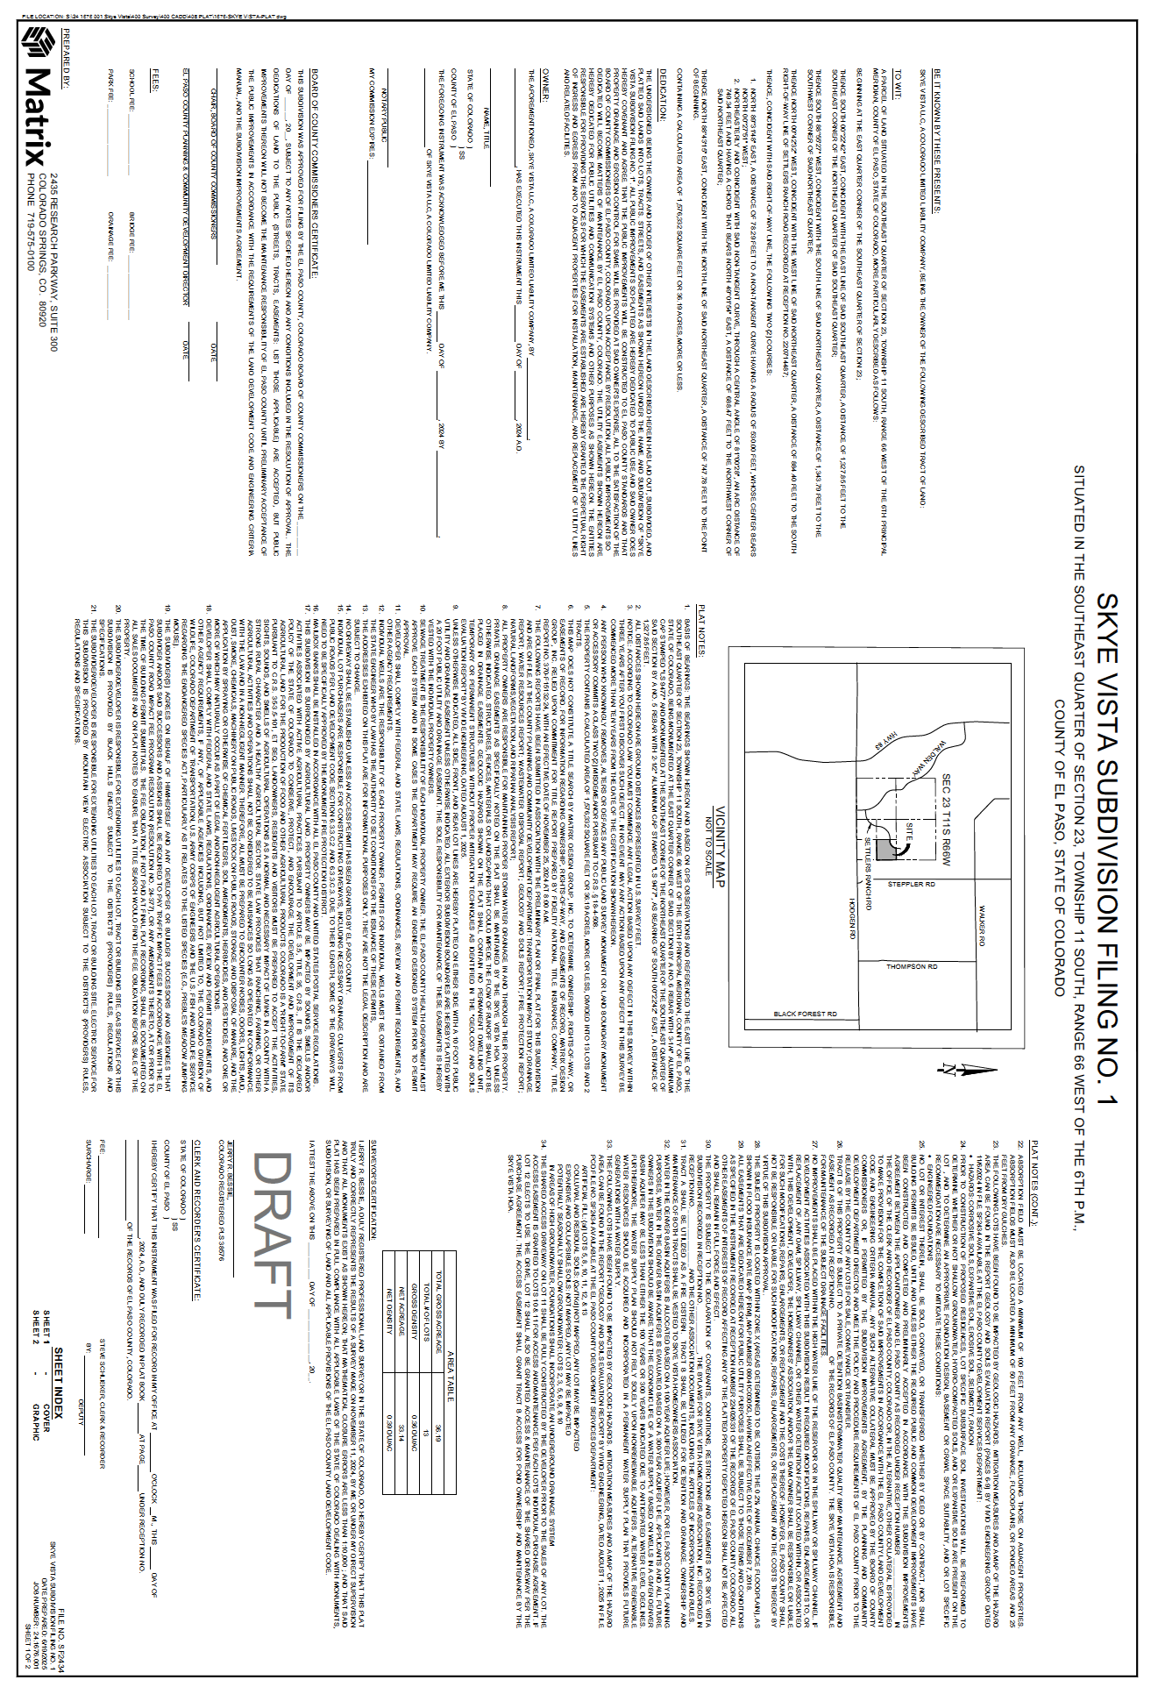
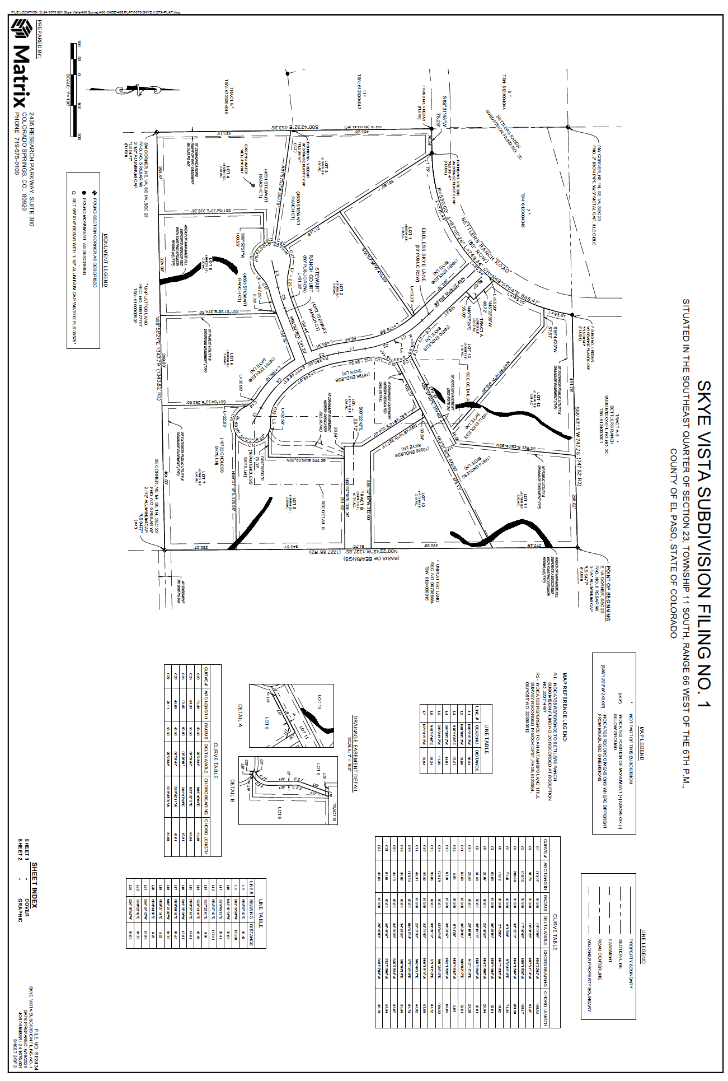

EXHIBIT “B”

Common Area

Tract B, Skye Vista Subdivision Filing No. 1,
County of El Paso, State of Colorado

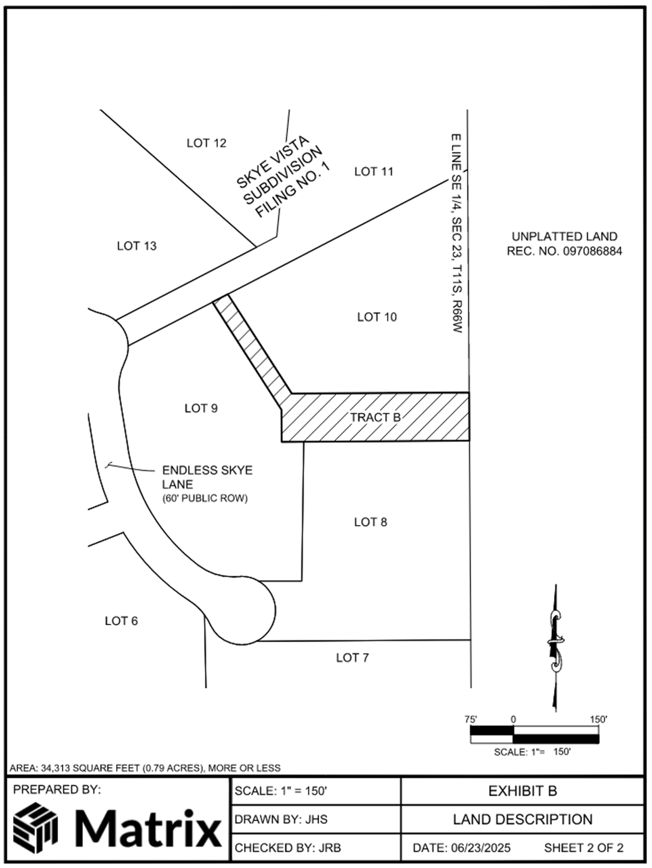

EXHIBIT “C”

Water Decree

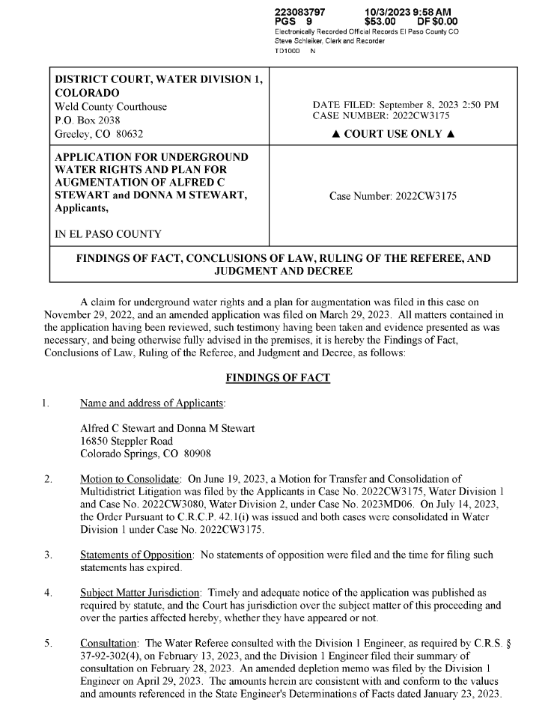
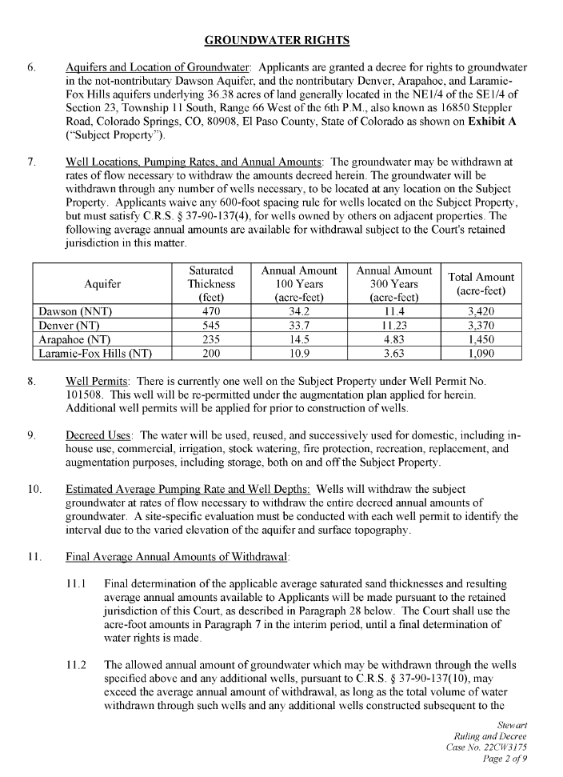
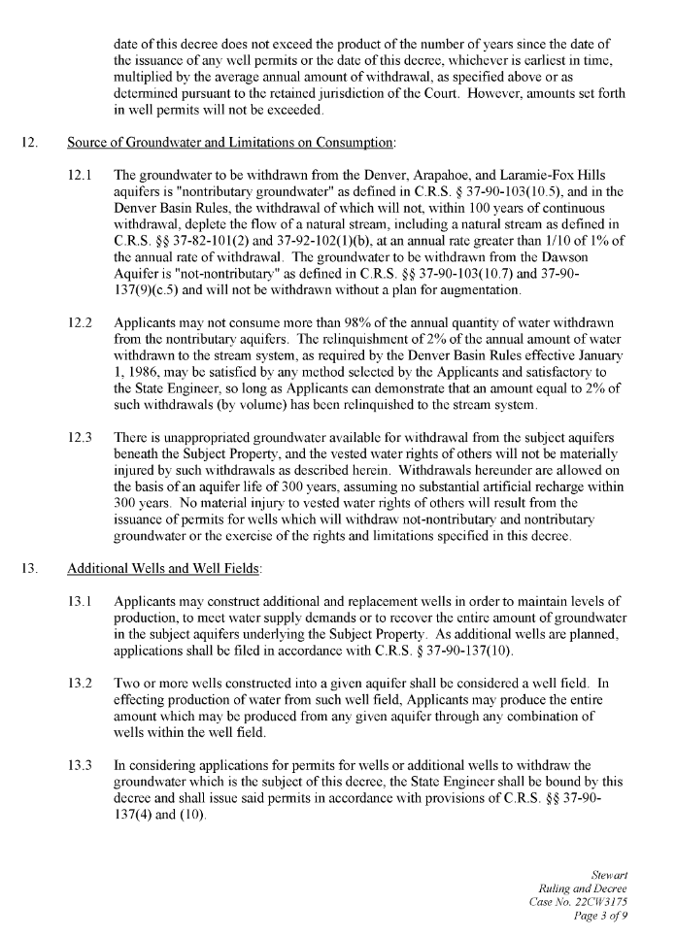
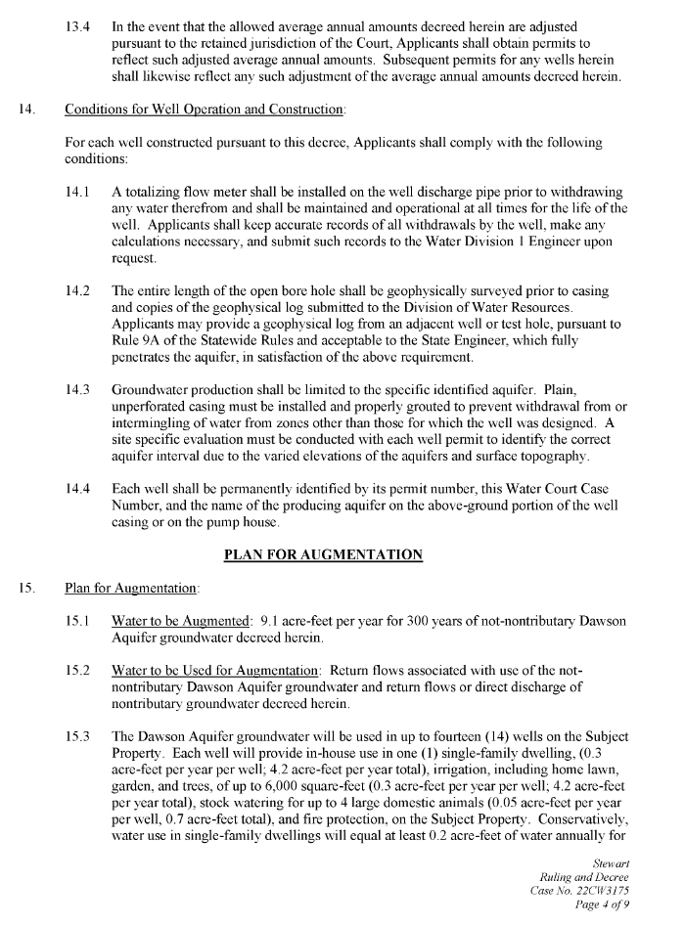
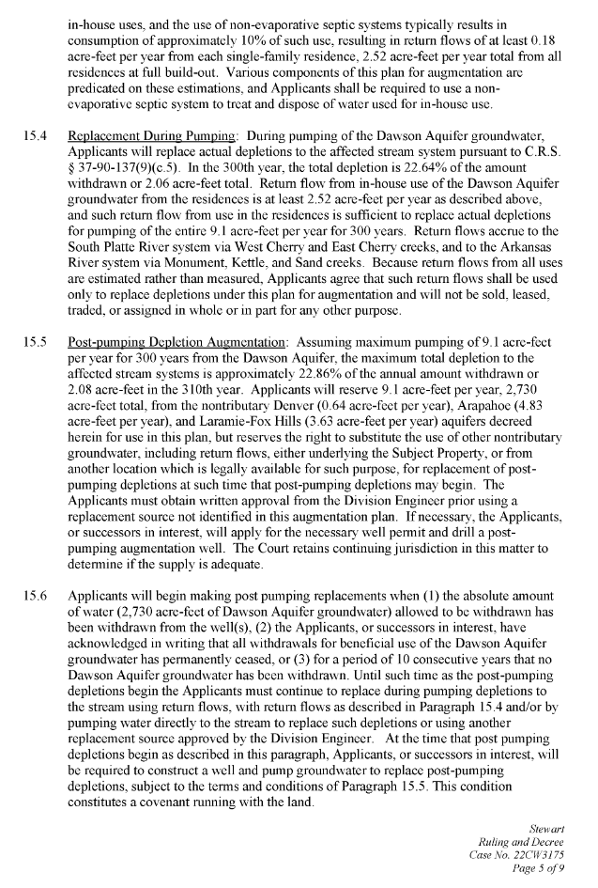
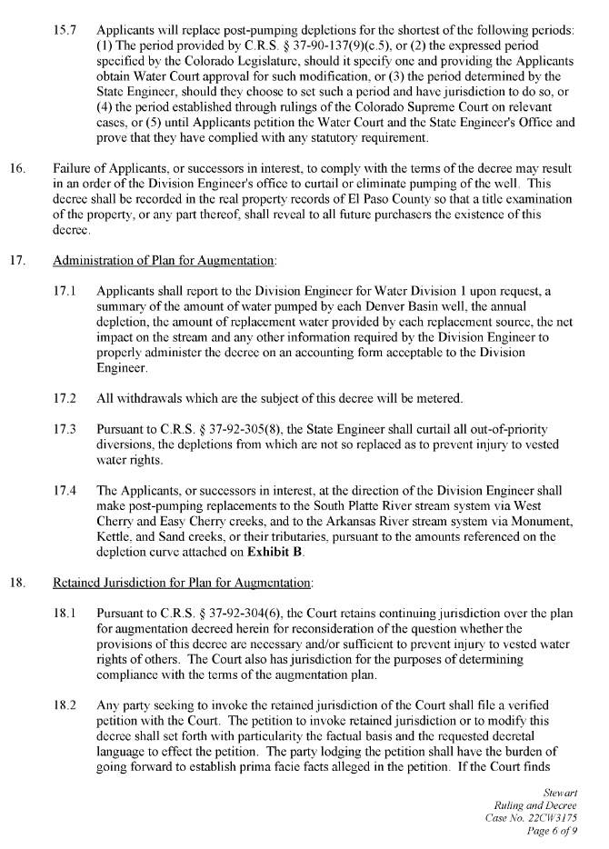
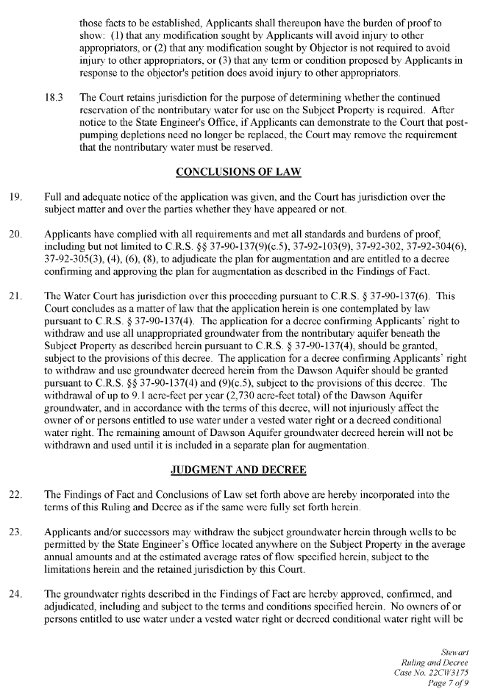
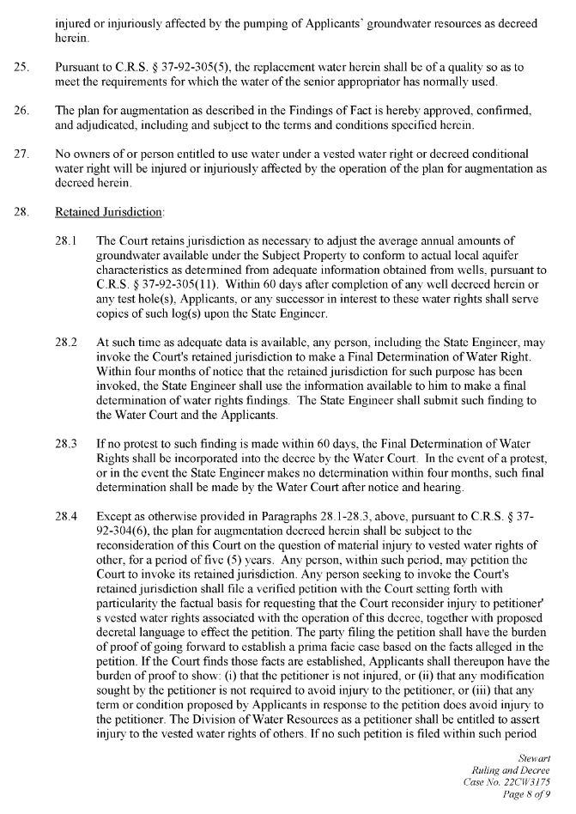
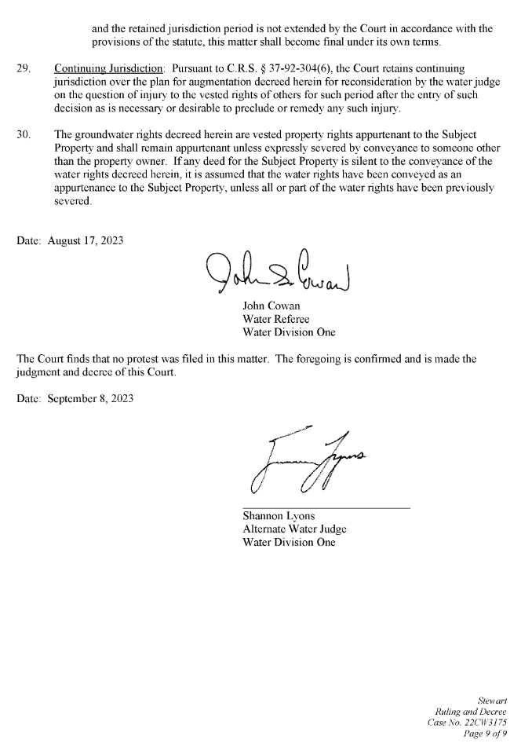
EXHIBIT “D”

Detention Basin Agreement

The Private Detention Basin/Stormwater Quality Best Management Practice Maintenance Agreement and Easement recorded on July 17, 2025 at Reception No. 225060724 of the real property records of El Paso County, Colorado (see attached copy).

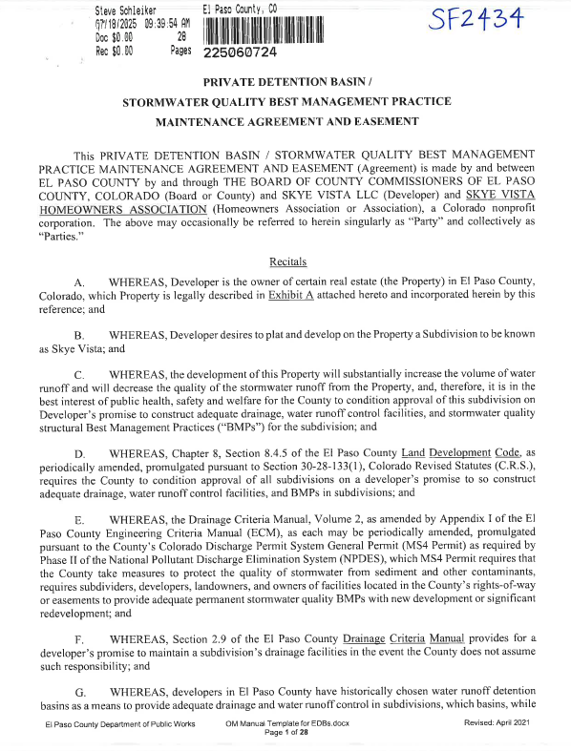
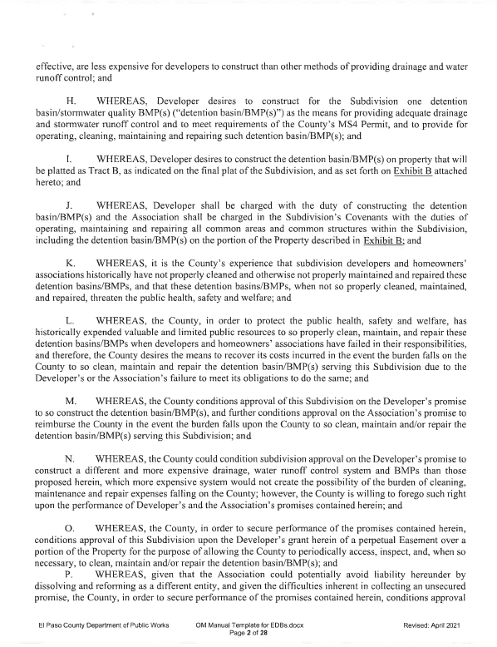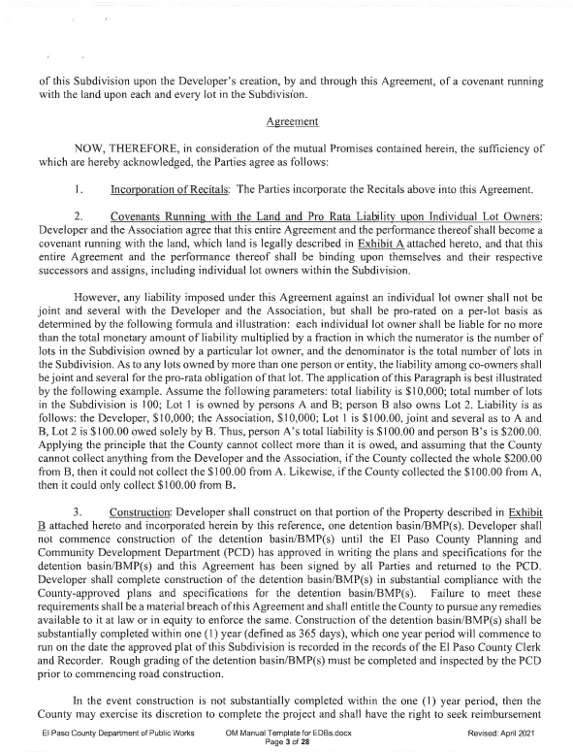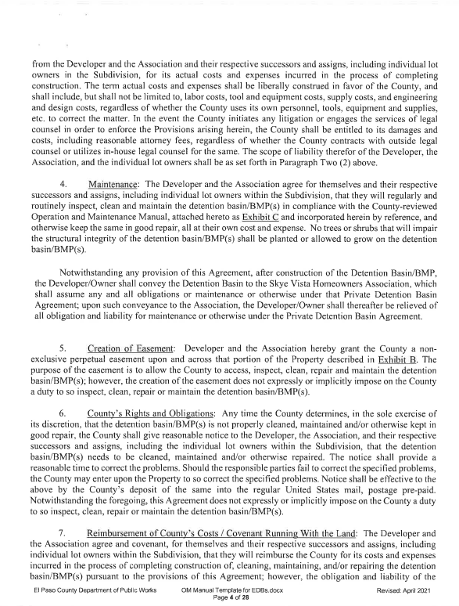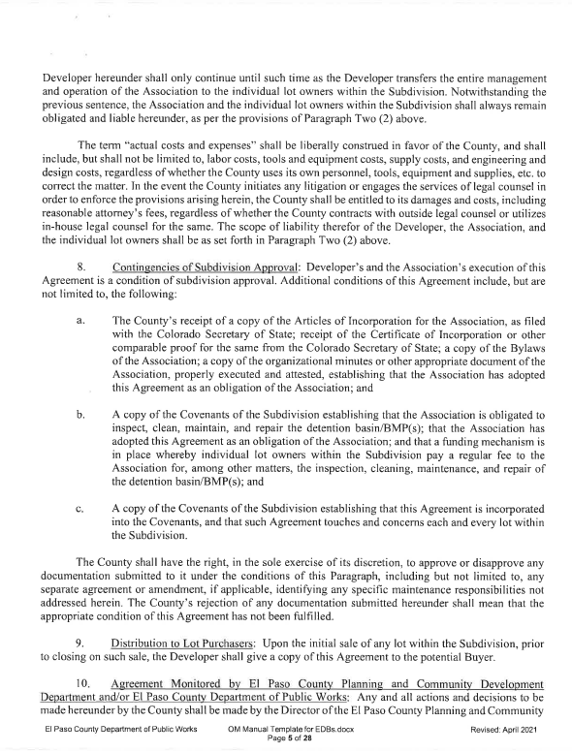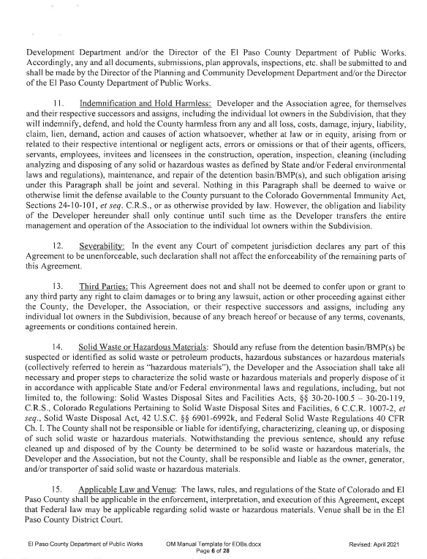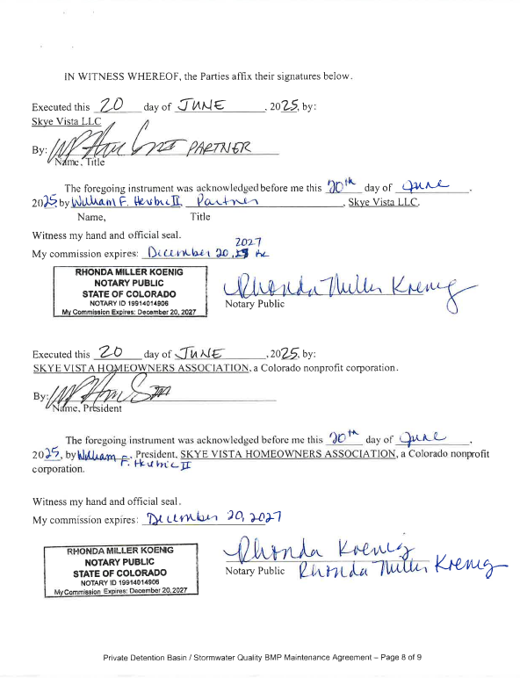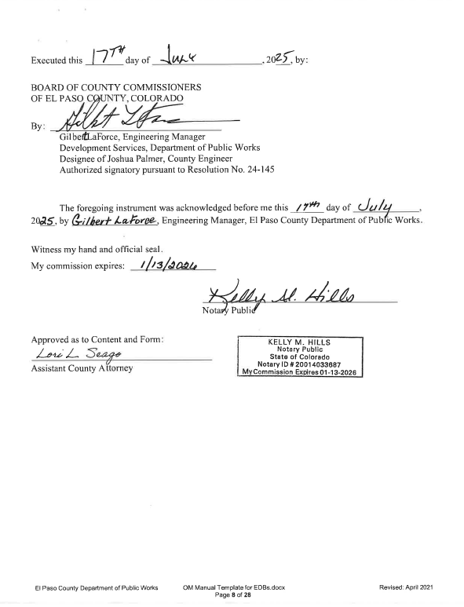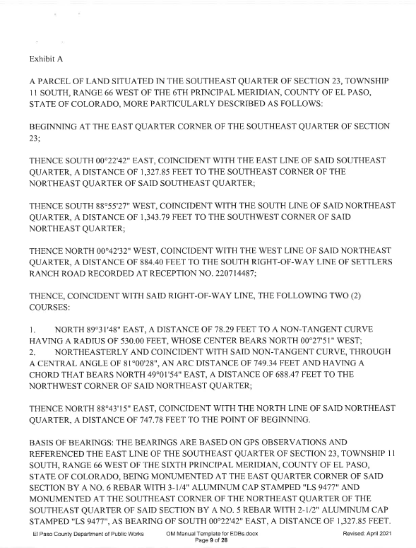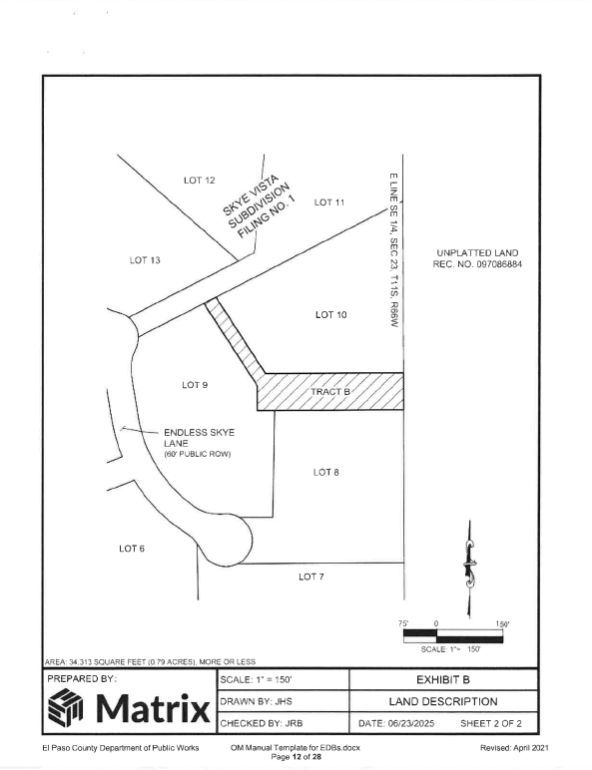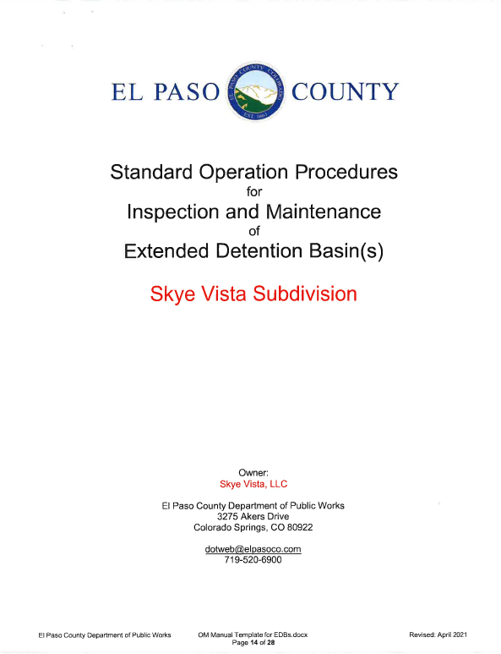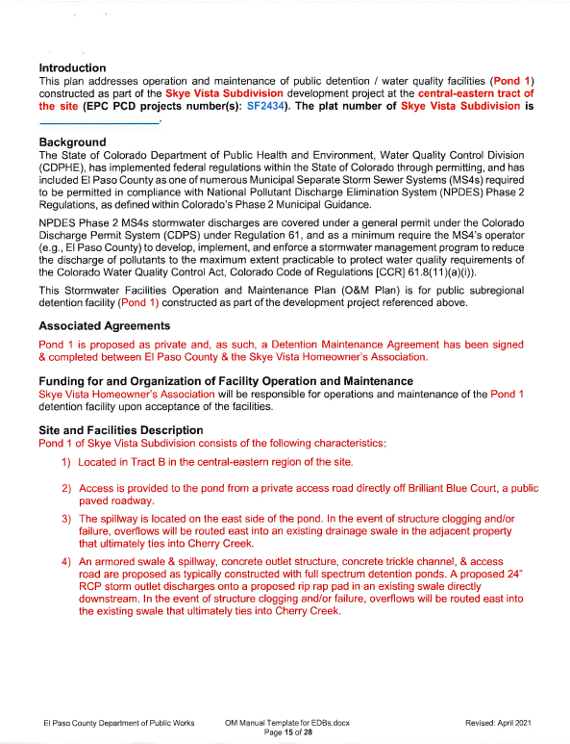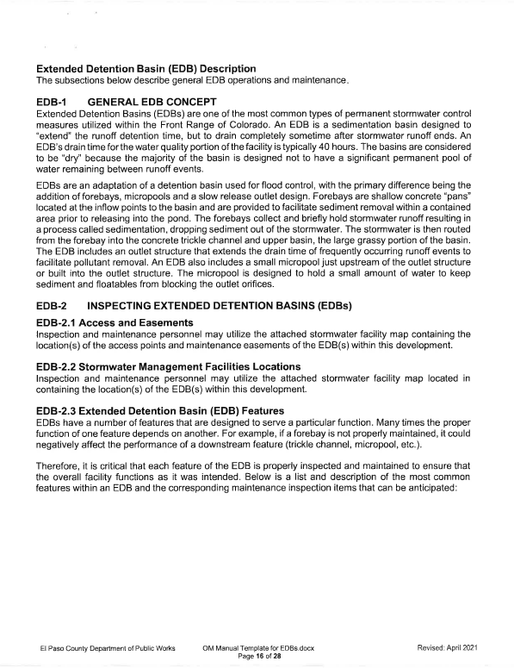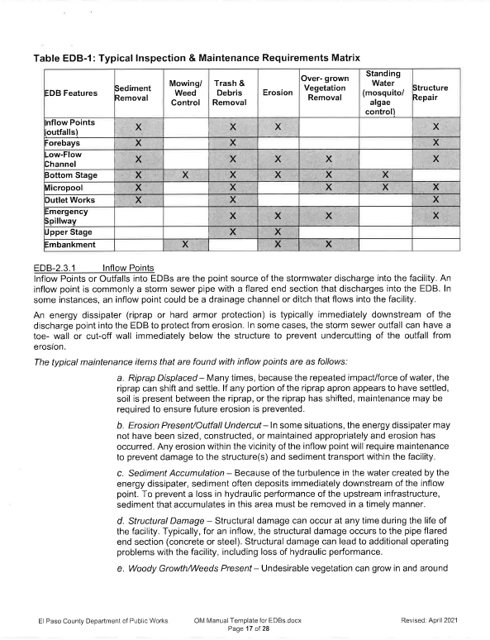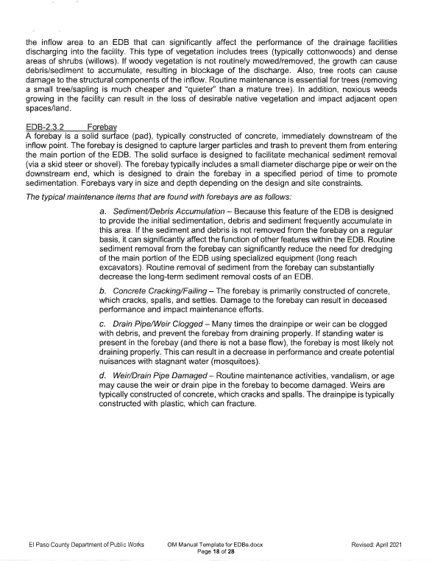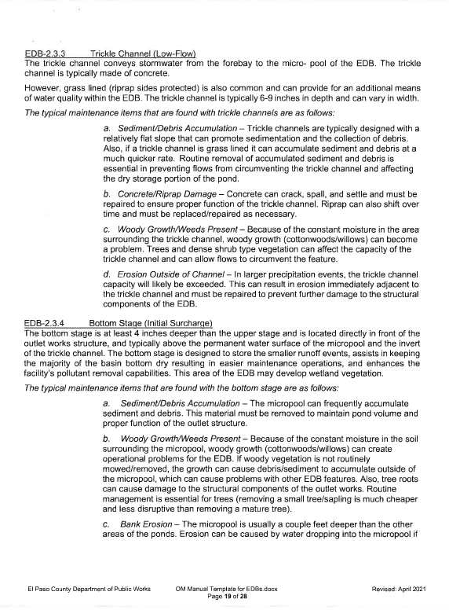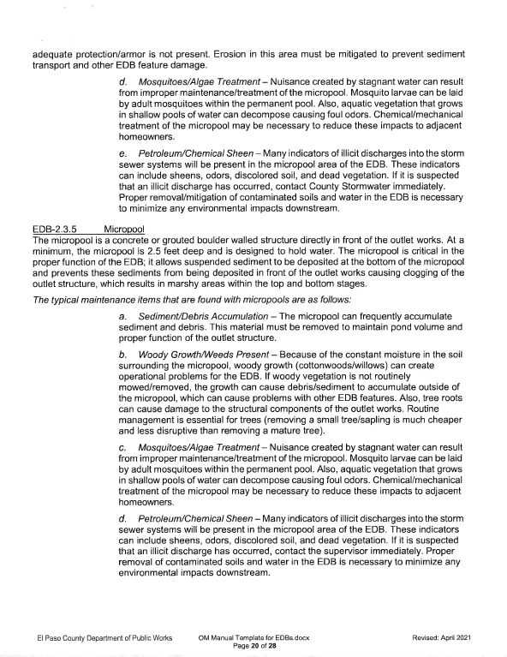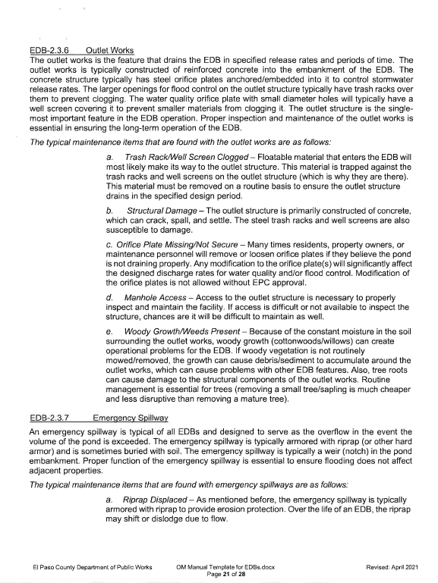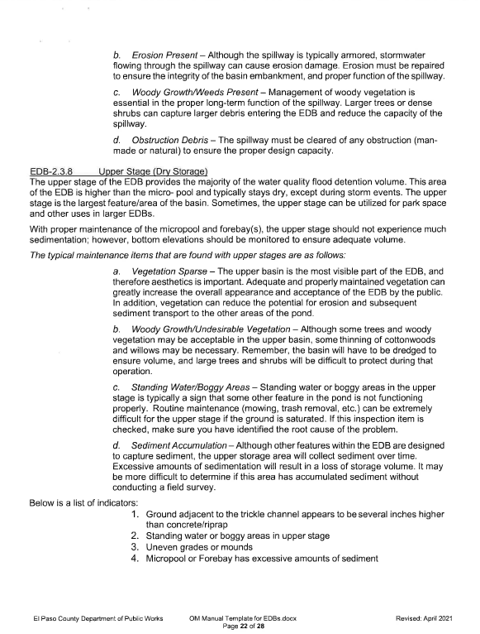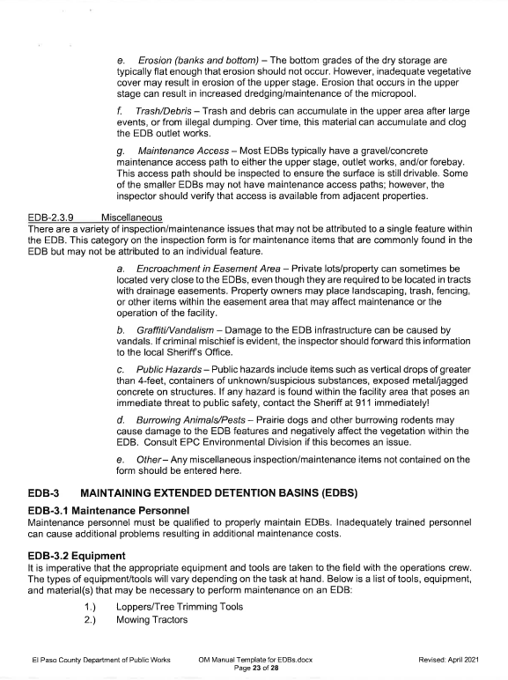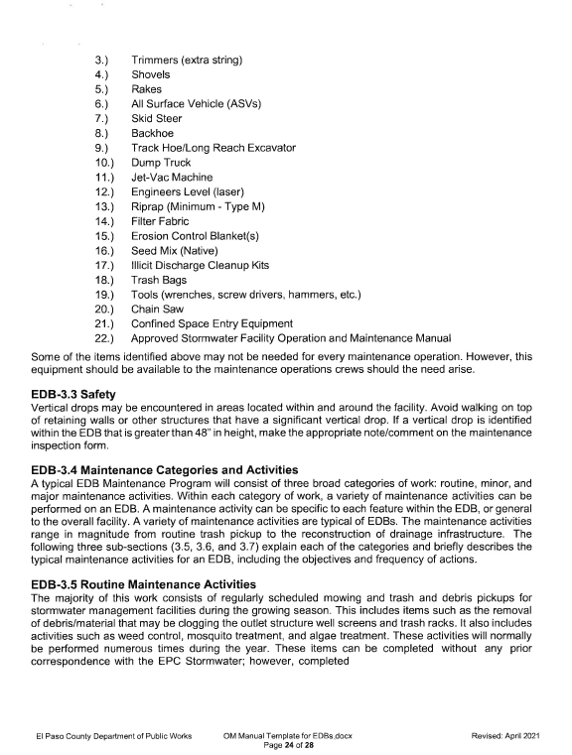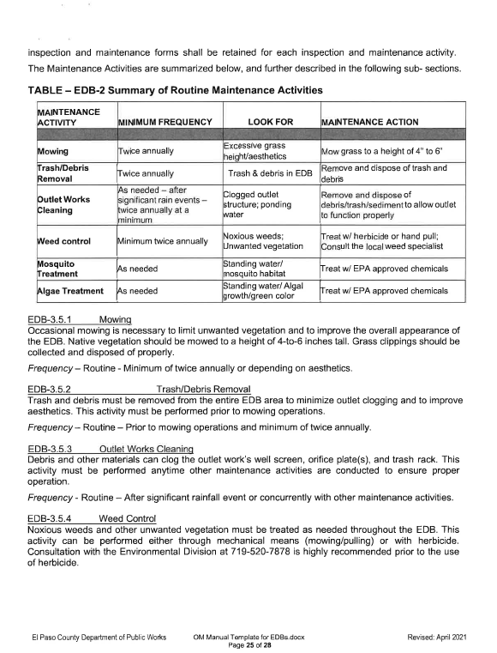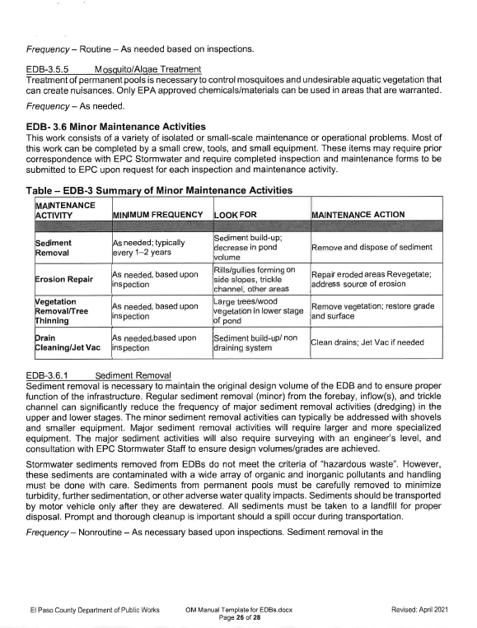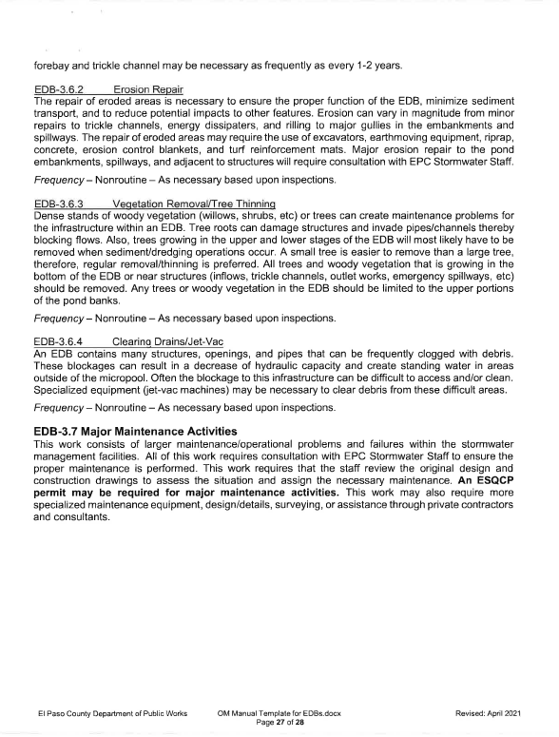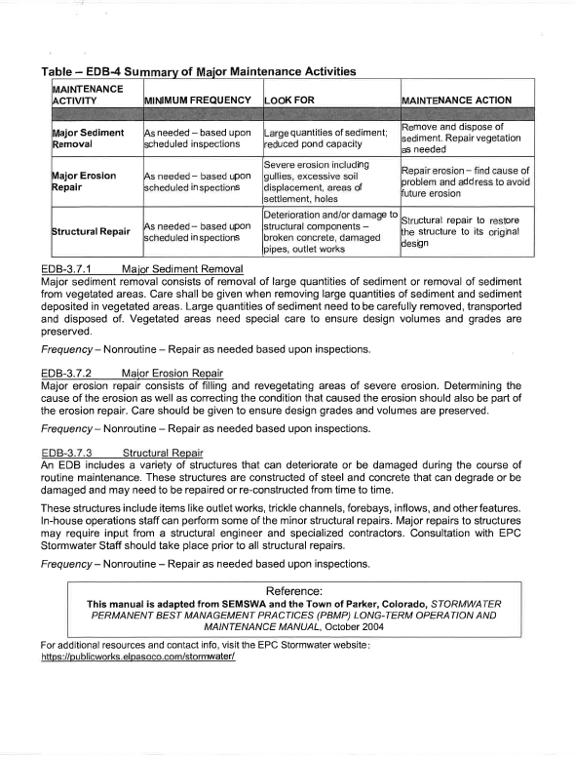
EXHIBIT “E”

Sample Water Deeds to Owners and Association

See attached.

SPECIAL WARRANTY DEED
(Water Rights)

THIS DEED, made this ____ day of ___________, 202__, between SKYE VISTA, LLC, a Colorado limited liability company (“Grantor”), whose address is _____________________________, and ______________________________ (“Grantee”), whose address is ___________________________.

WITNESS, that Grantor, for and in consideration of TEN AND NO/100 US Dollars ($10.00) and other good and valuable consideration, in hand paid, hereby sells and conveys to Grantee the following real property located in the County of El Paso, State of Colorado:

The following ground water and ground water rights (“Water Rights”) underlying the real property described as

Lot ____, ____________________ Subdivision, County of El Paso, State of Colorado (“Property”):

ANY AND ALL INTEREST IN 0.65 ACRE-FEET PER YEAR OF GROUNDWATER AND GROUNDWATER RIGHTS IN THE NOT-NONTRIBUTARY DAWSON AQUIFER DECREED IN CASE NO. 22CW3175, DISTRICT COURT, WATER DIVISION 1, RECORDED WITH THE EL PASO COUNTY, COLORADO CLERK AND RECORDER AT RECEPTION NO. 223083797 AND THE RIGHT TO USE 0.65 ACRE-FEET PER YEAR OF NOT-NONTRIBUTARY DAWSON AQUIFER GROUNDWATER PURSUANT TO THE PLAN FOR AUGMENTATION DECREED IN SAID CASE.

THESE GROUNDWATER AND GROUNDWATER RIGHTS SO CONVEYED, AND THE RETURN FLOWS THEREFROM, SHALL NOT BE SEPARATED FROM THE TRANSFER OF TITLE TO THE PROPERTY, AND SHALL NOT BE SEPARATELY CONVEYED, SOLD, TRADED, BARTERED, ASSIGNED OR ENCUMBERED IN WHOLE OR IN PART FOR ANY OTHER PURPOSE.

Grantor warrants the title to the Water Rights against all persons claiming under Grantor.

In witness whereof, Grantor has executed this deed on the date set forth above.

Skye Vista, LLC

By:______________________________
Print Name:_______________________
Title:_____________________________

STATE OF COLORADO )
) ss.
COUNTY OF EL PASO )

The foregoing instrument was acknowledged before me this ______day of __________, 202___, by _____________________, as __________________ of Skye Vista, LLC, a Colorado limited liability company.

Witness my hand and official seal.

My Commission Expires: .
[SEAL]
____________________________________
Notary Public

SPECIAL WARRANTY DEED
(Water Rights)

THIS DEED, made this ____ day of ___________, 202__, between SKYE VISTA, LLC, a Colorado limited liability company (“Grantor”), whose address is _____________________________, and ______[HOA]________________________ (“Grantee”), whose address is ___________________________.

WITNESS, that Grantor, for and in consideration of TEN AND NO/100 US Dollars ($10.00) and other good and valuable consideration, in hand paid, hereby sells and conveys to Grantee the following real property located in the County of El Paso, State of Colorado:

The following groundwater and groundwater rights (“Water Rights”) underlying the real property described as follows:

Lots 1-13 and Tracts A and B, Skye Vista Subdivision Filing No. 1, County of El Paso, State of Colorado (“Property”):

ANY AND ALL INTEREST IN GROUNDWATER AND GROUNDWATER RIGHTS IN THE NONTRIBUTARY DENVER, ARAPAHOE, AND LARAMIE-FOX HILLS AQUIFERS AS DECREED IN CASE NO. 22CW3175, DISTRICT COURT, WATER DIVISION 1, RECORDED WITH THE EL PASO COUNTY, COLORADO CLERK AND RECORDER AT RECEPTION NO. 223083797 AND THE RELATED INTEREST IN THE PLAN FOR AUGMENTATION DECREED IN SAID CASE.

192 ACRE-FEET OF WATER FROM THE DENVER AQUIFER, 1,449 ACRE-FEET OF WATER FROM THE ARAPAHOE AQUIFER, AND 1,089 ACRE-FEET OF WATER FROM THE LARAMIE-FOX HILLS AQUIFER ARE SPECIFICALLY RESERVED TO MEET POST-PUMPING REPLACEMENT OBLIGATIONS PURSUANT TO THE ABOVE REFERENCED PLAN FOR AUGMENTATION AND, THEREFORE, THESE AMOUNTS SHALL NOT BE SEPARATED FROM THE PROPERTY, AND SHALL NOT BE SEPARATELY CONVEYED, SOLD, TRADED, BARTERED, ASSIGNED OR ENCUMBERED IN WHOLE OR IN PART FOR ANY OTHER PURPOSE.

Grantor warrants the title to the Water Rights against all persons claiming under Grantor.

In witness whereof, Grantor has executed this deed on the date set forth above.

Skye Vista, LLC

By:______________________________
Print Name:_______________________
Title:_____________________________

STATE OF COLORADO )
) ss.
COUNTY OF EL PASO )

The foregoing instrument was acknowledged before me this ______day of __________, 202___, by _____________________, as __________________ of Skye Vista, LLC, a Colorado limited liability company.

Witness my hand and official seal.

My Commission Expires:
[SEAL]
____________________________________
Notary Public
Legal Description of Property

A PARCEL OF LAND SITUATED IN THE SOUTHEAST QUARTER OF SECTION 23, TOWNSHIP 11 SOUTH, RANGE 66 WEST OF THE 6TH PRINCIPAL MERIDIAN, COUNTY OF EL PASO, STATE OF COLORADO, MORE PARTICULARLY DESCRIBED AS FOLLOWS:

BEGINNING AT THE EAST QUARTER CORNER OF THE SOUTHEAST QUARTER OF SECTION 23;

THENCE SOUTH 00°22'42" EAST, COINCIDENT WITH THE EAST LINE OF SAID SOUTHEAST QUARTER, A DISTANCE OF 1,327.85 FEET TO THE SOUTHEAST CORNER OF THE NORTHEAST QUARTER OF SAID SOUTHEAST QUARTER;

THENCE SOUTH 88°55'27" WEST, COINCIDENT WITH THE SOUTH LINE OF SAID NORTHEAST QUARTER, A DISTANCE OF 1,343.79 FEET TO THE SOUTHWEST CORNER OF SAID NORTHEAST QUARTER;

THENCE NORTH 00°42'32" WEST, COINCIDENT WITH THE WEST LINE OF SAID NORTHEAST QUARTER, A DISTANCE OF 884.40 FEET TO THE SOUTH RIGHT-OF-WAY LINE OF SETTLERS RANCH ROAD RECORDED AT RECEPTION NO. 220714487;

THENCE, COINCIDENT WITH SAID RIGHT-OF-WAY LINE, THE FOLLOWING TWO (2) COURSES:

- NORTH 89°31'48" EAST, A DISTANCE OF 78.29 FEET TO A NON-TANGENT CURVE HAVING A RADIUS OF 530.00 FEET, WHOSE CENTER BEARS NORTH 00°27'51" WEST;
- NORTHEASTERLY AND COINCIDENT WITH SAID NON-TANGENT CURVE, THROUGH A CENTRAL ANGLE OF 81°00'28", AN ARC DISTANCE OF 749.34 FEET AND HAVING A CHORD THAT BEARS NORTH 49°01'54" EAST, A DISTANCE OF 688.47 FEET TO THE NORTHWEST CORNER OF SAID NORTHEAST QUARTER;

THENCE NORTH 88°43'15" EAST, COINCIDENT WITH THE NORTH LINE OF SAID NORTHEAST QUARTER, A DISTANCE OF 747.78 FEET TO THE POINT OF BEGINNING.

BASIS OF BEARINGS: THE BEARINGS are BASED ON GPS OBSERVATIONS AND REFERENCED THE EAST LINE OF THE SOUTHEAST QUARTER OF SECTION 23, TOWNSHIP 11 SOUTH, RANGE 66 WEST OF THE SIXTH PRINCIPAL MERIDIAN, COUNTY OF EL PASO, STATE OF COLORADO, BEING MONUMENTED AT THE EAST QUARTER CORNER OF SAID SECTION BY A NO. 6 REBAR WITH 3-1/4" ALUMINUM CAP STAMPED "LS 9477" AND MONUMENTED AT THE SOUTHEAST CORNER OF THE NORTHEAST QUARTER OF THE SOUTHEAST QUARTER OF SAID SECTION BY A NO. 5 REBAR WITH 2-1/2" ALUMINUM CAP STAMPED "LS 9477", AS BEARING OF SOUTH 00°22'42" EAST, A DISTANCE OF 1,327.85 FEET.

JERRY R. BESSIE, PLS 38576
PREPARED FOR AND ON BEHALF OF MATRIX DESIGN GROUP
707 n 17th street, SUITE 3150
denver, CO. 80202

