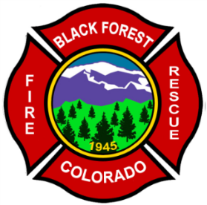
Black Forest Fire Rescue Protection District
11445 Teachout Road
Colorado Springs, Colorado 80908
Ph-719.495.4300
Fax 719.495.7504
Web- www.bffire.org

Office of the Fire Marshal

“Always Ready, Always Forward, Always Learning.”

FIRE COMMITMENT LETTER
Monday, November 16, 2020
Mr. Douglas H. Barber
The Black Forest Fire Rescue Protection District currently provides fire protection services to Bridle Bit Ranch Sub-Division, as they are in our primary response area. We will continue to provide fire protection services to the Bridle Bit Ranch Sub, Lot 10 (no. 62100-01-001 and the two adjoining lots No. 62000-00-461.
Black Forest is currently an ISO 5 in areas serviced by a hauled water system. Black Forest Fire Rescue provides structural and wildland fire suppression services from each station within the district.
The primary station servicing this subdivision is Black Forest station 1, located at 11445 Teachout Road, Colorado Springs, Co 80908 which is approximately 5.6 miles from the subdivision.
Any Questions may be directed to the Fire Chief or Deputy Fire Chief at 719-495-4300 or deputychief@bffire.org.

Sincerely,

James Rebitski,
Deputy Fire Chief
Black Forest Fire Rescue

