Early Assistance (EA) Meeting Number: EA24134 (EDARP Link)
Project Name: Ascent Church Addition and Renovation
Project Location: 1750 Deer Creek Rd. Monument, CO 80132
Project Parcel No.: 7111301010 (Assessor’s Link)
Project Description: Phased improvements to existing structures, grading, parking lot, and signage. Additions include an attached elevated deck, revised site access, a new 14,000 sf detached auditorium, and lighting.
EA Meeting Date: 1/30/2025 at 1:00 P.M.
Planning and Community Development: Miranda Benson (mirandabenson2@elpasoco.com)

El Paso County Planning & Community Development Planning Checklist

Request --
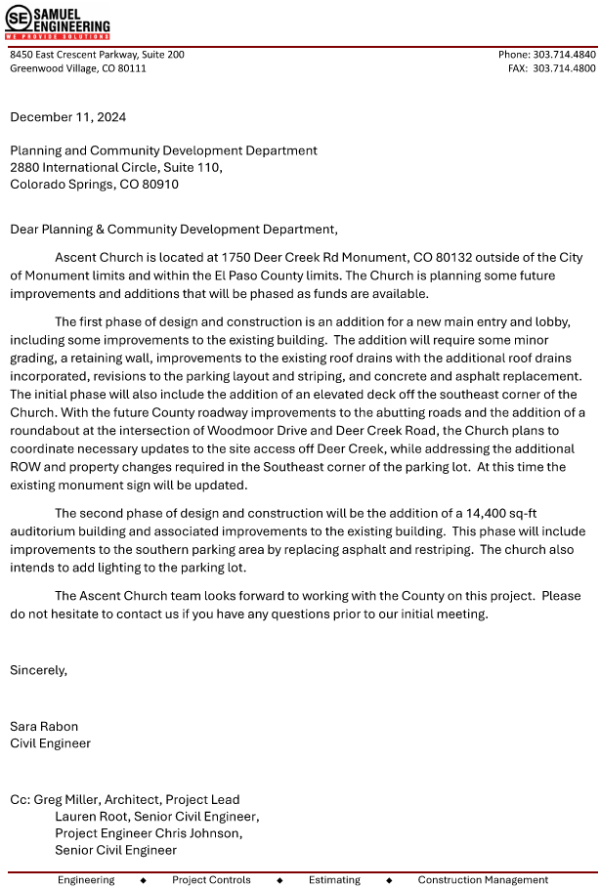
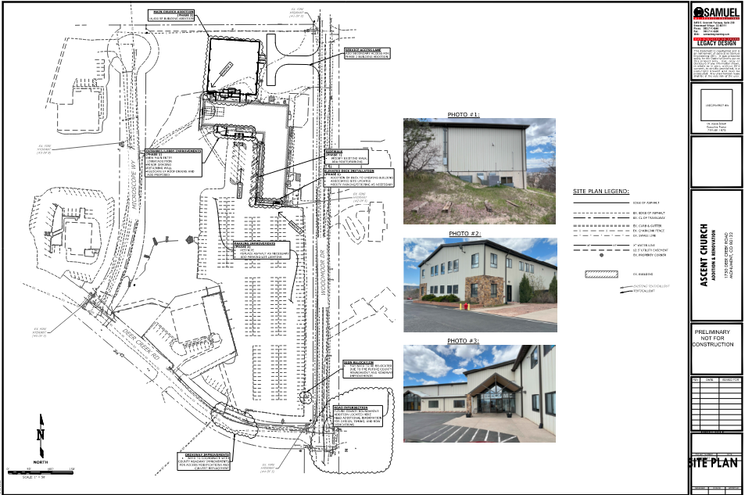

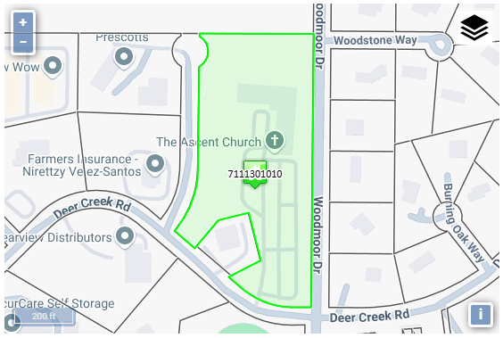https://property.spatialest.com/co/elpaso/#/property/7111301010

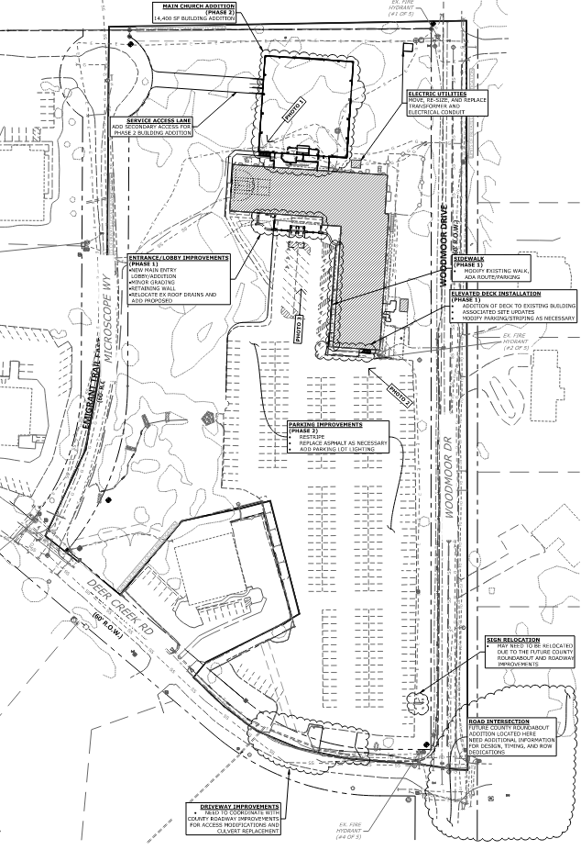
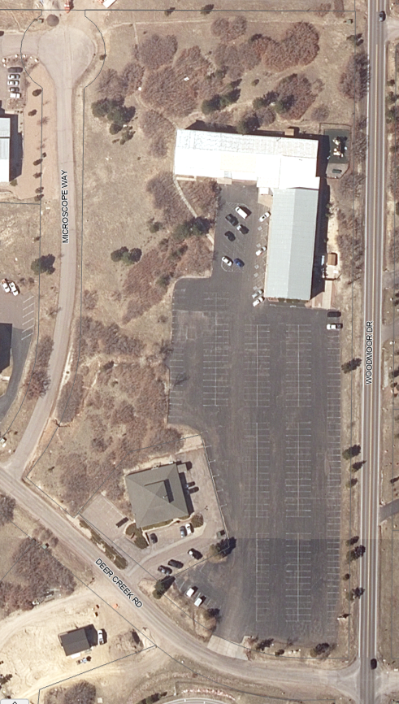
55’ Setback

Existing Zoning
District |  | Name
A-5 |  | Agricultural

Zoning Analysis
A-5, Agricultural District. The A-5 zoning district is a 5-acre district primarily intended to conserve agricultural resources and ranching operations and accommodate limited residential use.

Religious Institution — An establishment primarily for the conduct of religious activities, limited to sanctuary, educational classrooms, daycare, committee and office work, a single parsonage/rectory, or religious camp.
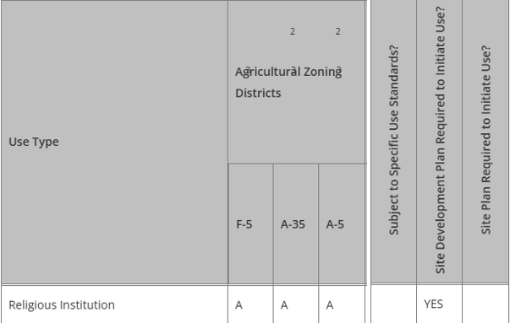
(LDC Table 5-1, Principal Uses Link)

Summary: A religious institution is an allowed use in the A-5, Agricultural, zoning district and requires a Site Development Plan (PPR- file) to initiate (or increase) the use.

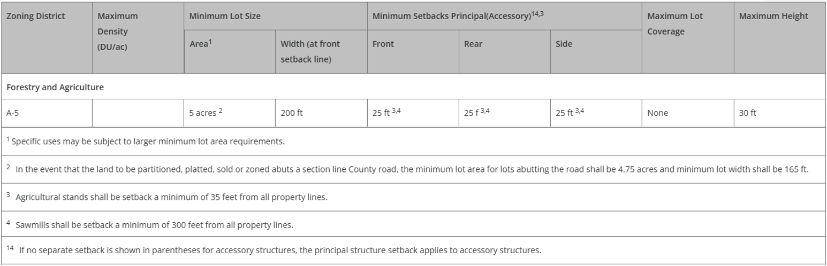
Zoning District Requirements (density, lot size, lot design standards, building setbacks)
(LDC Table 5-4, Density and Dimensional Standards Link)
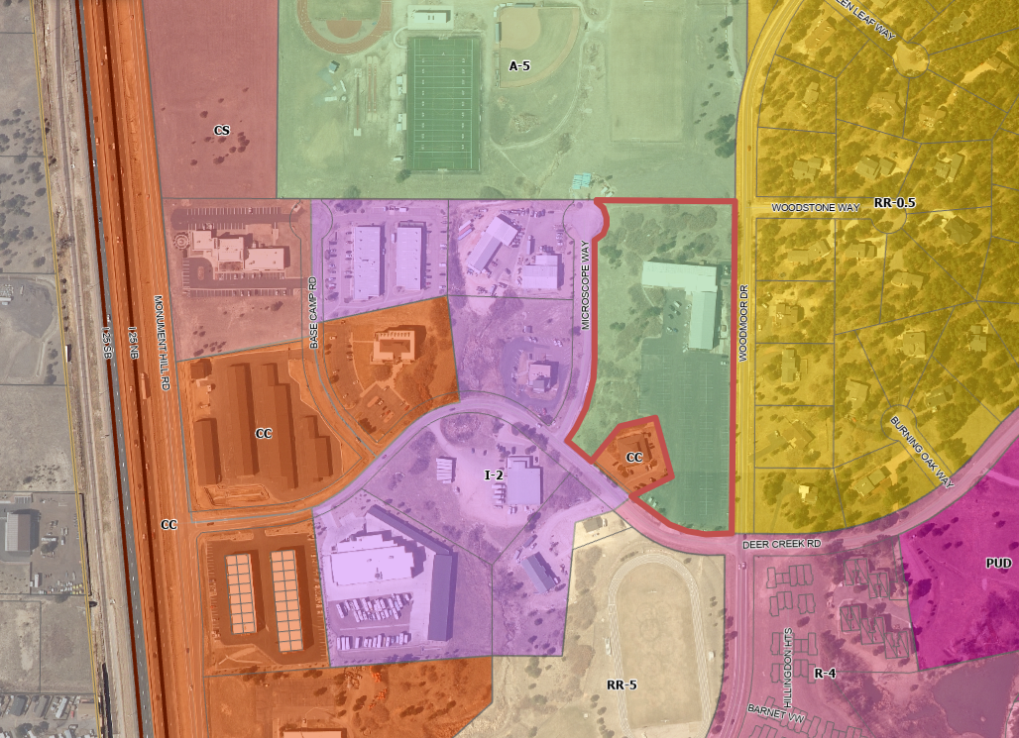
Zoning Map –
15’ LS buffer to Residential
Map of Platted Lot/ Tract (check plat notes & conditions of approval):

Plat No. 9102 -- VR94002 Tri-Lakes Subdivision
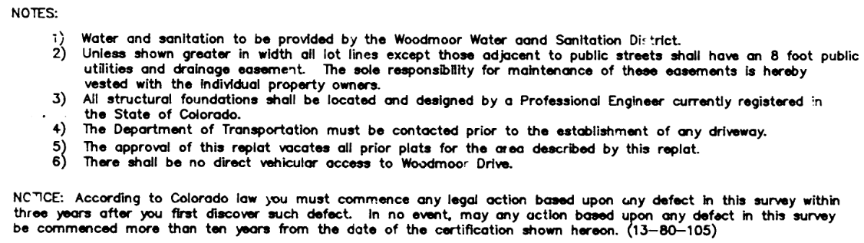
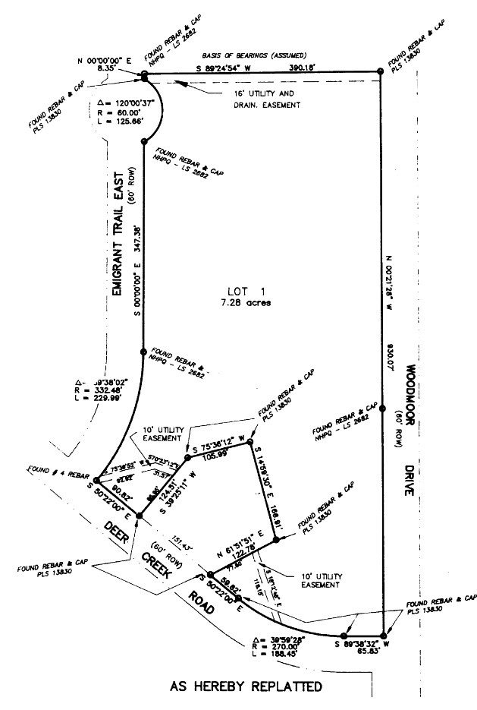
(EDARP File No. VR94022 Link)

Application Type(s) Hearing: Required/ Optional/ NO
Site Development Plan (PPR-)
*note – already initiated in EDARP

Processing Issues and Options
No major issues were identified for Land Development Code requirements (Planning Department).
Woodmoor Drive roadway improvements (?)

Relevant Past History:
The property was rezoned to A-1 in 1991 per BOCC Resolution 91-279 Land Use 57.
(EDARP File No. P91009 Link)
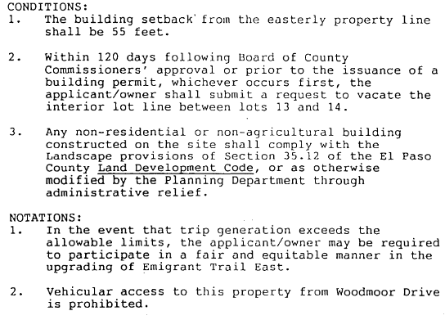

The zoning district A-1 became the current zoning district A-5.

Lot lines were vacated and the pentagon lot was carved out in 1995 per BOCC Resolution 94-450 Land Use 191. Plat image is included on previous page.
(EDARP File No. VR94022 Link)
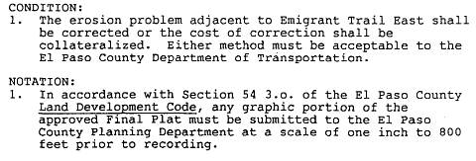

Previously approved Site Plan (11/1996) found in EDARP File No. P91009. (EDARP File No. P91009 Link) Titled “PLOT SITE PLAN” and listed first in Documents.
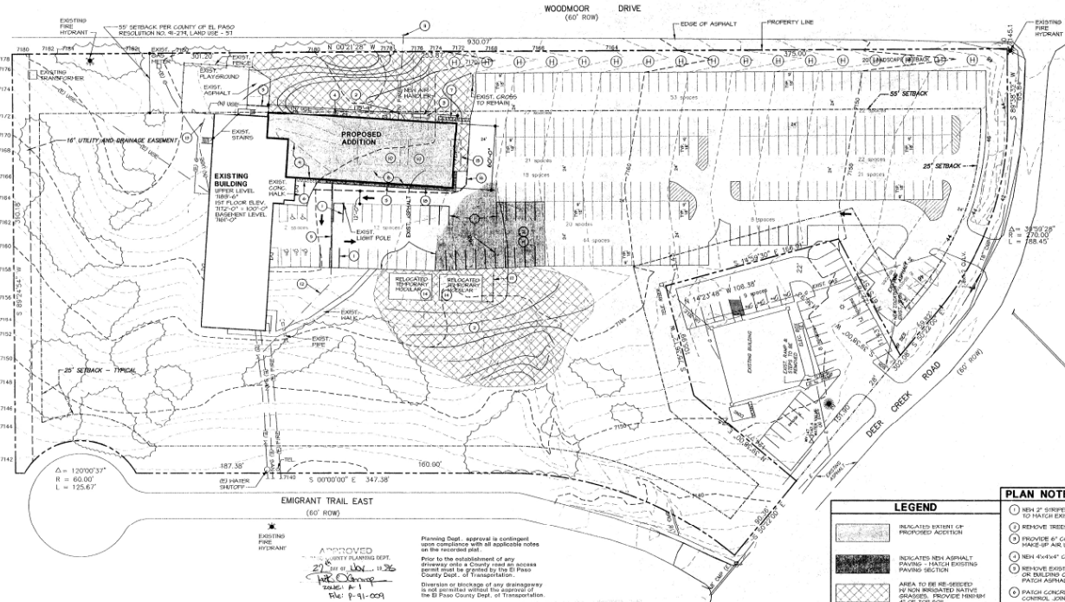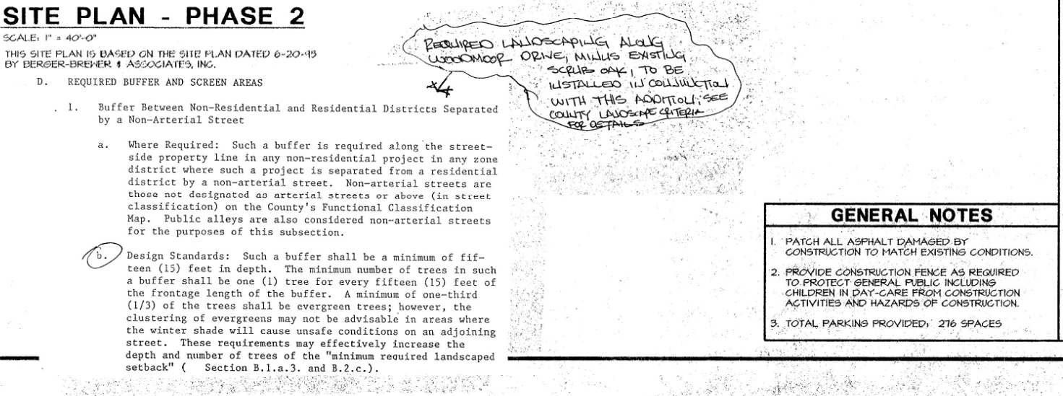
Design and Landscaping

Site Design/Layout (Lot pattern, circulation/road design, open space, preservation of natural features, compatibility internally and with adjacent land uses)

(Chapter 6 Link)
6.1.3. Americans with Disabilities Act (ADA) Site Accessibility
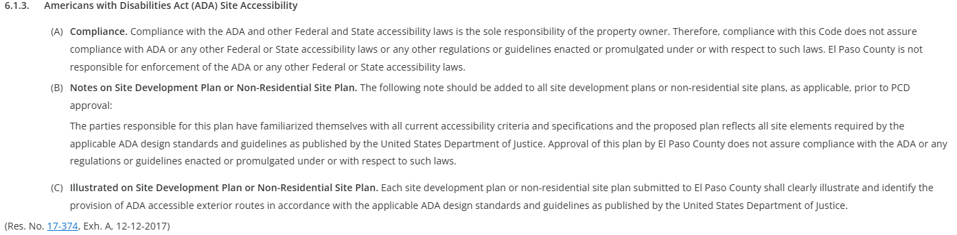

Landscaping
☐ | Expressway, Principal arterial - area depth 25’ - Trees required: 1 per 20’
☐ | Urban interchange/Intersection - area depth 25’- Trees required: 1 per 20’
☐ | Minor arterial - area depth 20’ - Trees required: 1 per 25’
☒ | Non-arterial - area depth 10’ 15’ - Trees required: 1 per 30’ 15’ (Table 6-1 and footnote)  On 3 sides - Deer Creek, Woodmoor Drive, Emigrant Trail
☒ | Parking lot landscaping required
☒ | Buffer between non-residential and residential districts separated by a non-arterial road or public alley
☒ | Zone Boundary Buffer  15’ residential adjacent zones (this overlaps with roadway LS)  10 shrubs per 1 tree substitute is ok / clustering is ok / utilizing existing vegetation towards count is ok – identify in your Site Dev Plan

(Table 6-1)

(Chapter 6 Link)
6.2.2. Landscape Requirements
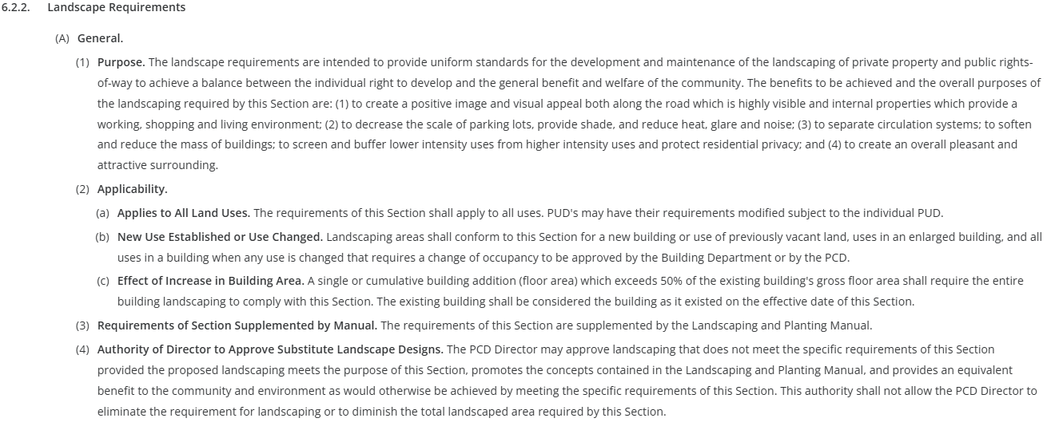
(B) Roadway Landscaping Requirements
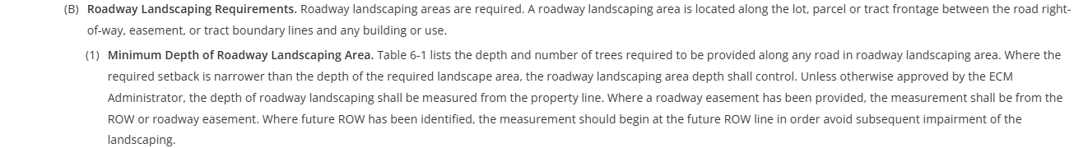
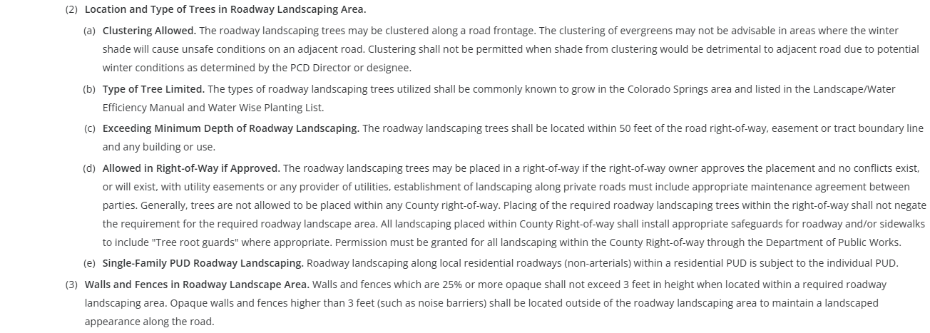
(C) Parking Lot Landscape Requirements
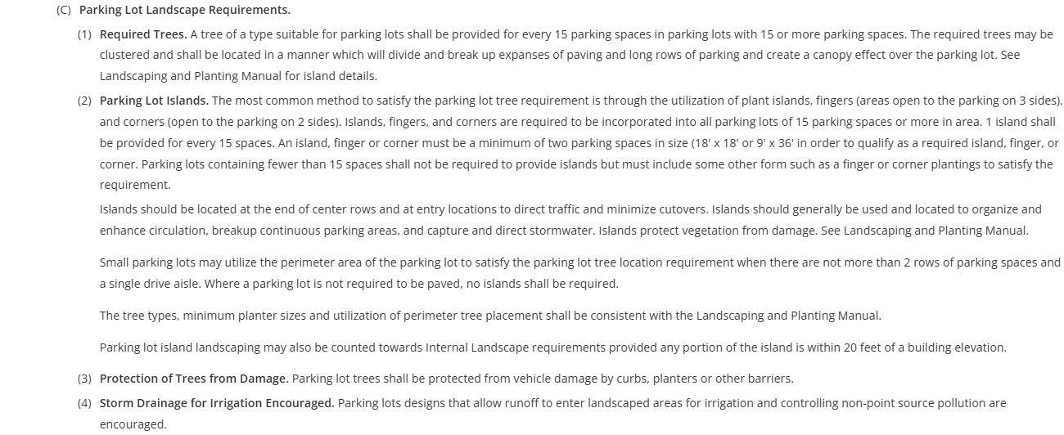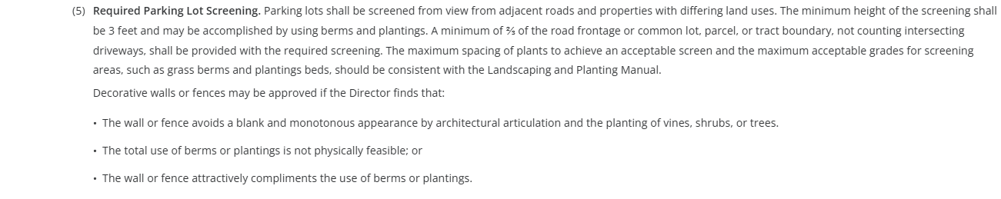
(D) Required Buffer and Screen Areas
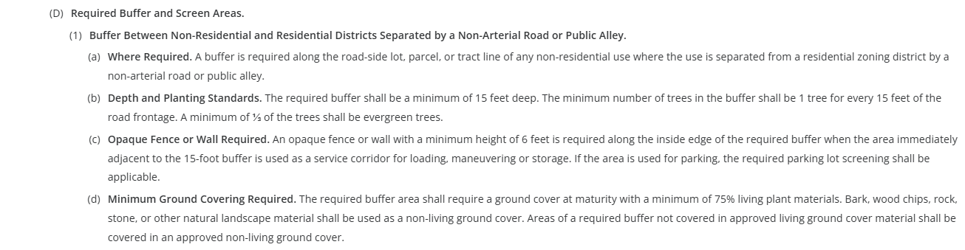
(E) Internal Landscaping **
(2) Requirements for Non-Residential Uses
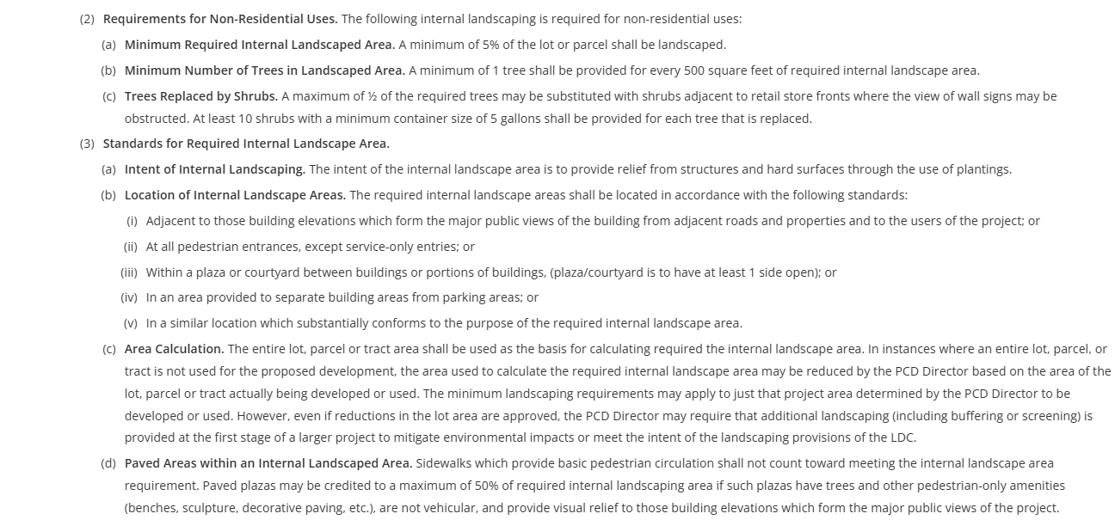
(3) Standards for Required Internal Landscape Area
(F) Minimum Plant Sizes and Percentage of Live Ground Cover
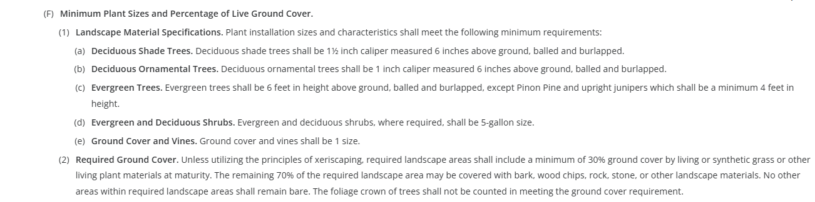
(G) Other Required Landscape Areas
Appendix D (Link) – Landscaping and Planting Manual

Signage:
(Chapter 6 Link)
6.2.10 Signs, On-Premise
PERMITS REQUIRED (separate sign application, SC-, required after Site Dev Plan)

Parking Requirements:
(Chapter 6 Link) (Table 6-2)
6.2.5 Parking, Loading, and Maneuvering Standards**
(A) General.
(B) General Parking Standards.
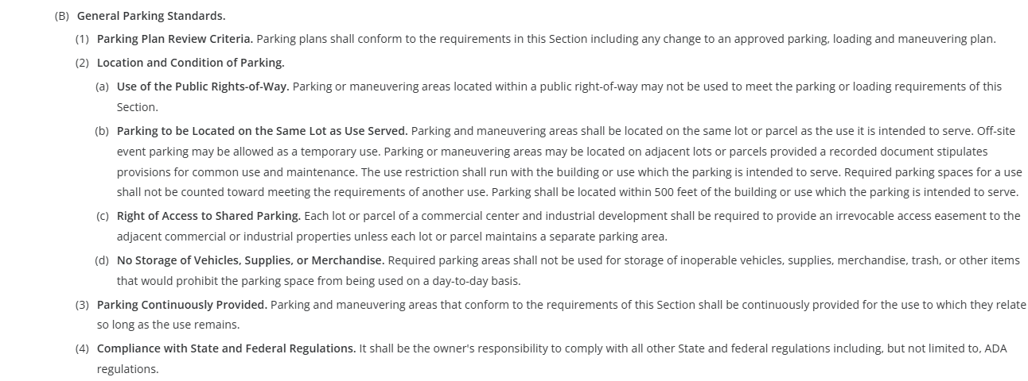
(C) Parking Design Standards.
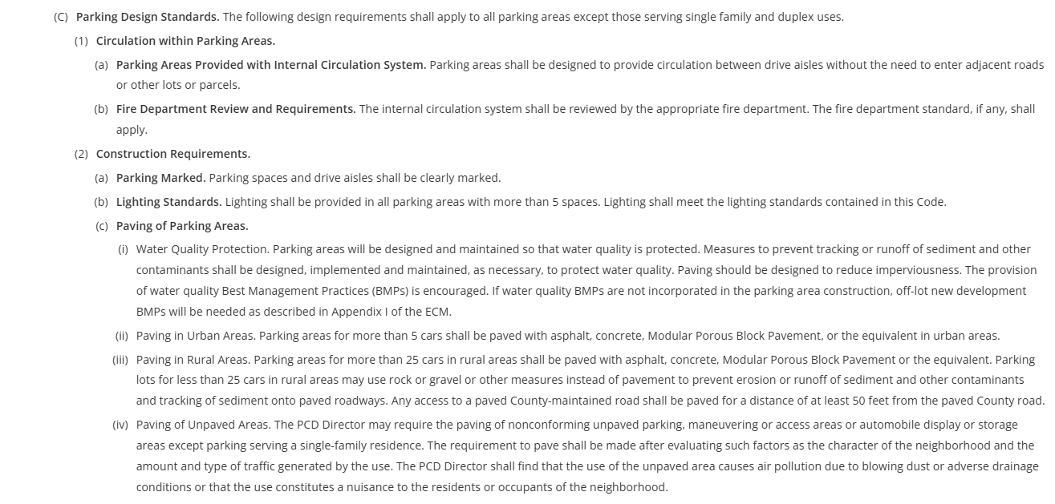
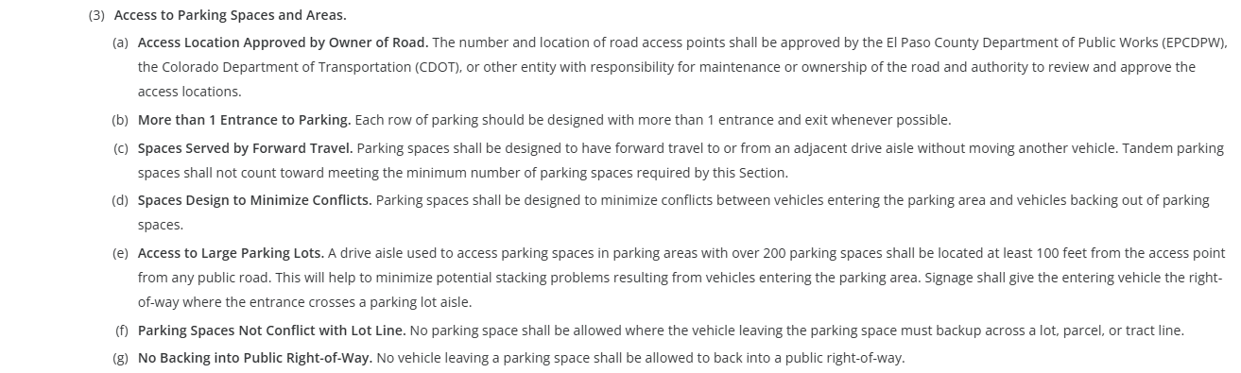
(D) Parking Space Requirements – Table 6-2, Above
Refer to Table 6-3 for Disabled Parking Space Requirements**
Refer to Table 6-4 for Parking Space Dimensional Requirements**
Refer to Table 6-5 for Dimensional Requirements for Compact Spaces**

Lighting:
(Chapter 6 Link) 6.2.3 Lighting
(B) Design Standards and Requirements
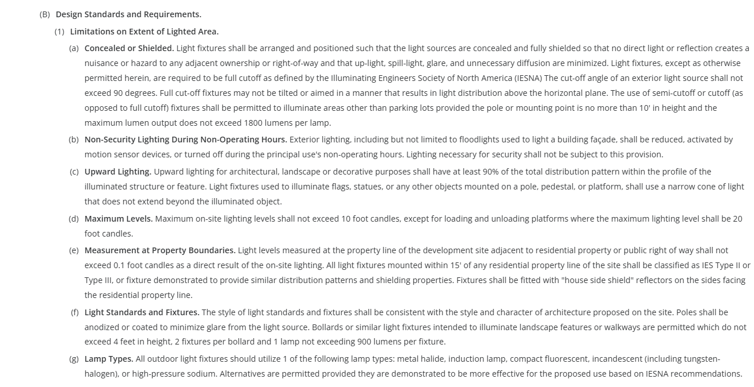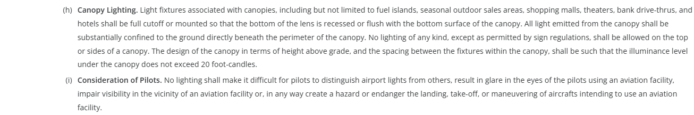
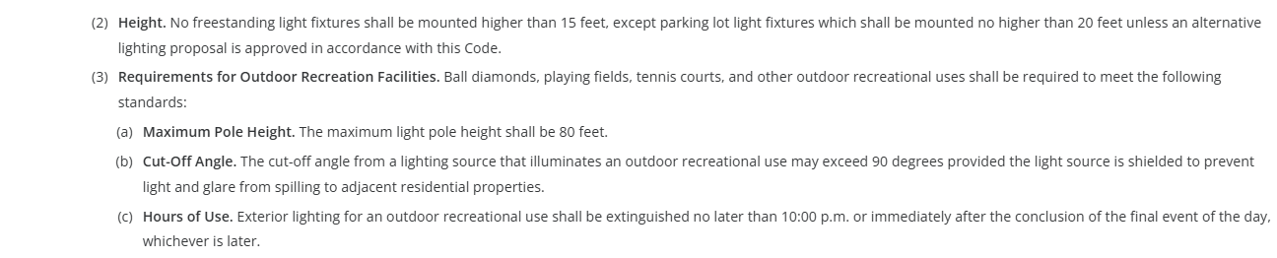 (C) Prohibited Lighting
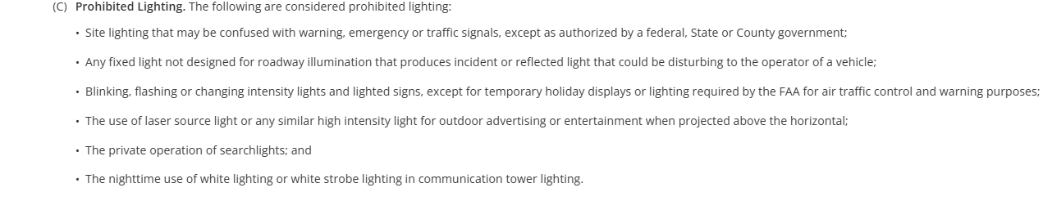
(D) Exemptions
Photometric Plan Required | ☒

Site Characteristics\ Constraints\ Environmental Standards:
(Chapter 6 Link) General Development Standards
6.2.7 Operational Standards (Dust and Debris Control, Noise, etc.)
(Chapter 6.3 Link) Environmental Standards**
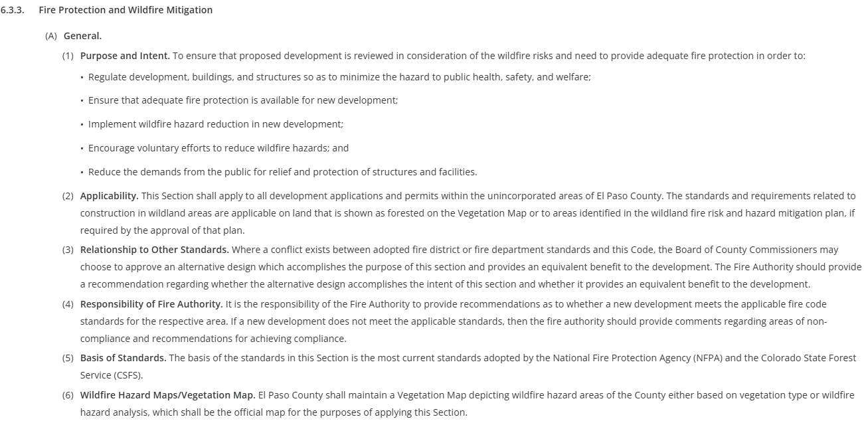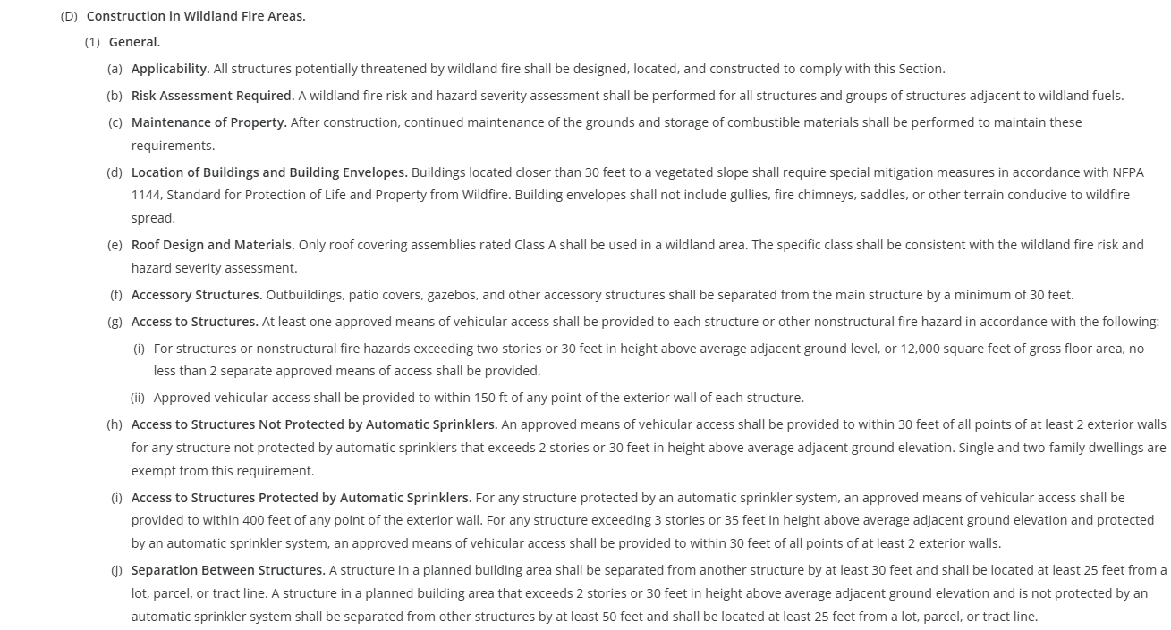

6.3.5 Grading and Erosion Control

6.3.9 Wildlife

☐ | 30% or greater slope | Comments: | N/A
☐ | CGS review previous concerns discussed |  | N/A
☐ | Floodplain |  | N/A
☐ | Noise mitigation required |  | N/A
☐ | Preble’s mouse |  | N/A

Air/Visual Quality:
(Chapter 6.3 Link)
6.3.1 Air Quality Standards

The property is not within an aviation overlay district.

Reduce visual impacts to adjacent residential: utilize buildings, landscaping, berms, fencing/walls, etc. (existing and proposed) to mitigate impacts.

Districts
Taxing Entities
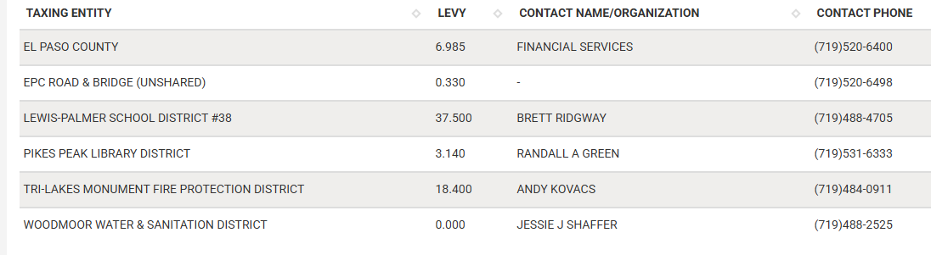

Road Impact Fees:
BOCC Res. No. 24-377, fee is applied at the time of building permit
Please provide the $ amount in the Letter of Intent

Proposed source of water |  |  | Proposed method of wastewater disposal
☐ | Central System |  | ☐ | Central System
District Name: |  | WOODMOOR WATER & SANITATION DISTRICT | District Name: |  | WOODMOOR WATER & SANITATION DISTRICT

Fire District:
Tri-Lakes Monument Fire Protection District

Fire District Design Concerns/Emergency Services Issues:
The FPD will be a reviewing agency – all returned comments will be made available to the applicant in EDARP.

Commissioner District: 1

Alternate Design:
(landscaping) consider using existing vegetation, shrub substitutes, etc.
(landscaping) parking lot – alternative proposal

Parks and trails:
No County parks or trails were identified on the property.

Annexations/Intergovernmental/ Jurisdictional Access issues:
Not applicable.

Helpful Links

Planning Website: https://planningdevelopment.elpasoco.com/

El Paso County Master Plan: https://planningdevelopment.elpasoco.com/#1510603950097-f5d985dc-35b2
Parks, Mineral and Water Master Plan: https://planningdevelopment.elpasoco.com/resources-and-references/#1516982531779-52cc0e87-01af

Forms and Templates: https://planningdevelopment.elpasoco.com/planning-development-forms/#1510677560407-ff8cfff5-69b2716b-00f9cbba-0c21

Land Development Code: https://library.municode.com/co/el_paso_county/codes/land_development_code

EDARP: https://epcdevplanreview.com/

Public GIS: https://elpasoco.maps.arcgis.com/apps/View/index.html?appid=5be6431018594c67b035ad0aad3e7e8a

Wrap Up
-If subdivision is proposed, recording fees, park and school fees and road impact fees apply.
-Fees are subject to change. The fees at the time of application apply.
-Pursuant to the adopted El Paso County Road Impact Fee Program (Resolution No. 12-382), a transportation impact fee, calculated on a per trip basis, may be due at the time of building permit issuance. Starting January 1, 2020, the transportation impact fee will be due for all new construction (Resolution No. 19-471).
-The fee for any additional waiver/deviation requests (more than two) - $550.00 each. Please note that requests for waivers and/or deviations may result in additional processing/review delay.
-All items requested must accompany the submittal for it to be complete, prior to payment request or the submittal will not be complete and ready for review agencies.
-A temporary use permit shall be applied for and approved for any staging area associated with development, such as a sales office, construction trailer, or contractor's equipment yard, prior to scheduling of the pre-construction meeting with El Paso County Planning and Community Development. If a Planned Unit Development is proposed, the temporary staging area should be shown on the development guidelines and phasing plan.
-All prospective timelines for review are subject to departmental staffing and workload.
-Early Assistance is valid for 12 months from submitting the EA application. If a project submittal is not received within 12 months, a new EA meeting may be required. An audio/video copy of the meeting is available in EDARP within the EA folder.
- Applications scheduled for public hearings may be heard as a regular item at the request of staff or a hearing body member.
- Any comments or commitments made by any member of the County Staff during this early assistance meeting are only preliminary in nature and should not be relied upon by the applicant. All prospective applicants should be informed that formal comments cannot be made by staff until after the application is submitted.

