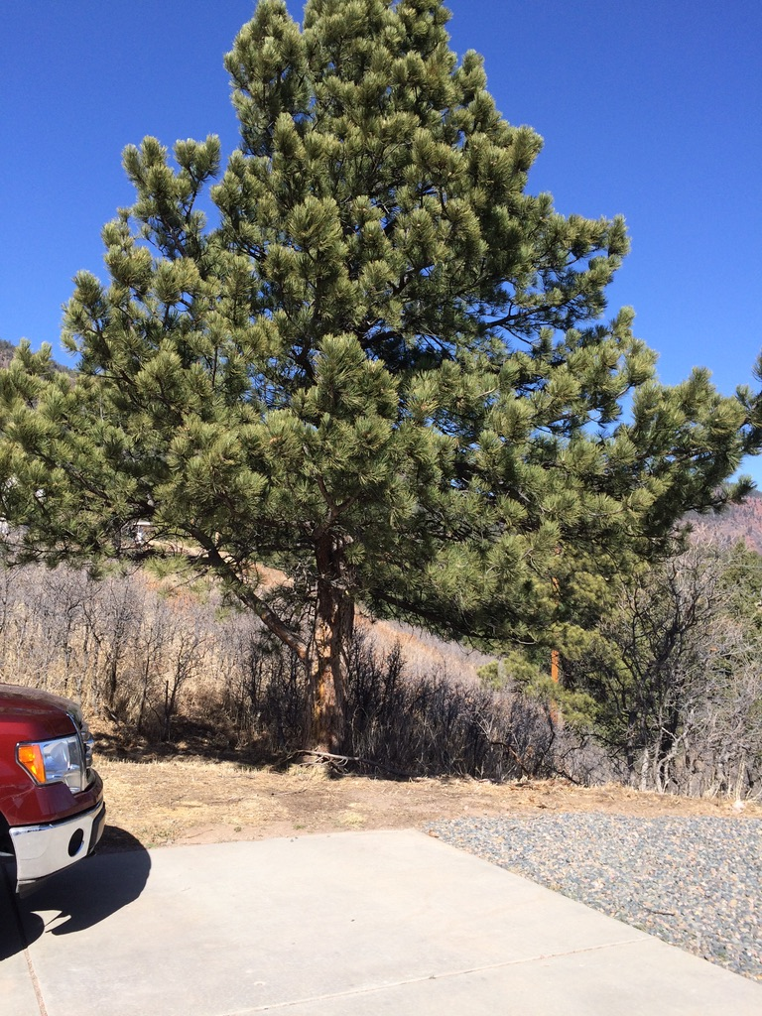

View of 30’ Pine Tree at corner of Garage
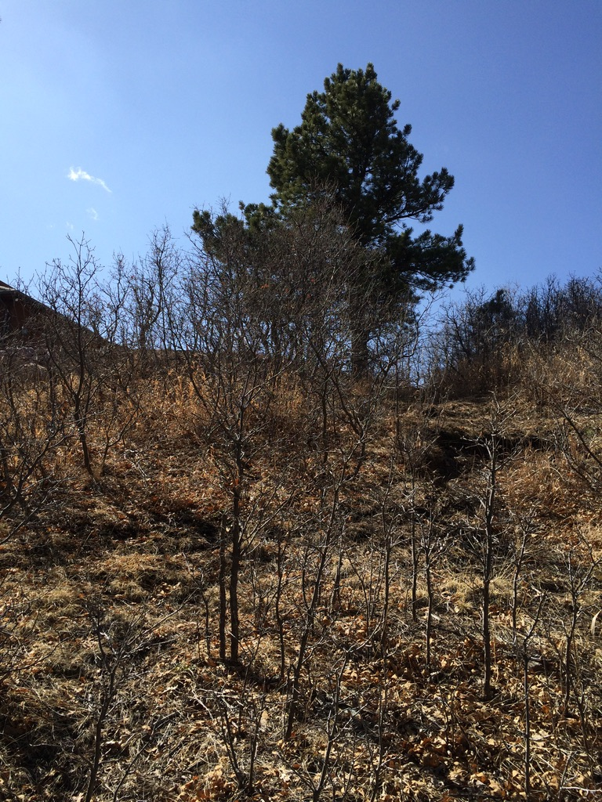
Drop off behind driveway

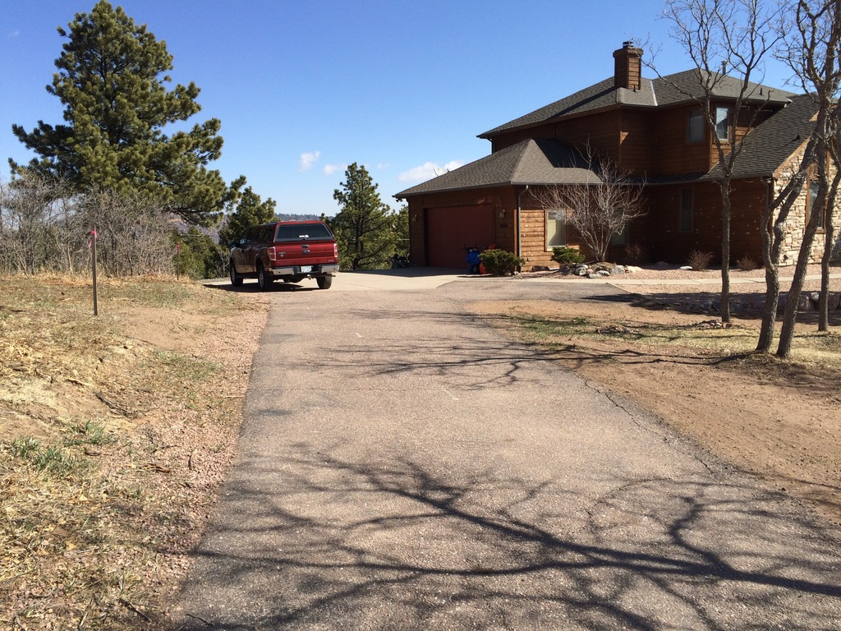

Existing garage. Proposed site is left of picture and indicated by the stake

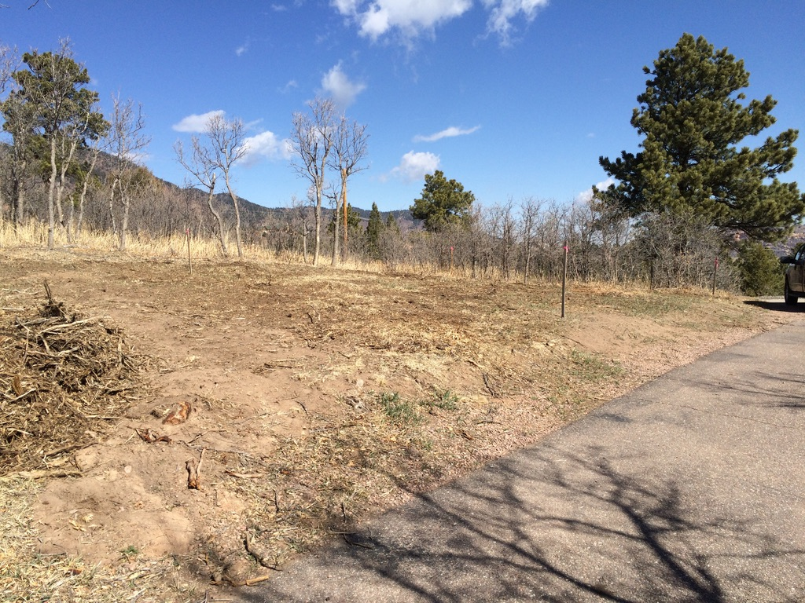

Proposed site at left (west) of driveway

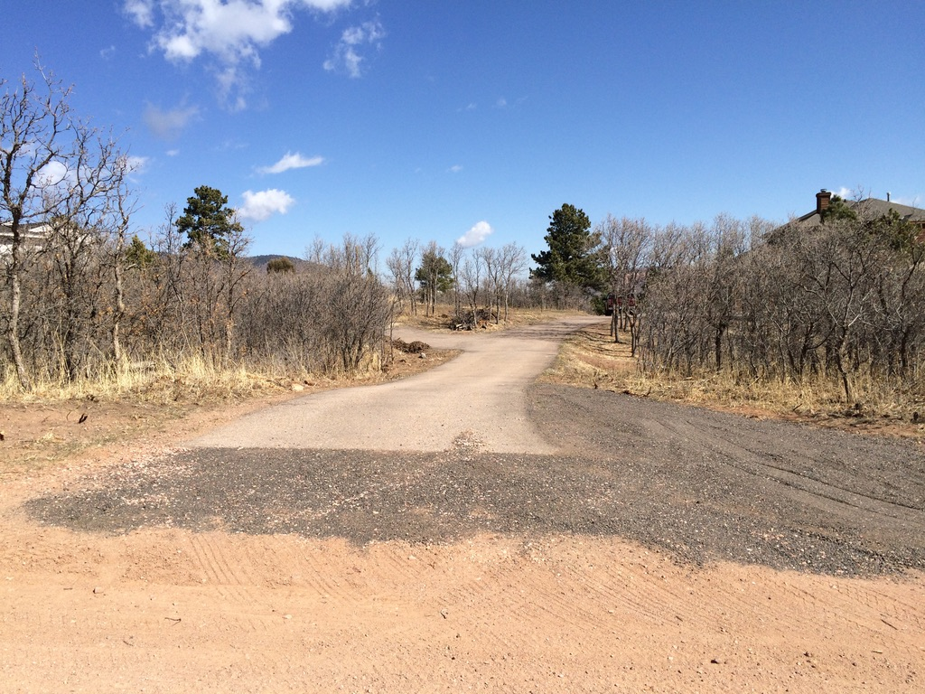

View of site from Limestone Road

