SADDLEHORN RANCH METROPOLITAN DISTRICT NOS. 1-3
2154 East Commons Avenue, Suite 2000
Centennial, CO 80122

September 1, 2020

Nina Ruiz, Planning Manager
El Paso County Planning & Community Development
2880 International Circle
Colorado Springs, CO. 80910

RE: Saddlehorn Ranch Metropolitan District Nos. 1-3 – Permanent Will-Serve Letter for Saddlehorn Ranch, Falcon/Peyton, CO

Dear Ms. Ruiz:

This Permanent Will-Serve Letter is to confirm that Saddlehorn Ranch Metropolitan District Nos. 1-3 (collectively, the “District”) will have an adequate water supply, and hereby commits to be the primary water service provider, on a permanent basis, to ROI Property Group, LLC (the “Applicant”) to serve the 816-acre Saddlehorn Ranch development at Curtis Road and Judge Orr Road, Falcon/Peyton, CO (the “Property”).

Our willingness to provide treated water for domestic purposes is based upon our understanding that the project is primarily comprised of up to 216 residential lots each having a minimum 2-1/2 acre size and based on this assumption the District intends to provide 150.08 acre-feet of water per year to the Property.

The terms of future service require compliance by the Applicant with all state and local statutory rules and regulations of the District, as approved by the District Board of Directors.

The service offered to the Applicant in this letter requires payment of all fees as established in the District's then current Rules and Regulations.

The Applicant shall pay for all costs to design, construct, and install any and all infrastructure, and acquire any easements, required or deemed necessary by the District to provide Service to the Property (including but not limited to: service taps, service lines, mainlines or any other improvements and facilities required, including any permits or improvements required by El Paso County). The Applicant shall design all such infrastructure according to the District's design standards and in accordance with the District's Rules and Regulations. Further, the Applicant shall reimburse the District for any and all costs the District incurs related to its review of the infrastructure design, construction and installation, including reimbursement of its engineers and consultants.

Service will be provided to the Property subject to the terms of the District’s Rules and Regulations, as amended from time to time, and the payment of all fees, rates and charges imposed thereunder. This will-serve commitment shall run only to the Property and shall not be transferable or assignable in any manner whatsoever.

Please do not hesitate to contact us with any questions regarding this Will-Serve Letter.

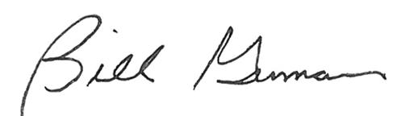
Yours truly,

Bill Guman, President
Saddlehorn Ranch Metropolitan District Nos. 1-3

