RETURN AFTER RECORDING TO:
Sara M. Frear
Mulliken Weiner Berg & Jolivet P.C.
102 South Tejon Street, Suite 900
Colorado Springs, Colorado 80903

ADDENDUM TO
CALM BREEZE POINT PRIVATE ACCESS ROW
AND
MAINTENANCE AGREEMENT

This ADDENDUM TO CALM BREEZE POINT PRIVATE ACCESS ROW AND MAINTENANCE AGREEMENT (this “Addendum”) is made to be effective as of the ____ day of _________, 2026 (the “Effective Date”), is executed by Callie Ammons and Kramer Ammons (the “Ammons”).

RECITALS

WHEREAS, the Calm Breeze Point Private Access Row and Maintenance Agreement (“Agreement”) was recorded on June 9 2022 under Reception No. 222079398 in the real property records of El Paso County; and

WHEREAS, the Ammons are fee simple owners of that certain real property known by street address as 12650 Calm Breeze Point, Colorado Springs, Colorado, more particularly described on Exhibit A (the “Ammons Parcel”), which property is vested with the rights provided under the Agreement and burdened by the obligations contained therein; and

WHEREAS, the Agreement and rights granted therein and the provisions thereof run with the Ammons Parcel, are appurtenant to the Ammons Parcel, are binding upon the Ammons Parcel and all present and future Ammons Parcel owners and shall inure to the benefit of the Ammons Parcel and all present and future Ammons Parcel owners; and

WHEREAS, The Agreement inures to the benefit of and is binding upon the Ammons Parcel owners and all subsequent Ammons Parcel owners and their respective successors and assigns.

WHEREAS, the Ammons intend to subdivide the Ammons Parcel into four new single-family lots as described in Exhibit B (the “New Parcels”); and

WHEREAS, this Addendum is executed to clarify that the Agreement applies to the owners of the New Parcels, as successors and assigns of the owners of the Ammons Parcel, to the same extent that it applied to the owners of the Ammons Parcel.

DECLARATION

NOW THEREFORE, for good and valuable consideration, the receipt and sufficiency of which is hereby acknowledged, the parties agree as follows:

Vesting. As set forth in paragraph 4 of the Agreement, each New Parcel owner, by acquiring an interest in a New Parcel shall automatically become vested with the rights provided under this Agreement and burdened by the obligations contained herein.

Run with the Land. As set forth in paragraph 8(c) of the Agreement, the Easement and rights granted therein and the provisions thereof shall run with the New Parcels, shall be appurtenant to the New Parcels, shall be binding upon the New Parcels and all present and future New Parcel owners and shall inure to the benefit of the New Parcels and all present and future New Parcel owners.

Successors and Assigns. As set forth in paragraph 8(f) of the Agreement, the Agreement shall inure to the benefit of and be binding upon the New Parcels and all subsequent New Parcel owners and their respective successors and assigns.
IN WITNESS WHEREOF, the undersigned has caused this ADDENDUM TO CALM BREEZE POINT PRIVATE ACCESS ROW AND MAINTENANCE AGREEMENT to be duly executed pursuant to proper authority duly given as of the day and year first above written.

CALLIE AMMONS | KRAMER AMMONS
STATE OF COLORADO )
) ss.
COUNTY OF EL PASO )

This document was acknowledged before me this ___ day of _____________________________, 2026, by Callie Ammons and Kramer Ammons.

Witness my hand and official seal.

My commission expires: _________________________.

(SEAL) ___________________________________
Notary Public

EXHIBIT A

AMMONS PARCEL EASEMENT AREA LEGAL DESCRIPTION

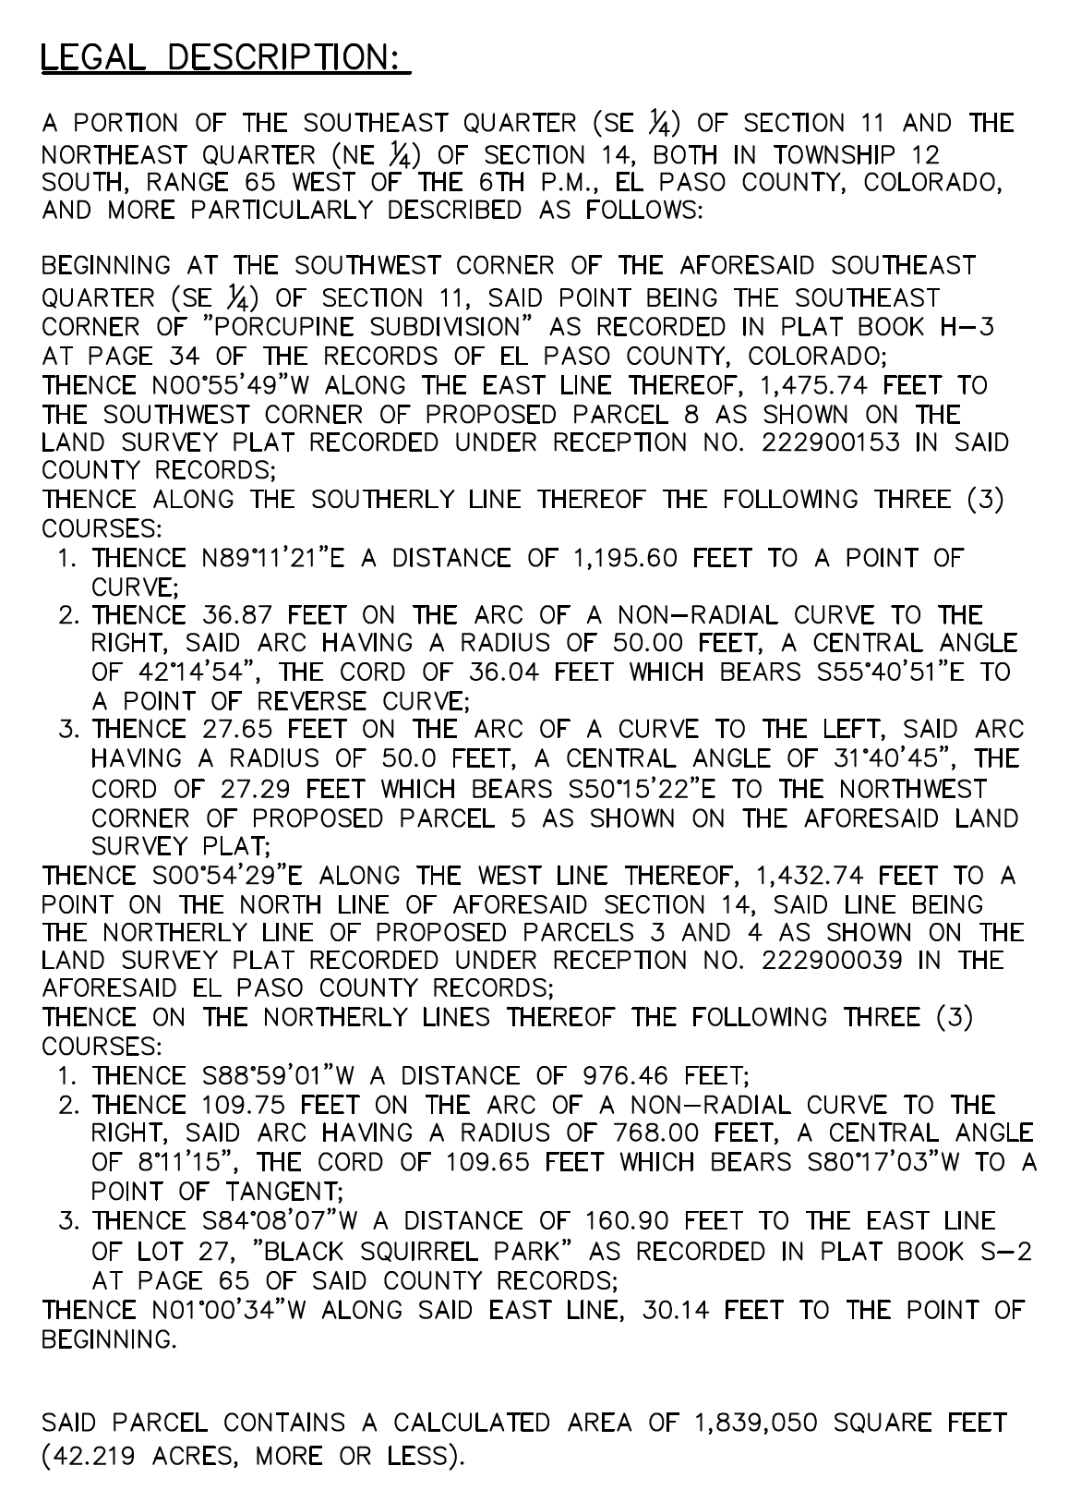

EXHIBIT B

CALM BREEZE FILING NO. 1 FINAL PLAT

