Item #7

Vicinity Map with Adjacent Property Owners
11880 Old England Drive Colorado Springs, Co 80908-4612
Zoning: PUD
Plat No: 11292
Legal Description: LOT 3 Camelot SUB

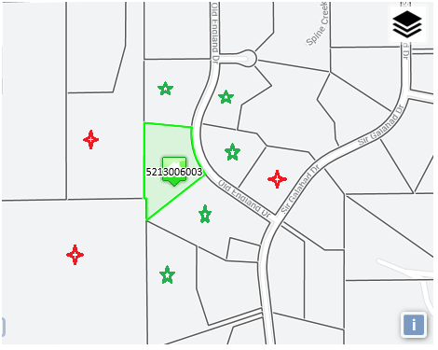

The adjacent neighbors with the red stars were notified via certified mail (documentation found under the Adjacent Property Owner Notification link). The adjacent neighbors with the green stars all signed the Notification of Adjacent Property document.

