Leffler Rezone Letter of Intent
January 9, 2025
Eric Leffler
4515 Ford Drive
Colorado Springs, CO 80908
Direct: 719.493.8617
Ericleffler81@gmail.com

Tax Schedule Numbers: 6214000097 and 6214000032
Acreage: 6.1 acres total
Current Zoning: RR-5
Requested Zoning: RR-2.5
Overlay: None
PCD File: P253

Site Description:
Eric Leffler is respectfully submitting an application for a map amendment (rezone) of 6.1 acres from the RR-5 zoning district to the RR-2.5 zoning district. The two subject parcels were legally created prior to the subdivision regulations and are metes and bounds. There are two dwellings on the property with parcel number 6214000097. The first dwelling was constructed in 1962 and is the primary dwelling unit. The second dwelling was approved as an extended family housing (now known as Detached Accessory Living Quarters for Permanent Occupancy) in 2014. The second parcel (parcel no. 6214000032) is vacant.
A concurrent request has been submitted to adjust the boundaries of these two parcels into two approximately 3 acre lots. The current lot configuration does not meet the county standards of RR-5 zoning as one of the lots is only 1.01 acres and was created prior to county subdivision rules and regulations. This rezone and concurrent application to Dimensional Boundary Line Adjustment would correct this zoning issue.

Utilities:
Mountain View Electric Association (MVEA) provides electrical service and Black Hills Energy provides natural gas services to the area. The existing dwellings are served by individual onsite wastewater treatment systems and two individual wells.

Natural Features:
There are no protected sensitive natural environments onsite (e.g. wetlands, endangered species habitat). The site is forested. Forestry management and wildfire mitigation will continue to occur onsite and will be the responsibility of each property owner.
Transportation:
The property is accessed from Ford Drive, a dedicated County local roadway. A private road, Leprechaun Lane, traverses through the property from Ford Drive to the north to Shady Lane to the south (book 2696, page 591). Leprechaun Lane is proposed to remain in place and will not be extinguished with the rezone or boundary line adjustment. No additional right-of-way dedication is required at this time.
There are two parcels in place today. If the rezone and boundary line adjustment are approved, the result will also be two parcels. There will be no increase in traffic as a result of either request.
Request:
Request for approval of a rezone of 6.1 acres from the RR-5 zoning district to the RR-2.5 zoning district.

Justification:
The pages that follow address each one of the criteria included within Section 5.3.5 (map amendment), of the El Paso County Land Development Code.
The application is in general conformance with the El Paso County Master Plan including applicable Small Area Plans or there has been a substantial change in the character of the neighborhood since the land was last zoned.
The proposed map amendment (rezone) is in general conformance with the Master Plan. Please see the Master Plan analysis below.
The rezoning is in compliance with all applicable statutory provisions, including but not limited to C.R.S. § 30-28-111 § 30-28-113, and § 30-28-116.
Pursuant to the El Paso County procedures, the County has posted the public hearing date in the newspaper ensuring all statutory requirements have been satisfied.
The proposed land use or zone district is compatible with the existing and permitted land uses and zone districts in all directions.
The property owner is requesting to rezone the property from the RR-5 zoning district to the RR-2.5 zoning district. The parcels located immediately adjacent are RR-5, however there are 4 parcels to the east zoned RR-2.5.
Below is a map depicting the surrounding development and zoning:
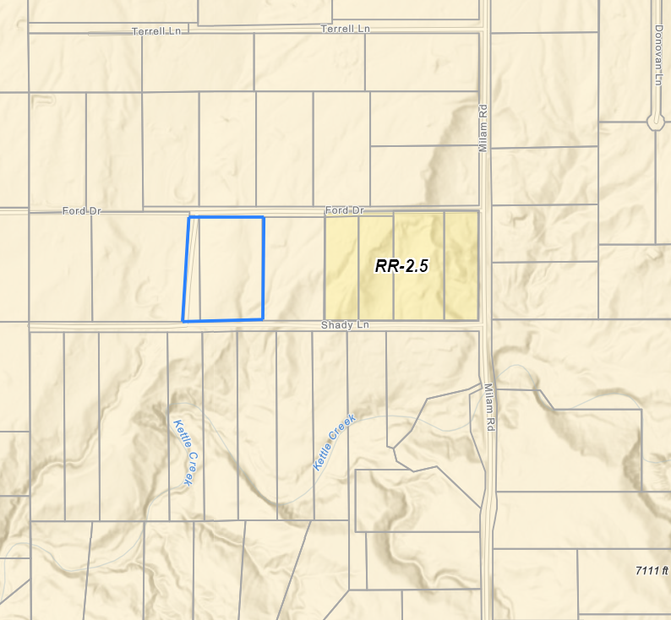
Section 3.2 of the Code provides the purpose statements for all conventional zoning districts within unincorporated El Paso County.
The purpose of the RR-2.5 (Residential Rural) zoning district:
“The RR-2.5 zoning district is a 2.5-acre district intended to accommodate low-density, rural, single family residential development.”
The purpose of the RR-5 (Residential Rural) zoning district:
“The RR-5 zoning district is a 5-acre district intended to accommodate low density, rural, single-family residential development.”
The primary difference in the intent of the above zoning districts is the dimensional standards, more specifically the minimum lot size requirement. With exception to the lot size, the districts’ purpose statement is the same. Both districts allow for single-family and rural land uses. The purpose statements of the zoning districts are compatible with one another.
The Land Development Code definition of “Compatibility” clearly points out that two items do not need to be identical in order to be considered compatible; “The characteristics of different uses, activities or designs which allow them to be located near or adjacent to each other in harmony. Some elements affecting compatibility include height, scale, mass and bulk of structures. Other important characteristics that affect compatibility are landscaping, lighting, noise, odor and architecture. Compatibility does not mean "the same as." Rather, compatibility refers to the sensitivity of the proposed use, activity or design in maintaining the character of existing development within the vicinity.”
Using the Code definition, compatibility can be accomplished if:
- Located adjacent to one another in harmony (coexist without negative impacts).
The RR-2.5 zoning district permitted uses is essentially a paired down, or less intense, list of those land uses allowed in the RR-5 zoning districts. There are no permitted uses in the RR-2.5 zone that are not permitted in the RR-5 zone district. The zone districts can remain adjacent in harmony.
All zone districts require a 25-foot front and rear setback. The side setback requirement in the RR-5 zone district is 25 feet whereas the RR-2.5 zone district requires 15 feet. The only dimensional standard difference of note is the minimum lot size requirement, however, the difference in lot size will not result in negative impacts to the surrounding properties.
- Compatible height
The RR-5 and RR-2.5 all allow for a maximum height of 30 feet.
- Compatible scale, massing, and bulk
The RR-5 zoning district has a maximum coverage of 25% whereas the RR-2.5 does not include maximum coverage. Anticipated structures include single-family detached dwellings, garages, and barns. The scale, massing, and bulk standards of the anticipated future improvements are identical.
- Compatible landscaping, light, noise, odor, and architecture
Both the RR-5 and RR-2.5 zone districts have the same landscaping, lighting, noise, and architectural standards.
- Maintain the character of existing development in the vicinity.
There are already parcels within the RR-2.5 zone district in the immediate area. The RR-2.5 zone district is a rural zone district and will maintain the rural residential character of the area.
The site is suitable for the intended use, including the ability to meet the standards as described in Chapter 5 of the Land Development Code, for the intended zone district.
Table 5-4 of the Land Development Code identifies the density and dimensional standards of the RR-2.5 zoning district:
- Minimum lot size: 2.5 acres
- Front Setback: 25 feet
- Side Setback: 15 feet
- Rear Setback: 25 feet
- Maximum Height: 30 feet

The concurrently reviewed boundary line adjustment depicts lot sizes meeting the 2.5 acres size limitation and the existing structures meeting the setback requirements.

Master Plan Elements
Below is an analysis of the various El Paso County Master Plan elements.

Your El Paso County Master Plan Analysis
Chapter 1 of Your El Paso Master Plan (2021) states that the Plan is “general in nature-it cannot tackle every issue in sufficient detail to determine every type of necessary action.” In addition, Chapter 1 goes on to state that the Plan “is intended to provide clearer and more coordinated policy, resulting in a document that effectively communicates County goals and identifies specific actions to achieve both County-wide and local area objectives.” When taken together, these two statements suggest to the reader that the Plan may only address certain issues at a cursory level and that specific steps or actions for addressing such issues may not be offered within the Plan. That conclusion is certainly the case in numerous instances and with regard to a variety of topical areas. However, where that is not the case is with respect to the requested map amendment (rezoning) to the RR-2.5 zoning district, as identified below.

Key Area Analysis
The subject property is identified in the Plan as being within the Forested Area Key Area. The Plan further describes the Key Areas as:

“This Key Area includes parts of the County where natural forests are the predominant feature such as Black Forest, areas north of Peyton, and areas along Highway 115 as well as lands within Pike National Forest. Pike National Forest is one of the County’s largest natural amenities and tourist destinations. Continued coordination with the U.S. Forest Service is critical to ensuring future development in areas adjacent to the Forest do not negatively impact the natural environment. There are also many established communities within Pike National Forest particularly in Ute Pass and along Highway 115. New development and any redevelopment in these locations should be of a lower intensity to mitigate any impacts on the Forest, properly manage stormwater, provide safe access to major roads and state highways for the traveling public and emergency response vehicles and adhere to the strictest building codes to prevent any hazards such as fires and soil erosion related to poor planning, design, and construction.

Managed residential growth, along with supportive commercial uses, have helped the other forested areas preserve their natural amenities while supporting the daily needs of a thriving local community. The seamless connection between the natural environment and small-scale, low intensity development is critical to their identity. All new development and redevelopment in this Key Area should strictly adhere to the transportation and infrastructure, stormwater requirements, built form, and transition guidelines outlined in their appropriate placetypes. Each development proposal should also be reviewed on a case-by-case basis to determine its specific impact on the forested area and the established character of the individual community.” (emphasis added)

As discussed above, the RR-2.5 zone district is already present in the immediate vicinity. The site may be accessed from a County roadway, Ford Drive. All necessary utilities are in place and are sized for the existing structures. Any new structures proposed will need to be properly permitted. All El Paso County Stormwater Division and Regional Building Code requirements have been satisfied. Please review the placetype section below for additional detail regarding an analysis of how the rezone is in compliance with the recommendations for the placetype. The proposed rezone is in general conformance with the Key Area.

Area of Change Analysis
The subject property is shown in the Areas of Change map within the Plan as being within the “Minimal Change: Undeveloped” area of change.

Page 21 of the Plan characterizes areas of “Minimal Change: Undeveloped” by stating:
“The character of these areas is defined by a lack of development and presence of significant natural areas. These areas will experience some redevelopment of select underutilized or vacant sites adjacent to other built-out sites, but such redevelopment will be limited in scale so as to not alter the essential character. New development may also occur in these areas on previously undeveloped land, but overall, there will be no change to the prioritized rural and natural environments.” (Emphasis added)

The vacant parcel is an underutilized vacant land next to 2.5-acre rural residential development to the east. The essential character is rural residential. Additional grading and roadwork are not proposed, allowing the project area to maintain the natural terrain, vegetation, and character. The rezone will be an extension of the existing character.

Placetype Analysis
The subject property is shown on the Placetypes map of Your El Paso Master Plan as being within the Large-Lot Residential Placetype.

Page 26 of the Plan identifies the following land uses as being Primary Land Uses within the Large-Lot Residential Placetype:
- Single-Family Detached Residential (typically 2.5-acre lots or larger)

In addition, the Placetype includes the following Supporting Land Uses:
- Parks/Open Space
- Commercial Retail
- Commercial Service
- Agriculture

The Large-Lot Residential Placetype is described further on page 26 as follows:
“The Large-Lot Residential placetype consists almost entirely of residential development and acts as the transition between placetypes. Development in this placetype typically consists of single-family homes occupying lots of 2.5 acres or more, and are generally large and dispersed throughout the area so as to preserve a rural aesthetic. The Large-Lot Residential placetype generally supports accessory dwelling units as well. Even with the physical separation of homes, this placetype still fosters a sense of community and is more connected and less remote than Rural areas. Large-Lot Residential neighborhoods typically rely on well and septic, but some developments may be served by central water and waste-water utilities. If central water and wastewater can be provided, then lots sized less than 2.5 acres could be allowed if; 1.) the overall density is at least 2.5 acres/lot, 2.) the design for development incorporates conservation of open space, and 3.) it is compatible with the character of existing developed areas.

Conservation design (or clustered development) should routinely be considered for new development within the Large-Lot Residential placetype to provide for a similar level of development density as existing large-lot areas while maximizing the preservation of contiguous areas of open space and the protection of environmental features. While the Large-Lot Residential placetype is defined by a clear set of characteristics, the different large-lot areas that exist throughout the County can exhibit their own unique characters based on geography and landscape.” (emphasis added)

The proposed development includes two parcels approximately 3 acres in size.

El Paso County Water Master Plan
The Executive Summary from the Water Master Plan (2018) states that “The Plan Water Master Plan (WMP) was developed for the Board of County Commissioners, El Paso County officials and staff, developers, citizens, and water providers within the County for the purpose of identifying and addressing water supply issues earlier in the land use entitlement process.” A water sufficiency finding is not required. It should be noted that the Water Master Plan only contemplates centralized providers and did not provide an analysis for individual well, as is proposed here.

The subject property is located within Planning Region 2 of the Water Master Plan, pursuant to Figure 3-1 on page 25. The Plan identifies the current supply and demand forecasts at full build out (year 2060) for each of the Planning Regions. The Table indicates that the current water supplies for Region 2 amounts to 13,607 AF of water per year with 2060 being 20,756 AF of water per year; therefore, there is projected to be a surplus supply of water for central water providers in this region of the County.

El Paso County Parks Master Plan
The El Paso County Parks Master Plan (2022) does not depict any planned or existing trails or open space on the subject property. Land dedication, or fees in lieu of land dedication are not required with a rezone application.

