Early Assistance Meeting Number: EA263
Project Name: CSP Suntide Verizon CRMS facility
Project Location: 1615 Cedar Valley Lane, Colorado Springs, CO 80919
Project Parcel Nos. 7302000094
Project Description: (9) NEW VERIZON WIRELESS ANTENNAS & EQUIPMENT ON (3) NEW CAMOUFLAGED ANTENNA FRAMES, (2) NEW & (1) FUTURE EQUIPMENT CABINETS ON NEW CONCRETE PAD WITH NEW STEEL EQUIPMENT CANOPY, NEW UNDERGROUND ELECTRICAL SERVICE, NEW UNDERGROUND FIBER OPTIC SERVICE, NEW 30KW DIESEL GENERATOR ON CONCRETE PAD, NEW 4X4 QUAD TRAIL FROM EQUIPMENT TO ANTENNAS
Meeting Date: 3/17/2026 at 2 PM

El Paso County Planning & Community Development Planning Checklist

Request – Map Provided by Applicant
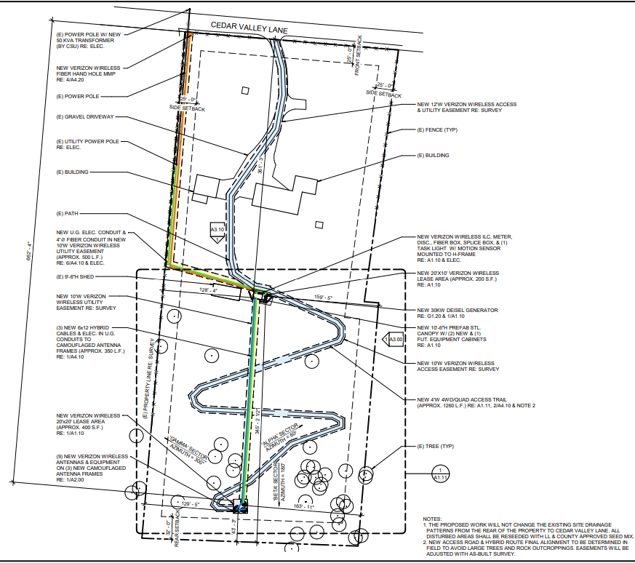

Zoning (check conditions of approval)
Existing Zone(s)
Zone |  | Name
A-5 |  | Agricultural
Zone Map
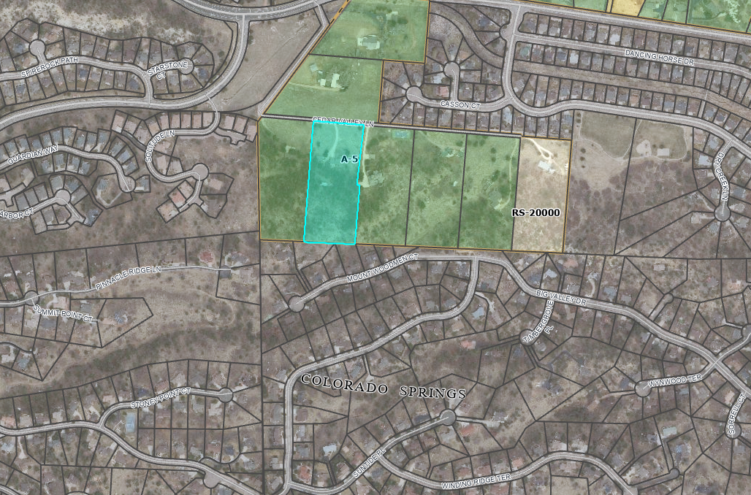

Zoning Analysis
CMRS Facility, Stealth is a Special Use in the A-5 Zoning District.
Two project files required: Special Use Permit (AL) first for zoning approval, then Tower (TWR). Staff initiates both projects.

- Special Use criteria in section 5.3.2. of the Land Use Code
(C) Criteria. In approving a special use, the following criteria may be considered:
  - The special use is generally consistent with the applicable Master Plan;
  - The special use will be in harmony with the character of the neighborhood, and will generally be compatible with the existing and allowable land uses in the surrounding area;
  - The impact of the special use does not overburden or exceed the capacity of public facilities and services, or, in the alternative, the special use application demonstrates that it will provide adequate public facilities in a timely and efficient manner;
  - The special use will not create unmitigated traffic congestion or traffic hazards in the surrounding area, and has adequate, legal access;
  - The special use will comply with all applicable local, state, and federal laws and regulations regarding air, water, light, or noise pollution;
  - The special use will not otherwise be detrimental to the public health, safety and welfare of the present or future residents of El Paso County; and/or
  - The special use conforms or will conform to all other applicable County rules, regulations or ordinances.
- Special Use Application Packet
- Tower (TWR) Project
  - Application form
  - Elevation Plans
  - Landscape Plans (may be waived at discretion of PCD Director)
  - Letter of Intent
  - Lease Agreement
  - PCM Applicability Form
  - Tower/Structure Removal Agreement
  - Site Plan Drawing

Submittal checklists and required documents for both applications can be found in attached links.

CMRS Facilities must comply with Use Specific Standards in 5.2.19. Commercial Mobile Radio Service Facility (CMRS) Facilities.
- Uploaded in full to EDARP Additional Documents page

(B) General Standards.
(1) Co-Location. Co-location of CMRS facilities is encouraged when feasible to minimize the number of CMRS facility sites. To further the goal of co-location:
- An applicant for a new freestanding CMRS facility shall demonstrate that a good faith effort has been made to co-locate on existing CMRS facilities. The applicant shall demonstrate that due to physical constraints, or economic or technological infeasibility, no such location or co-location is available. The applicant shall also demonstrate that contact has been made with the owners of all suitable structures within the search area of the proposed site and was denied permission to locate its CMRS facility on those structures;
- If a telecommunications competitor attempts to co-locate a CMRS facility on an existing or approved CMRS facility or location, and the parties cannot reach an agreement, the County may require a third-party technical study to be completed at the expense of both parties to determine the feasibility of co-location; and
- All facilities shall be designed and constructed to allow for co-location of a minimum of 2 users except for a small cell CMRS, pole mounted CMRS, or those otherwise specifically exempted by the BOCC.
(2) Compliance with FCC Standards. At the request of the PCD Director, which request shall occur no more than once per year, CMRS facility owners and operators shall certify that:
- The CMRS facility complies with the current FCC regulations prohibiting localized interference with reception of television and radio broadcasts; and
- The CMRS facility complies with the current FCC standards for cumulative field measurements of radio frequency power densities and electromagnetic fields.
In adopting this requirement, the County is not attempting to regulate radio frequency power densities or electromagnetic fields, which regulation is controlled by the FCC.
(3) Abandonment and Expiration. If the CMRS facility ceases operation for any reason for a period of one year:
- The CMRS facility shall be removed within 6 months of the expiration; and
- Any permit or approval authorizing the CMRS facility shall be considered expired.
(4) Application Approval or Denial. In considering an application for a CMRS facility, the County shall base its decision as to the approval or denial of the application on whether the proposed CMRS facility meets the design standards set forth in this Section and any approval criteria associated with the applicable application or review process.
(5) Accessory Equipment for a CMRS Facility. All accessory equipment for a CMRS Facility shall be 100% screened from view. All equipment shelters shall be located within the lease area for the CMRS facility. No equipment storage shelter shall exceed 15 feet in height. Equipment storage shelters shall be grouped as closely together as practical, so as to minimize impact on adjoining properties. The total area of all accessory equipment, including equipment storage shelters, shall not exceed 400 square feet per CMRS facility, except for a small cell facility where 17 square feet shall be the maximum allowed.
(6) Standards for Freestanding CMRS Facilities.
(a) Tower/Structure Removal Agreement. Prior to commencing construction of a new freestanding CMRS facility or any alteration of an existing freestanding CMRS facility, a Tower/Structure Removal Agreement shall be signed by the owner of the property and filed for recording with the Clerk and Recorder.
(b) Financial Assurance Required. Prior to commencing construction of a new freestanding CMRS facility or any alteration of an existing freestanding CMRS facility, the owner of a freestanding CMRS facility shall be required to provide the County with adequate financial assurance to cover removal of the facility if abandoned. The form of financial assurance shall be approved by the PCD Director. New financial assurance will be required prior approval of alteration of an existing freestanding CMRS facility and when the ownership of the lease or facility changes hands.
(c) Minimum Setbacks for Freestanding CMRS Facilities.
- Located Within 250 Feet of Residential Zoning District. A freestanding CMRS facility located within 250 feet of any property zoned for residential use shall be set back from any residential property line one foot of distance for every foot of facility height (as measured from grade elevation), plus an additional 10 feet.
- Located Over 250 Feet from Residential Zoning District. A freestanding CMRS facility located greater than 250 feet from property zoned for residential use shall meet the minimum setback requirements for structures and structures of the underlying zoning district and located in a manner to contain any freefall or icefall on the same property.
(d) Maximum Height for Freestanding CMRS Facilities. A freestanding CMRS facility, including antennae, shall not exceed the maximum structure height limit in the zoning district unless otherwise specifically authorized as a part of the special use or variance of use approval. Any tower that exceeds 200 feet shall require FAA approval prior to approval of a special use or variance of use.

(f) Design Standards for Freestanding CMRS Facilities. A freestanding CMRS facility shall adhere to the following design standards to minimize impacts:
- Compatible with Surrounding Area. A freestanding CMRS facility shall be designed to be compatible with surrounding buildings and structures and existing or planned uses in the area, subject to any applicable FAA regulations.
- Existing Vegetation. Existing land forms, vegetation and structures shall be used to screen the facility from view and blend in with the surrounding environment, to the extent practicable. Existing vegetation shall be preserved or enhanced, where feasible.
- No Lighting. The facility antennae shall not be lighted unless required by the FAA and authorized by the permit or approval.
- Dangerous Equipment and Attractive Nuisance. Any equipment that could be dangerous to persons or wildlife shall be adequately fenced. The attractive nuisance potential shall be minimized through fencing and methods to discourage unauthorized climbing.
- Dish Diameter Limited. The diameter of a microwave dish antenna shall not exceed 4 feet.
(g) Photo Simulations Required. Photo Simulations are to be provided for any new freestanding CMRS facility or for a Substantial Change to an existing freestanding CMRS facility. The Photo Simulations shall illustrate a minimum of three different views of what the site will look like once the antennae and associated equipment have been installed. Photos and Photo Simulations should show the "existing" and "proposed" conditions.
(7) Stealth CMRS Facility Design Standards. A stealth CMRS facility shall meet the same design standards and maximum height allowance as a freestanding CMRS facility.

Master Plan Info
- Area of Change: Minimal change, Developed
- Key Area: Enclaves
- Place type: Suburban Residential
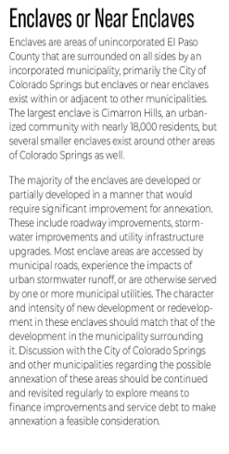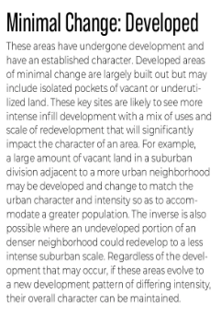
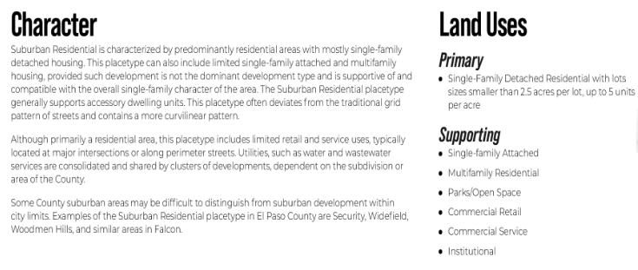

Zoning District Requirements (density, lot size, lot design standards, building setbacks)
District: A-5
Setbacks: 25 from all property lines
- Additional setback standards in green
Height: 30 feet

Map of Platted Lot/ Tract (check plat notes & conditions of approval):
N/A - Unplatted

Application Type(s) Hearing: Required/ Optional/ No
Special Use (AL) Project | No, Administrative unless elevated to hearing by PCD Director
Tower (TWR) Project | No, Administrative

Processing Issues and Options
Colorado Springs will be a review agency due to proximity.
Prior Stealth Tower approvals for reference:
TWR2528: https://epcdevplanreview.com/Public/ProjectDetails/200524
AL1921: https://epcdevplanreview.com/Public/ProjectDetails/111103
PPR2022: https://epcdevplanreview.com/Public/ProjectDetails/163692
AL1925: https://epcdevplanreview.com/Public/ProjectDetails/10355

Relevant Past History:

Design and Landscaping

Site Design/Layout (Lot pattern, circulation/road design, open space, preservation of natural features, compatibility internally and with adjacent land uses)
Screening and buffering from adjacent residential will be essential.

Landscaping
☐ | Expressway, Principal arterial area depth – 25’-Trees required 1 per 20’
☐ | Urban interchange/Intersection area depth – 25’- N/A
☐ | Minor arterial area depth 20’ – Trees required 1 per 25’
☐ | Non-arterial area depth 10’ – Trees required 1 per 30’
☐ | Parking lot landscaping required
☐ | Buffer between non-residential and residential districts separated by a non-arterial road or public alley  Zone Boundary Buffer

- All accessory equipment to be 100% screened from view
- (ii) Existing Vegetation. Existing land forms, vegetation and structures shall be used to screen the facility from view and blend in with the surrounding environment, to the extent practicable. Existing vegetation shall be preserved or enhanced, where feasible.
- (iv) Dangerous Equipment and Attractive Nuisance. Any equipment that could be dangerous to persons or wildlife shall be adequately fenced. The attractive nuisance potential shall be minimized through fencing and methods to discourage unauthorized climbing.
(2) Buffer Between Non-Residential, Multifamily Residential and Single-Family/Duplex Uses.
(a) Where Required. A buffer is required in the following situations:
(i) Along the lot, parcel, or tract line on the non-residential use property between the non-residential use and a residential zoning district.
(ii)Along the lot, parcel, or tract line on the multifamily use property between the multifamily use and a single-family or duplex zoning district.
(iii)On the residential side of the project when use to use compatibility is a concern.
(b)Depth and Planting Standards. The required buffer shall be a minimum of 15 feet deep. The minimum number of trees in the buffer shall be 1 tree for every 25 feet of common lot, parcel, or tract line. A minimum of ⅓ of the trees shall be evergreen trees.
(c)Opaque Fencing or Wall Required. An opaque fence or wall with a minimum height of 6 feet is required along the lot, parcel, or tract line except where the adjacent single-family or duplex residential zoning district or use abuts a required roadway landscaping area.

Signage:
If proposed, to follow 6.2.10. Signs, On-Premise in the Land Use Code, and to be identified on site plan (separate sign permit required).

Parking Requirements:
Show on site plan

Lighting:
- No Lighting. The facility antennae shall not be lighted unless required by the FAA and authorized by the permit or approval.
Photometric Plan Required | ☐

Site Characteristics\ Constraints\ Environmental Standards:
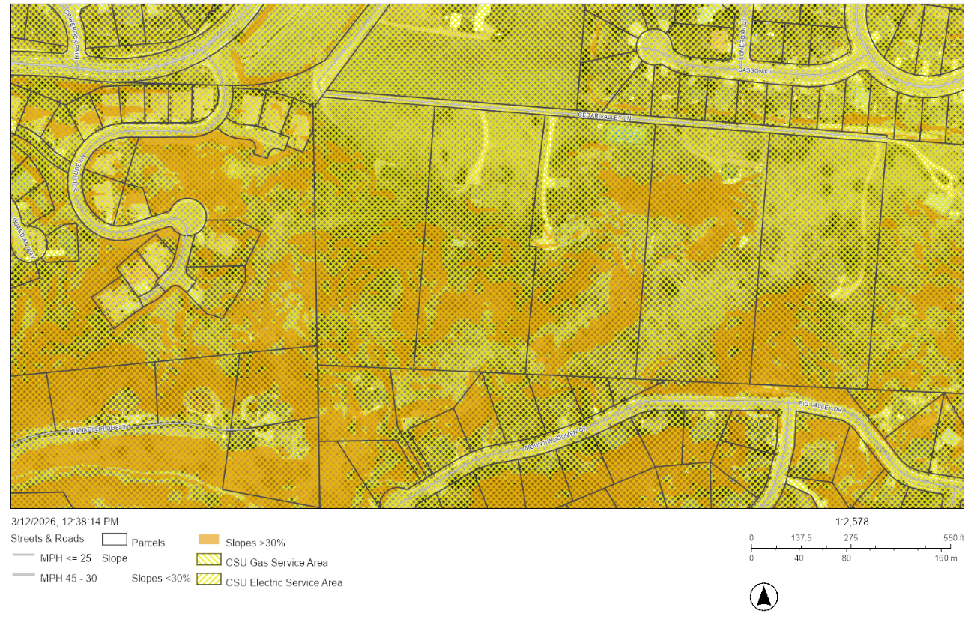

☒ | 30% or greater slope | Topography:
☐ | CGS review previous concerns discussed | Soils/geology:
☐ | Floodplain | Floodplain comment:
☐ | Noise mitigation required | Noise comment:
☐ | Preble’s mouse

Air/Visual Quality:

Districts

Taxing Entities
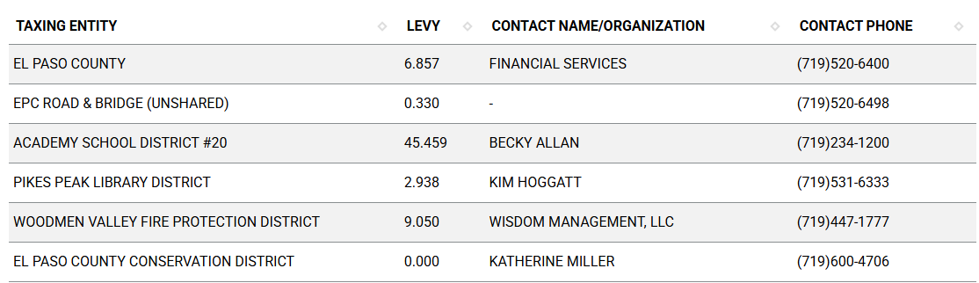

Proposed source of water |  |  | Proposed method of wastewater disposal
☐ | Central System |  | ☐ | Central System
District Name: |  |  | District Name:

Fire District:
Woodmen Valley Fire Protection District

Fire District Design Concerns/Emergency Services Issues:
Property is designated as Fire Hazard Vegetation per County GIS maps.
Colorado Wildfire Resiliency Code: Moderate Intensity
- A Wildland Fire and Hazard Mitigation Plan is required, to be prepared by a qualified professional.
Local qualified professionals found here, or as described in section 1.15 of the Land Use Code: Qualified Professional — A professional acceptable to the County, and who is either licensed by the State of Colorado to perform the type of work involved, who is accredited by or registered with a professional group and who is operating within the scope of accreditation or registration, or who is specifically or specially qualified to perform the type of work involved.

Commissioner District: 3

Alternate Design:
Code standards in Chapters 5 and 6 may be proposed to be modified in letter of intent.

Parks and trails:

Annexations/Intergovernmental/ Jurisdictional Access issues:
Colorado Springs Annex

Road Impact Fees:

Helpful Links

Planning Website: https://planningdevelopment.elpasoco.com/

El Paso County Master Plan: https://planningdevelopment.elpasoco.com/#1510603950097-f5d985dc-35b2
Parks, Mineral and Water Master Plan: https://planningdevelopment.elpasoco.com/resources-and-references/#1516982531779-52cc0e87-01af

Forms and Templates: https://planningdevelopment.elpasoco.com/planning-development-forms/#1510677560407-ff8cfff5-69b2716b-00f9cbba-0c21

Land Development Code: https://library.municode.com/co/el_paso_county/codes/land_development_code

EDARP: https://epcdevplanreview.com/

Public GIS: https://elpasoco.maps.arcgis.com/apps/View/index.html?appid=5be6431018594c67b035ad0aad3e7e8a

Wrap Up
-If subdivision is proposed, recording fees, park and school fees and road impact fees may apply.

-Fees are subject to change. The fees at the time of application apply.

-Road Impact Fees
Please see the following website for information on the EPC Road Impact Fee Project. https://publicworks.elpasoco.com/road-impact-fees/ to include fee schedule.
As of December 15, 2016, per Resolution 16-454, on and after January 1, 2020, property in the unincorporated area of the county that receives a Land Use Approval either in a public hearing or administratively, is subject to the payment of Road Impact Fees. After December 31, 2024, in accordance with BoCC Resolution 24-377 the fee is paid for new residential and non-residential uses and structures and expansions of non-residential uses and structures. Road Impact fees are typically paid at time of building permit. If no building permit is being obtained for a particular Land Use application, then Road Impact Fees must be paid at the time of Site Development Plan or Special Use approval. If there are questions about EPC Road Impact program or fees, please contact DPW Development Review Services and the Engineer of the Day.

- Engineering Criteria Manual (ECM) Deviations.
The fee for any additional ECM deviation requests (more than two per land use application) - $1483.00 each per current Fee Schedule. Please note ECM deviation requests may result in additional processing and project review time. ECM Deviations should be submitted prior to the initial Site Development Plan or Final Plat submittal to preclude changes having to be made to engineering plans and documents if the deviation is not approved. Submission of an ECM deviation request does not imply or guarantee that the deviation will be approved. An ECM Deviation form must be submitted to include complete exhibits and justification excluding cost with supporting engineering criteria. If there are questions about ECM Deviation requests, please contact DPW Development Review Services and the Engineer of the Day.

-The fee for any additional waiver/deviation requests (more than two) - $550.00 each. Please note that requests for waivers and/or deviations may result in additional processing/review delay.

-All items requested must accompany the submittal for it to be complete, prior to payment request or the submittal will not be complete and ready for review agencies.

-A temporary use permit shall be applied for and approved for any staging area associated with development, such as a sales office, construction trailer, or contractor's equipment yard, prior to scheduling of the pre-construction meeting with El Paso County Planning and Community Development. If a Planned Unit Development is proposed, the temporary staging area should be shown on the development guideline and phasing plan.

-All prospective timelines for review are subject to departmental staffing and workload.

-Early Assistance is valid for 12 months from submittal of the EA application. If a project submittal is not received within 12 months, a new EA meeting may be required. An audio/video copy of the meeting is available in EDARP within the EA folder.

- Applications scheduled for public hearings may be heard as a regular item at the request of staff or a hearing body member.

- Any comments or commitments made by any member of the County Staff during this early assistance meeting are only preliminary in nature and should not be relied upon by the applicant. All prospective applicants should be informed that formal comments cannot be made by staff until after the application is submitted.

