NOTICE OF PUBLIC HEARING

This notice provides options to observe and participate in the Board of County Commissioners public hearing on the following Quasi-Judicial land-use matter. The Board of County Commissioners’ (BOCC) hearing is scheduled for Thursday, March 12th, 2026, beginning at 9:00 A.M. The BOCC hearing will be held in the Centennial Hall Hearing Room located at 200 S. Cascade Avenue, Colorado Springs. You may attend the public hearings in-person or watch virtually by following the procedures below.

FILE NUMBER: VR253 LETKE
VACATION AND REPLAT
POWERS SUBDIVISION
A request by Mark Powers for approval of a 10.72-acre Vacation and Replat creating two (2) residential lots. The property is zoned RR-2.5, and the two proposed lots will be 7.58 acres and 3.10 acres in size. The subject property is located on Old Ranch Road and is approximately .08 miles east of the intersection of Old Ranch Road and Otero Avenue. (Parcel No. 6228005049) (Commissioner District No. 1)

Planner: JoeLetke@elpasoco.com Type of Hearing: Quasi-Judicial
Watch the Hearing Virtually
To watch the hearings live, visit: https://cloud.castus.tv/vod/elpasoco/video at the scheduled times.
Submit Public Comments
Members of the public may provide comments in person at the hearings or may submit written comments in advance through the EDARP project page.
To submit written comments through EDARP and view the Staff Report and all related documents for this item, please visit: https://epcdevplanreview.com/Public/ProjectDetails/200188. Written comments submitted through EDARP must be uploaded no later than one (1) day prior to each hearing in order to be included in the official record. Written comments will not be accepted the day of the hearings. In-person public comments are limited to three (3) minutes. If you are unable to use EDARP, written comments may alternatively be submitted by email to PCDhearings@elpasoco.com.

This notice was mailed on: 02/19/2026.

Planning and Community Development
2880 International Cir. Suite 110
Colorado Springs, CO 80910

NOTICE OF PUBLIC HEARING


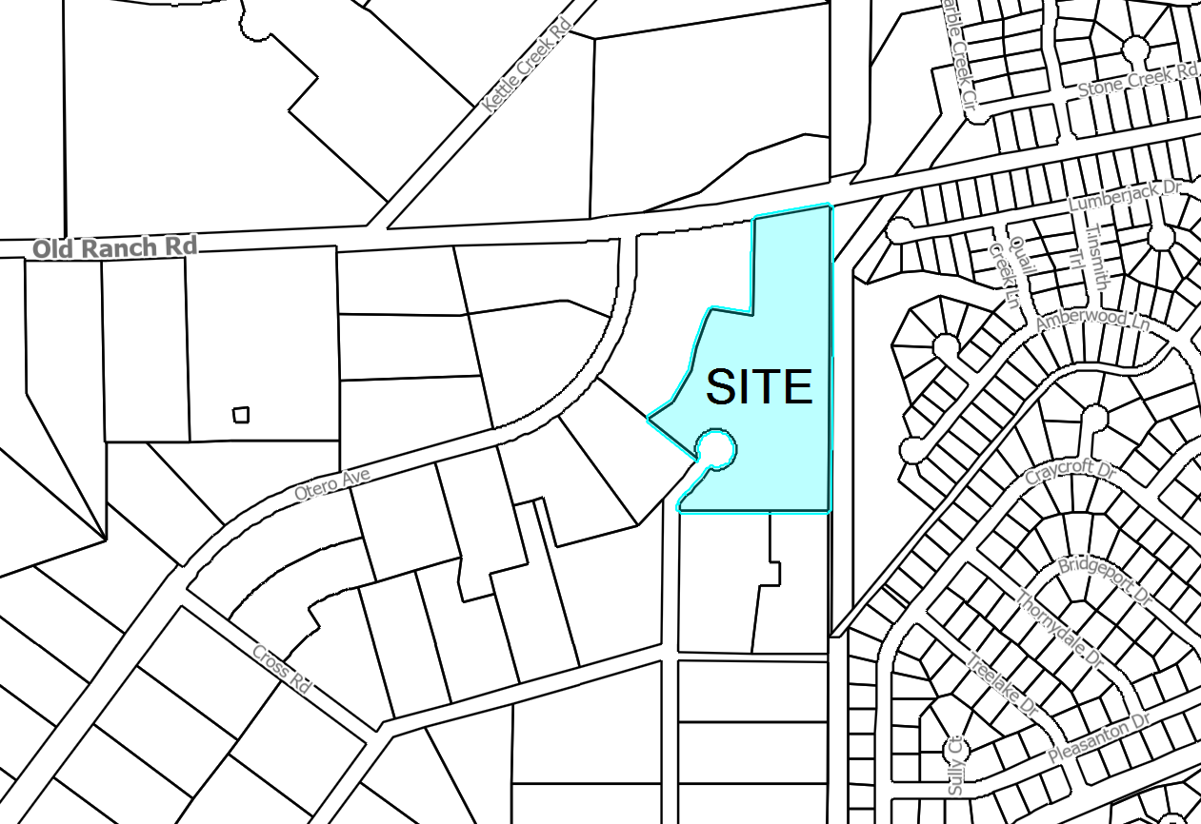
EL PASO COUNTY PARCEL INFORMATION

FILE NO.:
VR253
PARCEL:
6228005049
OWNER NAME:
Mark Powers
ADDRESS:
Old Ranch Road and Otero Avenue

