Early Assistance Meeting Number: EA2516
Project Name: Aspen Willow Estates
Project Location: North/Eastern part of EPC
Project Parcel Nos. 6100000298
Project Description: “The owner of the property would like to retain up to 5 acres of the 35-acre with the improvements on it and subdivide the remainder of the property. The property is zoned A-5. It is already zoned appropriately for 5-acre residential-agricultural uses. The applicant would like to create a total of 6 parcels leaving some acreage to accommodate access and private internal roads. It is estimated generally that 10% should be set aside for roads.”
Meeting Date: 4/16/25

El Paso County Planning & Community Development Planning Checklist

Request – Map Provided by Applicant
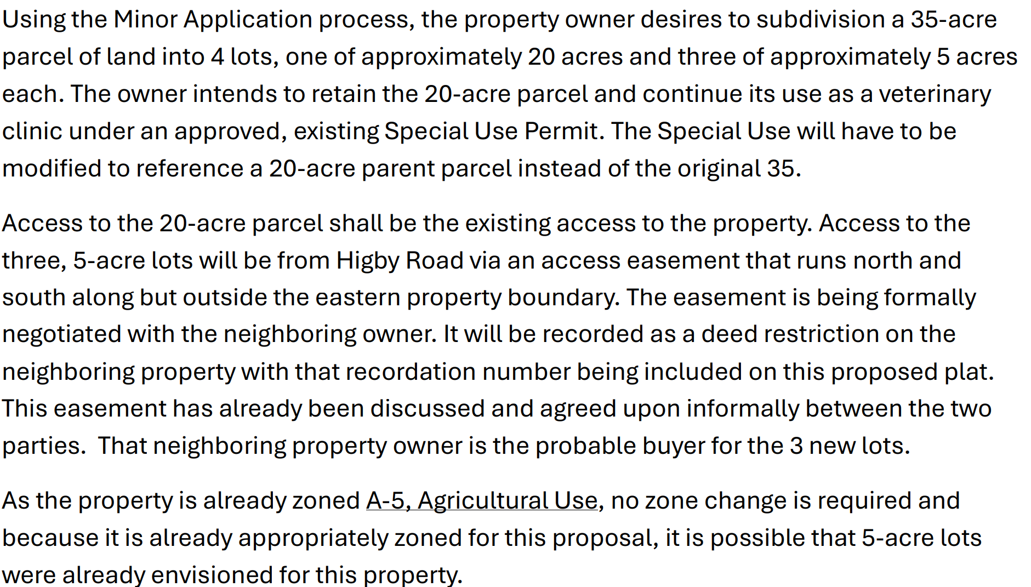

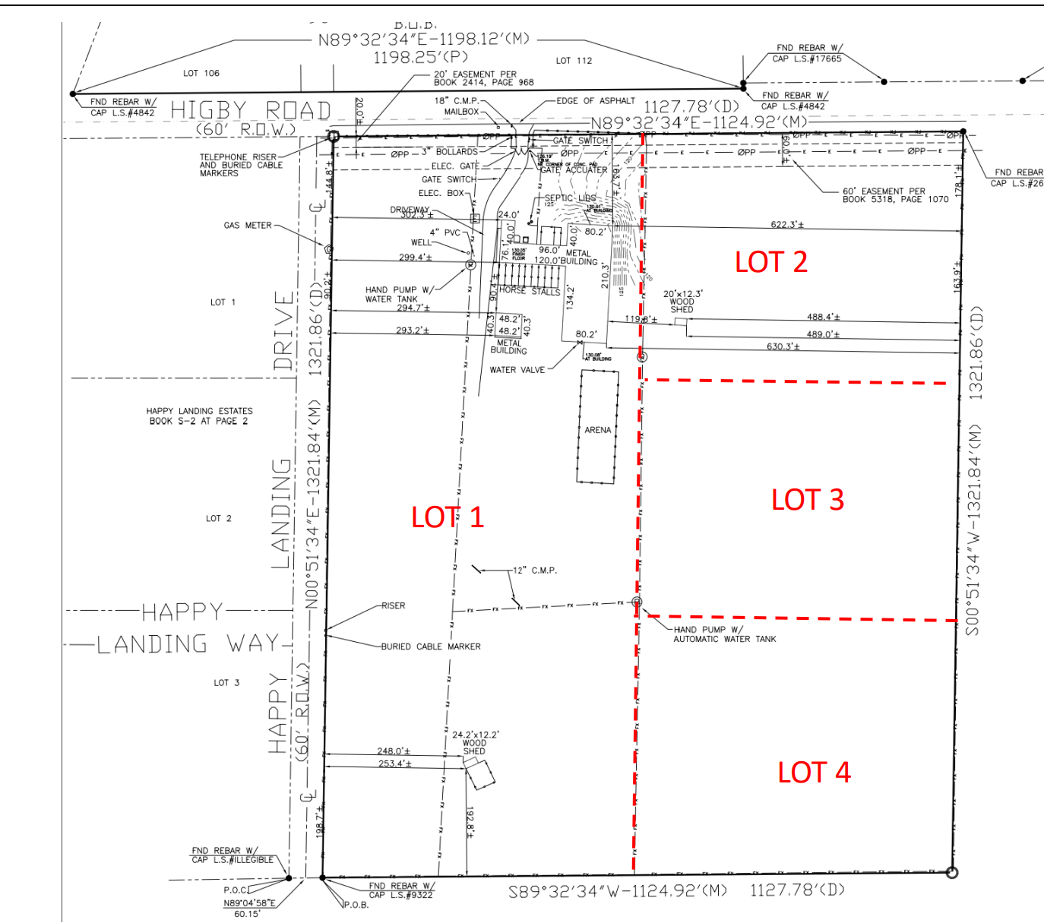

Zoning
Existing Zone(s)
Zone |  | Name
A-5 |  | Agricultural
Proposed Zone(s)
Zone |  | Name
A-5 |  | Agricultural

Zone Map
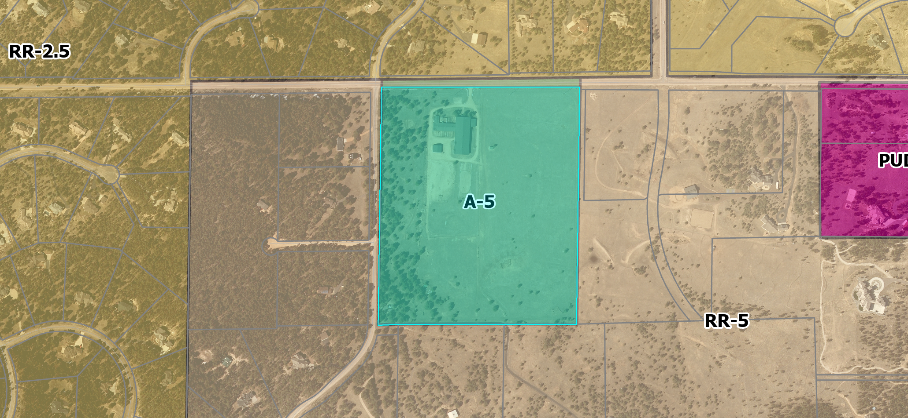

Zoning Analysis
-Surrounded by residential zoning with a mix of smaller lots of 2.5 -5 acres in size
-Keeping A-5 but creating more lots is consistent with character of community
-Maintaining A-5 zoning does allow for more agricultural uses vs rezoning to rr-5

Zoning District Requirements (density, lot size, lot design standards, building setbacks)
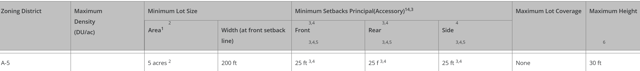
2 In the event that the land to be partitioned, platted, sold or zoned abuts a section line County road, the minimum lot area for lots abutting the road shall be 4.75 acres and minimum lot width shall be 165 ft.

3 Agricultural stands shall be setback a minimum of 35 feet from all property lines.

4 Sawmills shall be setback a minimum of 300 feet from all property lines.

6 One additional foot of height is allowed for each foot of additional setback provided above the required minimums up to a maximum of 100 feet. For example, a maximum height of 35 feet is allowed for structures setback a minimum of 30 feet from all property lines and a maximum height of 50 feet is allowed for structures setback a minimum of 45 feet from all property lines.

Application Type(s)
Final Plat | Hearing: Required

Approval Criteria:
Section 7.2.1

(f)
Criteria for Approval. In approving a final plat, the approving authority shall find that:
• The subdivision is in conformance with the goals, objectives, and policies of the Master Plan;
• The subdivision is in substantial conformance with the approved preliminary plan;
• The subdivision is consistent with the subdivision design standards and regulations and meets all planning, engineering, and surveying requirements of the County for maps, data, surveys, analyses, studies, reports, plans, designs, documents, and other supporting materials;
• Either a sufficient water supply has been acquired in terms of quantity, quality, and dependability for the type of subdivision proposed, as determined in accordance with the standards set forth in the water supply standards [C.R.S. § 30-28-133(6)(a)] and the requirements of Chapter 8 of this Code, or, with respect to applications for administrative final plat approval, such finding was previously made by the BoCC at the time of preliminary plan approval;
• A public sewage disposal system has been established and, if other methods of sewage disposal are proposed, the system complies with State and local laws and regulations, [C.R.S. § 30-28-133(6)(b)] and the requirements of Chapter 8 of this Code;
• All areas of the proposed subdivision which may involve soil or topographical conditions presenting hazards or requiring special precautions have been identified and that the proposed subdivision is compatible with such conditions [C.R.S. § 30-28-133(6)(c)];
• Adequate drainage improvements are proposed that comply with State Statute [C.R.S. § 30-28-133(3)(c)(VIII)] and the requirements of this Code and the ECM;
• Legal and physical access is provided to all parcels by public rights-of-way or recorded easement, acceptable to the County in compliance with this Code and the ECM;
• Necessary services, including police and fire protection, recreation, utilities, and transportation systems, are or will be made available to serve the proposed subdivision;
• The final plans provide evidence to show that the proposed methods for fire protection comply with Chapter 6 of this Code;
• Off-site impacts were evaluated and related off-site improvements are roughly proportional and will mitigate the impacts of the subdivision in accordance with applicable requirements of Chapter 8;
• Adequate public facilities or infrastructure, or cash-in-lieu, for impacts reasonably related to the proposed subdivision have been constructed or are financially guaranteed through the SIA so the impacts of the subdivision will be adequately mitigated;
• The subdivision meets other applicable sections of Chapter 6 and 8; and
• The extraction of any known commercial mining deposit shall not be impeded by this subdivision [C.R.S. §§ 34-1-302(1), et seq.]

Processing Issues and Options
-Plat must be approved prior to any other proposed development projects associated with the site
-lots 3 and 4 will need access to a road
.flag lots
.private driveway/access maintenance agreement
-3 or more lots require a road or a private driveway can be used

Relevant Past History:
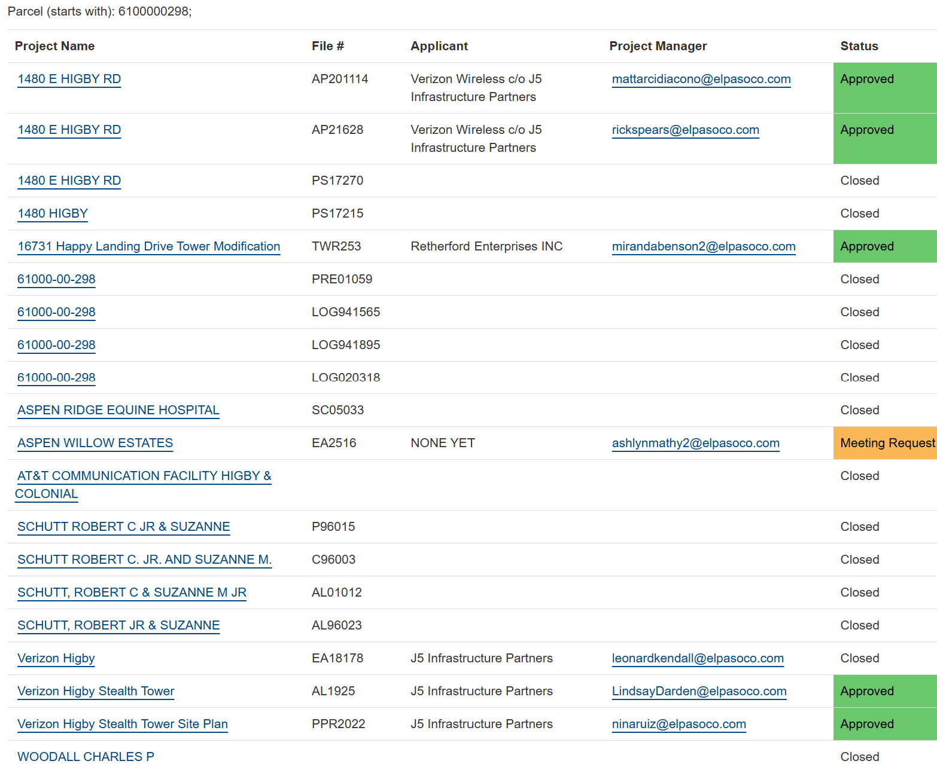

-Tower at property
.AL1925
.PPR2022
.TWR253
-Equine Vet Clinic
.AL01012
-Riding academy/commercial stable
. AL96023

Design and Landscaping

Site Design/Layout (Lot pattern, circulation/road design, open space, preservation of natural features, compatibility internally and with adjacent land uses)
-creating larger style lots does not require landscaping within the lots
-anything abutting roads will

Landscaping
☐ | Expressway, Principal arterial area depth – 25’-Trees required 1 per 20’
☐ | Urban interchange/Intersection area depth – 25’- N/A
☒ | Minor arterial area depth 20’ – Trees required 1 per 25’
☒ | Non-arterial area depth 10’ – Trees required 1 per 30’
☐ | Parking lot landscaping required
☐ | Buffer between non-residential and residential districts separated by a non-arterial road or public alley

Section 6.2.2
https://library.municode.com/co/el_paso_county/codes/land_development_code?nodeId=CH6GEDEST_6.2DESTANFAAC

Signage:
-sign permit on file

Parking Requirements:
-resubmit all associated plans for special use after plat is completed
-parking can be depicted on site plan

Lighting:
-resubmit all associated plans for special use after plat is completed
-any existing lighting should be depicted on site plan

Site Characteristics\ Constraints\ Environmental Standards:
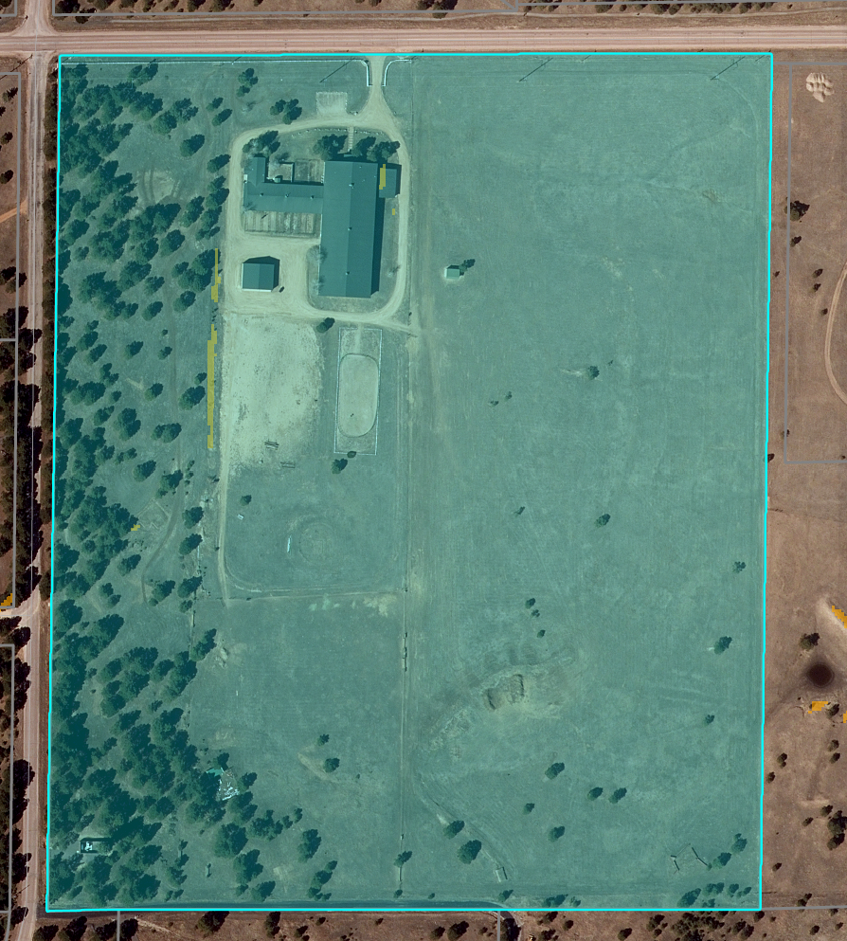
-minimal slope

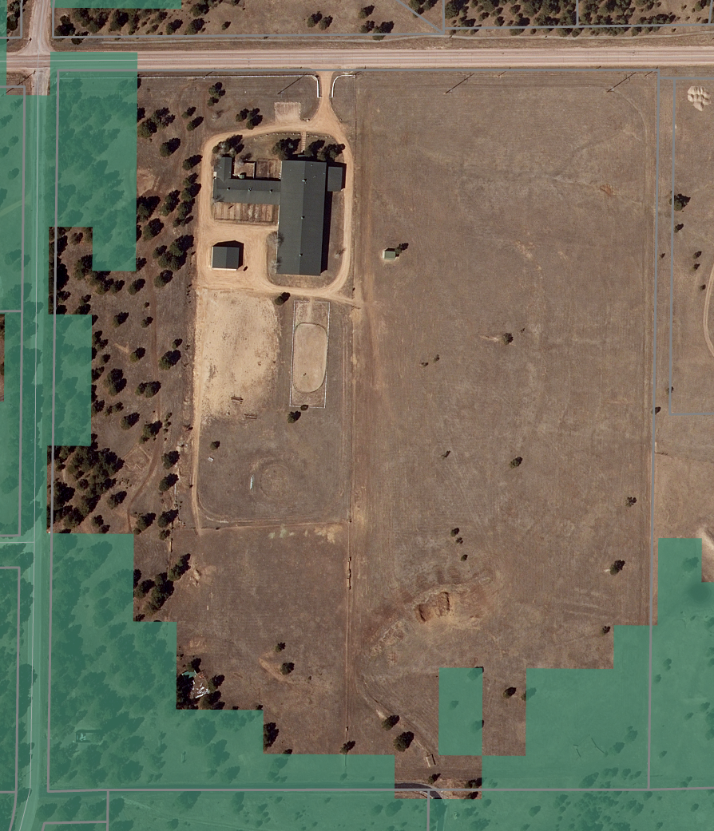
-areas with high fire risk

Flag lot:
(4)
Flag Lots.
(a)
Only Allowed Where Other Options Impractical. Flag lots shall only be used where other lot layouts are impractical.
(b)
Not Used to Avoid Public Road or Utilities Construction. Flag lots shall not be used as a means of avoiding the construction of public roads or the extension of utilities.
(c)
Cul-De-Sac Required. The lot layout shall incorporate a cul-de-sac where 3 or more abutting flag lots would occur.
(d)
Shared Access. Flag lots shall be required to share access where inadequate frontage exists for multiple accesses in accordance with the access requirements of the ECM.
(e)
Minimum Pole Width. The minimum width for a flag lot pole shall be 30 feet.
(f)
Maximum Pole Length. The length of the flag lot pole shall not exceed the length of the longest side of the flag portion of the flag lot.
(g)
Pole Not Included in Lot Area. The area of the pole of the flag lot shall not be included in the lot area in meeting the minimum lot area requirements. Where the pole is irregular or wedge shaped the PCD Director shall determine where the flag pole is measured to.

☐ | 30% or greater slope
☒ | CGS review required (separate fee to CGS)
☐

Taxing Entities
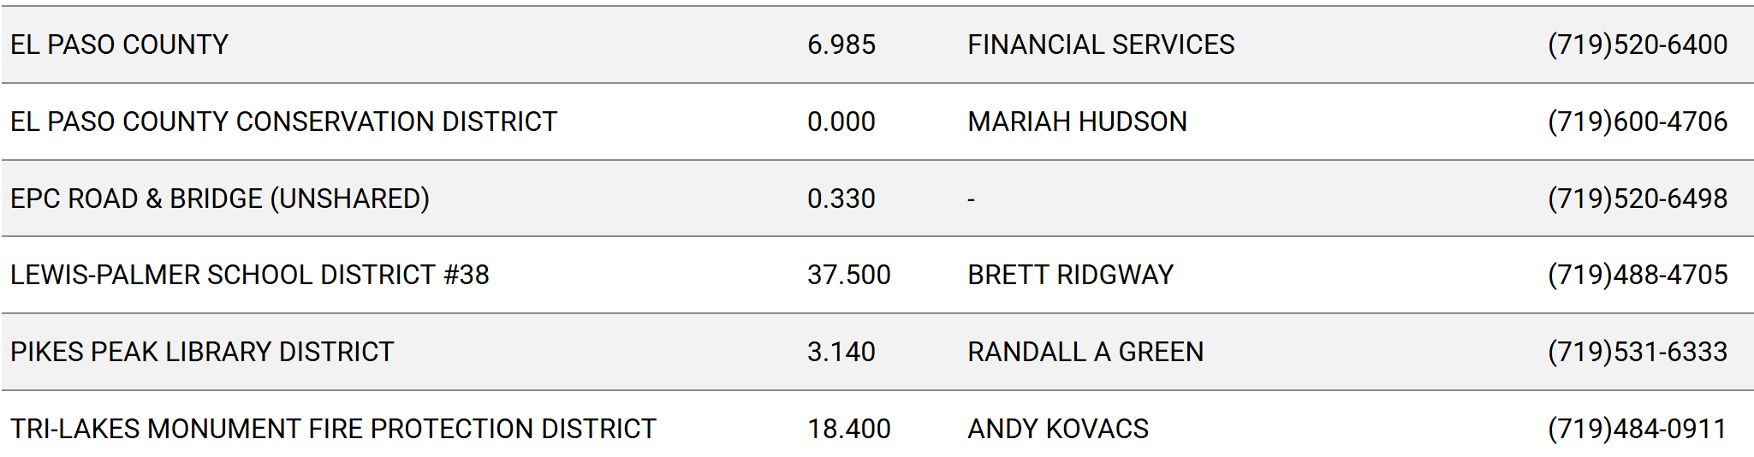

Proposed source of water |  |  | Proposed method of wastewater disposal
☐ | Central System |  | ☐ | Central System
District Name: |  | well | District Name: |  | septic

Water/wastewater comments
Section 8.4.7 of LDC

Verify that wells can support for future use of a large scale subdivision
-state: 100 yr water finding
-county: 300 yr water finding
Section 8.4.2.b
**well and septic**
- Section 8.4.7
water resource report/state required summary form
- Section 8.4.8
On site treatment:
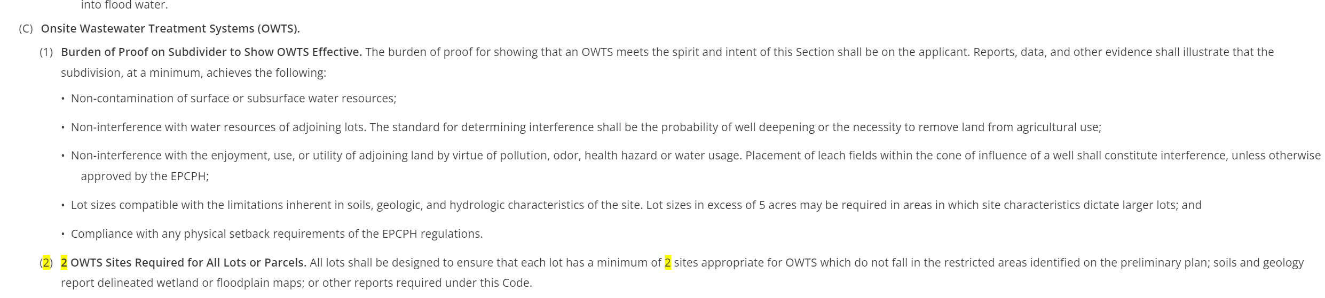

Fire District:
-Tri Lakes Fire Protection District
-Fire Protection Report is required
-Section 6.3.3 of the LDC
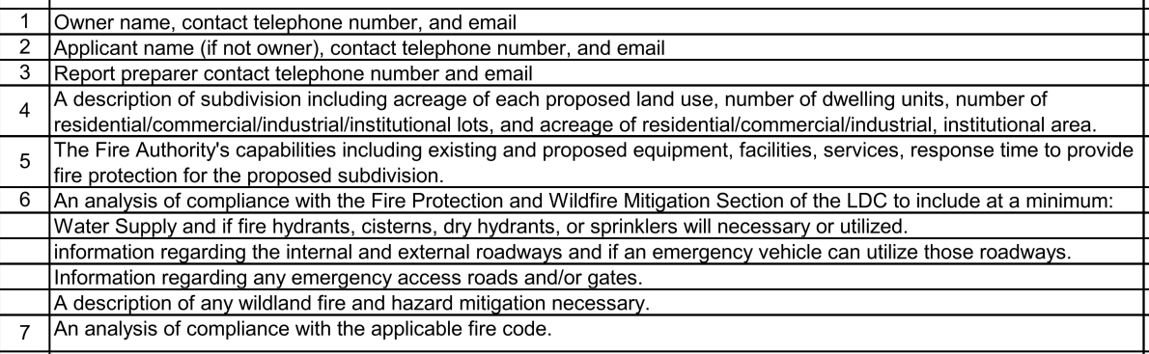

Parks and trails:
-Community services parks division
719 520 6375
-any planned trails near the property/adjacent to the property

Annexations/Intergovernmental/ Jurisdictional Access issues:

Your El Paso Master Plan

Placetype:
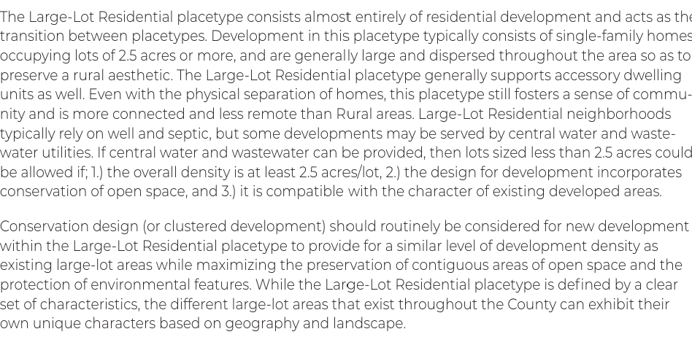

Recommended Land Uses:
- 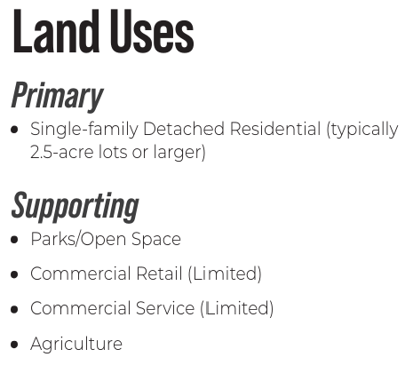

Goals, Objectives, Strategies:


Area of Change Designation:
Description:
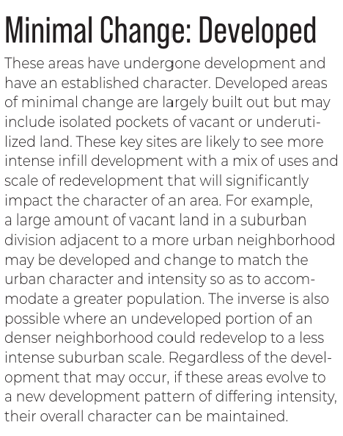

Goals, Objectives, Strategies:
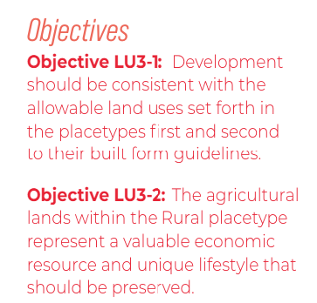

Key Area:

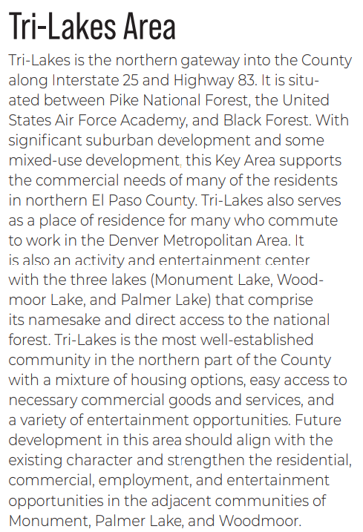

Water Master Plan Area: 2
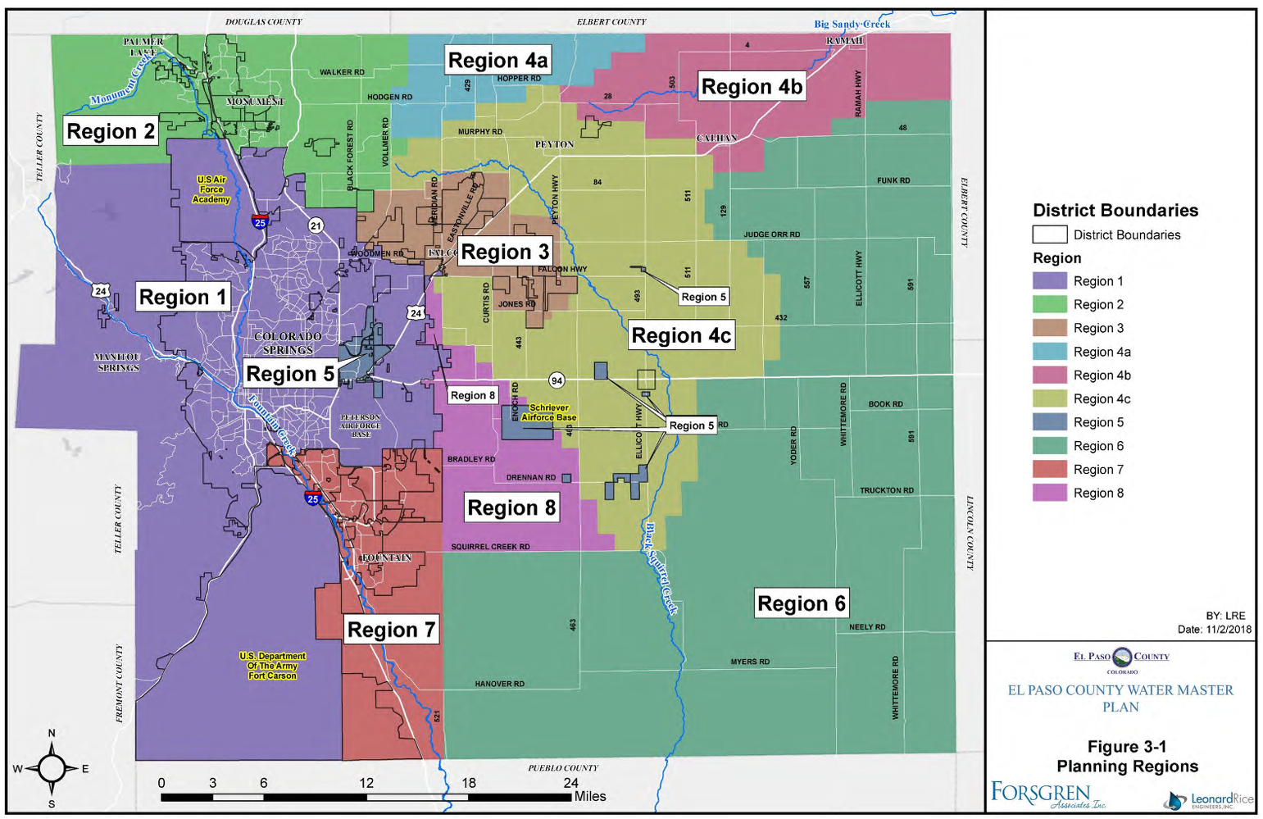

Recommendations:
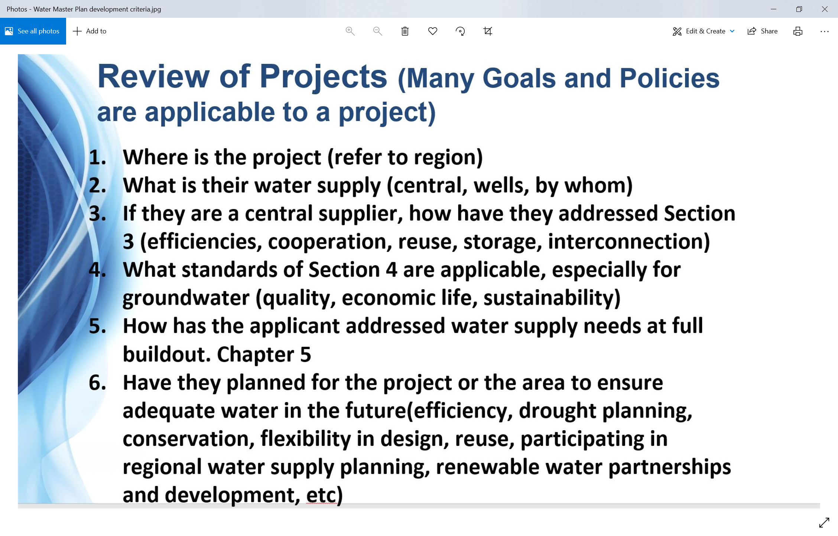
-Please depict answers to #1-6 in the letter of intent
-Applicant required to account for water availability for the next 300 years. This may include working with a water attorney an the Colorado Water Court to meet the County’s mandate.
https://assets-planningdevelopment.elpasoco.com/wp-content/uploads/WaterMasterPlan2018/Water-Master-Plan-2018-A-Copy.pdf

Wildlife impact
Rank – 3

-natural features report
-wildfire and hazard mitigation plan
-associated agencies will review project

Parks Master Plan:
Parks Administration Office
(719) 520-7529
Parks@elpasoco.com

https://communityservices.elpasoco.com/parks-planning/

Helpful Links

Planning Website: https://planningdevelopment.elpasoco.com/

El Paso County Master Plan: https://planningdevelopment.elpasoco.com/#1510603950097-f5d985dc-35b2
Parks, Mineral and Water Master Plan: https://planningdevelopment.elpasoco.com/resources-and-references/#1516982531779-52cc0e87-01af

Forms and Templates: https://planningdevelopment.elpasoco.com/planning-development-forms/#1510677560407-ff8cfff5-69b2716b-00f9cbba-0c21

Land Development Code: https://library.municode.com/co/el_paso_county/codes/land_development_code

EDARP: https://epcdevplanreview.com/

Public GIS: https://elpasoco.maps.arcgis.com/apps/View/index.html?appid=5be6431018594c67b035ad0aad3e7e8a

Wrap Up
-If subdivision is proposed, recording fees, park and school fees and road impact fees apply.
-Fees are subject to change. The fees at the time of application apply.
-Pursuant to the adopted El Paso County Road Impact Fee Program (Resolution No. 12-382), a transportation impact fee, calculated on a per trip basis, may be due at the time of building permit issuance. Starting January 1, 2020 the transportation impact fee will be due for all new construction (Resolution No. 19-471).
-The fee for any additional waiver/deviation requests (more than two) - $550.00 each. Please note that requests for waivers and/or deviations may result in additional processing/review delay.
-All items requested must accompany the submittal for it to be complete, prior to payment request or the submittal will not be complete and ready for review agencies.
-A temporary use permit shall be applied for and approved for any staging area associated with development, such as a sales office, construction trailer, or contractor's equipment yard, prior to scheduling of the pre-construction meeting with El Paso County Planning and Community Development. If a Planned Unit Development is proposed, the temporary staging area should be shown on the development guideline and phasing plan.
-All prospective timelines for review are subject to departmental staffing and workload.
-Early Assistance is valid for 12 months from submittal of the EA application. If a project submittal is not received within 12 months, a new EA meeting may be required. An audio/video copy of the meeting is available in EDARP within the EA folder.

- Applications scheduled for public hearings may be heard as a regular item at the request of staff or a hearing body member.

- Any comments or commitments made by any member of the County Staff during this early assistance meeting are only preliminary in nature and should not be relied upon by the applicant. All prospective applicants should be informed that formal comments cannot be made by staff until after the application is submitted.

