

FALCON FIRE PROTECTION DISTRICT
Fire Prevention Division
7030 Old Meridian Road
Falcon, Colorado 80831
Business Number: 719-495-4050 Business Fax: 719-495-3112



Lieutenant/Fire Marshal Curtis L. Kauffman
Email: ckauffman@falconfirepd.org Cell #: 719-641-2139

Date: August 26, 2026

To: EDARP
C/O: Ryan Howser
Planning & Community Development
2882 International Circle, Suite 110
Colorado Springs, CO 80910
Phone: 719-520-6049
Email: rynhowser@elpasoco.com

Project Name: Falcon Reserve Final Plat
File Prefix: SF-Final Plat
Parcel/s: 5225400001
Zone: CR, proposed RM-12
File Number: SF2617
Review #: 1

This letter serves as comments on the preliminary plan. You are responsible for complying with all sections, codes and references with the fire code based on the 2021 International Fire Code and local amendments.

RED: Local Amendments
Blue: Fire Department Comments

PLEASE READ THIS ENTIRE DOCUMENT, YOU ARE RESPONSIBLE FOR EVERYTHING CONTAINED HERIN!

The following are ACTION ITEMS that need to be completed.

503.1 Where required. Fire apparatus access roads shall be provided and maintained in accordance with Sections 503.1.1 through 503.1.3 and Appendix D.

503.2 Specifications. Fire apparatus access roads shall be installed and arranged in accordance with Sections 503.2.1 through 503.2.8 and Appendix D.

503.2.1 Dimensions. Fire apparatus access roads shall have an unobstructed width of not less than 20 feet (6096 mm), exclusive of shoulders, except for approved security gates in accordance with Section 503.6, and an unobstructed vertical clearance of not less than 13 feet 6 inches (4115 mm). modifications to the required access widths where they are inadequate for fire or rescue operations or where necessary to meet the public safety objectives of the jurisdiction.

503.2.2 Authority. The fire code official shall have the authority to require or permit modifications to the required access widths where they are inadequate for fire or rescue operations or where necessary to meet the public safety objectives of the jurisdiction.

Section 503.2.3 Surface. Fire apparatus access roads shall be designed and maintained to support the imposed loads of fire apparatus and shall be surfaced so as to provide all-weather driving capabilities.

503.2.4 Turning radius. The required turning radius of a fire apparatus access road shall be determined by the fire code official. 33’ inside and 53’ outside radius.

503.2.5 Dead ends. Dead-end fire apparatus access roads in excess of 150 feet in length shall be provided with an approved area for turning around fire apparatus.

503.2.7 Grade. The grade of the fire apparatus access road shall be within the limits established by the fire code official based on the fire department’s apparatus. 10% maximum.

503.2.8 Angles of approach and departure. The angles of approach and departure for fire apparatus access roads shall be within the limits established by the fire code official based on the fire department’s apparatus. Less than 8° degrees (not % percent).

Section 505.1. Address Identification. New and existing buildings shall be provided with approved address identification. The address identification shall be legible and placed in a position that is visible from the street or road fronting the property. Address identification characters shall contrast with their background. Address numbers shall be Arabic numbers or alphabetical letters. Numbers shall not be spelled out. Each character shall be not less than 4 (four) inches (102 mm) high with a minimum stroke width of 1/2 inch (12.7 mm). Address size based on distance from the street: up to 75 feet is 5 inches, greater than 75 to 150 feet is 6 inches; greater than 150 feet to 250 feet is 8 inches; and greater than 250 feet is 10 inches 5 inches high with a minimum stroke width of 1/2 inch. Where required by the fire code official, address identification shall be provided in additional approved locations to facilitate emergency response. Where access is by means of a private road and the building cannot be viewed from the public way, a monument, pole, or other sign or means shall be used to identify the structure. Address identification shall be maintained. Address numbers shall be visible from the street side and in both directions of road travel for each new home.

507.1 Required water supply. An approved water supply capable of supplying the required fire flow for fire protection shall be provided to premises on which facilities, buildings or portions of buildings are hereafter constructed or moved into or within the jurisdiction.

507.2 Type of water supply. A water supply shall consist of reservoirs, pressure tanks, elevated tanks, water mains or other fixed systems capable of providing the required fire flow.

Section 507.3 Fire Flow. Amend Section 507.3 to read as follows:
507.3 Fire Flow. Fire flow requirements for buildings or portion of buildings and facilities shall be determined by an approved method as outlined in Appendix B of this code. A fire flow report shall be provided to Falcon Fire Protection District prior to any combustible materials arriving on site.

507.4 Water supply test. The fire code official shall be notified prior to the water supply test. Water supply tests shall be witnessed by the fire code official or approved documentation of the test shall be provided to the fire code official prior to final approval of the water supply system.

Section 507.5 Fire hydrant systems. Amend Section 507.5 to read as follows:
507.5 Fire hydrant systems. Fire hydrant systems shall comply with Sections 507.5.1 through 507.5.6, NFPA 24, and Appendix C.

Section 507.5.1 Where required. Amend Section 507.5.1 to read as follows.
507.5.1 Where required. Where a portion of the facility of building hereafter constructed or moved into or within the jurisdiction is more than 400 feet from a hydrant on a fire apparatus access road, as measured by an approved route around the exterior of the facility or building, on-site fire hydrants and mains shall be provided where required by the fire code official.
Exceptions:
- For Group R3 and Group U occupancies, the distance requirement shall be 600 500 feet.
- For buildings equipped throughout with an approved automatic sprinkler system installed in accordance with Section 903.3.1.1 or 903.3.1.2, the distance requirement shall be 600 500 feet.
- Use of alternative water supply per NFPA 1142 or the International Wildland-Urban Interface Code as authorized by the fire code official.

507.5.4 Obstruction. Unobstructed access to fire hydrants shall be maintained at all times. The fire department shall not be deterred or hindered from gaining immediate access to fire protection equipment or fire hydrants.

507.5.5 Clear space around hydrants. A 3-foot (914 mm) clear space shall be maintained around the circumference of fire hydrants, except as otherwise required or approved.

507.5.6 Physical protection. Where fire hydrants are subject to impact by a motor vehicle, guard posts or other approved means shall comply with Section 312.

APPENDIX B FIRE-FLOW REQUIREMENTS FOR BUILDINGS
User note:
About this appendix: Appendix B provides a tool for the use of jurisdictions in establishing a policy for determining fire-flow requirements in accordance with Section 507.3. The determination of required fire flow is not an exact science, but having some level of information provides a consistent way of choosing the appropriate fire flow for buildings throughout a jurisdiction. The primary tool used in this appendix is a table that presents fire flow based on construction type and building area based on the correlation of the Insurance Services Office (ISO) method and the construction types used in the International Building Code®.

B101.1 Scope. The procedure for determining fire-flow requirements for buildings or portions of buildings hereafter constructed shall be in accordance with this appendix. This appendix does not apply to structures other than buildings.

B105.1 One- and two-family dwellings, Group R-3 and R-4 buildings and townhouses. The minimum fire-flow and flow duration requirements for one- and two-family dwellings, Group R-3 and R-4 buildings and townhouses shall be as specified in Tables B105.1(1) and B105.1(2).

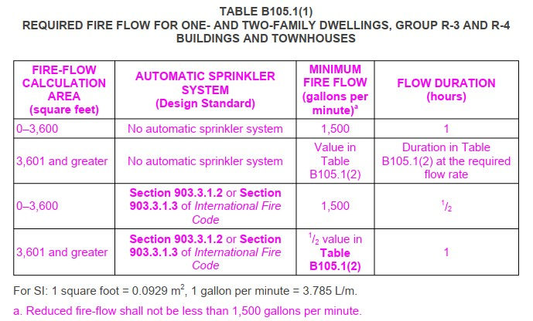

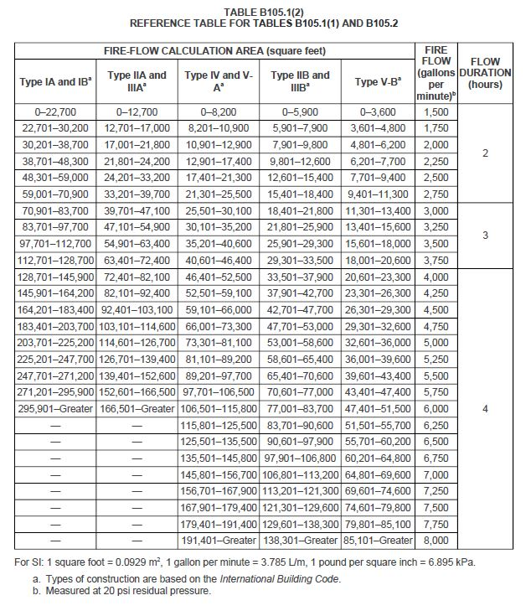

Section B105.4 Simultaneous flows. Add a new section to read as follows:
B105.4 Simultaneous flows. Any hydrant must produce a minimum flow of 1,500 gallons per
minute at 20 psi of residual pressure when flowing individually, or a minimum of 750 gallons per minute at 20 psi residual pressure when flowing simultaneously to be considered by Table C102.1 or by Table C102.1’s footnotes as one of the minimum hydrants required to protect any structure, hazard, or potential hazard.

APPENDIX C FIRE HYDRANT LOCATIONS AND DISTRIBUTION
User note:
About this appendix: Appendix C focuses on the location and spacing of fire hydrants, which is important to the success of fire-fighting operations. The difficulty with determining the spacing of fire hydrants is that every situation is unique and has unique challenges. Finding one methodology for determining hydrant spacing is difficult. This particular appendix gives one methodology based on the required fire flow that fire departments can work with to set a policy for hydrant distribution around new buildings and facilities in conjunction with Section 507.5.

C101.1 Scope. In addition to the requirements of Section 507.5.1, fire hydrants shall be provided in accordance with this appendix for the protection of buildings, or portions of buildings, hereafter constructed or moved into the jurisdiction.

C102.1 Minimum number of fire hydrants for a building. The number of fire hydrants available to a building shall be not less than the minimum specified in Table C102.1.

C103.1 Hydrant spacing. Fire apparatus access roads and public streets providing required access to buildings in accordance with Section 503 shall be provided with one or more fire hydrants, as determined by Section C102.1. Where more than one fire hydrant is required, the distance between required fire hydrants shall be in accordance with Sections C103.2 and C103.3.

C103.2 Average spacing. The average spacing between fire hydrants shall be in accordance with Table C102.1.
Exception: The average spacing shall be permitted to be increased by 10 percent where existing fire hydrants provide all or a portion of the required number of fire hydrants.

APPENDIX D FIRE APPARATUS ACCESS ROADS
User note:
About this appendix: Appendix D contains more detailed elements for use with the basic access requirements found in Section 503, which gives some minimum criteria, such as a maximum length of 150 feet and a minimum width of 20 feet, but in many cases does not state specific criteria. This appendix, like Appendices B and C, is a tool for jurisdictions looking for guidance in establishing access requirements and includes criteria for multiple-family residential developments, large one and two-family subdivisions, specific examples for various types of turnarounds for fire department apparatus and parking regulatory signage.

D101.1 Scope. Fire apparatus access roads shall be in accordance with this appendix and all other applicable requirements of the International Fire Code.

Section D102.1 Access and loading. Amend Section D102.1 to read as follows:
D102.1 Access and loading. Facilities, buildings, or portions of buildings hereafter constructed shall be accessible to fire department apparatus by way of an approved fire apparatus access road with asphalt, concrete, or other approved driving surface capable of supporting the imposed load of fire apparatus weighing up to 75,000 pounds with a minimum single axle weight of 27,000 pounds. Alternative methods such as brick pavers, road, base, and gravel as approved by the fire code official.

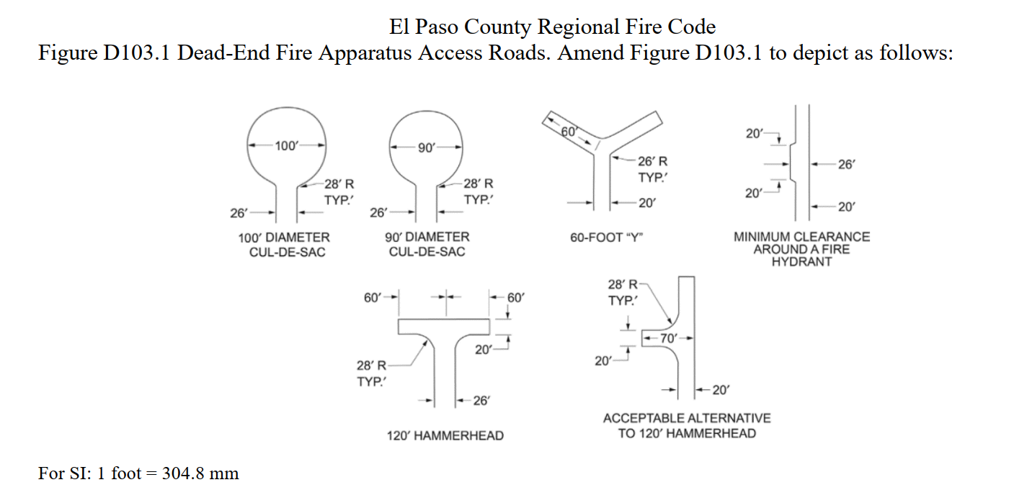

D103.3 Turning radius. The minimum turning radius shall be determined by the fire code official.

D103.4 Dead Ends. Dead-end fire apparatus access roads in excess of 150 feet (45 720 mm) shall be provided with width and turnaround provisions in accordance with Table D103.4.

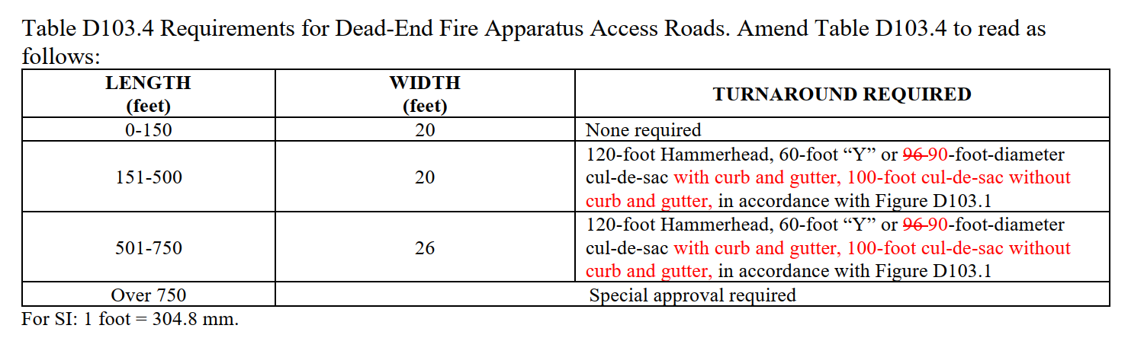

D103.6 Signs. Where required by the fire code official, fire apparatus access roads shall be marked with permanent NO PARKING—FIRE LANE signs approved by the fire code official and comply with the most current Manual on Uniform Traffic Control Devices (MUTCD) for Streets and Highways. Signs shall have a minimum dimension of 12 inches wide by 18 inches high and have red letters on a white reflective background. Signs shall be posted on one or both sides of the fire apparatus road as required by Section D103.6.1, D103.6.2, or D103.6.3, and indicate the extent of the no parking zone.

D103.6.1 Roads less than 28 feet in width. Fire lane signs as specified in Section D103.6 shall be posted on both sides of fire apparatus access road(s).

D103.6.2 Roads 28 feet to less than 34 feet in width. Fire lane signs as specified in Section D103.6 shall be posted on one side of fire apparatus access road(s).

D103.6.3 Roads 34 feet and greater. Fire lane signs are not required on either side of fire apparatus access road(s).

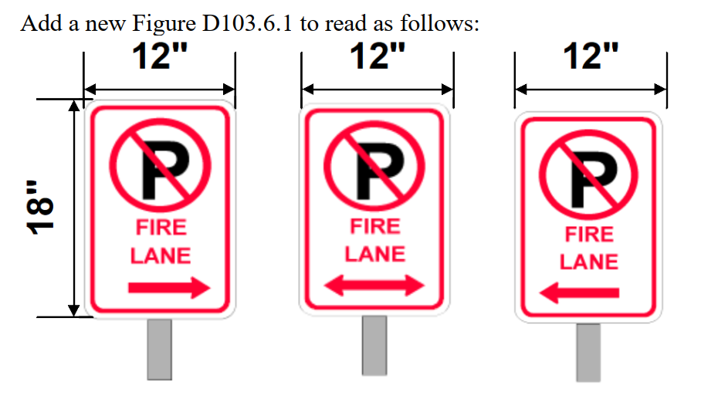

D105.1 Where required. Where the vertical distance between the grade plane and the highest roof surface exceeds 30 feet (9144 mm), approved aerial fire apparatus access roads shall be provided. For purposes of this section, the highest roof surface shall be determined by measurement to the eave of a pitched roof, the intersection of the roof to the exterior wall, or the top of parapet walls, whichever is greater.
Exception: Where approved by the fire code official, buildings of Type IA, Type IB or Type IIA construction equipped throughout with an automatic sprinkler system in accordance with Section 903.3.1.1 and having fire fighter access through an enclosed stairway with a Class I standpipe from the lowest level of fire department vehicle access to all roof surfaces.

D105.2 Width. Aerial fire apparatus access roads shall have a minimum unobstructed width of 26 feet (7925 mm), exclusive of shoulders, in the immediate vicinity of the building or portion thereof.

D105.3 Proximity to building. One or more of the required access routes meeting this condition shall be located not less than 15 feet (4572 mm) and not greater than 30 feet (9144 mm) from the building and shall be positioned parallel to one entire side of the building. The side of the building on which the aerial fire apparatus access road is positioned shall be approved by the fire code official.
D105.4 Obstructions. Overhead utility and power lines shall not be located over the aerial fire apparatus access road or between the aerial fire apparatus road and the building. Other obstructions shall be permitted to be placed with the approval of the fire code official.

Section D107.1 One- or two-family dwelling residential developments. Amend D107.1 to read as follows:
D107.1 One- or two-family dwelling residential developments. Developments of one- or two-family dwellings where the number of dwelling units exceeds 30 shall be provided with two separate and approved fire apparatus access roads.
Exceptions:
1. Where there are more than 30 dwelling units on accessed from a single public or private fire apparatus access road and all dwelling units are equipped throughout with an approved automatic. sprinkler system in accordance with Section 903.3.1.1, 903.3.1.2 or 903.3.1.3, access from two directions shall not be required.
2. The number of dwelling units on accessed from a single fire apparatus access road shall not be increased unless fire apparatus access roads will connect with future development, as determined by the fire code official.
3. The fire code official is authorized to modify the requirement of two separate and approved fire apparatus access roads, when they are not possible due to location on property, topography, waterways, non-negotiable grades, or similar.

Section D107.2. Amend Section D107.2 to read as follows:
D107.2 Remoteness. Where two fire apparatus access roads are required, they shall be placed a distance apart equal to not less than one-half of the length of the maximum overall diagonal dimension of the property or area to be served, measured in a straight line between accesses.
Exception: The fire code official is authorized to modify this requirement when the required remoteness is not possible due to the location on property, topography, waterways, non-negotiable grades or similar.

The following are ATTENTION ITEMS that apply to this review.

Section 1402.1 Temporary Fire Access Road. Temporary access roads shall be an all-weather surface comprised of either the first lift of asphalt or concrete/compacted gravel to a thickness capable of supporting the imposed loads of fire department apparatus. A 20-foot minimum width shall be maintained unless the permanent road is designed less than 20 feet, in which case the temporary road shall be the intended width of the permanent road. Adequate street signs and fire lane signs shall be installed where applicable. Temporary access roads must be maintained in accordance with this section. Temporary roads serving as fire lanes shall not be in place more than 6 months without special approval from the fire department.”

TIMING OF INSTALLATION: Fire department access roads shall be made serviceable prior to and during the time of construction except when approved alternative methods of protection are provided.

ACCESS FOR FIREFIGHTING: Approved vehicle access for firefighting shall be provided to all construction/demolition sites. Vehicle access shall be provided by either temporary or permanent roads capable of supporting vehicle loading under all weather conditions. Vehicle access shall be maintained until permanent fire apparatus access roads are available.

Attention Contractor/Applicant:

YOU ARE RESPONSIBLE TO COMPLETE THE FOLLOWING ITEMS.

Please complete the following items:

- Permits – Ensure all applicable permits are obtained from the Pikes Peak Regional Building Department (PPRBD).
- Follow the Colorado State Forest Service for all mitigation guidelines; csfs.colostate.edu
- Review of the comment letter from Falcon Fire Protection District. You are responsible for complying with the entire fire code as amended and any applicable NFPA’s referenced.
- Ensure all Action Items have been addressed.
- Plan review comments (this letter) shall be on site and available to the fire inspector.

FINAL PLAT REVIEW FEES:
The Falcon Fire Department collects a cost recovery fee of $429.00 for development final plat reviews. SITE ACCESS APPROVED

WATER PLAN REVIEW:
Submit a clean water plan for review. Go to our website (falconfirepd.org) and review and fill out the Water Supply Checklist and the FFPD Water Supplies for Fire Protection forms under Builder/Developer Information>Water Supply/Hydrants. They must be submitted with the water plan. There is a fee for the water plan review. $154.00 for plan review and $55.00 per new fire hydrant.

We do not accept credit cards. The payment shall be made to the Falcon Fire Protection District via check. The check can be mailed or delivered directly to administration offices located at 7030 Old Meridian Road Falcon, Colorado 80831. Please be advised that any new or future construction documents will not be reviewed by the Falcon Fire Protection District until fees are paid in full.

Please let me know if there are any questions and/or concerns. You may contact me via email at the top of the letter.

Sincerely,

Curtis L. Kauffman

Curtis L. Kauffman
Fire Prevention Division
Lieutenant/Fire Marshal

