JULY 14, 2021
DBC Project: 21541-00CSCV

LEGAL DESCRIPTION:
LOT 3 IN LAKESHORE INDUSTRIAL PARK, COUNTY OF EL PASO, STATE OF COLORADO, TOGETHER WITH A NON-EXCLUSIVE INGRESS and EGRESS EASEMENT OVER THE WESTERLY 30 FEET OF THE SOUTHERLY 407.80 FEET OF LOT 4 IN SAID LAKESHORE INDUSTRIAL PARK. (Description from warranty deed recorded under reception No. 220061212 of the records of El Paso County, Colorado.)

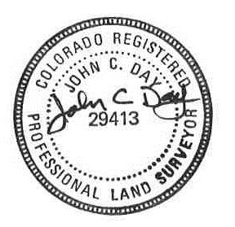

JOHN C. DAY PLS 29413
FOR AND ON BEHALF OF
DREXEL, BARRELL & CO.
3 SOUTH 7TH STREET
COLORADO SPRINGS, COLORADO 80905 7141

