Project: | El Paso County Pedestrian Crossings Improvements Project
Project No. | MTF C040-083
Project Code: | 26666
Parcel No.: | RW-2
Zoning: | RR-5
Structures: | Small Sign – Historical Site (<20 SF), Wooden Fire Memorial (>20SF)

January 13, 2026

El Paso County Planning and Development
2880 International Circle, Suite 110
Colorado Springs, CO 80910

RE: Request for Administrative Relief for Structures Becoming Non-Conforming Due to County ROW Acquisition
6770 Shoup Road/12510 Black Forest Road
El Paso County, Colorado Assessor Parcel No. 5207000092

Dear Ms. Herington:

El Paso County is acquiring a portion of property in fee simple for the Pedestrian Crossings Project. This property is owned by the Black Forest Community Foundation and is on the northwest corner of Black Forest Road and Shoup Road (see attached legal description and exhibit). The property currently contains two conforming signs (see attached photos), permitted and located in compliance with the El Paso County Land Development Code (LDC) and applicable setback requirements for the RR-5 district.

Based on the County’s proposed right-of-way expansion, these structures will become non-conforming as a result of the County’s acquisition action, not due to any action by the property owner.

We respectfully request approval of Administrative Relief allowing the existing conforming signs to remain in their current locations after the County’s right-of-way acquisition, with their legal, conforming status formally recognized and documented through the relief process.

This request is submitted under the provisions of the El Paso County Land Development Code that allow administrative relief where:
- A structure is legally established and conforming at the time of review
- A governmental action (in this case, County ROW acquisition) causes the structure to become nonconforming through no action of the owner.
- The resulting nonconformance does not create an adverse impact to public health, safety, or welfare.
- Relief supports preservation of existing improvements that do not interfere with planned County infrastructure.

The signs in question:
- Do not obstruct sight distance or roadway safety.
- Do not conflict with proposed construction activities.
- Have historically existed without issue.
- Would serve no public purpose by being removed or relocated only due to a boundary change initiated by the County.

This condition meets the general intent of the LDC's administrative relief process, which provides a mechanism to address unique, acquisition-created nonconformities that are not the result of voluntary property owner actions.

Thank you for your consideration.

Sincerely,
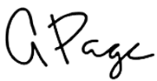

Andrea Page
TRS Corp.
Representing the El Paso County Department of Public Works

Enclosures: Legal Description, Exhibit, Photos

cc: Howard Schwartz, Project Manager, El Paso County Department of Public Works
Project File

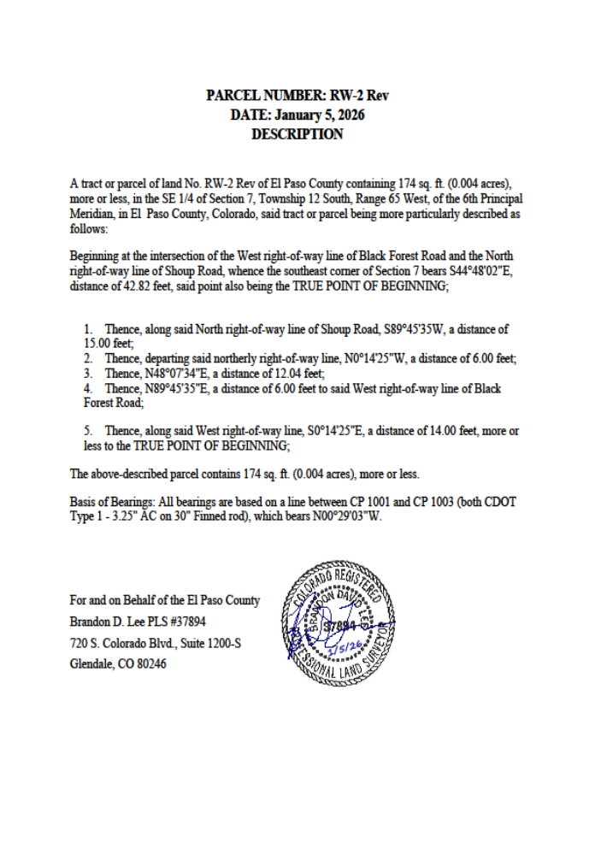

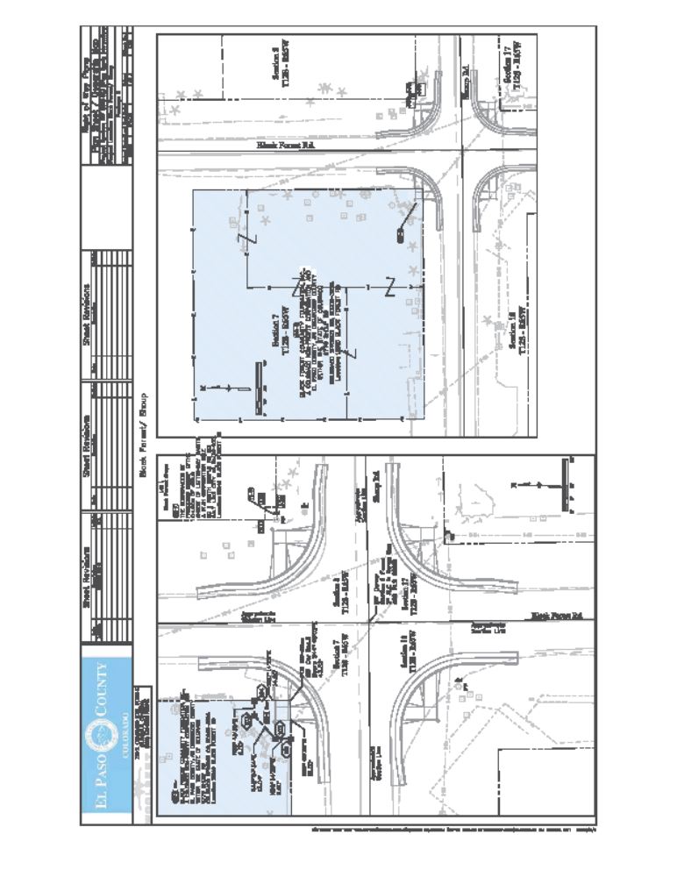

EXHIBIT – Photographs of sign and structure at 6770 Shoup Road

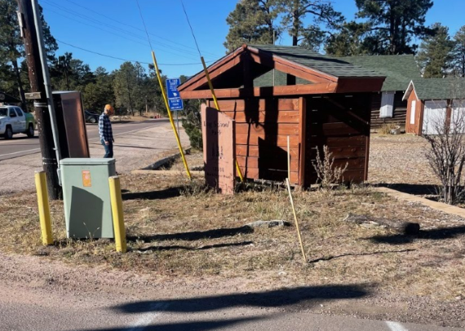
Sign (< 20 SF)
Memorial Structure

