TRAFFIC MEMO PLAN
Variance of Use (VA) Request
Property: 11910 Green Acres Lane, Colorado Springs, CO 80908
Zoning: RR-5 (Residential Rural)
Lot/Parcel Size: 5.06 Acres
Legal description: Lot 2 Treasured Acres Fil No 1
Applicant/Owner: Sterling Providence, LLC
Representative: Holly Eide, Sterlingprovidence@gmail.com, 763-291-1572
Parcel/Tax Schedule No.: 5215001032
Date: March 19, 2026
Proposed Activity:
Typical daily on-site attendance: approximately 6-8 staff.
Occasional: Maximum on-site 10–12; this is less often and may occur due to in-studio guests/interviewees.
12 parking spaces proposed within existing disturbed areas.

Public Traffic
No customer or public traffic will be generated. The proposed use is limited to staff and parcel deliveries consistent with a residence and low-impact office use. No public events, retail traffic, or walk-in services are proposed.
Traffic Impact
The proposed use meets current county standards for no TIS. We propose that we qualify for the Traffic Impact Study Exemption in the Engineering Criteria Manual B.1.2.D. This section of ECM B.1.2.D
Vehicular Traffic:
- Daily vehicle trip-end generation is less than 100
- The peak hour trip generation is less than 10;
- Staff have staggered start times;
- There are no additional proposed minor or major roadway intersections on major collectors, arterials, or State Highways;
- The increase in number of vehicular trips does not exceed the existing trip generation by more than 10 peak hour trips or 100 daily trip ends;
- The change in type of traffic to be generated (i.e., the addition of truck traffic) does not adversely affect the traffic currently planned for and accommodated within, and adjacent to, the property;
- Acceptable LOS on the adjacent public roadways, accesses, and intersections will be maintained;
- No roadway or intersection in the immediate vicinity has a history of safety or accident problems; and
- There is no change of land use with access to a State Highway.
Parking, Access, ADA Compliance, and Fire Lane
- Parking and Circulation - Parking will be limited to staff vehicles. The number of vehicles on-site will generally be equal to number of employees present, no public visitations. No parking will occur in the shared driveway or within easements. Parking spacing will meet county regulations.
- ADA Parking (Required Commitment) - Should this be required, we will add one (1) ADA-compliant parking space for ADA compliance. This improvement, if required, will be implemented within existing disturbed areas and reflected on the site plan.
Proposed ADA parking, onsite parking and fire lane (Visual Only - not drawn to scale)
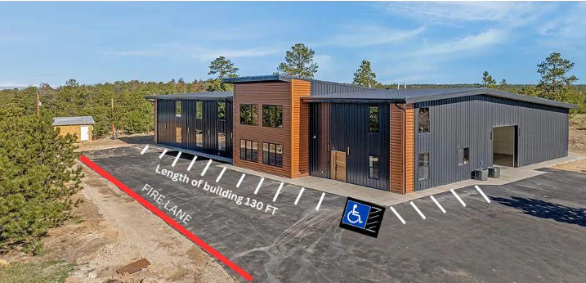
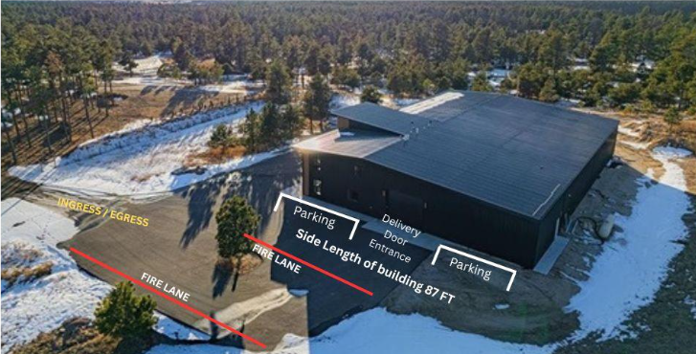

- Fire Lane (Required Commitment) - A fire department inspection completed in Nov. 2025 and again in Mar. 2026 (pictured below on site property) indicated there is ample roadway, turnaround and onsite access for local fire/emergency. If recommended by fire dept. a fire lane will be added, maintained and shown on site plan to comply with recommendation. Property currently meets all fire code requirements for the intended occupancy levels proposed.
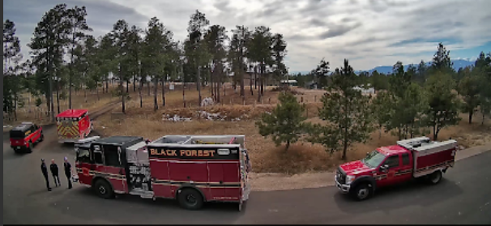

Vehicles, Deliveries, and Off-Site Impacts
- Vehicles - The use includes staff passenger vehicles. Daily trips would be limited to staff in attendance or the occasional scheduled guest for interviews. A standard pickup truck and pull-behind trailer may be used for operational needs, including transport of materials to off-site events.
- Deliveries - Deliveries will be consistent with typical residential deliveries and normal service activity, with occasional deliveries for administrative and media production use not to exceed a standard box truck/residential delivery truck (FedEx, UPS, etc.). Deliveries will be received on-site and handled within existing buildings. No public pickup or customer delivery traffic is proposed.
- Off-Site Impacts - All off-site impacts have been addressed; traffic and parking will remain minimal and limited to staff. The site provides adequate on-site parking, circulation, and open space. No off-site parking in shared driveway/easements is proposed.
Traffic Easement
There is a shared access easement and maintenance agreement recorded with the clerk and recorders office for Green Acres Lane.
- Lot 3 of Treasured Acres Filing No. 1 Subdivision (lot directly east of this one) has a legal access easement across on the southeast portion of the property.
- Maintenance responsibilities for the shared access are included in the recorded access and maintenance agreement.
- Maintenance is shared for easement off Burgess Road to 11910. An invoice is periodically For any required maintenance, an invoice is periodically sent to all neighbors sharing costs or repairs/maintenance. Recent repairs were performed on Nov. 2025 (Section 1 gravel entrance off Burgess Road south onto Green Acres [shared by 5 neighbors]. Repairs to Section 3 gravel easement between Lots 1, 2 & 3 was completed Feb. 2026. All costs were borne by Sterling Providence/11910 Green Acres Ln.

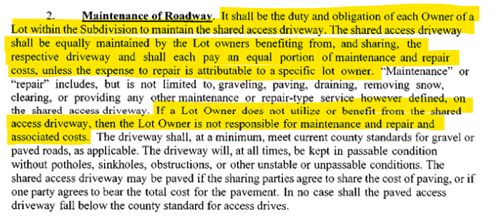
Easement Location – Ingress and Egress
