SITE PLAN
Variance of Use (VA) Request
Property: 11910 Green Acres Lane, Colorado Springs, CO 80908
Zoning: RR-5 (Residential Rural)
Lot/Parcel Size: 5.06 Acres
Legal description: Lot 2 Treasured Acres Fil No 1
Applicant/Owner: Sterling Providence, LLC
Representative: Holly Eide, Sterlingprovidence@gmail.com, 763-291-1572
Parcel/Tax Schedule No.: 5215001032
Date: March 24, 2026

Lot Area Coverage
Under El Paso County RR-5 zoning, maximum lot coverage is 25%. Property has 0.56 acres of disturbance when combining the residence and driveway. The site is approximately 11.1% covered, leaving approximately 88.9% open space, well below the allowable coverage limit.
Existing / Proposed Land Use
- Existing - Residential Rural.
- Proposed - Variance of Use for low-intensity indoor administrative office and podcast / media production use within the existing residence/building, with limited accessory storage incidental to the primary use.
Total Gross Building Sq. Footage: 16,000+ (Residence 8,509; Garage 7,605)
No Physical Alterations: No new building additions are proposed as part of this Phase 1 Variance of Use application.
Property is zoned RR-5 Residential Rural
To reduce the impact and retain the residential character of the surrounding neighborhood, it is proposed that parking for staff not require creating parking lanes or painted lines. There is more than enough area in the driveway to meet the needs of the staff being proposed.
Road Impact Fee
Is applicable to this Variance Use application.
- Following categories proposed: Warehouse and/or office
- Owner agrees on behalf of self and any developer or builder successors and assignees that Subdivider and/or said successors and assigns shall be required to pay traffic impact fees in accordance with the El Paso County Road Impact Fee Program Resolution, or any amendments thereto, at or prior to the time of building permit submittals. If not paid, at final plat recording, it shall be documented on all sales documents and plat notes to ensure a title search would find fee obligation prior to sale.
Landscape Plan
Separate plan submitted to meet county standards for mitigation and lower residential impact.

Lighting
No lighting is proposed under this application. Lighting remains residential in nature as approved after final construction.
Open Space / Landscaping
- Disturbed Areas - A separate disturbed-area / revegetation exhibit is also attached. Proposed revegetation area shown in red, proposed to maintain less than 1 acre disturbance. Identified bare or previously disturbed areas proposed for restoration will be seeded with a native low-growth seed mix and maintained as stabilized open landscape area rather than regular parking, storage, or circulation area.
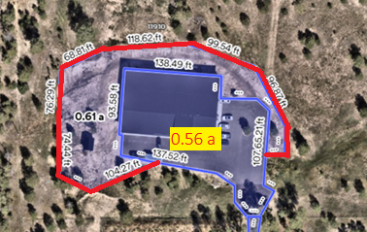
- Parking
  - Roadway landscaping is not applicable due to lack of frontage.
  - 12 spaces maximum proposed. Parking lot landscaping not proposed.
  - 15 spaces or more trigger requirements for landscape.
  - Staff parking is accommodated within the existing driveway / paved area.
  - No striped parking lanes are proposed at this Phase 1 stage.

- Buffering - A preliminary landscape and screening plan is submitted with the application. Existing evergreen tree lines along the south and east property interfaces are proposed to remain and be counted toward required buffering to the extent allowed by County review. Supplemental evergreen infill is proposed where needed to address gaps in screening or tree count compliance. A 15-foot landscape buffer study area is shown along the affected residential interfaces, and a 6-foot opaque screening treatment is proposed where required by final County review.
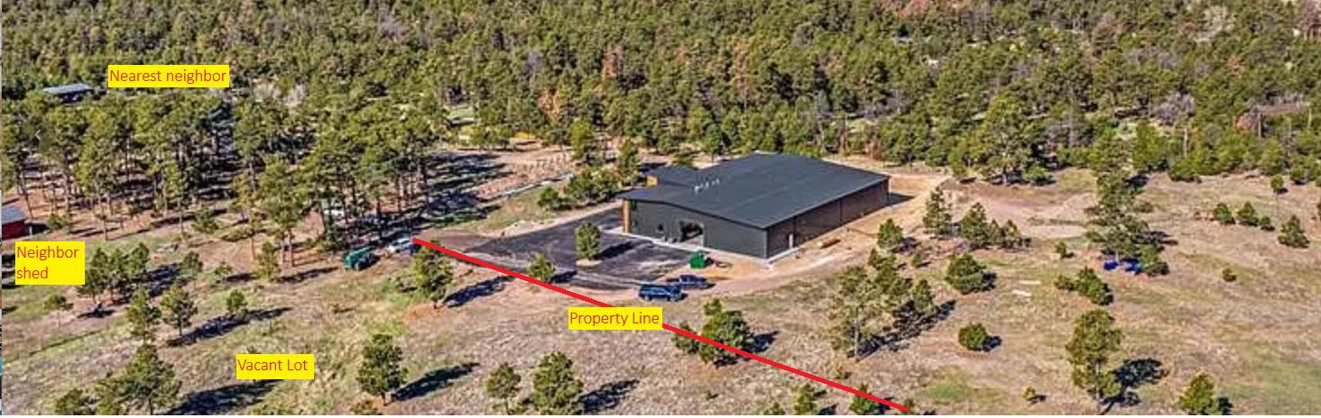

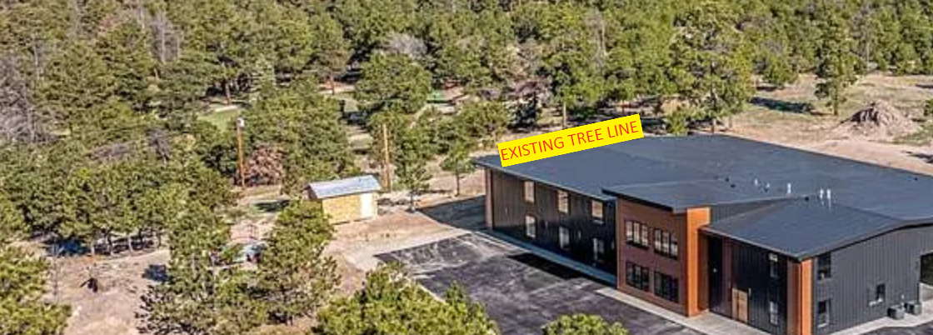
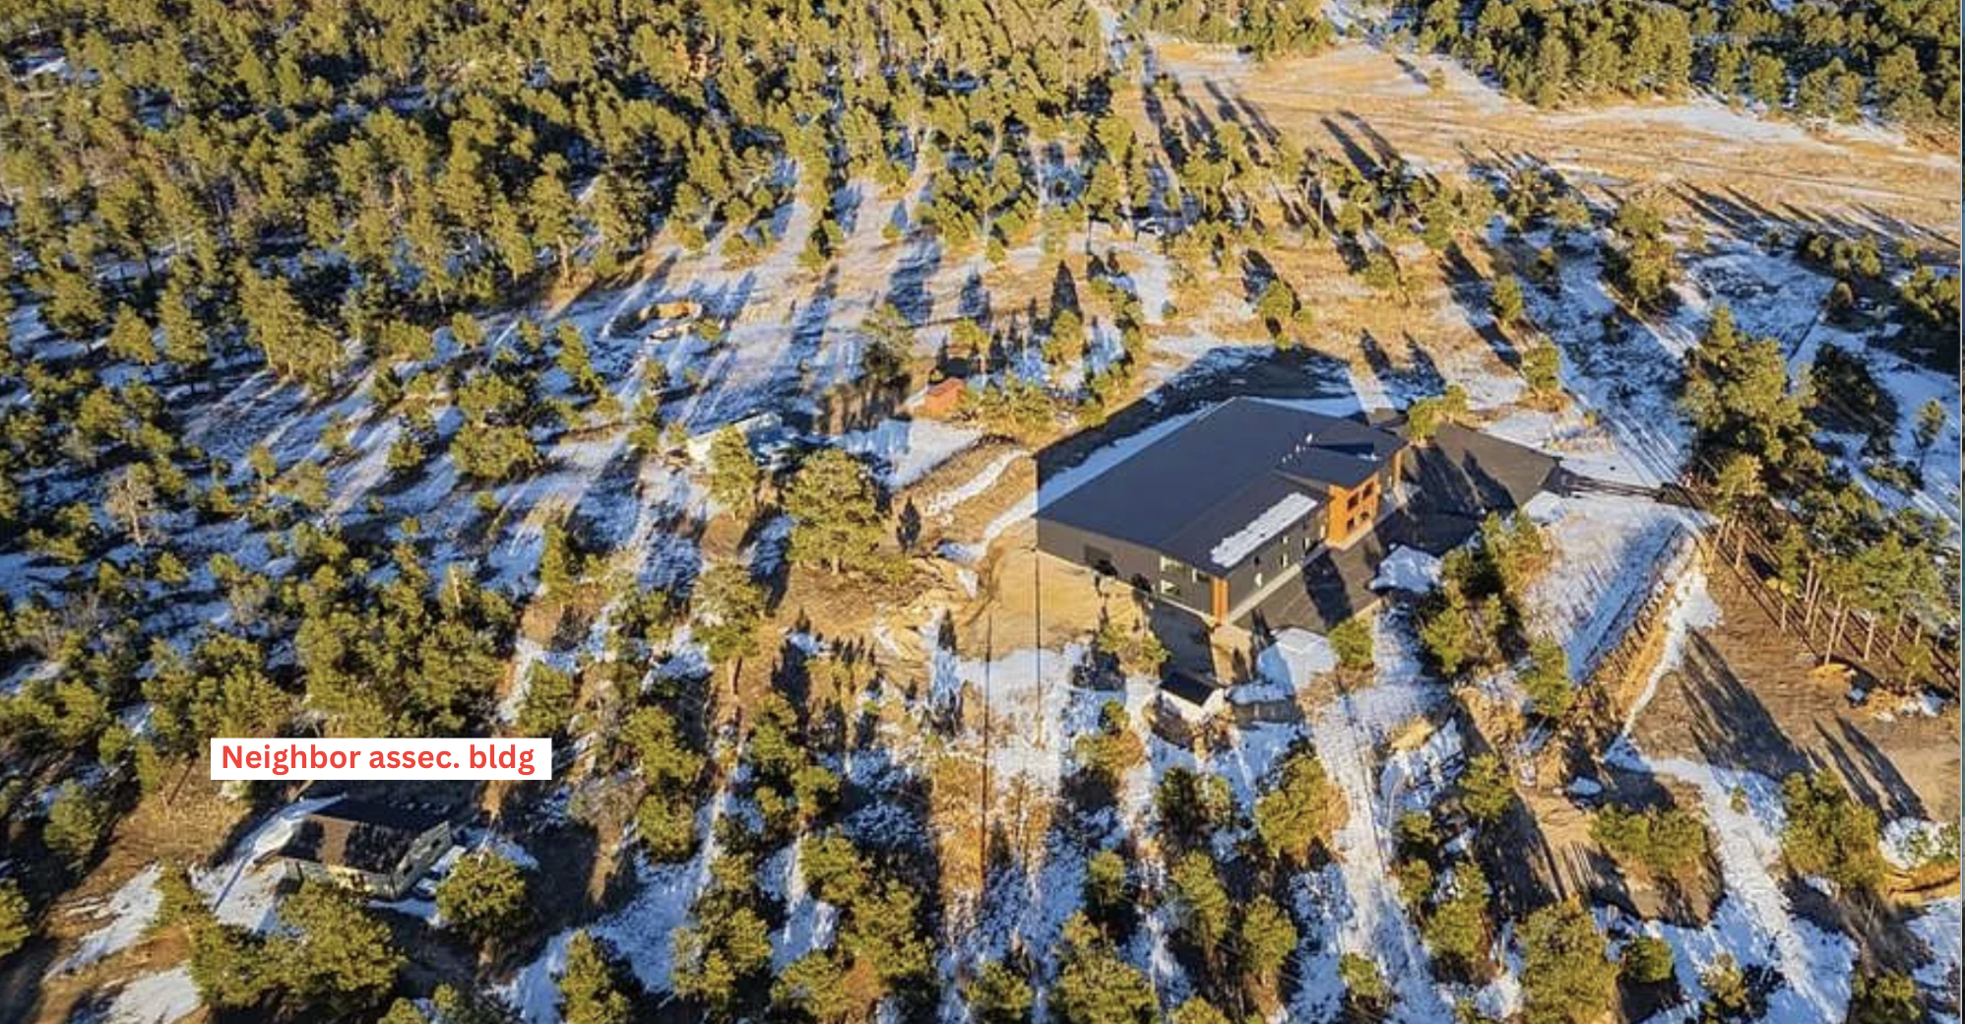

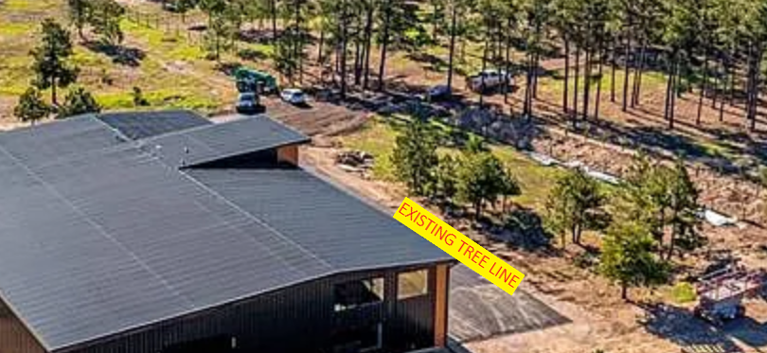
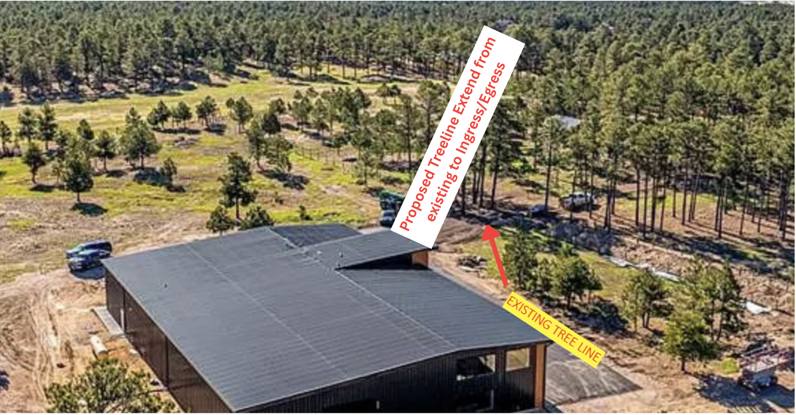

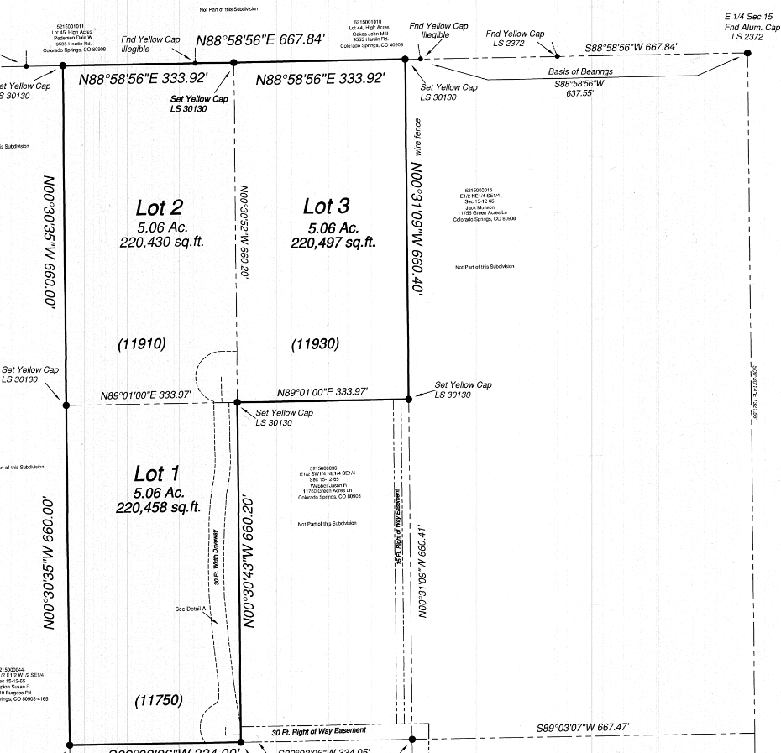

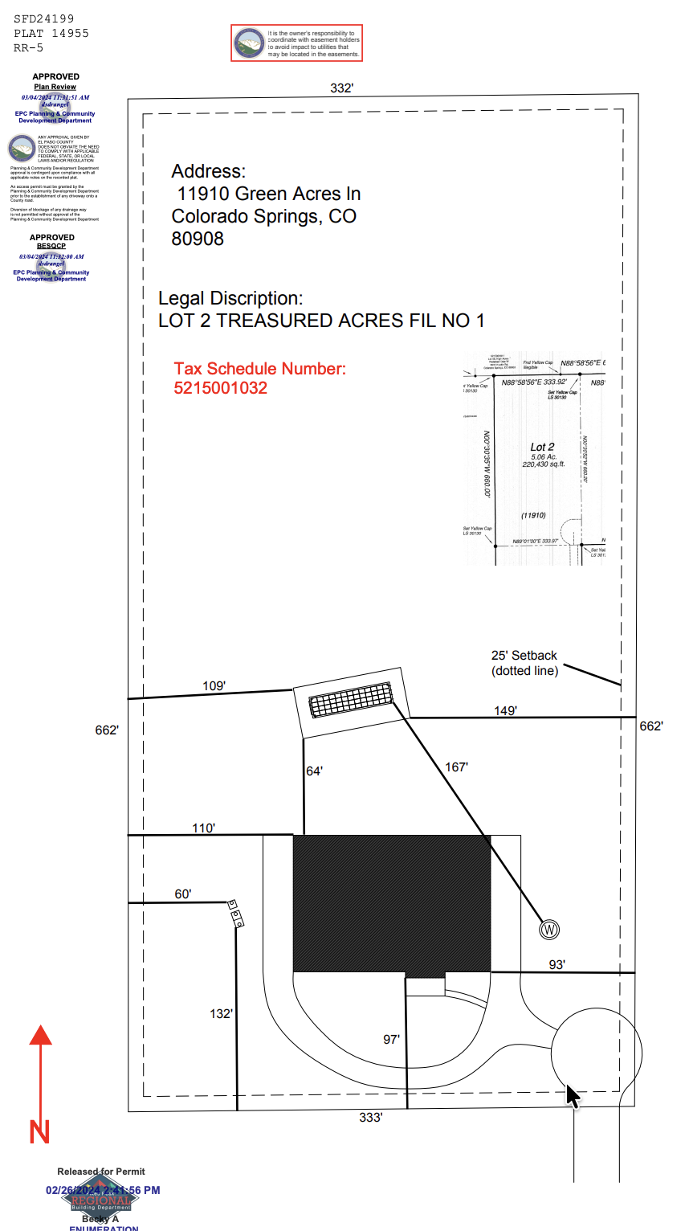
Zone Map (existing conditions of approval)
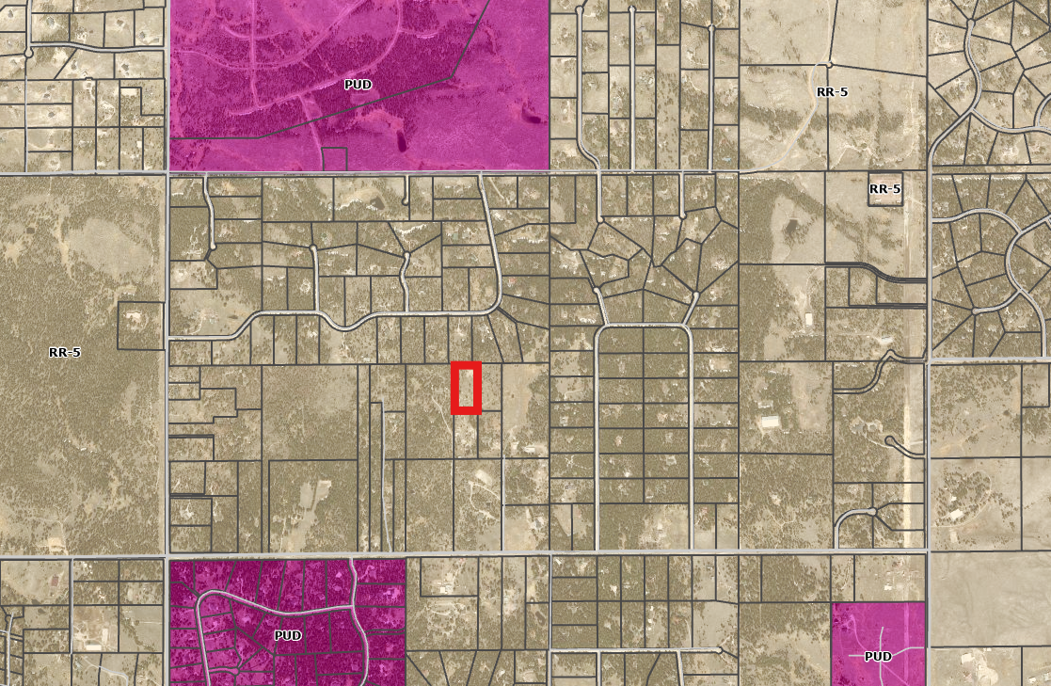

Zoning District Requirements (density, lot size, lot design standards, building setbacks)
Zone District | Min. Lot Size | Min. Setbacks |  |  | Max. Lot Coverage | Max. Height
Zone District | Min. Lot Size | Front | Rear | Side | Max. Lot Coverage | Max. Height
RR-5 | 5 acres | 25’ | 25’ | 25’ | 25% | 30’

Drainage:
- Drainage basin and bridge fees are only assessed with a subdivision action; these fees do not apply to this application.
- This property is in Zone X, Area of Minimal Flood Hazard, based upon review of the FEMA FIRM. The flood map for the selected area is number 08041C0320G, effective on 12/7/2018. This area does not contain a regulatory floodplain.
- The previously completed drainage report for this subdivision can be found on EDARP under PCD File No. MS219: https://epcdevplanreview.com/Public/ProjectDetails/175501 .
- EPC Stormwater Permit (ESQCP) is needed if one of the following criteria are triggered:
  - Mitigation for Item 1 below is being addressed and will meet county requirements.
  - Items 2-4 are not present nor being proposed.
- Develop the site and disturb >1ac of soil, or:
- <1ac of soil disturbance but the site is part of a larger common plan of development, or:
- Cut and/or fill >500 cubic yards of soil, or:
- The site is located in or adjacent to a sensitive area.
- If/when the site has >1ac of un-excluded soil disturbance, a stormwater quality treatment facility (PCM) will be needed for the runoff from the non-excluded areas. Exclusions can be found in our PCM Applicability Form and ECM Appendix I.7
  - Exclusion being requested as not applicable to our application: Large Lot Single Family Sites (ECM Appendix I.7.1.B.5) and Sites with Land Disturbance to Undeveloped Land that will Remain Undeveloped (ECM Appendix I.7.1.B.7)
  - “A single-family residential lot, or agricultural zoned lands, greater than or equal to 2.5 acres in size per dwelling and having a total lot impervious area of less than 10 percent. A total lot imperviousness greater than 10 percent is allowed when a study specific to the watershed and/or MS4 shows that expected soil and vegetation conditions are suitable for infiltration/filtration of the WQCV for a typical site”
    - Impermeable Surface Percentage: Parcel currently at 24% impervious which meets exclusion threshold. (~13% impervious if bare areas revegetated; revegetation is planned see prior notes on disturbed areas and landscape plan.)
- Stormwater documents are required with the Site Development Plan, no stormwater documents required with Variance of Use application

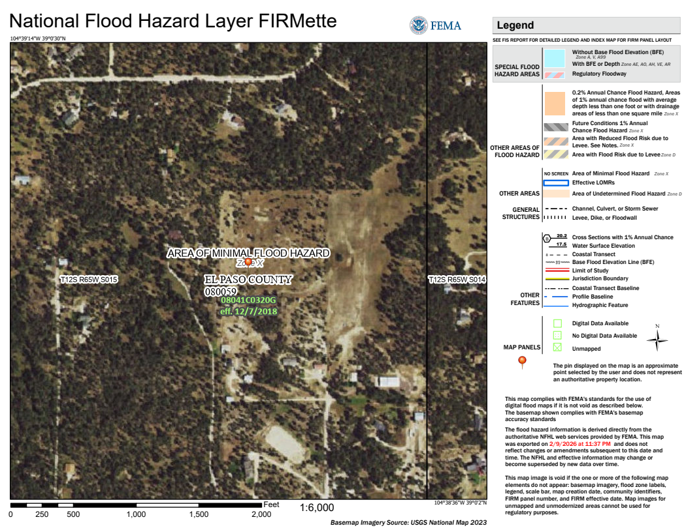

Detention/Water Quality PCM & Downstream Conveyance Information
Per ECM Chapter 3.2.8.B: “The proposed project or developed land use shall not change historical runoff values, cause downstream damage, or adversely impact adjacent properties.”
- No change to existing structure, land or additional disturbed areas are proposed. T

Plat Map or Parcel Map (conditions of approval): Treasured Acres Filing No. 1; Lot 2; MS-21-009
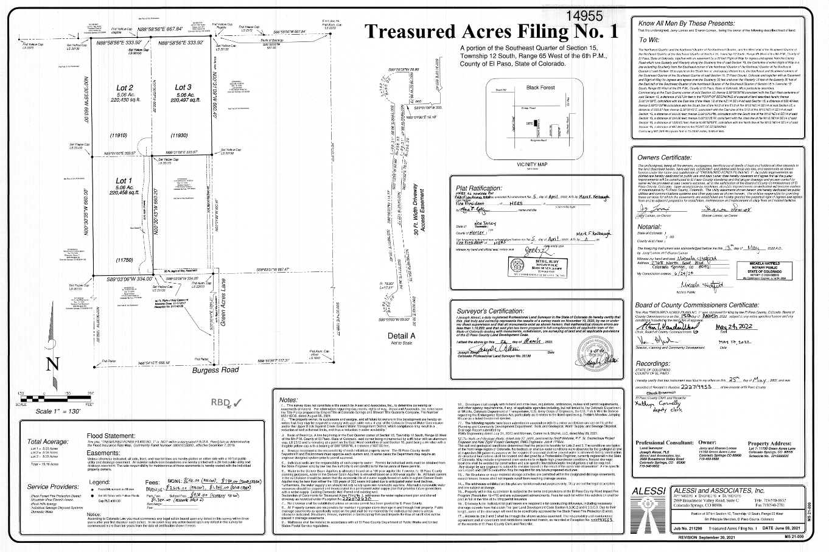

Relevant Past History:
MS-21-009: The property was platted through a minor subdivision process. This included the access as indicated above.

SFD24199 & PPRBD Plan R186622 approved a single-family dwelling.

ADD25716 approved 3 shipping containers on a residential property.

SEP2413: Septic permit was reviewed and approved as a residential onsite wastewater treatment facility. Letter of Acceptance and OWTS flow and tolerance are within this proposed application and exceed tolerance levels proposed. See Septic Engineer Approval Letter submitted with application and to OWTS for approval of permit change request from “residential use to commercial”.

Site Characteristics\ Constraints\ Environmental Standards:
☐ | 30% or greater slope | Comment: | None
☐ | CGS review required (separate fee to CGS) | Comment: | None
☐ | Floodplain | Comment: | None
☐ | Noise mitigation required | Comment: | None
☐ | Preble’s mouse | Comment: | None

Wildlife impact
- This property is considered to have a low wildlife impact potential.

El Paso Master Plan

Placetype:
Character: Large Lot Residential

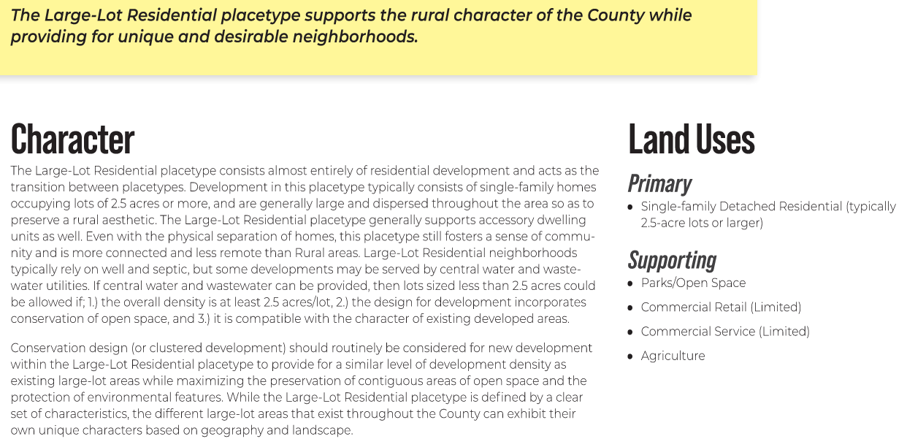

Area of Change Designation:
Description: Minimal Change Undeveloped

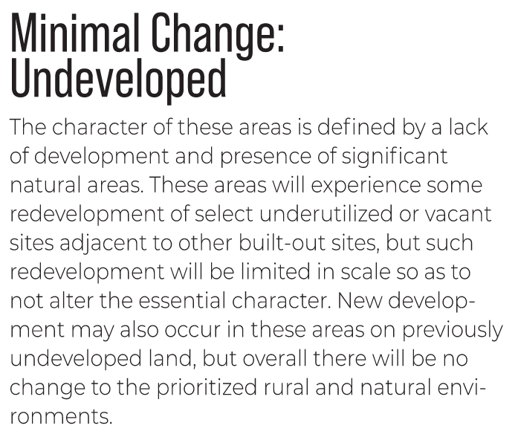

Key Area:
Description: Forested Area

