LANDSCAPE PLAN
Variance of Use (VA) Request
Property: 11910 Green Acres Lane, Colorado Springs, CO 80908
Zoning: RR-5 (Residential Rural)
Lot/Parcel Size: 5.06 Acres
Legal description: Lot 2 Treasured Acres Fil No 1
Applicant/Owner: Sterling Providence, LLC
Representative: Holly Eide, Sterlingprovidence@gmail.com, 763-291-1572
Parcel/Tax Schedule No.: 5215001032
Date: March 23, 2026

Landscape plan is intended to demonstrate the requested variance use can meet County mitigation standards for lowering impact to surrounding residential properties. The plan preserves the existing tree line, supplements screening only where needed, identifies a 15-foot landscape buffer study area, proposes an opaque screening treatment where required, and restores disturbed ground to native low-growth cover, while leaving final measured quantities and technical details to the later Site Development Plan stage.
See separate diagram titled: PRELIMINARY CONCEPT LANDSCAPE / BUFFER PLAN
Preliminary Concept Landscape / Buffer Plan
Approximate concept only. Intended as a handoff base for a surveyor, planner, landscaper, landscape architect, or engineer to formally draft submittal sheets. Final tree counts, fence lengths, and disturbed-area limits to be verified.
Disturbed Areas
To reduce disturbed areas and maintain county standards of not more than 1 acre of disturbance, native low-growth seed will be added to disturbed areas shown in red around the structure and driveway to meet re-vegetation requirements and limit disturbed areas.
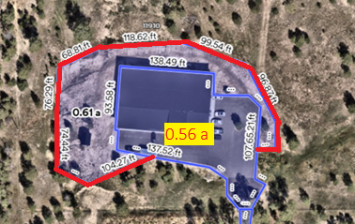

Preliminary Landscape / Buffer Plan
Buffering between properties currently exists by way of evergreen trees. Should more be required, landscape will adhere to meet county standards at a rate of 1 tree for every 25 feet. One-third of the trees will be evergreen.
Existing Tree Inventory
Existing trees - evergreen/deciduous. Natural buffer presently in place.
