September 16, 2026
To Whom It May Concern:

This letter is to inform you that an application for a proposed land-use project occurring in your area has been received by Planning & Community Development (PCD). Please note that PCD will send additional notification prior to any future decision regarding this proposal. To submit public comments, please go to the project directly using the EDARP link below.
PCD File No.: P258, Sundance West Rezone
Project Description: Rezone 19.52 acres from RR-5 to RR-2.5. For more information, see the applicant’s Letter of Intent within the EDARP project file (link below).
Property Owner(s):  Matthew & Gene Dunston  1230 Scarsbrook Court  Monument, CO 80132 | Applicant/Representative:  Vertex Consulting Services, LLC  5825 Delmonico Drive, Ste 320  Colorado Springs, CO 80903  nina.ruiz@vertexcos.com  303-906-8800
Tax ID/Parcel No.: 6125001003  Location of Project: 5525 Hodgen Rd | Zoning District: RR-5 (Residential Rural)  Land Size: 19.51 Acres
View project documents online (EDARP): https://epcdevplanreview.com/Public/ProjectDetails/204056
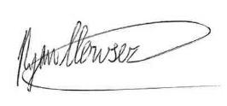
If you have questions/concerns regarding the proposal, please contact me using the information below.
Respectfully,

Ryan Howser–Principal Planner
El Paso County Planning & Community Development
(719) 520-6049 ryanhowser@elpasoco.com

Planning and Community Development
2880 International Cir. Suite 110
Colorado Springs, CO 80910

NOTICE OF LAND-USE APPLICATION

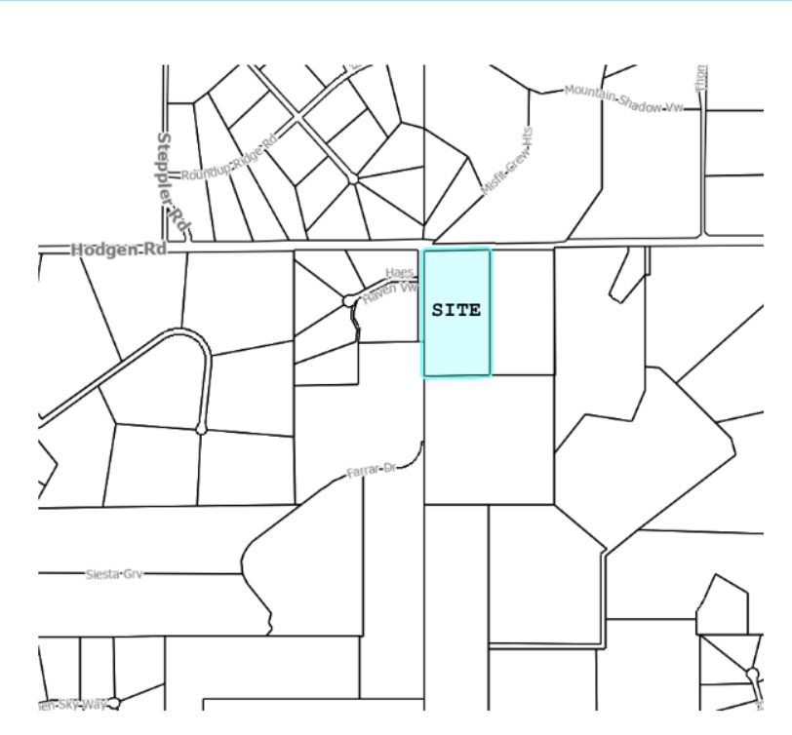

EL PASO COUNTY PARCEL INFORMATION

FILE NO.:
P258
PARCEL NO.:
6125001003
OWNER:
Matthew & Gene Dunston
ADDRESS:
1230 Scarsbrook Court

