Early Assistance Meeting Number: EA266
Project Name: Cog Railway Platform
Project Location: Manitou Springs Ruxton Ave
Project Parcel Nos. 7400000003
Project Description: The property being evaluated is in El Paso County and is currently zoned F-5 (Forestry and Recreation District). The site is just south of the Manitou Springs city boundary and begins at the unpaved portion of Ruxton Avenue. The proposed project includes relocating the “point of departure” that currently serves the Cog Railway from its current location in Manitou Springs, to the parcel directly south in El Paso County. The site is heavily forested with steep terrain and significant natural features including Ruxton Creek and large boulders. The new “point of departure” will include a covered landing platform that can accommodate ~200 people.
Meeting Date:

El Paso County Planning & Community Development Planning Checklist

Request – Map Provided by Applicant
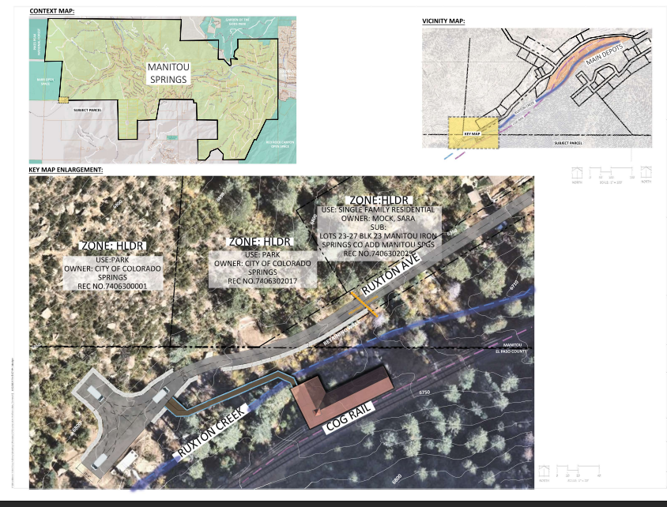

Zoning (check conditions of approval)
Existing Zone(s)
Zone |  | Name
F5 |  | Forestry and Recreation Zoning District
Zone Map
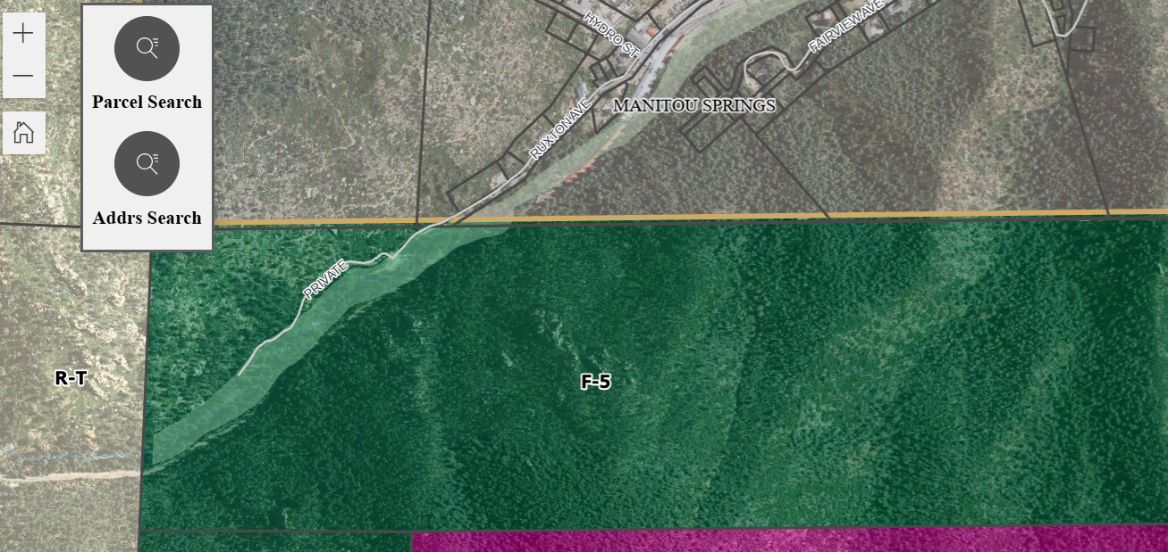

Zoning Analysis
3.2.1. A, Agricultural and F, Forestry District Purposes
(AF-5, Forestry and Recreation District. The F-5 zoning district is a 5 acre district intended to accommodate the conservation of forest resources, protect the natural environment and preserve open space, while accommodating limited residential use.
Staff finds the use is a hybrid of the following allowed uses:

Allowed-Agritainment- Agritainment — Ongoing or seasonal events and/or activities, whether for remuneration or not, of an agricultural nature that are offered to the public for the purpose of recreation, entertainment, and/or education.
Public Park and Open Space, Public Way building Space

Park, Regional — Parks of more than 200 acres in area which are intended to serve the resource preservation and recreation needs of the entire County population, especially those residents within a radius of from approximately 5-10 miles.

Public Improvement — Any drainageway, roadway, parkway, sidewalk, pedestrian way, tree, lawn, parking area, lot improvement, or other facility which benefits the public.

Public Park — A lot, tract or parcel of land devoted primarily to recreation, operated by a governmental or quasi-governmental entity.

Trails — A corridor or recreational easement developed for non-motorized uses such as biking, hiking, horseback riding.

Zoning District Requirements (density, lot size, lot design standards, building setbacks)
25’ front, rear & side

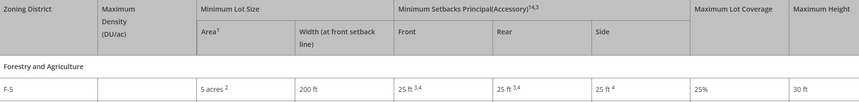

Map of Platted Lot/ Tract (check plat notes & conditions of approval):
Unplatted parcel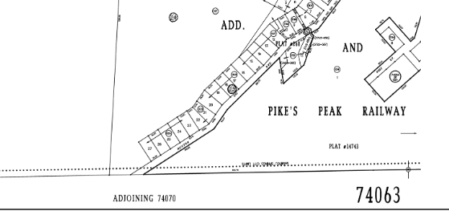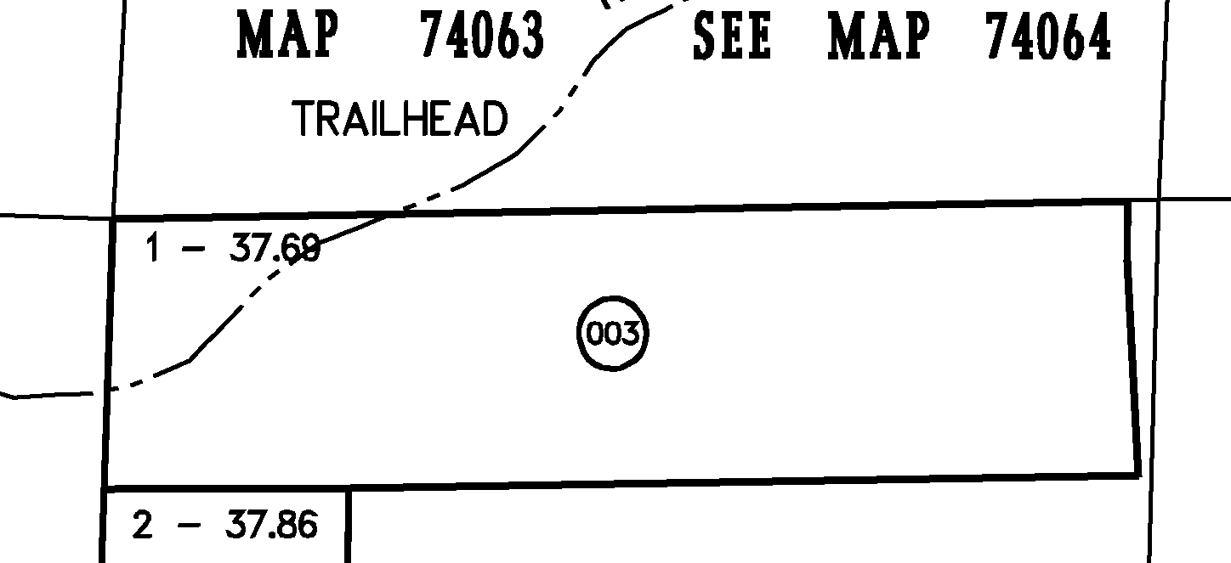

Application Type(s) Hearing: Required/ Optional/ No
Site Development Plan

Processing Issues and Options
Recommend a neighborhood meeting to inform community. Anticipate alternative landscape plan. Very little landscape to be proposed. No water available- hardscape around structure.

Is Ruxton to continue as a private driveway to serve the facility?

Deviation for grade?

Relevant Past History:
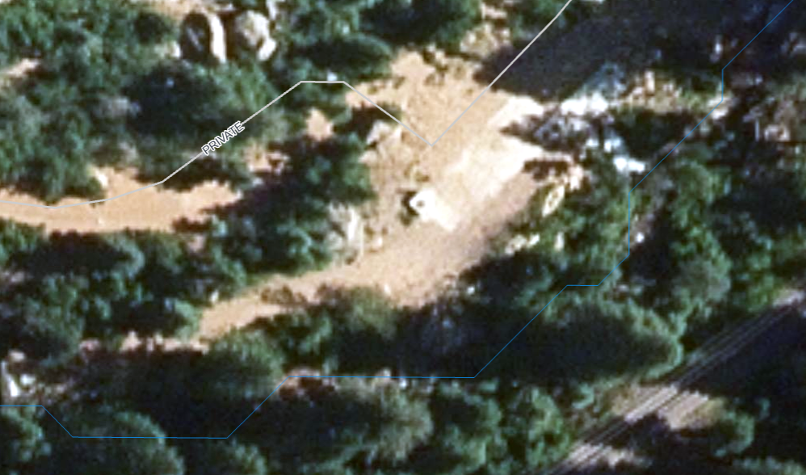 CSU infrastructure

Design and Landscaping

Site Design/Layout (Lot pattern, circulation/road design, open space, preservation of natural features, compatibility internally and with adjacent land uses)
- Incorporate turnaround for Fire/ER as well as shuttles.
- No parking for customers proposed.
- Is new train depot to be located on existing concrete or is new disturbance proposed?
- Concerns with Rock slide/ Slope GEO study needed.
- Retaining Wall Standards.
- (1)Building Permit Required for Retaining Walls Retaining Surcharge. A building permit is required for a retaining wall that retains a surcharge.
- (2)Building Permit Required for Retaining Walls Over 4 Feet High. A building permit is required for a retaining wall greater than 4 feet in height.
- (3)Retaining Walls 7 Feet High Considered Accessory Structure. A retaining wall over 7 feet in height is considered an accessory structure and shall meet the accessory structure setback requirements. If no accessory structure setbacks are established by this Code, the principal structure setbacks are applicable.(4)Established Prior to Principal use. A retaining wall, when necessary for development, may be established prior to the principal use.

Landscaping: Alternative suggested
☐ | Expressway, Principal arterial area depth – 25’-Trees required 1 per 20’
☐ | Urban interchange/Intersection area depth – 25’- N/A
☐ | Minor arterial area depth 20’ – Trees required 1 per 25’
☒ | Non-arterial area depth 10’ – Trees required 1 per 30’
☐ | Parking lot landscaping required
☐ | Buffer between non-residential and residential districts separated by a non-arterial road or public alley

This authority shall not allow the PCD Director to eliminate the requirement for landscaping or to diminish the total landscaped area required by this Section.
(B)Roadway Landscaping Requirements. Roadway landscaping areas are required. A roadway landscaping area is located along the lot, parcel or tract frontage between the road right-of-way, easement, or tract boundary lines and any building or use.
USE EXISTING VEGETATION to count towards roadway landscape/internal.
Exceeding Minimum Depth of Roadway Landscaping. The roadway landscaping trees shall be located within 50 feet of the road right-of-way, easement or tract boundary line and any building or use.

(b)Refuse Areas Screened. Refuse collection areas, including trash bins, shall be screened from view from adjacent properties and roads by an opaque wall or fence, architectural elements, dense evergreen plantings with a minimum planting height of 6 feet, or berms with dense plantings creating an opaque appearance with a minimum height of 6 feet.

Signage: Code Section: 6.2.10. Signs, On-Premise
Depict signage details on site dev plan. A sign permit to be submitted separately.

(4)Exemptions.
The following signs are exempt from the requirement to obtain a sign permit provided the sign complies with the restrictions and performance standards identified. The following signs shall further conform to the site distance requirements in Chapter 2 of the ECM, and the signs shall be located entirely on private property unless otherwise provided.
(a)Government Signs. Government signs, including signs erected by the County or other governmental entities for government purposes, or signs that are otherwise required by law.
(b)Indoor Signs. Signs located entirely inside the premises of a building or enclosed space.
(c)Vehicle Signs. Signs on a vehicle using a roadway.
(d)Traffic Control Device Signs. Traffic control signs necessary to help ensure safe vehicular travel.
(e)Utility Signs. Signs of utilities indicating danger and service or safety information are exempt from the requirements of this Section
(f)Bus Bench and Shelter Signs. Bus bench and shelter signs located within public right-of-way or public improvement easement are exempt from the requirements of this section provided the location of the bus bench or shelter has been approved either by the El Paso County Department of Public Works or via a County contract for transit services.
(g)Temporary Signs. Signs erected for a limited time.

(D)Regulations by Zoning District.
(1)Agricultural, Forestry, and Residential Zoning Districts. The following sign allowances and standards shall apply in agricultural, forestry, and residential zoning districts including recreational vehicle and mobile home zoning districts, residential PUD zoning districts, and within the residential areas of mixed use PUD zoning districts.
(a)Identification Signs.
(i)Number and Use of Identification Signs. 2 identification signs indicating the name of the subdivision shall be allowed at each road entrance to a subdivision or development.
(ii)Low-Profile. All identification signs shall be low-profile and shall not exceed 40 square feet in area and shall not exceed 6 feet in height. Low-profile identification signs shall be located at least 25 feet from all lot, parcel, or tract lines adjacent to public and private rights-of-way or easements.
(iii)Wall Sign Standards. Wall signs used as identification signs shall be attached to a freestanding wall or fence and shall not exceed 40 square feet in area. The wall sign shall not extend above the height of the freestanding wall or fence.

Parking Requirements:
Shuttle stacking / parking / unloading/loading depicted on a sheet within plan set.
Hybrid Plan- train depot 1/250 seats however there is no customer parking at this location. Stacking requirements are not addressed in Code for this type of use. Please propose Plan based on TIS

Lighting:
6.2.3 Lighting Plan required
(2)Height. No freestanding light fixtures shall be mounted higher than 15 feet, except parking lot light fixtures which shall be mounted no higher than 20 feet unless an alternative lighting proposal is approved in accordance with this Code.
Photometric Plan Required | ☐

Site Characteristics\ Constraints\ Environmental Standards:
6.3.3.(2)Applicability. This Section shall apply to all development applications and permits within the unincorporated areas of El Paso County. The standards and requirements related to construction in wildland areas are applicable on land that is shown as forested on the Vegetation Map or to areas identified in the wildland fire risk and hazard mitigation plan, if required by the approval of that plan.

6.3.3.C.1 Design standards apply: Areas without water-Cisterns/Dry Hydrants

6.3.3.C.2
(d)Turnaround Required on Dead-End Roads. Every dead-end road more than 300 feet in length shall be provided with a roadway termination meeting ECM standards.
(e)Road Grades in Wildland Fire Areas. Within wildland fire areas, road grades steeper than 10 percent may be permitted where the Fire Authority and ECM Administrator recommend that the mitigation measures are adequate and the approval authority approves the mitigation measure.

(D)Construction in Wildland Fire Areas.

☒ | 30% or greater slope | Topography: | Severe slope
☐ | CGS review | Soils/geology:8.4.9 |  | Recommend a CGS review, but not required due to terrain; CGS review fee paid to CGS
☒ | Floodplain | Floodplain comment: |  |  | Along Creek  Fences and walls within a 100-year floodplain shall comply with the requirements of the Floodplain Regulations. Zone A
☐ | Noise mitigation required | Noise comment:
☐ | Preble’s mouse
EPC Environmental: Tree removal outside of nesting; possible 404 pending Wetland Study;

Air/Visual Quality:
6.3.8. Wetlands

(A)General.
(1)Purpose. The purpose of this Section is to ensure wetlands are identified during the development process, and that appropriate actions are taken to minimize negative impacts to wetlands and avoid the removal of wetlands where practicable or as may be required by the U.S. Army Corps of Engineers (USACOE).
(2)Applicability. This Section shall apply to all activities and to the review of development applications and approval of development permits on lots, tracts or parcels that include wetlands identified on the National Wetland Inventory, or otherwise identified by field inspection or in the drainage report.
(B)Wetlands Standards.
(1)Reductions of Impacts and Avoidance. Wetlands offer important wildlife habitat, improve surface water quality, and are often indicators of significant natural hazards. When developing a lot, tract or parcel, wetlands should be incorporated into the design of the project or avoided when practical. Storm drainage system design should consider the presence of wetlands and limit impacts that can result from flow volumes, flow rates, and water quality entering a wetland.

6.2.8. Maintenance Plans

(A)General.
(1)Purpose. Maintenance plans are intended to provide for the long term maintenance and care of roads, common areas, recreational and park areas or facilities, open space, bikeways, trails, paths, malls, parking areas, sanitation facilities, common sewerage or water system, permanent BMPs, or private detention ponds where responsibility for operation and maintenance is shared by 2 or more dwelling units, ownerships, businesses, or uses, or any other similar facility.
(2)Applicability. An applicant for a development which includes non-governmental maintenance and care of roads, common areas, recreational and park areas, or facilities, open space, bikeways, trails, paths, malls, parking areas, sanitation facilities, common sewerage or water system by 2 or more dwelling units or uses, private detention ponds, permanent BMPs, or any other similar type of facility and tracts that are not building sites, is responsible for preparing a maintenance plan as part of the development application for the project.
(B)Standards. Maintenance plans shall meet the following requirements:
(1)Address All Required Elements. The maintenance plan shall address all the required elements that will not be maintained by a governmental or quasi-governmental agency. SNOW
(2)Best Available Maintenance Practices. The maintenance plan shall provide for best available practices to maintain the lot, parcel, or tract for the use specified in the maintenance plan.
(3)Mechanism for Adequate Maintenance Funding. An individual or organization shall be designated to provide an adequate funding mechanism to ensure maintenance and annual monitoring of the lot, parcel, or tract for the life of the project.
(4)County Informed of Responsible Party. An adequate mechanism shall be included in the maintenance plan to keep the County informed of any changes in ownership or responsibility for the maintenance of the lot, parcel, or tract.
(5)Contingency Plan. An adequate contingency plan shall be provide for the long term maintenance of the site if irrigation water is removed from the site or the use of the site changes significantly.(C)Recording Maintenance Plans. All BMP Maintenance Plans shall be recorded in the records of the El Paso County Clerk and Recorder's Office.

6.3.4. Forestry

(4)Forestry Management Plan.
(a)Forestry Management Plan Required. A forestry management plan shall be developed and submitted with the development application. The plan should describe the overall forestry management program for the subject property in conformance with the standards identified.

(A)General.
(1)Purpose. To ensure that proposed development is reviewed in consideration of forestry issues to:
• Identify forest health concerns and inform purchasers of developed lot, parcel, or tract;
• Improve overall forest health; and
• Implement wildfire hazard reduction.
(2)Applicability. The provisions of this Section shall apply to the review and approval of all development applications and permits on land that is forested.

Districts

Taxing Entities
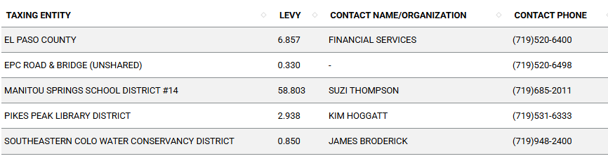

Road Impact Fees: Due at building permit
Address in Traffic Memo account for no customer trips -shuttle only

Proposed source of water NA |  |  | Proposed method of wastewater disposal, Temporary Facilities? yes
☐ | Central System |  | ☐ | Central System
District Name: |  |  | District Name:

City Attorney – access bi-modal; parking for CoG to remain the same; shuttle; smaller transit; TIS MEMO Bi Modal needed to address; trail natural trail not urban trail

Fire District: Manitou Springs FD
Outside of city limits- grades turn a round-snow removal; hydro road; Response ESA AMR Ambulance; transport agreement via City Council.
Max grade MS Code 10%

Chief of Police- traffic increase- motor and bimodal

Will this result in additional users? Police has MOU with the surrounding agencies
Discussion with MOU for ER response with multi agencies

Fire District Design Concerns/Emergency Services Issues:
A wildland fire hazard mitigation report is required to be prepared by a qualified professional and submitted in support of the application See 6.3.3 of the LDC AND

https://planningdevelopment.elpasoco.com/#1515613078151-9a697e85-b1a7

(2)Wildland Fire and Hazard Mitigation Plan Required.
(a)General Plan Standards and Requirements.
When a subject lot, parcel, or tract falls within a wildland fire area, a wildland fire risk and hazard mitigation plan shall be prepared by a qualified professional and shall be tailored to the stage of development application and the stage of subdivision-related construction. A higher level of plan may be submitted at any stage of the process so long as it is implemented at the final stage of development. Plans shall utilize the Colorado State University (CSU) Guidelines and NFPA standards, as applicable. Additional fire precaution measures may be required because of fire hazard in the following areas:

(i)Areas depicted as forested on the Vegetation Map;(ii)Areas rated as fire hazards by the CSFS;(iii)Where slopes in or adjacent to proposed development are in excess of 20%; or(iv)Where the local fire protection agency identifies a specific fire danger.(b)Development of Plan. (i)General Mitigation Plan Requirements. This plan shall include, but not be limited to, the following:
• Access, ingress, egress, and evacuation;

• Fuel modification;

• Water supply;

• Construction, location, and design of structures; and

• Ignition potential.

(ii)Approval of Wildland Fire and Hazard Mitigation Plan. The Approval Authority shall approve the mitigating measures relative to access, defensible space, water supply, and construction based on the relative risk and hazard rating.(3)Wildland Fire Risk and Hazard Severity Analysis Required. (a)Risk Assessment to be Performed. A risk and hazard rating analysis shall be performed to determine the level of the wildland fire threat to life and values at risk prior to building permit authorization in high hazard areas unless completed as part of the wildland fire and hazard mitigation plan.(b)Basis for Mitigation Measures. The risk and hazard ratings shall be the basis for the implementation of mitigation measures relative to vegetation, other combustibles, and construction criteria.(c)Analysis Rating Factors. The following shall be considered in analyzing the risk factors:
• The history of local wind, relative humidity, temperature, and fine fuel moisture content shall be considered in determining defensible space.

• All vegetative fuels and other combustible materials shall be evaluated for their potential to contribute to the intensity and spread of wildland fire.

• Slope and aspect shall be evaluated as to their potential to increase the threat of wildland fire to life or improved lot, parcel, or tract.

• The factors determining required defensible space shall include the history of wildland fire for the area.

• Fire-safe routes for emergency service apparatus and for egress shall be evaluated.

• Other factors that can affect the risk of ignition or the spread of wildland fire on improved lot, parcel, or tract, including the risk of structure fires spreading to vegetation, shall be part of the analysis.

(d)Recommendation of Wildland Fire Risk and Hazard Rating. The rating assignments developed to meet the requirements of this Code may be reviewed by the Fire Authority who may provide a recommendation regarding the rating.(4)No Permit or Approval Granted without Compliance. No permit or approval associated with development, construction or occupancy shall be approved or issued until the provisions of this standard are satisfied. Notwithstanding the foregoing, the Planning and Community Development Director shall have the authority to grant administrative variances to the design standards of this Section upon the finding of two or more of the following criteria:
• The fire authority responsible for providing fire protection services, as applicable, to the project has adopted a fire code with a more stringent design standard from that contained herein;

• The application of a design standard will cause undue hardship or practical exceptional difficulties; or

• An alternate design standard will satisfy the intent and meet the goals of these Fire Protection and Wildfire Mitigation Regulations.

(5)Defensible Space Requirements. (a)General. The Defensible Space Requirements in Table 6.8 shall be implemented as minimum requirements in association with development in any Wildland Fire Area.
Table 6-8. Defensible Space Clearing and Structural Summary (Recommendations from NFPA by Wildland Fire Hazard Severity Analysis)

Low Hazard High Hazard
9.14 m (30 ft) clearance.
Class A roof.
No portion of trees or other vegetation within 3.048 m (10 ft) of chimney outlets.
Trees within defensible space shall be pruned to minimize ladder fuels. 9.14 m (30 ft) irrigated.
Class A roof.
30.48 m (100 ft) fuel treatment.
Noncombustible siding/decks, and boxed eaves.
Selected fire-resistant trees within 9.1 m (30 ft) of structures.
Selected thinning of trees and shrubs.
Trees within defensible space shall be pruned to minimize ladder fuels.
All trees and shrubs pruned of dead material.
No portion of trees or other vegetation within 3.48 m (10 ft) of chimney outlets.

(b)Maintenance of Defensible Space and Associated Fuel Break Thinning. Defensible space and fuel break thinning work shall be completed and maintained to the standards described in the Colorado State University's Cooperative Extension Fact Sheet 6.302. The responsibility for maintaining defensible space and associated fuel break thinning lies with the landowner. Noncompliance with defensible space maintenance standards will be enforced as a zoning violation.(6)Fuels Modification During Development and After Construction. (a)Identification of Modification Required. Identification of fuel modification measures may be required in order to reduce the threat of wildfire. If fuel modification is determined to be necessary, the plan shall be prepared by a qualified professional. A fuel modification plan shall comply with NFPA requirements. Required elements shall include but are not limited to the following:
• Identification of fuel type, volume and loading, in conjunction with an assessment of slope and aspect, to determine the ability for a wildfire to spread;

• Reduction of fuel loading and modification of fuel types to reduce the risk to structures or adjacent vegetation, including the creation of fuel breaks; and

• Creation of defensible space to protect structures from approaching wildfire and reduce the potential for turning a structure fire into a wildfire.

(b)Fuel Modification Standards. When the Wildland Fire Risk and Hazard Mitigation Plan requires establishment of a fuel modification area:
• The modifications shall extend at least 30 feet from structures;

• Ground fuels within the defined defensible space shall be treated or removed;

• Live vegetation within the defensible space shall have dead material removed and shall be thinned and pruned;

• Dead or downed fuels within the defensible space of buildings shall be removed or treated to maintain the fuel modification area;

• Vegetation under trees within the fuel modification area shall be maintained at a height that will preclude ground fire from spreading in the tree crown;

• The fuel modification plan shall include a maintenance element with the responsibility for maintenance defined;

• In these areas all slash (fallen trees, shrubs, pulled stumps, and other combustible materials) may be required to be disposed of from an area extending to at least 150 feet from the road centerline prior to the acceptance of any roads;

• All slash shall also be removed from the vicinity of the home sites prior to final building inspection; and

• Continuous proper forest management to maintain a low wildfire danger shall be guaranteed.

(7)Combustible Materials. Propane tanks and other combustible liquids storage shall conform to NFPA 30, Flammable and Combustible Liquids Code, NFPA 58, Liquefied Petroleum Gas Code, and the Wildland Fire Risk and Hazard Mitigation Plan. Other combustible materials shall be removed from the defensible space or stored in conformance with the fire protection plan.

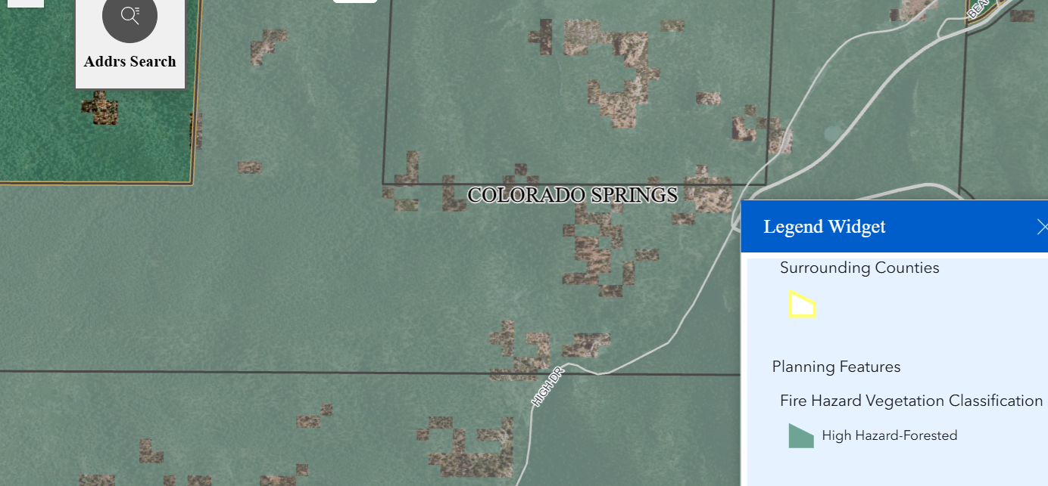

Parks and trails:
The 2022 El Paso County Parks Master Plan shows no impacts to existing or proposed parks, trails, or open space. As such no trail easement dedications will be necessary for this project.
The property is adjacent to City of Colorado Springs Parkland. Please work with both City of CS and Manitou to develop trail connectivity and depict on Site Development Plan.

Easements for trails and drives.

Annexations/Intergovernmental/ Jurisdictional Access issues:
Manitou Springs owns Ruxton Ave. until Unincorporated site.

Is this covered with MOU for AMR? For fire response?

Private road or drive verses Public Owned roadway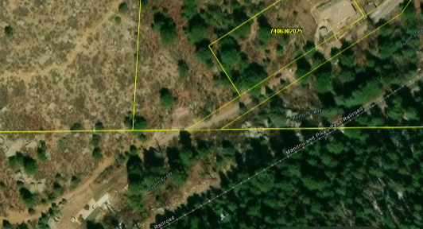

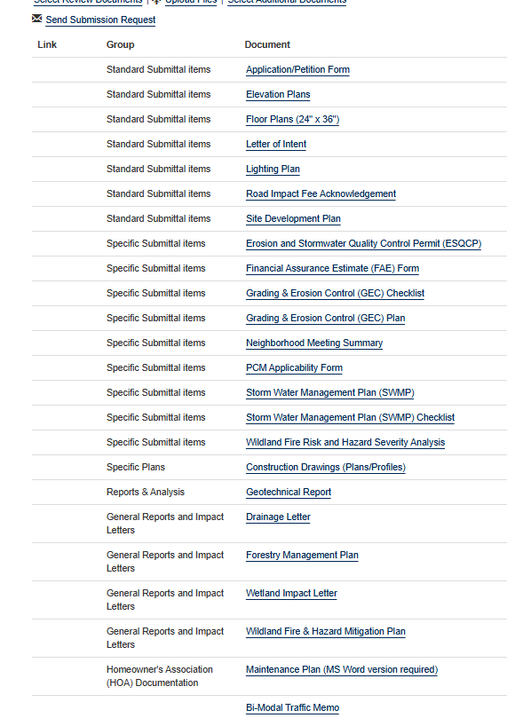
EASEMENTS

Helpful Links

Planning Website: https://planningdevelopment.elpasoco.com/

El Paso County Master Plan: https://planningdevelopment.elpasoco.com/#1510603950097-f5d985dc-35b2
Parks, Mineral and Water Master Plan: https://planningdevelopment.elpasoco.com/resources-and-references/#1516982531779-52cc0e87-01af

Forms and Templates: https://planningdevelopment.elpasoco.com/planning-development-forms/#1510677560407-ff8cfff5-69b2716b-00f9cbba-0c21

Land Development Code: https://library.municode.com/co/el_paso_county/codes/land_development_code

EDARP: https://epcdevplanreview.com/

Public GIS: https://elpasoco.maps.arcgis.com/apps/View/index.html?appid=5be6431018594c67b035ad0aad3e7e8a

Wrap Up
-If subdivision is proposed, recording fees, park and school fees and road impact fees may apply.

-Fees are subject to change. The fees at the time of application apply.

-Road Impact Fees
Please see the following website for information on the EPC Road Impact Fee Project. https://publicworks.elpasoco.com/road-impact-fees/ to include fee schedule.
As of December 15, 2016, per Resolution 16-454, on and after January 1, 2020, property in the unincorporated area of the county that receives a Land Use Approval either in a public hearing or administratively, is subject to the payment of Road Impact Fees. After December 31, 2024, in accordance with BoCC Resolution 24-377 the fee is paid for new residential and non-residential uses and structures and expansions of non-residential uses and structures. Road Impact fees are typically paid at time of building permit. If no building permit is being obtained for a particular Land Use application, then Road Impact Fees must be paid at the time of Site Development Plan or Special Use approval. If there are questions about EPC Road Impact program or fees, please contact DPW Development Review Services and the Engineer of the Day.

- Engineering Criteria Manual (ECM) Deviations.
The fee for any additional ECM deviation requests (more than two per land use application) - $1483.00 each per current Fee Schedule. Please note ECM deviation requests may result in additional processing and project review time. ECM Deviations should be submitted prior to the initial Site Development Plan or Final Plat submittal to preclude changes having to be made to engineering plans and documents if the deviation is not approved. Submission of an ECM deviation request does not imply or guarantee that the deviation will be approved. An ECM Deviation form must be submitted to include complete exhibits and justification excluding cost with supporting engineering criteria. If there are questions about ECM Deviation requests, please contact DPW Development Review Services and the Engineer of the Day.

-The fee for any additional waiver/deviation requests (more than two) - $550.00 each. Please note that requests for waivers and/or deviations may result in additional processing/review delay.

-All items requested must accompany the submittal for it to be complete, prior to payment request or the submittal will not be complete and ready for review agencies.

-A temporary use permit shall be applied for and approved for any staging area associated with development, such as a sales office, construction trailer, or contractor's equipment yard, prior to scheduling of the pre-construction meeting with El Paso County Planning and Community Development. If a Planned Unit Development is proposed, the temporary staging area should be shown on the development guideline and phasing plan.

-All prospective timelines for review are subject to departmental staffing and workload.

-Early Assistance is valid for 12 months from submittal of the EA application. If a project submittal is not received within 12 months, a new EA meeting may be required. An audio/video copy of the meeting is available in EDARP within the EA folder.

- Applications scheduled for public hearings may be heard as a regular item at the request of staff or a hearing body member.

- Any comments or commitments made by any member of the County Staff during this early assistance meeting are only preliminary in nature and should not be relied upon by the applicant. All prospective applicants should be informed that formal comments cannot be made by staff until after the application is submitted.

