MAYBERRY PUD 2

(First Place @ Mayberry)

Natural Features Report

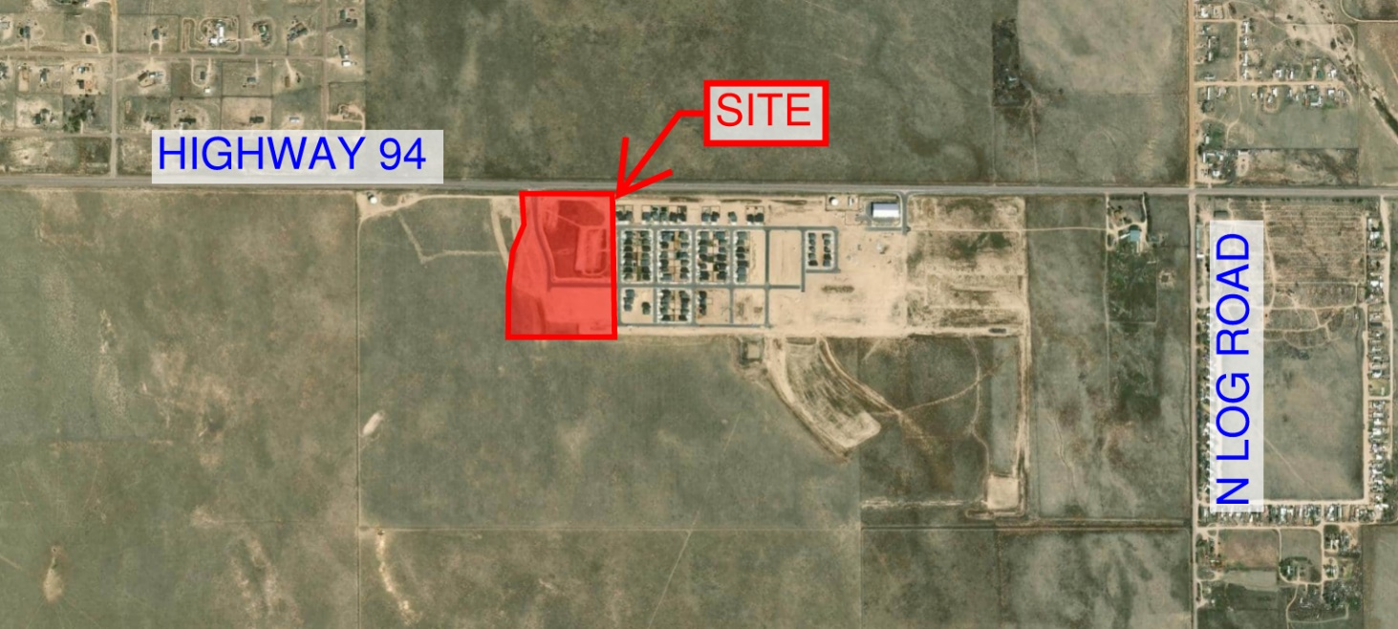

Prepared By:
Kimley-Horn
2 North Nevada Avenue, Suite 900 Colorado Springs, CO

On Behalf of:
Mayberry Communities, LLC
3296 Divine Heights, Suite 208
Colorado Springs, CO

Site Location, Size, Zoning:
Parcel ID Nos.: 3414102014, 3414102014 and 3414102015
Area/Acreage: ±18.85 AC
Existing Zoning: PUD
Location: The development limits are located in the Northwest quarter (1/4) of Section 14, Township 14 South, Range 63 West of the Sixth Principal Meridian. Southeast of Highway 94 and Springs Road Intersection.

Topography
The topography of the project site is mixed between relatively flat to moderately sloped towards the west/southwesterly direction. The existing slopes are slight to moderate with no portions of the proposed site possessing slopes that would prevent development. The site is suitable for development and is not impacted by the flat or moderately sloped grades as current acceptable state and local best grading practices will be employed during development including grading and erosion control activities. The site slopes to the south and west where drainage will be collected into detention facilities prior to discharge into the Ellicott Consolidated Drainage Basin.

Wetlands
There are no jurisdictional wetlands found on site.

Vegetation and Soils
The site is currently vacant with moved earth. Topographically the site is
fairly flat to gently rolling terrain, with overall slopes less than 9 percent across the property.

Scenic Resources & Unique Natural Areas
Wildlife impacts are expected to be generally low based on review of the El Paso County Wildlife Descriptors Map. Additional wildlife impacts may be identified by other entities with wildlife jurisdiction.
The natural mountain backdrop of the Rampart Range is perhaps the best natural feature of Mayberry Communities with sweeping views the mountain skyline and surrounding grasslands in nearly all directions. The scenic view shed is impaired somewhat by intervening development; however, the panoramic views remain quite spectacular.

Wildlife and Migratory Birds
While the area’s most distinctive wildlife is probably the prairie dog, the Colorado Division of Wildlife notes the following as also present in the area; however, the Division also expresses no concern regarding negative and/or unmitigated impacts to wildlife:

- Mule and White Tailed Deer
- Pronghorn Antelope
- Fox species
- Coyote
- Rabbits
- Raptors
- Songbirds
- Numerous Small Mammals

Due to the construction activity and adjoining residential developments, it is not anticipated that the Mayberry PUD 2 project will have no significant impacts on wildlife in the area.

The U.S. Fish and Wildlife Service’s IPaC mapper and website database (https://ecos.fws.gov/ipac/) was used to determine the potential of migratory birds within the area. The IPaC mapper listed six (6) migratory birds that may be affected; however, this list may also include birds occurring outside this area’s FWS office jurisdiction. Breeding migratory birds do receive statutory protection; however, the site contains very few if any trees.

